Microbes in Space: A Meta-Analysis of the Microbial Distance-Decay Relationship

Dave R Clark, Graham JC Underwood, Terry J McGenity, Alex J Dumbrell

School of Biological Sciences, University of Essex, Wivenhoe Park, Colchester, Essex, CO4 3SQ, UK.

Running title: Microbial Distance-Decay Relationships

Supplementary Material

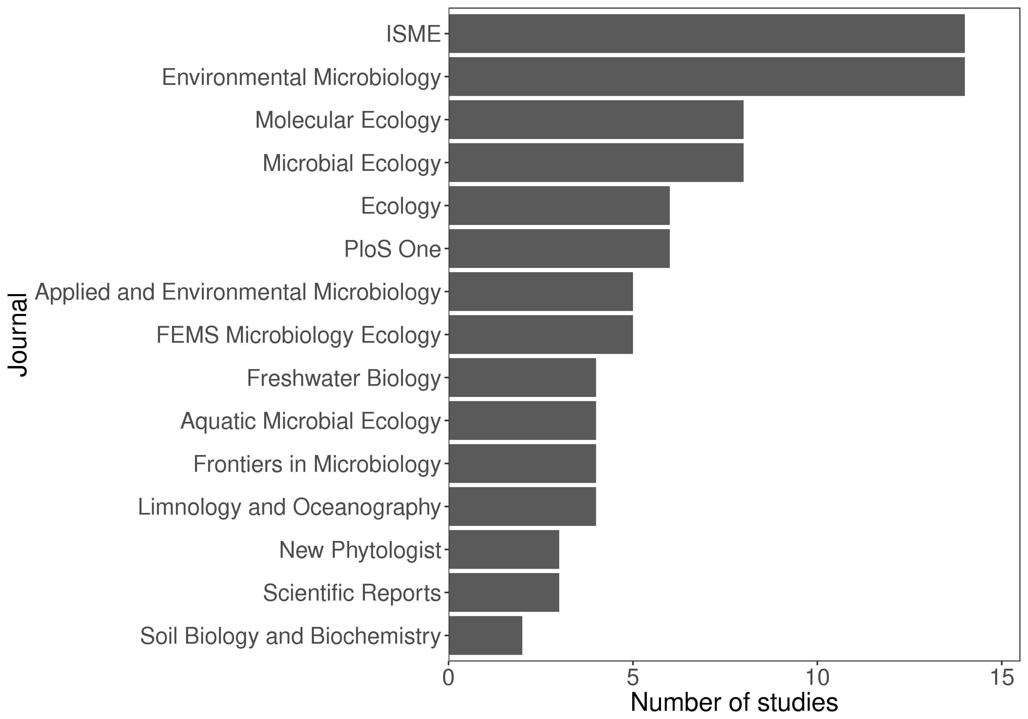

Figure S1. The number of distance-decay relationships used in this analysis from different journals. Only the most frequent 15 journals are shown.

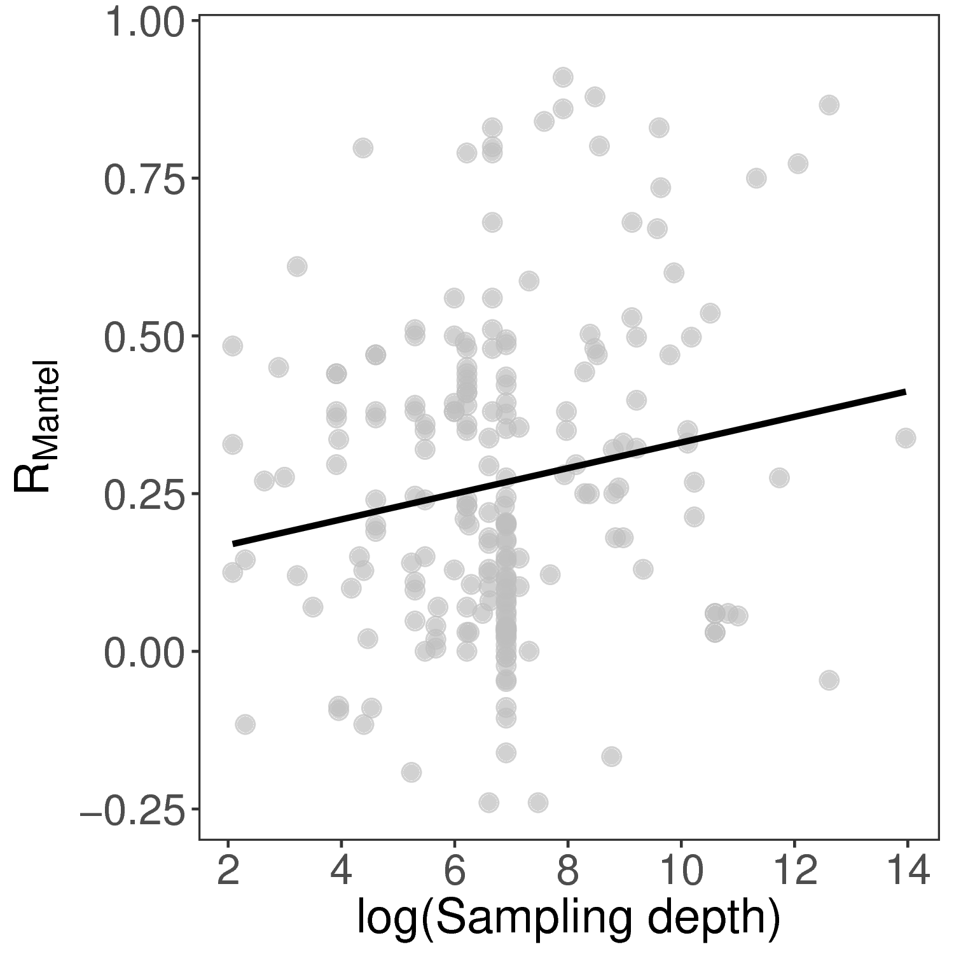Figure S2. The relationship between Mantel correlation coefficients and sampling depth. The solid line is the fit from a linear model (slope = 0.02, *P* < 0.05, adj-R2 = 0.02). Sampling depth refers to the sequencing depth of sequence-based approaches, or the number of individuals counted for morphological studies. Fingerprinting studies are excluded from this analysis.