**Title:** Spatial Scaling Patterns of β-Diversity are Context-Dependent for the Majority of Biodiversity

**Authors:** Dave R. Clark, Graham J.C. Underwood, Terry J. McGenity, and Alex J. Dumbrell

**Addresses:** School of Biological Sciences, University of Essex, Wivenhoe Park, Colchester, Essex, CO4 3SQ, UK.

**Keywords:** Bacteria, Archaea, Eukarya, spatial ecology, Mantel test, macroecology, dispersal limitation

**Running title:** Microbial Distance-Decay Relationships

**Abstract**

Ecological communities closer together in space and time, are generally more similar than those further apart, as defined by the distance-decay (d-d) of similarity relationship. Historically, microorganisms were assumed to defy this relationship due to their capacity for long distance, passive dispersal, and high population densities. Yet, recent studies have recorded highly variable d-d relationships in a range of microbial communities from disparate environments, using very different methods. The range of biological contexts incorporated by these studies may explain the differing distance-decay relationships reported as the dispersal of microorganisms may vary between different study systems, or spatial scales. Furthermore, methodological differences between studies will differ in their ability to detect rare species, thereby leading to contrasting estimates of compositional similarity between communities. Therefore, I sought to understand whether the variability in microbial d-d relationships is caused by different study methodologies, or biological contexts. To do this, I conducted an exhaustive meta-analysis and gathered data on 287 microbial d-d relationships. Given that most studies statistically test for d-d relationships using the Mantel correlation test, I used the Mantel correlation coefficient as a measure of effect size. I found that d-d relationships were weakly but significantly related to measures of community coverage, whilst different community quantification methods (e.g. community fingerprinting, high-throughput sequencing, morphological) only effected statistically-significant d-d relationships. The use of phylogenetic community similarity indices resulted in significantly weaker d-d relationships than compositional similarity metrics (e.g. Jaccard’s or Bray-Curtis index). Distance-decay relationships were significantly weaker in soils than other study systems, but significantly stronger in host-associated systems, potentially reflecting the ecological properties of the host taxon. The strength of the d-d relationships was also positively related to the spatial scale of the study but, against expectation, did not vary between different study taxa. I conclude that the microbial d-d relationship is dependent on biological context, but that methodological choices by the researcher can also strongly influence the strength of this relationship. I provide suggestions for selecting methods that will minimise methodological noise, and enhance ecological signal.

**Introduction**

The distance-decay (d-d) of community similarity is one of the most commonly studied relationships in macroecology (Nekola & White 1999; Condit *et al.* 2002; Soininen *et al.* 2007). The relationship quantifies how the similarity of community composition decays with increasing geographic distance between communities, such that communities close together contain more similar species assemblages than those further apart. Distance-decay relationships are able to inform us about the dispersal abilities of organisms present in the community, the connectivity of communities, as well as the spatial configuration of the environment. Consequently, the relationship is of great importance in understanding the spatial configuration of global biodiversity, with potential implications for conservation efforts (Nekola & White, 1999). Accordingly, the relationship has been well studied across a wide range of organisms with varying dispersal abilities and ecological properties, revealing distance-decay relationships over a range of spatial scales.

One group of organisms previously thought to defy the d-d relationship are microorganisms. One of the earliest hypotheses about the potential for microbial distance-decay relationships was formulated by Dutch microbiologist, Baas-Becking. Within this hypothesis, Baas Becking postulated that “Everything is everywhere but, the environment selects” (Baas Becking 1934). The rationale behind this hypothesis was that microorganisms should be efficient dispersers, as their small size may facilitate long distance, passive dispersal (Wilkinson et al., 2012). Additionally, the high population densities often observed in environmental microbial communities, might facilitate dispersal through “mass effects”, whereby organisms naturally disperse from areas of high density to less favourable habitat (Shmida & Wilson, 1985). Therefore, “Everything is eveywhere” suggests that microbial distance-decay relationships are exclusively the result of spatially structured environmental factors (Finlay & Fenchel 2004). This interpretation of the microbial d-d relationship is compatible with niche theory, which posits that communities are assembled form as the result of interactions between species with the environment (Holt, 2009). The role of purely spatial processes such as dispersal, to create distance-decay relationships in microbial communities, is not acknowledged.

However, modern molecular evidence refutes this. The rapid development of molecular methods to study microbial communities, coupled with the provocative nature of “Everything is everywhere” has resulted in an explosion of studies testing the distance-decay relationship in microbial communities. These studies reveal mixed results. A number of studies have found no correlation between microbial community composition and distance (Hazard *et al.* 2013; Kivlin *et al.* 2014), showing that communities separated by large geographic distances can be equally similar to those separated by small distances. However, many studies have reported relationships, varying in steepness, between microbial community composition and geographic distance for a range of scales and taxa (Dumbrell *et al.* 2010; Martiny *et al.* 2011; Barreto *et al.* 2014), even when the spatial structure of the environment has been accounted for (e.g. Green et al., 2004). These results suggests that microbial communities may be structured by spatial processes, and not solely by the environment, in disagreement with “Everything is everywhere” and niche theory. This finding is, instead, concordant with neutral theory, which suggests that stochastic processes, such as dispersal, determine the composition of a community (Hubbell, 2001). The ability of ecologically very different processes (niche and neutral) to generate d-d relationships suggests that, variability in this relationship may be related to organisms’ dispersal abilities, connectivity and/or spatial distance between communities, and environmental heterogeneity. Therefore, biological context may explain the disparity in microbial d-d relationships.

Here, context could be considered to be the organisms studied (e.g. Bacteria, Archaea, Fungi, Protists etc.), the study system in question (soil, freshwater, extreme systems), or the spatial scale of the study. Distance-decay relationships may vary by taxonomic groups due to different traits that may allow certain taxa to disperse more efficiently, such as differing cell sizes (Wilkinson *et al.* 2012; Soininen *et al.* 2013). Different study system may also influence the rate of the d-d relationship as previously reported (Soininen *et al.* 2007). This may be because environments differ in connectivity, for example, host associated communities may be poorly connected due to the restricted dispersal/range size of the host, and therefore will exhibit steeper distance-decay relationships. Additionally, environments will by the physicochemical gradients they are able to support. Stable, undisturbed habitats such as soils have been shown to support considerable pH gradients over relatively short distances (e.g. Dumbrell *et al*. 2010), resulting in stronger distance-decay relationships. In contrast, well mixed surface waters may support far more diffuse gradients, resulting in shallower distance-decay curves. Finally, the spatial scale over which the study occurs could influence the result. Larger spatial scales may result in a decrease in dispersal between communities, and greater environmental heterogeneity, both of which should result in steeper d-d relationships (Martiny *et al.* 2011), whereas small scale studies will likely sample more similar communities, and within the dispersal range of microorganisms, leading to a shallow d-d relationship.

On the other hand, methodological differences between studies may contribute to variability in microbial distance-decay relationships. From serially sequencing clone libraries, through community fingerprinting methods, and most recently high-throughput sequencing, previous research into the microbial d-d relationship is based upon a plethora of methods with varying degrees of taxonomic resolution and community coverage (Muyzer 1999; Glenn 2011). These methodologies differ markedly in their ability to quantify microbial communities, and in particular the rare species that form the majority of a microbial community. Methods that are only able to quantify the most common (and widespread) species (such as morphological, or community fingerprinting methods) are likely to miss the rare, restricted taxa. The result of this is that communities will appear artificially similar, resulting in a weaker distance-decay relationship. In contrast, methods that adequately quantify the “rare biosphere”, such as high-throughput sequencing, will be able to better detect the species that differ between communities, and therefore more accurately quantify the community similarity, resulting in stronger d-d relationships. In addition to the varying methods used to quantify microbial communities, there are now an array of indices available to quantify the (dis)similarity between microbial communities, including qualitative (based on presence/absence of species), quantitative (based on composition and abundance of species), and phylogenetic (based on relatedness of communities). Such indices have different properties in terms of how they weight rare or common species, and in how they are influenced by sample sizes or species richness (Baselga 2012; Beck *et al.* 2013), as well as what they quantify (e.g. phylogenetic similarity versus compositional similarity). The use of different indices could contribute to the strength of a distance-decay relationship. For example, phylogenetic indices may result in weaker distance-decay relationships because communities can be phylogenetically closely related, but may differ at the operational taxonomic unit (OTU) level (e.g. Bryant et al., 2008).

Given the variability in microbial d-d relationships reported in the literature, I sought to understand whether methodological or contextual differences between studies may influence reported d-d relationships in microbial communities. To do this, I conduct a meta-analysis to synthesise available data on the microbial distance-decay relationship, and test whether factors relating to methodological or contextual aspects of each study influence this relationship. Specifically, I test the following hypotheses:

* H1: Bacteria will show stronger d-d relationships than other microbial groups due to their smaller size and higher population densities.
* H2: Soils and host-associated study systems will show stronger d-d relationships than other systems due to their ability to maintain steep physicochemical gradients, or limited range size of the host taxon, respectively.
* H3: The spatial extent of a study will be positively related to the strength of a d-d relationship, as larger scale studies will incorporate greater environmental heterogeneity, and lower dispersal between the most distant communities.
* H4: Higher resolution community quantification methods, such as high-throughput sequencing, will yield stronger d-d relationships due to their ability to quantify rare taxa, and thus more accurately quantify community (dis)similarity.
* H5: Sampling depth (e.g. number of sequences, or number of individuals counted) will be positively related to the strength of d-d relationships, for the same reason as in H4.
* H6: The strength of d-d relationships will vary between similarity indices, and in phylogenetic methods will result in weaker d-d relationships than compositional metrics.

**Methods**

*Meta-Analysis*

In order to test the effects of ecological context and methodology on the microbial d-d relationship, I first conducted a systematic literature search using the Web of Science search portal. To do this, I designed five different search terms in order to maximise the size of the resulting dataset, whilst minimising irrelevant (e.g. studies of “macroorganisms”) studies (Table 1). All five searches were conducted on 08/06/2017, and all search results published between 1900-2017 were retained. I downloaded all search results from Web of Science and used the “metagear” package (version 0.4) in R (version 3.4.1) to manually screen abstracts for suitability for inclusion in our study (R Development Core Team 2016; Lajeunesse 2016). Suitable studies were defined as those that indicated a test of the relationship between spatial or geographic distance. I focussed on studies that had tested the distance-decay relationship using the Mantel correlation test, as this is the most common method of testing this relationship in microbial ecology (Ramette, 2007; Lisboa et al., 2014), and provides an easily intepretable effect size measure (Harrison, 2010). The Mantel test is used to test for correlation between two distance matrices (i.e. community dissimilarity and geographic distance). Mantel correlation coefficients vary between -1 and 1, with values of 1 indicating strong positive correlation, 0 indicates no/weak correlation, and -1 shows strong negative correlation. To standardise correlation coefficients between studies that had used similarity matrices, rather than dissimilarity matrices, I multiplied the former by -1, so that all correlation coefficients reflect the correlation between dissimilarity and geographic distance. For clarity, here a Mantel correlation coefficient of 1 indicates a strong d-d relationship. Partial Mantel statistics (which are able to test for correlation between two matrices whilst controlling for a third) were excluded as they may be heavily influenced by which other variables are included in the test, and are therefore not easily comparable between studies. In order to test our hypotheses, I recorded several variables relating to the ecological context of each study, as well as the methods used (Table 2).

*Statistical Analyses*

In order to determine whether d-d relationships varied between categoric variables (as in H1, H2, H4, and H6), I used ANOVA tests. To test hypotheses 3 and 5, I used linear regressions. I first log transformed both study scale and sequencing depth as these variables spanned several orders of magnitude.

**Results**

The Web of Science searches resulted in 2,250 search hits (Table 1). After removing duplicate hits (i.e. studies that appeared in multiple searches), this number decreased to 2,031 hits. Manual screening of the abstracts yielded 547 studies that were deemed to be potentially suitable for use in this analysis. A total of 287 Mantel correlation coefficients were successfully obtained from 108 studies represented in 33 journals (Figs. 1, S1). Of the 547 studies that were not suitable for inclusion within this analysis, most had not tested for correlation between geographic distance and community (dis)similarity (although the abstract still contained the search terms), whilst others had used different methods (e.g. multilocus sequence typing on individual species, or spatial eigenvector analysis). Reported Mantel correlation coefficients ranged from -0.24 to 0.95, with a mean of 0.27 (std. error = 0.014).

*Influence of biological context on D-D relationship*

In order to determine whether different ecological contexts can influence the strength of d-d relationships, I tested the influence of ecological factors including study taxa, study system, and spatial scale. Within the dataset, the most commonly studied taxa were Bacteria, followed by Fungi, microbial Eukaryotes, and Archaea. No significant difference was found in the Mantel coefficients associated with each taxa (*F*5, 281 = 1.39, *P* = 0.23), in disagreement with H1. Examining only statistically significant Mantel coefficients revealed marginally significant differences between taxa (*F*5, 172 = 2.51, *P* < 0.05) with studies incorporating both bacteria and fungi (*n* = 3) simultaneously, being significantly lower than studies on Archaea (Tukey HSD; *P* < 0.05).

Of the 20 different biomes recorded, 11 had fewer than three d-d relationships, and these biomes were excluded from biome analyses. The most frequently studied biomes were grasslands (*n* = 62), forest (*n* = 57), and lakes (*n =* 44). Mantel coefficients differed significantly between biomes (*F*8, 262 = 8.80, *P* < 0.001), in partial agreement with H2. Specifically, sponge associated communities displayed higher coefficients than all other biomes (Tukey HSD; *P* < 0.05 in all cases), and grassland communities had lower coefficients than most other biomes (Forest, lake, ocean, river, sediment, and sponge. Tukey HSD; *P* < 0.05 in all cases). Furthermore, the different types of environmental materials sampled showed significant differences in Mantel coefficients (Fig. S3; *F*4, 280 = 7.35, *P* < 0.001). Surprisingly, soils showed significantly lower coefficients than host-associated, sediment, or water d-d coefficients (Tukey HSD; *P* < 0.01 in all cases), in contrast with H2.

Finally, concordant with H3, there was a significant, positive relationship between the (log) spatial scale and the Mantel coefficient (slope = 0.016, *P* < 0.001, adj-*R2* = 0.12), showing that studies with larger spatial extents tend to find stronger correlations between community dissimilarity and geographic distance (Fig. 4). This relationship held when we examined only significant Mantel coefficients, and after accounting for sampling effort (slope = 0.016, *P <* 0.001, adj-*R2* = 0.13). Sampling effort was not correlated with spatial scale (Pearson’s ρ = 0.03, *P* = 0.64), showing that studies that incorporate larger spatial scales, do not necessarily incorporate more samples.

*Influence of methodological factors on the distance-decay relationship*

To determine whether the microbial distance-decay relationship may be influenced by methodological factors, I tested whether the method of community characterisation, sampling depth, or choice of community similarity index influence the Mantel correlation coefficient. In contrast to H4, high-throughput sequencing methods (HTS) did not result in significantly higher Mantel coefficients compared to fingerprinting methods, or other low resolution methods (Figure 2A; *F*2, 284 = 0.19, *P* = 0.83). However, when only statistically significant (alpha = 0.05) Mantel coefficients were examined (Fig. 2B), high-throughput sequencing based studies showed higher Mantel coefficients, approaching statistical significance (*F*2, 175 = 2.73, *P* = 0.07).

Sequencing depth was also significantly and positively related to the Mantel coefficient, albeit with a small effect size (Fig. S2; slope = 0.02, *P* < 0.05, adj-*R2* = 0.02), supporting the hypothesis (H5) that greater sequencing depth would result in stronger d-d relationships. Sequencing depth was not correlated to sampling effort (Pearson’s ρ = 0.03, *P* = 0.64), showing that studies with greater sequencing depth did not necessarily incorporate more samples.

In line with H6, significant differences were detected between dissimilarity indices (*F*14, 271 = 4.96, *P* < 0.001). Several indices were excluded from this analysis as they had too few occurrences to calculate a reliable estimate of the central tendency (indices with < 4 occurrences were excluded). Tukey HSD tests showed Mantel coefficients from Raup-Crick and Unifrac indices were significantly lower than Bray-Curtis (*P* < 0.01 in each case, Fig. 3A), whilst Sørensen based coefficients were higher than Euclidean, Raup-Crick, and Unifrac indices (*P* < 0.01 in all cases, Fig. 3A). Furthermore, Mantel coefficients were significantly different between index types (Fig. 3B; *F*2, 284 = 5.41, *P* < 0.01), and Tukey HSD tests showed that Mantel coefficients based on phylogenetic distances were significantly lower than both abundance (*P* < 0.01) and binary based indices (*P* < 0.05), supporting H6.

**Discussion**

Two decades of research into the spatial ecology of microbial communities has resulted in a highly variable impression of the microbial distance-decay (d-d) relationship. Our meta-analysis of 287 microbial d-d relationships has revealed two main findings. Firstly, d-d relationships may be influenced by methodological choices, including the sequencing depth used and the type of dissimilarity index. Secondly, as expected, the d-d relationship also appears to be dependent on various aspects of biological context, with different d-d relationships observed between different biomes and spatial scales.

The rapid development of methods in microbial ecology has improved our ability to detect and characterise ecological patterns in microbial communities, with high-throughput sequencing (HTS) platforms able to quantify microbial communities in ever increasing detail (Roesch *et al.* 2007; Caporaso *et al.* 2012). The tremendous sequencing depth of HTS platforms allows them to illuminate the “rare biosphere” (Caporaso et al., 2012), thus elevating them over other approaches such as “fingerprinting” which tend to capture a smaller proportion of the community. Initially, our results suggested that HTS-based approaches yielded similar strength d-d relationships to lower-resolution methods, such as fingerprinting and lower throughput methods, such as Sanger sequencing, suggesting that the massive sequencing depths offered by HTS platforms are not necessary to capture these ecological patterns (van Dorst *et al.* 2014). However, when we examined only statistically significant d-d relationships, the relationships derived from HTS approaches were stronger than other approaches. The ability of different methods to alter the strength of the d-d relationship is expected for two reasons. Firstly, fingerprinting and HTS approaches capture microbial diversity at different taxonomic resolutions. Comparative approaches have shown that fingerprinting approaches such as ARISA may be comparable to HTS data at the phylum level for instance (Gobet *et al.* 2014). Fingerprinting methods are therefore limited in that they may not detect compositional differences between communities at increasingly fine taxonomic resolutions (Ramette & Tiedje 2007; Bissett *et al.* 2010). This may weaken the d-d relationship in instances where communities are similar at the family level, but dissimilar at finer taxonomic levels. Secondly, fingerprinting methods are less able to sample from the “rare biosphere”, unlike HTS approaches. This is significant as, microbial communities often follow an occupancy-abundance relationship in which the most common organisms are also the most widespread, and the rarer organisms are the most restricted (Soininen & Heino 2005; Liu *et al.* 2015). Therefore, sampling only the most common, widespread organisms would flatten the d-d relationship by making communities appear artificially similar in composition. This is in contrast to recent studies which show that spatial turnover in communities is adequately reflected by “common species” (Heino & Soininen 2010). However, microbial communities are often enormously diverse and exhibit extremely “long tailed” species abundance distributions, such that the vast majority of microbial species in a community are “rare” (Hong *et al.* 2006; Galand *et al.* 2009; Locey & Lennon 2016). Therefore, it is likely that in microbial communities, common species alone may not adequately reflect patterns in spatial turnover (Galand *et al.* 2009).

Another methodological choice that was found to influence the strength of the microbial d-d relationship is the choice of dissimilarity index. Dissimilarity indices can vary in the type of data they consider (quantitative vs qualitative), the type of distance they quantify (compositional vs. phylogenetic), and the weight they place on common, rare, or absent species (Anderson *et al.* 2011). Within our study, we found significant differences in the d-d relationship between different indices, and between different index types. In particular, d-d relationship using phylogenetic indices were significantly flatter than compositional indices, whereas there was no difference between binary (presence/absence) and abundance based indices. Phylogenetic dissimilarity metrics may result in lower Mantel correlation coefficients for the same reason that fingerprinting methods do; because communities predominantly differ at fine taxonomic resolutions. This means that whilst communities differ in exact species or OTU composition, they can still be phylogenetically closely related, as communities may be highly similar at higher taxonomic ranks. In contrast, community composition metrics give no weight to how related communities are at broader taxonomic levels. The result of this is that communities appear more similar when phylogenetic indices are used (Bryant et al., 2008), potentially resulting in flatter d-d relationships (and therefore lower Mantel coefficients). This effect might be exacerbated when all sampled communities are from environmentally similar sites, which select for particular taxonomic groups. For example, extremophilic habitats such as solar salterns, can be hihgly similar at broad taxonomic levels, yet distinct at the OTU/species level (Zhaxybayeva *et al.* 2013; Clark et al., 2017).

Surprisingly, no difference was observed between quantitative and qualitative dissimilarity indices. This suggests that qualitative compositional differences between communities drive d-d relationships rather than quantitative changes in species composition and abundance. In agreement with previous studies that have applied both binary and abundance based indices, these two measures of community similarity are likely to be highly correlated (Martiny *et al.* 2011), and result in similar estimations of d-d relationships (e.g. Green *et al*. 2004, Glassman *et al*. 2015). This analysis also revealed that classic dissimilarity metrics, such as Bray-Curtis or Jaccard's index, are overwhelmingly the most frequently used in studies of microbial d-d relationships. These indices are undoubtedly amongst the most frequently used, not only in microbial ecology, but also more widely in ecology. I to draw attention to several contemporary indices that may better suit the types of questions microbial ecologists ask. Classic metrics do not take into consideration co-occurrence information present within the data. To this end, a new family of metrics have been defined that account for species co-occurrence as well as shared taxa (Schmidt *et al.* 2017). Additionally, many indices rely on equal sample sizes, and are sensitive to differences in species richness (Green & Bohannan 2006), with potentially confounding effects on d-d relationships (Baselga 2007). Chao *et al*. (2005) therefore extended classic indices such as Jaccard and Sørensen to account for unobserved species, and to make them less sensitive to variable sample sizes, reducing the need for post-sequencing normalisation of sample sizes (McMurdie & Holmes 2014). Finally, many indices are known to merge true compositional turnover (replacement of species) and nestedness (whereby communities are subsets of one another). To combat this, modified versions of classic indices such as Jaccard, Sorensen, and Bray-Curtis have been developed, allowing the partitioning of community similarity metrics into their turnover and nestedness components. This should enable a more mechanistic understanding of the processes behind d-d relationships (Baselga 2010, 2013; Podani & Schmera 2011). I echo the call of Green and Bohanan (2006) for microbial ecologists to exercise more care in their choice of dissimilarity metrics, especially now that many are implemented in popular and freely accessible analysis software, such as R (e.g. Baselga and Orme 2012).

Whilst significant differences were found between different methodological approaches, we also found differences relating to the biological context of each study. Against our expectation, soil based studies had weaker d-d relationships than studies using other environmental materials. Soils are relatively stable habitats, in that they maintain physical structure and are therefore capable of maintaining significant environmental gradients over relatively small spatial scales. Therefore, we expected the combination of high habitat heterogeneity coupled with limited opportunity for dispersal to result in stronger d-d relationships than for example, oceanic waters, where physicochemical gradients are more diffuse. It is possible that the environmental gradients present in soils do not change linearly over geographic distance, for example if the similar environmental conditions are patchily distributed. Alternatively, soil microorganisms may be able to disperse more effectively than previously thought, perhaps via association with other soil organisms (Warmink *et al.* 2011), migratory species such as birds (Bisson et al., 2007), wind blown soil particles (Kellogg & Griffin 2006; Favet *et al.* 2013), or via bioaerosols (Joung *et al.* 2017).

Originally, we expected that studies of aquatic microbial communities may show the weakest d-d relationships as riverine or oceanic hydrology may provide an effective dispersal mechanism, thus homogenising microbial communities and presenting more diffuse environmental gradients over larger spatial scales. Contrarily, we found that aquatic communities actually showed stronger d-d relationships indicating increased spatial turnover in aquatic microbial communities. Soininen *et al*. (2007) recorded similar distance-decay rates between terrestrial, marine and aquatic ecosystems, showing that biome-dependent d-d relationships may be a feature of microbial communities. Host-associated communities showed relatively strong, but variable d-d relationships. We suggest that this is caused jointly by the ecology of the host species, in combination with the degree of host specificity with the associated microbial community. For example, if the host is not dispersal limited, and associates with a large variety of microorganisms, then the d-d relationship may be relatively flat. However, if the host is dispersal limited, and associates with a very specific microbiome, the d-d relationship might be steeper. To develop our understanding of the macroecology of host-associated microbial communities, an interesting approach would be to compare microbial d-d relationships of sessile and motile hosts (motile host-associated d-d relationships were excluded in this analysis), as incorporating the ecology of the host (e.g. movement, interactions, range size) would likely provide further explanatory power.

Finally, we also found a relationship between the strength of the d-d relationship and the spatial scale over which the study was conducted. Scale-dependent d-d relationships have previously been reported (Bissett *et al.* 2010; Martiny *et al.* 2011; Soininen *et al.* 2011), albeit with contrasting results. Our results are comparable to those of Martiny *et al*. (2011) and Soininen *et al*. (2011) who reported that d-d relationships for various microbial communities were generally steeper as greater spatial scales were incorporated. The scale dependence of this relationship may be explained by greater environmental heterogeneity in large scale studies, thus communities are subjected to different environmental filters, resulting in more dissimilar communities. In combination with this, communities separated by very large geographic distances should have minimal dispersal between them, assuming connectivity is linearly related to geographic distance. Alternatively, this observation may be a statistical artefact, caused by studies with very large spatial extents incorporating many zero similarity community comparisons (i.e. communities with no species in common), therefore biasing our quantification of the d-d relationship (Millar *et al.* 2011; Steinbauer *et al.* 2012). This point highlights that careful consideration is required in the statistical analysis of d-d relationships, especially when incorporating large geographic extents or highly dissimilar communities.

Despite its common use in the literature as evidence for neutral processes in microbial ecology, the d-d relationship alone does not provide evidence for neutral processes acting on microbial communities. As discussed previously, d-d relationships can arise from spatially autocorrelated environmental gradients as well as dispersal limitation (Nekola & White 1999). Furthermore, dispersal limitation itself is not solely a property of ecological neutrality. Dispersal limitation may be stochastic as predicted by neutral theory (Chave 2004), but also by asymmetric dispersal abilities between organisms (Salomon *et al.* 2010; Liu & Zhou 2011), thus violating the central tenet of neutral theory; that organisms are ecologically equivalent (Hubbell 2001). Thus we suggest caution in attributing distance-decay relationships to either niche or neutral processes without further evidence, for example from examining species-abundance distributions (e.g. Dumbrell *et al*. 2010). However, this is not to say that examining distance-decay relationships is futile as the relationship jointly reflects species turnover due to historical, environmental, and spatial factors, all of which are important factors to consider in studying biodiversity (Nekola & White 1999).

Moving beyond distance-decay relationships, focussing on other factors that influence the compositional similarity of microbial communities should provide interesting results. For example, quantifying the extent to which microorganisms differ in their dispersal abilities, and what traits are responsible for these differences may help to provide information on the biogeography of microorganisms at the population level, and given appropriate statistical approaches may allow us to predict the range size and habitat occupancy of different microbes. Furthermore, it is commonly assumed that the connectivity between communities is linearly related to the spatial distance between communities. However, given that different dispersal vectors may disperse microorganisms over differing geographic distances, this assumption may not be valid. Therefore, the growing movement towards examining the role of connectivity *per se* *(*Declerck et al. 2013; Vannette et al. 2016), rather than using geographical distance as a proxy, will likely provide a fruitful direction for spatial microbial ecology. By modeling the dispersal process itself and accounting connectivity, a more mechanistic understanding of the spatial ecology of microbial communities could be gained.

**References**

Anderson MJ, Crist TO, Chase JM *et al.* (2011) Navigating the multiple meanings of β diversity: A roadmap for the practicing ecologist. *Ecology Letters*, **14**, 19–28.

Baas Becking LGM (1934) *Geobiologie of inleiding tot de milieukunde*. W.P. Van Stockum & Zoon, The Hague, Netherlands.

Barreto DP, Conrad R, Klose M, Claus P, Enrich-Prast A (2014) Distance-decay and taxa-area relationships for bacteria, archaea and methanogenic archaea in a tropical lake sediment (J Waldenström, Ed,). *PLoS ONE*, **9**, e110128.

Baselga A (2007) Disentangling Distance Decay of Similarity from Richness Gradients: Response to Soininen *et al*. 2007. *Ecography*, **30**, 838–841.

Baselga A (2010) Partitioning the turnover and nestedness components of beta diversity. *Global Ecology and Biogeography*, **19**, 134–143.

Baselga A (2012) The relationship between species replacement, dissimilarity derived from nestedness, and nestedness. *Global Ecology and Biogeography*, **21**, 1223–1232.

Baselga A (2013) Separating the two components of abundance-based dissimilarity: Balanced changes in abundance vs. abundance. *Methods in Ecology and Evolution*, **4**, 552–557.

Baselga A, Orme CDL (2012) betapart: an R package for the study of beta diversity. *Methods in Ecology and Evolution*, **3**, 808–812.

Beck J, Holloway JD, Schwanghart W (2013) Undersampling and the measurement of beta diversity. *Methods in Ecology and Evolution*, **4**, 370–382.

Bissett A, Richardson AE, Baker G, Wakelin S, Thrall PH (2010) Life history determines biogeographical patterns of soil bacterial communities over multiple spatial scales. *Molecular Ecology*, **19**, 4315–4327.

Bisson IA, Marra PP, Burtt EH, Sikaroodi M, Gillevet PM (2007) A molecular comparison of plumage and soil bacteria across biogeographic, ecological, and taxonomic scales. *Microbial Ecology*, **54**, 65-81.

Bryant JA, Lamanna C, Morlon H, Kerkhoff AJ, Enquist BJ, Green JL (2008) Microbes on mountainsides: contrasting elevational patterns of bacterial and plant diversity. *Proceedings of the National Academy of Sciences USA*, **105** (Supplement 1), 11505-11511.

Caporaso JG, Lauber CL, Walters W a *et al.* (2012) Ultra-high-throughput microbial community analysis on the Illumina HiSeq and MiSeq platforms. *The ISME Journal*, **6**, 1621–1624.

Chao A, Chazdon RL, Colwell RK, Shen T-J (2005) A new statistical approach for assessing similarity of species composition with incidence and abundance data. *Ecology Letters*, **8**, 148–159.

Chave J (2004) Neutral theory and community ecology. *Ecology Letters*, **7**, 1–39.

Clark DR, Mathieu M, Mourot L, Dufossé L, Underwood JC, Dumbrell AJ, McGenity TJ (2017) Biogeography at the Limits of Life: Do Extremophilic Microbial Communities Show Biogeographic Regionalisation? *Global Ecology and Biogeography,* In press.

Condit R, Pitman N, Leigh EG *et al.* (2002) Beta-diversity in tropical forest trees. *Science*, **295**, 666–669.

Declerck SAJ, Winter C, Shurin JB, Suttle CA, Matthews B (2013) Effects of patch connectivity and heterogeneity on metacommunity structure of planktonic bacteria and viruses. *The ISME Journal*, **7**, 533–42.

van Dorst J, Bissett A, Palmer AS *et al.* (2014) Community fingerprinting in a sequencing world. *FEMS Microbiology Ecology*, **89**, 316–330.

Dumbrell AJ, Nelson M, Helgason T, Dytham C, Fitter AH (2010) Relative roles of niche and neutral processes in structuring a soil microbial community. *The ISME Journal*, **4**, 337–345.

Favet J, Lapanje A, Giongo A *et al.* (2013) Microbial hitchhikers on intercontinental dust: catching a lift in Chad. *The ISME Journal*, **7**, 850–867.

Finlay BJ (2002) Global dispersal of free-living microbial eukaryote species. *Science*, **296**, 1061–1063.

Finlay BJ, Fenchel T (2004) Cosmopolitan Metapopulations of Free-Living Microbial Eukaryotes. *Protist*, **155**, 237–244.

Galand PE, Casamayor EO, Kirchman DL, Lovejoy C (2009) Ecology of the rare microbial biosphere of the Arctic Ocean. *Proceedings of the National Academy of Sciences USA*, **106**, 22427–22432.

Glassman SI, Peay KG, Talbot JM *et al.* (2015) A continental view of pine-associated ectomycorrhizal fungal spore banks: A quiescent functional guild with a strong biogeographic pattern. *New Phytologist*, **205**, 1619–1631.

Glenn TC (2011) Field guide to next-generation DNA sequencers. *Molecular Ecology Resources*, **11**, 759–769.

Gobet A, Boetius A, Ramette A (2014) Ecological coherence of diversity patterns derived from classical fingerprinting and Next Generation Sequencing techniques. *Environmental Microbiology*, **16**, 2672–2681.

Green J, Bohannan BJM (2006) Spatial scaling of microbial biodiversity. *Trends in Ecology and Evolution*, **21**, 501–507.

Green JL, Holmes AJ, Westoby M *et al.* (2004) Spatial scaling of microbial eukaryote diversity. *Nature*, **432**, 747–750.

Harrison F (2011) Getting started with meta‐analysis. *Methods in Ecology and Evolution*, **2**, 1-10.

Hazard C, Gosling P, van der Gast CJ *et al.* (2013) The role of local environment and geographical distance in determining community composition of arbuscular mycorrhizal fungi at the landscape scale. *The ISME Journal*, **7**, 498–508.

Heino J, Soininen J (2010) Are common species sufficient in describing turnover in aquatic metacommunities along environmental and spatial gradients? *Limnology and Oceanography*, **55**, 2397–2402.

Holt RD (2009) Bringing the Hutchinsonian niche into the 21st century: ecological and evolutionary perspectives. *Proceedings of the National Academy of Sciences USA*, **106** (Supplement 2), 19659-19665.

Hong SH, Bunge J, Jeon SO, Epstein SS (2006) Predicting microbial species richness. *Proceedings of the National Academy of Sciences USA*, **103**, 117–122.

Hubbell SP (2001) *The Unified Neutral Theory of Biodiversity and Biogeography*. Princeton University Press. Princeton, NJ, USA.

Joung YS, Ge Z, Buie CR (2017) Bioaerosol generation by raindrops on soil. *Nature Communications*, **8**, 14668.

Kellogg CA, Griffin DW (2006) Aerobiology and the global transport of desert dust. *Trends in Ecology and Evolution*, **21**, 638–644.

Kivlin SN, Winston GC, Goulden ML, Treseder KK (2014) Environmental filtering affects soil fungal community composition more than dispersal limitation at regional scales. *Fungal Ecology*, **12**, 14–25.

Lajeunesse MJ (2016) Facilitating systematic reviews, data extraction and meta-analysis with the metagear package for R. *Methods in Ecology and Evolution*, **7**, 323–330.

Legendre P, Fortin M-J, Borcard D (2015) Should the Mantel test be used in spatial analysis?. *Methods in Ecology and Evolution*, **6**, 1239–1247.

Lisboa FJG, Peres-Neto PR, Chaer GM, da Conceição Jesus E, Mitchell RJ, Chapman SJ, Berbara RLL (2014) Much beyond mantel: bringing procrustes association metric to the plant and soil ecologist’s toolbox. *PloS ONE*, ***9***, e101238.

Liu L, Yang J, Yu Z, Wilkinson DM (2015) The biogeography of abundant and rare bacterioplankton in lakes and reservoirs of China. *The ISME Journal*, **9**, 2068–2077.

Liu J, Zhou S (2011) Asymmetry in species regional dispersal ability and the neutral theory. *PLoS ONE*, **6**, e24128.

Locey KJ, Lennon JT (2016) Scaling laws predict global microbial diversity. *Proceedings of the National Academy of Sciences USA*, 201521291.

Martiny JBH, Eisen JA, Penn K, Allison SD, Horner-Devine MC (2011) Drivers of bacterial β-diversity depend on spatial scale. *Proceedings of the National Academy of Sciences USA*, **108**, 7850–7854.

McMurdie PJ, Holmes S (2014) Waste not, want not: why rarefying microbiome data is inadmissible. *PLoS Computational Biology*, **10**, e1003531.

Millar RB, Anderson MJ, Tolimieri N (2011) Much ado about nothings: Using zero similarity points in distance-decay curves. *Ecology*, **92**, 1717–1722.

Muyzer G (1999) DGGE/TGGE a method for identifying genes from natural ecosystems. *Current Opinion in Microbiology*, **2**, 317–322.

Nekola JC, White PS (1999) The distance decay of similarity in biogeography and ecology. *Journal of Biogeography*, **26**, 867–878.

Podani J, Schmera D (2011) A new conceptual and methodological framework for exploring and explaining pattern in presence - absence data. *Oikos*, **120**, 1625–1638.

R Developement Core Team (2016) R: A Language and Environment for Statistical Computing. *R Foundation for Statistical Computing, Vienna, Austria*.

Ramette A (2007) Multivariate analyses in microbial ecology. *FEMS Microbiology Ecology*, **62**, 142-160.

Ramette A, Tiedje JM (2007) Biogeography: an emerging cornerstone for understanding prokaryotic diversity, ecology, and evolution. *Microbial Ecology*, **53**, 197–207.

Roesch LFW, Fulthorpe RR, Riva A *et al.* (2007) Pyrosequencing enumerates and contrasts soil microbial diversity. *The ISME Journal*, **1**, 283–90.

Salomon Y, Connolly SR, Bode L (2010) Effects of asymmetric dispersal on the coexistence of competing species. *Ecology Letters*, **13**, 432–441.

Shmida AVI, Wilson MV (1985) Biological determinants of species diversity. *Journal of Biogeography*, **12** 1-20.

Schmidt TSB, Matias Rodrigues JF, von Mering C (2017) A family of interaction-adjusted indices of community similarity. *The ISME Journal*, **11**, 791–807.

Sogin ML, Morrison HG, Huber JA *et al.* (2006) Microbial diversity in the deep sea and the underexplored “rare biosphere.” *Proceedings of the National Academy of Sciences USA*, **103**, 12115–12120.

Soininen J, Heino J (2005) Relationships between local population persistence, local abundance and regional occupancy of species: Distribution patterns of diatoms in boreal streams. *Journal of Biogeography*, **32**, 1971–1978.

Soininen J, Korhonen JJ, Karhu J, Vetterli A (2011) Disentangling the spatial patterns in community composition of prokaryotic and eukaryotic lake plankton. *Limnology and Oceanography*, **56**, 508–520.

Soininen J, Korhonen JJ, Luoto M (2013) Stochastic species distributions are driven by organism size. *Ecology*, **94**, 660–670.

Soininen J, McDonald R, Hillebrand H (2007) The distance decay of similarity in ecological communities. *Ecography*, **30**, 3–12.

Steinbauer MJ, Dolos K, Reineking B, Beierkuhnlein C (2012) Current measures for distance decay in similarity of species composition are influenced by study extent and grain size. *Global Ecology and Biogeography*, **21**, 1203–1212.

Vannette RL, Leopold DR, Fukami T (2016) Forest area and connectivity influence root-associated fungal communities in a fragmented landscape. *Ecology*, **97**, 2374–2383.

Warmink JA, Nazir R, Corten B, van Elsas . JD (2011) Hitchhikers on the fungal highway: The helper effect for bacterial migration via fungal hyphae. *Soil Biology and Biochemistry*, **43**, 760–765.

Wilkinson DM, Koumoutsaris S, Mitchell EAD, Bey I (2012) Modelling the effect of size on the aerial dispersal of microorganisms. *Journal of Biogeography*, **39**, 89–97.

Zhaxybayeva O, Stepanauskas R, Mohan NR, Papke RT (2013) Cell sorting analysis of geographically separated hypersaline environments. *Extremophiles*, **17**, 265–275.

**Tables and Boxes**

Table 1. Details of the five Web of Science search terms and, the number of hits. A Web of Science search history file is provided in the Supplementary Material.

|  |  |  |
| --- | --- | --- |
| Search | Search terms | Number of hits |
| 1 | TS = (biogeograph*) AND TS = (bacteria* OR archaea* OR microb* OR microorganism*) | 1,872 |
| 2 | TS = (macroecolog*) AND TS = (bacteria* OR archaea* OR microb* OR microorganism*) | 85 |
| 3 | TS = ("everything is everywhere") AND TS = (bacteria* OR archaea* OR microb* OR microorganism*) | 53 |
| 4 | TS = ("geographic distance") AND TS = (bacteria* OR archaea* OR microb* OR microorganism*) | 133 |
| 5 | TS = ("distance decay") AND TS = (bacteria* OR archaea* OR microb* OR microorganism*) | 107 |
| * is used as a wildcard to allow searches to match multiple terms, e.g. microb* could match “microbiome”, “microbial”, and “microbe” | | |

Box 1. Details of the explanatory variables extracted from each study.

|  |
| --- |
| *Community characterisation method*  This refers to the method used to quantify the species present in their sample and their abundances (if applicable). Each d-d relationship was categorised into either high-throughput sequencing (HTS; Pyrosequencing, Illumina, Ion Torrent, Pac-Bio), community fingerprinting (ARISA, TRFLP, DGGE, PhyloChip), or other (Sanger sequencing, morphological identification).  *Sampling depth*  This refers to the sequencing depth in sequencing based studies, or number of individuals counted in morphological based studies. For sequencing studies, we recorded the number of sequences after rarefaction, or if this was not given, the average number of sequences per sample. As it is hard to quantify the sampling depth of fingerprinting approaches, we recorded these as NA and excluded them from analyses involving sampling depth.  *Sampling effort*  This variable represents the number of individual communities/samples used to formulate the d-d relationship.  *Dissimilarity index*  We recorded the dissimilarity index from which each d-d relationship was calculated. After these had been recorded, we categorised them as abundance based (Bray-Curtis, Horn-Morisita, Euclidean, Hellinger, Theta), binary (Jaccard, Raup-Crick, Sørensen, Simpson, βsim), or phylogenetic (Unifrac, Rao, β-mean nearest taxon distance, β-mean pairwise distance).  *Study taxon*  We categorised d-d relationships into broad taxonomic categories (Archaea, Bacteria, Eukarya, Fungi). If a d-d relationship was based on multiple taxa, then an appropriate category was added as necessary (I.e. bacteria + archaea).  *Scale*  We recorded scale as the maximum distance separating communities (in km). If this was not stated in text or provided in supplementary material (e.g. in a geographic distance matrix), it was calculated from given geographic coordinates, or estimated from the d-d graph itself or from scaled maps, if no coordinates were provided.  *Biome*  We categorised d-d relationships based on their biome (agriculture, air, aquifer, indoor, coral, desert, dune, flower, forest, grassland, ice, lake, marsh, mine, ocean, paddy, river, sediment, sewer, sponge), reflecting the type of environment the communities occupied.  *Environmental material*  This variable represents the type of material that the sampled communities occupied. We categorised d-d relationships as air, host, sediment, soil, or water.  *P value*  As an additional comparison, we also recorded *P -*values for d-d relationships where possible. We recorded unadjusted *P*-values, and here use a global alpha value of 0.05 for simplicity, regardless of multiple tests conducted by each study. |

**Figures**

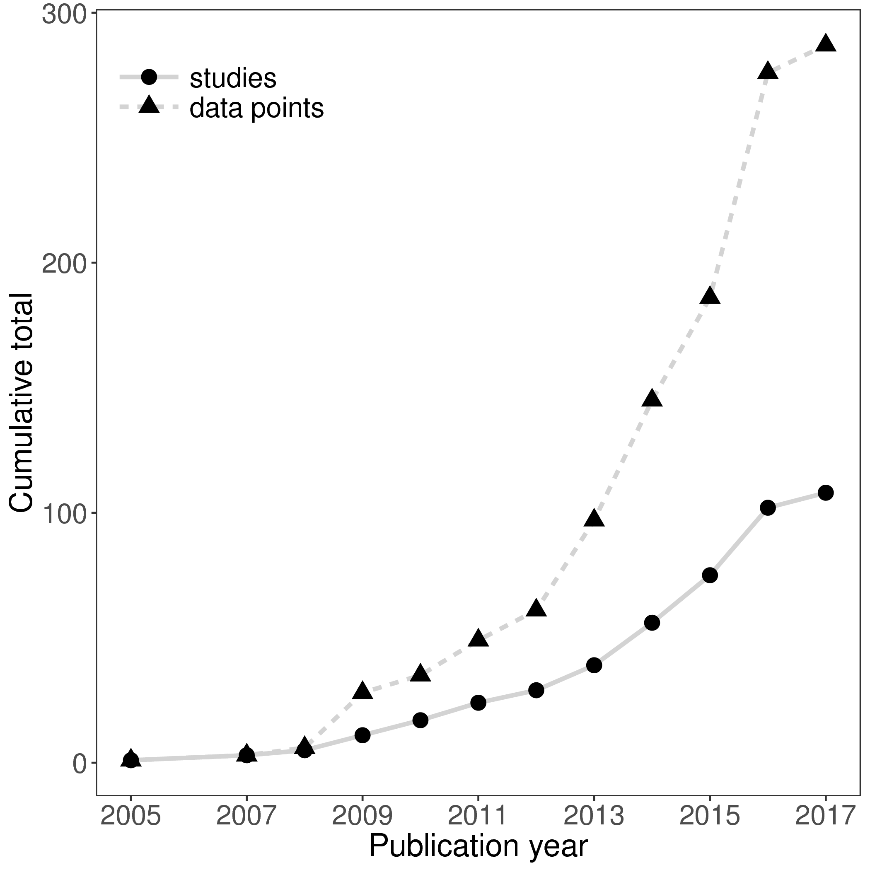

Figure 1. The cumulative number of distance-decay relationships and publications included in this study, through time.

Figure 2. (A) All, and (B) only statistically significant, Mantel correlation coefficients (RMantel) from studies based on high-throughput sequencing (HTS), community fingerprinting approaches (such as DGGE or TRFLP), or other low resolution/throughput methods (morphological identification, Sanger sequencing). Larger Mantel coefficients indicate stronger correlation between community dissimilarity and geographic distance.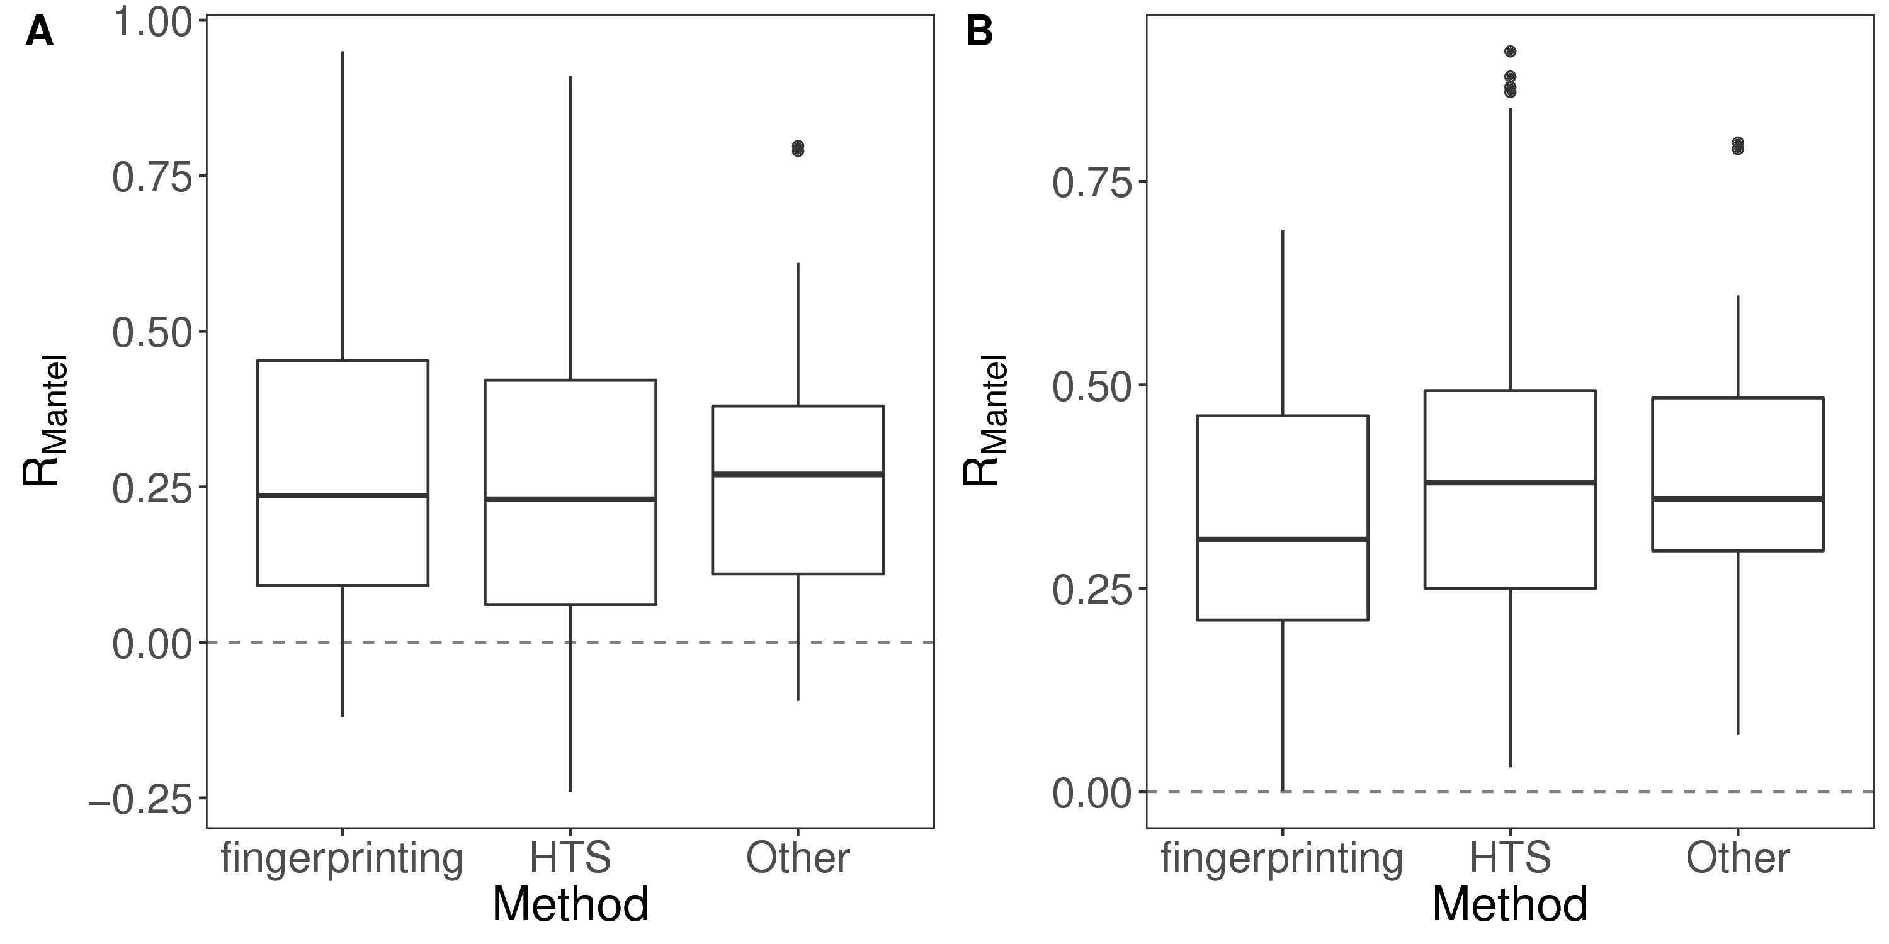

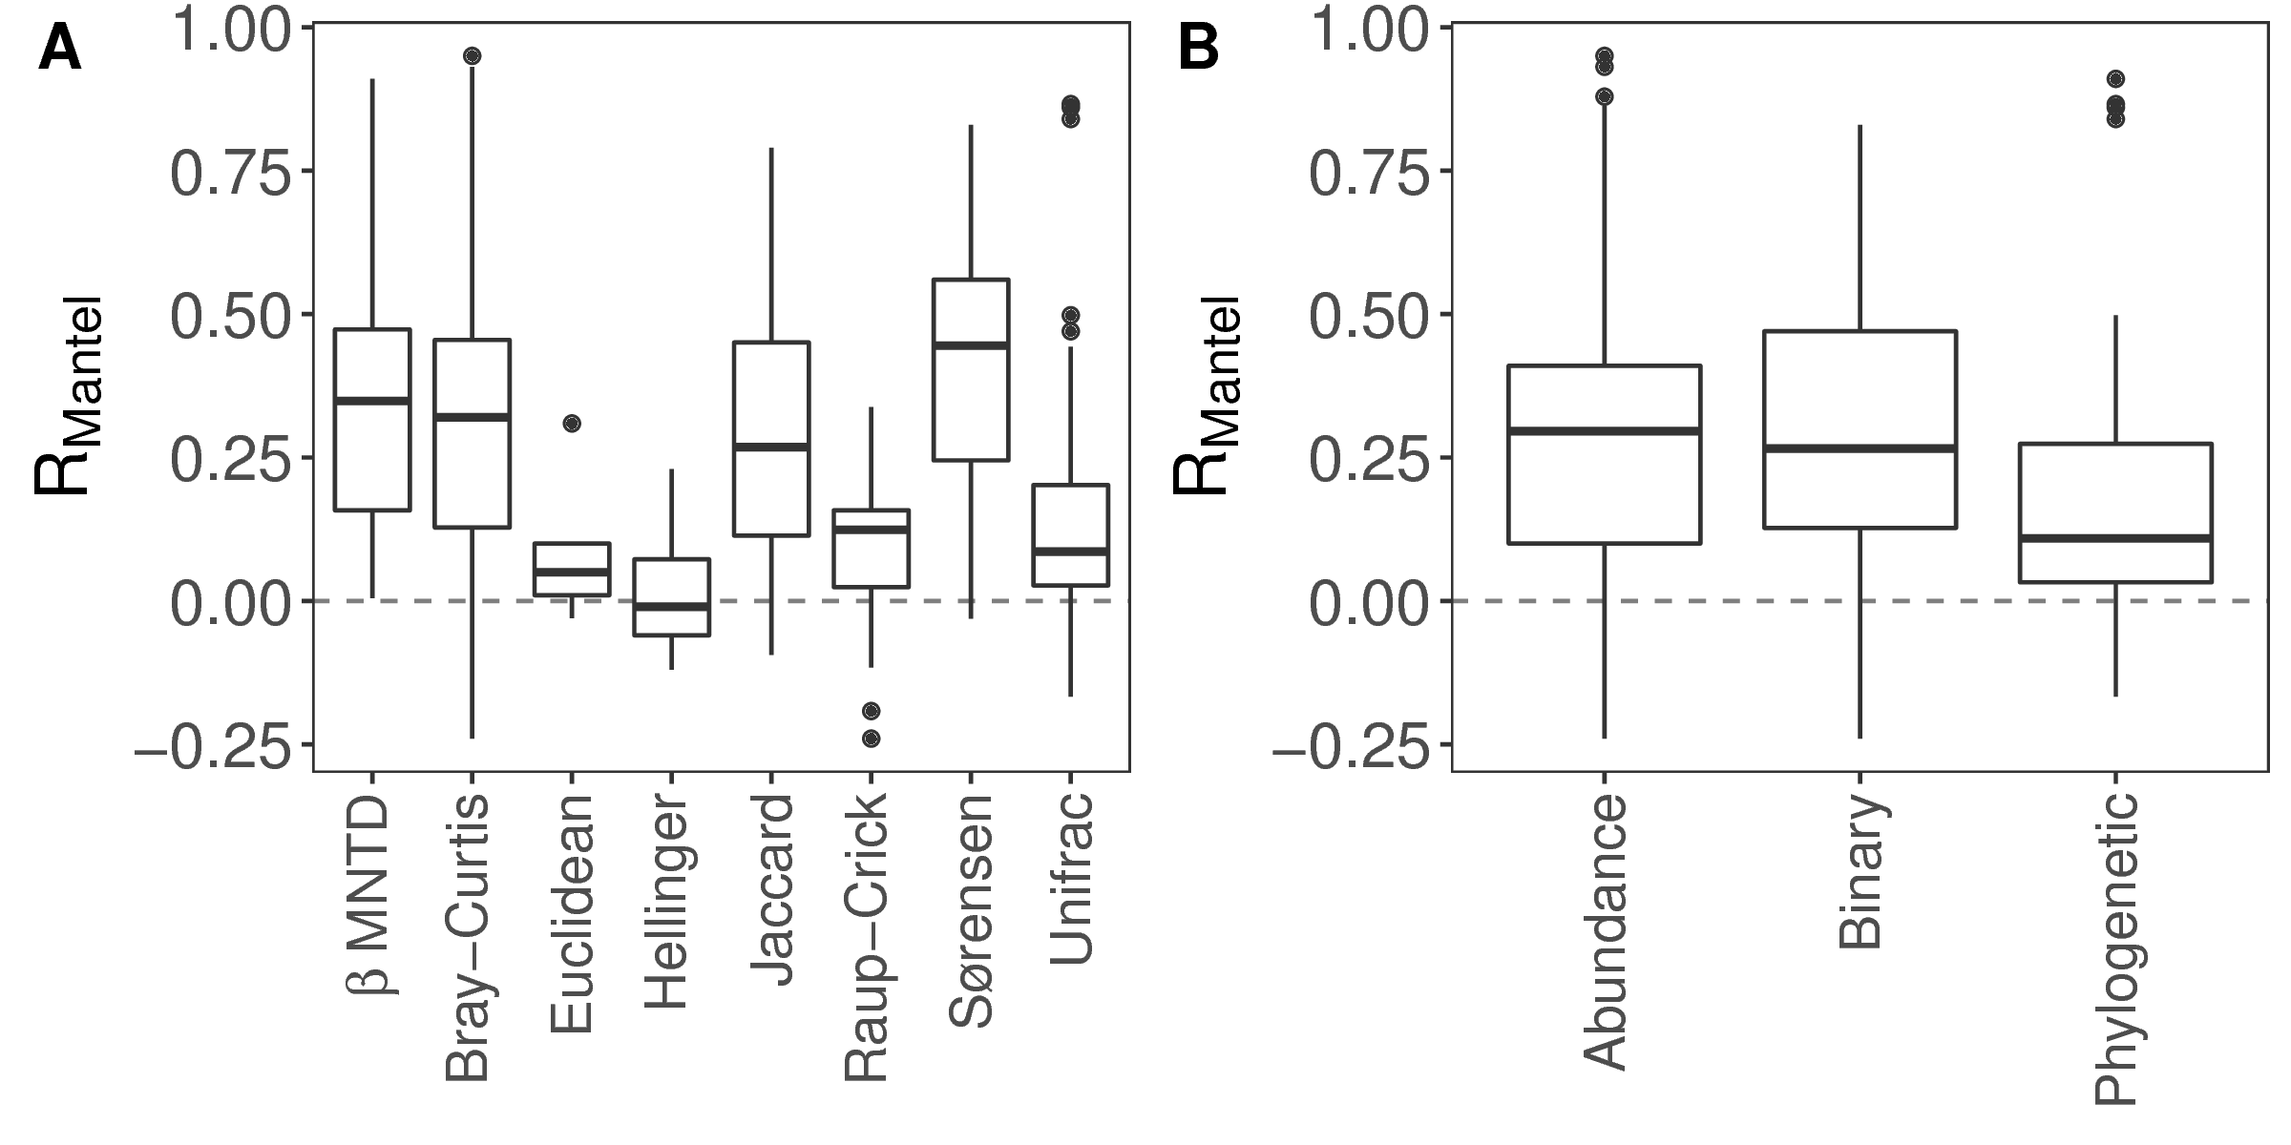

Figure 3. Mantel correlation coefficients from distance-decay relationships based on (A) different dissimilarity indices and, (B) different types of dissimilarity index. Index types reflect the different data requirements and type of distance (e.g. community composition or phylogenetic relatedness). Larger Mantel coefficients indicate stronger correlation between community dissimilarity and geographic distance.

Figure 4. The relationship between Mantel correlation coefficients and the geographic extent over which the distance-decay relationship was measured. The solid line shows the fit of a linear model (slope = 0.016, *P* < 0.001, adj-R2 = 0.12). The positive relationship indicates that larger scale studies tend to record stronger distance-decay relationships.