**POINT DELINEATIONS THROUGH AGGREGATION**

Step 1.

Follow these links to download the tool and associated spatial data:

<https://www.dropbox.com/sh/t75uwhnxdpqa3zr/TG40DGgxaQ>

Download both files: *shedTopology10162012_circularASR.zip* (164 MB) and *WIRTMDLcatchments.zip*(30 KB). Expand both files in any directory. Let me know when you’ve downloaded the data so I can take them off the cloud.

Step 2.

Open an instance of ArcMap. Right-click on “ArcToolbox” and “Add Toolbox,” and browse to the file *~WIRTMDL HUC14 delineation.tbx* within the *WIRTMDLcatchments.zip* package. Click on the script called *Aggregate Network*.

Step 3.

Add the polygon shapefile contained within *shedTopology10162012_circularASR.zip* to your ArcMap instance. Add a hydroline layer of your choice. Create an empty point shapefile. Populate the shapefile with points where you want to “break” your watershed network. Each point must fall within the sub-watershed polygon associated with the stream reach where you want the break to occur (green point in image below). The green point break will delineate the upstream watershed at the outfall of the sub-watershed (red point in image below).

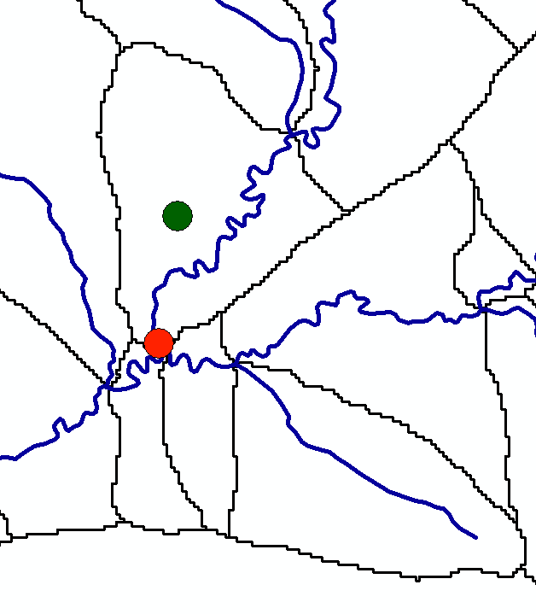

Step 4.

Add a field to the point shapefile where a unique ID will be stored. The IDs of the aggregated watershed delineations will conform to this ID. Populate each field with a unique ID.

Step 5.

Run the *Aggregate Network* tool. The argument “Subsheds” must be the shapefile contained within the file, *shedTopology10162012_circularASR.zip*. The “Hydro lines” argument should be the underlying hydrolines you will use to run SWAT. Define output shapefiles for watersheds and hydrolines and click OK.