Questions to Consider for Next Week

1. How well does the model estimate the biomass when we have good estimates of parameters?
   * Does having 1 estimate for natural mortality impact the model results?
2. What happens to the model biomass when our catchability estimate is higher than reality?
   * What are the implications of this for stock assessments in general?
   * What happens to model estimates of natural mortality? Why?
3. What happens to the model biomass when our natural mortality estimate is higher than reality?
   * What are the implications of this for stock assessments in general?
   * What happens to model estimates of catchability? Why?

Accurate Model Priors for Natural mortality and Catchability

Table 1: Natural Mortality and Catchability Priors and the real parameter values

|  |  |
| --- | --- |
| Parameter | Value |
| Actual Catchability | 0.3 |
| Actual Median Natural Mortality | 0.2 |
| Median of Catchability Prior | 0.3 |
| Median of Natural Mortality Prior | 0.2 |

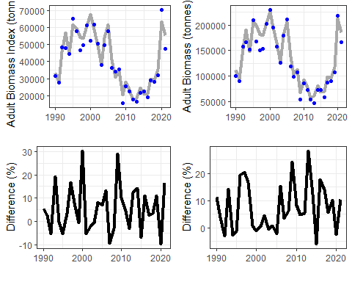

Figure 1: The SAM adult biomass results compared to (TOP) the SAM adult biomass (grey line) compared to the Actual Adult Biomass (Blue points). BOTTOM figure is the percent difference between the SAM estimated adult biomass and the Actual adult biomass.

Table 2: A Table showing the difference between the SAM adult biomass estimates the actual adult biomass. (Mean difference) and |Absolute difference|

|  |  |  |
| --- | --- | --- |
| Comparsion | Tonnes | Percentage |
| Mean Adult Biomass (SAM - Actual) | 7600 | 7.5 |
| Mean Adult Biomass |SAM - Actual| | 9400 | 8.7 |

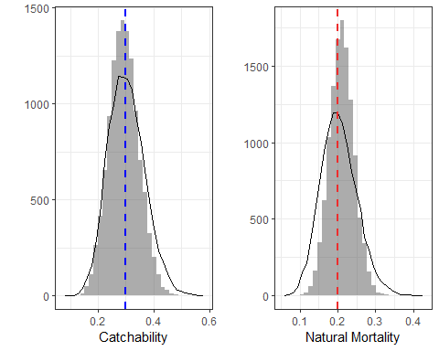

Figure 2: The Prior and Posterior distributions for catchability and mortality. The Prior distribution is approximated by the line, while the model predictions (aka Posteriors) are given by the histogram (bars). In the left figure, the blue dashed line is the catchability (q) you defined for the simulations, this is a fixed unchanging value. In the figure on the right, the red dashed line is the average natural mortality (m) you defined, note that natural mortality varies each year in our simulations, but our Stock Assessment Model (SAM) is constrained to estimate one m for the entire time series.

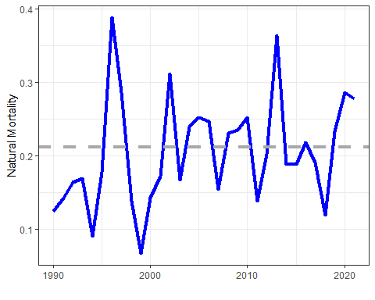

Figure 3: The actual natural mortality (blue line) time series, the grey dashed line is the median of the natural mortality parameter estimate from the SAM.

Catchability Prior higher than actual catchability

Table 3: Natural Mortality and Catchability Priors and the real parameter values

|  |  |
| --- | --- |
| Parameter | Value |
| Actual Catchability | 0.3 |
| Actual Median Natural Mortality | 0.2 |
| Median of Catchability Prior | 0.56 |
| Median of Natural Mortality Prior | 0.2 |

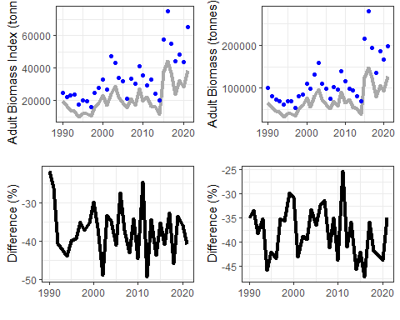

Figure 4: The SAM adult biomass results compared to (TOP) the SAM adult biomass (grey line) compared to the Actual Adult Biomass (Blue points). BOTTOM figure is the percent difference between the SAM estimated adult biomass and the Actual adult biomass.

Table 4: A Table showing the difference between the SAM adult biomass estimates the actual adult biomass. (Mean difference) and |Absolute difference|

|  |  |  |
| --- | --- | --- |
| Comparsion | Tonnes | Percentage |
| Mean Adult Biomass (SAM - Actual) | -45000 | -38 |
| Mean Adult Biomass |SAM - Actual| | 45000 | 38 |

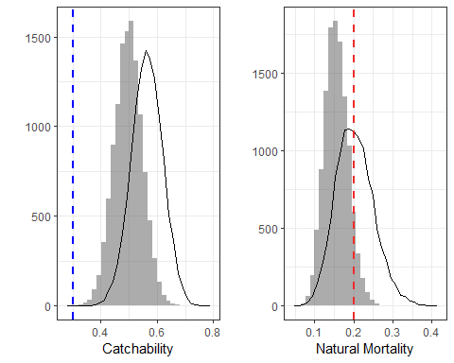

Figure 5: The Prior and Posterior distributions for catchability and mortality. The Prior distribution is approximated by the line, while the model predictions (aka Posteriors) are given by the histogram (bars). In the left figure, the blue dashed line is the catchability (q) you defined for the simulations, this is a fixed unchanging value. In the figure on the right, the red dashed line is the average natural mortality (m) you defined, note that natural mortality varies each year in our simulations, but our Stock Assessment Model (SAM) is constrained to estimate one m for the entire time series.

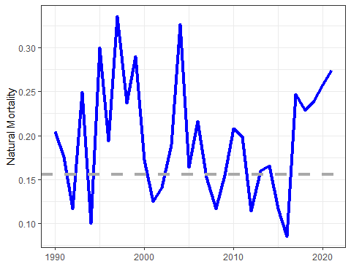

Figure 6: The actual natural mortality (blue line) time series, the grey dashed line is the median of the natural mortality parameter estimate from the SAM.

Mean natural mortality prior higher than actual mean natural mortality

Table 5: Natural Mortality and Catchability Priors and the real parameter values

|  |  |
| --- | --- |
| Parameter | Value |
| Actual Catchability | 0.3 |
| Actual Median Natural Mortality | 0.2 |
| Median of Catchability Prior | 0.3 |
| Median of Natural Mortality Prior | 0.42 |

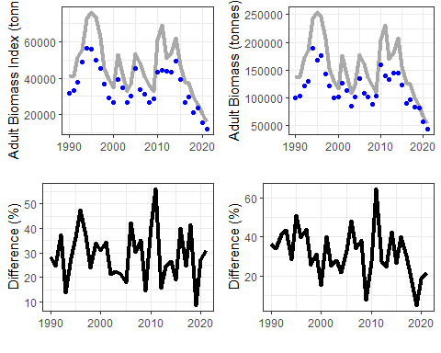

Figure 7: The SAM adult biomass results compared to (TOP) the SAM adult biomass (grey line) compared to the Actual Adult Biomass (Blue points). BOTTOM figure is the percent difference between the SAM estimated adult biomass and the Actual adult biomass.

Table 6: A Table showing the difference between the SAM adult biomass estimates the actual adult biomass. (Mean difference) and |Absolute difference|

|  |  |  |
| --- | --- | --- |
| Comparsion | Tonnes | Percentage |
| Mean Adult Biomass (SAM - Actual) | 38000 | 32 |
| Mean Adult Biomass |SAM - Actual| | 38000 | 32 |

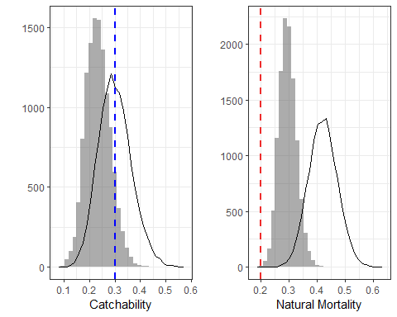

Figure 8: The Prior and Posterior distributions for catchability and mortality. The Prior distribution is approximated by the line, while the model predictions (aka Posteriors) are given by the histogram (bars). In the left figure, the blue dashed line is the catchability (q) you defined for the simulations, this is a fixed unchanging value. In the figure on the right, the red dashed line is the average natural mortality (m) you defined, note that natural mortality varies each year in our simulations, but our Stock Assessment Model (SAM) is constrained to estimate one m for the entire time series.

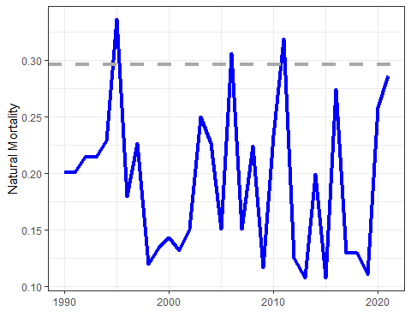

Figure 9: The actual natural mortality (blue line) time series, the grey dashed line is the median of the natural mortality parameter estimate from the SAM.