Population Dynamics Tutorial

Eura Nama

# Population Dynamics Tutorial Project

# Tutorial Objectives and Overview

1. There are 2 main components to this tutorial that you should ask me lots of questions about until you really understand what is happening!
   1. *Explore Logistic Growth*
      * Explore the logistic growth, explore changing *r*, *K*, and variability in *r* (the *sd* parameter).
        1. how does changing *r* effect population growth?
        2. how does changing *K* effect population growth?
        3. how does changing these parameters impact the maximum of the population growth curve?
      * What happens when you include (and increase) variability in *r*?
   2. *Logistic Growth and Harvesting*
      * Explore dynamics of logistic growth model with harvesting and no variability
        1. what happens to population if you ‘harvest’ the population at a value less than Maximum Population Growth (MPG)?
        2. what happens to population if you ‘harvest’ the population at the MPG?
        3. what happens to population if you ‘harvest’ the population above the MPG?
      * What happens if you ‘harvest’ the population at the MPG but there is variability in *r*?
        1. How does increasing the variability effect the population?
   3. BONUS: Does anyone know what the MPG is called in Fisheries Science?

# The Tutorial Tutorial

1. Open the file “Population_Dynamics_tutorial.Rmd” in R-Studio
2. On lines 65-78 you can change the input parameters for the analysis and explore how changing these parameters influences the logistic model results iii Press the “Knit” button in the tool bar
   * Make sure that you closed (and saved if you want to keep the results) the word document

Table 1: A Table of your parameter settings

| Parameter | Value |
| --- | --- |
| Intrinsic rate of growth (*r*) | 0.15 |
| Carrying Capacity (*K*) | 2500 |
| Standard deviation of *r* | 0.025 |
| Harvest (in numbers) | 93.75 |
| Number of simulations | 300 |
| Model | logistic |

# PART I: Exploring population dynamics with no variability in *r* and no harvesting

In this example we start the population with 1 individual and track the population over the next 100 years.

Figure 1: Population size over time with your selected *r* and *K* parameters.

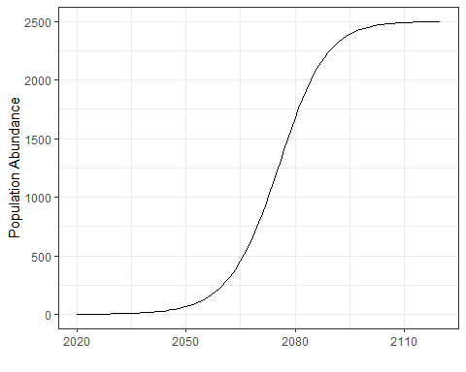

Figure 2: Population growth figure, comparing annual population growth to population size.

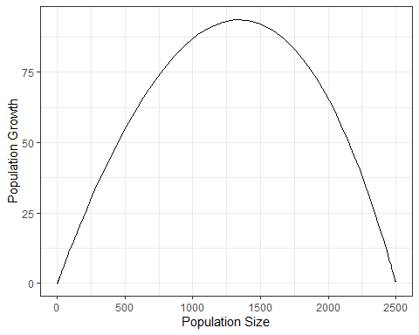

Figure 3: Population growth rate figure, comparing annual population growth rate to population size

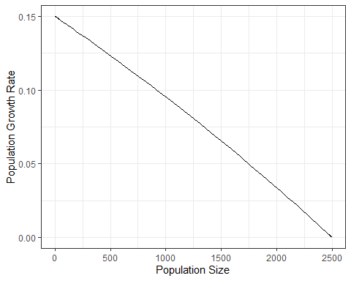

# Part II: Exploring the population dynamics with variability in *r* but no harvesting

In these examples we start the population with 1 individual and track the population over the next 100 years. Because we are adding in random variability we also want to run a number of simulations to explore the range of variability in the data. Each line represents one simulation.

Figure 4: Population size over time with your selected *r* and *K* parameters. Each line represents one simulation.

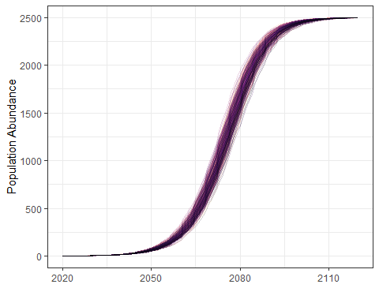

Figure 5: Population growth figure, comparing annual population growth to population size. Each line represents one simulation.

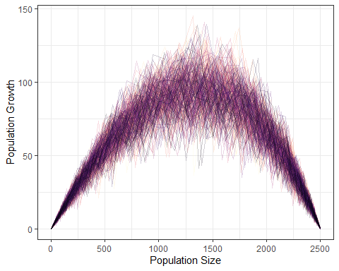

Figure 6: Population growth rate figure, comparing annual population growth rate to population size. Each line represents one simulation.

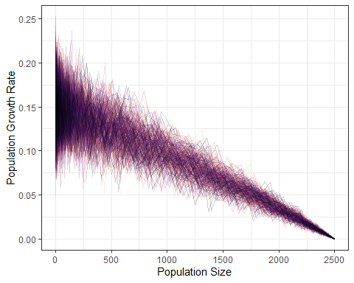

# Part III: Exploring the population dynamics with no variability in *r* and a fixed harvesting

For this example we start the population at the carrying capacity (*K*) and harvest a set number of individuals from the population (default harvests the population at MPG)

Figure 7: Population size over time with your selected *r* and *K* parameters.

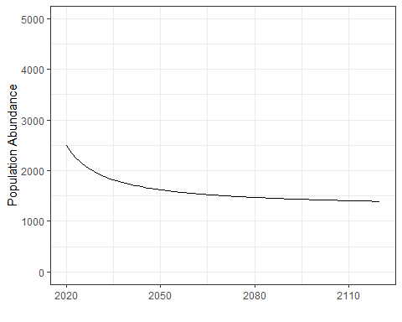

Figure 8: Population growth figure, comparing annual population growth to population size.

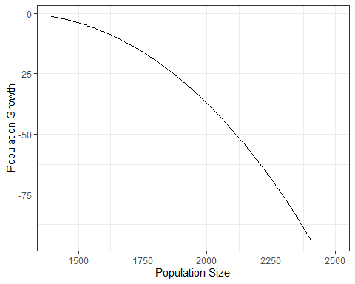

Figure 9: Population growth rate figure, comparing annual population growth rate to population size.

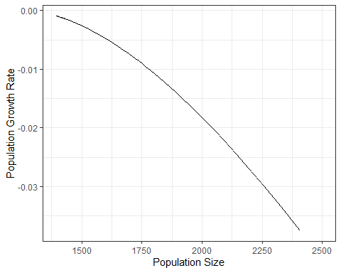

# Part IV: Exploring harvesting the population while adding in variability.

For this example we start the population at half the carrying capacity (K/2) and harvest a set number of individuals from the population (default harvests the population at MPG. Note that for these simulations if the population abundance is < the harvest we set N to 0

Figure 10: Population size over time with your selected *r* and *K* parameters. Each line represents one simulation.

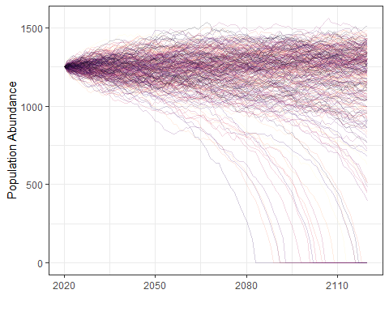

Figure 11: Population growth figure, comparing annual population growth to population size. Each line represents one simulation.

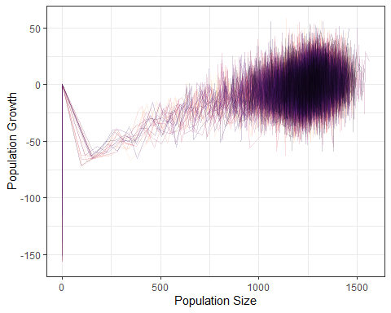

Figure 12: Population growth rate figure, comparing annual population growth rate to population size. Each line represents one simulation.

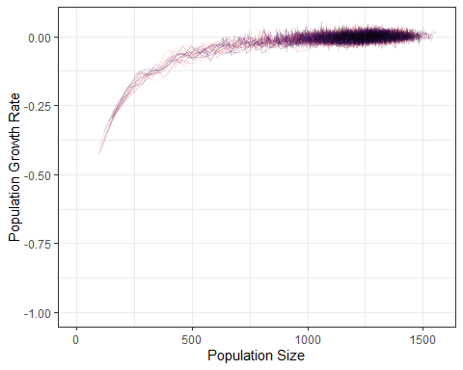

# Terms and Jargon

*Important*: Pretty much all of these ‘definitions’ are simplifications that serve our purposes, but if you go deeper into Fisheries Science you will see that it is often much more complex than this.

* *Simulation:* Process of using certain mathematical/statistical equations and tools to develop data and test the impact of varying inputs and assumptions on the end results. Stochastic simulations incorporate statistical uncertainty in model parameters to generate multiple outcomes by accounting for various types of uncertainty.
* *Realizations:* When running a stochastic simulation a realization is one set of results, there can be many realizations.
* *Natural Mortality:* The proportion of the population that dies from ‘natural causes’ in a given year.
* *Exploitation:* The proportion of the population that is captured by the fishery in a given year.