Model Tutorial

Eura Nama

Table 1: A Table of your input values for the current run of your simulation

|  |  |
| --- | --- |
| Parameter | Value |
| Number of Tows | 20 |
| Catchability | 0.3 |
| Area swept by a tow | 10000 m² |
| Number of Simulations | 9 |
| Survey Design | NAFO |

So we have a method to generate random fields (or a bunch of them if we want) so now I want to make our model

Here I am distributing the biomass across the area according to the GMRF.

So now we should sample from our area. Given last weeks results we will use both a random sample of the area each year and a stratified survey using the NAFO grid. Let’s see if one does better than the other at this.

The final? step is to take the survey results and then plug those into a model to see how we do. We can estimate biomass, but we don’t actually have any real data on catchability, recruitment, natural mortality, or growth rates, so we have to make assumptions about those. All we really know is biomass and removals.

## Time difference of 10.20718 secs

Talk about priors and posteriors

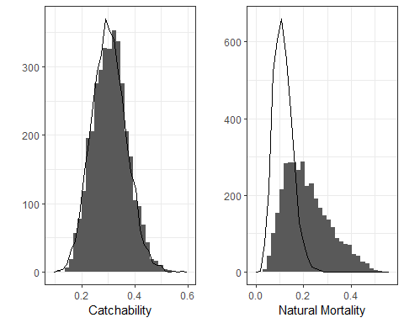

Figure 1: The Prior distributions for catchability and mortality

Talk about model results

