Stock Assessment Tutorial

Eura Nama

# Stock Assessment Model (SAM) Tutorial Project

## Tutorial Overview

1. There are 3 main components to this tutorial that you should ask me lots of questions about until you really understand what is happening!
2. *Simulation* - This will provide us with *fake* data that was generated with set parameters and results in our *known* data to compare against - The biomass of the adults and the recruits generated in these simulations is then distributed across the survey domain. - You do not need to do anything for this as we have all the parameters set and this will run without you having to change anything
3. *Survey Design* - Here we sample from the simulated data above, you can determine the number of stations to sample and the design of the survey - The survey data is then used to create indices of adult Biomass and Recruits which are inputs into the Stock Assessment Model (SAM)
4. *Stock Assessment Model (SAM)* - The indices from the survey are inputted into the Stock Assessment Model to get an estimate of the model biomass - Here you have control of 2 input parameters, *Catchability* and *Natural mortality*. - By varying these input parameters you can explore how being *wrong* about these parameters would impact your believe about the status of the stock
5. Much of the heavy lifting is done behind the scenes and your goal will be to understand how changing the survey design and/or the 2 model parameter impacts the biomass estimates from our Stock Assessment Model (SAM)

## What are we doing?

A. Today you are going to run a simple Stock Assessment Model (SAM) for the Dusky Scallop Shark (*Dustious maximus*) stock in the Gulf of Maine using a Delay Difference model i. Instead of getting 1-year of data, this tutorial will automatically simulate the biomass dynamics of this stock between 1990 and 2021 - The simulations are used to make ‘fake’ real world data which we then use to understand how survey design and ii. Using this simulated data you will design a survey to sample the biomass in the area (similar to Tutorial #2) in each year iii. Then this survey data will be used in the Delay Difference Stock Assessment Model (SAM) to get an estimate of biomass for each year iv. You can vary several parameters to see how they influence the model results. B. The stock and the survey is the same as used in Tutorial/Lecture #2, we just have multiple years of data as part of this survey C. For the survey design we will again have 2 variables as part of the survey design that you can control i. You can vary the number of survey tows - You have the same constraints as in Lecture 2, I’d suggest you try a low value and a high value as based on what you found in Tutorial #2 ii. You can decide if you want to have a *Random* or stratified survey - The only stratification option this time is using the *NAFO* sub-areas D. The survey indices will then be used as the inputs into the Delay Difference Stock Assessment Model (SAM). There will be two model inputs you can adjust i. The survey *catchability prior*.  
- Survey catchability can be difficult to estimate in the real world, but it is a critical parameter to scale up from a survey index to a biomass index - The Stock Assessment Model (SAM) requires ‘prior’ knowledge of what we believe survey catchability is. - In our simulation we have set catchability to be a constant at 0.3

# Questions to Consider

1. How well does the survey index compare to the ‘actual biomass’?
   * Does changing the number of survey stations or the stratification (NAFO vs Random) influence this?
   * Given these results and your experience from Lecture 2, would you recommend the NAFO or Random survey?
   * How many stations would you recommend?
2. How well does the Stock Assessment compare to the ‘actual biomass’
3. How does varying the prior on the catchability impact the Stock Assessment results?
   * What are the consequences of being wrong about catchability?
4. How does varying the prior on natural mortality impact the Stock Assessment results?
5. How do you think having a fixed natural mortality term is impacting the Stock Assessment results?

# The Tutorial Tutorial

1. Open the file “Stock_Assessment_tutorial.Rmd” in R-Studio
2. On line 89 of this file you can change the number of tows used in the survey. Default is 20 tows
3. On lines 95-97 of this file you can change the underlying biomass distribution
   * To do this you add a # symbol at the start of the lines you do not want, and removed it from the line you do want
4. You can change the number of simulations run on line 100.
   * I suggest trying 1, 4, and 250 (this will be slow!) to see how your opinion changes with more realizations of your data.
5. Press the “Knit” button in the tool bar
   * Make sure that you closed (and saved if you want to keep the results) the word document.

Table 1: A Table of your input values for the current run of your simulation

|  |  |
| --- | --- |
| Parameter | Value |
| Number of Tows | 200 |
| Catchability | 0.3 |
| Natural Mortality | 0.2 |
| Area swept by a tow | 10000 m² |
| Survey Design | NAFO |

So we have a method to generate random fields (or a bunch of them if we want) so now I want to make our model

Here I am distributing the biomass across the area according to the GMRF.

## Time difference of 18.49108 secs

Priors are essentially a guide for the model to help inform likely values for the parameters. Sometimes they are well know (informative), sometimes they are not much more than an ‘educated’ guess. In our example you should tweak the priors for catchability (*q*) and natural mortality (*m*) to see how these influence the estimate of both these parameters and the other parameters in the model. You should be thinking *are their consequences to getting these wrong and if so what are they*.

## NULL

## NULL

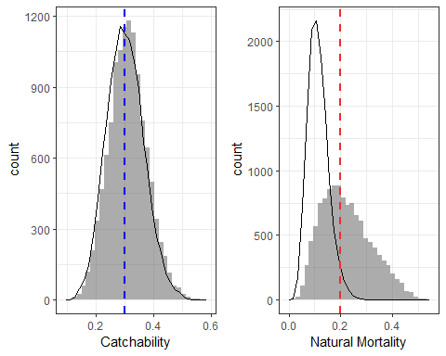

Figure 1: The Prior and Posterior distributions for catchability and mortality. The Prior distribution is approximated by the line, while the model realizations (aka Posteriors) are given by the histogram (bars). In the left figure, the blue dashed line is the catchability (q) you defined for the simulations, this is a fixed unchanging value. In the figure on the right, the red dashed line is the average natural mortality (m) you defined, note that natural mortality varies each year in our simulations, but our Stock Assessment Model (SAM) is constrained to estimate one m for the entire time series.

Here are two biomass figures. The first is the q-corrected Model Estimated biomass compared to the survey biomass index. The second is the Stock Assessment estimated biomass compared to the Actual simulated biomass. **Recall, the Actual simulated biomass would be ‘unknown’ in a real world Stock Assessment, here it is a check of how well our models have done**.

So how well is the Stock Assessment Model (SAM) doing at recreating the Survey Index?

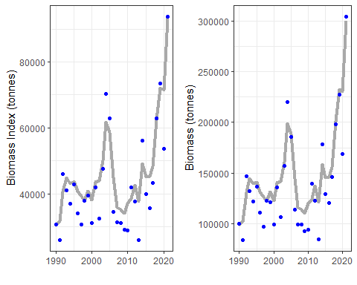

Figure 2: The model biomass results compared to a) the survey index biomass, here we have q-corrected the Stock Assessment biomass (the grey line) and compared it to the Survey Biomass Index. In b) we have the Stock Assessment biomass (grey line) compared to the Actual Biomass that we simulated.

ggplot(mod.actual) + geom_line(aes(x = years, y = natural.mort),  
 size = 1.5, color = "blue") + geom_hline(aes(yintercept = DD.out$median$M),  
 size = 1.5, linetype = "dashed", color = "darkgrey") + theme_bw()

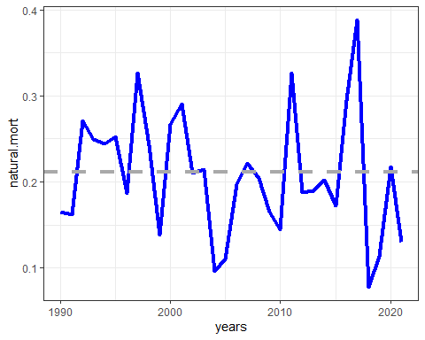

ggplot(mod.actual) + geom_line(data = mod.res, aes(y = biomass,  
 x = years), size = 1.5, color = "darkgrey") + geom_point(aes(x = years,  
 y = biomass), size = 1.5, color = "blue") + theme_bw()

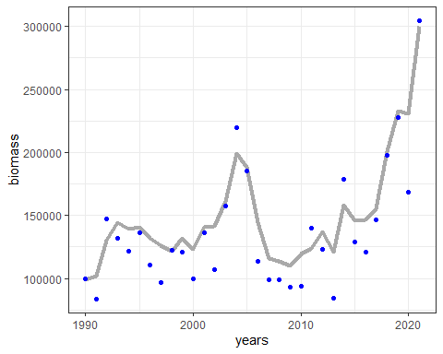

ggplot(mod.actual) + geom_line(data = mod.res, aes(y = recruits,  
 x = years), size = 1.5, color = "darkgrey") + geom_point(aes(x = years,  
 y = recruits), size = 1.5, color = "blue") + theme_bw()

## Warning: Removed 1 row(s) containing missing values (geom_path).

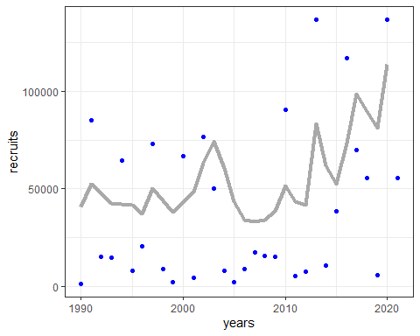

ggplot(mod.actual) + geom_line(data = mod.res, aes(y = exploitation.rate,  
 x = years), size = 1.5, color = "darkgrey") + geom_point(aes(x = years,  
 y = exploitation.rate), size = 1.5, color = "blue") + theme_bw()

