Survey Simulation Example

Eura Nama

# Survey Parameters

Just so you can keep track in the document, we return the survey parameters that you set for this simulation.

Table 1: A Table of your input values for the current run of your simulation

|  |  |
| --- | --- |
| Parameter | Value |
| Number of Tows | 20 |
| Total Biomass | 100000 tonnes |
| Catchability | 0.3 |
| Area swept by a tow | 10000 m² |
| Number of Simulations | 20 |
| Biomass distribution | NAFO |

## Survey Simulation

So now we can review the input data we have for our survey. First we will look at some figures. First off, lets take a look at our survey area, included in this figure are the North Atlantic Fishery Organization (NAFO) subareas that are the basis for the NAFO stratification, and the bathymetry of the region, which is used as the basis of the depth stratification (Figure 1).

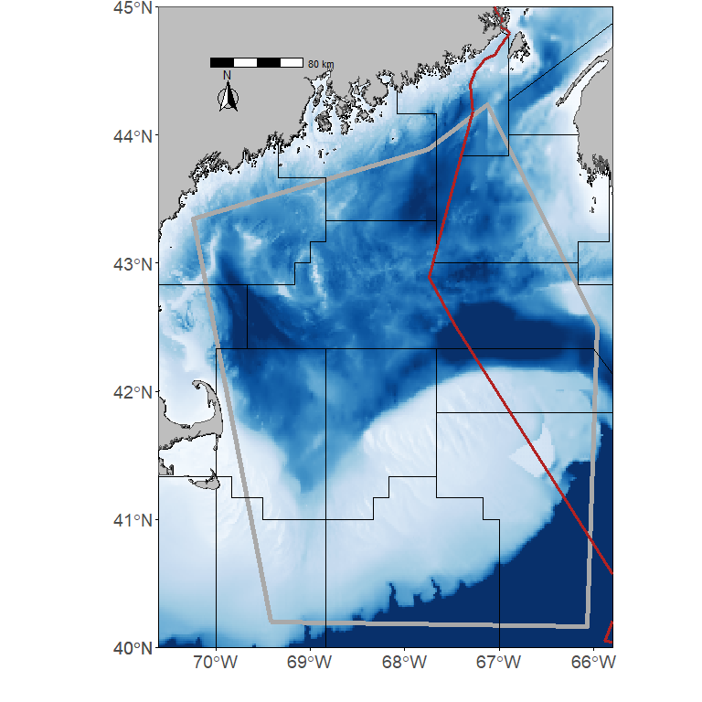

Figure 1: The assessment area for the Dusky Scalloped Shark (*Dustious maximus*) is outlined by the thick grey line. The thin black lines are the NAFO subareas in the region. The red line divides shows the division between the economic exclusive zone (EEZs) for Canada and the United States. The bathymetry in the region is also shown.

Now we can also show the distribution of the biomass in the area. If 20 is greater than 1 then we’ll show two or three realizations from the models depending on how many simulations we ran. First we show the biomass distribution with the random survey stations overlain (Figure 2).

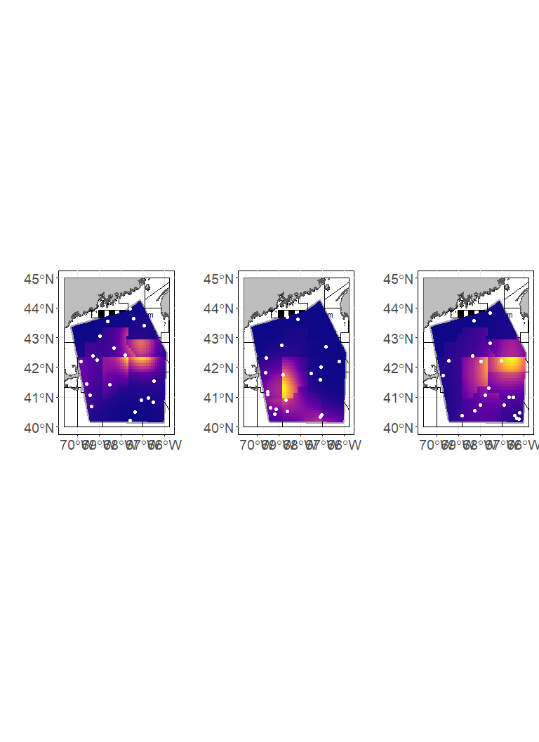

Figure 2: Biomass distribution with the random survey stations overlain

Next we show the biomass distribution with the NAFO survey stations and NAFO strata overlain (Figure 2).

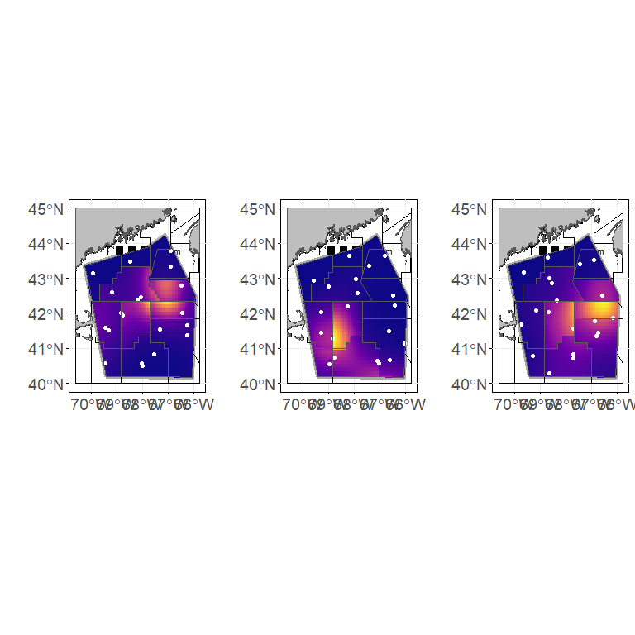

Figure 3: Biomass distribution with the NAFO survey stations and NAFO stratification polygons overlain

Finally, we show the biomass distribuiton with the Depth survey stations and Depth stratification overlain (Figure 4)

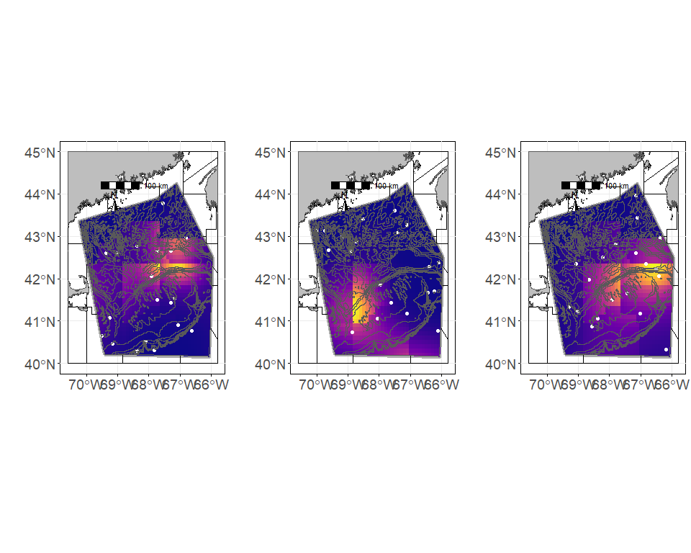

Figure 4: Biomass distribution with the Depth survey stations overlain and the Depth stratification polygons overlain.

So at this point we have a survey where we have no stratification, a survey stratified by NAFO area, and a survey that is stratified on depth. Next up I need to make up some biomass distributions, we can distribute biomass spatially (GMRF), within the NAFO areas, by depth, and maybe some other weird way.

I think to do this I’m gonna need to carve up the area into grids, that will let me do the random way and some other non-random way of doing it. I think the nafo and depth areas are my way in to splitting up the biomass in those (I think I’ll probably need to go back to the bathy polygons to pull that off). Going to need to make each polygon kinda a biomass field aren’t I, then we land a sample somewhere in that field to get estimate. Lazy way would be to make each polygon have identical biomass everywhere (maybe that’s the easy way) then we can make it more complex from there.

# Now we can compare the random survey estimates to the depth and NAFO stratified surveys.

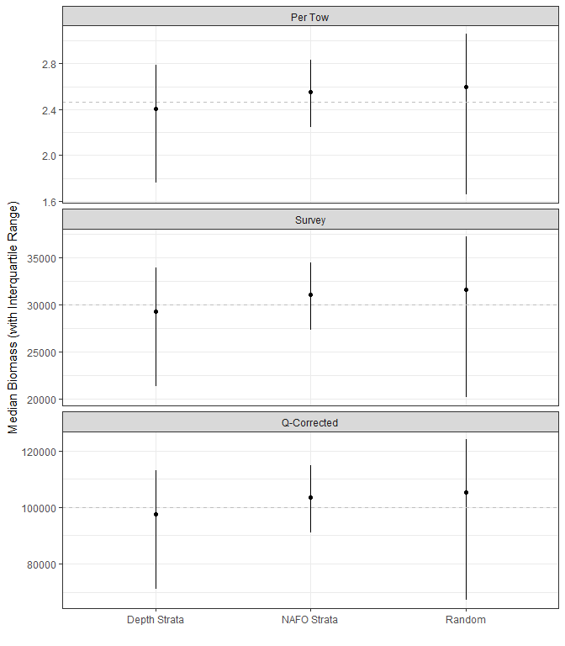

Figure 5: Biomass estimates from the 3 different survey sampling schemes. When the number of simulations run = 1 this provides the mean and 95% CI from that simulation. When the number of simulations is >1 and < 10 the mean biomass for each simulation is shown. When the number of simulations is >=10 we show the median biomass of the simulations along with the interquartile range of the biomass from the simulations