Survey Tutorial

Eura Nama

# Survey Tutorial Project

1. Your job is to design an annual trawl survey for Dusky Scallop Shark (*Dustious maximus*; Figure 2). The survey occurs June when the stock is spawning.
2. The stock area shown has been chosen as a compromise between the stock biology, stakeholder input, and operational constraints.
3. In planning your survey there are 2 variables you can control
   1. You can vary the number of survey tows
      * From start to finish it takes approximately 3 hours to complete a tow and finish the scientific analyses
      * The vessel is available for the entire month of June
   2. You can decide if you want to have a random or stratified survey
      * There are 2 options for stratification
        + NAFO sub-areas (Figure 2)
        + Depth strata (Figure 3)
      * Note that the tows will be allocated proportionally to the area of each stratum.
4. You can also ‘simulate’ different biomass distributions to see if this changes you opinion on either the stratification scheme or the number of stations you need.
   1. The “Random” option distributes the biomass using a ‘random field’
      * There is a spatial pattern to the data but the pattern is randomly generated
   2. The “NAFO” option has an underlying ‘random field’ which sets the pattern for each simulation
      * Then this field is augmented depending on which NAFO strata you are in
      * The central area biomasses are elevated
      * The nearshore and offshore biomasses are lower
   3. The “Depth” option also has an underlying ‘random field’ which sets the pattern for each simulation
      * Then this field is augmented by each Depth strata
      * As depths increase the biomasses will be lower than expected

# Topics to Consider

1. How does increasing the number of tows influence the accuracy and the precision of the results?
   * Consider the trade-offs between the number of tows and accuracy and precision of the survey results with logistical constraints of running a survey
2. When you have few survey stations (e.g. ≈20) why are the stratified survey biomass estimates generally biased?
   * *Hint* Look at the NAFO stratification (Figure 5)
3. Consider Figure 1 and discuss how biological, social, economic, or political factors could influence the design of the survey of the (*D. maximus*) stock (population) in this Region.

* *Hints*:
  + Biological versus artificial boundaries
  + Canada versus United States
  + Survey occurs during spawning

1. Consider Figures 4 - 6 and Table 2.
   * Which of the 3 sampling methods (Random, NAFO stratification, Depth stratification) would you suggest to use for the survey and why?
   * Does changing the underlying biomass distribution effect your opinion?

# Survey Parameters

Just so you can keep track in the document, we return the survey parameters that you set for this simulation.

Table 1: A Table of your input values for the current run of your simulation

|  |  |
| --- | --- |
| Parameter | Value |
| Number of Tows | 200 |
| Total Biomass | 100000 tonnes |
| Catchability | 0.3 |
| Area swept by a tow | 10000 m² |
| Number of Simulations | 1000 |
| Biomass distribution | NAFO |

## Survey Simulation

So now we can review the input data we have for our survey. First we will look at some figures. First off, lets take a look at our survey area, included in this figure are the North Atlantic Fishery Organization (NAFO) subareas that are the basis for the NAFO stratification, and the bathymetry of the region, which is used as the basis of the depth stratification (Figure 1).

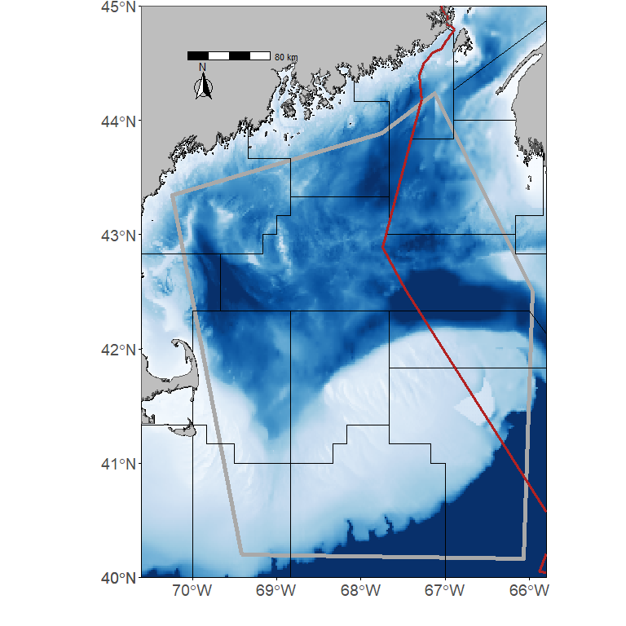

Figure 1: The assessment area for the Dusky Scalloped Shark (Dustious maximus) is outlined by the thick grey line. The thin black lines are the NAFO subareas in the region. The red line divides shows the division between the economic exclusive zone (EEZs) for Canada and the United States. The bathymetry in the region is also shown.

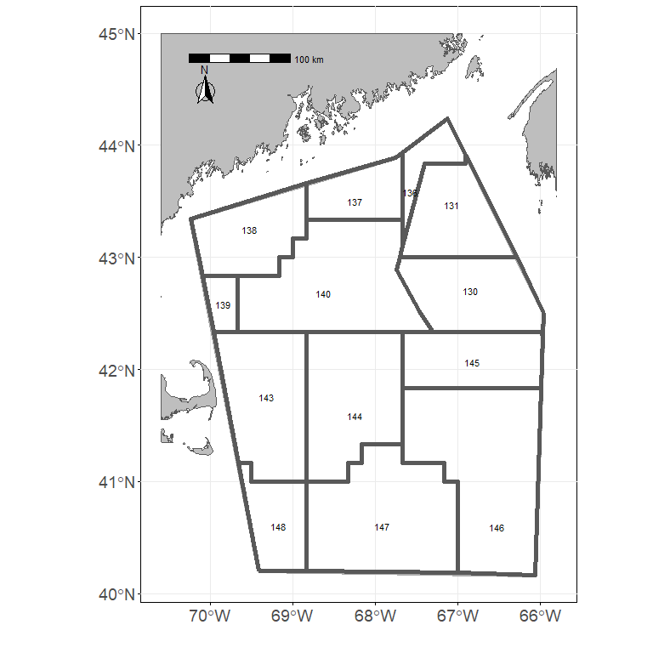

Figure 2: The NAFO stratification polygons used for stratification.

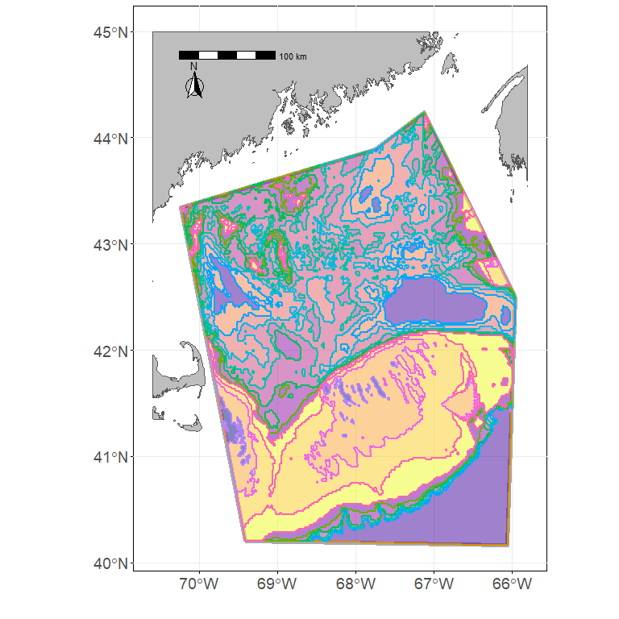

Figure 3: The Depth stratification polygons used for stratification.

Now we can also show the distribution of the biomass in the area. If 1000 is greater than 1 then we’ll show two or three realizations from the models depending on how many simulations we ran. First we show the biomass distribution with the random survey stations overlain (Figure 4).

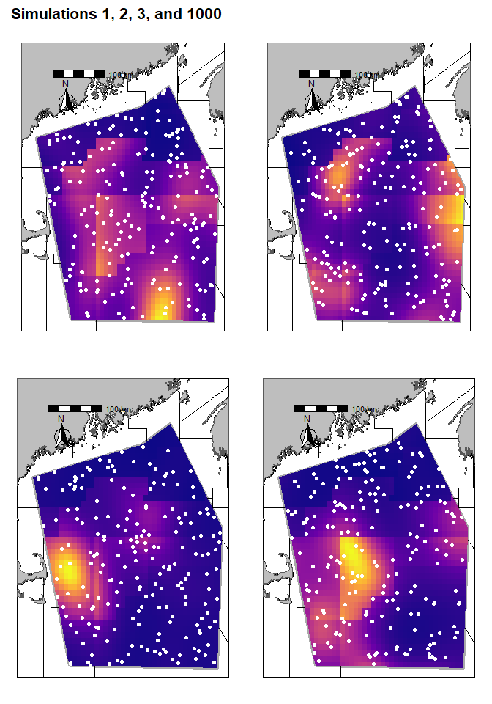

Figure 4: Biomass distribution with the random survey stations overlain

Next we show the biomass distribution with the NAFO survey stations and NAFO strata overlain (Figure 4).

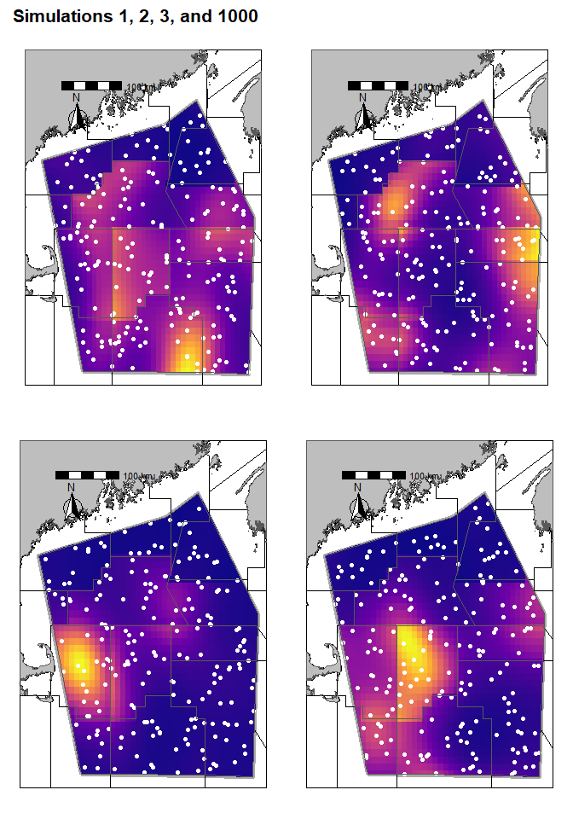

Figure 5: Biomass distribution with the NAFO survey stations and NAFO stratification polygons overlain

Finally, we show the biomass distribuiton with the Depth survey stations and Depth stratification overlain (Figure 6)

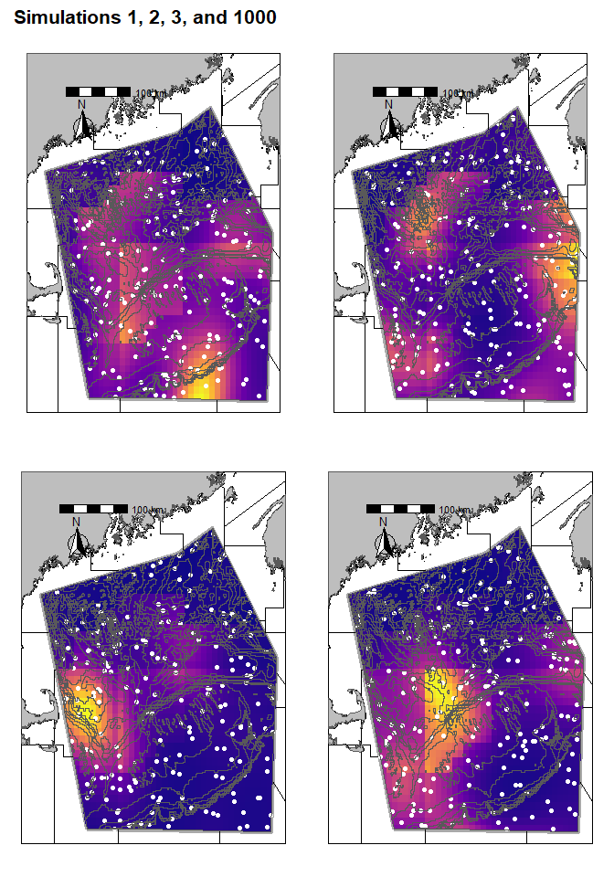

Figure 6: Biomass distribution with the Depth survey stations overlain and the Depth stratification polygons overlain.

# Now we can compare the random survey estimates to the depth and NAFO stratified surveys.

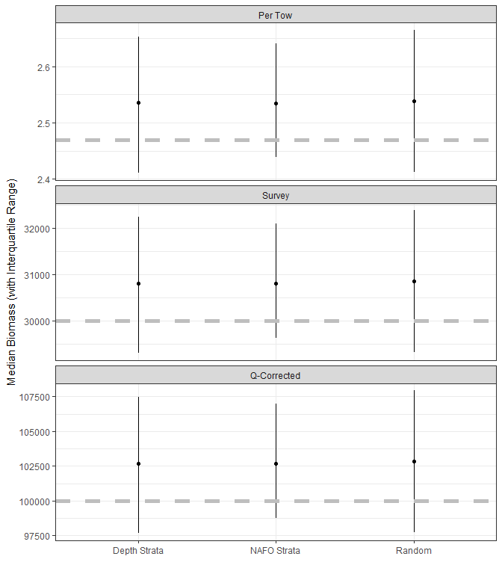

Figure 7: Biomass estimates from the 3 different survey sampling schemes. When the number of simulations run = 1 this provides the mean and 95% CI from that simulation. When the number of simulations is >1 and < 10 the mean biomass for each simulation is shown. When the number of simulations is $≥$ 10 we show the median biomass of the simulations along with the interquartile range of the biomass from the simulations

Table 2: A Table of the results from your simulation when 10 or more simulations are performed. Note that the Biomass is the mean biomass from all simulations and the Lower/Upper Quartiles represet the 25% and 75% quartiles repsectively

|  |  |  |  |  |  |
| --- | --- | --- | --- | --- | --- |
| Tow Stratification | Biomass | Lower Quartile | Upper Quartile | Number of Sims | Biomass Dist |
| Depth Strata | 102900 | 97650 | 107500 | 1000 | NAFO |
| NAFO Strata | 102900 | 98760 | 107000 | 1000 | NAFO |
| Random | 102900 | 97730 | 107900 | 1000 | NAFO |