Haddock S-R models

David Keith

11/14/2021

## 0.1 Thoughts

So our first thought was a simple stock-recruitment model using the linearization of the Ricker SR model, so

$$log\left(\frac{Rec}{SSB}\right)=log(a)−b×SSB+ϵ_{i}$$

So we now have all the stocks in the NE and NW Atlantic and we can now look at this the ensemble picture of the S-R relationship. The Recruit-SSB relationships look as awful here as they always do (Figure 1). Note that I have removed 2016 from the GB Haddock model, it’s such an outlier and it’s all alone it totally swamps any signal in the data for GB Haddock.

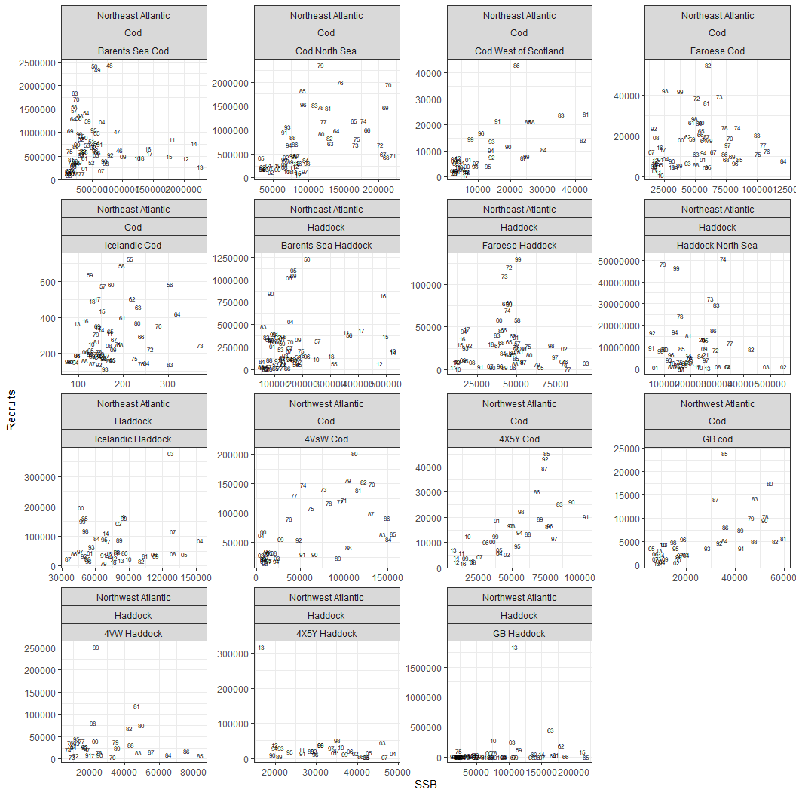

Figure 1: Recruits vs SSB for the world largest Haddock stock and some other less important things.

The linearization of the relationship really makes it easier to see what’s going on. Certainly those Barents Sea stocks seem to have the most increase in variability of Rec/SSB as SSB declines compared to others, so that fun takeaway from the other day was very specific to those stocks. The Haddock stocks seem to have more variability in the S-R relationship than cod. I’d guess that 4 (maybe 5) of the cod stocks S-R relationship would be considered non-significant statistically (Figure 2). Final think I’m seeing is the Rec/SSB for the North Sea for both species is really high compared to everywhere else (I’m sure that’s been noted before elsewhere).

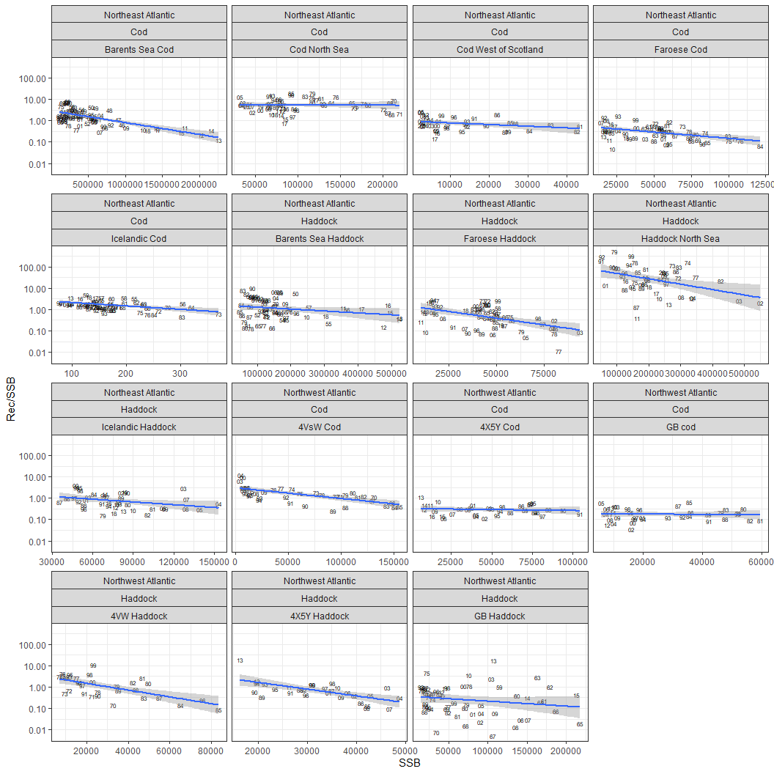

Figure 2: Recruits/SSB (log scale) vs SSB, Linear model fit on log(10) scale

From this, I think the linear relationship holds pretty well at lower SSB for these stocks, but for Cod we have really no evidence of an S-R relationship for half the stocks. So, I did something I like doing and split the data up, this time I split it at 0.4 of maximum SSB and fit linear models for each half of the data to see if anything interesting popped (Figure 3), obviously some of these look a bit silly. But that triggered me to think of a piecewise regression model for the data, which did more what I was hoping for (Figure 4). It’s an interesting mix of responses, I think all the ‘breakpoints’ are < 50% of max SSB, but that could be an artifact of having most of the data at < 50% of maximum SSB, or maybe it is something biologically interesting? The RAM idea of higher variability in recruitment near edge of their range might be in here if I squint really hard, maybe?

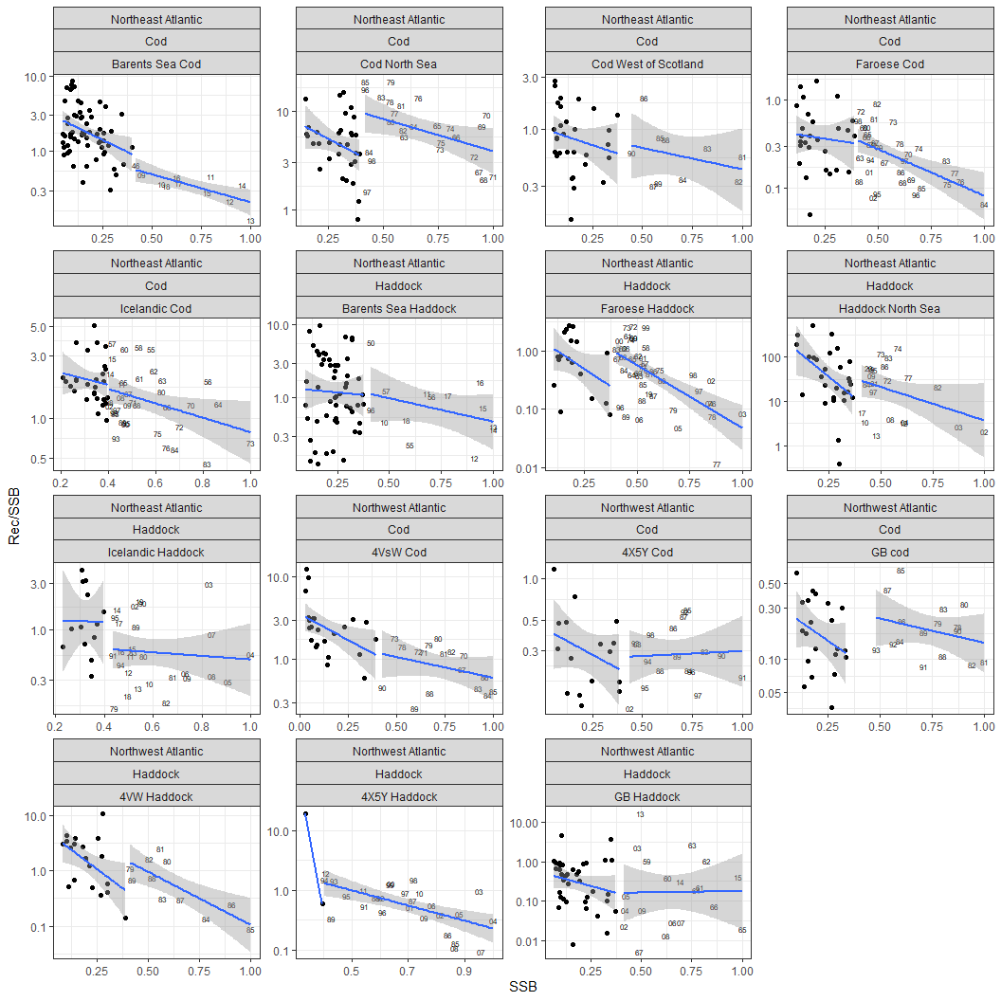

Figure 3: Recruits/SSB (log scale) vs SSB with SSB as a proportion of maximum SSB. Linear model fit to data > 0.4 of maximum SSB.

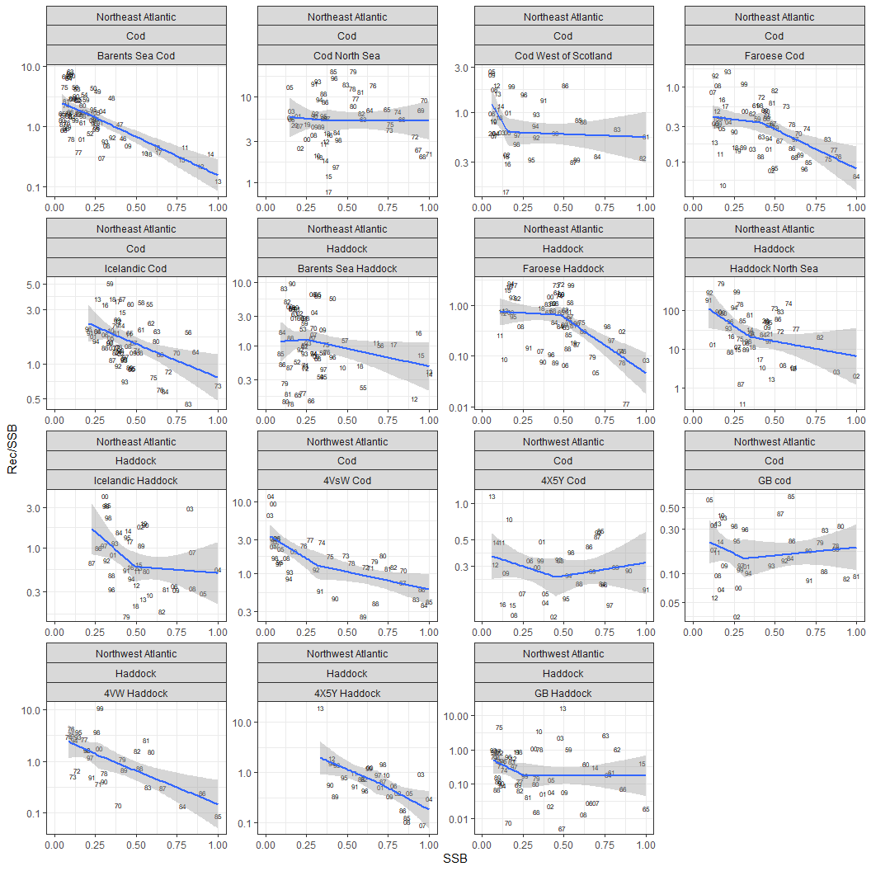

Figure 4: Recruits/SSB (log scale) vs SSB with SSB as a proportion of maximum SSB. Piecewise regression with the breakpoint based on the data, only 1 knot allowed and forcing a linear fit for each piece.

So now we can formally model the stock-recruit relationship, for the moment it’s just a standard Ricker model formulation but all stocks included in one shot. I think what my main takeaway is that variance issue, the residuals for the haddock stocks generally seem to be larger than observed for the cod stocks (Figure 5). A quick hacky estimate of the size of residuals suggests that the Haddock variance is higher, with the residuals being almost twice as large for Haddock, and it is pretty remarkably consistent on each side of the pond.

# The cod model  
#mod.stan <- lmer(log.rssb.stan ~ ssb.prop + (1+ssb.prop|stock) ,data= dat)  
#summary(mod.stan)  
#plot(mod.stan)  
#ranef(mod.stan)  
#se.ranef(mod.stan)  
  
# Mod logged data...  
mod.log <- lmer(log.r.ssb ~ ssb.prop + (1+ssb.prop|stock) ,data= dat)  
#summary(mod.log)  
#plot(mod.log)  
#ranef(mod.log)  
#se.ranef(mod.log)  
  
#dat$res.stan <- residuals(mod.stan)  
dat$res.log <- residuals(mod.log)  
size.resid <- dat %>% dplyr::group_by(region,species) %>% dplyr::summarise(abs.res =mean(abs(res.log)))

## `summarise()` has grouped output by 'region'. You can override using the `.groups` argument.

# Here is the mean absolute size of the residuals from the model broken out by species and Region.   
print(size.resid)

## # A tibble: 4 x 3  
## # Groups: region [2]  
## region species abs.res  
## <chr> <chr> <dbl>  
## 1 Northeast Atlantic Cod 0.508  
## 2 Northeast Atlantic Haddock 0.893  
## 3 Northwest Atlantic Cod 0.498  
## 4 Northwest Atlantic Haddock 0.981

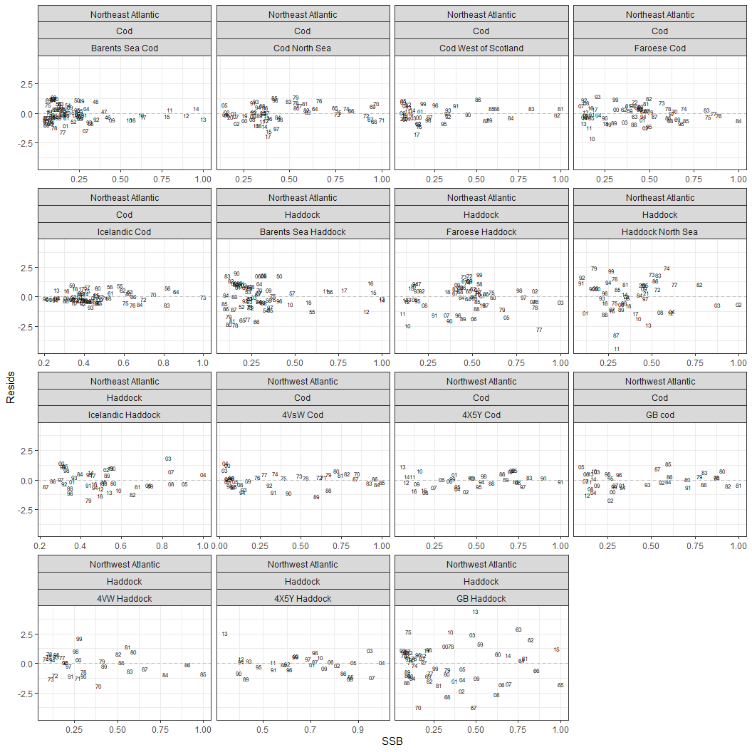

Figure 5: Residuals vs SSB (Proportion) from the stock-recruit model using log(Rec/SSB) ~ SSB

So having done this, most of what I was thinking about when looking at the Barents Sea stocks is probably off to the bin. The two obvious bits I think this could inform

1: Higher variability in recruitment for Haddock. I’m not sure if the S-R methods are necessary to pull this info out.

2: Might RAM’s recruitment variability along edges be tested here, I think that may be worth exploring more.