Haddock S-R models

David Keith

11/14/2021

# 1 Fogarty Analysis

Fogarty re-analysis Figure 1

This analysis will compare recruitment between the primary harvested sympatric Atlantic Cod and Haddock stocks in the Atlantic Ocean, comparing the period before 1993 (*Pre-1993 Period*) with the period from 1993 onwards (*Recent Period*), data shown in Figure 1.1. This is Figure 1 from Fogarty

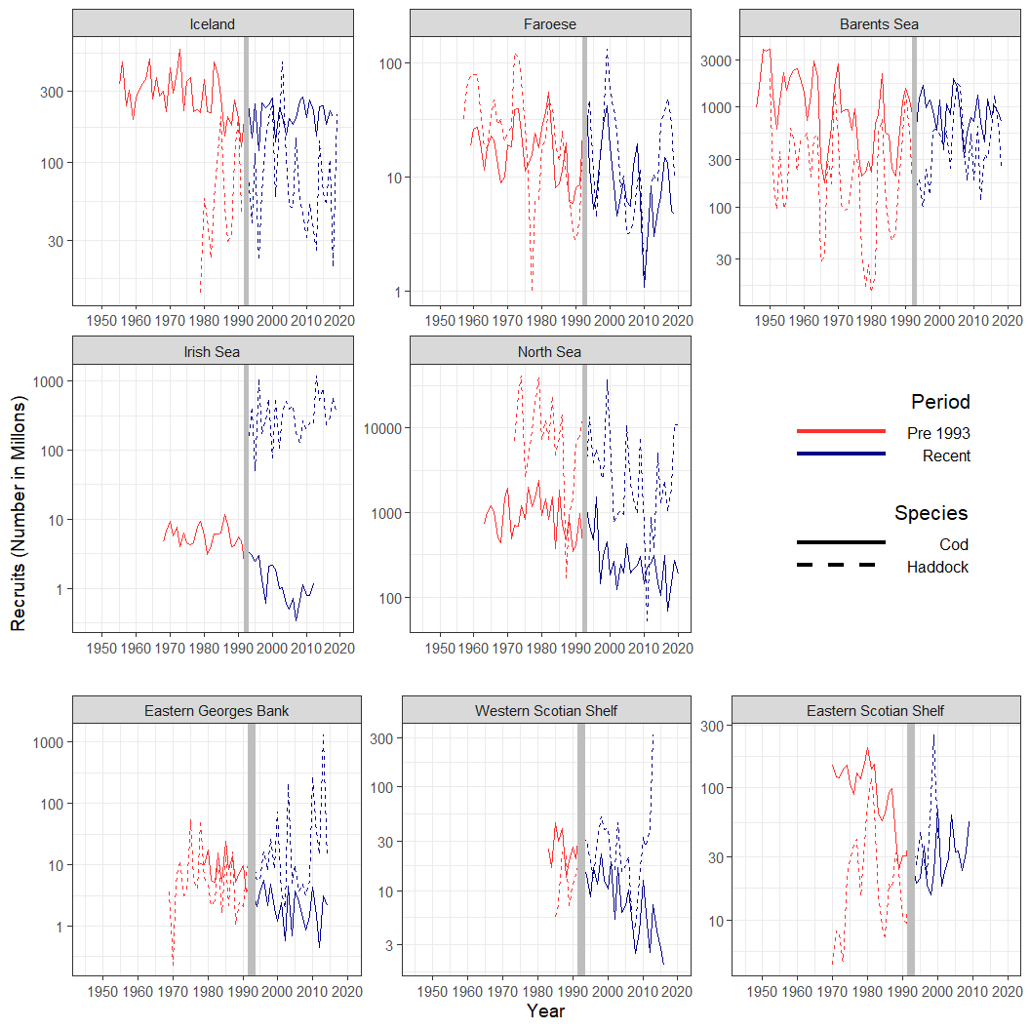

Figure 1.1: Recruitment (in millons) time series for 8 Atlantic Cod (solid line) and Haddock (dashed line) stocks in the Atlantic Ocean. The red line indicates data from the Pre-1993 Period, while the blue line is for the Recent Period. The vertical grey line indicates the division between the two periods

Next up was a simple stock-recruitment model using the linearization of the Ricker SR model.

$$log\left(\frac{Rec}{SSB}\right)=log(a)−b×SSB+ϵ_{i}$$

**Here is Figure 2 from Fogarty, the Residual plot from the S-R models**

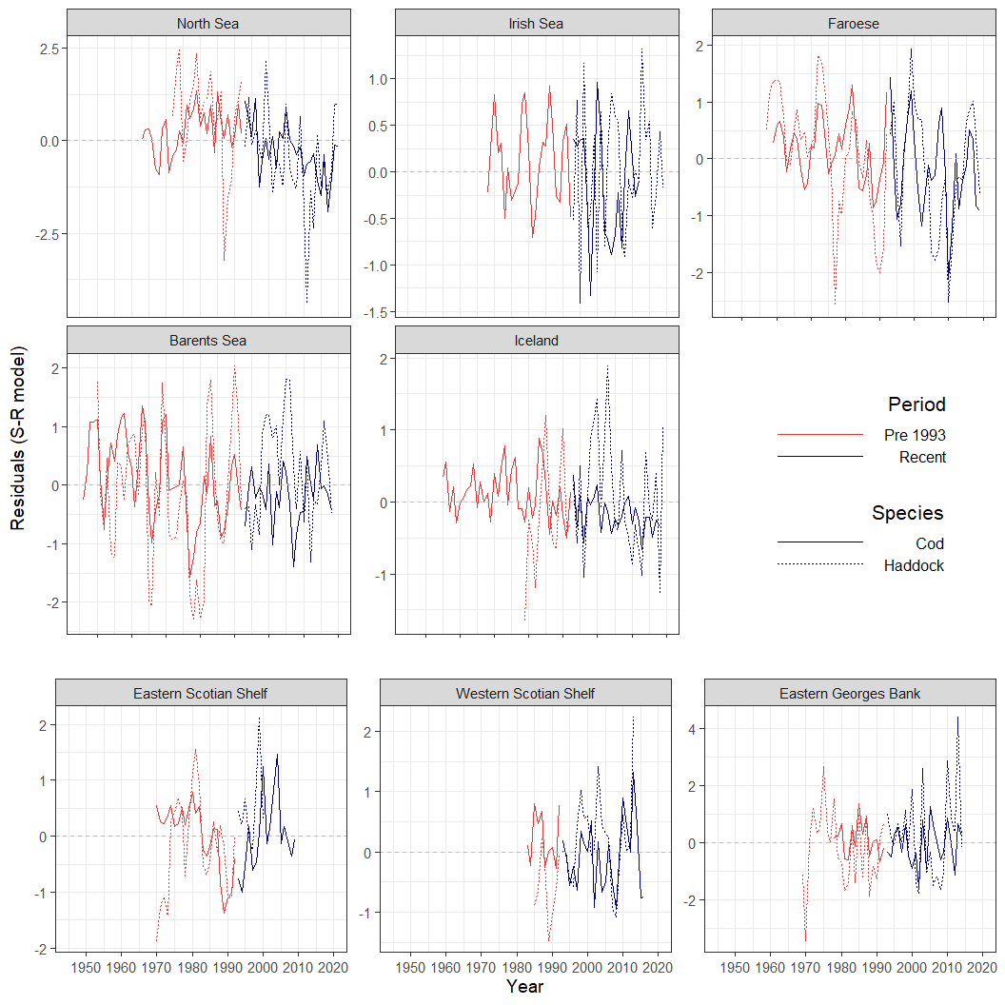

Figure 1.2: Residuals from the Ricker Stock recruitment model.

**Here is the GAM residual plot, kind of Figure 2, but for the smoothed time series**

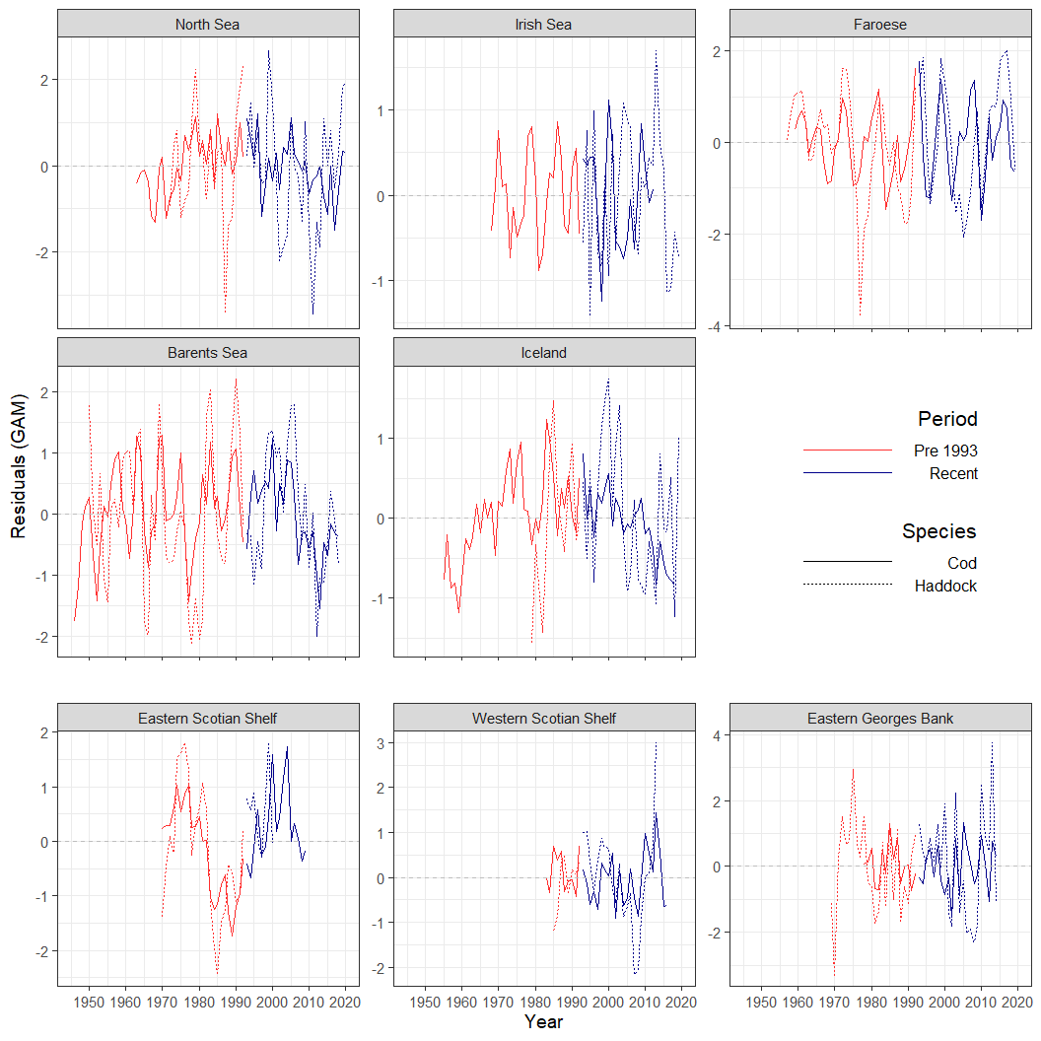

Figure 1.3: Recruit residuals from the GAM model.

**Next up is Figure 3, which will be the SD of the residuals from both the GAM and the S-R models, I will split this into 2 figures, the first being the S-R model SDs. The only way I can see getting a 95% CI around these would be to bootstrap them, but I don’t see any real utility in doing that as it doesn’t change our story at all. I can do it, but not sure what it adds other than making the figure look more ‘cool’.**

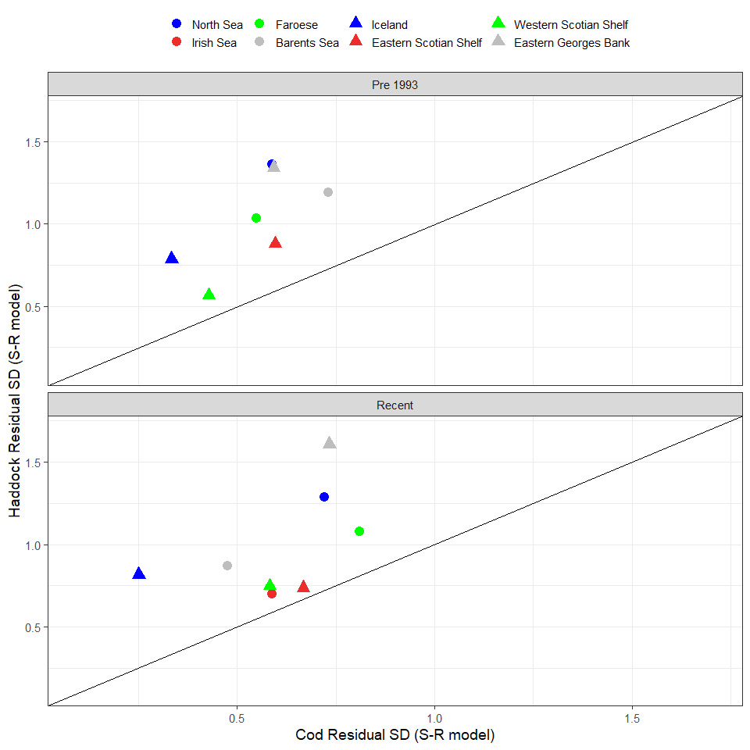

Figure 1.4: Standard deviation of the log residuals from the Ricker S-R Model

**Same figure as above, but only using data in which we have overlapping years of data between the stocks in a given Location**

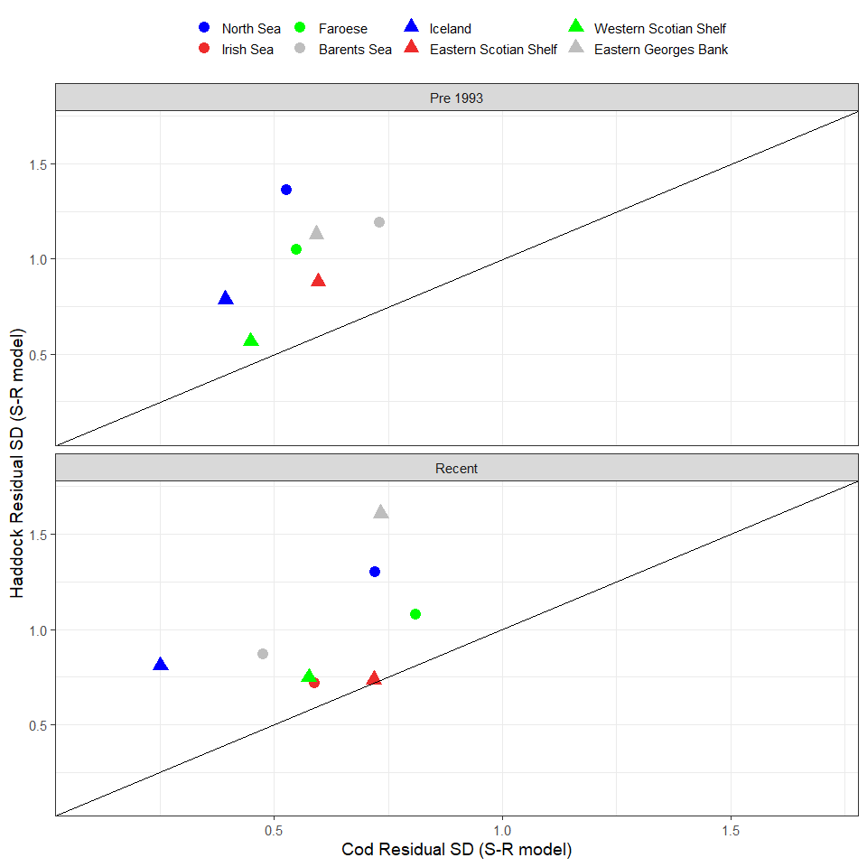

Figure 1.5: Standard deviation of the log residuals from the Ricker S-R Model but using residuals only from years in which data is found in both time series.

**Here are the SDs of the residuals from the GAMs. The only way I can see getting a 95% CI around these would be to bootstrap them, but I don’t see any real utility in doing that as it doesn’t change our story at all. I can do it, but not sure what it adds other than making the figure look more ‘cool’.**

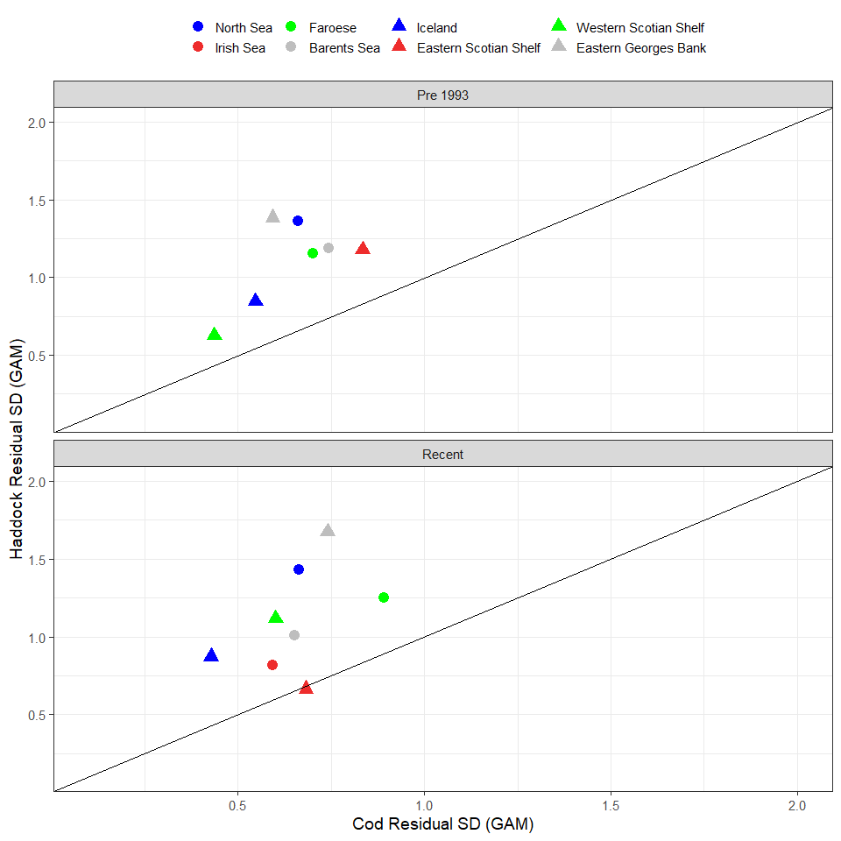

Figure 1.6: Standard deviation of the log residuals from the GAMs

**Same figure as above, but only using data in which we have overlapping years of data between the stocks in a given Location**

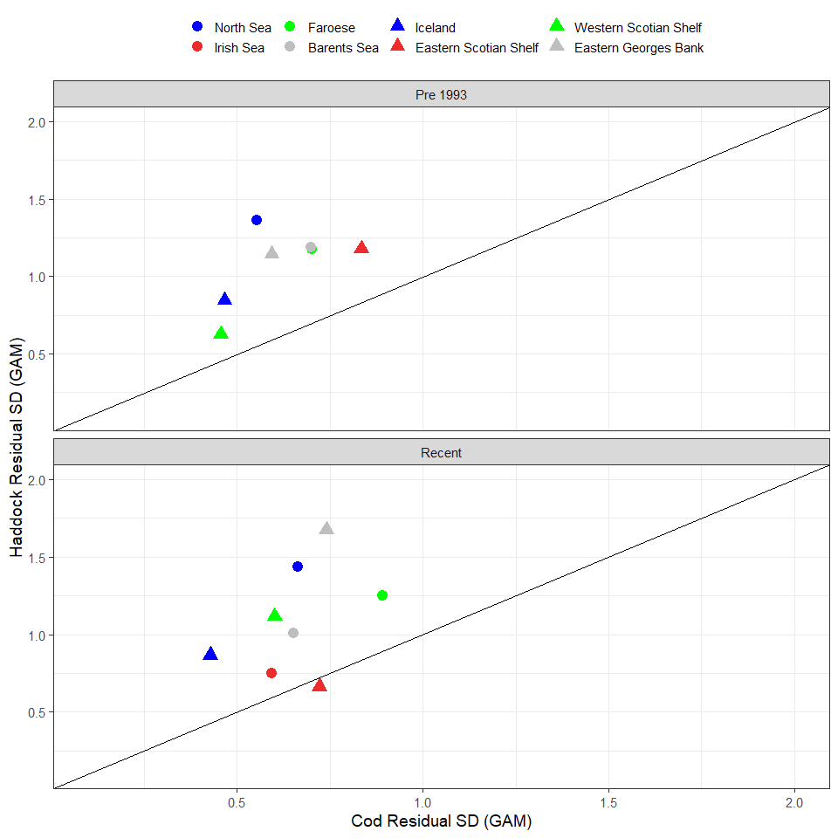

Figure 1.7: Standard deviation of the log residuals from the GAMs but using residuals only from years in which data is found in both time series.

**Now Figure Table 2 replacement with ACF’s split out into pre and recent, this is for the GAM residuals**

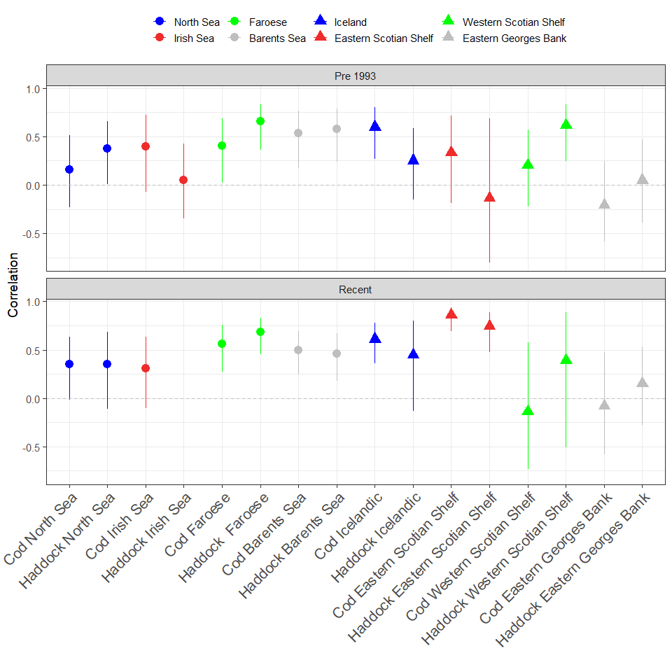

Figure 1.8: Autocorrelation of recruitment residuals from GAMs in each Period.

**Now Figure Table 2 replacement with ACF’s split out into pre and recent,this is for the S-R residuals**

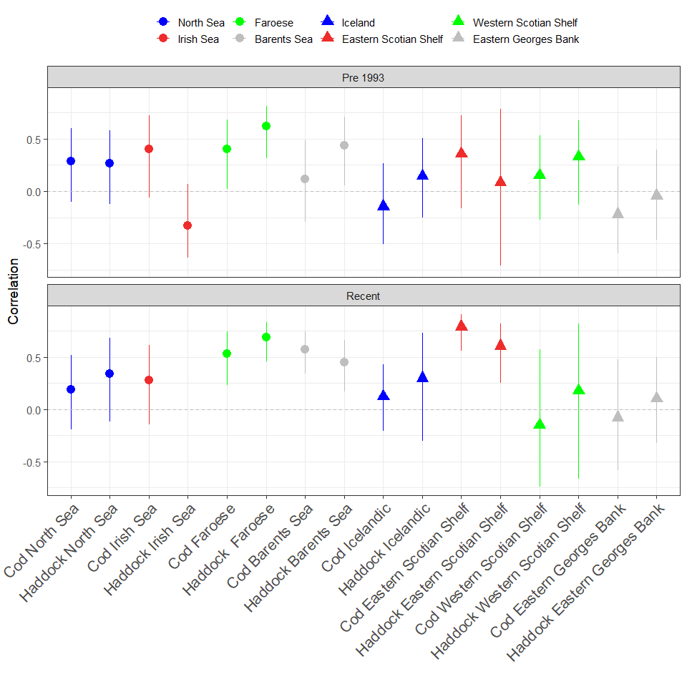

Figure 1.9: Autocorrelation of recruitment residuals from Ricker Stock Recruitment models in each Period.

**Cross Correlations with time series split between the Periods**

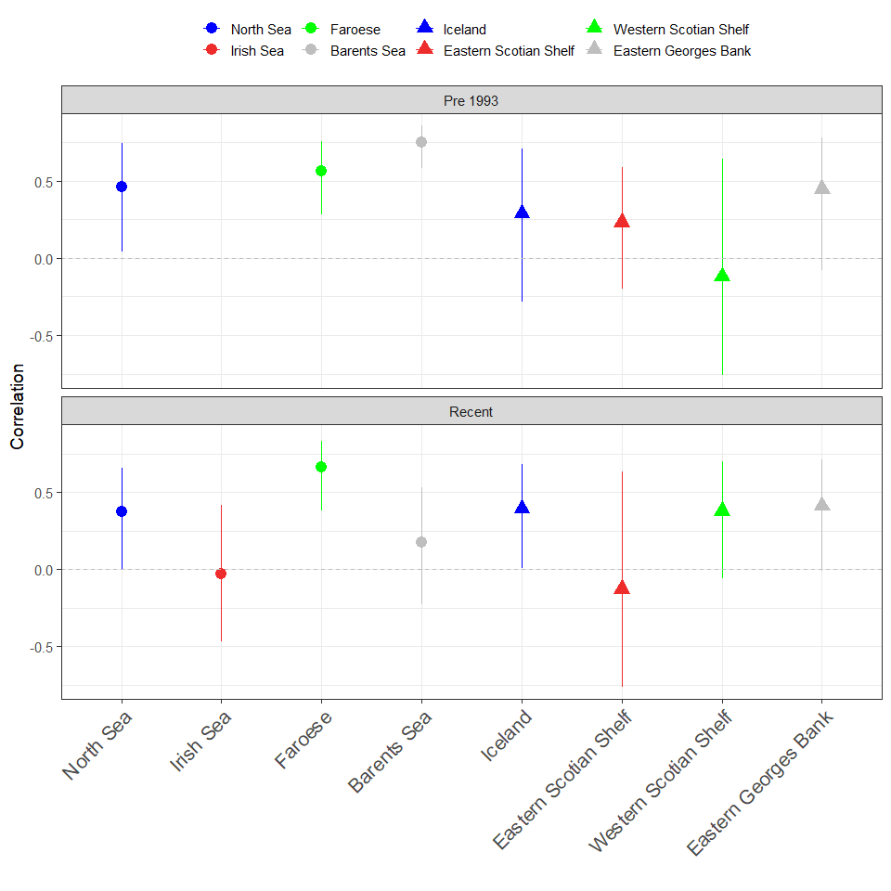

Figure 1.10: Cross correlation of the recruiment (log scale) time series

**Figure 5 is the Alpha from the Stock Recruitment models, now will be 2 panels.**

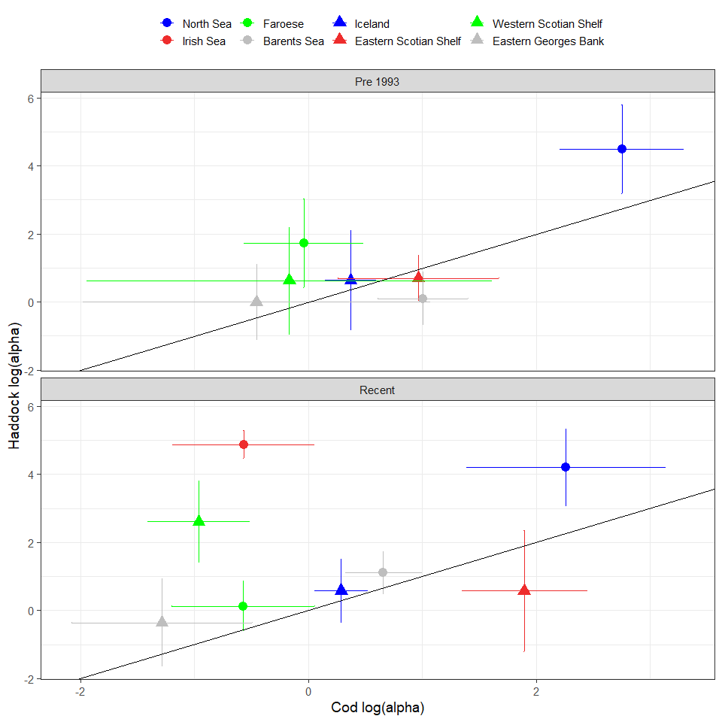

Figure 1.11: Estimated log(alpha) from Ricker Stock Recruitment models for each stock in the Pre 1993 and Recent period.

**“Alpha” using the mean of the log(Rec/SSB) for SSB of <= 0.2 of maximum SSB**

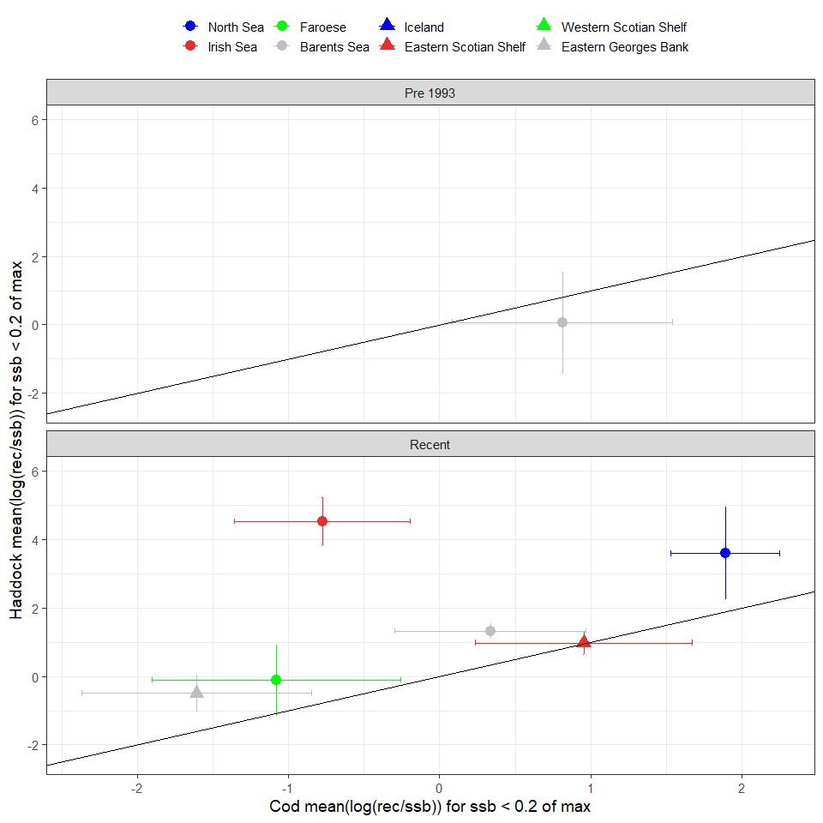

Figure 1.12: The mean log(Rec/SSB) when SSB is <= 0.2 of maximum ssb

**“Alpha” using the mean of the log(Rec/SSB) for SSB of <= 0.4 of maximum SSB**

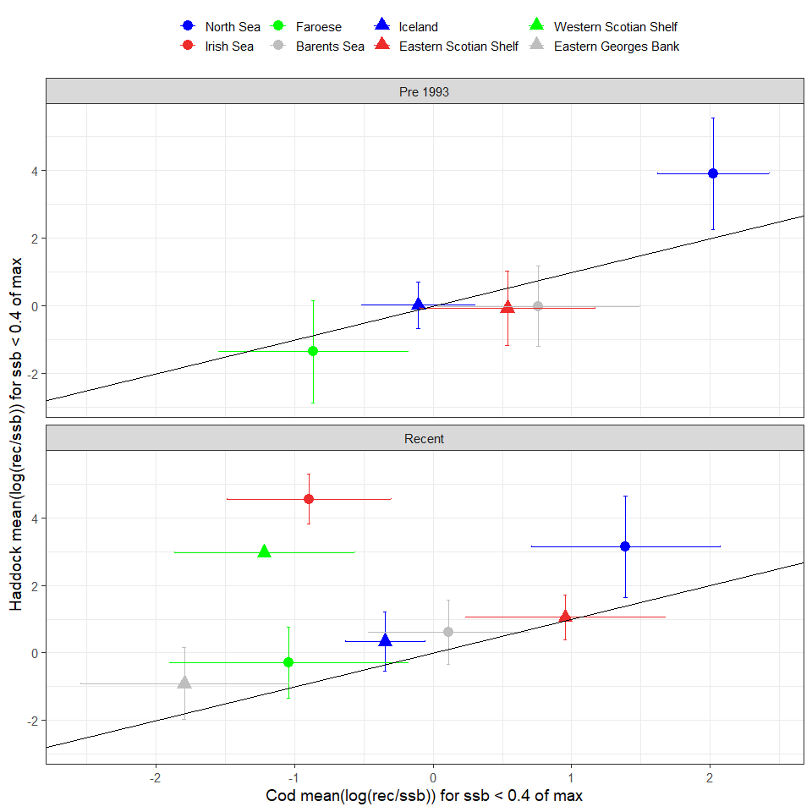

Figure 1.13: The mean log(Rec/SSB) when SSB is <= 0.2 of maximum ssb

**This figure is the frequency of the SSB data by stock and era showing where data lands in terms of SSB, I show figure with 20% and 40% cut offs., data is binned into 10 bins (so about every 0.1 is a bin)**

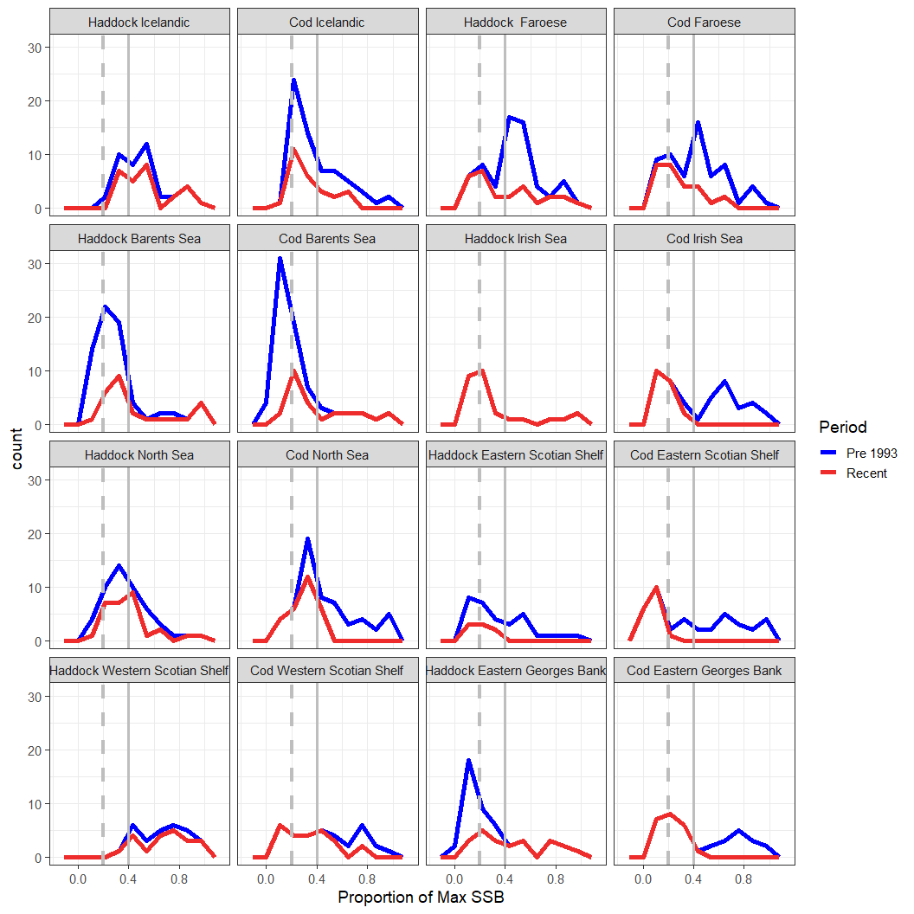

Figure 1.14: Here is a density plot of the SSB values by each period. Vertical grey dashed line is the SSB of 0.2 while the grey solid vertical line is 0.4.

# 2 Appendix

**The fits of the Ricker S-R model, first is the one with two periods**

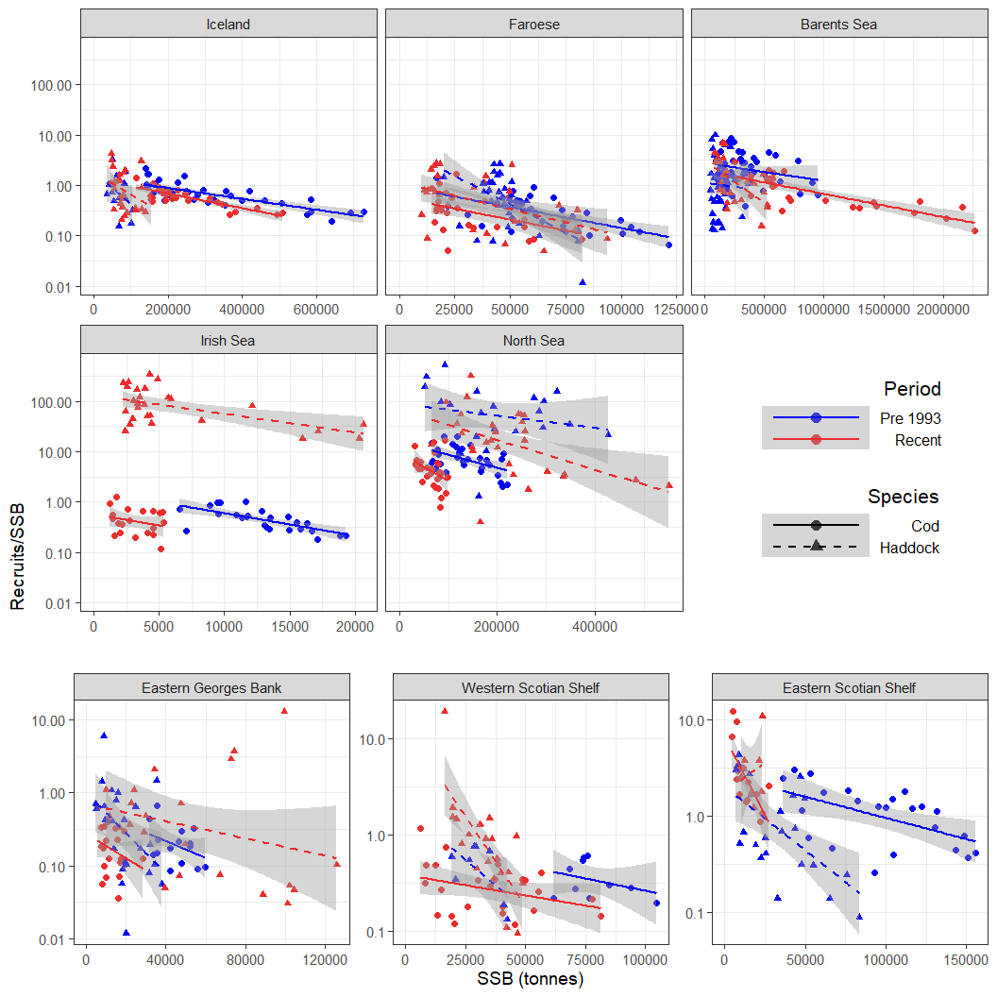

Figure 2.1: Recruits/SSB (log scale) vs SSB, Linear model fit on log(10) scale with Alpha calculated for pre 1993 and recent periods

**Now the S-R model with just the one period**

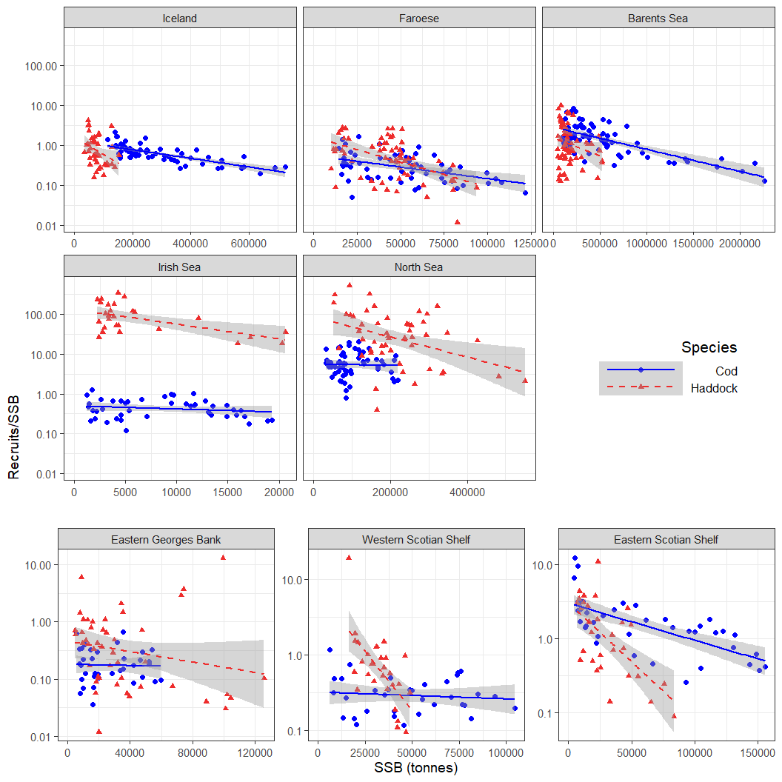

Figure 2.2: Recruits/SSB (log scale) vs SSB, Linear model fit on log(10) scale with no differentiation between Periods. Used for Residual analyses.

**Here are the GAM fits from the Recruit time series, GAMs were fit on the log scale**

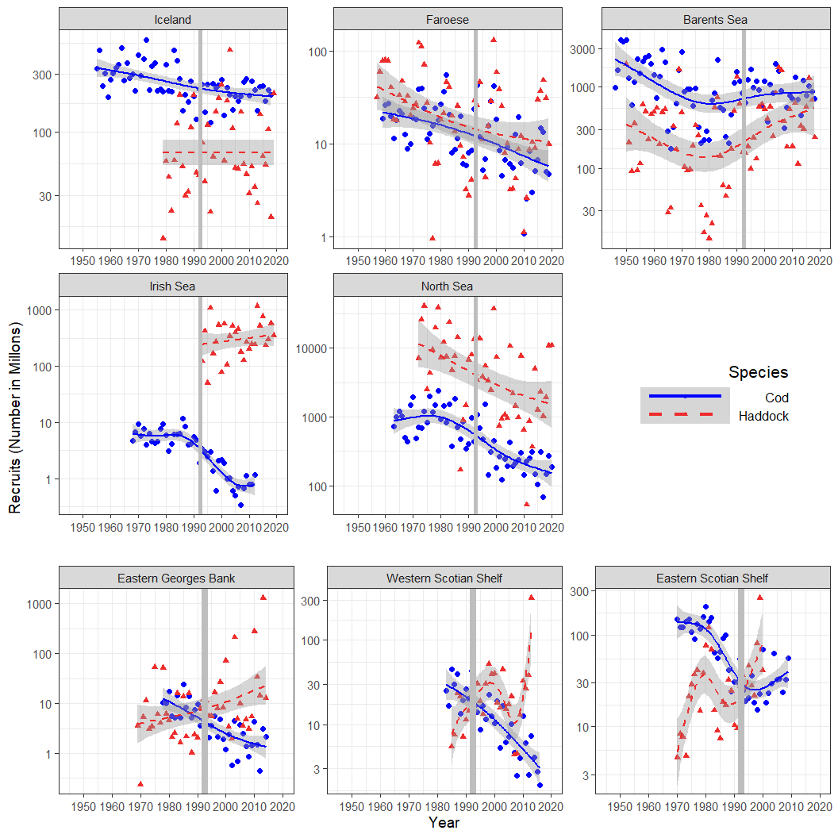

Figure 2.3: Recruitment (in millons) time series for 8 Atlantic Cod and Haddock stocks in the Atlantic Ocean. The vertical grey line indicates the division between the two periods. The lines are the GAM fits with 95% CI in the shaded Region

**We can make a cross-correlation figure by region to if we want**

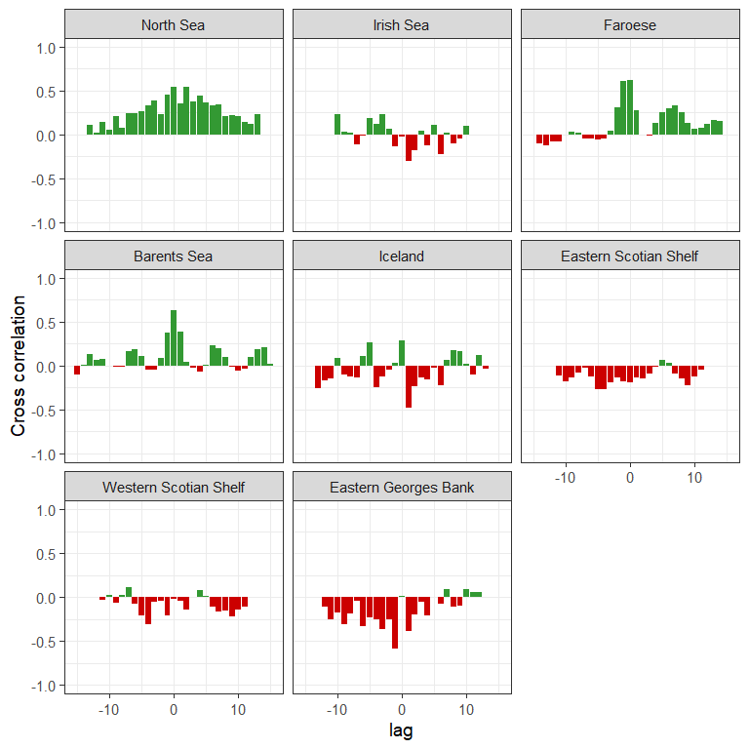

Figure 2.4: Cross correlation of recruitment time series for all Location.

**ACF figure for the full SR model residuals**

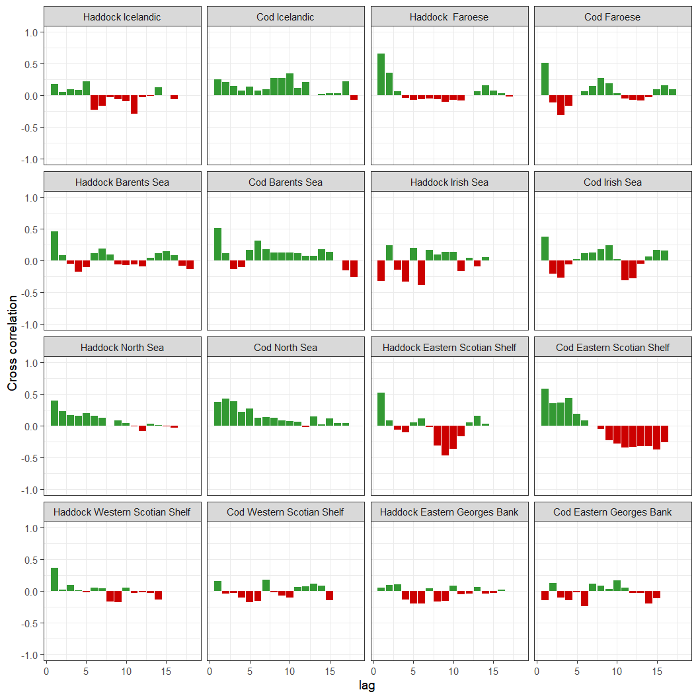

Figure 2.5: Autocorrelation of recruitment residuals from the full stock recruitment model for each stock.

** ACF figure for the GAM model residuals**

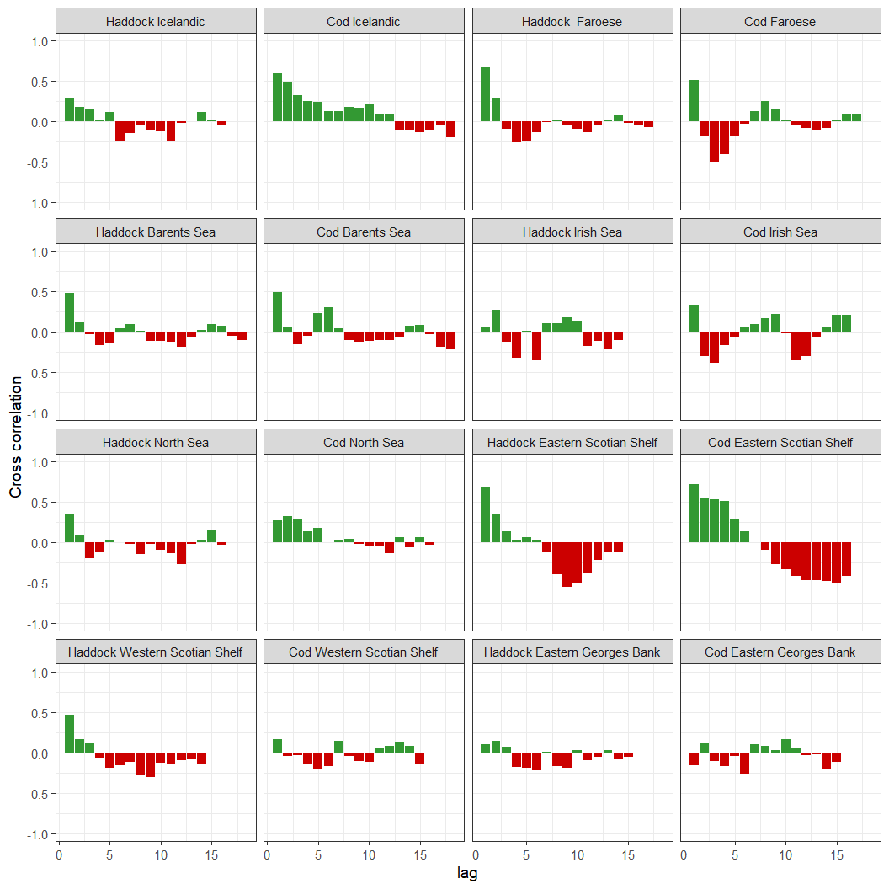

Figure 2.6: Autocorrelation of recruitment residuals from the GAMs for each stock.