Haddock S-R models

David Keith

11/14/2021

# Tables

Table 2: The Ricker and GAM residuals along with the Ricker model fit summmaries for each stock in each period.

| Location | Species | Period | Region | SD(GAM residuals) | SD(S-R residuals) | R squared | log(alpha) | SD(log(alpha)) |
| --- | --- | --- | --- | --- | --- | --- | --- | --- |
| Eastern Georges Bank | Cod | Pre 1993 | Northwest Atlantic | 0.59 | 0.59 | 0.160 | -0.46 | 0.78 |
| Eastern Georges Bank | Cod | Recent | Northwest Atlantic | 0.74 | 0.73 | 0.088 | -1.29 | 0.41 |
| Eastern Georges Bank | Haddock | Pre 1993 | Northwest Atlantic | 1.40 | 1.30 | 0.203 | -0.00 | 0.57 |
| Eastern Georges Bank | Haddock | Recent | Northwest Atlantic | 1.70 | 1.60 | 0.083 | -0.36 | 0.66 |
| Western Scotian Shelf | Cod | Pre 1993 | Northwest Atlantic | 0.44 | 0.43 | 0.117 | -0.17 | 0.91 |
| Western Scotian Shelf | Cod | Recent | Northwest Atlantic | 0.60 | 0.58 | 0.122 | -0.96 | 0.23 |
| Western Scotian Shelf | Haddock | Pre 1993 | Northwest Atlantic | 0.63 | 0.57 | 0.383 | 0.63 | 0.80 |
| Western Scotian Shelf | Haddock | Recent | Northwest Atlantic | 1.10 | 0.75 | 0.556 | 2.61 | 0.61 |
| Eastern Scotian Shelf | Cod | Pre 1993 | Northwest Atlantic | 0.83 | 0.60 | 0.287 | 0.96 | 0.36 |
| Eastern Scotian Shelf | Cod | Recent | Northwest Atlantic | 0.68 | 0.67 | 0.488 | 1.89 | 0.28 |
| Eastern Scotian Shelf | Haddock | Pre 1993 | Northwest Atlantic | 1.20 | 0.88 | 0.373 | 0.70 | 0.35 |
| Eastern Scotian Shelf | Haddock | Recent | Northwest Atlantic | 0.67 | 0.74 | 0.048 | 0.57 | 0.91 |
| Iceland | Cod | Pre 1993 | Northeast Atlantic | 0.55 | 0.33 | 0.620 | 0.57 | 0.11 |
| Iceland | Cod | Recent | Northeast Atlantic | 0.43 | 0.25 | 0.714 | 0.49 | 0.12 |
| Iceland | Haddock | Pre 1993 | Northeast Atlantic | 0.85 | 0.79 | 0.149 | 0.64 | 0.75 |
| Iceland | Haddock | Recent | Northeast Atlantic | 0.87 | 0.82 | 0.127 | 0.59 | 0.47 |
| Faroese | Cod | Pre 1993 | Northeast Atlantic | 0.70 | 0.55 | 0.429 | -0.04 | 0.27 |
| Faroese | Cod | Recent | Northeast Atlantic | 0.89 | 0.81 | 0.194 | -0.57 | 0.32 |
| Faroese | Haddock | Pre 1993 | Northeast Atlantic | 1.20 | 1.00 | 0.309 | 1.73 | 0.67 |
| Faroese | Haddock | Recent | Northeast Atlantic | 1.30 | 1.10 | 0.257 | 0.13 | 0.37 |
| Irish Sea | Cod | Pre 1993 | Northeast Atlantic | 0.51 | 0.46 | 0.483 | 0.51 | 0.30 |
| Irish Sea | Cod | Recent | Northeast Atlantic | 0.59 | 0.59 | 0.065 | -0.57 | 0.32 |
| Irish Sea | Haddock | Recent | Northeast Atlantic | 0.81 | 0.72 | 0.246 | 4.57 | 0.22 |
| North Sea | Cod | Pre 1993 | Northeast Atlantic | 0.66 | 0.59 | 0.256 | 2.75 | 0.28 |
| North Sea | Cod | Recent | Northeast Atlantic | 0.66 | 0.72 | 0.135 | 2.26 | 0.45 |
| North Sea | Haddock | Pre 1993 | Northeast Atlantic | 1.10 | 1.00 | 0.126 | 3.41 | 0.50 |
| North Sea | Haddock | Recent | Northeast Atlantic | 1.30 | 1.00 | 0.336 | 3.16 | 0.47 |
| Barents Sea | Cod | Pre 1993 | Northeast Atlantic | 0.74 | 0.73 | 0.052 | 1.00 | 0.20 |
| Barents Sea | Cod | Recent | Northeast Atlantic | 0.65 | 0.47 | 0.671 | 0.66 | 0.17 |
| Barents Sea | Haddock | Pre 1993 | Northeast Atlantic | 1.20 | 1.20 | 0.002 | 0.10 | 0.40 |
| Barents Sea | Haddock | Recent | Northeast Atlantic | 1.00 | 0.87 | 0.324 | 1.10 | 0.32 |

# Figures

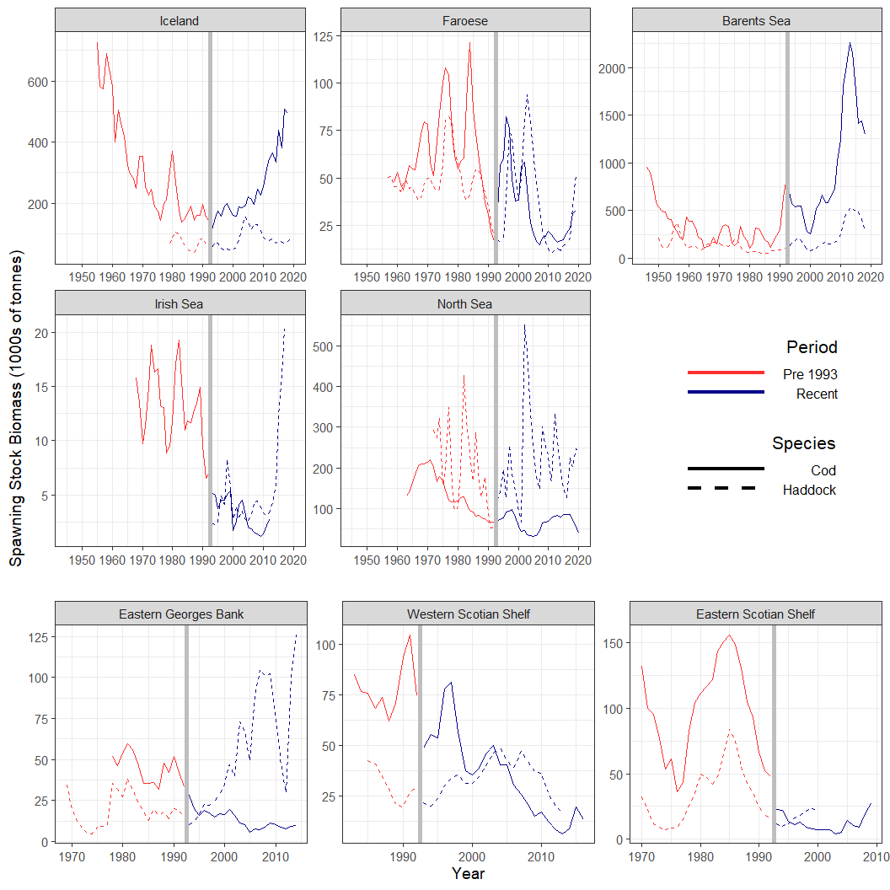

Figure 1: SSB (thousands of tonnes) time series for 8 cod (solid line) and haddock (dashed line) stocks in the Atlantic Ocean. The red line indicates data from the Pre-1993 Period, while the blue line is for the Recent Period. The vertical grey line indicates the division between the two periods.

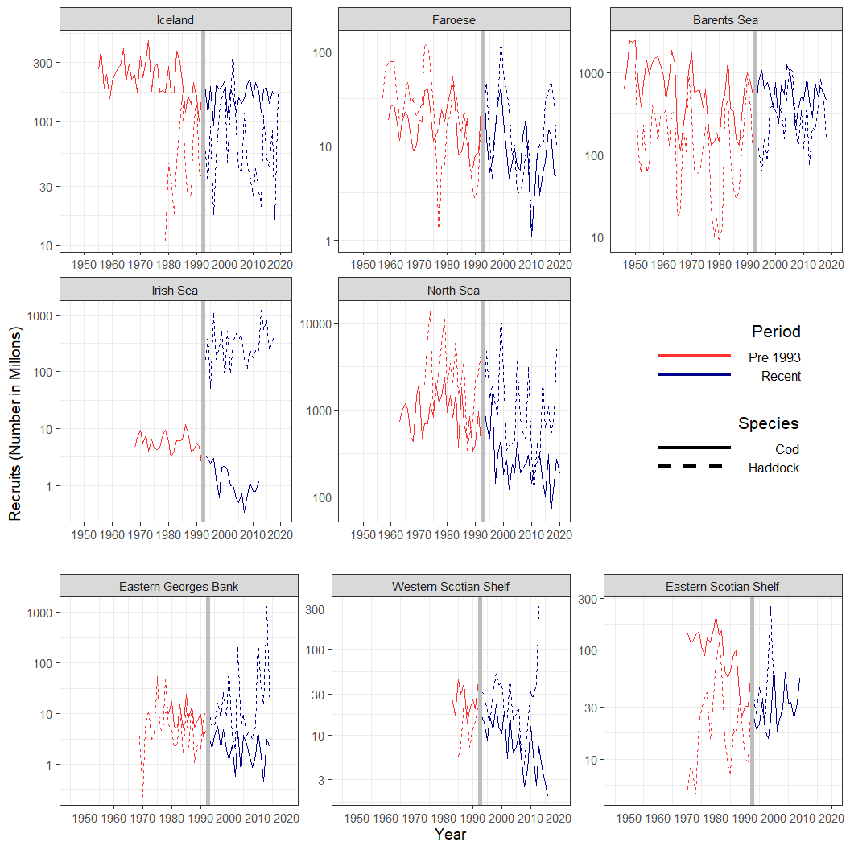

Figure 2: Recruitment (in millions) time series for 8 cod (solid line) and haddock (dashed line) stocks in the Atlantic Ocean. The red line indicates data from the Pre-1993 Period, while the blue line is for the Recent Period. The vertical grey line indicates the division between the two periods.

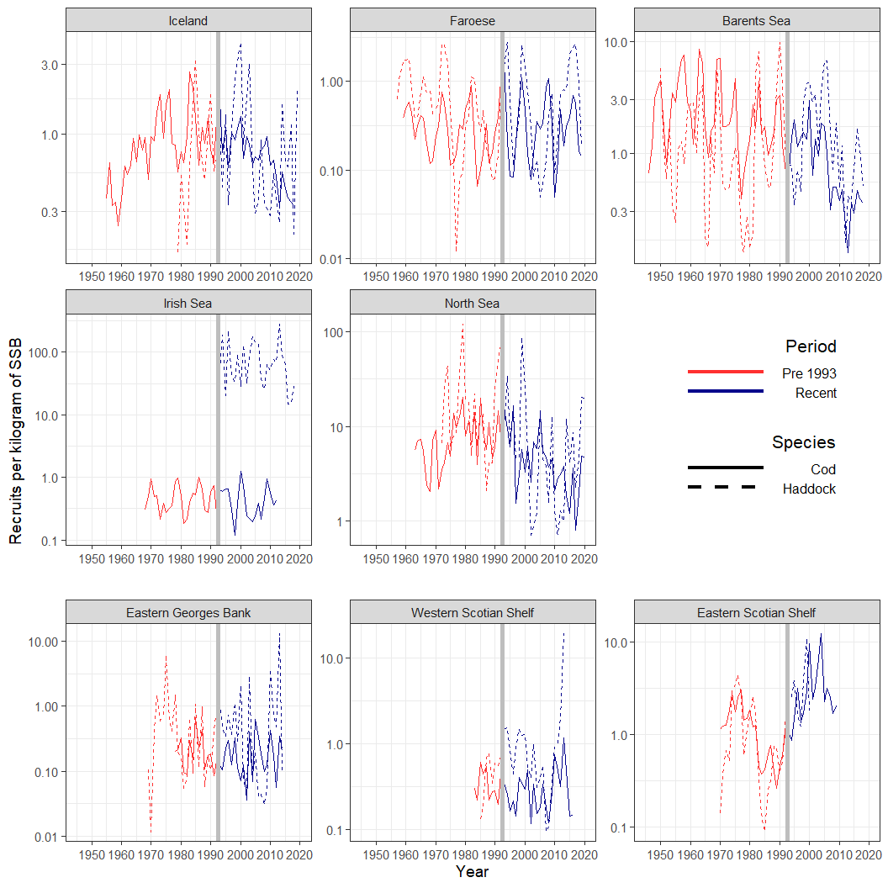

Figure 3: Time series of the number of recruits produced per kilogram of SSB for 8 cod (solid line) and haddock (dashed line) stocks in the Atlantic Ocean. The red line indicates data from the Pre-1993 Period, while the blue line is for the Recent Period. The vertical grey line indicates the division between the two periods.

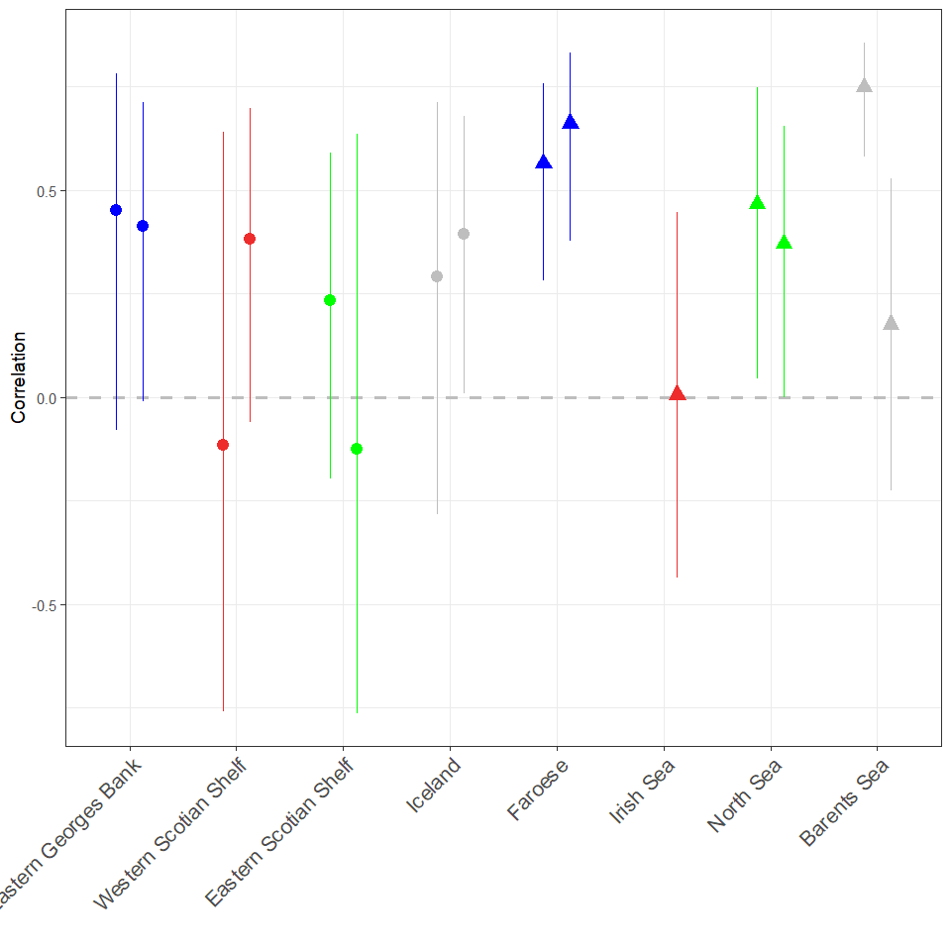

Figure 4: Correlation of the recruitment (log scale) time series between cod and haddock stocks in each region. For each stock the Pre 1993 period is shown on the left and the Recent period is on the right. The error bars represent the 95//% Confidence Intervals.

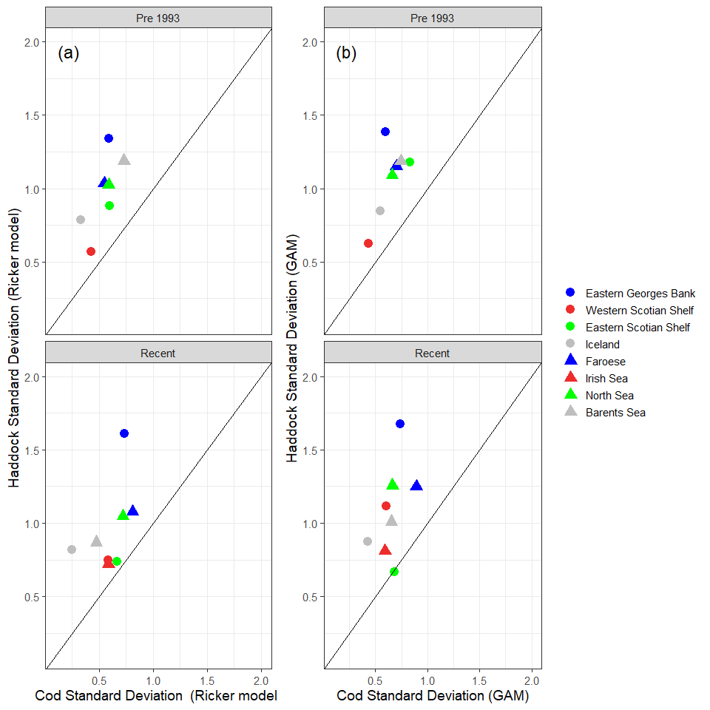

Figure 5: Standard deviation of the log residuals from a) the Ricker S-R Model, and b) the Generalized Additive Models (GAMs).

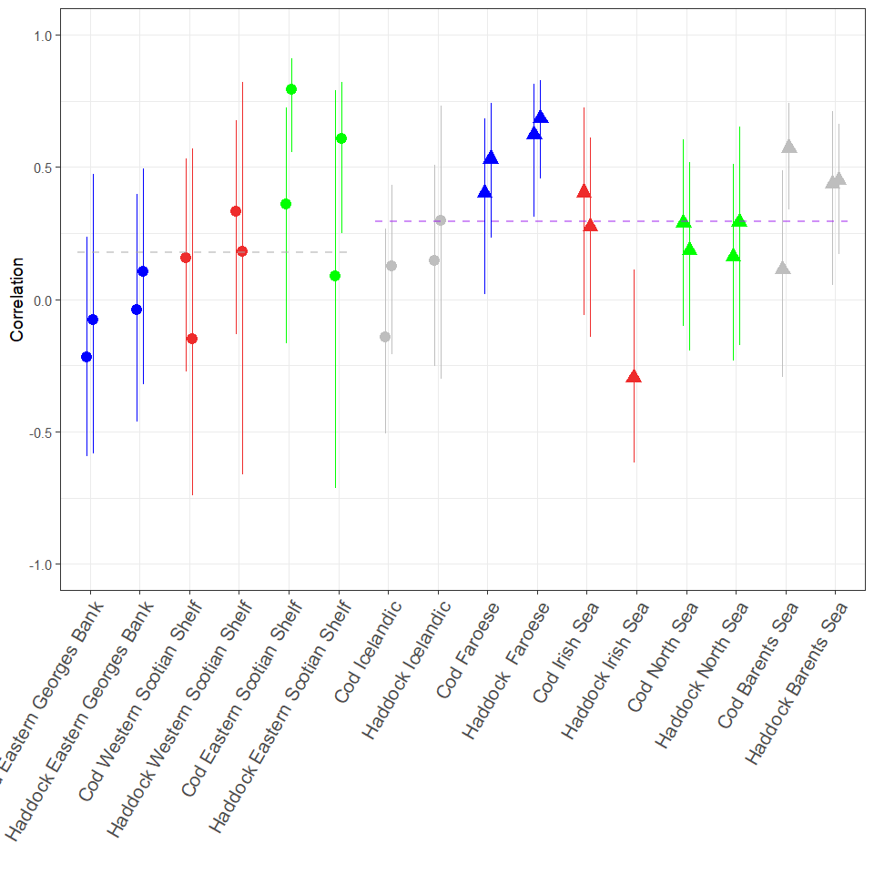

Figure 6: Autocorrelation of recruitment residuals from Ricker stock recruitment model. For each stock the Pre 1993 period is shown on the left and the Recent period is on the right. The dashed lines show the average correlation for the North West Atlantic (left) and North East Atlantic (right) stocks. The error bars represent the 95//% Confidence Intervals.

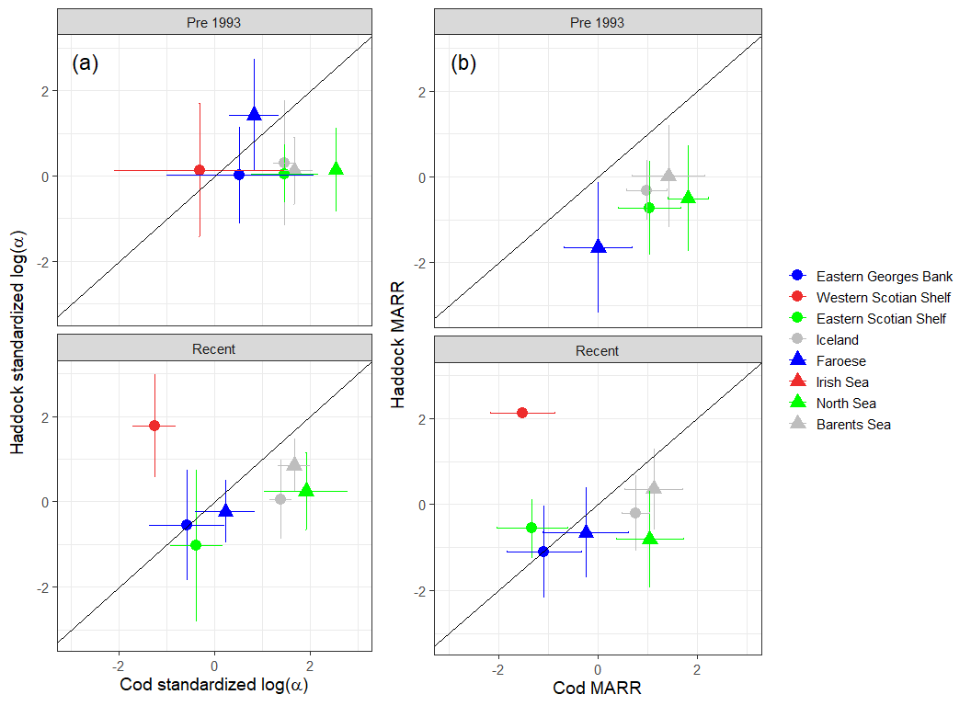

Figure 7: The log of the maximum annual reproductive rate estimated using a) the Ricker stock recruitment model for each stock in the Pre-1993 and Recent period with 95% confidence intervals and b) the mean recruitment when SSB is = 0.4 of maximum SSB. The error bars in b) represent 1 standard deviation from the mean (there was insufficient data in the recent period for Western Scotian Shelf Haddock to calculate the standard deviation).

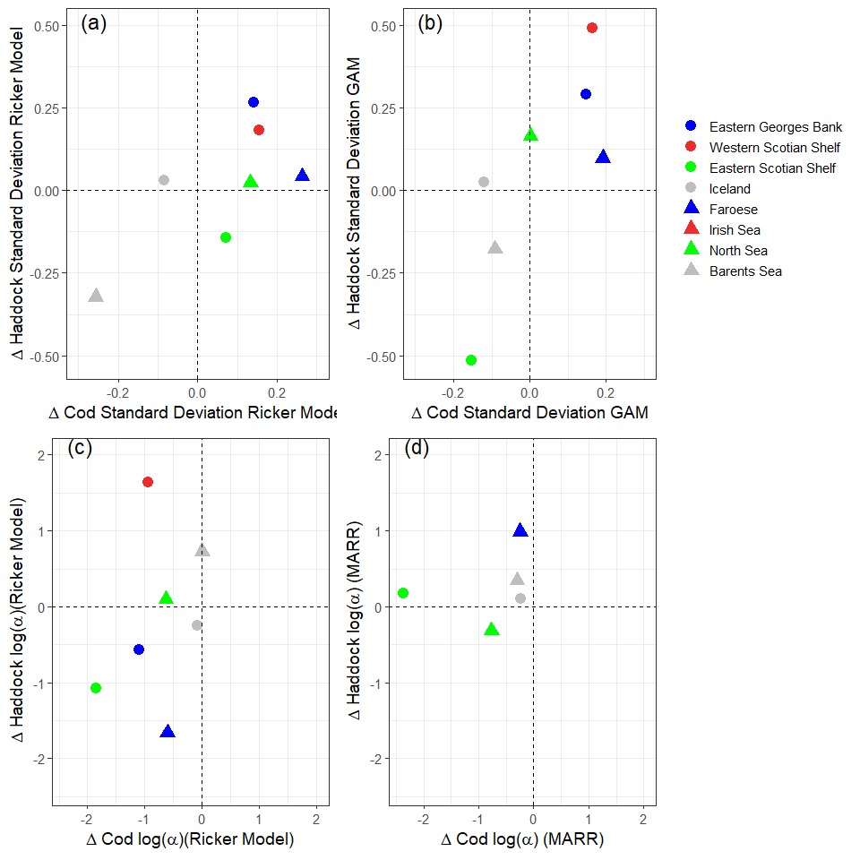

Figure 8: The change in the Standard Deviation of the Residuals between the Recent and Pre 1993 period for the a) Ricker S-R Model, and b) Generalized Additive Models (GAMs). The change in the alpha estimates between the Recent and Pre 1993 period for the c) Ricker S-R Model, and d) alpha at 40% of maximum SSB. Positive values indicate the estimate in the Recent period was larger than Pre 1993 period.

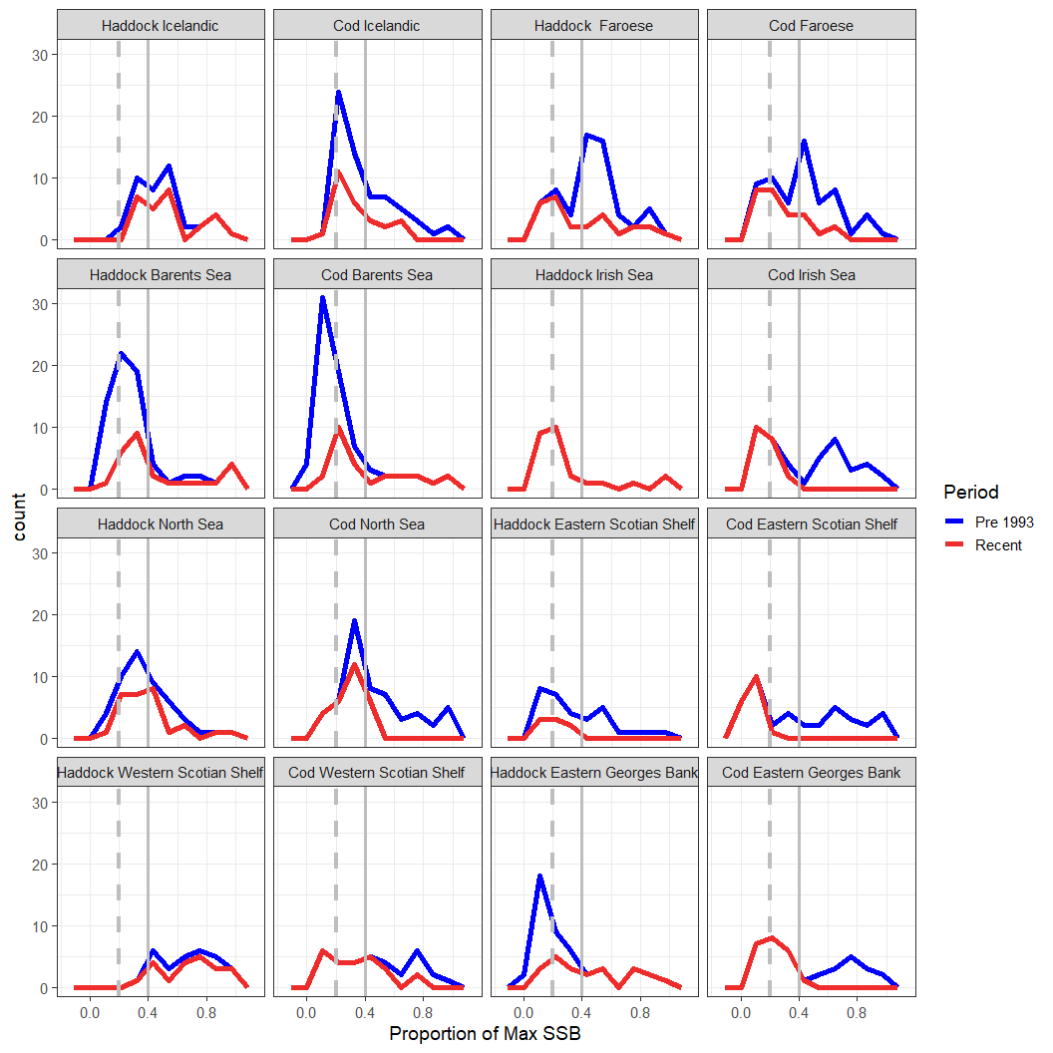

Figure 9: Density plots of the SSB values by each period as percentage of the maximum for the whole time series. Vertical grey dashed line is 0.2 of maximum SSB while the grey solid vertical line is 0.4. Note that for the cod on the Eastern George Bank and the Western Scotian shelf, in the Pre 1993 period, all SSB values were above 40% of the maximum values.

# Appendix

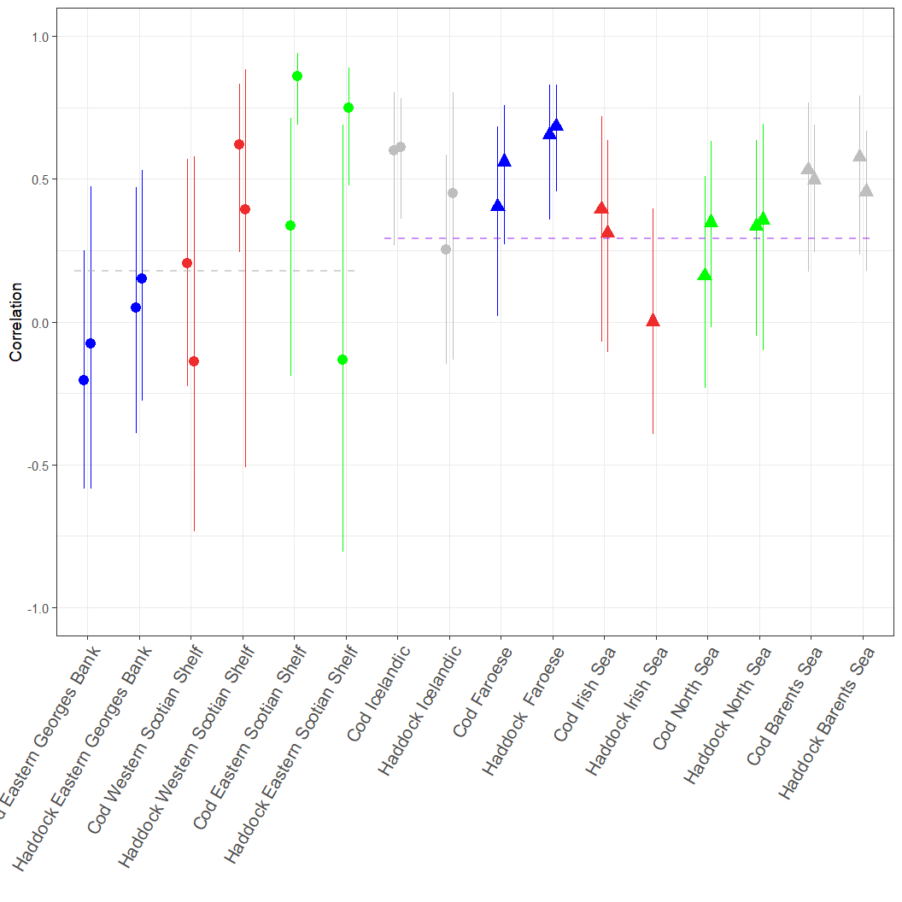

Figure 10: Autocorrelation of recruitment residuals from GAMs in each Period.

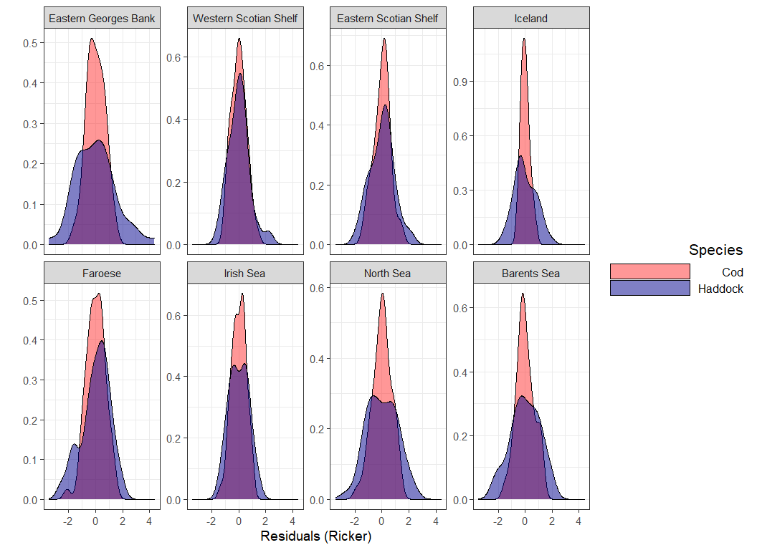

Figure 11: Residuals from the Ricker Stock recruitment model.

# Here’s an appendix analysis where we just use the same years of data for a couple of the analyses.

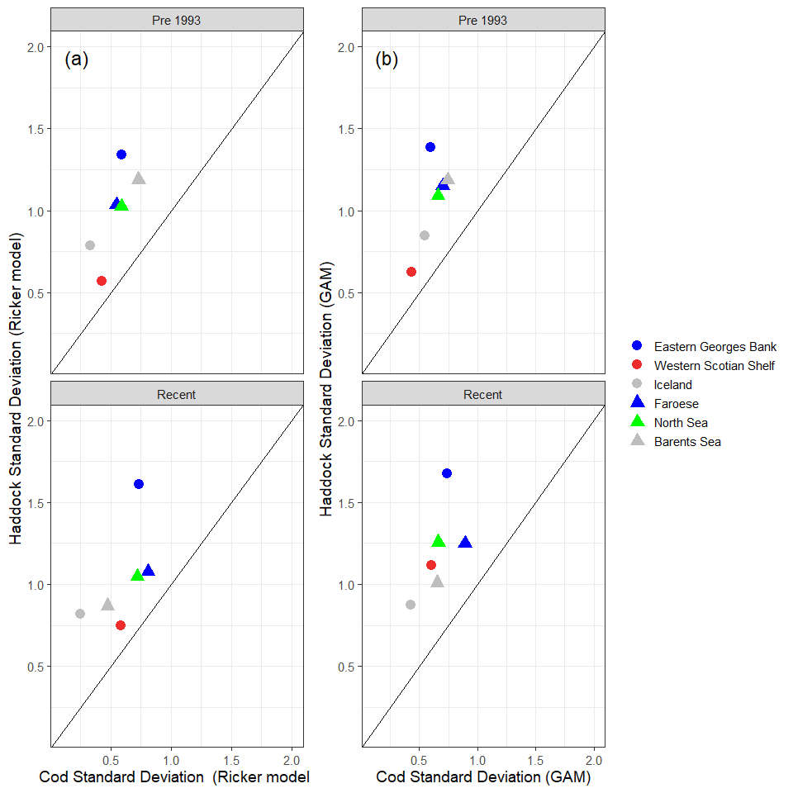

Figure 12: Standard deviation of the log residuals from a) the Ricker S-R Model, and b) the Generalized Additive Models (GAMs) using data from 1985-2013.

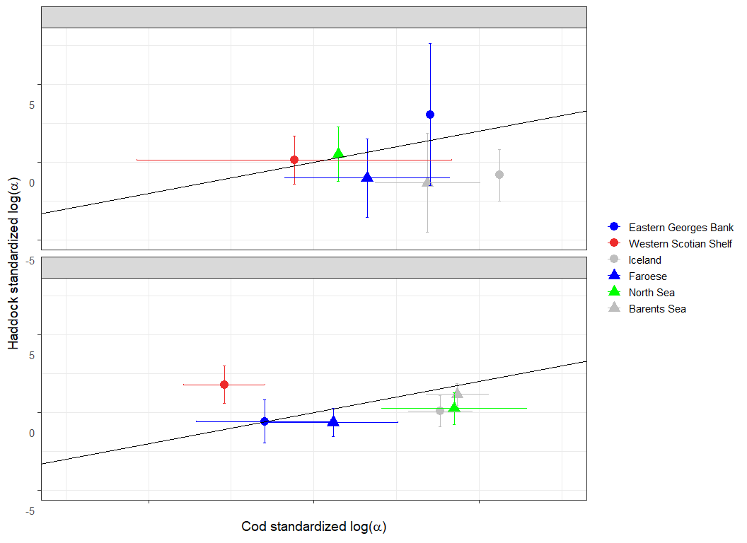

Figure 13: The log of the maximum annual reproductive rate estimated using a) the Ricker stock recruitment model for each stock in the Pre-1993 and Recent period with 95% confidence intervals and b) the mean recruitment when SSB is = 0.4 of maximum SSB using the subset of stocks with data from 1985-2013. The error bars in b) represent 1 standard deviation from the mean (there was insufficient data in the recent period for Western Scotian Shelf Haddock to calculate the standard deviation).

Table A1: The cross-correlation of the recruitment indices (log scale) between stocks found in the Northwest and Northeast Atlantic using years in which data is available for each of the stocks (1985-20213). Due to data limitations Eastern Scotian Shelf and Irish Sea stocks were excluded from this analysis.

| Regions | Haddock | Cod |
| --- | --- | --- |
| Eastern Georges Bank and Western Scotian Shelf | 0.70 | 0.85 |
| Iceland and Faroese | 0.30 | 0.19 |
| Iceland and North Sea | 0.10 | -0.28 |
| Iceland and Barents Sea | 0.20 | 0.12 |
| Faroese and North Sea | 0.40 | 0.25 |
| Faroses and Barents Sea | -0.20 | -0.20 |
| North Sea and Barents Sea | 0.02 | -0.18 |

**The fits of the Ricker S-R model, first is the one with two periods**

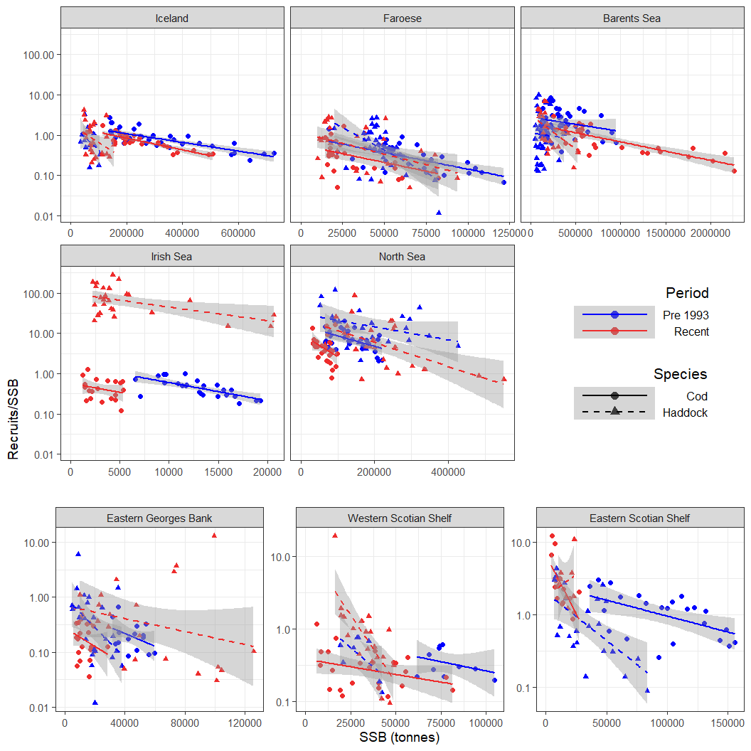

Figure 14: Recruits/SSB (log scale) vs SSB, Linear model fit on log(10) scale with Alpha calculated for pre 1993 and recent periods

**Now the S-R model with just the one period**

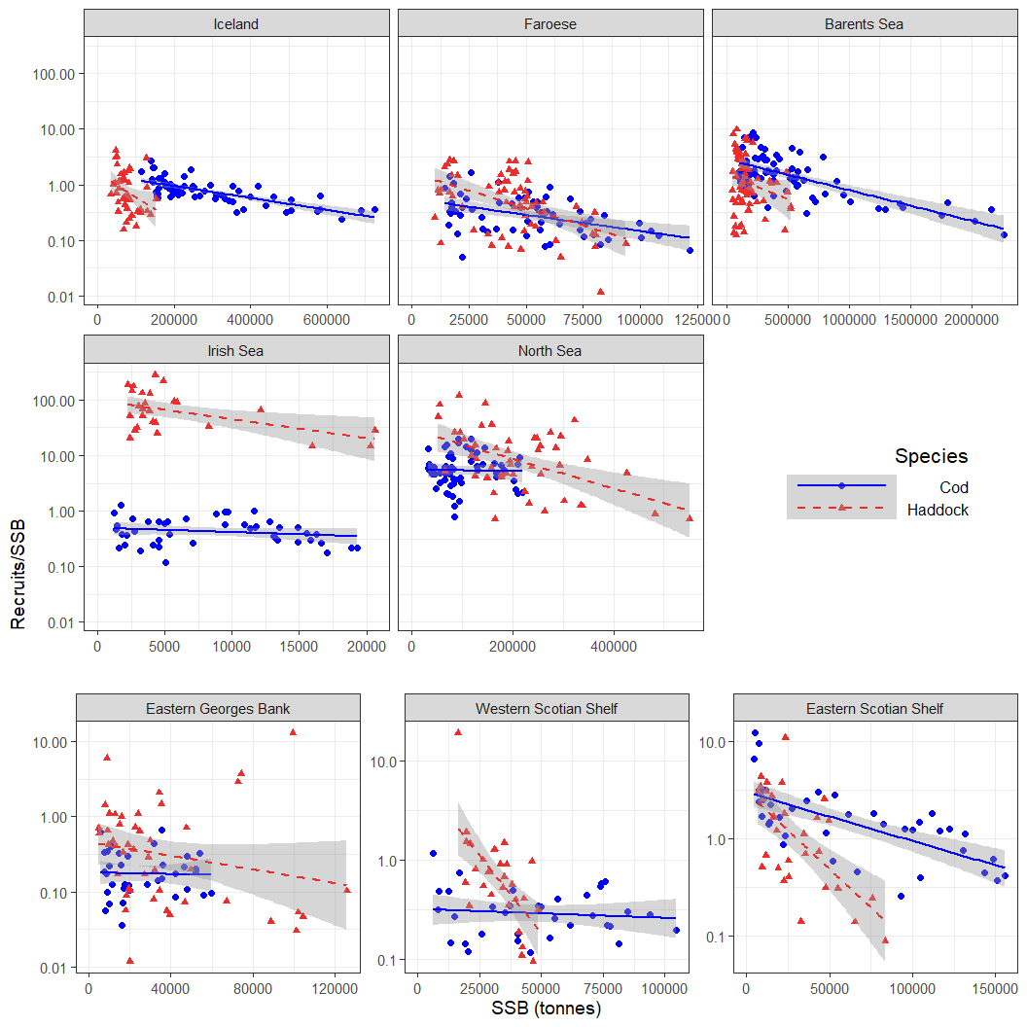

Figure 15: Recruits/SSB (log scale) vs SSB, Linear model fit on log(10) scale with no differentiation between Periods. Used for Residual analyses.

**Here are the GAM fits from the Recruit time series, GAMs were fit on the log scale**

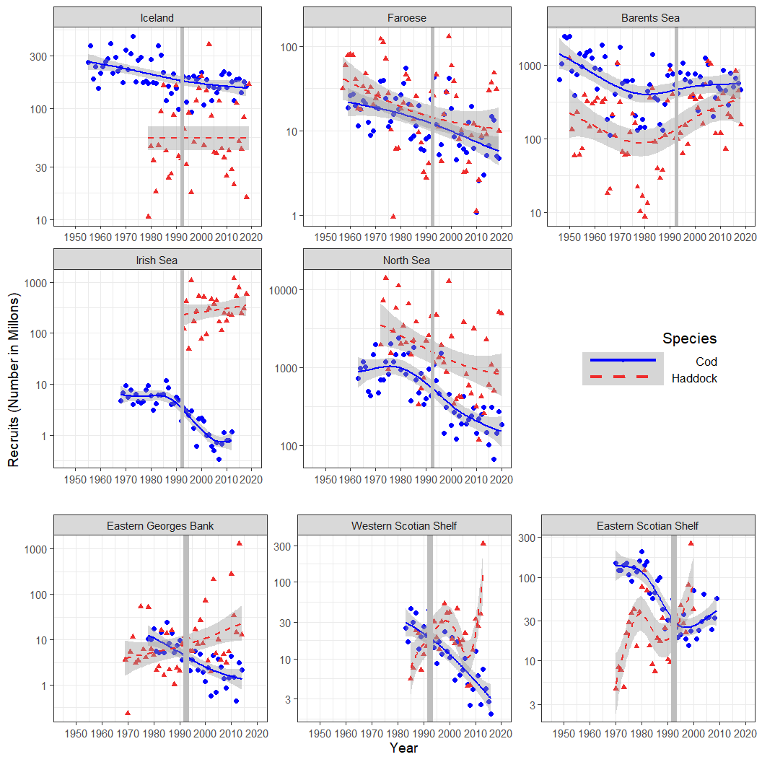

Figure 16: Recruitment (in millons) time series for 8 Atlantic Cod and Haddock stocks in the Atlantic Ocean. The vertical grey line indicates the division between the two periods. The lines are the GAM fits with 95//% CI in the shaded Region

**We can make a correlation figure by region to if we want**

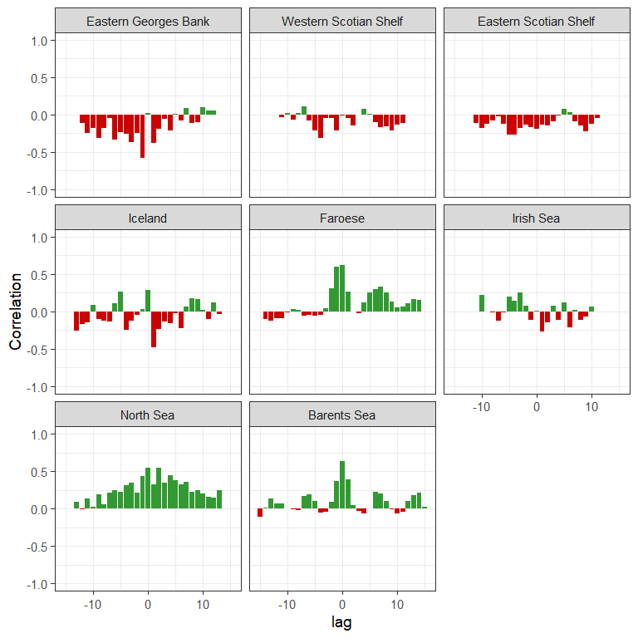

Figure 17: Correlation of recruitment time series for all Location.

**ACF figure for the full SR model residuals**

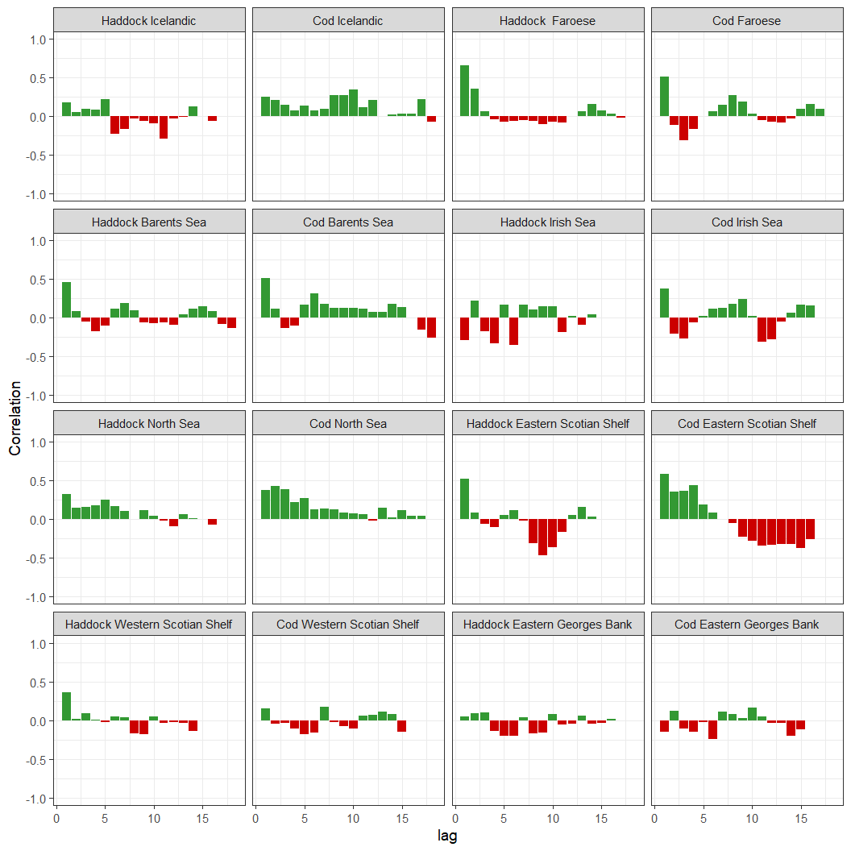

Figure 18: Autocorrelation of recruitment residuals from the full stock recruitment model for each stock.

** ACF figure for the GAM model residuals**

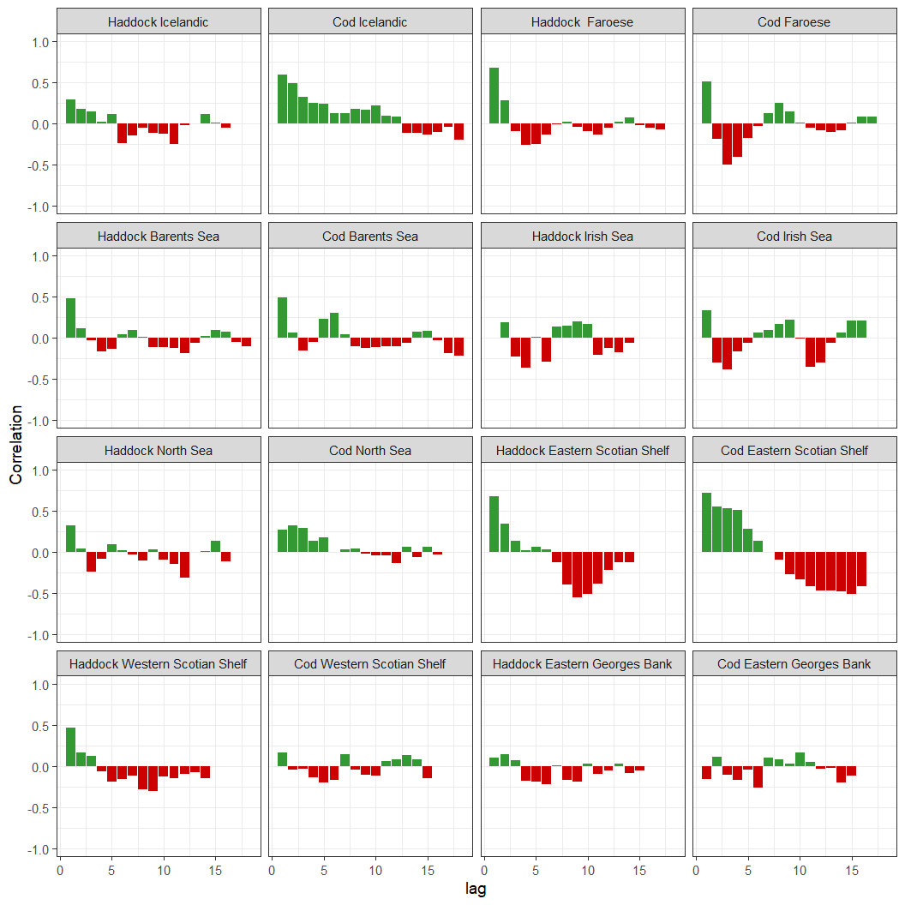

Figure 19: Autocorrelation of recruitment residuals from the GAMs for each stock.

**Here is Figure 2 from Fogarty, the Residual plot from the S-R models**

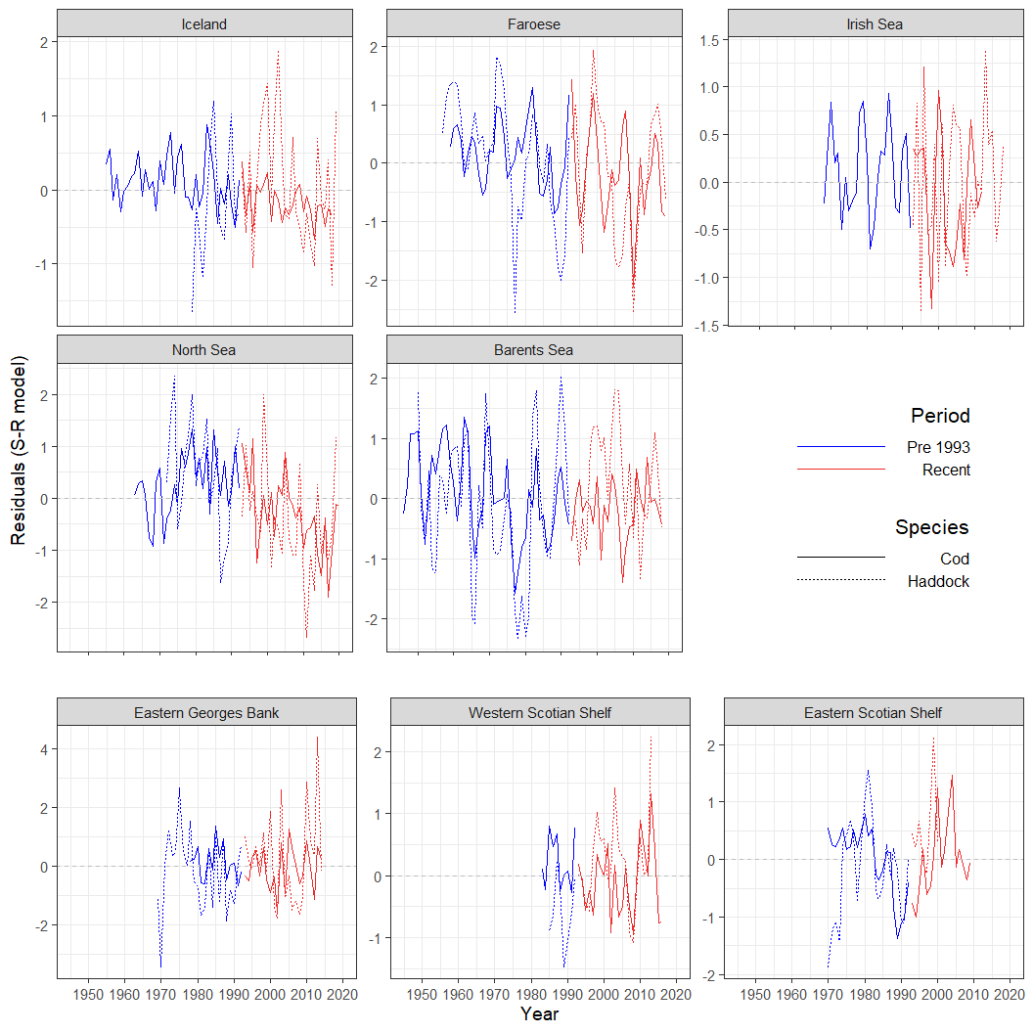

Figure 20: Residuals from the Ricker Stock recruitment model.

**Here is the GAM residual plot, kind of Figure 2, but for the smoothed time series**

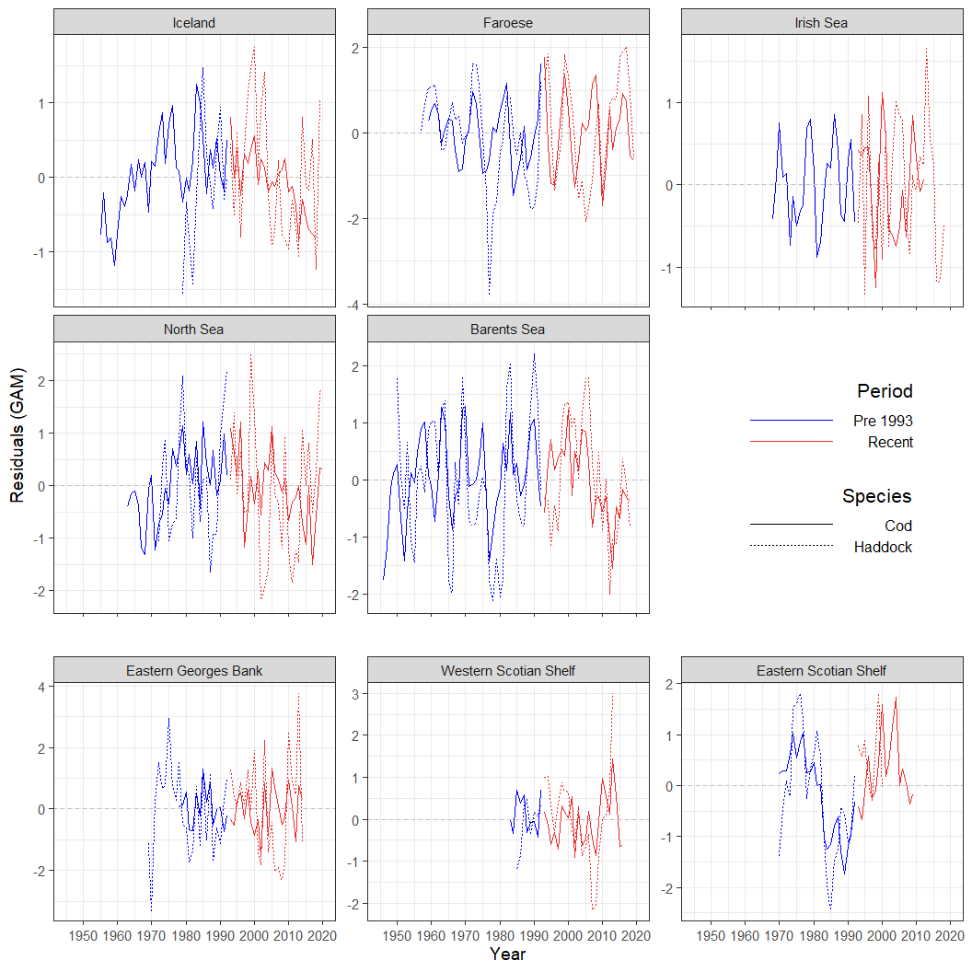

Figure 21: Recruit residuals from the GAM model.