Supplement A

Summary of the stocks included in this analysis. The minimum and maximum ages were obtained from original stock assessment output. AFSC is the Alaska Fisheries Science Center, TRAC is the Transboundary Resources Assessment Committee, DFO is Fisheries and Oceans Canada, NEFSC is the Northeast Fisheries Science Center, and ICES is the International Council for the Exploration of the Sea
Stock | Order | Family | Genus | Species | Minimum Age | Maximum Age | First Year | Final Year | Location | Management Body
Aleutian Islands | Gadiformes | Gadidae | Gadus | chalcogrammus | 1 | 15 | 1979 | 2015 | Pacific (Alaska) | AFSC
Aleutian Islands | Gadiformes | Gadidae | Gadus | macrocephalus | 0 | 20 | 1977 | 2015 | Pacific (Alaska) | AFSC
Bering Sea & AI | Pleuronectiformes | Pleuronectidae | Pleuronectes | quadrituberculatus | 3 | 25 | 1978 | 2016 | Pacific (Alaska) | AFSC
Bering Sea & AI | Pleuronectiformes | Pleuronectidae | Atheresthes | stomais | 1 | 21 | 1977 | 2016 | Pacific (Alaska) | AFSC
Bering Sea & AI | Gadiformes | Gadidae | Gadus | macrocephalus | 0 | 20 | 1977 | 2017 | Pacific (Alaska) | AFSC
Bering Sea & AI | Scorpaeniformes | Hexagrammidae | Pleurogrammus | monopterygius | 1 | 11 | 1978 | 2016 | Pacific (Alaska) | AFSC
Bering Sea & AI | Pleuronectiformes | Pleuronectidae | Lepidopsetta | polyxystra | 1 | 20 | 1981 | 2016 | Pacific (Alaska) | AFSC
Bering Sea & AI | Pleuronectiformes | Pleuronectidae | Limanda | aspera | 1 | 20 | 1976 | 2017 | Pacific (Alaska) | AFSC
Bering Sea & AI | Gadiformes | Gadidae | Gadus | chalcogrammus | 1 | 10 | 1965 | 2017 | Pacific (Alaska) | AFSC
Gulf of Alaska | Gadiformes | Gadidae | Gadus | chalcogrammus | 1 | 10 | 1976 | 2016 | Pacific (Alaska) | AFSC
Gulf of Alaska | Gadiformes | Gadidae | Gadus | macrocephalus | 0 | 19 | 1977 | 2015 | Pacific (Alaska) | AFSC
NAFO 5-6 GB | Gadiformes | Gadidae | Melanogrammus | aeglefinus | 1 | 9 | 1970 | 2017 | NW Atlantic | TRAC
NAFO 2-4 NFLD | Gadiformes | Gadidae | Gadus | morhua | 2 | 11 | 1985 | 2014 | NW Atlantic | DFO
NAFO 2-4 NGSL | Gadiformes | Gadidae | Gadus | morhua | 3 | 13 | 1977 | 2014 | NW Atlantic | DFO
NAFO 2-4 SGSL | Gadiformes | Gadidae | Gadus | morhua | 2 | 12 | 1973 | 2014 | NW Atlantic | DFO
NAFO 2-4 Fa-SGSL | Clupeiformes | Clupeidae | Clupea | harengus | 2 | 11 | 1980 | 2011 | NW Atlantic | DFO
NAFO 2-4 Sp-SGSL | Clupeiformes | Clupeidae | Clupea | harengus | 2 | 11 | 1980 | 2011 | NW Atlantic | DFO
NAFO 2-4 SGSL | Pleuronectiformes | Pleuronectidae | Hippoglossoides | platessoides | 4 | 16 | 1980 | 2015 | NW Atlantic | DFO
NAFO 2-4 SGSL | Scombriformes | Scombridae | Scomber | scombrus | 1 | 10 | 1969 | 2011 | NW Atlantic | DFO
NE Arctic | Gadiformes | Gadidae | Gadus | morhua | 3 | 14 | 1949 | 2017 | NE Atlantic | ICES
NE Arctic | Gadiformes | Gadidae | Melanogrammus | aeglefinus | 3 | 13 | 1953 | 2016 | NE Atlantic | ICES
NE Arctic | Gadiformes | Gadidae | Pollachius | virens | 3 | 12 | 1973 | 2016 | NE Atlantic | ICES
North Sea | Clupeiformes | Clupeidae | Clupea | harengus | 0 | 8 | 1947 | 2015 | NE Atlantic | ICES
Celtic Sea | Clupeiformes | Clupeidae | Clupea | harengus | 1 | 9 | 1958 | 2015 | NE Atlantic | ICES
North Sea | Perciformes | Ammodytidae | Ammodytes | tobianus | 0 | 4 | 1983 | 2015 | NE Atlantic | ICES
Baltic Sea 22-24 | Clupeiformes | Clupeidae | Clupea | harengus | 0 | 7 | 1991 | 2015 | NE Atlantic | ICES
Faroes 5a | Gadiformes | Gadidae | Pollachius | virens | 3 | 14 | 1988 | 2015 | NE Atlantic | ICES
Faroes 5b | Gadiformes | Gadidae | Melanogrammus | aeglefinus | 0 | 9 | 1957 | 2015 | NE Atlantic | ICES
Faroes 5b | Gadiformes | Gadidae | Pollachius | virens | 3 | 14 | 1985 | 2015 | NE Atlantic | ICES
Faroes 5b | Gadiformes | Gadidae | Gadus | morhua | 2 | 10 | 1961 | 2015 | NE Atlantic | ICES
Iceland | Clupeiformes | Clupeidae | Clupea | harengus | 3 | 13 | 1990 | 2015 | NE Atlantic | ICES
Iceland 5a | Gadiformes | Gadidae | Gadus | morhua | 1 | 14 | 1956 | 2016 | NE Atlantic | ICES
Iceland 5a | Gadiformes | Gadidae | Melanogrammus | aeglefinus | 1 | 10 | 1980 | 2016 | NE Atlantic | ICES
Baltic Sea 28 | Clupeiformes | Clupeidae | Clupea | harengus | 1 | 7 | 1978 | 2014 | NE Atlantic | ICES
Baltic Sea | Clupeiformes | Clupeidae | Sprattus | sprattus | 1 | 7 | 1975 | 2014 | NE Atlantic | ICES
Baltic Sea 25-32 | Clupeiformes | Clupeidae | Clupea | harengus | 1 | 7 | 1975 | 2014 | NE Atlantic | ICES
North Sea 22-24 | Pleuronectiformes | Soleidae | Solea | solea | 2 | 8 | 1986 | 2014 | NE Atlantic | ICES
Baltic Sea | Gadiformes | Gadidae | Gadus | morhua | 0 | 7 | 1994 | 2016 | NE Atlantic | ICES
Celtic Sea 27.6a | Gadiformes | Gadidae | Merlangius | merlangus | 1 | 7 | 1982 | 2017 | NE Atlantic | ICES
Celtic Sea 7a | Gadiformes | Gadidae | Merlangius | merlangus | 1 | 7 | 1981 | 2017 | NE Atlantic | ICES
Celtic Sea | Gadiformes | Gadidae | Gadus | morhua | 1 | 7 | 1972 | 2016 | NE Atlantic | ICES
Celtic Sea | Pleuronectiformes | Soleidae | Solea | solea | 1 | 9 | 1972 | 2016 | NE Atlantic | ICES
Irish Sea 7a | Pleuronectiformes | Pleuronectidae | Pleuronectes | platessa | 1 | 8 | 1982 | 2016 | NE Atlantic | ICES
Irish Sea | Perciformes | Moronidae | Dicentrarchus | labrax | 2 | 7 | 1972 | 2016 | NE Atlantic | ICES
Irish Sea | Gadiformes | Gadidae | Gadus | morhua | 0 | 6 | 1968 | 2016 | NE Atlantic | ICES
Irish Sea 7e | Pleuronectiformes | Pleuronectidae | Pleuronectes | platessa | 2 | 10 | 1982 | 2016 | NE Atlantic | ICES
Irish Sea | Pleuronectiformes | Soleidae | Solea | solea | 2 | 12 | 1971 | 2016 | NE Atlantic | ICES
Irish Sea | Gadiformes | Gadidae | Melanogrammus | aeglefinus | 0 | 8 | 1993 | 2016 | NE Atlantic | ICES
North Sea 6a | Gadiformes | Gadidae | Gadus | morhua | 1 | 7 | 1982 | 2016 | NE Atlantic | ICES
Celtic Sea RA | Gadiformes | Gadidae | Melanogrammus | aeglefinus | 1 | 6 | 1992 | 2016 | NE Atlantic | ICES
Bay of Biscay | Clupeiformes | Clupeidae | Sardina | pilchardus | 1 | 8 | 2003 | 2016 | NE Atlantic | ICES
North Sea | Gadiformes | Gadidae | Melanogrammus | aeglefinus | 0 | 8 | 1972 | 2016 | NE Atlantic | ICES
North Sea 4 20 | Pleuronectiformes | Pleuronectidae | Pleuronectes | platessa | 1 | 10 | 1958 | 2016 | NE Atlantic | ICES
North Sea | Gadiformes | Gadidae | Trisopterus | esmarkii | 0 | 3 | 1984 | 2017 | NE Atlantic | ICES
North Sea | Gadiformes | Gadidae | Pollachius | virens | 3 | 10 | 1970 | 2016 | NE Atlantic | ICES
North Sea 4-7 20 | Gadiformes | Gadidae | Gadus | morhua | 1 | 6 | 1964 | 2019 | NE Atlantic | ICES
North Sea | Gadiformes | Gadidae | Merlangius | merlangus | 1 | 8 | 1991 | 2016 | NE Atlantic | ICES
North Sea 7d | Pleuronectiformes | Soleidae | Solea | solea | 1 | 11 | 1983 | 2019 | NE Atlantic | ICES
North Sea 7d | Pleuronectiformes | Pleuronectidae | Pleuronectes | platessa | 1 | 7 | 1981 | 2016 | NE Atlantic | ICES
North Sea | Pleuronectiformes | Scopthalmidae | Scopthalmus | maximus | 1 | 8 | 1982 | 2016 | NE Atlantic | ICES
North Sea 4 | Pleuronectiformes | Soleidae | Solea | solea | 1 | 10 | 1958 | 2019 | NE Atlantic | ICES
NE Arctic | Clupeiformes | Clupeidae | clupea | harengus | 2 | 12 | 1990 | 2018 | NE Atlantic | ICES
NE Arctic | Gadiformes | Gadidae | Micromesistius | poutassou | 1 | 10 | 1982 | 2018 | NE Atlantic | ICES
NAFO 5-6 EGB | Gadiformes | Gadidae | Gadus | morhua | 1 | 10 | 1979 | 2015 | NW Atlantic | TRAC
NAFO 5-6 | Pleuronectiformes | Pleuronectidae | Glyptocephalus | cynoglossus | 3 | 11 | 1985 | 2015 | NW Atlantic | NEFSC
NAFO 5-6 GOM | Gadiformes | Gadidae | Melanogrammus | aeglefinus | 1 | 9 | 1978 | 2013 | NW Atlantic | NEFSC
NAFO 5-6 GB | Gadiformes | Gadidae | Gadus | morhua | 1 | 10 | 1979 | 2012 | NW Atlantic | NEFSC
NAFO 5-6 | Gadiformes | Phycidae | Urophycis | tenuis | 1 | 9 | 1964 | 2011 | NW Atlantic | NEFSC
NAFO 5-6 | Perciformes | Moronidae | Morone | saxatilis | 1 | 13 | 1983 | 2012 | NW Atlantic | NEFSC
NAFO 5-6 | Pleuronectiformes | Paralichthyidae | Paralichthys | dentatus | 0 | 7 | 1982 | 2012 | NW Atlantic | NEFSC
NAFO 5-6 | Pleuronectiformes | Pleuronectidae | Limanda | ferruginea | 1 | 6 | 1974 | 2011 | NW Atlantic | NEFSC
NAFO 5-6 GOM | Gadiformes | Gadidae | Gadus | morhua | 1 | 9 | 1983 | 2011 | NW Atlantic | NEFSC
NAFO 5-6 | Perciformes | Sparidae | Stenotomus | Chrysops | 0 | 7 | 1984 | 2014 | NW Atlantic | NEFSC
NAFO 5-6 | Pleuronectiformes | Pleuronectidae | Hippoglossoides | platessoides | 1 | 11 | 1981 | 2018 | NW Atlantic | NEFSC
NAFO 5-6 | Gadiformes | Gadidae | Pollachius | virens | 1 | 9 | 1971 | 2013 | NW Atlantic | NEFSC
NAFO 5-6 | Pleuronectiformes | Pleuronectidae | Pseudopleuronectes | americanus | 1 | 7 | 1984 | 2013 | NW Atlantic | NEFSC
NAFO 5-6 | Scombriformes | Scombridae | Scomber | scombrus | 1 | 10 | 1969 | 2016 | NW Atlantic | NEFSC

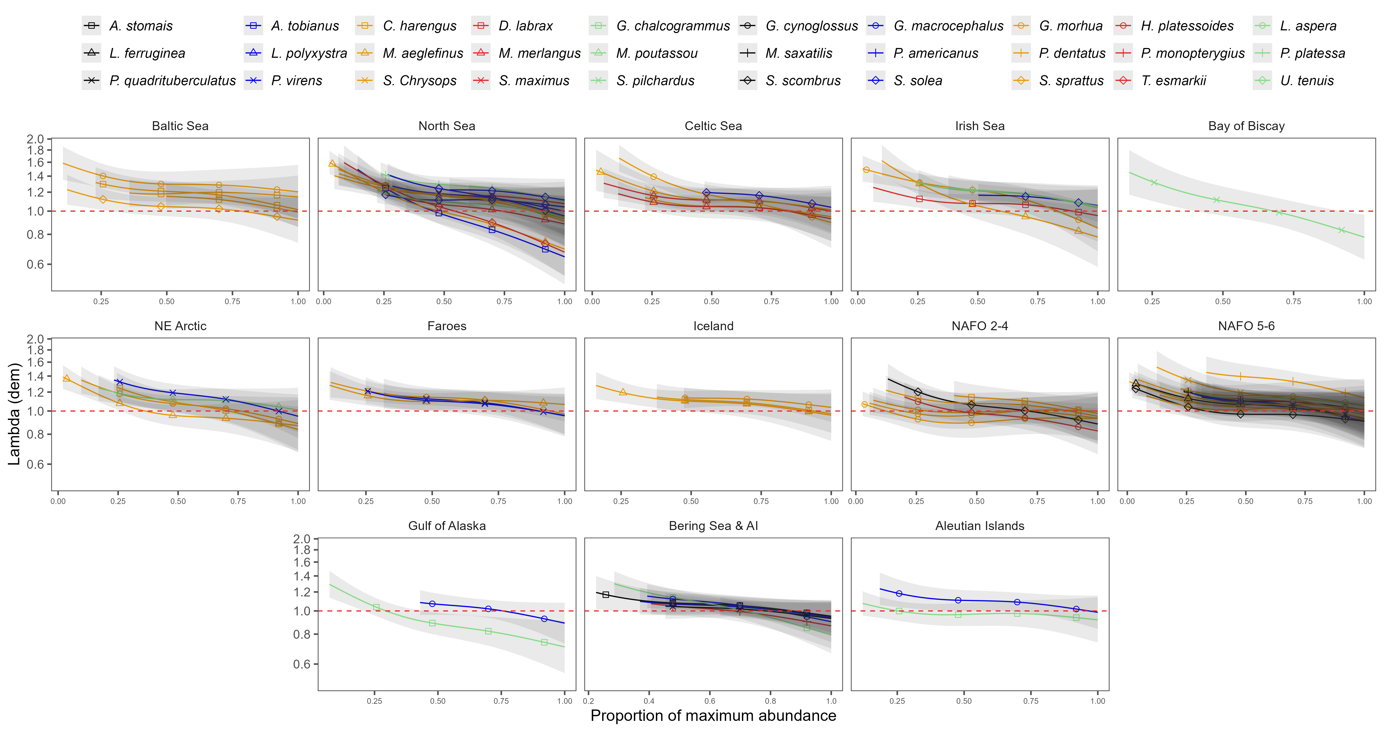
Figure A. Density dependence of $λ_{dem}$ for each stock in the analysis plotted regionally.

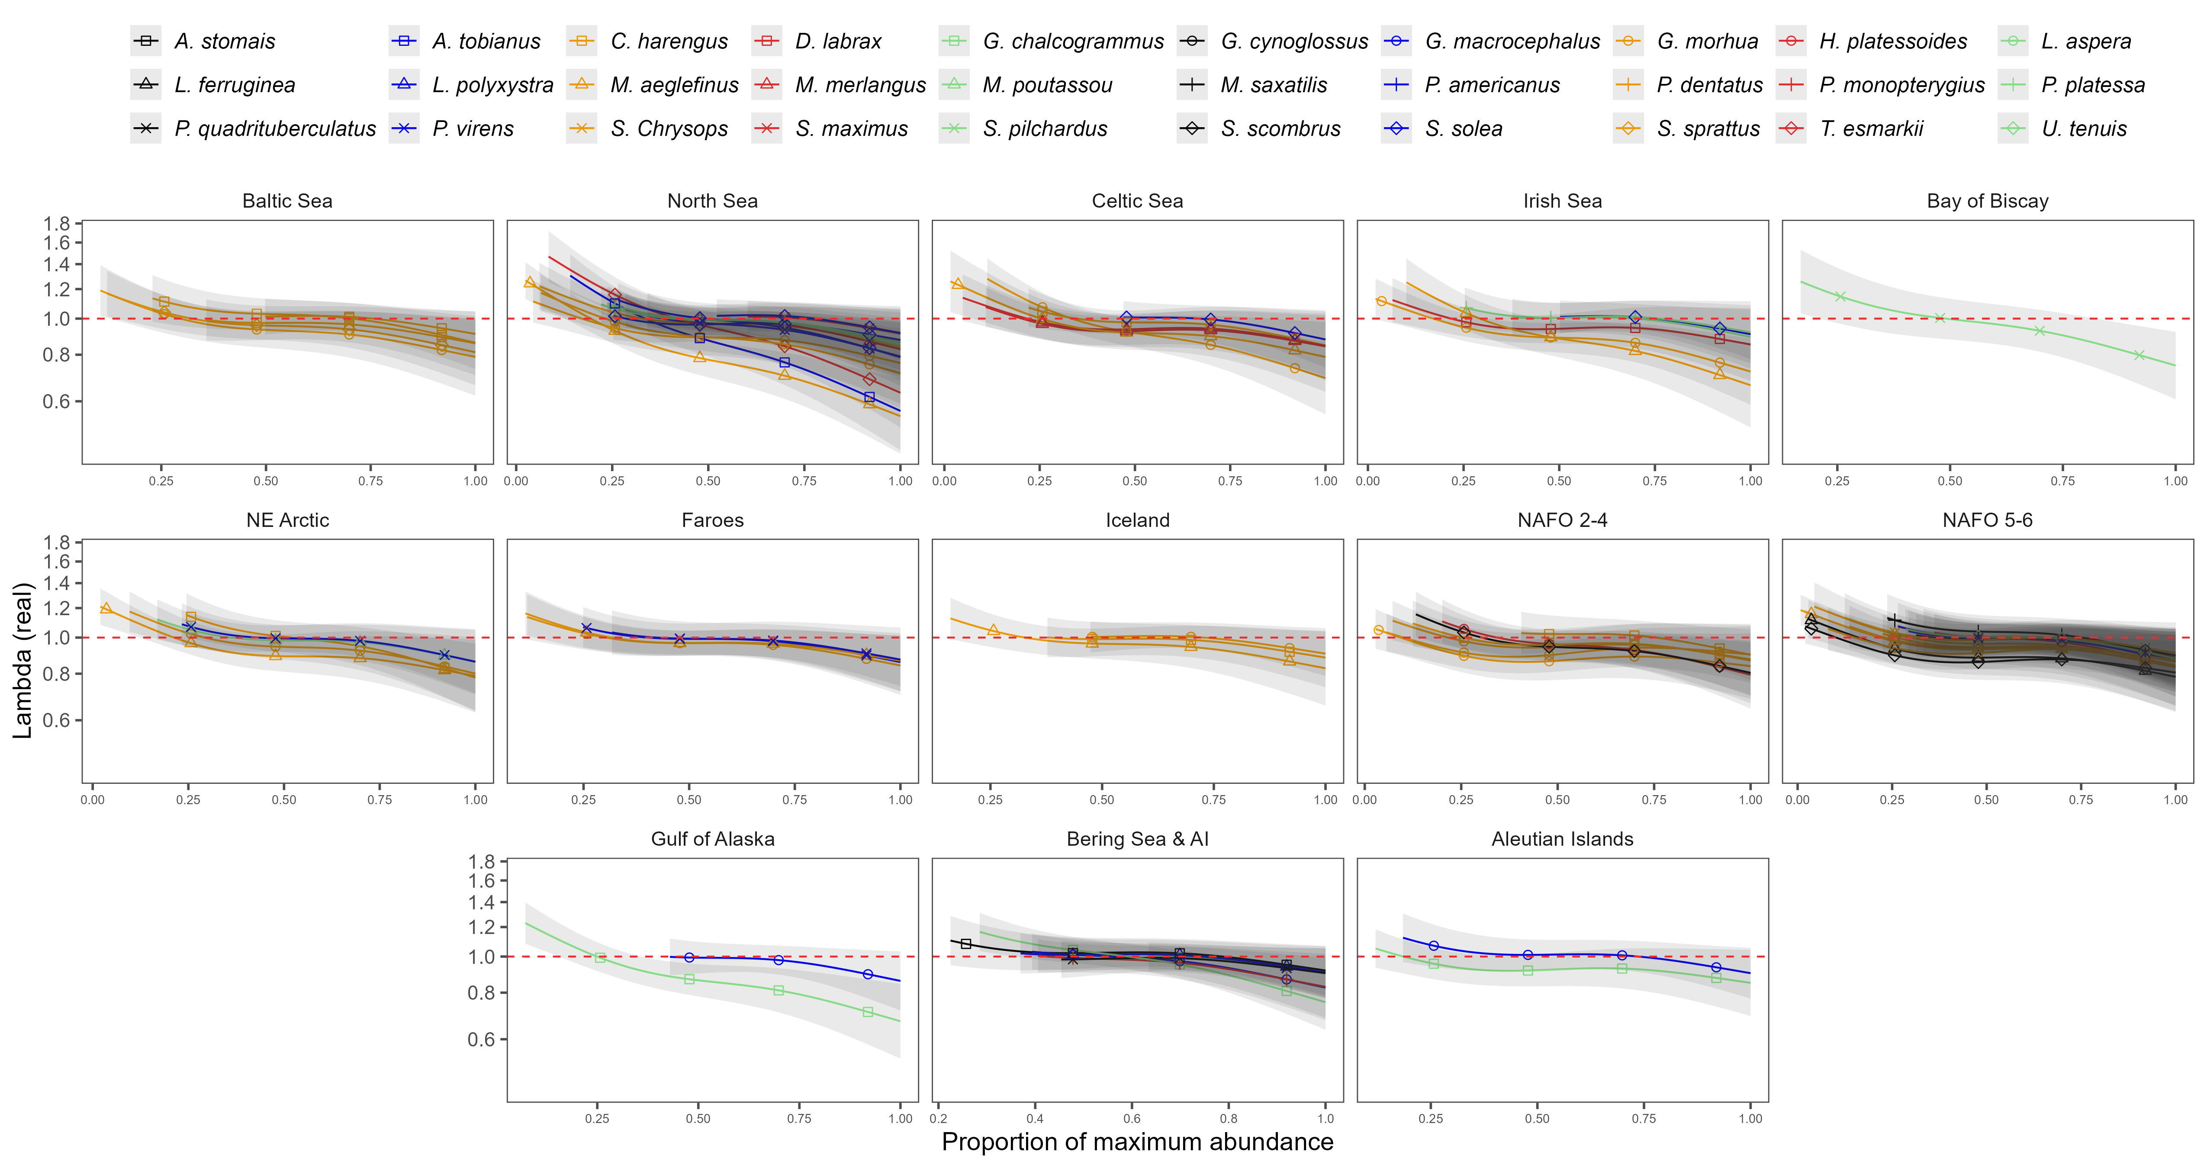
Figure A. Density dependence of $λ_{real}$ for each stock in the analysis plotted regionally.

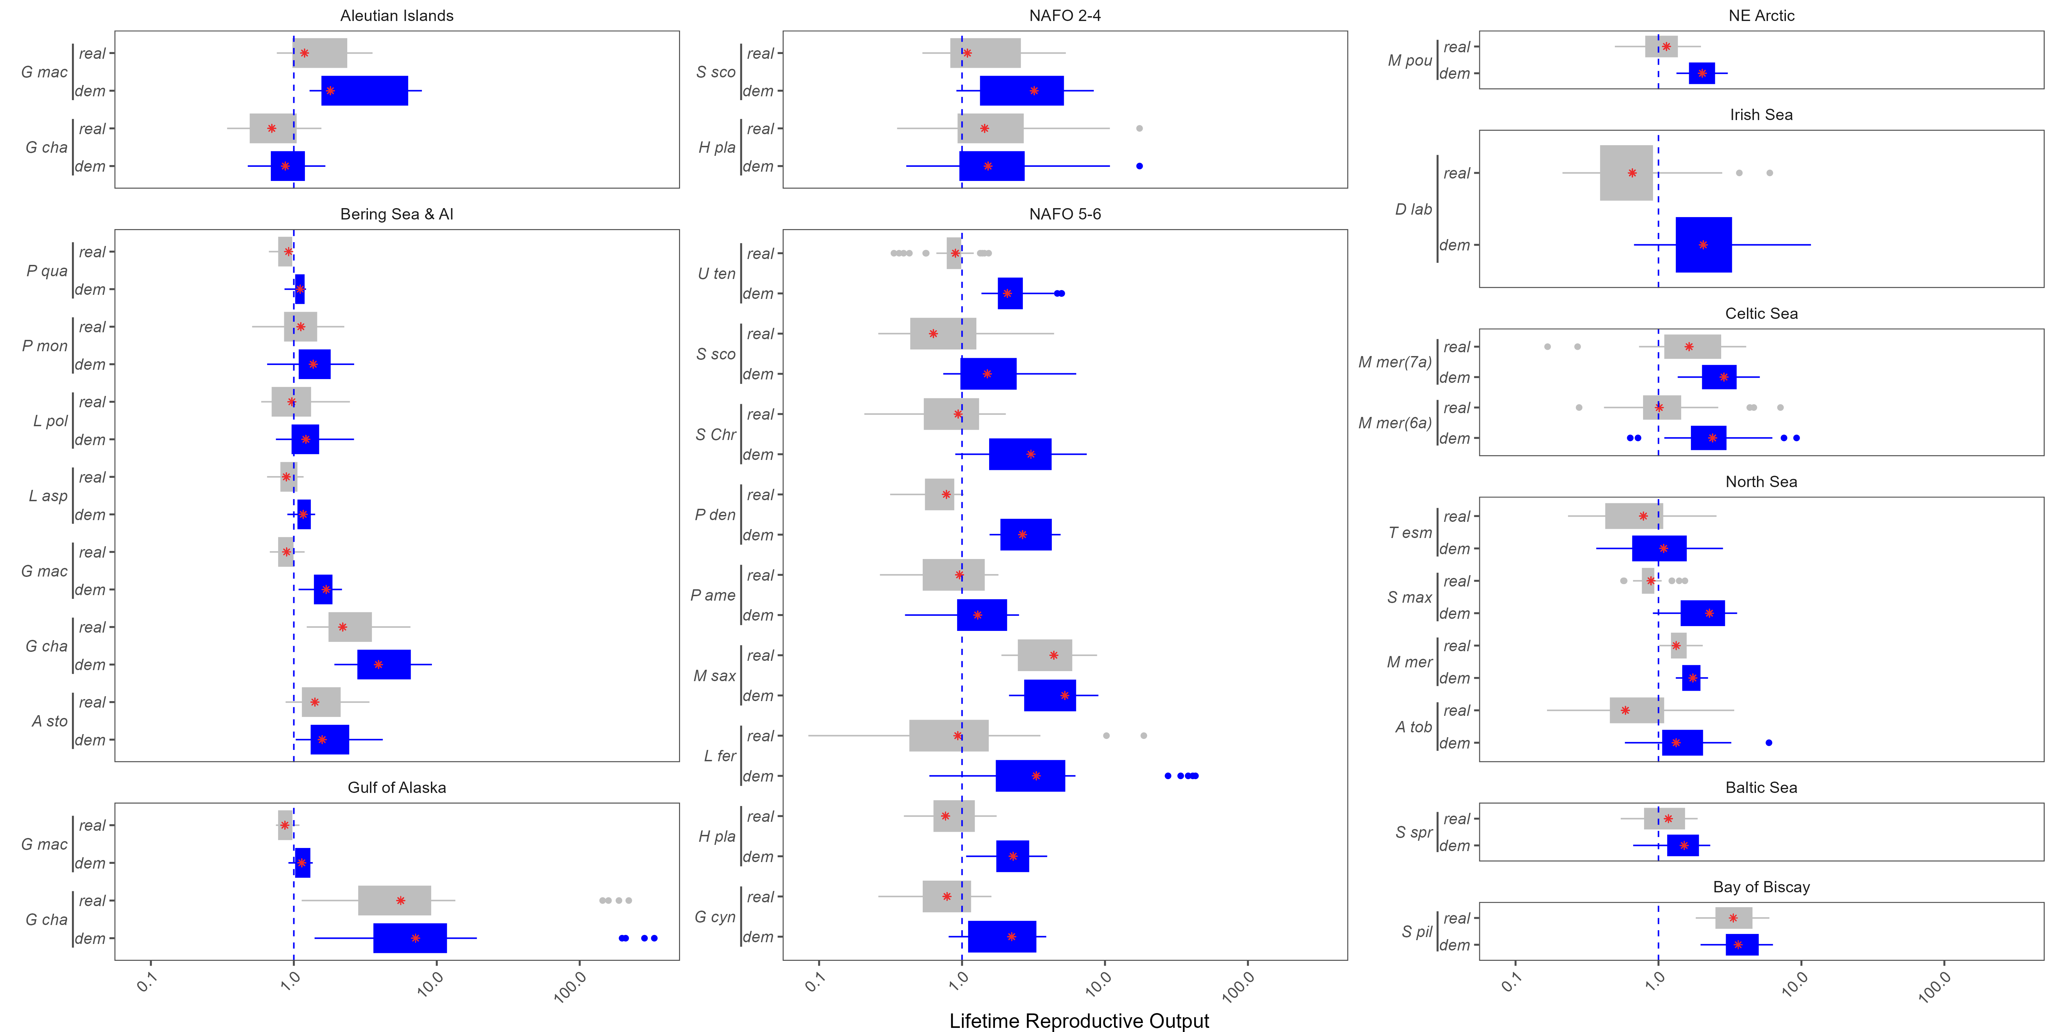
Figure A. $R_{0}$ estimates for the remainder of the stocks in this analysis (x-axis), plotted by the location of the stock(panels). The abbreviated species name is provided on the y-axis.

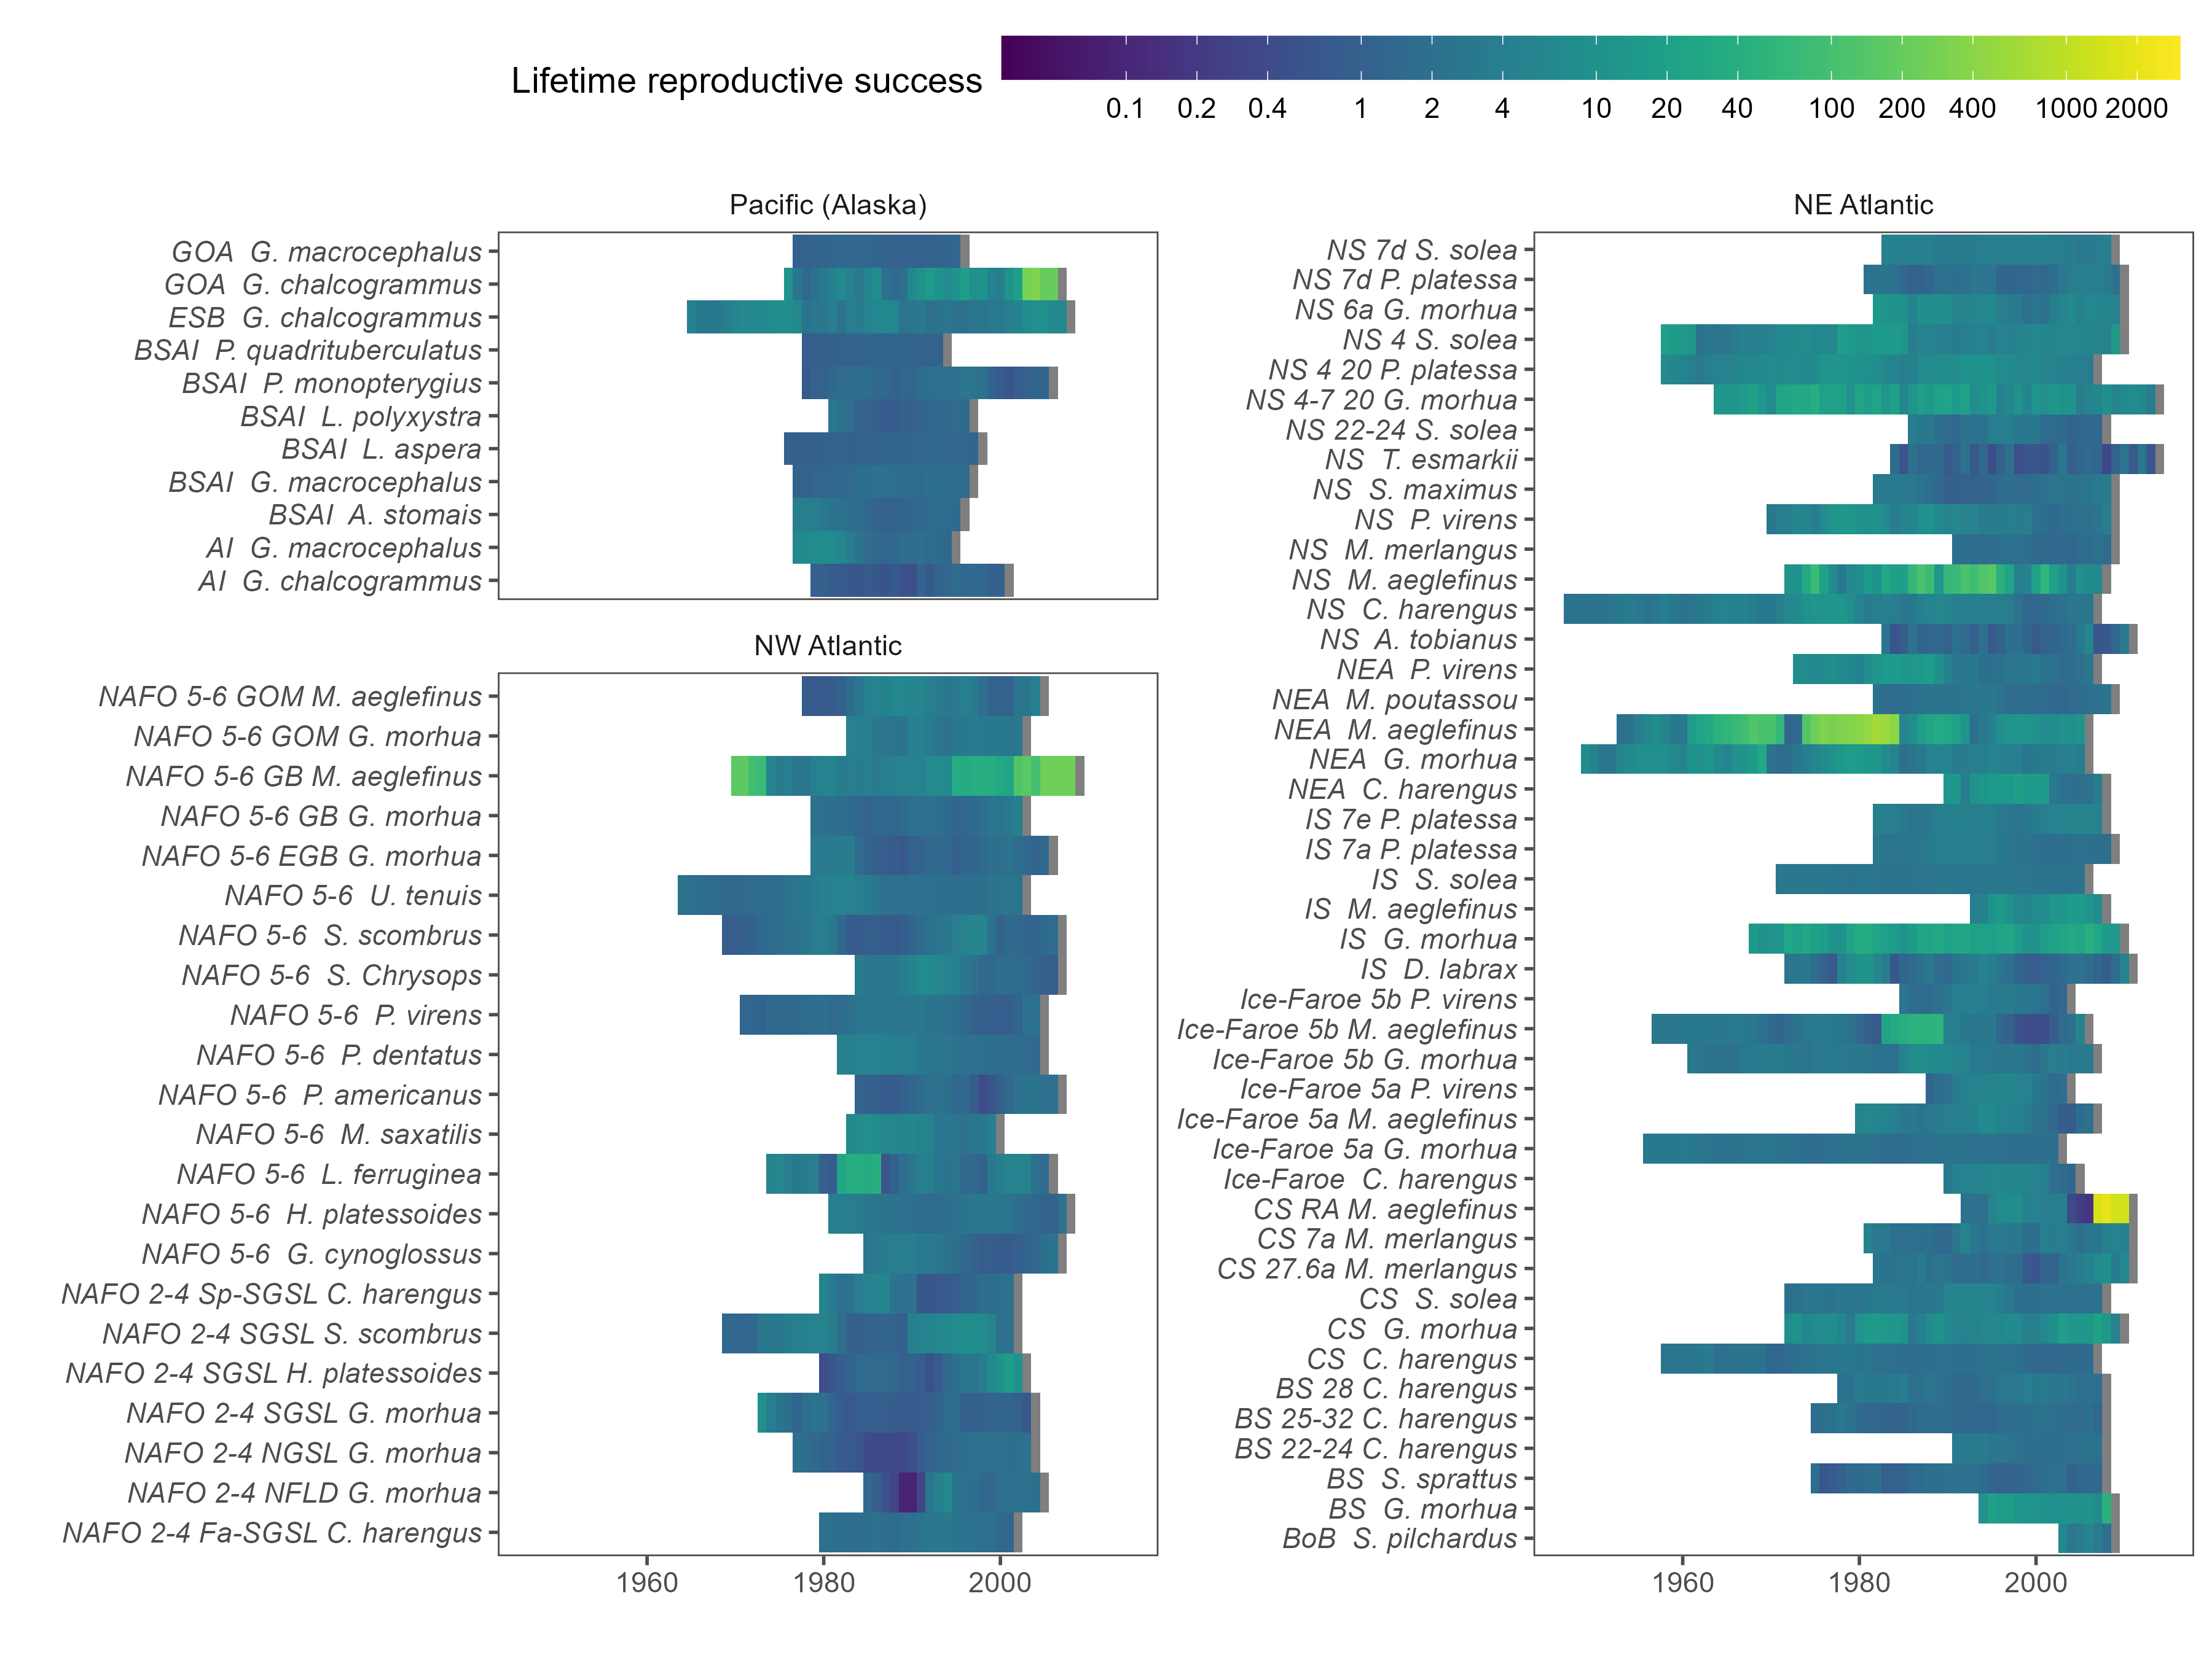
Figure A. $R_{0}$ estimates for every cohort for each species excluding the effects of fishing.

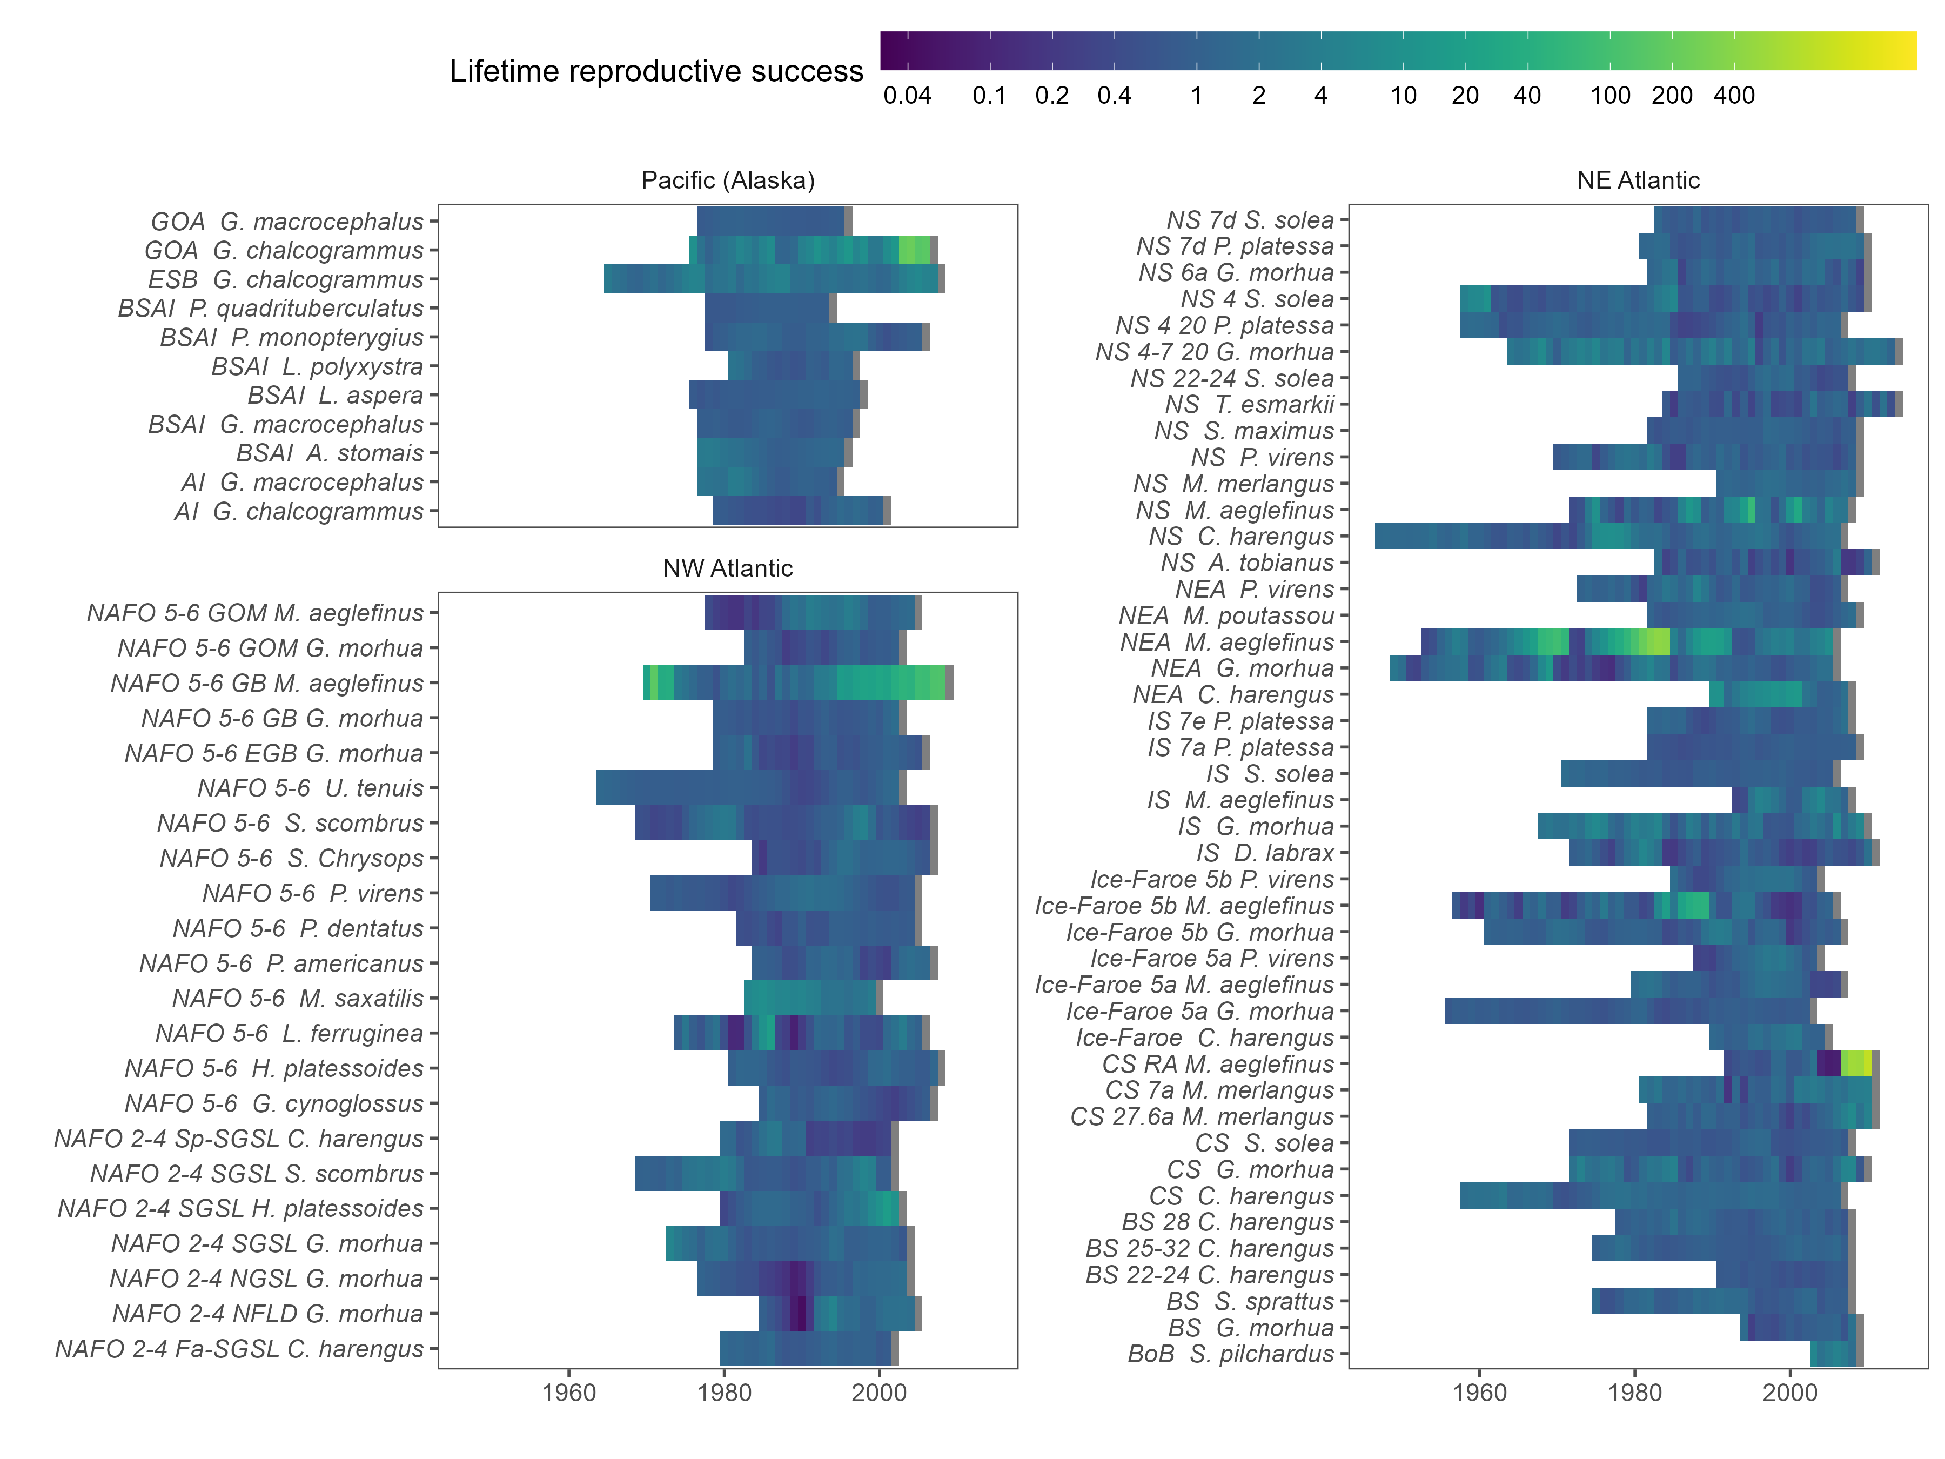
Figure A. $R_{0}$ estimates for every cohort for each species including the effects of fishing.

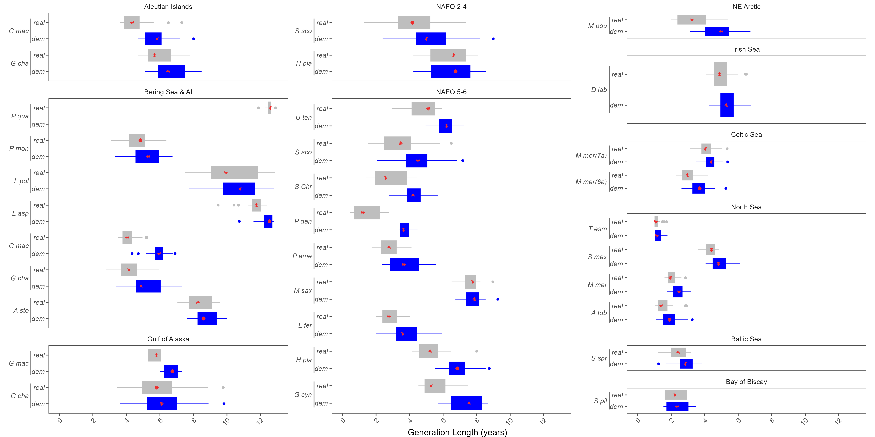
Figure A. Generation length estimates for the remainder of the stocks in this analysis (x-axis), plotted by the location of the stock (panels). The abbreviated species name is provided on the y-axis.

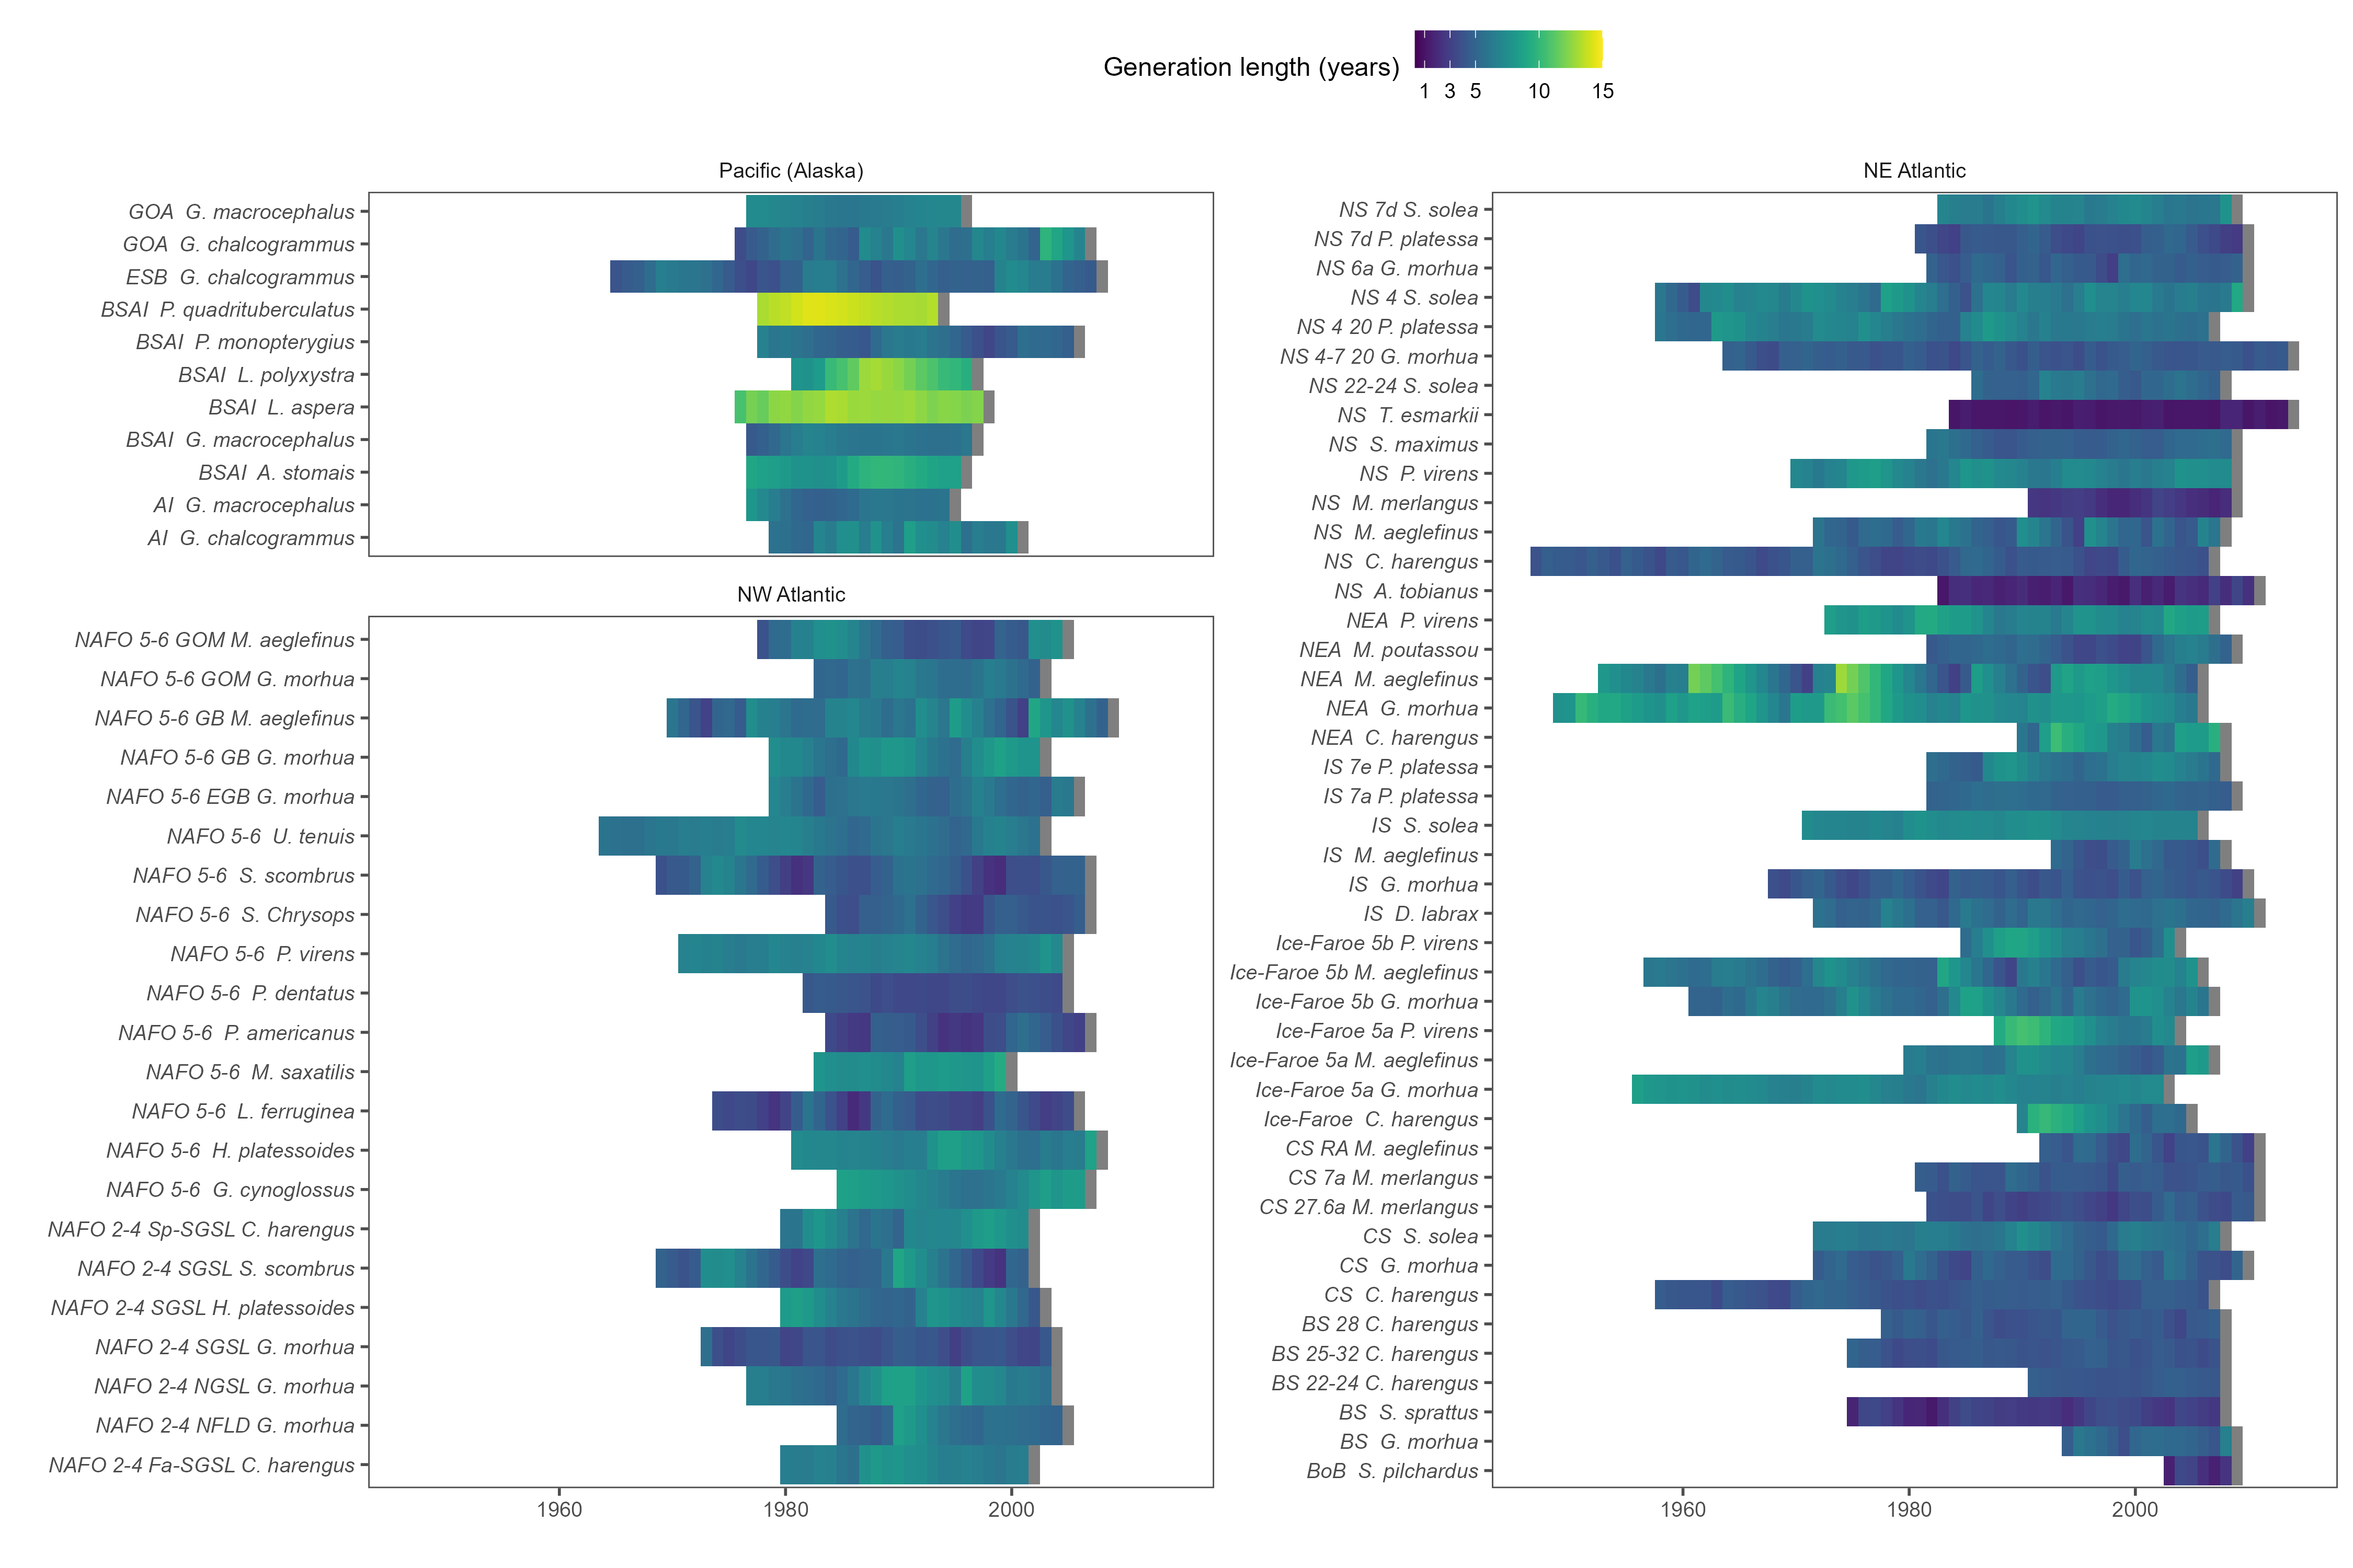
Figure A. Generation length estimates for every cohort for each species excluding the effects of fishing.

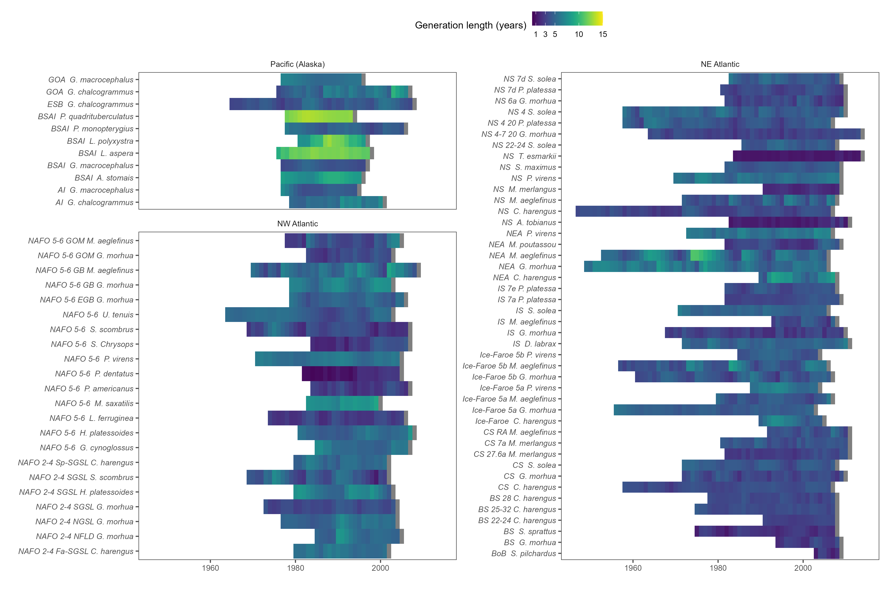
Figure A. Generation length estimates for every cohort for each species including the effects of fishing.

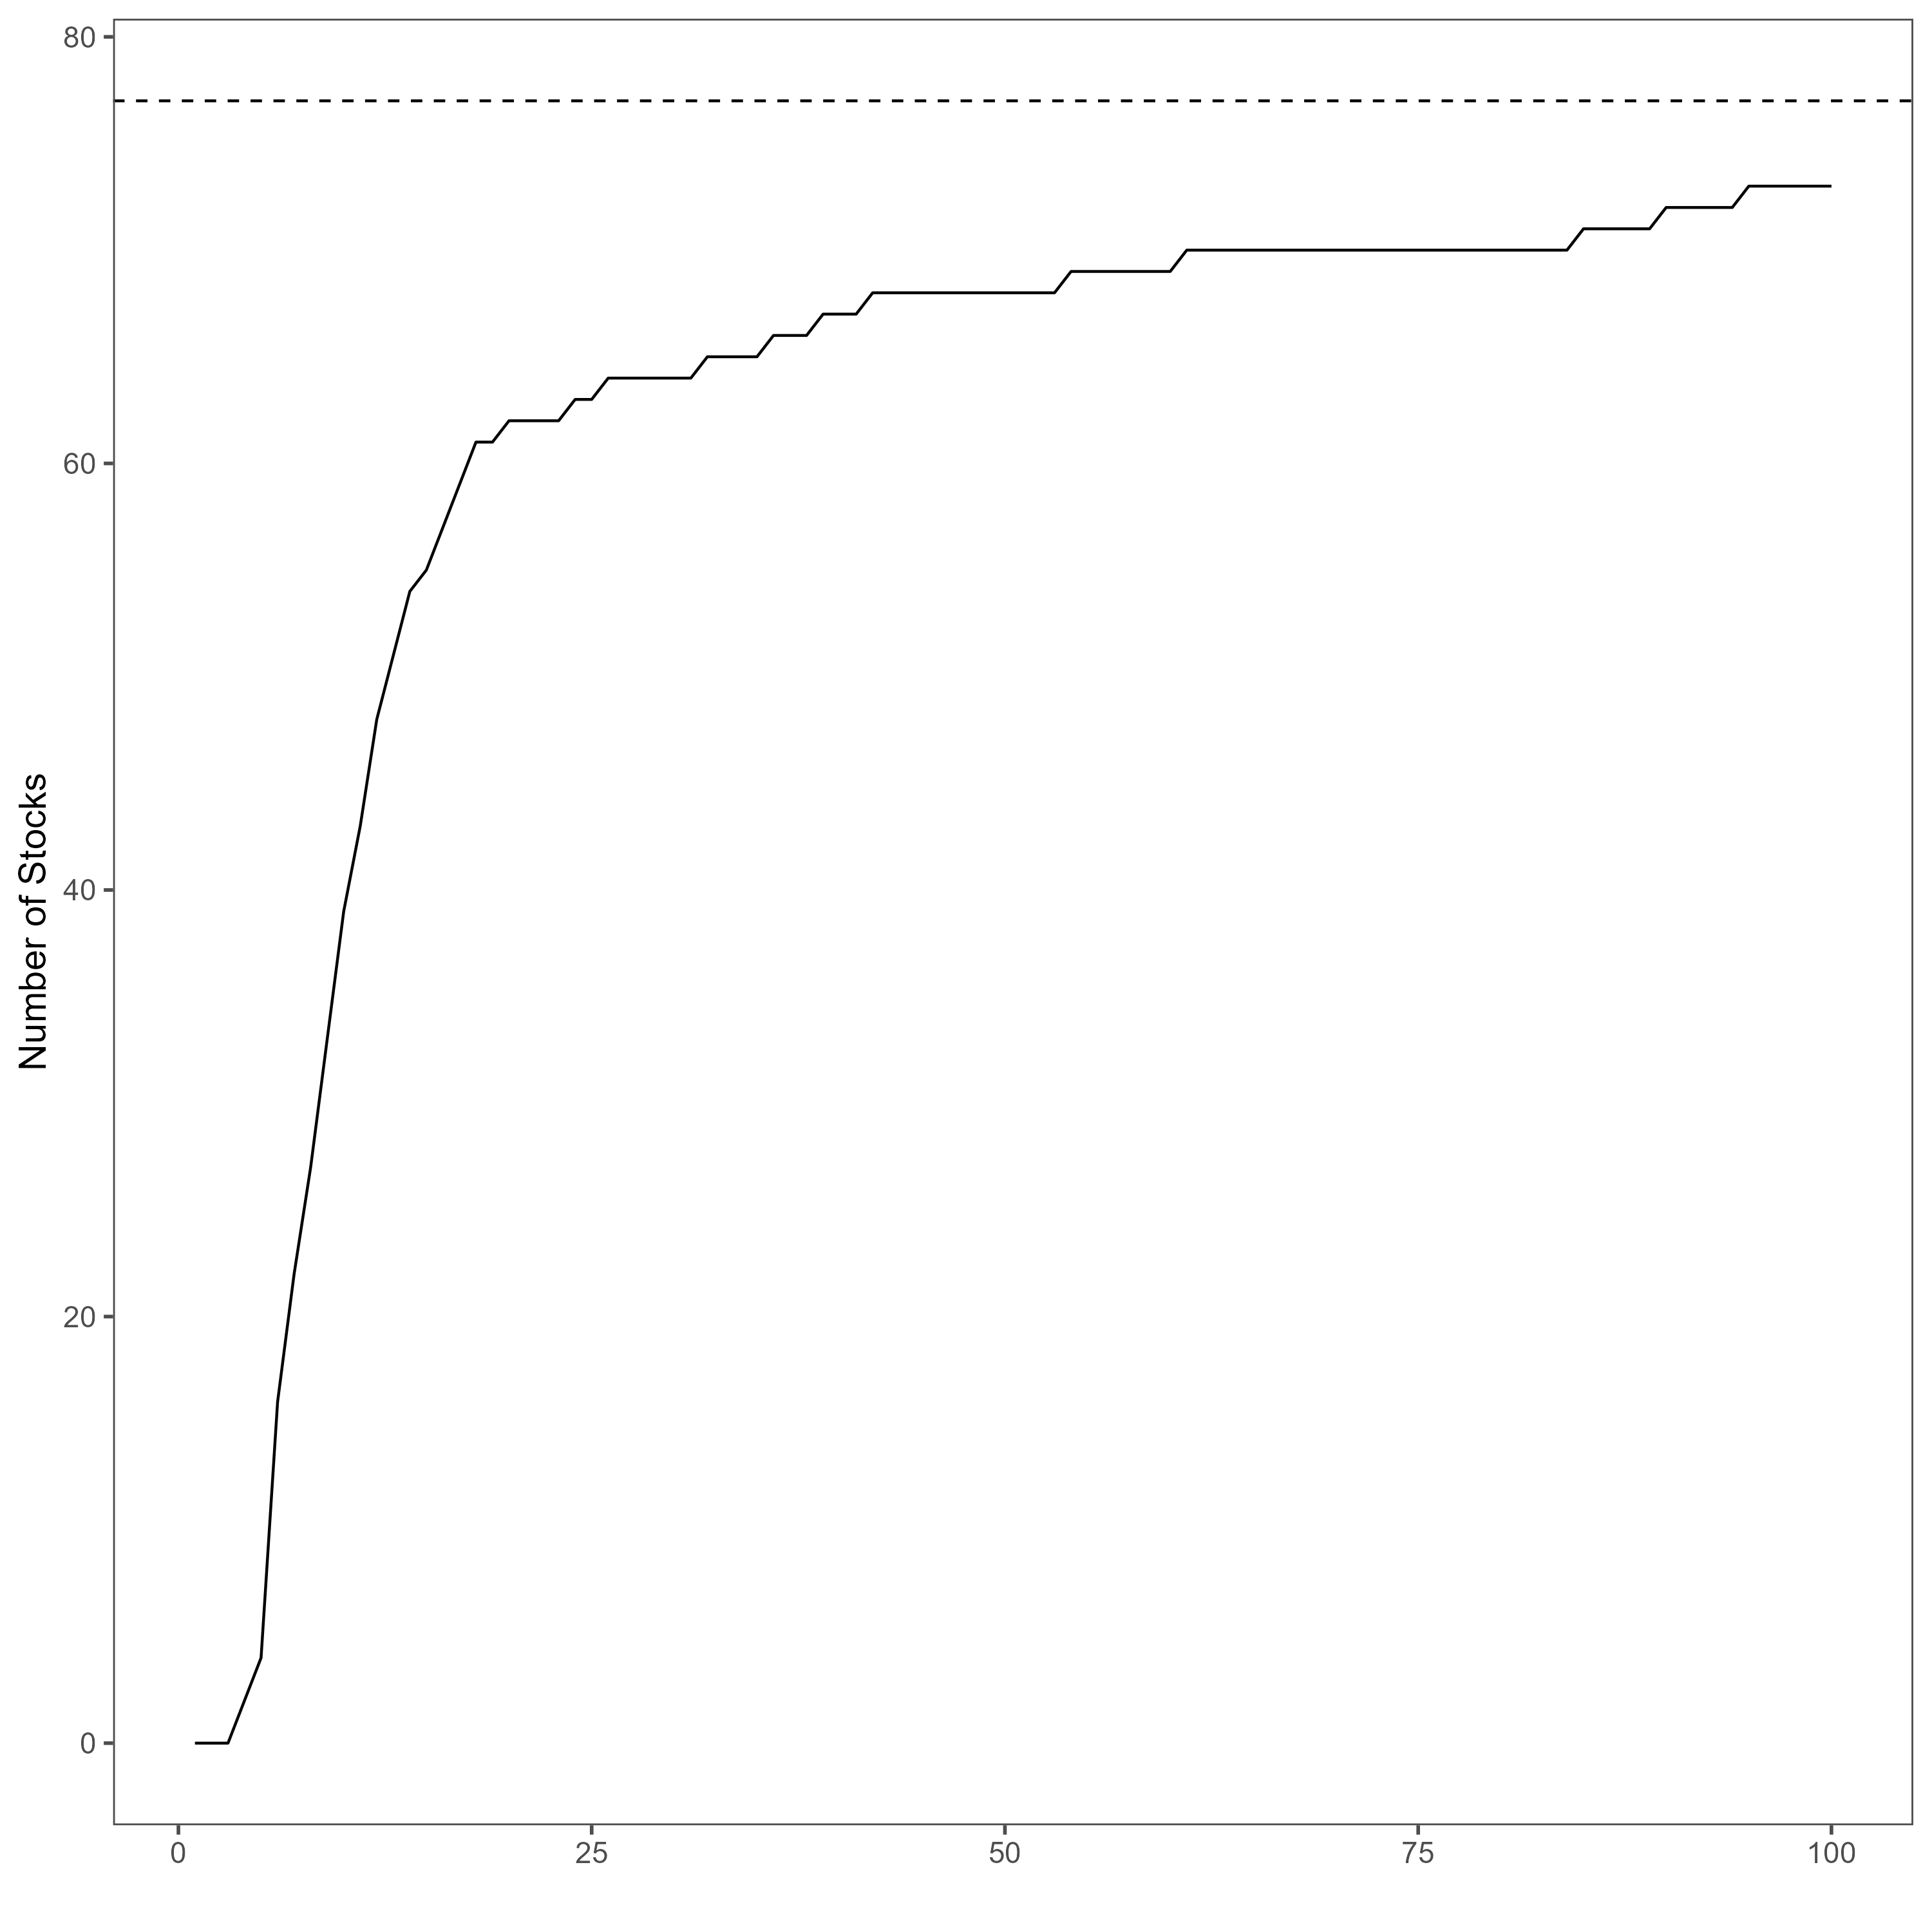
Figure A. The number of stocks (-axis) which doubled in size after a given number of simulated years (x-axis) with no fishing mortality The dashed line represents the 77 stocks in the analysis.

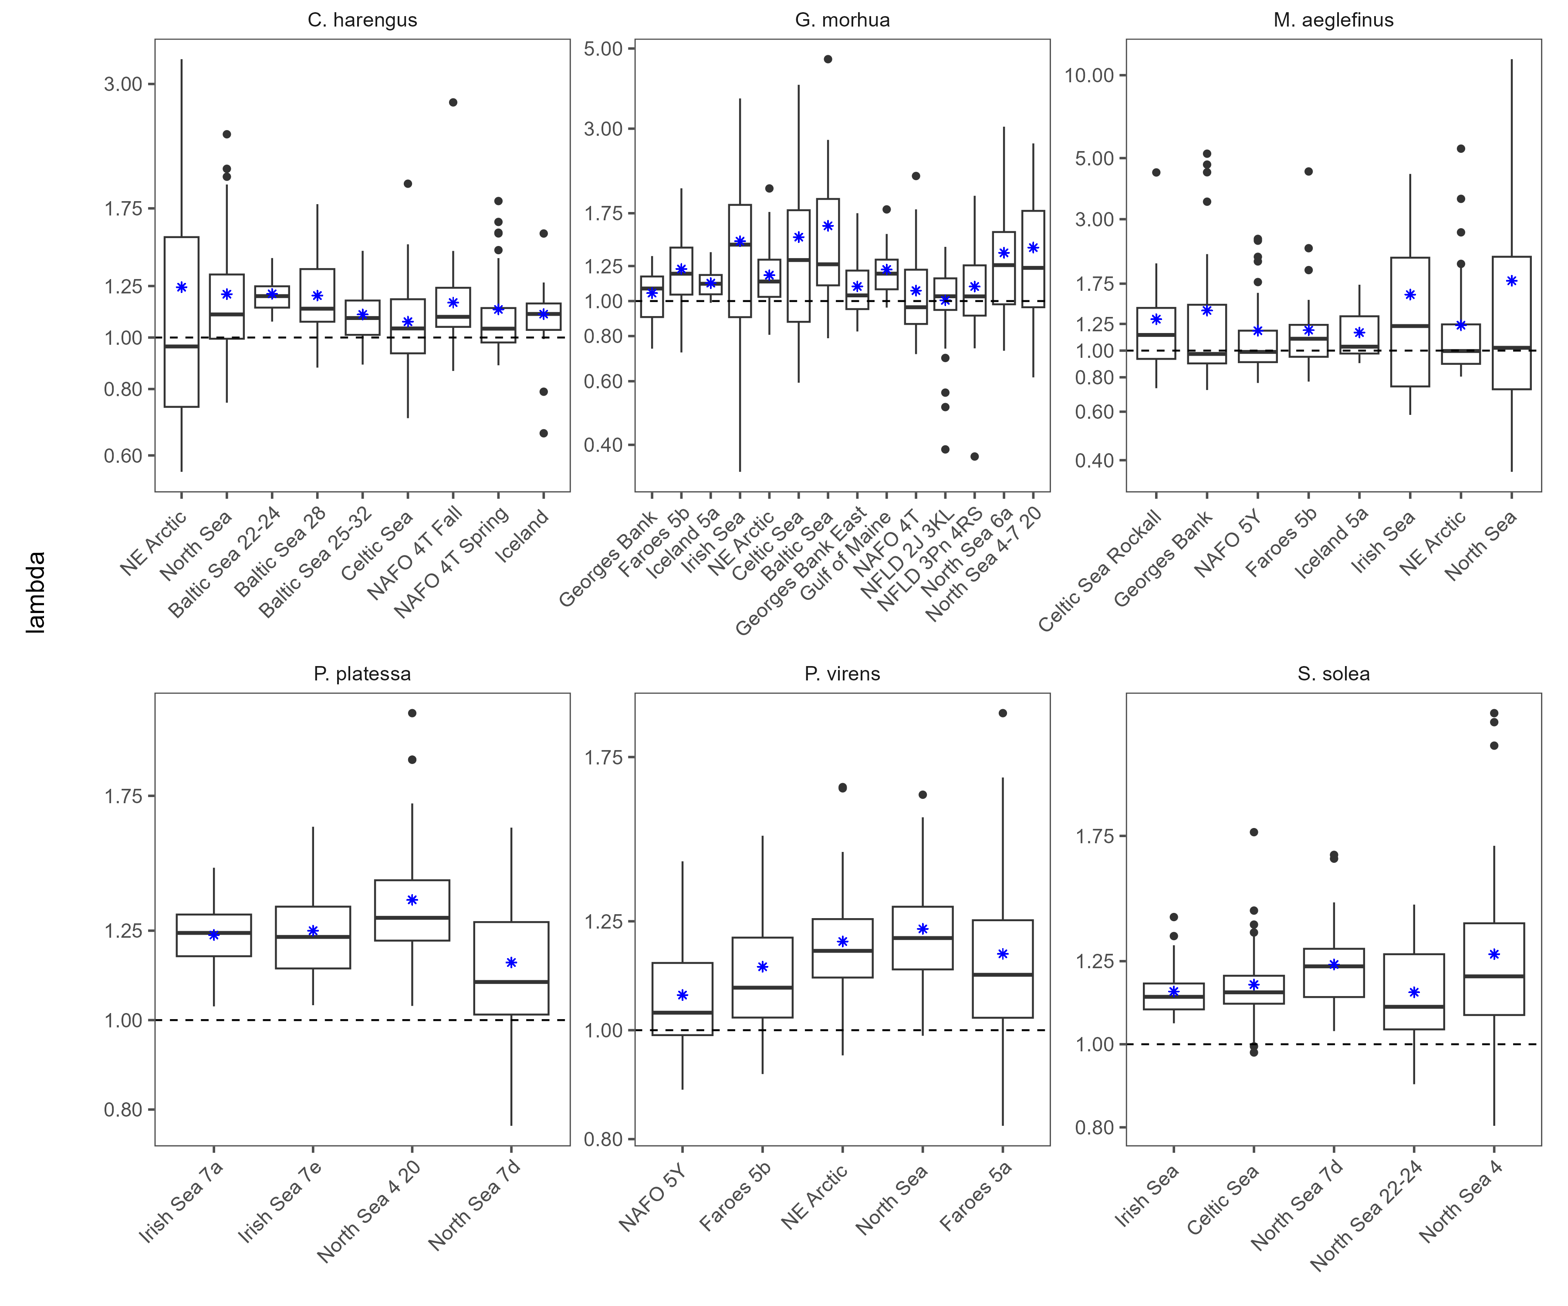
Figure A. Boxplots of $λ_{dem}$ estimates from the analysis in which the abundances were back-calculated for stocks in which the youngest age-class data available were greater than 1. A subest of the results are shown here, with data for each stock of G. morhua, M. aeglefinus, P. virens, C. harengus, P. platessa, and S. solea. The blue stars indicate the mean and the dashed horiztonal line represents a $λ$ of one. The y axis is on the log scale.

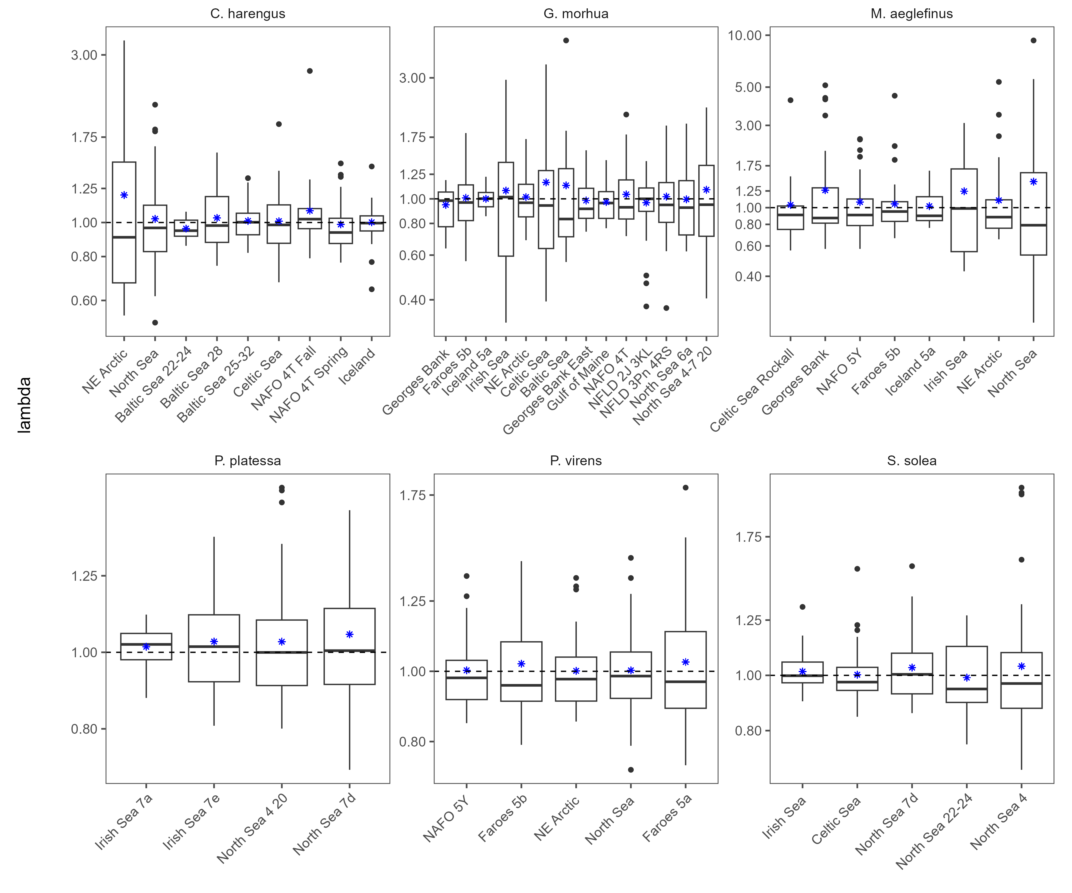
Figure A. Boxplots of $λ_{real}$ estimates from the analysis in which the abundances were back-calculated for stocks in which the youngest age-class data available were greater than 1. A subest of the results are shown here, with data for each stock of G. morhua, M. aeglefinus, P. virens, C. harengus, P. platessa, and S. solea. The blue stars indicate the mean and the dashed horiztonal line represents a $λ$ of one. The y axis is on the log scale.

