Condition Environment Draft Story Summary

DK

13/5/2021

## Introduction

1. Oceanographic conditions are known to influence natural fluctuations in fish stocks, however disentangling environmental variability from fishing effects remains challenging despite significant efforts to improve science advice through an ecosystem approach to fisheries management (EAFM).
2. Fisheries management decisions often include setting removals limits in terms of biomass; however, these decision are complicated by fluctuations in stock size due to variable recruitment, growth, condition, and survival all of which are influenced by the environment. For the world’s largest wild scallop fisheries, the sea scallop (*Placopecten magellanicus*) found off the northeastern United States and eastern Canada, reliable indices of recruitment are available through fishery independent surveys; however, outside of major recruitment events, annual variations in growth underlie major fluctuations in catch rate and yield
3. Growth is an integrated response of energy acquisition and expenditure. For scallop, growth can be defined either in terms of an increase in some dimension of the shell or in terms of the change in the soft tissue. the growth and size of the adductor muscle will also vary throughout the year. For *P. magellanicus*, intra-annual changes in the meat weight for the same shell height are characterized by increases in weight in late winter and early spring and declines during spawning in the late summer and early fall
4. Inter-annual differences in meat weight for the same shell height are likely due to environmental conditions. Talk about our paper and other papers here.
5. Management decisions for the Canadian Georges Bank sea scallop fishery are based on annual scientific surveys, with estimates from these surveys used in a Bayesian state space assessment model

## Methods

1. Standard GB backgrounder
2. Talk about 3 models based on Xiaohan’s work
   1. SST last + SST this (Full)
   2. SST last (Last)
   3. Condition autocorrelation model (Current)
3. Discuss assessment model
   1. I don’t want to get deep into details here, just show the process model and where condition fits in. This part could get out of control quickly so mostly just want to refer back to relevant publications.
   2. Explain and show how we project forward.
   3. Explain the retrospective analysis, if that’s the right word for it
4. Statistical analyses of the results of the retrospective modelling. Compare models using AICc
   1. A few simple linear models looks like it’ll do the trick.
      1. Biomass ~ model
      2. Delta B ~ model
      3. Prop B error ~ model

## Results

1. Compared SC-SST models with existing biological-only model
   * SC best predicted by Full model, but more parsimonious “Last” model would be preferred based on AICc. Current model has lower predictive ability and higher AICc.

|  |  |  |  |  |  |
| --- | --- | --- | --- | --- | --- |
|  | LL | AICc | Delta LL | Delta AICc | df |
| Full | -52.2 | 113.7 | 11.3 | 0 | 4 |
| Last | -53.9 | 114.7 | 9.5 | 0.9 | 3 |
| Current | -63.5 | 133.7 | 0 | 20 | 3 |

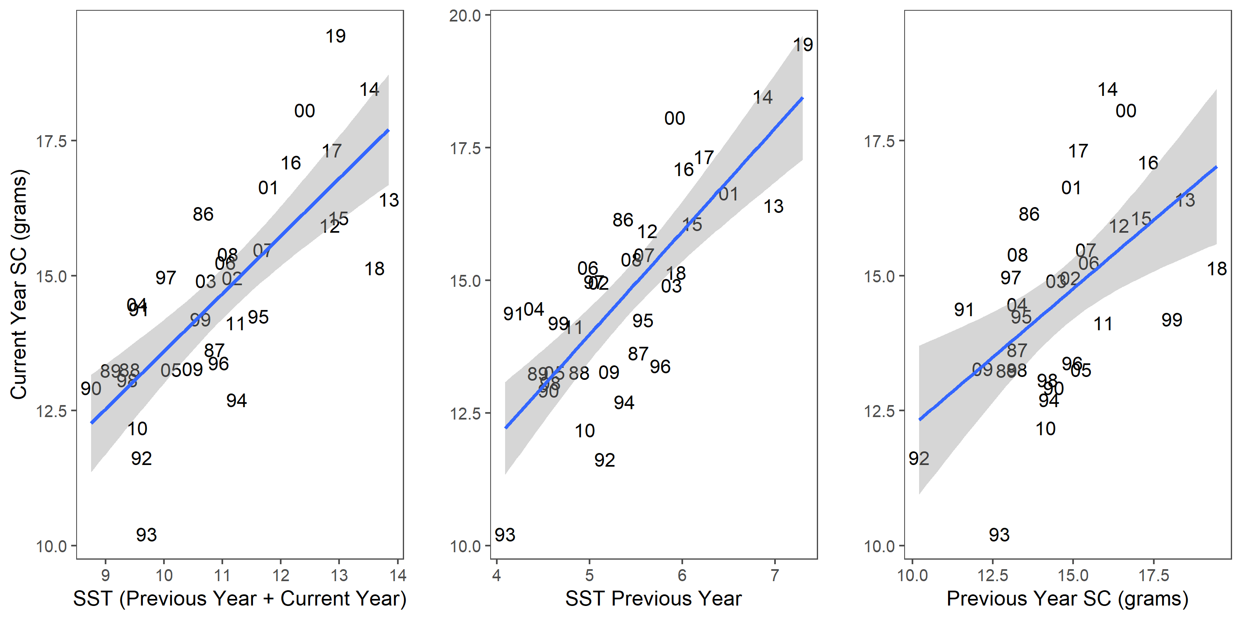

Figure 1: The fits of the 3 projection methods to Scallop Condition

1. Retrospective Analysis
   * Compared each of these models with the realized biomass estimate from the model from 1987-2019
     + The biomass from the one year projections methods all were slightly positively biased (≈ 10-12% : Figures 2 and 3)
     + The bias and uncertainty of the currently used method is slightly smaller (though not significantly different) than either SC-SST model was used. The currently used method bias was ≈ 2200 tonnes, while the Full Model bias (SST Current + SST Last) was ≈ 2400 tonnes Figures 2 and 3.

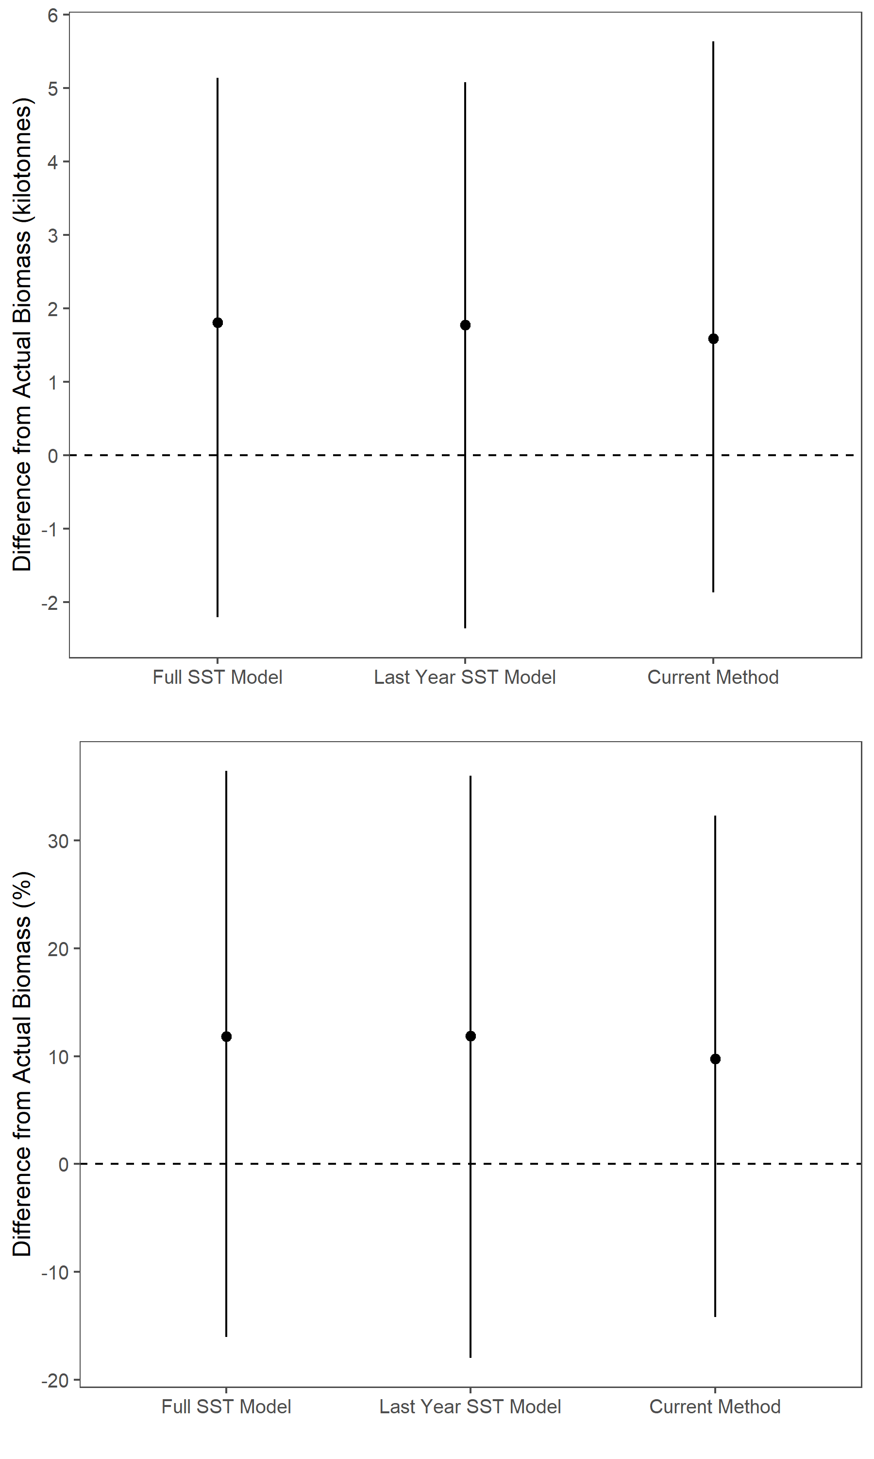

Figure 2: Difference (tonnes) in median biomass from actual observed biomass estimate for each method. Second panel is the proportional difference.

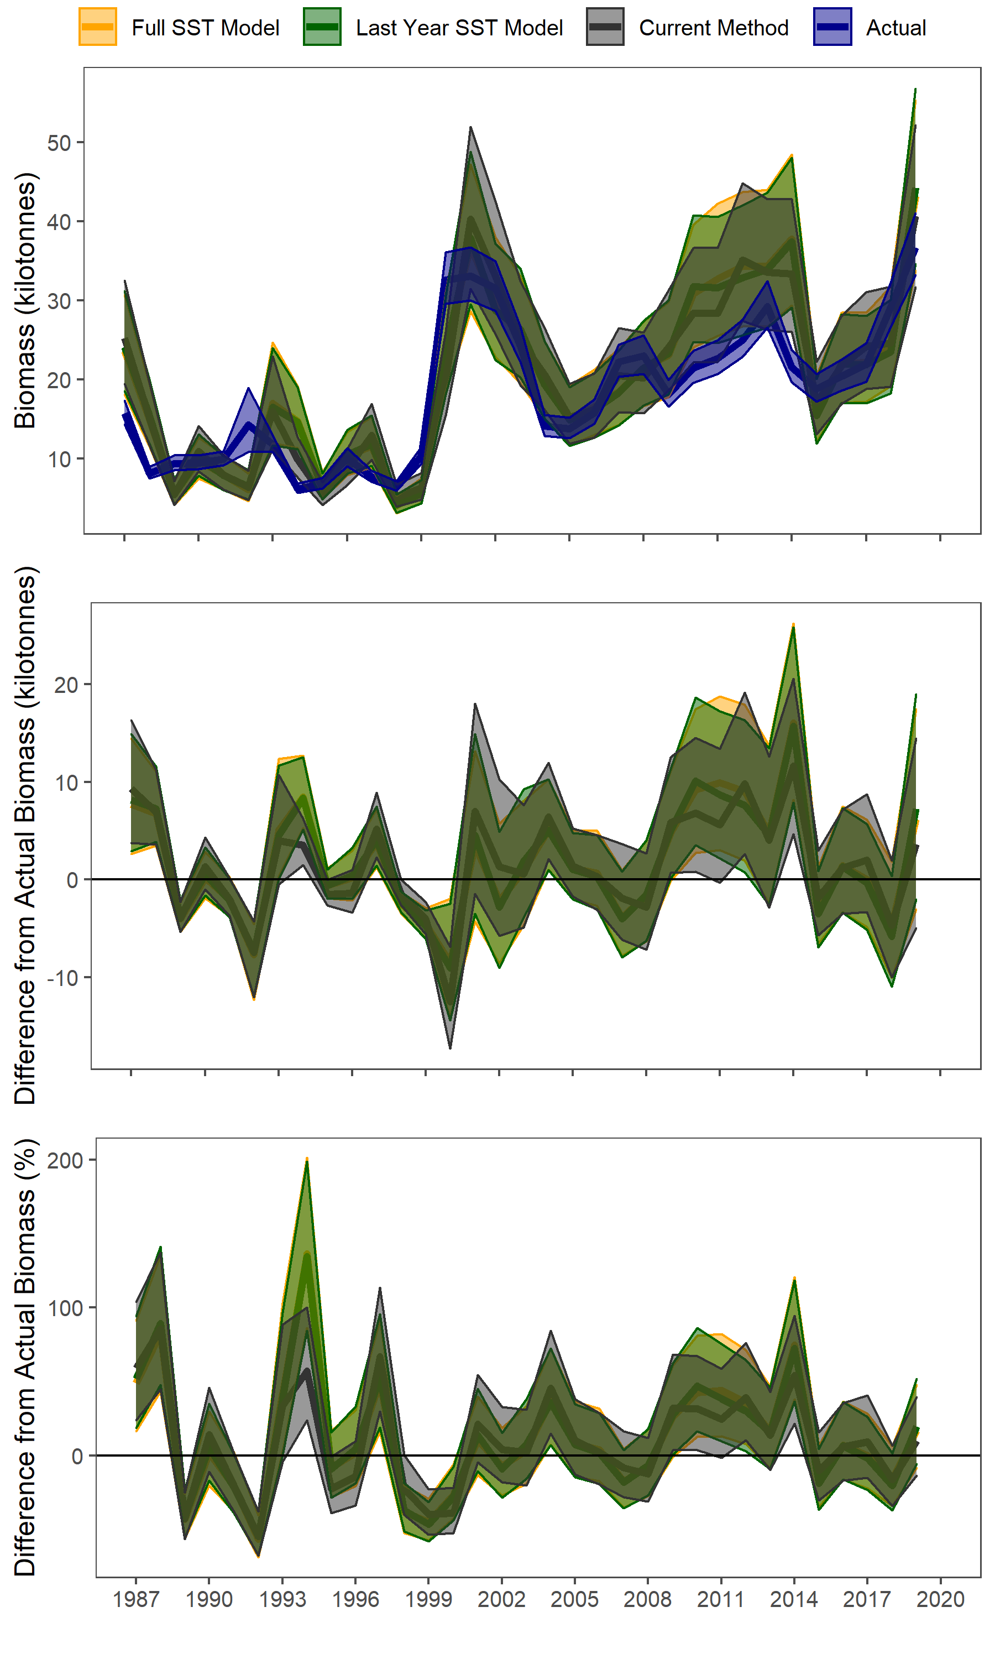

Figure 3: Time series of the Actual biomass and biomass estimates from the 3 one-year projection models. Second panel is the difference (tonnes) in median biomass from actual observed biomass estimate for each method. Thrid panel is the proportional difference.

## Discussion

1. Summarize results.
   * SST model can produce better estimates of scallop condition
   * But this doesn’t translate into better estimates of scallop biomass
   * This is due to relatively small bias in the biomass predictions from the model due to an over-estimate of other productivity parameters and the underestimate of condition using the existing method.
   * Results show how complex incorporating environmental simple environmental relationships into a stock assessment may not have desired consequences and you need to test your model before you operationalize it.
   * Points to the need for more integrated modelling frameworks (Next-Gen) in which environmental considerations are directly integrated into the model formulations rather than simple parameters derived outside of the assessment model.
2. Conclusion
   * It was a good try, but sadly it didn’t work.