Seasonal and Long term variability in species distribution of Atlantic cod (*Gadus morhua*) and Yellowtail Flounder (*Limanda ferruginea*) on Georges Bank

Keith D.M.a,b, Sameoto J.A.a, Keyser F.M.a, Andrushchenko I.a

a Fisheries and Oceans Canada b Dalhousie University

Sustainably managing marine fisheries has long been recognized as a global priority which has proven difficult to achieve. The reasons sustainable fisheries management goals have not been achieved include various socio-economic, political, and scientific factors. Scientifically, one of the major challenges has been understanding how environmental factors influence both the spatial and temporal dynamics of a stock. Fisheries science has spent a great deal of effort collecting data, both biological and environmental, which are inherently spatial and temporal in nature. Computational and statistical limitations have resulted in science products which do not fully utilize the spatio-temporal information contained in these data and tend to treat a stock as a homogeneous entities. Fortunately, computational advances coupled with more accessible statistical methods has resulted in new methodologies which can harness the spatio-temporal information contained in these fisheries data. Here we develop temporally variable species distribution models for yellowtail flounder (*Limanda ferruginea*) and Atlantic cod (*Gadus morhua*) on Georges Bank (GB) using a suite of static environmental covariates and presence-absence information from groundfish trawl surveys in Canada and the United States. These models indicate there are both seasonal and long term shifts in the distribution of both species. The average sea surface temperature (SST; average from 1997-2008) and depth were significant predictors of the distribution of both species throughout the year. Significant shifts in the distribution of both species occurs relatively frequently, with the distribution of cod observed to differ approximately every 5 years, while the Yellowtail distribution appears to fluctuate every 3 years. These shifts in distribution are not random, with the center of gravity of the core areas for both species shifting to the north and east throughout the study period. Much of this shift is due to the loss of the species from southern and western portions of GB. Models for both species were also relatively successful at capturing the spatial dynamics of the stock up to 3 years into the future. The seasonal distribution of cod and yellowtail are relatively consistent throughout the late winter and spring. In the fall the distribution of cod shifts towards the edge of the bank. Shifts in the distribution of the species during spawning has resulted in an increase in the proportion of both species in Canadian waters. For cod there has been a substainal decline in encounter probability during spawning in the two large closures in the United States, while yellowtail are now predominately found straddling the Canada-U.S. border during spawning with Closed Area II in the U.S. containing almost half of the area with a high probabilty of encounter in recent years. Here we show how these models are able to provide novel insights into both seasonal and inter-annual variability in species distributions and identify environmental covariates which have a relationship with the distribution of these species. Incorporation of these kinds of information into science advice will improve our ability to sustainably manage these stocks.

# Introduction

Sustainable management of marine fisheries has been recognized as a critical challenge facing society in the 21st century (CBD 2018). The challenges facing sustainable fisheries management are multifaceted and include complex socio-economic, political, and scientific interactions (CITE). Environmental and ecological research has been at the heart of fisheries science for well over a century (CITE). From the early days of fisheries science it was recognized that an inability to fully account for spatial processes was potentially a serious issues to surmount (CITE). Many of the traditional fisheries methods developed, and still currently used to assess fisheries, required strong assumptions about the underlying spatial processes; during the development of these methods these assumptions were often identified as potentially problematic (CITE Ricker, BH, and maybe Carl and Ray’s book). A number of methods had subsequently been developed to attempt to account for spatial processes, but computational limitations had restricted the complexity of these models (CITE - Allowing for multiple fleets was one of these). In more recent years a flurry of computational and statistical advances have enabled the development of models in which spatial processes can be more rigorously addressed within these traditional fisheries modelling frameworks (Aeberhard et al. 2018; Thorson et al. 2015b, 2015a; Cadrin 2020).

One of the earliest modelling frameworks developed to explicitly account for spatial patterns and processes were species distribution models with (SDMs; CITE early SDM work both terrestrial and fisheries). These models use environmental data along information about the species to map the likelihood of encountering a species across some land(sea)-scape and originated with attempts to map terrestrial plant distributions (CITE). In the marine realm SDM’s have been used to assist with the development of Marine Protect Areas (MPAs), MPA networks, Species at Risk (SAR), name some other shit (CITE). In many cases SDM’s assume that there is no temporal change in the relationship between the environment cues and the response of the species to these cues; these SDM’s essentially provide a snapshot in time based on available data. To better predict future states more sophisticated SDM’s frameworks have been developed in which the underlying relationships can vary both in time and space (CITE).

*I need a segue paragraph which I’m not sure what it looks like, maybe something like this?*

The collection of data in fisheries science, both biological and environmental, is often inherently spatial and temporal in nature. In the past, computational and statistical limitations have resulted in science products which do not fully utilize the spatio-temporal information contained in these data, for example, SDM applications often average temporally and the year in which the biological data is collected is not accounted for (CITE), while stock assessment methods aggregate information spatially and treat stocks as homogeneous entities (dynamic pools?? CITE). Fortunately, the aforementioned computational advances coupled with more accessible statistical methods has resulted in new methodologies which can better harness the spatio-temporal information inherent in the data; this is especially relevant in regions in which there is a long history of high quality environmental, ecological, and fishery data collection.

Georges Bank (GB) has been home to some of the most productive fisheries in the world for centuries and is home to a wealth of natural resources [CITE]. For this reason this area has been host to intensive scientific research programs for decades (CITE SOME STUFF). This research has resulted in a wealth of scientific knowledge about the geology, environment, and ecology of this area (CITE SOME STUFF). Historically numerous countries had large fisheries in the region but with the expansion of territorial seas to 200 miles offshore in the late 1970’s, resource exploitation (e.g. fisheries) on GB fell under the jurisdiction of Canada and the United States (CITE NAFO something). The final demarcation of the Canadian and United States territorial waters on GB were implemented with an International Court of Justice decision in 1984 (CITE). Within three years of this decision both countries had developed their own independent groundfish surveys which each covered the entirety of the bank at different times of the year.

Historically, GB was home to large groundfish fisheries including Atlantic cod (*Gadus morhua*), Atlantic haddock (*Melanogrammus aeglefinus*), Yellowtail flounder (*Limanda ferruginea*) and numerous other species (CITE). As observed throughout the northwest Atlantic, the biomass of Atlantic cod on GB declined significantly in early 1990’s and there have been little evidence for recovery of this stock since this collapse (Andrushchenko et al. 2018). Yellowtail flounder on GB had been at low abundance on the bank since the 1970’s, but evidence for a rapid recovery of this species was observed in the early 2000’s and resulted in directed fisheries for this species for several years, unfortunately this recovery was short lived and the abundance of this species has been near historical lows for the last decade (Legault and McCurdy 2018). While the status of these two groundfish species remains poor, other groundfish stocks (e.g. Atlantic haddock) have experienced large increases in biomass over the last decade, and currently the most lucrative fishery on GB has been an invertebrate sea scallop fishery which has experienced unprecedented productivity over the last two decades [Finley et al. (2019); CITE SABHU and DVORA].

Fisheries management bodies in both Canada and the United States have implemented measures to protect cod and yellowtail on GB. While these measures vary between the countries, both countries have collaborated to develop a shared bycatch quota for these two species; this quota has declined substantially for both species over the last decade (Andrushchenko et al. 2018; Legault and McCurdy 2018). In addition to these regulations which attempt to directly limit the removals of these two species, both countries have implemented closures. In the United States two large closed area were implemented (Closed Area I and 2) in 1994, these closures were designed to aid in the recovery of groundfish and invertebrate stocks on GB (Murawski et al. 2000; Link et al. 2005). In Canada the groundfish fishery is not permitted to fish on GB during cod spawning; since 2010 this closure has started in the 5th week of the year and lasts until May 31st. The Canadian Offshore Scallop Fishery (COSF) also faces restrictions on fishing during the peak spawning periods with time-area closures limiting the area this fishery can operate in February and March (cod; DFO (2019)) and June (yellowtail; DFO 2014).

Here we use a recently developed statistical framework (CITE R-INLA) to develop spatio-temporal species distribution models for two depleted groundfish stocks on GB (Atlantic cod and Yellowtail flounder). Our objectives were; 1) Use a suite of static environmental layers to determine whether any of these environmental data informed the distribution of either species, 2) determine whether the species distributions changed over time and if so how rapidly changes in the distributions could be observed, 3) determine whether the species distributions change seasonally using data from groundfish surveys in the winter, spring, and fall, 4) using these two species as a case study investigate how well existing closures on GB align with these species during spawning and 5) quantify how well the models can predict the spawning distribution of these species 1, 2, and 3 years into the future.

# Methods

### Study area

Georges Bank (GB), located in the northwest Atlantic straddling the US-Canada maritime border, is a 3-150 m deep plateau that covers approximately 40,000 and is characterized by high primary productivity, and historically high fish abundance (Townsend and Pettigrew 1997). It is an eroding bank with no sediment recharge, and covered with coarse gravel and sand that provides important habitat for many species (Valentine and Lough 1991). Since 1984, GB has been divided between the US and Canada and, while some collaborative management exists, the US and Canadian portions are largely managed separately (Figure 1).

### Data

Survey data were obtained from the Fisheries and Oceans Canada (DFO) winter RV survey from 1987-2019 and the National Marine Fisheries Service (NMFS) spring and fall groundfish surveys from 1972-2019. The DFO-winter survey on GB typically occurs in February and early March, the NMFS-spring survey typically occurs in April and May, while the NMFS-fall survey generally takes place between September and November. For all surveys only tows deemed *successful* were used in this analysis. This resulted in 2590 tows from the DFO-winter survey, 2393 tows from the NMFS-spring survey, and 2506 tows from the NMFS-fall survey.

### Environmental covariates

A suite of 21 environmental variables with spatial information were obtained for this analysis (Table 1). To eliminate redundant variables, variance Inflation Factors (VIFs) were calculated for all variables and any variables with VIF scores > 3 were removed. This procedure was repeated until no variables remained with a VIF score > 3 (CITE ZUUR). Using the remaining 16 variables a Principle Component Analysis (PCA) was undertaken for each survey using the data from station locations for each survey these environmental data with the top 4 PCA components retained (these accounted for at least 80% of the variability in the data) and were included as covariates for the models that follow.

### Statistical Analysis

A Bayesian hierarchical methodology was implemented using the Integrated Nested Laplace Approximation approach available within the R Statistical Programming software R-INLA (CITE R and INLA). In recent years R-INLA has seen a rapid increase in use to model species distributions in both within the terrestrial and marine realms (CITE SOME PAPERS). This methodology solves stochastic partial differential equations on a spatial triangulated mesh; this mesh is typically based on the data available (CITE RUE). To avoid edge effects the mesh is extended beyond the boundaries of the data, the mesh used in this study included 6610 vertices (Figure 2).

For the INLA models data up to 2016 were used, while survey data from 2017-2019 were excluded from the main analysis and used only as testing data for the spawning distribution case study. For all analyses the response variable was presence absence of the species of interest () and a *Bernoulli* GLM was utilized within R-INLA.

Each variable retained after the VIF analysis along with the 4 PCA components were added to the model individually, all continuous covariates were modelled using the INLA random walk smoother which allows for non-linear relationships between the response and each variable (Cite ZUUR Vol 1). The continuous covariates were centred at their mean value and scaled by their standard deviation, covariates which were highly skewed (e.g. depth) were log transformed before being standardized. Due to low sample size of several of the levels the Sediment type (Sed ; data obtained from McMullen et al. 2014) were amalgamated into one factor level which was represented by the ‘intercept’ term in models which included the Sediment type. This amalgamated level represented approximately 7% of survey tows across the three surveys (approximately 93% of the survey tows were on the Sand or Gravel-Sand bottoms).

Four spatial random fields () were compared for each species and each survey, these included a) a static random field (t = 1), b) independent random fields every 10 years, c) independent random fields every 5 years, and d) and independent random fields every 3 years. For b-d the random fields were set from the most recent year, so that when the time series was not a multiple of the time series length the first years of data had a shorter duration random field (e.g. the 10 year random fields for NMFS-spring survey were 2007-2016, 1997-2006, 1987-1996, 1977-1986, and 1972-1976). Models with the same covariate structure but different random fields were compared using WAIC, CPO, and DIC; the results for each of these metrics were similar and only the WAIC results are discussed further. In all cases the static spatial field was an inferior model when compared to models with multiple random fields and the results discussed here use the 10/5/3 year random fields.

Initial model selection for the different covariate models was undertaken using a static random field (due to computational constraints) by adding individual covariates. For this first analysis covariates were retained if low WAIC (CPO and DIC results were similar to WAIC so only WAIC is discussed further) scores were observed across multiple models. For cod this analysis identified depth (DEP) and the average sea surface temperature between 1997 and 2008 (SST) as having low WAIC scores in 2 of the 3 surveys (Data obtained from Greenlaw et al. 2010). For yellowtail, depth (DEP) was the primary covariate observed, in addition sediment grain size (SED), and the average chlorophyll concentration between 1997 and 2008 (CHL) were retained due to their low scores in one survey. These variables were added pairwise (e.g. models included SST + DEP, DEP + CHL, and SST + CHL) for both species and again compared using WAIC. For cod a three term model including additive terms for SST, DEP, and CHL was the most complex model tested, while for yellowtail the most complex model included SST, DEP, and SED. For this step additional covariates were retained if the WAIC for that model resulted in an improvement of the WAIC of more than 2 when compared to the lowest WAIC more parsimonious model.

### Model Validation

Five fold cross validation was used to test the predictive performance of the models. The data were randomly divided into 5 subsets and trained using 4 of the subsets, the 5th dataset was treated as a testing dataset to determine how well the model was able to predict out of sample data. Model performance was measured by comparing the the model residuals from the training data to the prediction error from the testing data, the metrics used for this comparison were Root Mean Squared Error (RMSE), Mean Average Error (MAE), and the standard deviation (SD). For computational reasons the models compared using 5 fold cross validation were intercept only, SST (cod), DEP (yellowtail), DEP + SST, the 5 year random field was used for all model validation for both species.

### Spawning Aggregation Case Study

These model results were used to track changes in the distributions of cod and yellowtail during spawning on GB. Cod spawn between November and May on GB with a spawning peak in February and March; the DFO Winter survey occurs during this period and was used for the cod spawning analyses (O’Brien et al. 1993). Yellowtail spawning occurs mostly in the spring between April and August, with peak spawning in May and June; the NMFS Spring survey occurs during this period and was used for the yellowtail analyses (O’Brien et al. 1993). To test how well these surveys were able to predict future spawning aggregations data from the 2017-2019 surveys was used as a testing dataset . This analysis utilized the predictions from the 3 and 5 year random field with the SST + Dep models to predict the EP of observed data 1, 2, and 3 years into the future. For each of the 3 years the predictive error was estimated using RMSE, MAE, and SD and this was compared to the observed residual error from each model (given similarity of the results only the RMSE is discussed).

There are 4 distinct partial closures within the domain of these surveys, two large year round closures on the U.S. side of GB, and two smaller time-area closures in Canadian waters which effect the Canadian Offshore Scallop Fleet (COSF). There is also a full closure of GB to the Canadian Groundfish fishery which begins in early February, this closure is not explored in detail here due to the complete exclusion of this fishery from GB. In the U.S. Closed Area I (CA II) and Closed Area II (CA II) were implemented in 1994 in an effort to rebuild stocks in the region (Link et al. 2005). CA I is approximately 3950 km² and extends outside the primary domain of the surveys in this study; this analysis is limited to the region of which is inside the primary survey domain of this study (1938 km²). CA II straddles and Canadian border and covers 6807 km² with the majority of this area (6683 km²) within the domain used in this study. Portions of both of these areas have allowed for scallop fishery access in a sub-area of the closure since 1999 (O’Keefe and DeCelles 2013; Link et al. 2005).

On the Canadian side the objectives of both the time-area closures are to reduce discards from the COSF of spawning cod and yellowtail. One closure occurs in February and March and is designed to protect spawning cod, this closure was first implemented in 2006; the other closure was first put in place in 2007, occurs in June, and is designed to protect spawning yellowtail. The location and size of each closure can vary from year to year and they employee unique methodologies to delineate the closed area in any given year, although the location of the yellowtail closure has not changed since 2014 (DFO 2014, 2019). For this analysis the historical trends of EP within the domain of the COSF was quantified and compared to the EP within the Canadian cod and yellowtail closures designs between 2007-2016 using only the 5 year random field model.

# Results

### Model Selection

Initial model selection resulted in a significant reduction in the number of covariates in the model. For cod, the Winter (DFO) and Spring (NMFS) both identified SST as significant covariates, while the Spring survey also identified depth and stratification, the Fall (NMFS) survey did not indicate any covariates with an WAIC that were a significant improvement from the intercept only model, although again the inclusion of Depth did result in a slightly smaller WAIC (Figure 4). For yellowtail, inclusion of depth significantly improved the models in all 3 seasons (surveys), while Sediment type (Sed) and chlorophyll concentration in the Fall had a similar impact on the model WAIC as SST. As a result SST, Depth, Chl, and Sed were used to explore the development of more complex covariate models. For cod these more complex models resulted in an additive Dep + SST model being the preferred model in all 3 seasons (Figure 5). For yellowtail the best models with 2 covariates included some combination of Dep, SST, and Sed, further model selection indicated that the best model for yellowtail in all 3 seasons was an additive model including Dep, SST, and Sed (Figures 5 and 6). The cod the 5 year random field had the lowest WAIC in all seasons, while for yellowtail the 3 year field was preferred for Winter and Spring, while the 5 year field was preferred for Fall (Figure 7).

### Environmental Variables

The spatial fields for the three environmental variables retained by model selection are shown in Figure 8. The average SST between 1997 and 2008 had the largest effect on the EP (encounter probability) of cod, they were generally more likely to be found in regions of the bank with a lower SST. For all 3 surveys the EP declined rapidly in regions of the bank in which the SST was above approximately 10°C (Figure 9). The depth relationship was also retained in the final cod model though the effect on EP was substantially smaller, during the Winter and Spring the EP peaked between 70-82 meters and declined slowly in shallower and deeper waters (Figure 9).

For yellowtail depth had the largest effect on EP, with Yellowtail being most likely to be observed between depths of 66-75 meters in each of the 3 surveys and the EP being highest for this effect during the Spring (Figure 10). The average SST between 1997 and 2008 was also included in the final model in all three seasons, with yellowtail EP generally declining slightly as SST increased. The sediment type also had a significant influence on the EP for yellowtail, with Sand and Gravel-Sand having higher EP’s than other sediment types, this difference is most notable during the Winter, but model selection slightly favoured the Sediment model in the Spring and Winter as well although the effect size declined in these years (Figures 9 and 6).

Inter-annual and Seasonal Variability

For both species the distribution shifted towards the north and east throughout the study period (Figure 11). For cod the shift in distribution occurred relatively rapidly in the 1990s and the center of gravity has been relatively stable since this period (Figure 11). This shift in distribution of cod has largely occurred due to the loss areas with high encounter probabilities on the U.S. side of the bank (Fig Supplement), the center of gravity of the population has been well within Canadian waters since this shift for all 3 surveys. In addition, the fall survey indicates that cod has tended to be distributed along the northern edge of GB and the distribution of cod during this time likely includes the northern slope of the bank where there is limited survey coverage. The area of high encounter probability has followed a similar temporal pattern as the distribution, with a rapid decline in the area of high encounter probability for cod occurring in the 1990s in the winter and spring ((Figure 12)). In the fall the decline in high encounter probability (HEP) was observed approximately a decade earlier than in the winter or spring, the area of HEP has been much smaller during the fall, given the location of the stock along the edge of the bank during this period it is likely that a substantial portion of the population is located along the slope where survey coverage is limited ((Figure 12 and Supplement).

The yellowtail shift in distribution has in large part been due to a loss of HEP along the southern flanks of GB and the region of HEP has been consolidated in a central region of GB which straddles the ICJ line dividing Canada and the U.S (Figure 11 and Supplement). This center of gravity of yellowtail has been very stable both seasonally and inter-annually since the 1990s despite large changes in the HEP area during this time. The trends in and size of the HEP area for the Spring and Fall surveys have been very similar since the 1980s with large increases in HEP area in the 1990s followed by variable yet increasing HEP area ((Figure 12). The Winter survey identifies an area of similar location and size, but the Winter HEP trend has been in decline since a period of increase in the 1990s ((Figure 12).

### Validation and Prediction

The 5-fold cross validation indicated that all of the models were able to predict the distribution for all species and surveys without a significant loss of accuracy, the mean error of the residuals for the validation training set predictions were similar to the error from the predicted test data, although the mean error of the test data were generally more variable ((Figure 13). The RMSE from the test and training data showed similar patterns for both species and most of the models, although notably the RMSE from the intercept only Yellowtail model was somewhat lower than either of the models with covariates indicating that the the inclusion of explicit covariates may result in a small loss of out of sample prediction for this species ((Figure 13).

The 3 and 5 year random field models resulted in a loss of accuracy when predicting the spawning distributions of each species 1, 2, and 3 years into the future (Figure 14), but the predictions were well below the RMSE associated with a model with no predictive ability (dashed line Figure 14). For both species the 2018 data consistently had the lowest prediction accuracy with the predictive models tending expect encounters where no individuals were observed. (Figure 14 and Supplement).

# Discussion

Here we have shown how models which incorporate environmental, spatial, and multi-scale temporal information can be used to partition static environmental relationships from dynamic changes which occur both inter and intra-annually. This framework enables a better understanding of the magnitude of dynamical shifts along with identifying regions of consistently high and low probability of encounter throughout the study region. The results indicate that few of the static environmental covariates related to groundfish distribution with only a static SST layer, depth, and sediment type having any consistent relationship to the likelihood of encountering either species throughout the duration of this study. A general shift in the distribution of both species towards the east and north was identified, in both cases this shift was in large part due to the loss of high EP areas in the southern and western portion of GB. In addition, the analysis of surveys from different times of the year provided a snapshot of the seasonal changes in the distributions of the species; we observed that the yellowtail distribution is relatively stable throughout the year, while cod move towards the slope of GB during the fall. The models were able to predict the location of spawning cod and yellowtail up to 3 years in the future with only a modest loss of predictive. Finally, the models were used to better understand how the overlap between the closed areas and the high EP areas during spawning for both species has changed over time in both the U.S. and Canada.

### Yellowtail

In the U.S. portion of GB closures were put in place in 1994 to assist with the rebuilding of stocks in the region, these closures have been considered as instrumental in the rebuilding of several stocks in the late 1990s (Murawski et al. 2000; Link et al. 2005). Here we see a slight increase in the high EP area for yellowtail during spawning in CA I around the time the closure was put in place which followed a steady decline in the 1970s and 1980s. The high EP area has subsequently declined steadily for yellowtail during its spawning period in CA I. While CA I historically had represented less than 15% of high EP yellowtail area, in recent decades this has dropped to near 0. Given the restrictions on fishing activity inside CA I during this period, it is likely that this shift in the distribution is due the shifting environmental conditions on GB (Allyn et al. 2020). Closed Area II (CA II), which straddles the ICJ line, had experienced a large rapid decline in high EP yellowtail area during spawning in the years leading up to the implementation of the CA II closure. This was followed by an large rapid increase in high EP for yellowtail when CA II was put in place. In recent years CA II has contained a substantial proportion of the high EP yellowtail area on GB during spawning and appears to represent the last large scale habitat suitable for yellowtail on the U.S. side of GB. The rapid expansion of the core yellowtail habitat in the early 2000’s was centred on CA II with spillover evident into Canada and corresponded to a rapid increase in yellowtail biomass on GB (Legault and McCurdy 2018). The core area of high EP for yellowtail remained relatively stable starting in the early 2000s and was similar in size to what was observed in the 1970s before this closure was put in place. While these results suggest evidence of a positive association between this closure and yellowtail status, the abrupt yellowtail population decline in the early 2010s (Legault and McCurdy 2018), despite the ongoing minimal fishing effort in the area, suggest that the shifting environmental conditions on GB may now be effecting the stock within CA II (Pershing et al. 2015).

On the Canadian side of GB (approximated here by the domain of the COSF) there has been no directed yellowtail fishery since 2012 (Legault and McCurdy 2018). The primary source of fishery mortality comes from bycatch in the Canadian groundfish and COSF fisheries. In an effort to protect these spawning aggregations from bycatch from these fisheries on GB the Canadian groundfish fishery is excluded from GB from early February until the end of May while the COSF is excluded from fishing inside the time-area closure analyzed in this study in June. Unfortunately, this time-area closure protects only a small proportion of the high EP yellowtail spawning area within the COSF fishing domain. While the area in which the COSF is excluded from are predominately regions in which yellowtail are commonly found, due to their limited size these closures are likely to have little impact on bycatch in the COSF. This aligns with previous research which found that bycatch rates from the COSF remain elevated when this closure is in place [Cite PLOS-one].

The depth, static SST, and sediment type were generally the most influential variables for yellowtail for all the models tested. Yellowtail was unlikely to be found on bottom types which did not include sand and was more frequently found at depths between 66-75 meters (Johnson et al. 1999) and in historically lower SST regions of the bank; most of the remaining habitat which meet these criteria are found in CA II and in Canadian waters on GB. The random fields in each season (see supplemental material) also indicated a consistent increased likelihood of encountering yellowtail in the region straddling the Canadian and U.S. border which suggests there is some unexplained ecological or environmental significance in this region. The shift in the distribution of yellowtail away from more southern and western parts of GB combined with the declines in biomass of yellowtail throughout the U.S. supports the view that the environmental change which has been observed throughout U.S. waters has been a factor in the recent decline of yellowtail both on GB and throughout the region (**???**; NFSC 2012; Legault and McCurdy 2018; Pershing et al. 2015). Given the loss of Yellowtail from the warmer portions of the bank observed in this study it is possible that the remaining core area around CA II and in Canada represents the most northern suitable habitat on GB for this species. If temperatures continue to increase as projected the suitability of this habitat may decline which would increase the risk of extirpation of yellowtail from GB irrespective of any fisheries management action (Allyn et al. 2020).

### Cod

On the U.S. side of GB there was a rapid decline in the high EP area within CA I for cod during spawning which continued even after this area was closed. This decline was similar to the decline observed at the bank scale and in recent years there has been no high EP area within CA I. Similar rapid declines were observed in CA II and since 1987 this represents a loss of over 7000 km² of high EP area in the U.S. despite the implementation of these closures. These two closures represented approximately 29% of the high EP cod area during spawning in the late 1980s but only 8% of the high EP spawning area on GB in more recent eras. These declines are similar to what has been experience throughout the U.S. side of GB during this time, with a loss of cod from U.S. waters and a shift in the distribution of the species to be predominately located in Canadian waters throughout the year.

On the Canadian side of GB (approximated here by the domain of the COSF) while there has been a large decline in high EP area, this decline has been far more muted than experienced in U.S. waters. Declines in Canada peaked at approximately 41% in the COSF domain in recent years. Combined with the losses observed in the U.S. this resulted in a rapid increase in the proportion of the high EP domain being located in Canada; the COSF domain accounted for only 16% of high EP during spawning in the late 1980s, but in the most recent era this had increased to 58% of the high EP area for cod was located with the COSF domain. Similar to yellowtail, the closure of the COSF to protect spawning aggregations of cod are predominately located in high EP areas, but due to their limited size the closures protect only a small percentage of the high cod EP area within the COSF domain. This agrees with evidence that bycatch rates remain elevated when this closure is in place due to the small size of these closures with respect to the area of the COSF [Cite PLOS-one].

For cod the static SST layer and depth were the most influential covariates and indicated that cod preferred the colder portions of the bank throughout the year. The distribution of cod has steadily shifted throughout the duration of the study period. While the depth preference of cod is more variable than yellowtail (Fahay et al. 1999; Johnson et al. 1999), as observed with yellowtail, the loss of high EP areas in the more southern and western reaches of the bank have primarily been the reason for the apparent shift in the distribution of cod into Canadian waters. More advanced models using either a dynamic SST or modelled bottom temperature layer would lead to further insights into how changes in the thermal environment have influenced the distribution of cod over time (Greenan et al. 2019; Pershing et al. 2015). The interpretation of the static SST layer used in these analyses as thermal effect is likely somewhat unrealistic as it assumes that the relative temperature patterns and the species reaction to these patterns have remained static over the study period.

The high EP area for cod collapsed rapidly in the early 1990’s in unison with the collapse of cod (and other groundfish) stocks throughout the Northwest Atlantic (Bundy et al. 2009). Since the collapse the core area has remained relatively consistent but has continued to slowly shift to the north and east throughout the year, though the shift is more pronounced in the fall. The fall distribution of cod is likely now located on the northeastern slope of the bank outside of the core survey domains of any of the surveys. This northeastern shift of the population over the course of this study suggests that the surveys are no longer sampling the entirety of this population throughout the course of the year (i.e. a higher proportion of the stock is now located outside of this area). Each of the survey indices area used as inputs to the cod stock assessment model for eastern GB cod (Andrushchenko et al. 2018). This assessment model suffered from such significant retrospective patterns that this stock assessment model was eventually rejected; it is possible that the observed shift in the distribution of cod outside of the survey domain was an unknown contributing factor to the model retrospective problems (Andrushchenko et al. 2018). In addition, because the management of this stock is shared between Canada and the U.S., the observed shift in the core distribution to Canadian waters suggests that shared management policies, such as quota sharing agreements between the two jurisdictions, may require regular review (e.g. TMGC 2002).

# Conclusions

These models provide insight into how the distribution of both species changes both seasonally and inter-annually and how many environmental covariates, when treated spatially, have little impact on these patterns. The only static environmental data which had a significant effect on the species distributions were the average sea surface temperature (1997-2008), depth, and bottom type (yellowtail only). The inter-annual shifts in species distribution indicate the increasing importance of Canadian waters for both species on GB which is likely is due to the long-term environmental shifts observed in the region. The distributional shifts also highlight the difficulties encountered by static closed areas in light of environmental change, for both species the utilization of the closed areas has changed over time and for CA I it is likely this area not longer contains substantial areas of core habitat for either of these species in the current environment at any time of the year. Given the habitat constraints faced by both species the continuation of directed environmental change will likely put both species at increased risk of extirpation from U.S. waters and, in the longer term, all of GB irrespective of any fisheries management action. The utilization of the spatio-temporal information contained in these models provides novel insights which can be used to improve science advice (e.g. accounting for shifting distributions in stock assessment and choosing the location of protected areas) and lead to more informed fisheries management decisions.

## Acknowledgements

Ms. Pectindy

Table 1: Enviromental variables used in the analysis

|  |  |  |  |  |
| --- | --- | --- | --- | --- |
| Data | Variable | Source | Resolution(m) | Units |
| USGS Yearly median Bottom Shear Stress | Year.median |  | 3500 |  |
| Stratification from 1996-2007 | strat |  | 2500 | none |
| Seasonal Range of SST | sst.rg |  | 972 |  |
| Average SST | sst.avg |  | 972 |  |
| Benthic Silicate | sil |  | 6000 |  |
| Sediment Grain size (CONMAP) | Sed |  | - | none |
| Sand | sand |  | 6000 |  |
| Seasonal Range of Benthic Salinity 1996-2007 | sal.rg |  | 6000 |  |
| Benthic Salinity 1996-2007 | sal.avg |  | 6000 |  |
| Benthic Phosphate 1996-2007 | phos.avg |  | 6000 |  |
| Benthic Nitrate 1996-2007 | nit.avg |  | 40000 |  |
| Mud | Mud |  | 6000 |  |
| Average K490 | k490.avg |  | 8000 | none |
| USGS Median of Bottom Shear Stress | gmaine |  | 3500 |  |
| Benthic Complexity | complexity |  | 397 |  |
| Slope | slope |  | 397 |  |
| Depth | Dep |  | 397 |  |
| Aspect | comlaspect |  | 397 |  |
| Seasonal Range of Sea Surface Chlorophyll | chl.rg |  | 1119 |  |
| Average Sea Surface Chlorophyll | Chl |  | 855 |  |
| Benthic Current Stress with Wind and Tidal Influences | botstr.wt |  | 952 |  |
| Benthic Current Stress with only tidal influence | botstr.t |  | 3800 |  |

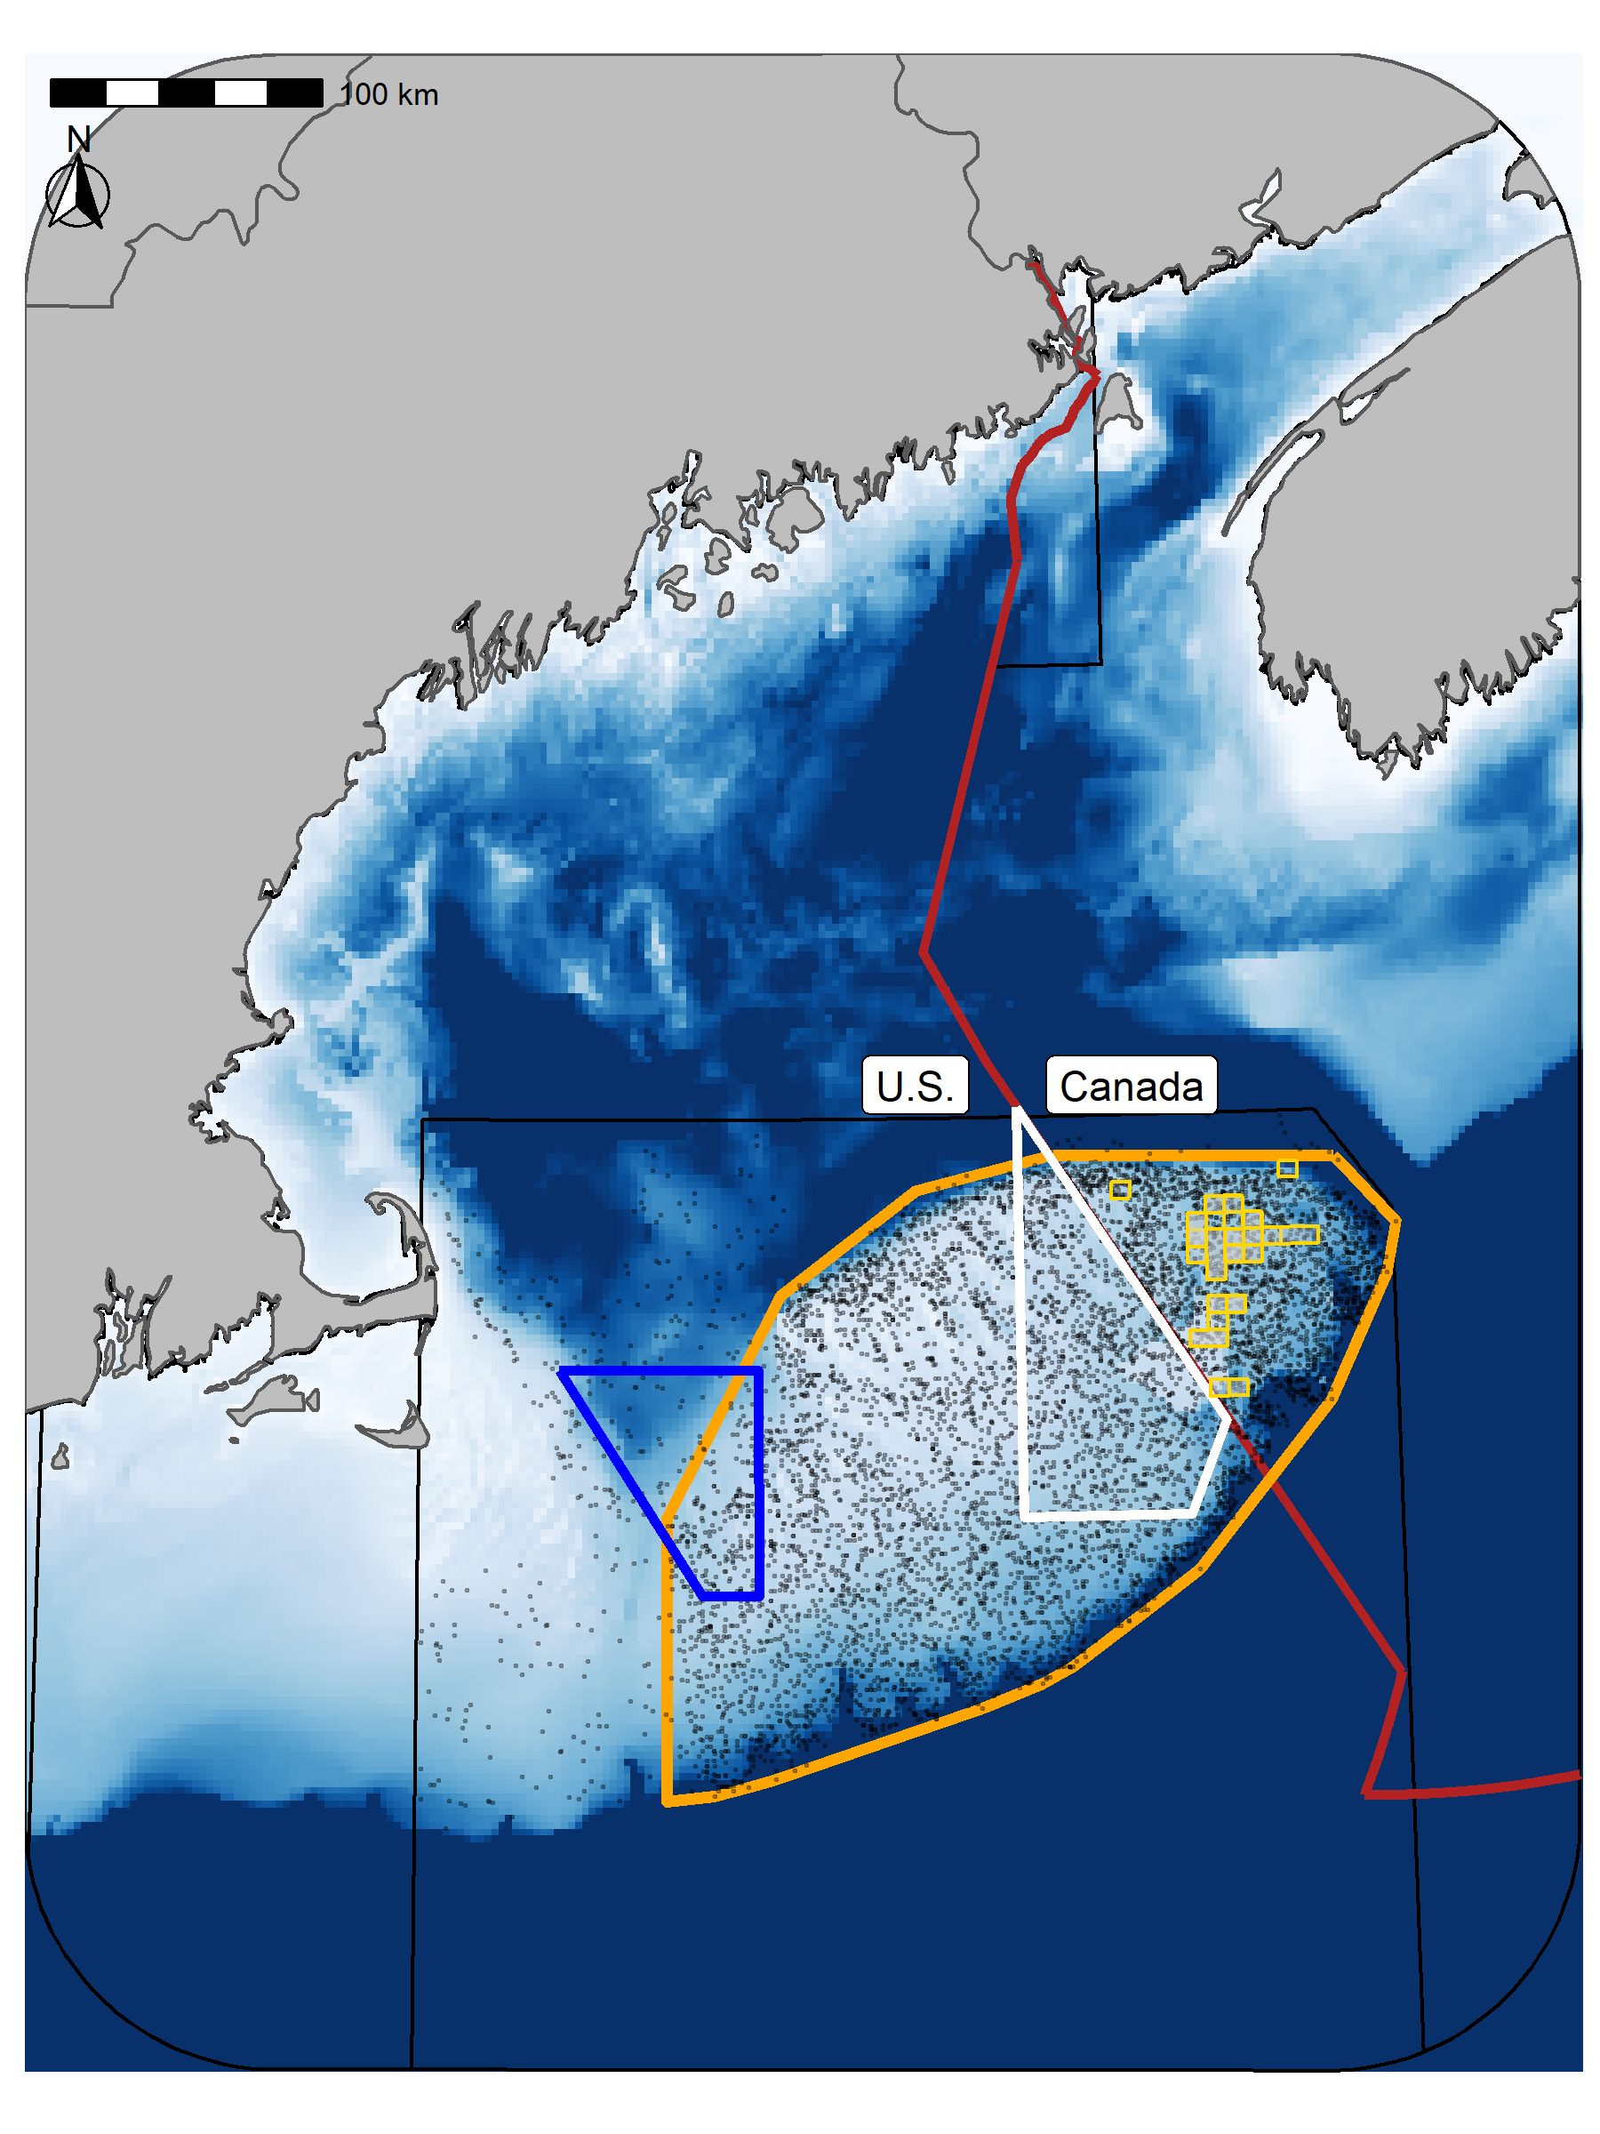

Figure 1: Georges Bank (GB) study area. Points represent the sample locations for each of the three surveys and the orange outline represets the core region of GB included in these analyses (42,000 km²). In the U.S. the blue polygon is Closed Area I (CA I) and the white polygon is Closed Area II (CA II). In Canada the small gold bordered cells (each cells covers an area of approximately 42.7 km²) represent areas which have been included in either the cod or yellowtail closures at least once. Some of the cells have been part of both closures and not all cells are closed each year; darker fill indicates cells which have been closed more frequently. The red line indicates the Canadian exclusive economic zone (EEZ).

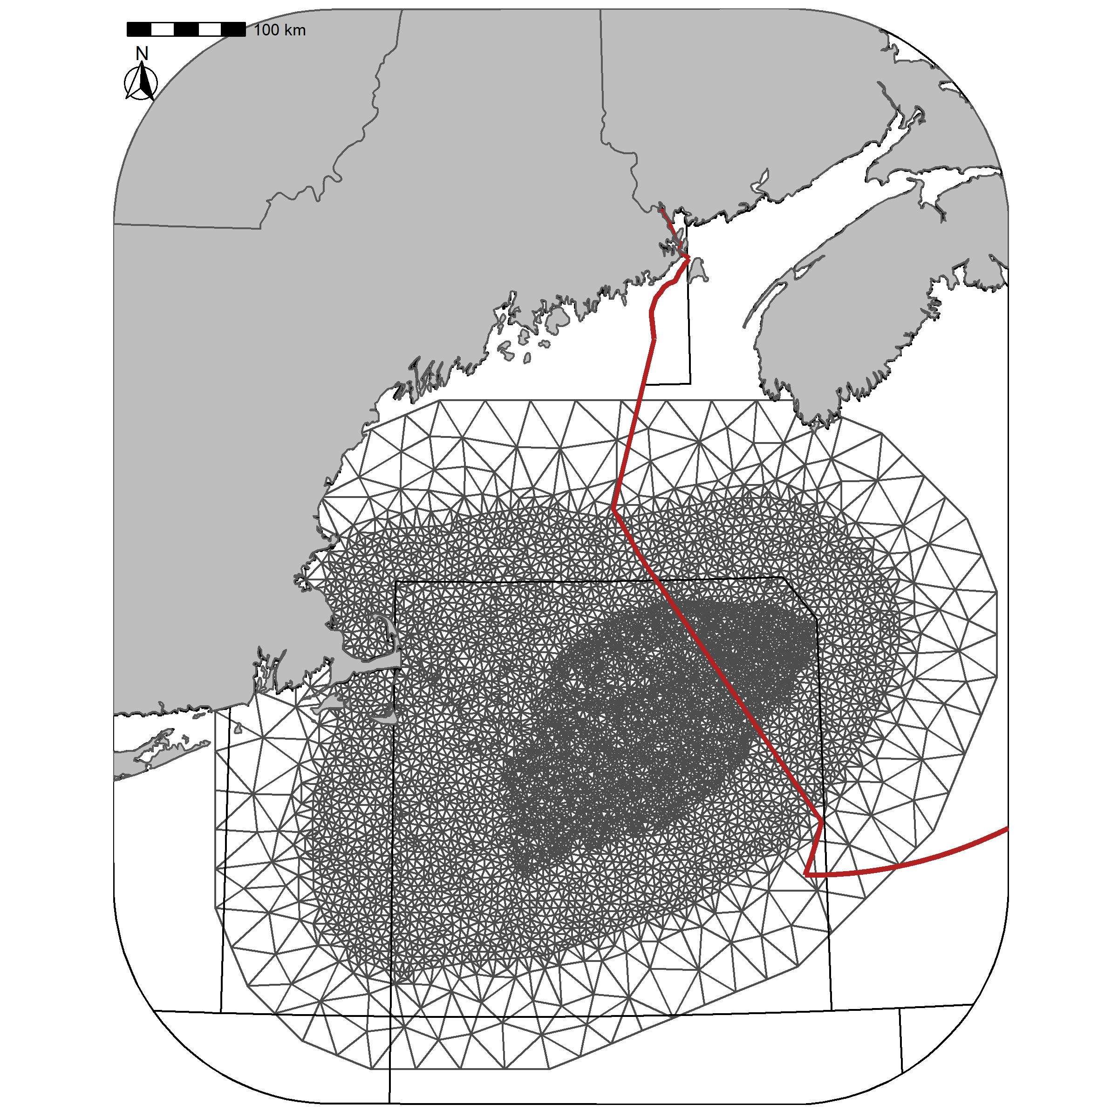

Figure 2: Delaunay triangular mesh used for the spatial fields mesh. The mesh contains 6610 vertices.

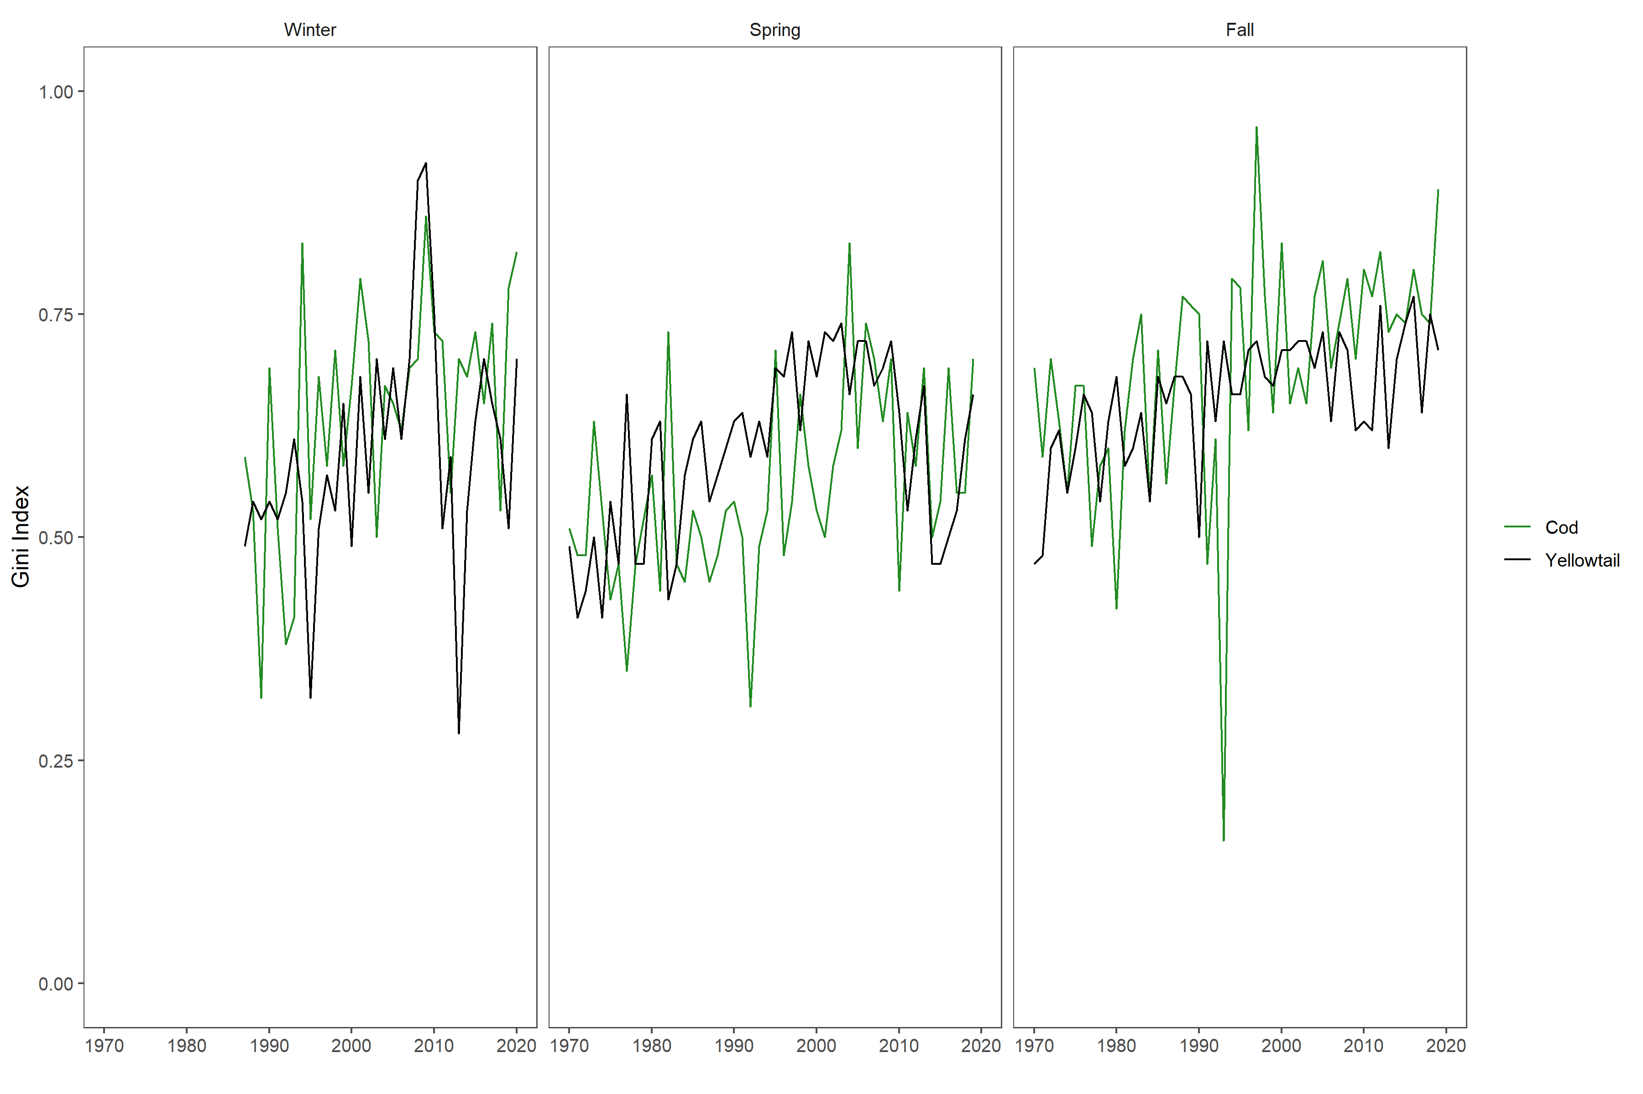

Figure 3: Gini Index

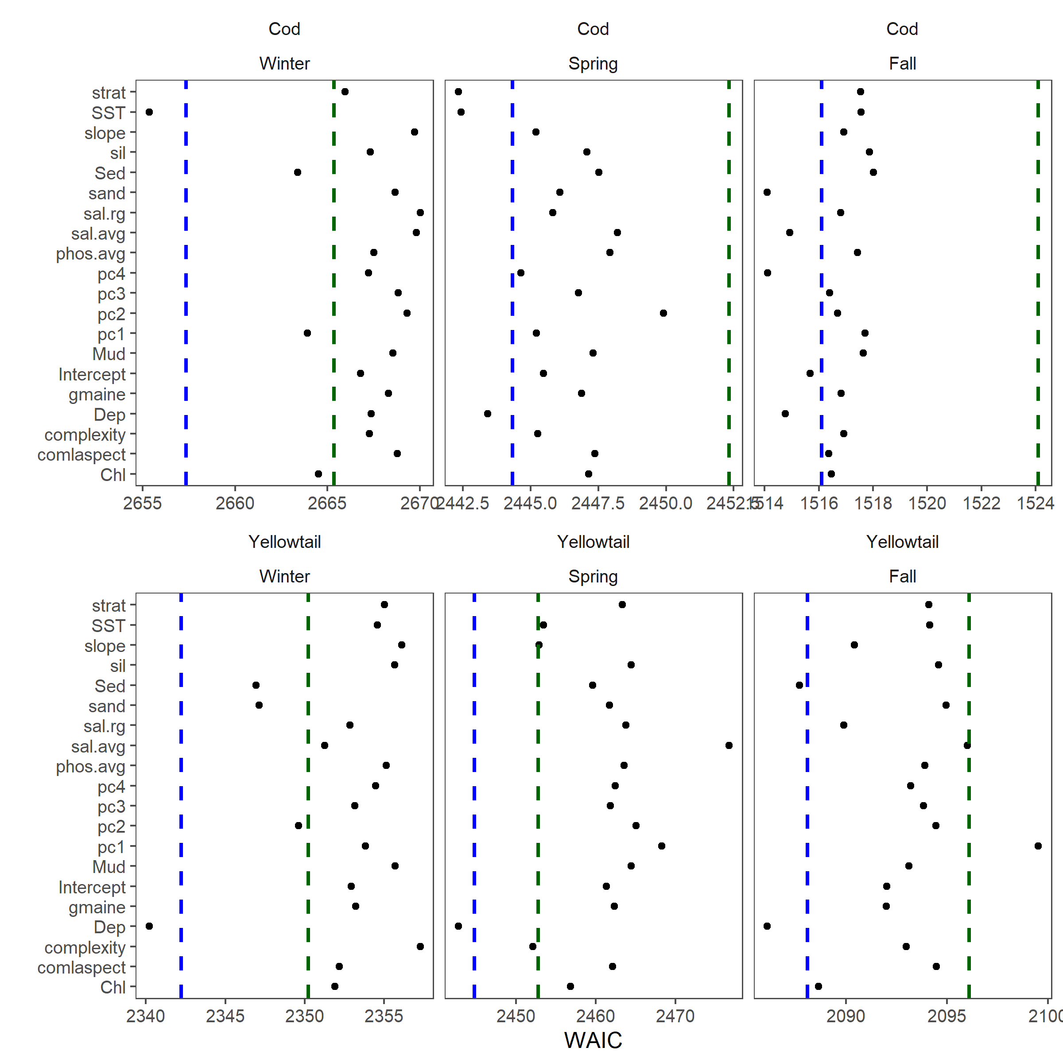

Figure 4: Initial stage of forward model selection using each of the environmental covariates individually. This model selection was done using a static random field. Blue dashed line represents 2 WAIC units larger than the preferred model, the red dashed line is 10 WAIC units larger than the preferred model WAIC.

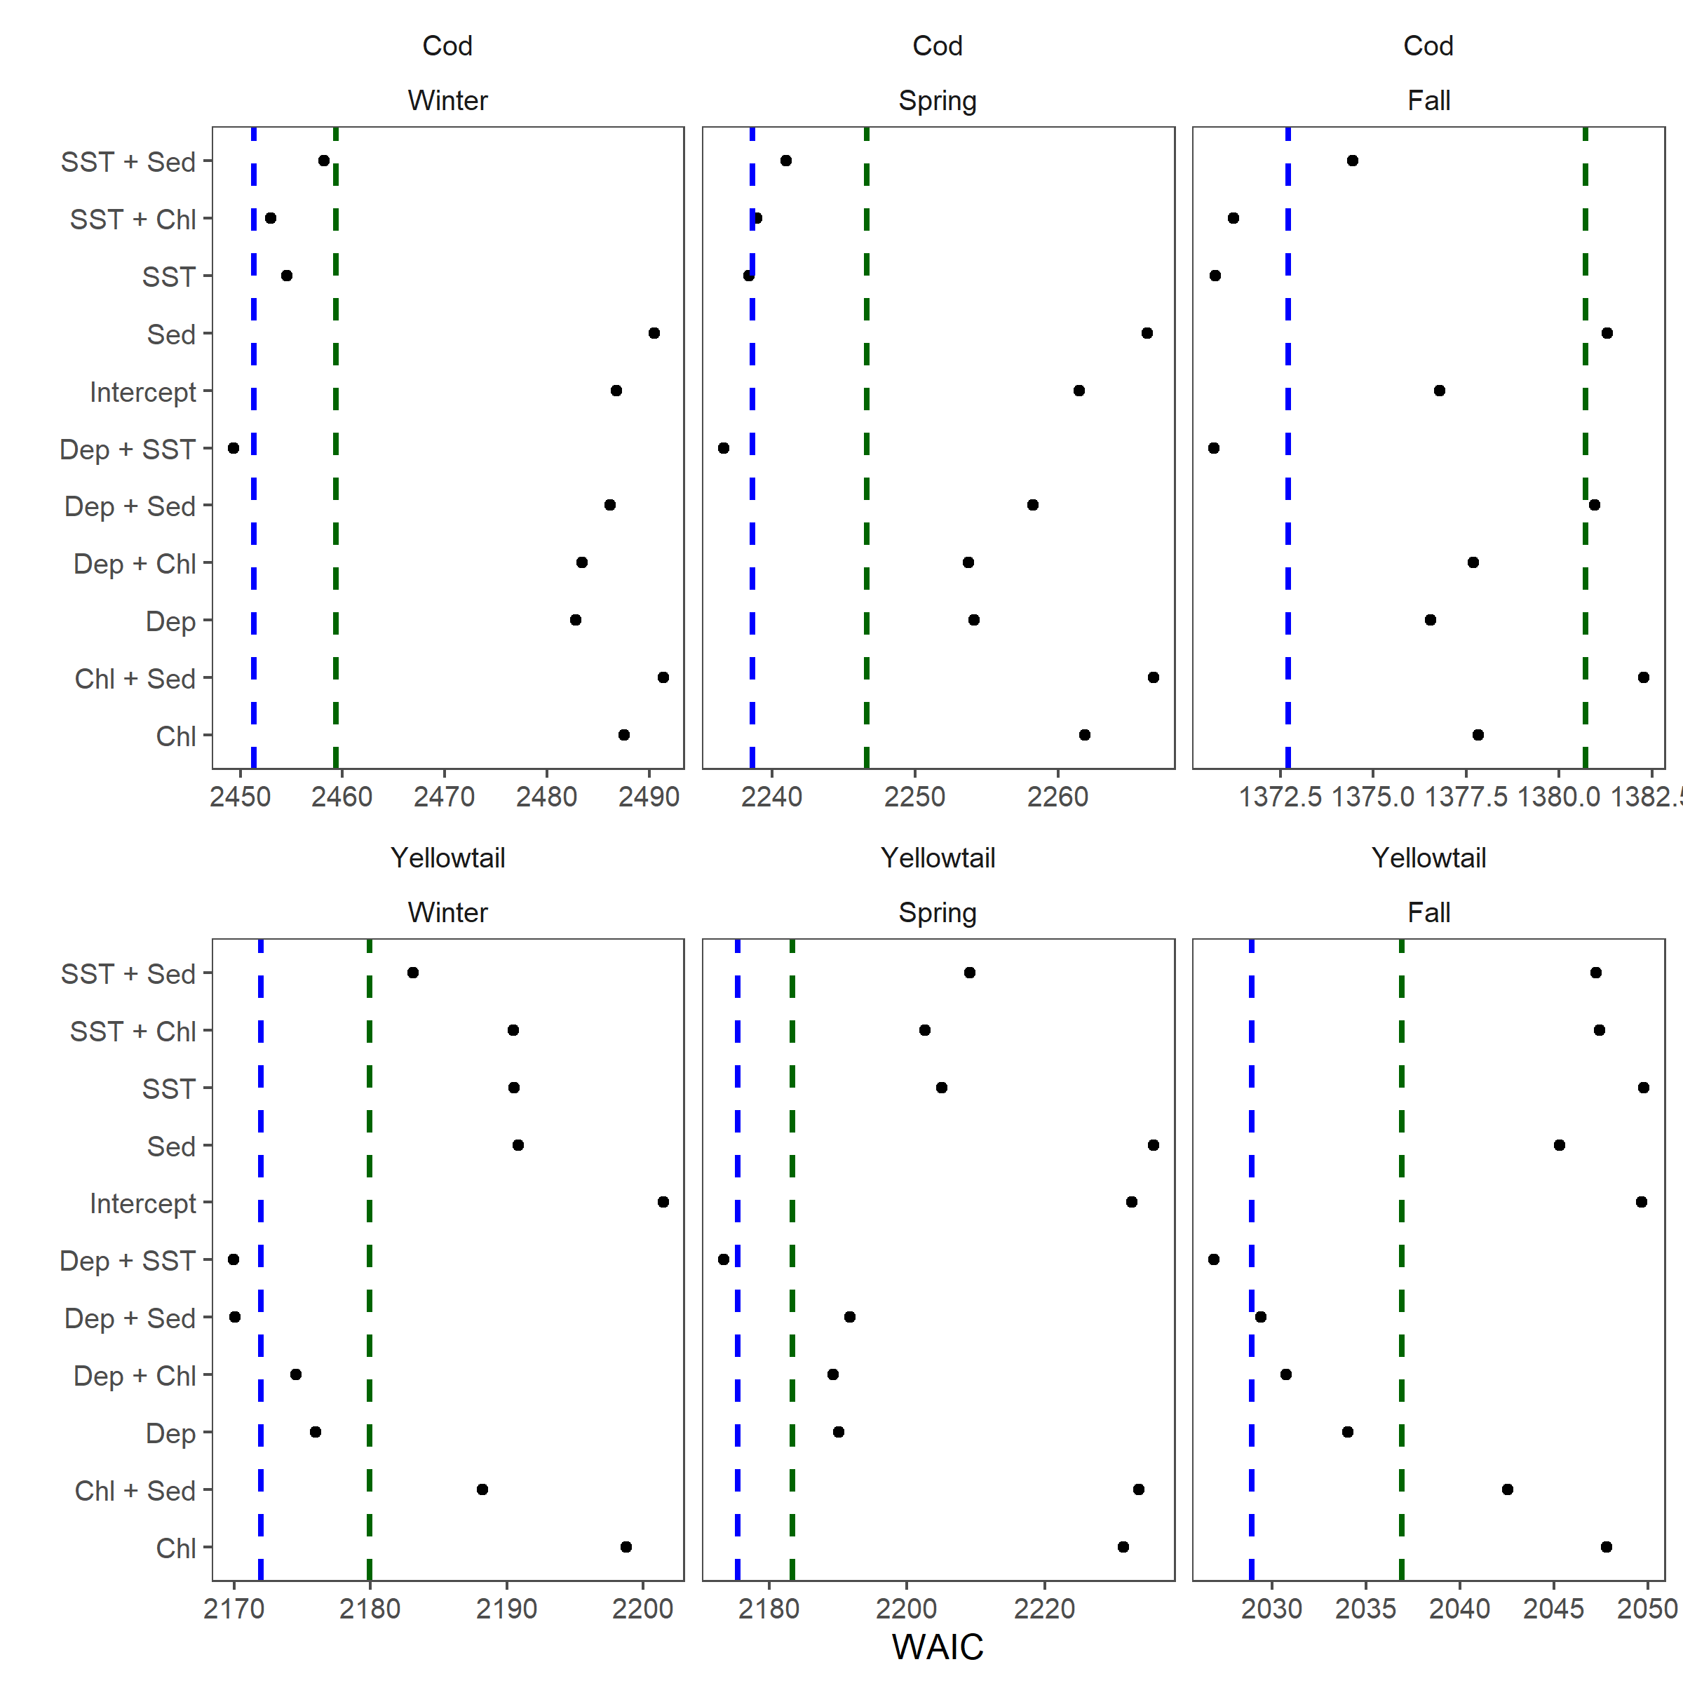

Figure 5: Stage 2 of model selection including additive models with 2 covariates based on the covariates identified in the initial model selection stage. These models were compared using the 10-year random field models. Blue dashed line represents 2 WAIC units larger than the preferred model, the red dashed line is 10 WAIC units larger than the preferred model WAIC.

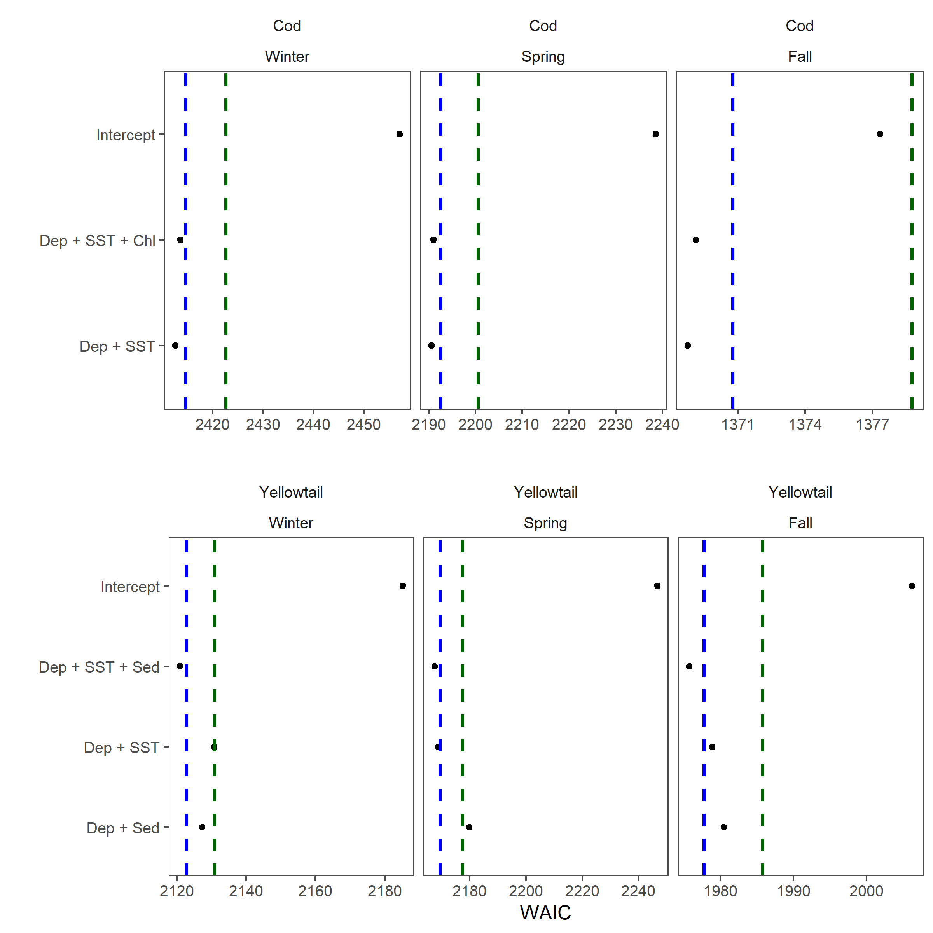

Figure 6: Final stage of covariate model selection which includes model with up to 3 covariate terms based on models selected at stage 2. Blue dashed line represents 2 WAIC units larger than the preferred model, the red dashed line is 10 WAIC units larger than the preferred model WAIC.

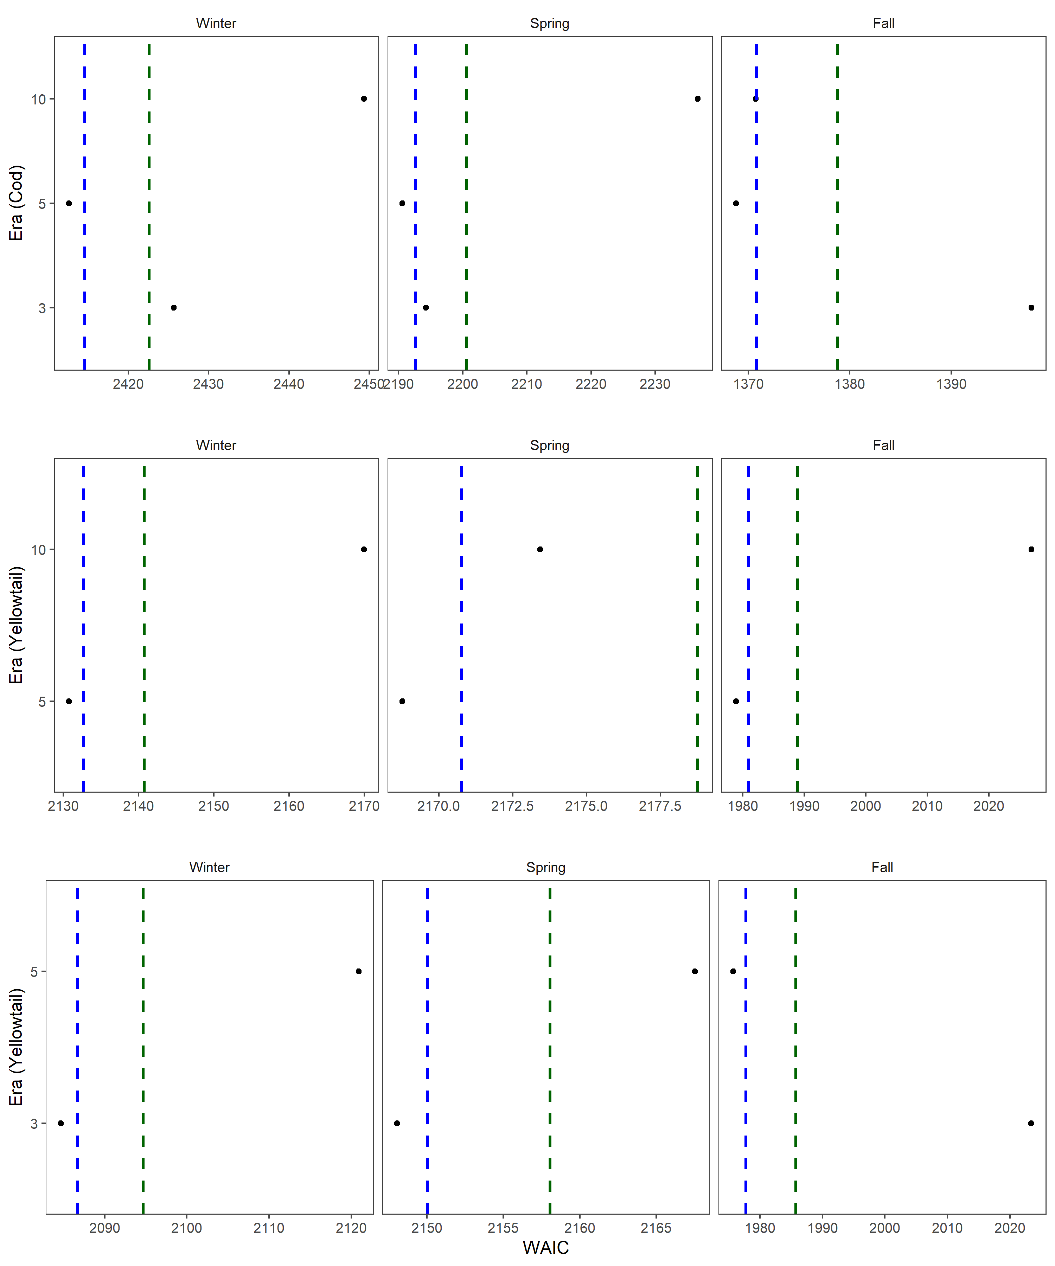

Figure 7: Model selection comparing the random fields models. For cod the model used is Dep + SST for all of the random fields. For Yellowtail the 5 and 10 year random fields were compared using the Dep + SST model, while the 5 and 3 fields were compared using the slightly preferred Dep + SST + Sed model. Blue dashed line represents 2 WAIC units larger than the preferred model, the red dashed line is 10 WAIC units larger than the preferred model WAIC.

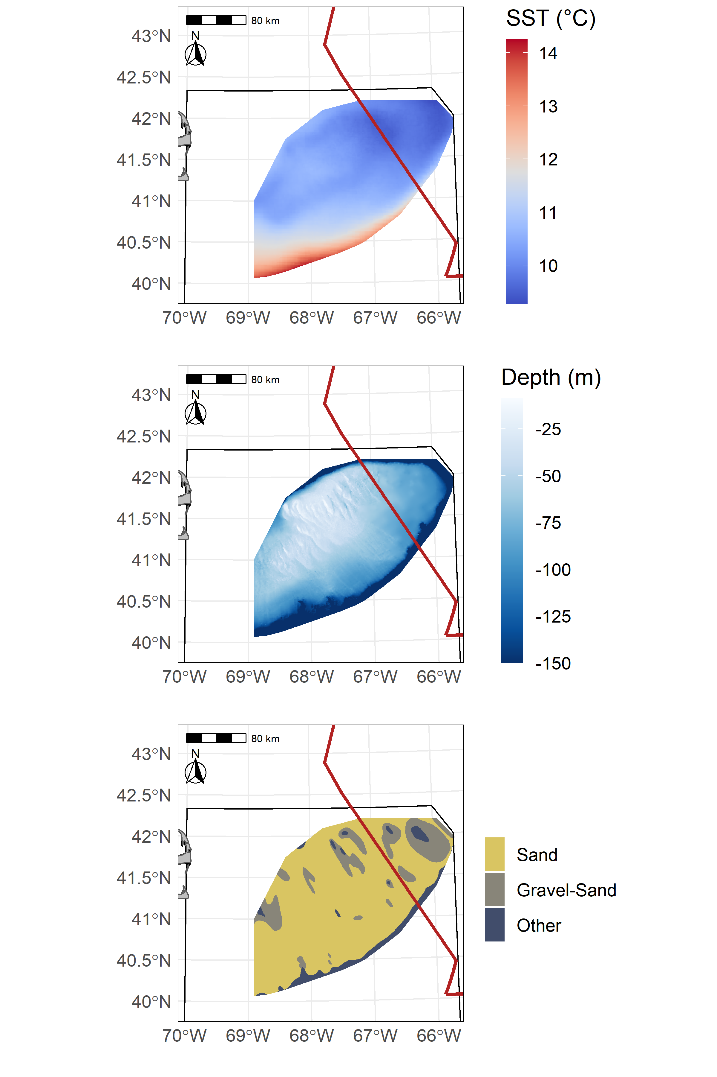

Figure 8: Average Sea Surface Temperature on Georges Bank (GB) from 1997-2008 (SST in °C) in the top panel, GB bathymetry (depth in meters) in the center panel, and GB sediment type in the bottom panel.

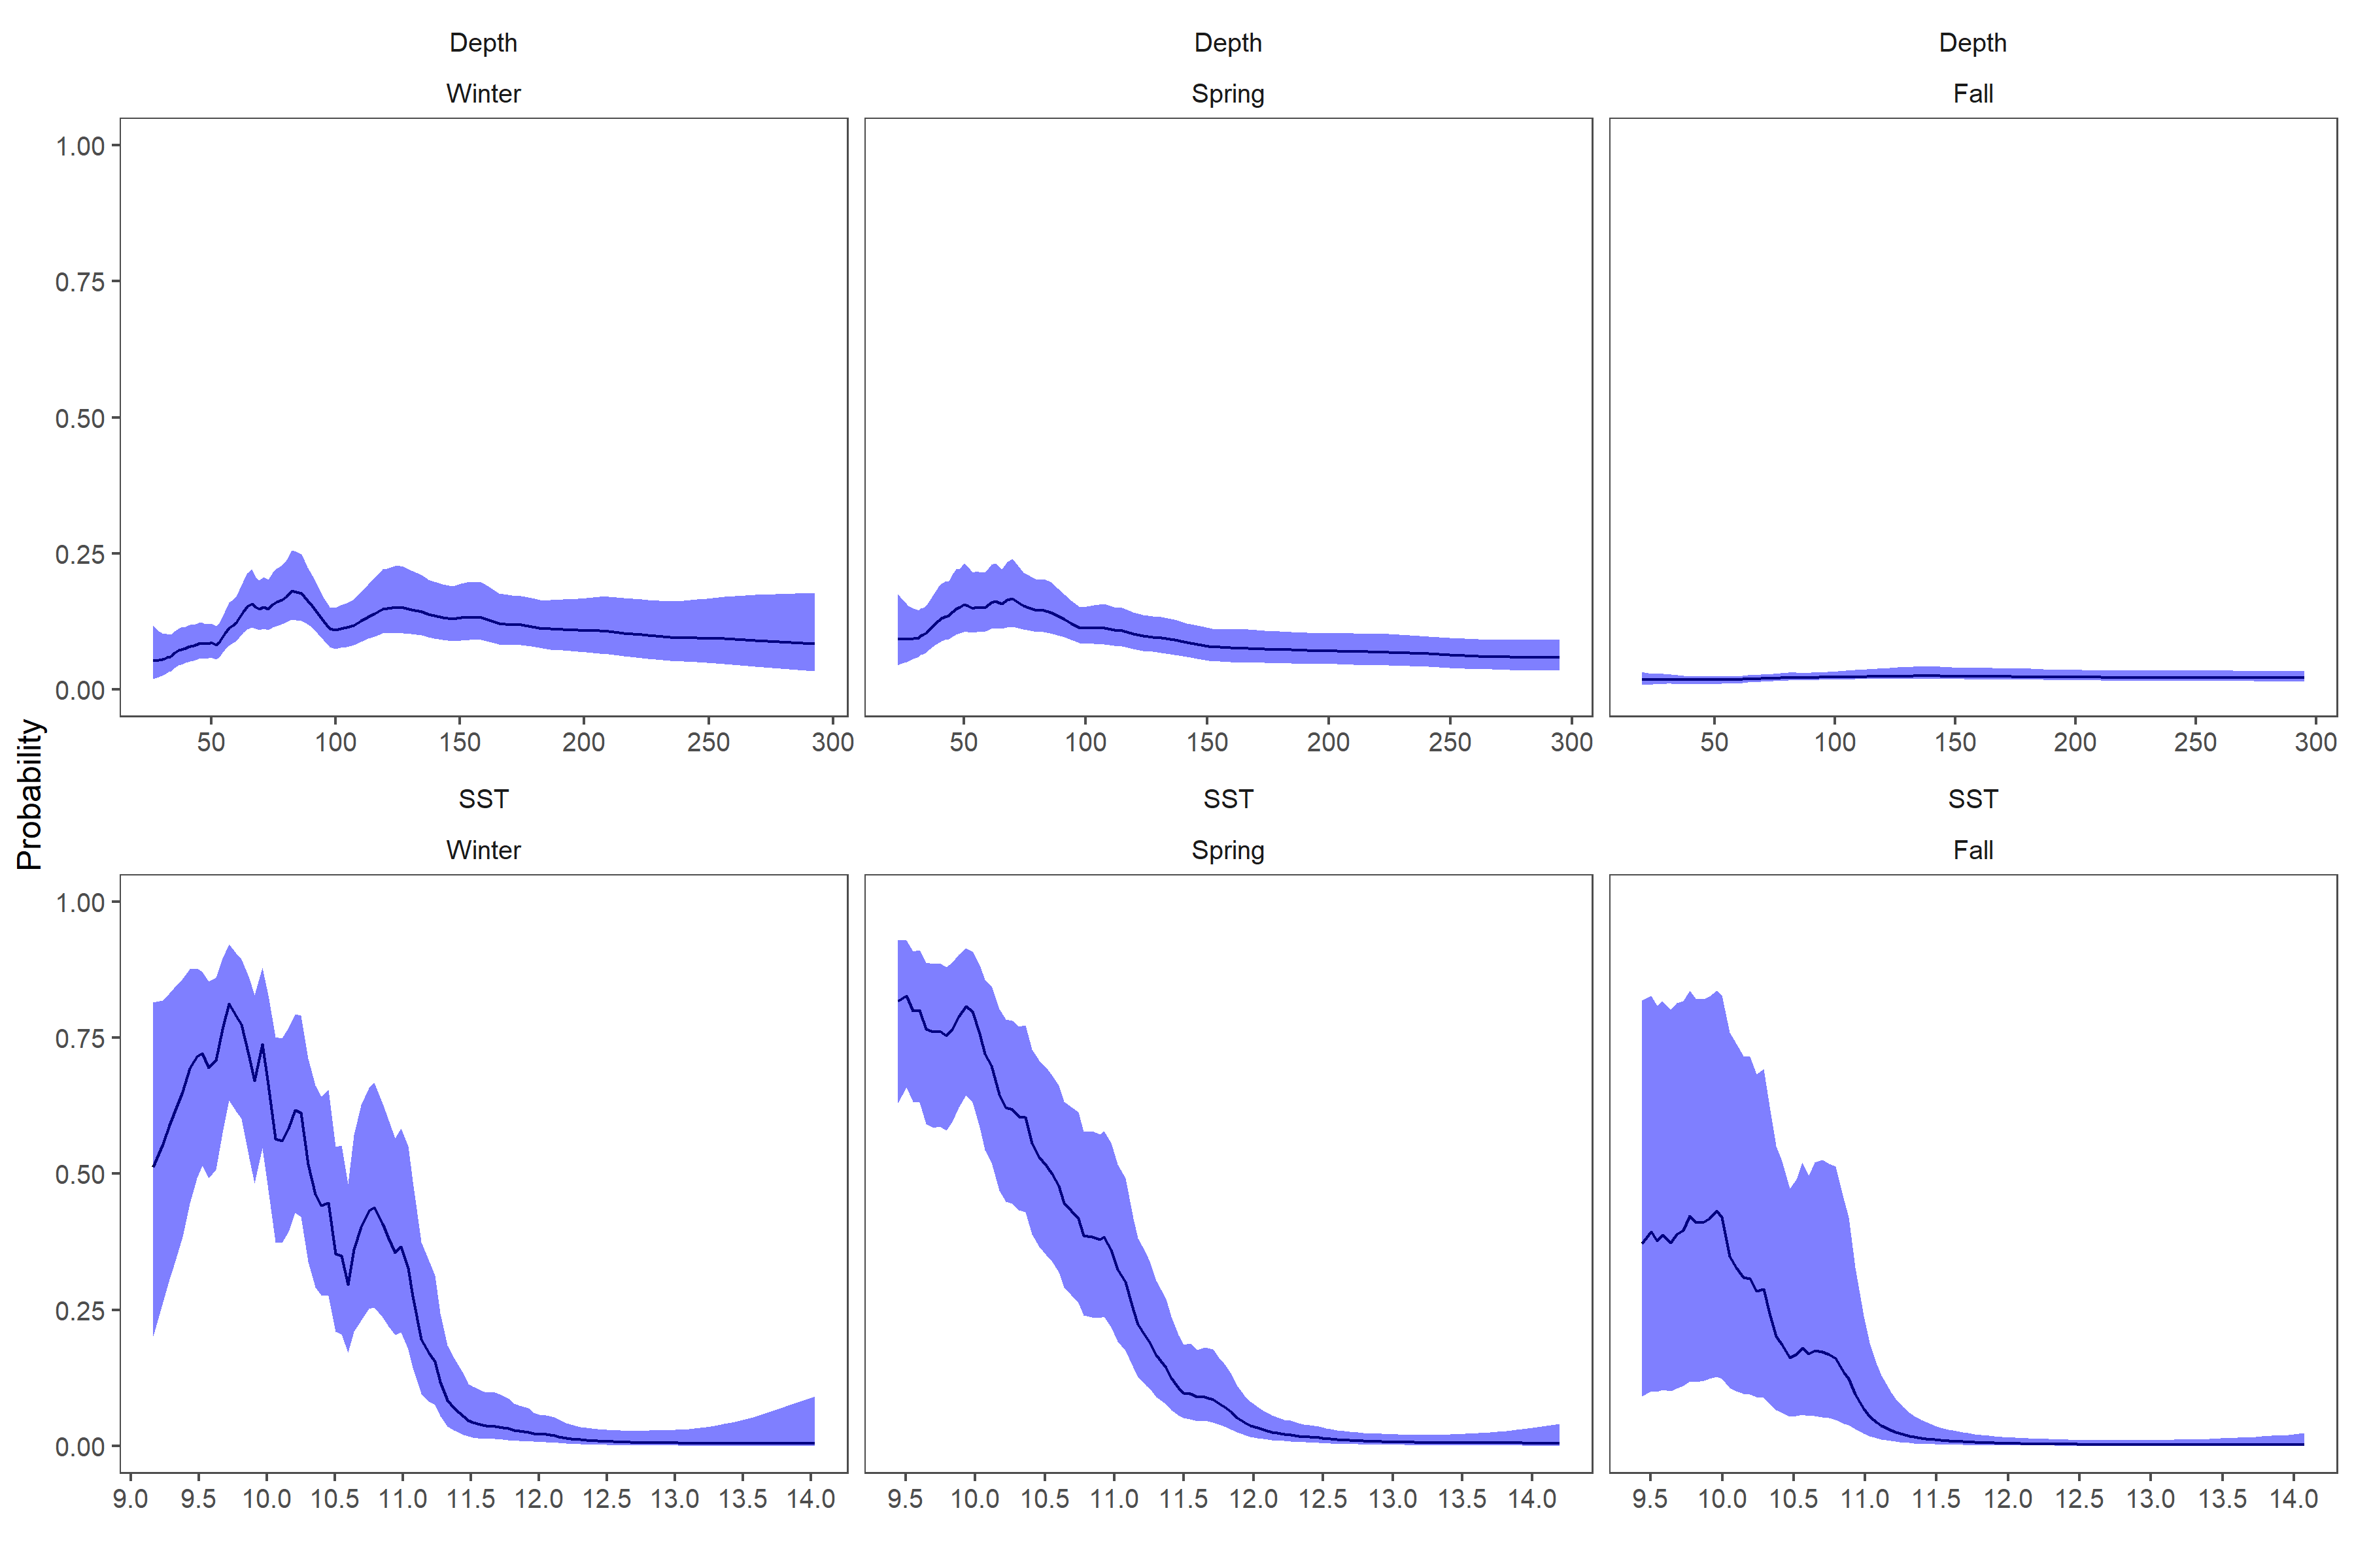

Figure 9: Fixed effects for cod from each survey, top row is the depth covariate effect, bottom row is the SST effect. Results transformed to the probability scale and the blue shaded region represents the 95% credible interval.

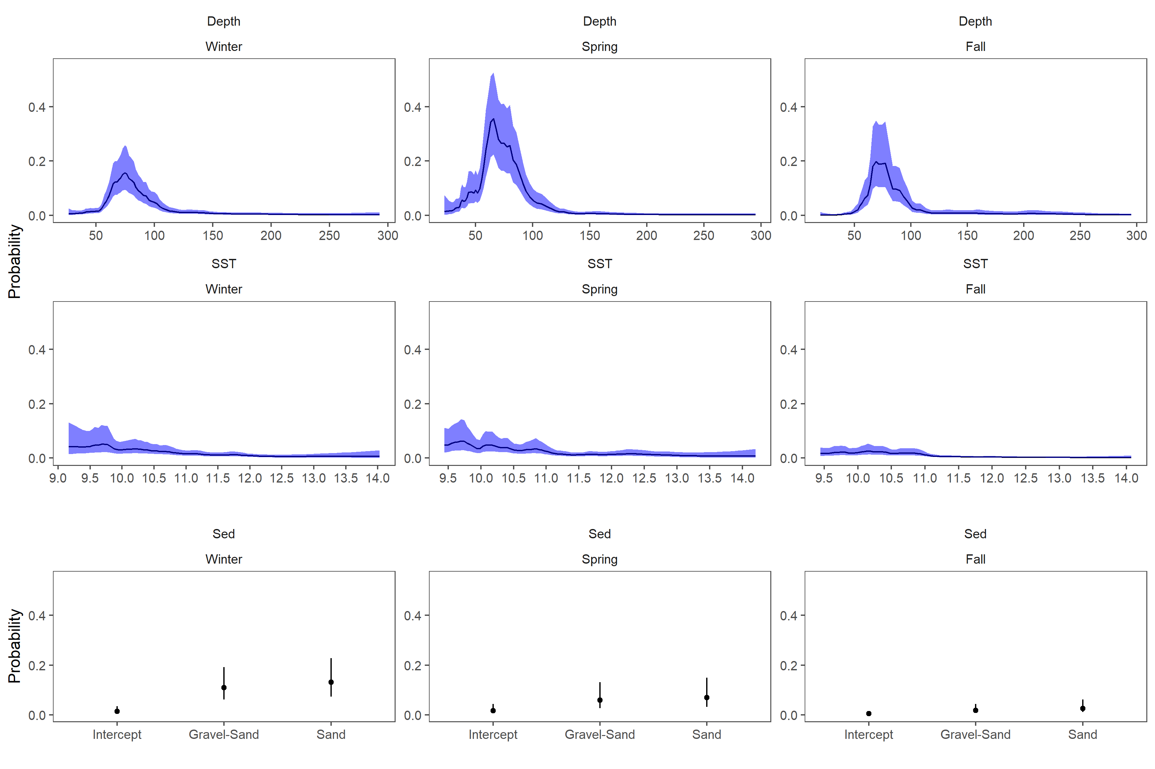

Figure 10: Fixed effects for yellowtail from each survey, the top row is the depth covariate effect, middle row is the SST effect and the bottom row is the effect of sediment type. Results transformed to the probability scale, and the blue shaded region and the error bars represent the 95% credible intervals.

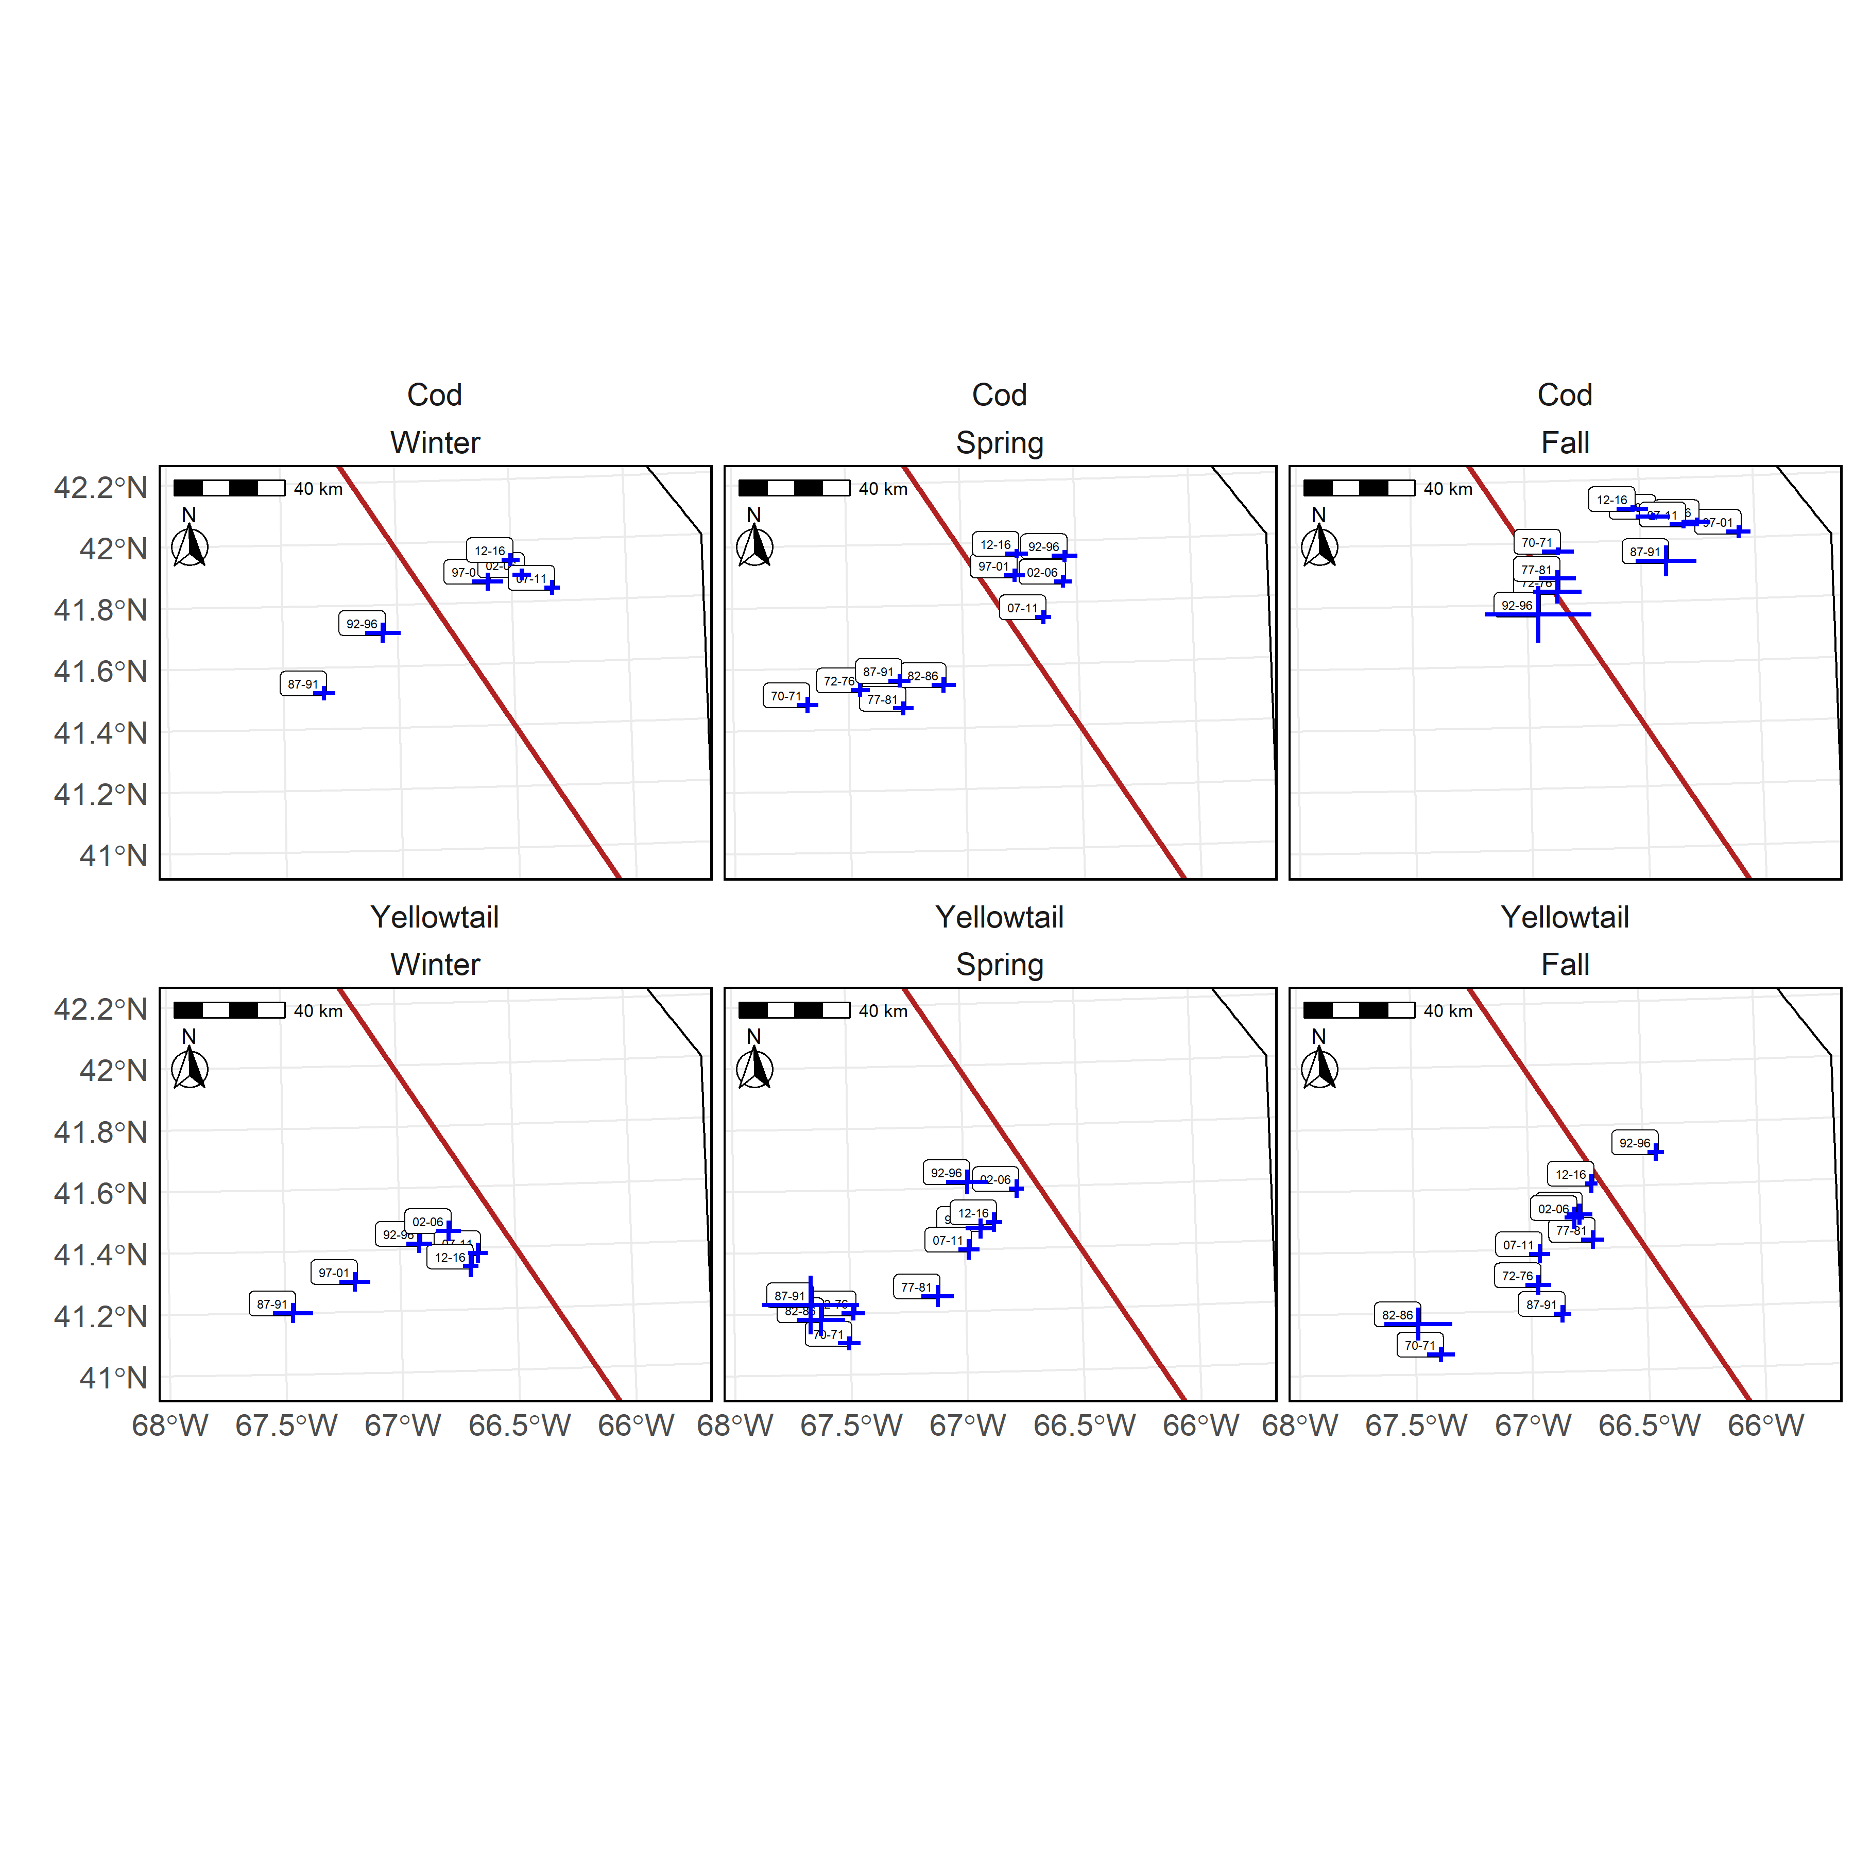

Figure 11: Center of Gravity (COG) for the high EP areas for cod (top panel) and yellowtail (bottom panels) in the Winter (left), Spring (center), and Fall (right). Blue lines indicate ±3 standard deviation units from the mean COG for each era using the 5 year random field models. Labels indicate the years associated with each era and the red line is border between the U.S. and Canada.

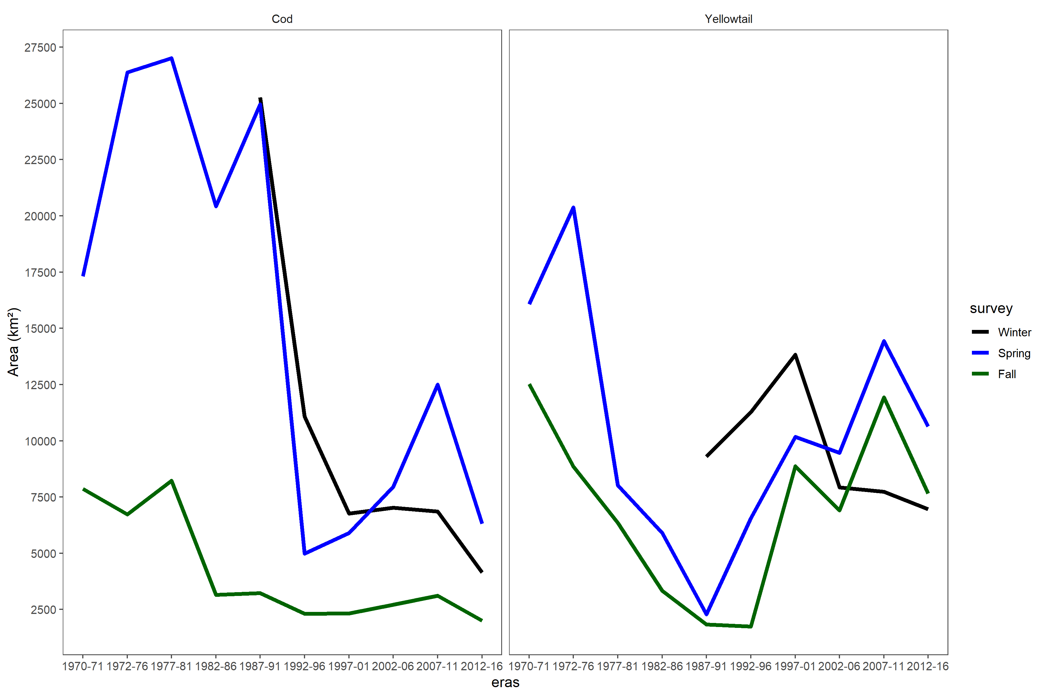

Figure 12: Time series of the total area on GB classified as high EP for each of the three surveys. The cod time series is on the left and the yellowtail on the right. The black line represents the Winter trend, the Blue line is the Spring trend and the red line is the Fall trend.

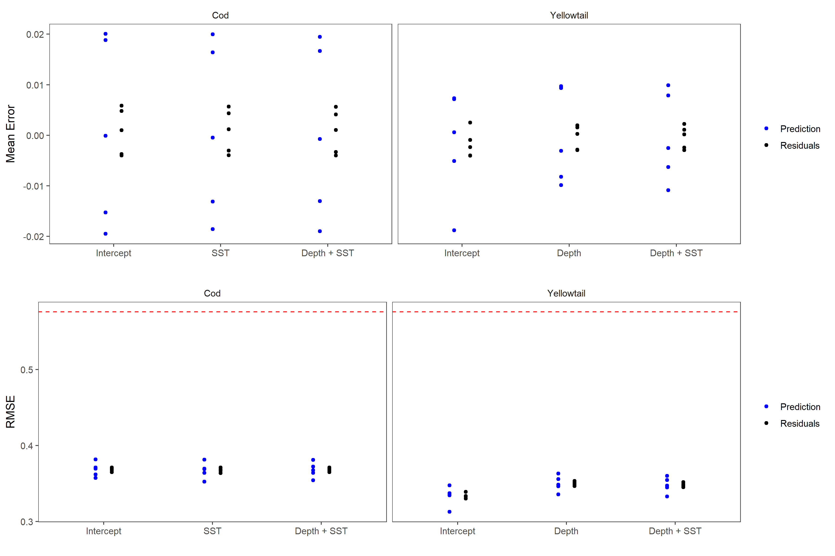

Figure 13: Results of 5 fold cross validation analyses. Top panels represents the mean error for each of the three covariate models tested for cod and yellowtail. Blue points represent the prediction error from the testing dataset, while the black points are the residuals from the training dataset. The bottom panels are the Root Mean Squared Error (RMSE) for these models. The dashed line represents the RMSE for randomly generated data and represents the RMSE for a model with no predictive ability.

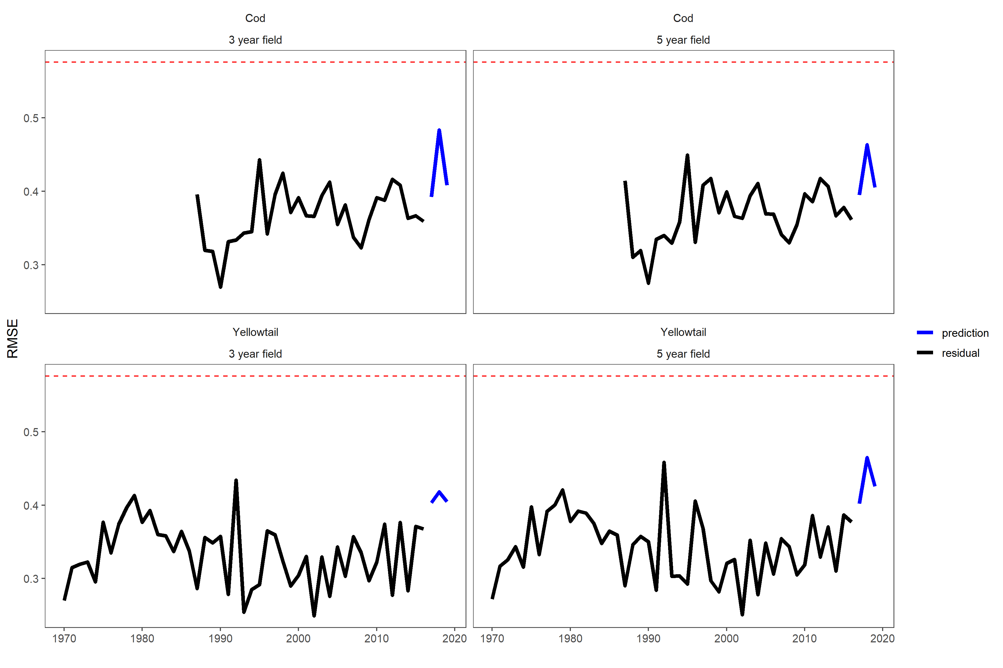

Figure 14: The residual Root Mean Squared Error for the model in each year in black. The blue lines represent the prediction RMSE for years 2017, 2018, and 2019. The model used include the SST and Depth covariates, the cod results are in the top row and yellowtail in the bottom row and the results for the 3-year fields are on the left and the 5-year random field on the right. The dashed line represents the RMSE for randomly generated data and represents the RMSE for a model with no predictive ability.

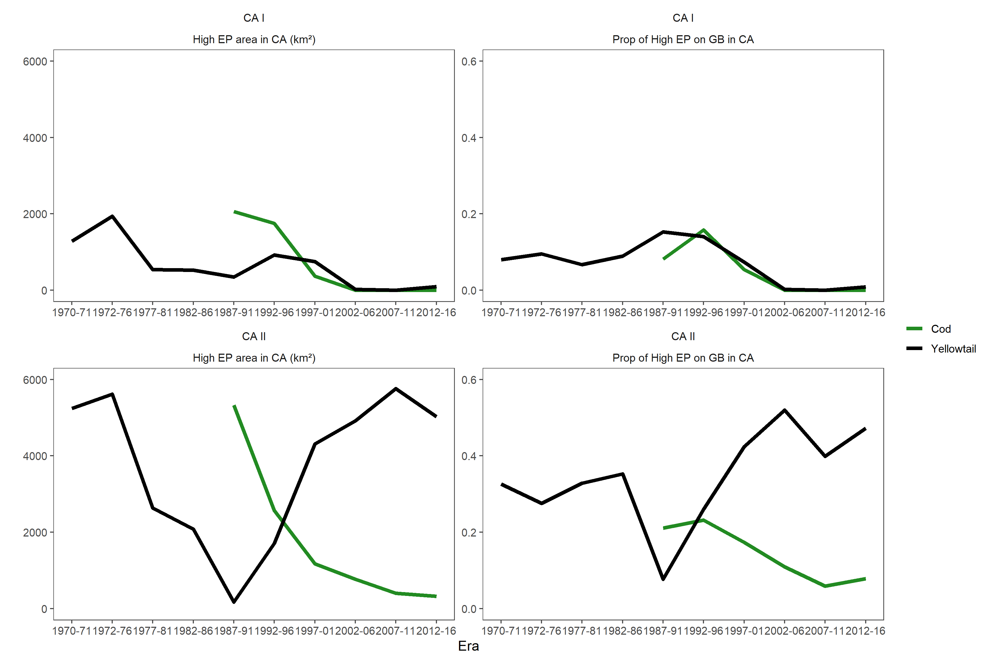

Figure 15: The high EP area located within the U.S. Closed Area I (CA I; top row) and Closed Area II (CA II; bottom row). The panels on the left represents the total area of high EP by era. The panels on the right is the proporiton of the total high EP on GB which is located within the closure. The green line represent cod and the black line represents yellowtail.

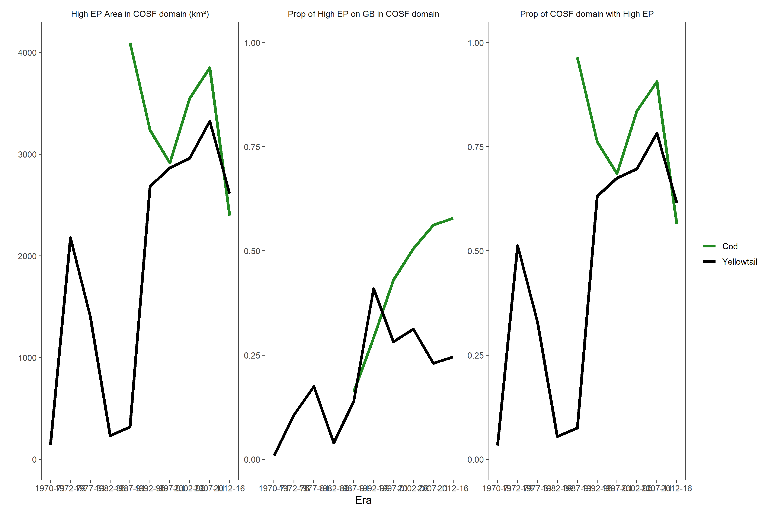

Figure 16: The high EP area located within the Canadian Offshore Scallop Fishing (COSF) domain during spawning in each era. The panel on the left represents the total area of high EP, the middle panel is the proportion of the total high EP area on GB found within the COSF domain. The panel on the right is the proporiton of the COSF domain that is classified as high EP. The green line represents cod and th e black line represents yellowtail.

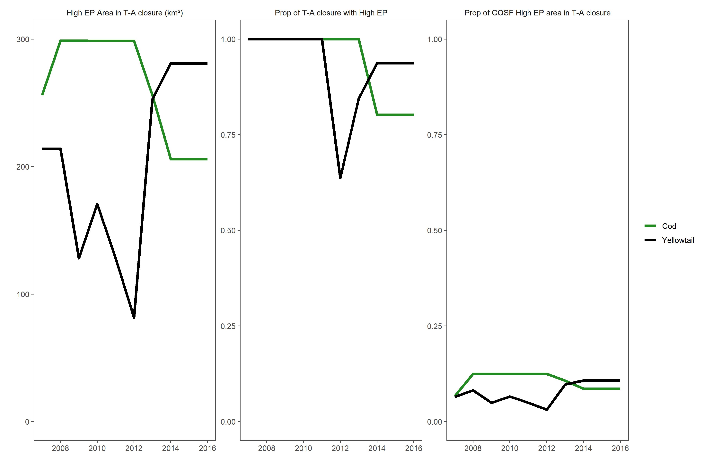

Figure 17: The high EP area located within the Candian Offshore Scallop Fishery (COSF) cod and yellowtail closures during spawning for each species. The panel on the left represents the total area of high EP by year for each closure, the middle panel is the proportion of the closure with a high EP. The panel on the right is the proporiton of the total high EP within the COSF domain that is located within the closure. The green line represents cod closure and the black line represents yellowtail.

# References

Aeberhard, W.H., Flemming, J.M., and Nielsen, A. 2018. Review of State-Space Models for Fisheries Science. Annual Review of Statistics and Its Application **5**(1): 215–235. Annual Reviews. doi:[10.1146/annurev-statistics-031017-100427](https://doi.org/10.1146/annurev-statistics-031017-100427).

Allyn, A.J., Alexander, M.A., Franklin, B.S., Massiot-Granier, F., Pershing, A.J., Scott, J.D., and Mills, K.E. 2020. Comparing and synthesizing quantitative distribution models and qualitative vulnerability assessments to project marine species distributions under climate change. PLOS ONE **15**(4): e0231595. Public Library of Science. doi:[10.1371/journal.pone.0231595](https://doi.org/10.1371/journal.pone.0231595).

Andrushchenko, I., Legault, C.M., Martin, R., Brooks, E.N., Wang, Y., and Andrews, S. 2018. Assessment of Eastern Georges Bank Atlantic Cod for 2018. TRAC. Ref. Doc **2018/01**: 97.

Bundy, A., Heymans, J.J., Morissette, L., and Savenkoff, C. 2009. Seals, cod and forage fish: A comparative exploration of variations in the theme of stock collapse and ecosystem change in four Northwest Atlantic ecosystems. Progress in Oceanography **81**(1): 188–206. doi:[10.1016/j.pocean.2009.04.010](https://doi.org/10.1016/j.pocean.2009.04.010).

Cadrin, S.X. 2020. Defining spatial structure for fishery stock assessment. Fisheries Research **221**: 105397. doi:[10.1016/j.fishres.2019.105397](https://doi.org/10.1016/j.fishres.2019.105397).

CBD. 2018, May 11. Aichi Biodiversity Targets. Available from <https://www.cbd.int/sp/targets/> [accessed 11 March 2020].

DFO. 2014. Scallop Fishery Area/Time Closure to Reduce Yellowtail Flounder By-catch on Georges Bank in 2014.

DFO. 2019. Scallop Fishery Area/Time Closure to Protect Atlantic Cod (Gadus morhua) Spawning Aggregations in NAFO Division 5Z (Georges Bank).

Fahay, M.P., Berrien, P.L., Johnson, D.L., and Morse, W.W. 1999. Atlantic Cod, *Gadus morhua*, Life History and Habitat Characteristics. NOAA Technical Memorandum.

Finley, M., Brooks, E.N., McCurdy, Q., Barrett, M.A., and Wang, Y. 2019. Assessment of Haddock on Eastern Georges Bank for 2019. TRAC. Ref. Doc **2019/xx**: 92.

Greenan, B.J.W., Shackell, N.L., Ferguson, K., Greyson, P., Cogswell, A., Brickman, D., Wang, Z., Cook, A., Brennan, C.E., and Saba, V.S. 2019. Climate Change Vulnerability of American Lobster Fishing Communities in Atlantic Canada. Front. Mar. Sci. **6**. Frontiers. doi:[10.3389/fmars.2019.00579](https://doi.org/10.3389/fmars.2019.00579).

Greenlaw, M.E., Sameoto, J.A., Lawton, P., Wolff, N.H., Incze, L.S., Pitcher, C.R., Smith, S.J., and Drozdowski, A. 2010. A geodatabase of historical and contemporary oceanographic datasets for investigating the role of the physical environment in shaping patterns of seabed biodiversity in the Gulf of Maine. Available from <http://waves-vagues.dfo-mpo.gc.ca/Library/342505.pdf>.

Johnson, D.L., Morse, W.W., Berrien, P.L., and Vitaliano, J.J. 1999. Yellowtail Flounder, Limanda ferruginea, Life History and Habitat Characteristics. NOAA Technical Memorandum.

Legault, C.M., and McCurdy, Q.M. 2018. Stock Assessment of Georges Bank Yellowtail Flounder for 2018. TRAC. Ref. Doc **2018/03**: 64.

Link, J., Almeida, F.P., Valentine, P., Auster, P., Reid, R.N., and Vitaliano, J. 2005. The Effects of Area Closures on Georges Bank. *In* Benthic Habitats and the Effects ofFishing (American Fisheries Society, Symposium 41,Bethesda, Maryland, 12–14 November, 2002). (Eds P.W.Barnes and J.P. Thomas). pp. 345–368.

McMullen, K.Y., Paskevich, V.F., and Poppe, L.J. 2014. 2014, GIS data catalog, in Poppe, L.J., McMullen, K.Y., Williams, S.J., And Paskevich, V.F., Eds., 2014, USGS east-coast sediment analysis: Procedures, database, and GIS data (ver. 3.0, November 2014). Available from <http://pubs.usgs.gov/of/2005/1001/>.

Murawski, S.A., Brown, R., Lai, H.-L., Rago, P.J., and Hendrickson, L. 2000. Large-scale closed areas as a fishery-management tool in temperate marine systems: The Georges Bank experience. Bull. US FIsh Comm **66**: 775–798. Available from <https://www.ingentaconnect.com/content/umrsmas/bullmar/2000/00000066/00000003/art00020> [accessed 24 July 2019].

NFSC. 2012. 54th Northeast Regional Stock Assessment Workshop (54th SAW), assessment summary report. Available from <https://repository.library.noaa.gov/view/noaa/4184> [accessed 1 September 2020].

O’Brien, L., Burnett, J., and Mayo, R. 1993. Maturation of 19 Species of finish off the northeast coast of the United States, 1985-1990. NOAA Technical Report NMFS.

O’Keefe, C.E., and DeCelles, G.R. 2013. Forming a Partnership to Avoid Bycatch. Fisheries **38**(10): 434–444. doi:[10.1080/03632415.2013.838122](https://doi.org/10.1080/03632415.2013.838122).

Pershing, A.J., Alexander, M.A., Hernandez, C.M., Kerr, L.A., Bris, A.L., Mills, K.E., Nye, J.A., Record, N.R., Scannell, H.A., Scott, J.D., Sherwood, G.D., and Thomas, A.C. 2015. Slow adaptation in the face of rapid warming leads to collapse of the Gulf of Maine cod fishery. Science **350**(6262): 809–812. American Association for the Advancement of Science. doi:[10.1126/science.aac9819](https://doi.org/10.1126/science.aac9819).

Thorson, J.T., Ianelli, J.N., Munch, S.B., Ono, K., and Spencer, P.D. 2015a. Spatial delay-difference models for estimating spatiotemporal variation in juvenile production and population abundance. Can. J. Fish. Aquat. Sci. **72**(12): 1897–1915. doi:[10.1139/cjfas-2014-0543](https://doi.org/10.1139/cjfas-2014-0543).

Thorson, J.T., Shelton, A.O., Ward, E.J., and Skaug, H.J. 2015b. Geostatistical delta-generalized linear mixed models improve precision for estimated abundance indices for West Coast groundfishes. ICES J Mar Sci **72**(5): 1297–1310. doi:[10.1093/icesjms/fsu243](https://doi.org/10.1093/icesjms/fsu243).

TMGC. 2002. Development of a Sharing Allocation Proposal for Transboundary Resources of Cod, Haddock and Yellowtail Flounder on Georges Bank. Fisheries and Oceans Canada. Fisheries Management Regional Report **2002/01**: 1–59. Available from <http://www.bio.gc.ca/info/intercol/tmgc-cogst/documents/FMR_2002_01.pdf>.

Townsend, D.W., and Pettigrew, N.R. 1997. Nitrogen limitation of secondary production on Georges Bank. J Plankton Res **19**(2): 221–235. doi:[10.1093/plankt/19.2.221](https://doi.org/10.1093/plankt/19.2.221).

Valentine, P., and Lough, R.G. 1991. The Sea Floor Environment and the Fishery of Eastern Georges Bank - The Influence of Geological and Oceanographic Environmental Factors on the Abundance and Distribution of Fisheries Resources of the Northeast United States Continental Shelf. Open- File Rep: 91–439.