ConCat/Split V3.0

What is ConCat/Split?
ConCat/Split is a Windows 95/NT4 context menu extension that provides 2 complementary facilities:

1. A file split facility that lets you easily convert a single large file into several smaller ones. You can copy these smaller files onto floppy disks, or send them through email facilities that will not cope with large files.

2. A file concatenation facility that performs the same operation as the command line "copy /b SrcFile1+SrcFile2 [+SrcFileN] DestnFile" operation. With ConCat you can append any number of files and store the result as a new file, or overwrite one of the original files.

Registered Version Features
The registered version of Split/ConCat adds the following advanced features:

- The ability to automatically create a batch file that will let you join the files back on a system that doesn't have Split/ConCat installed.

- ConCat can re-order the files you want to join, making it unimportant to select the files in the correct order with Explorer in the first place.

Installation
ConCat is supplied as a compressed file archive. Copy the compressed file to an empty floppy disk or new sub-directory on your hard disk & extract the files. When you have uncompressed the supplied file, you should have the following files in addition to the original:


ConCat.dll The ConCat Context Menu DLL


ConCat.doc WordPad documentation


ConCat.txt Text documentation


ConCat.inf The Setup Information File

Note: If you already have an existing version of ConCat installed on your machine, you should remove it now by using the Control Panel, Add/Remove Programs applet. See the information below for details.

To Install ConCat, select the ConCat.inf Setup Information File in an Explorer window and choose File, Install, or right click on the file and choose the Install menu.

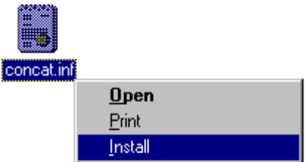

How To Use It
Split
Anytime you select a single file in an Explorer window, you will find that you have an extra context menu item "Split File...".
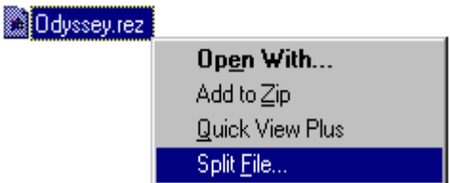

If you choose this item you will see the Split dialog box (retail version shown):

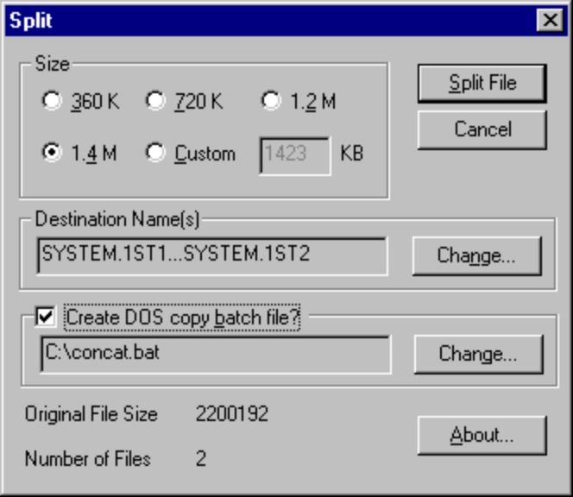

Operation of this dialog box is straight forward. The size radio buttons provide you with pre-set file sizes for common floppy disk sizes, and the option of a custom size setting.

The destination name shows the range of file names that you will get as a result of the split operation. You can change the file name (and path) for the destination files if you use the Change button.

Additionally the retail version of Split also allows you to create a batch file with the DOS command to enable you to rejoin the files easily on any MSDOS compatible system that doesn't have Split/ConCat installed.

To perform the split operation, press the Split File button.

Note: the split operation is non-destructive, it will not delete your original file.

Operation is fast (depending only on the size of file you are splitting).

Concatenate
Anytime you select more than a single file in an Explorer window, you will find that you have an extra context menu item "Concatenate Files...".

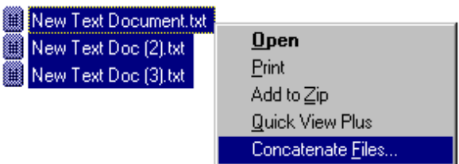

The order of the items in the Explorer window dictates the order that the files are copied. The first file is always the one with the focus (dotted rectangle). If you select the first item, hold the shift key and click the last item that you want. Then right click on the first item to bring up the context menu you should get the desired result.

If you choose the Concatenate Menu you will get the Concatenate Files dialog box (retail version shown):

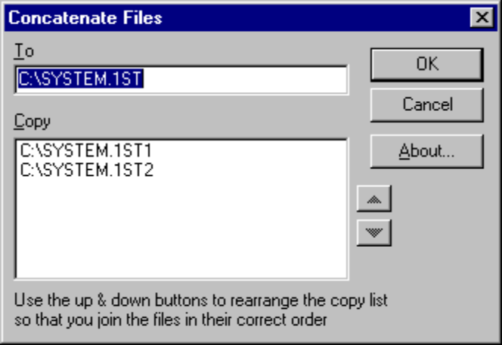

In the freeware version, the default destination file name is the same as the first selected file. If you want to alter this, change the "To" file name before you press the OK button.

The retail version of ConCat incorporates the following extra features:

1. Buttons associated with the list box that let you easily re-order the source files so that they are in the correct order for joining. Select the file in the Copy list box and use the up and down buttons as required. The buttons respond to the keyboard accelerators Alt+U & Alt+D.

2. Automatically selects the correct destination filename for files that are split and retain their Split/ConCat naming convention.

Removal
Use the Control Panel, Add/Remove Programs item. Select the ConCat item (listed as "Concatenate Context Menu Extension (Remove Only)") and click the Add/Remove button.

Because the Windows INF de-installer cannot currently delete files that are loaded in memory, we recommend that if you want to remove Split/ConCat, that you first reboot your machine, and then remove it without first using it. This will ensure that the files are correctly deleted.

Contact
If you have any questions, you can contact us at:

jdd@compuserve.com.

Please take a look at our web site to see the services we offer and download our other free software utilities.

http://ourworld.compuserve.com/homepages/jdd

If you need help, or have any suggestions for improvements to any of our utilities, then please contact us via Email. It's always good to hear from people using our products, so please let us know how you find them.

Thanks
JD Design
162 Mow Cop Road
Mow Cop
Stoke-on-Trent
ST7 4NH
England

