Instruction for using The Hordeum Toolbox (THT)

- Web, FTP and mysql information
Currently, the THT website is hosted on a computer at bcblab. The web address is: http://lab.bcb.iastate.edu/yhames04. There are also a FTP server and a mysql server accompanying the web server at the same address. Yves Sucaet is currently administrating that computer. Username is yhames04, and password is gdcb**.
- Registration and login

  - Registration
An interface for registration is offered. To start, click on the “register” in the upper left corner of the page and the interface will be brought up. Fill all the required information and clicker on the “Register!” button to submit. If you don’t find your institution in the supplied list, you will need to contact an administrator to add your institution.
Note: No fields in the registration form can be left blank. Type “N/A” if you don’t have information. Username should start with alphabetic characters and the password should be at least 6 characters long and contain both characters and numbers.
Todo: The evaluation of the submit information and user privilege are not implement currently.
  - Login and logout
Once your registration process is done, you can log into THT by submitting your username and password in the upper left form. Once logged in, a logout button will appear in the upper left corner.
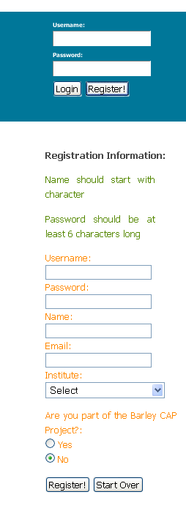

- Data input
We support both form based data input for individual data, such as information about a particular dataset, experiment, institution etc., as well as spreadsheet-based batch data input. All the links for data inputs are summarized in the Data Input Gateway page, which can be accessed through the database menu. There is also a quick link to Database Input Gateway in the “quick links” menu.
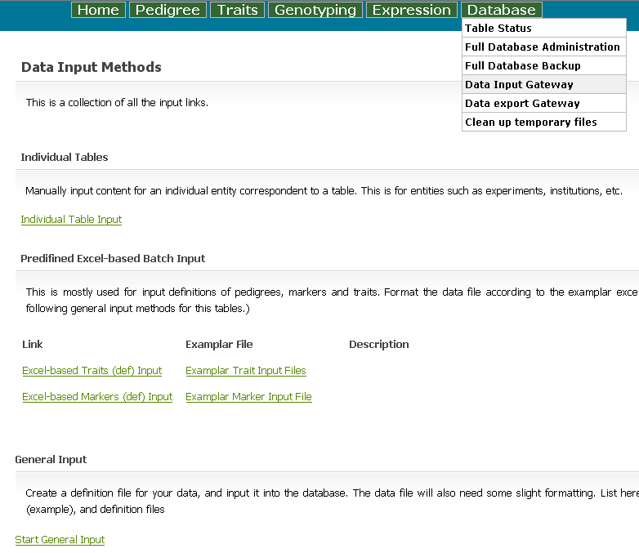

  - Data input to individual table
Some information is more easily input individually, this is especially true if the information involved is correspondent to a single record in a single table. Examples for this kind of information includes the information about individual institutions, breeders, dataset, experiment, line, units, etc. Shown below is an example of how to add a marker record using the form based input. The “uid” of a record is generated automatically and serves as the primary key for the table, so the correspondent input field is disabled. Foreign records referenced will be displayed in select boxes. For example, unigene and marker_type are referenced by markers, and the records of these tables are displayed as options in the select boxes here. Up to 200 foreign records are display in the select box (the number can be changed by the developer). If a referenced record is not in the database yet, the user need input the referenced record first and then come back this page.

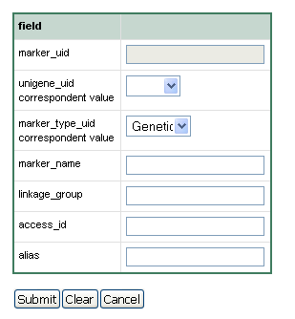
  - Predefined Spreadsheet-based batch inputs
We developed Spreadsheet-based methods for batch inputs. Special scripts have been written to handle some of the most frequently used batch inputs, as is listed below. In order to take advantage of these methods, the input Excel files needs to formatted according to the example files shown below.
Note: The general input method (see c) has superseded these special input methods.
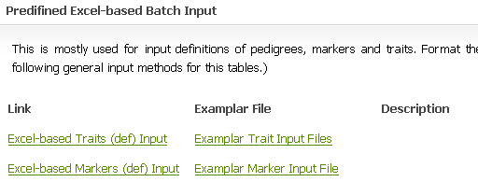
  - The general input method
The general input method separates the data from their definition. It uses a single script to handle input of data of different formats. Shown below are some of the Data file and Definition file we have tested.
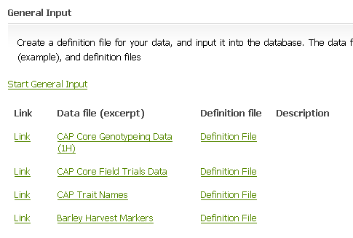
Rules for formatting the data file
- Data are in rows
- The first row contains comments of the data
- The second row contains comments of the columns
- For spreadsheet containing grid data, where the data is specified by both columns and rows (see N206Sydney_mn_fixed.xls for example), cells in the second row correspondent to the grid data specifies the fields/table/type of data in these cells.
- Data start from the third row.
- Occasionally, data submitted by users contain extra statistical information at the bottom, these should be eliminated as they need to be parsed separately.

Rules for formatting the data definition file (see CAP_Fieldtrials_Def as example)
- The definition file contains three rows. The first row is general comment.
- The second row contains comments for the columns.
- If the spreadsheet contains grid data, the last cell in the second row will contain specifications for the definition of the correspondent cells in the second row, in the format of #field_name[::fieldname2::table2]/table_name/number_of_columns/type (0 for character values, 1 otherwise). Fieldname2 and table2 are used when the correspondent field(field_name) alone is not a unique key of table(table_name).

- Database related operations
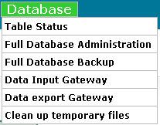
- Full Database Administration.
We installed the phyMyAdmin (http://www.phpmyadmin.net/), which basically offers a web-based interface for all the database operations.
- Full Database Backup.
Perform mysqldump and output the result in one big SQL file.
- Data export gateway.
Output the contents in a single table.
TODO: output customized search results.

- Line selection and Marker selection
  - Explicit line selection.
Particular lines can be explicitly selected through the menus “Pedigree”->”Select Lines”
  - Explicit marker selection.
Similar to line selection, go through menus “Genotyping” -> “Select Markers”.
Markers can be selected from a range in a map, or from the “THT Map” graphic interface, as is shown below.

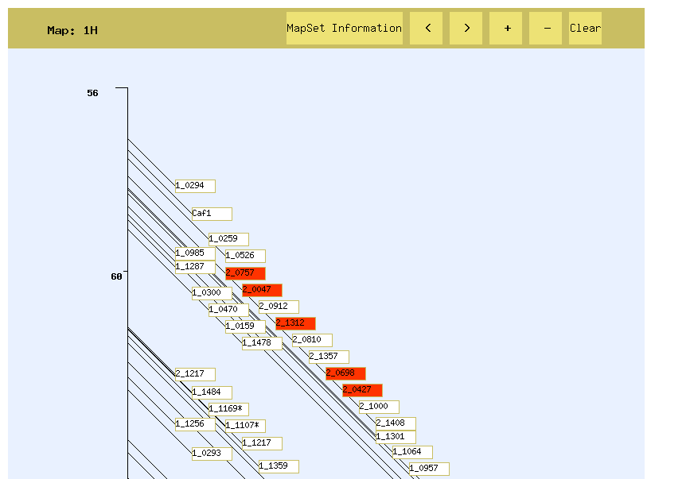

- Search and advanced search
  - Search
There is a basic key word search located in the left column. It searches the query word in every table and displays the record as well as the table name.

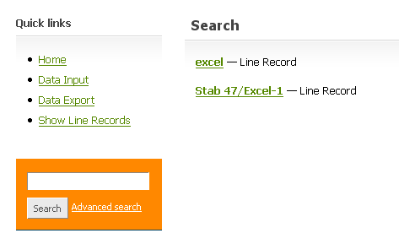

  - Advanced search
The advanced search makes it possible to refine the search of lines and markers (and phenotypes in the future) based on combinations of properties.

First choose the search range
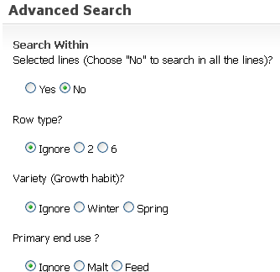
Second select by the phenotype range:

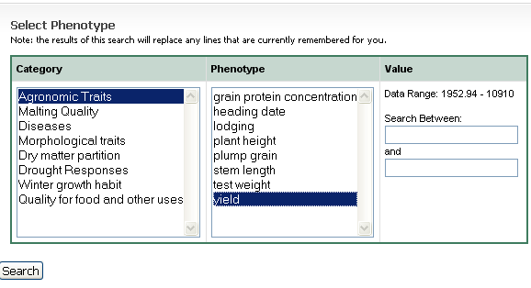
Or select by the marker values: (currently, these two searches are independent)
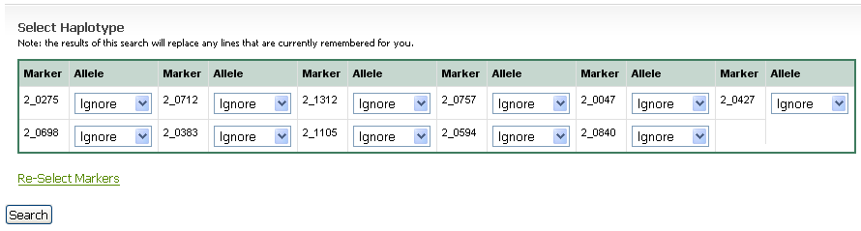
Appendix

Suggestions for the data uniformity
We encountered a couple of consistency problems during data processing, including:
- Units are different in different datasets.
Suggestion: uniform the units in the datasets, or define phenotypes with different units as different phenotypes.
- In-correct pedigree notations and pedigree specified in scattered files.
Suggestion: conform to the Purdy format. Extract the pedigree definitions into a separate excel file using the CAP Core format for all the lines involved in one experiment.
- Extra information in the spreadsheets. It is often the case that certain statistical or control information are listed in the same spreadsheet as the main data, and there is no regularity as to where and what these information could be between different datasets.
Suggestion: Keep the main data in one clean file. For the control lines, format them as the trial lines.
- Special characters in the line names and redundancy in the line names.
We found some cases of the line names that may cause trouble, for example, line names of pure numeric characters, line names containing “/”, line names containing “spaces”. Some line names may be redundant, such as “robust” and “robust-2”.
Suggestion: Avoid special characters in the line names.

