High School Graduation Examination

Overview: Every years, grade 12th student in Vietnam have to participate in one of the most crucial test in academic journey. Many prestigious universities in the country will based on these grades to determine student ‘s profile. Therefore, Having a test that can parse student based on 12 years of study for a subject is difficult task. This R project will provides you some insight into these topic:

As a student, you will need to take a test of 3 compulsory subject: Math, Literature (Vietnamese) and foreign languages (English, Russia, Korean, German, French and Cantonese)

So you might ask what are the percentage of the participants of each languages in the total test ?

\*Other indicate that people don’t attend. Therefore, I will ignore these subsets inside my dataset. This happen because during 2023-2024, many universities in Vietnam accept IETLS. According to IELTS ASIA, “IELTS is accepted by Vietnam as evidence of English language proficiency. If you are applying to study at undergraduate or postgraduate level in Vietnam, it is likely that you will be required to present your IELTS result as part of your application.”\*

As you can see English take up almost 99%, following is Russia is just slightly 0.3% and French, Cantonese and German, …

So there will be a bias in some degree due to the fact that the grade of other languages in each subject is much better than English. This is because people on the city, who have chance to experience these languages such as Russian is living in the capital and Cantonese is small of population is living in Sai Gon city.

Here is the the total grade of each subject in each languages:

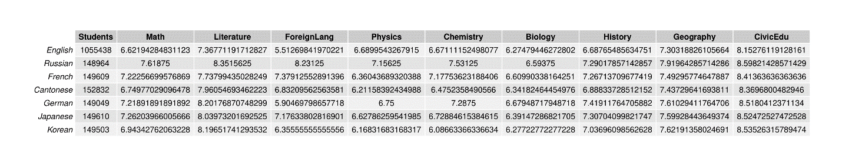

* There is a problems with literature due to the fact that there are everybody participating into that. There fore distribute as a graphs where have a error

Conclusion: As we can see, most of grades schemes fit into the Bell curve. So the quality of the test is good because it can parse students into separate groups of grades