

**Rapport du TP « Mini-Chat » de Systèmes d'Exploitation Centralisés**

Guohao DAI, Groupe E

Première année - Département Sciences du Numérique

2020-2021

1. **Overview**

For the server:

1. Run the server, the server first registers the signal processing function of SIGINT, which is used to implement the server exit function
2. The server creates a public named pipe and opens the pipe file in read-only mode
3. Read the structure data information from the client
4. If the client’s data is identified as IS_NEW_CLIENT, it means that the client is communicating for the first time, and the server will create a corresponding private named pipe for this client, which is identified by the PID of the secondary client
5. Next, the server continues to judge the client's message. If the message is CLIENT_QUIT, it means that the client has existed. At this time, the server needs to close the private pipe link.
6. If the client's data is a normal message, the server will reply to the client from the private channel

For the client

1. Run the client program, the client will first send its identification information PID to the server through a shared pipeline
2. The server will create a corresponding private channel for the new client
3. Next, the client only needs to read the data in the corresponding private pipe
4. **Problems encountered**

**Q1**: How to exit the client and server?

For each client, after sending the data identified by CLIENT_QUIT to the server, the client ends the process directly.

For the server, after receiving the CLIENT_QUIT data from the client, it disconnects the private pipe of the corresponding client and deletes the private pipe file.

After the server is started, it cannot end by itself. You need to press CTRL+C to generate the SIGINT signal. After the server captures the SIGINT signal, it will disconnect the shared pipeline and delete the shared pipeline file.

**Q2**: How to achieve private chat between two clients?

To achieve private chat between clients, you can add a header before the data sent by the client, such as “ to: [Client_PID] [Client_Message] ”. If so, intercept the target PID and the message to be sent, and record the target PID with the member flag in its structure. After the server receives the message, it judges the member tag of the structure. If it is a private chat, it will be sent separately; otherwise, it will broadcast the data to all clients in a loop.

1. 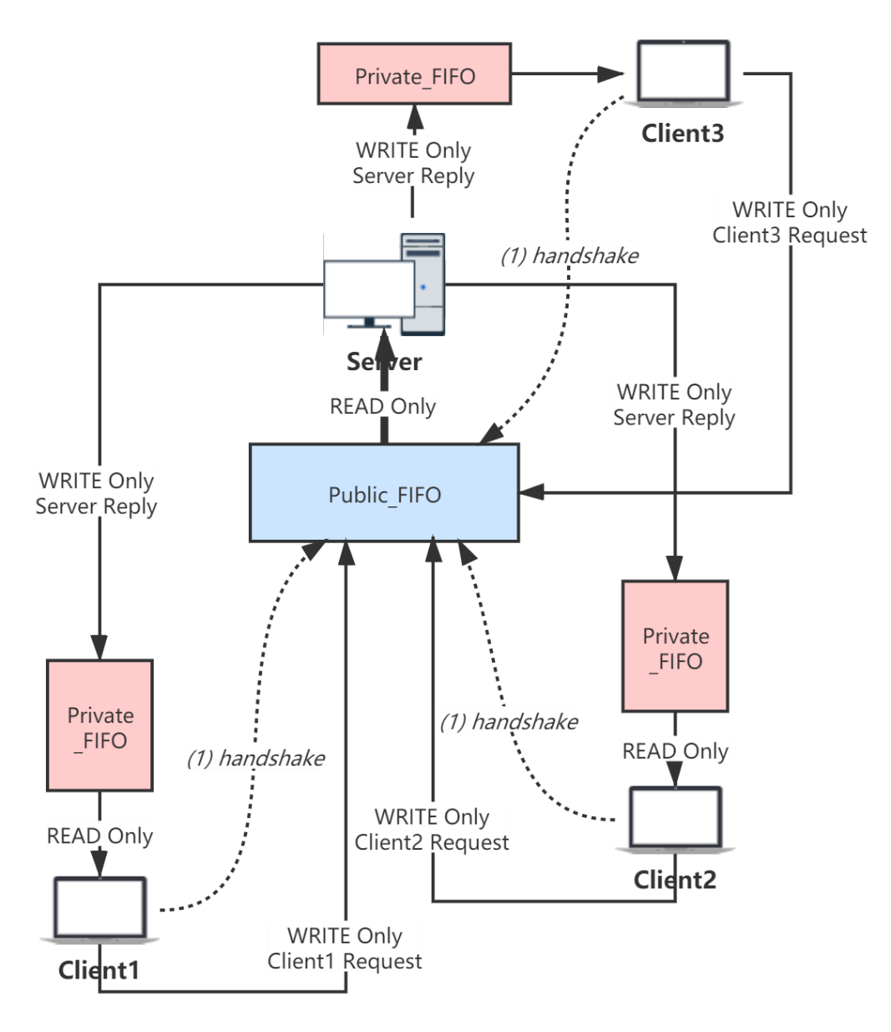**Annexes**

Figure 1: The functional flow diagram of “Server / Client Architecture”