实验2-5-2 二进制转格雷码实验报告

一、仿真结果

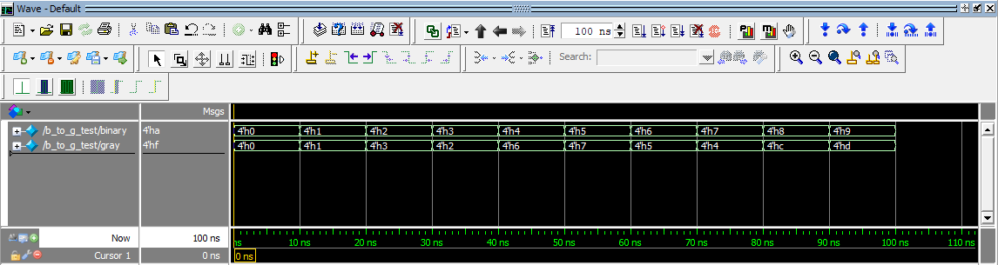

二、分析和说明

1、真值表

|  |  |  |  |  |  |  |  |
| --- | --- | --- | --- | --- | --- | --- | --- |
| b3 | b2 | b1 | b0 | g3 | g2 | g1 | g0 |
| 0 | 0 | 0 | 0 | 0 | 0 | 0 | 0 |
| 0 | 0 | 0 | 1 | 0 | 0 | 0 | 1 |
| 0 | 0 | 1 | 0 | 0 | 0 | 1 | 1 |
| 0 | 0 | 1 | 1 | 0 | 0 | 1 | 0 |
| 0 | 1 | 0 | 0 | 0 | 1 | 1 | 0 |
| 0 | 1 | 0 | 1 | 0 | 1 | 1 | 1 |
| 0 | 1 | 1 | 0 | 0 | 1 | 0 | 1 |
| 0 | 1 | 1 | 1 | 0 | 1 | 0 | 0 |
| 1 | 0 | 0 | 0 | 1 | 1 | 0 | 0 |
| 1 | 0 | 0 | 1 | 1 | 1 | 0 | 1 |
| 1 | 0 | 1 | 0 | 1 | 1 | 1 | 1 |
| 1 | 0 | 1 | 1 | 1 | 1 | 1 | 0 |
| 1 | 1 | 0 | 0 | 1 | 0 | 1 | 0 |
| 1 | 1 | 0 | 1 | 1 | 0 | 1 | 1 |
| 1 | 1 | 1 | 0 | 1 | 0 | 0 | 1 |
| 1 | 1 | 1 | 1 | 1 | 0 | 0 | 0 |

2、工作原理及表达式

设四位二进制数为*b3、b2、b1、b0*；其对应的四位格雷码数为*g3、g2、g1、g0* 其中：

最高位保留：

*g3=b3*

其他各位：

例：

二进制数为 1 0 0 1

$⨁$ $⨁$ $⨁$

格雷码为 1 1 0 1