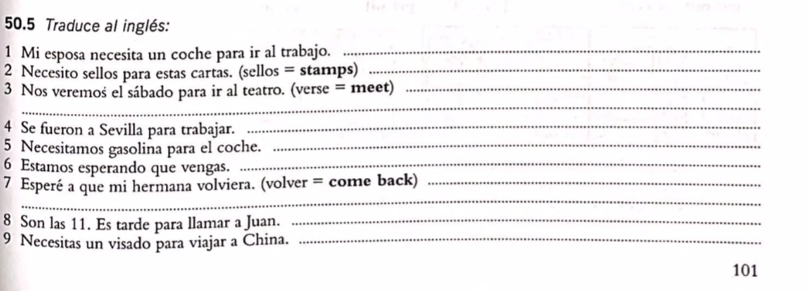
1. My wife needs a car to go to work.
2. I need some stamps for this letters.
3. Let’s meet on Saturday to go to the theater.
4. They went to Sevilla to work.
5. We need gasoline for the car.
6. We are waiting for you to come.
7. I waited for my sister to come back.
8. It is 11. Is too late to call Juan.
9. You need a visa for travelling to China.

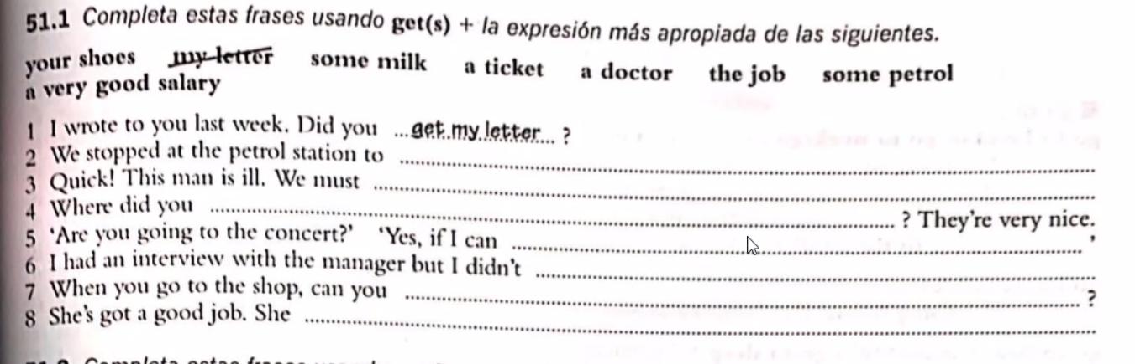

1. get my letter.
2. get some petrol.
3. get him to a doctor
4. get your shoes.
5. get a ticket I will go to the concert.
6. get the job.
7. get some milk.
8. gets a very good salary.

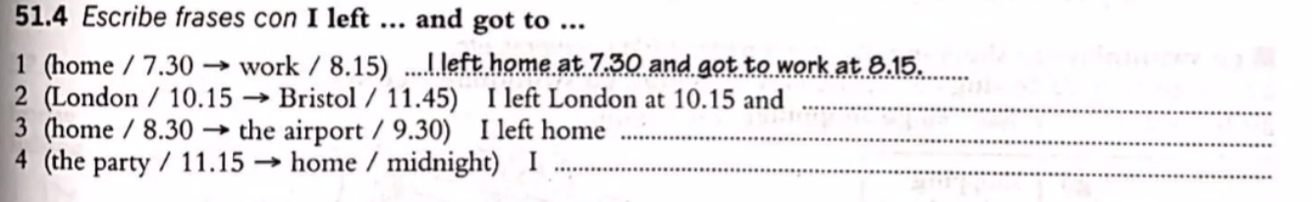
1. I left home at 7.30 and got to work at 8.15
2. I left London at 10.15 and got to Bristol at 11.45
3. I left home at 8.30 and got to the airport at 9.30
4. I left the party at 11.15 and got home at midnight.

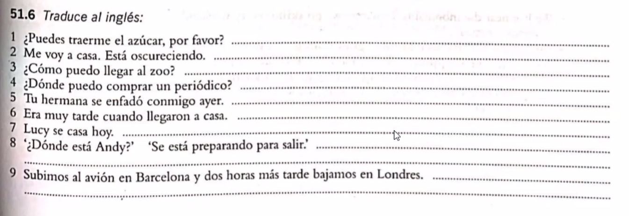
1. can you lend me the sugar, please?
2. I’m going home. It’s getting dark.
3. How can I get to the zoo?
4. Where can I get a newspaper?
5. Your sister got angry with me yesterday.
6. It was very late when we arrived home.
7. Lucy is getting married today.
8. Where is Andy? He’s getting ready to get out.
9. We got on the plane in Barcelona and 2 hours later we got off in London.

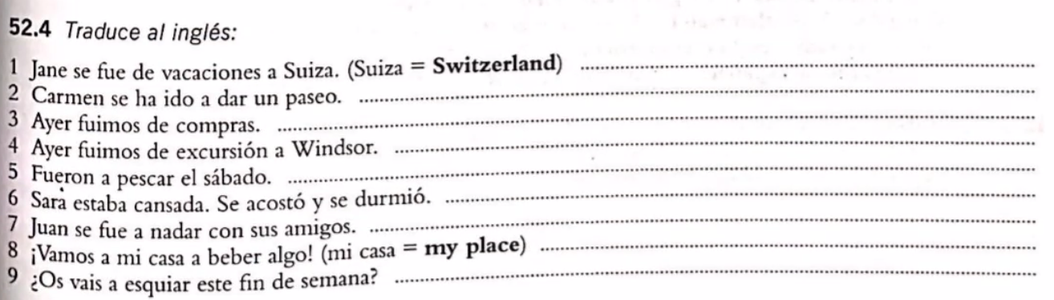
1. Jane went on vacations to Switzerland.
2. Carmen has gone for a walk.
3. Yesterday we went shopping.
4. Yesterday we went to an excursion at Windsor.
5. They went fishing last Saturday.
6. Sara was tired. She went to bed and fell asleep.
7. Juan went swimming with his friends.
8. Let’s go to my place to drink something.
9. Are you going skiing this weekend?

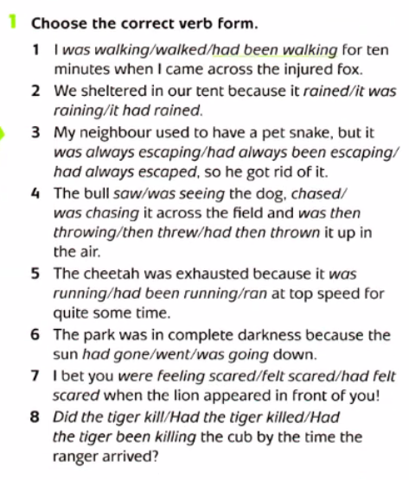

1. Had been walking

2. It was raining.

3. Was always escaping.

4. saw, chased, then threw it up

5.had been running

6. had gone down.

7. felt scared.
8. had the tiger killed.

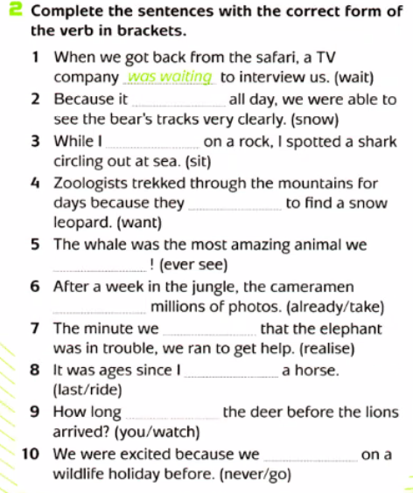

1. Was waiting.

2. Had been snowing.

3. Was sitting.
4. Wanted.

5. Have ever seen.

6. Had already taken
7. Realized.

8. Had last ridden.
9. Did you watch.

10. Have never gone on

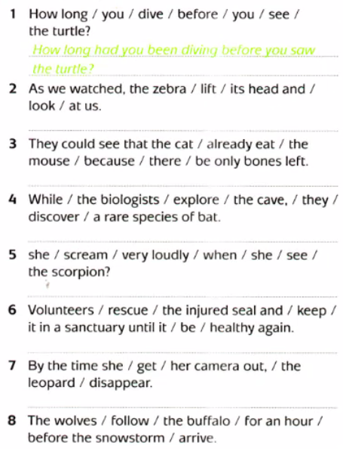
1. How long had you been diving before you saw the turtle?

2. As we watched, the zebra lifted its head and look at us.

3. They could see that the cat had already eaten the mouse because there were only bones left.
4. While the biologist were exploring the cave, they discovered a rare species of bat.
5. Did she scream very loudly when she saw the scorpion?

6. Volunteers rescued the injured seal and kept it in a sanctuary until it was healthy again.
7. By the time she got her camera out the leopard had disappeared.
8. The wolves had been following the buffalo for an hour before the snowstorm arrived.

Threatening, threaten.

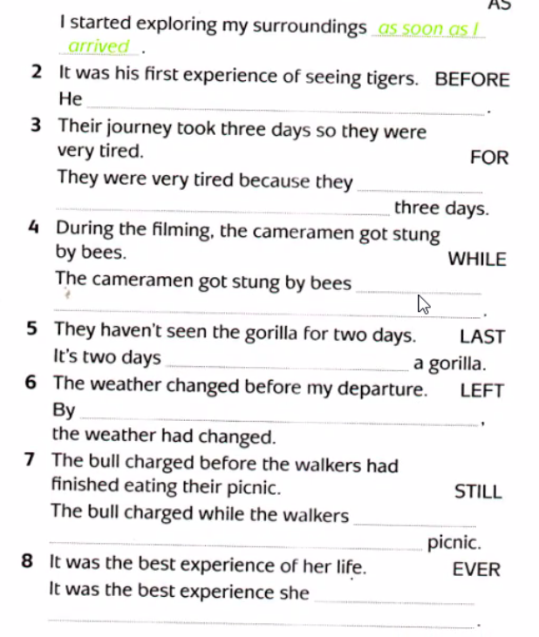
2. He had never seen tigers before.

3. They were very tired because they were on a journey for 3 days.

4. The cameramen got stung by bees while filming.

5. It’s 2 days since they last saw a gorilla.

6. By the time I left the weather had changed.

7. The bull charged while the walkers were still eating their picnic.

8 It was the best experience she had ever lived.

