DRAFT – NOT FOR DISTRIBUTION

ECB: EMU’S Feature, Not Its Flaw (or “It’s NOT the Central Bank, Stupid!”)

Introduction

The crisis in the euro area naturally sows doubts about the region’s institutions, of which the European Central Bank (ECB) is the most prominent and powerful. As a result, it is natural to wonder whether the crisis – or the difficulties in managing it – reflects flaws in the design of the ECB.

In fact, the opposite seems to be the case. The ECB’s design and policy apparatus incorporate many elements inherited from Germany’s Bundesbank, one of the most effective central banks in modern experience. The euro-area crisis largely reflects the institutional environment in which the ECB is situated, rather than any flaw in the ECB’s design. Ultimately, the challenges in the euro area arise from the lack of a fiscal and prudential union, which leads to poor incentives on the part of fiscal policymakers and financial intermediaries.

To make this clear, consider the following thought experiment: Switch the ECB and the Fed so that the ECB operates with its usual rules and practices as the central bank of the United States, while the Federal Reserve serves as the central bank of the euro area. In our view, the ECB would have both advantages and disadvantages operating in the United States. Compared to the Fed, the ECB’s legal mandate (which prioritizes price stability) would provide greater anti-inflation credibility. At the same time, the ECB’s lack of supervisory authority would limit its timely access to information in a crisis when it may be called on to serve as a lender of last resort. The balance of these pluses and minuses does not seem particularly lopsided. If, in contrast to its normal rules, the ECB also were given supervisory authority in the United States, its overall effectiveness might surpass the Fed’s.

Conversely, the Federal Reserve would face the same challenges in the euro area that the ECB confronts today, and possibly more. Three examples suffice to make the point. First, in its role as a bank supervisor, the Fed could not rely, as it does in the United States, on a region-wide fiscal agent as a deposit guarantor or as a source of funding to resolve insolvent intermediaries: there is no Federal Deposit Insurance Corporation (FDIC) in the euro area. Second, the Fed could not rely, as it does in the United States, on “riskless” sovereign debt to conduct open-market operations. In the euro area, filling the central bank’s balance sheet with the public-sector debt of the region’s member countries could severely diminish market discipline on their governments, fueling fiscal profligacy. Third, even the basic payments system that the Fed operates to clear interbank payments would become politically controversial in the euro area if, as one suspects, it leads in a banking crisis to sizable cross-border imbalances. These imbalances would expose healthy sovereigns to the risks of fiscally weaker nations, indirectly subsidizing fiscal

This essay explores these central banking issues in some detail, highlighting the origin and evolving role of the ECB. It notes instances in which ECB choices may have contributed over time to financial instability. But it generally highlights the central role of the fiscal and prudential framework – rather than the ECB – in setting the stage for (and sustaining) the crisis. Neither a change in the ECB’s design nor in its basic practices would have altered these fundamental conditions.

Arrival of the ECB

The ECB is the most successful institution created by the Maastricht Treaty that established European Monetary Union (EMU) and the euro. It stands virtually alone as an official euro-area organization. In the face of extraordinary skepticism at its start, the ECB instantly established a high level of anti-inflation credibility. It achieved numerous technical and logistical feats such as: (1) the formation of a unified euro-area liquid money market in which to conduct daily policy operations; (2) the developments of a real-time clearing mechanism (the TARGET system) for cross-border payments in the euro area; and (3) the simultaneous introduction of new euro notes and coin across the world’s second largest economic zone. Failure in any of these endeavors might have brought the entire euro project crashing down at an early date.

Over time, the ECB secured its anti-inflation reputation by keeping inflation close to its stated quantitative goal. In doing so, it also safeguarded the new currency, the euro in the face of sizable economic, financial and political shocks. The euro is the world’s second most important currency based on turnover in the foreign exchange market, on the foreign exchange reserves held by the world’s central banks, and on the currency share of international debt securities or cross-border lending. In terms of notes and coin in circulation, the euro surpasses even the U.S. dollar. In addition to the 17 countries of the euro area, the euro is the transactions currency in several other European economies, and is the currency to which more than 20 countries and territories peg their exchange rate. More than half the goods imports into the euro area (and more than two thirds of its exports) are invoiced in euros. Reflecting this effective track record, the ECB’s mechanisms for implementing monetary policy – such as the marginal lending and deposit facilities – have been mimicked by other central banks (including the Federal Reserve) in search of best practice.

These achievements make the ECB one of the world’s most powerful and effective economic policy institutions. Yet, no central bank can achieve the long-run goals of price and economic stability in a vacuum. Astute observers – like Henry Thornton and Walter Bagehot – understood long ago that economic stability is not feasible without a modicum of financial stability. Due to its importance in securing financial stability, the role of a central bank as a lender of last resort is more than 200 years old. More recently, macroeconomists have emphasized how imprudent fiscal behavior can overwhelm the stability sought by central banks. The challenges that the euro-area crisis poses for the ECB reflect precisely reflect such mutually reinforcing financial and fiscal stresses.

In the coming sections, we briefly summarize the operations, structure and institutional environment of the ECB as it relates to the ongoing crisis. For the purpose of illumination, we frequently make comparison to the U.S. Federal Reserve System. The limited aim of this exposition is to identify factors that contributed to the imbalances leading to the euro-area crisis or to the difficulties in managing the crisis. Other sources provide a comprehensive description of the structure and operations of the ECB. The discussion begins with basic monetary policy operations. It highlights how ECB policies evolved during the crisis beyond narrow monetary policy, stumbling (like the Fed and some other central banks) into quasi-fiscal operations. It then turns to the role of the ECB in matters of financial stability and, finally, to the changing framework for financial stability oversight in the euro area.

Setting Monetary Policy

The Maastricht Treaty provides the ECB with a hierarchical mandate to secure price stability ahead of other potential goals sought by euro-area policymakers. Because this mandate can be altered only by the unanimous consent of all European Union (EU) countries (including those that are not members of the euro area), the Treaty secures the policy independence of the ECB more irreversibly than the laws of individual countries that govern most of the world’s 160-odd central banks. For example, in the United States, a simple majority of Congress, supported by the President, can revise at any time the Federal Reserve Act that establishes the objectives and authority of the U.S. Federal Reserve. Such a major revision occurred in 2010 with the passage of the Dodd-Frank Act, which narrowed some Fed powers and added others.

The Maastricht Treaty went considerably further in buttressing ECB independence. Its authors understood that profligate fiscal policy could pressure a central bank to accept higher inflation. Consequently, the Treaty forbids the ECB from taking instructions from EMU member governments. It also forbids the ECB from financing those governments directly. The so-called “no bailout” clause of the Treaty also prohibits the ECB from supporting governments in fiscal distress. We can safely assume that the no-bailout clause aimed at restraining imprudent fiscal behavior on the part of EMU governments by underpinning market discipline.

Even before the ECB began setting monetary policy for the euro area, its Governing Council clarified the Treaty price stability mandate by announcing a quantitative target for inflation (measured by the euro-area harmonized index of consumer prices – HICP) of “less than, but close to 2%.” The track record highlights the ECB’s success: Over the past decade – a period when ECB policies can reasonably be thought to have determined the euro-area inflation rate – HICP inflation has averaged 2.1% (with a standard deviation of 0.8%). For comparison, U.S. consumer price inflation averaged 2.4% (with a standard deviation of 1.4%) over the same period.

Like other independent central banks, the ECB uses a short-term unsecured interbank lending rate (measured by the Euro Overnight Index Average, or Eonia) as its favored instrument to achieve the objective of price stability. The ECB intervenes in this interbank lending market primarily by auctioning supplies of euro liquidity to banks in the euro area. Outside of crisis periods, these ECB operations usually involve fixed allotments of euros that banks can acquire on a temporary, collateralized basis at an auction-determined interest rate. Altering the supply of these temporary euro loans allows the ECB to influence the market rate for interbank lending. This process of supplying liquidity is analogous to the Federal Reserve’s open market operations (OMOs) in securities that provide aggregate reserves to the U.S. banking system and, thereby, alter the federal funds rate at which banks lend to each other overnight on an unsecured basis.

In normal times, such lending to credit institutions typically dominates the ECB’s balance sheet. In contrast, Treasury securities usually form the largest portion of Fed assets. Yet, the ECB is still exposed to the risks of governments, because the collateral that the ECB accepts against its loans may be composed of euro-area government debts. In addition, the well-being of the euro-area credit institutions to which the ECB lends depends on the fiscal health of their home states.

Unlike the Federal Reserve, which conducts open-market operations only through the Federal Reserve Bank of New York, the ECB conducts monetary policy operations through each of its member national central banks (NCBs) in their own countries. This decentralized operational procedure partly reflects a flexible technology that allows coordination by the ECB of NCB open-market operations in the various domestic markets. However, the practice was driven largely by the need to integrate – from the very start of EMU – the existing national short-term markets into a deep and liquid euro-area-wide money market that would permit the implementation of ECB monetary policy operations.

For similar reasons, the ECB was virtually compelled from the beginning to adopt a variety of existing NCB practices, including those regarding acceptable collateral in their home markets. The choices of acceptable collateral reflected the euro area’s reliance on bank (rather than securities) finance and, in some cases, the lack of deep capital markets in which to conduct open-market operations. In practice, this approach meant that the collateral of all euro-area governments would be treated equally. For example, at the start of EMU, for example, a central government debt instrument with a residual maturity up to one year faced no “haircut” or discount: put differently, one euro of debt in market value from any euro-area government was sufficient to collateralize a one-euro ECB loan. While longer-maturity debt faced a modest haircut, it was independent of credit quality or liquidity. In contrast, the ECB routinely applied different valuation haircuts to non-government collateral according to liquidity and creditworthiness.

The lack of haircut differentiation naturally benefits less creditworthy governments and those whose debt is less liquid. Arguably, it also weakens confidence in enforcement of the Maastricht Treaty’s no-bailout clause, helping to diminish the potential impact of market discipline on fiscal policymakers. Already in 1999, when the ECB had barely begun to implement monetary policy, observers warned that the use of government debt as collateral could have virtually the same impact as an open market purchase of that debt. The lack of collateral differentiation strengthens that claim.

To be sure, the Federal Reserve currently differentiates only modestly between Federal and municipal debt, with the latter currently having an extra haircut of 1%. However, the creditworthiness of U.S. states is less varied than that of euro-area countries. Partly, this reflects far lower state debt burdens. In addition, many U.S. states long ago enacted debt-priority rules in their constitutions, thereby raising their creditworthiness. Aside from Spain, which enacted a debt priority rule in 2011, no euro-area country has done so.

How significant was the influence of the ECB’s collateral practices? A critical aspect of the euro-area crisis was the lack of market discipline on fiscal policy – especially in countries such as Greece and Portugal – in the years ahead of the crisis. Thus, the 10-year government bond yield differential between Greece and Germany was less than 25 basis points as recently as mid-2007, when the global financial crisis began. Buiter and Sibert argued already in 2005 that the ECB’s failure to differentiate euro-area sovereign collateral helped compress yield spreads in the region. They proposed that the ECB adjust haircuts inversely with credit ratings and that the debt of countries in violation of EMU fiscal rules be made ineligible as collateral.

To be fair, numerous factors contributed to this mispricing of risk. A broad market myopia regarding risk already was event in global securities markets ahead of the crisis. The zero-risk-weight that euro-area bank supervisors assigned to bank holdings of government debt in determining regulatory capital requirements likely had (and has) greater influence on bank portfolio selection than the ECB’s collateral rules. Finally, complacency about to default risk has characterized the runup to many sovereign debt crises, not just that in the euro area. Nevertheless, ECB rules buttressed, rather than countered, these distortions, helping to limit the role of market discipline on euro-area sovereign debt.

In the context of crisis management, the ECB’s broad acceptance of collateral from a wide range of eligible financial institutions provided significant advantages. Notably, the ECB was able to satisfy the euro area’s soaring euro liquidity needs even in the early stages of the 2007-09 crisis. By comparison, the Federal Reserve traditionally had lent only to depository institutions – not to shadow banks – against a relatively narrow range of collateral. Consequently, the Fed was pressed to innovate rapidly and aggressively in order to deliver liquidity where and when it was needed – such as investment banks and money market mutual funds. By the end of 2008, the Fed’s alphabet soup of facilities for liquidity provision brought it roughly to the standards that the ECB’s policies had achieved from the start.

Like the Federal Reserve, financial crisis repeatedly compelled the ECB to expand its balance sheet aggressively. For both central banks, the Lehman failure of September 2008 provided the first impetus for a balance sheet surge (See Figure w). If we define “quantitative easing” (QE) as the supply of reserves to the banking system beyond the level needed to reach the central bank’s target interest rate, the Fed has engaged in QE continuously since that episode. While the ECB (unlike the Fed) never lowered its official interest rate target (the “main refinancing operation” on fixed-rate tenders, or MRO) below 1%, it supplied aggregate reserves to the euro-area banking system well in excess of levels needed to secure a 1% rate in the interbank lending market. Consequently, the surge of ECB assets since September 2011 can reasonably be interpreted as a round of QE comparable in scale to the post-Lehman round. As a result, ECB assets again exceed those of the Federal Reserve.

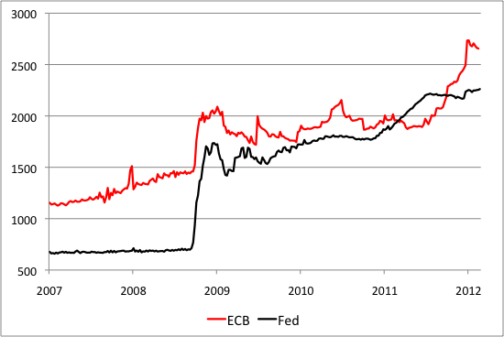Figure w. Assets of the European Central Bank and the Federal Reserve System (Billions of Euros), 2007–Jan 2012.
Note: U.S. dollar assets of the Federal Reserve are translated into euros at an exchange rate of $1.30 per euro. Sources: FRB H.4.1 and ECB.
As the financial crisis in the euro evolved, the ECB’s normal mechanism of settling cross-border payments became a potential source of instability. The real-time gross settlements system – known as TARGET II – resulted in the buildup of large country exposures to the balance sheet of the “Eurosystem” – the combined entity including the ECB and its NCBs. In normal times, the random ebb and flow of funds transfers across countries in the euro area is largely offsetting, resulting in near-zero TARGET balances. Despite some warnings about the potential for cross-border payments instability, the lack of large, persistent TARGET imbalances until the financial crisis limited attention to the risks.

Since 2007, however, banks in fiscally-stressed countries have gradually lost access to private funding and depended increasingly on official funding through their NCBs. More recently, deposit flight from weaker banking systems to stronger ones has made TARGET payments even more lopsided, accelerating the rise of liabilities from NCBs in countries with weaker banking systems to the Eurosystem. The principal counterpart of these liabilities is a large and growing exposure of Germany’s central bank – the Bundesbank – to the Eurosystem (see Figure x). From a balanced position as recently as 2006, the Bundesbank has cumulated an asset position against the Eurosystem of nearly EUR 500 billion as of January 2012.

Figure x. Bundesbank Claims on the Eurosystem (Billions of Euros), 1999-Jan 2012.
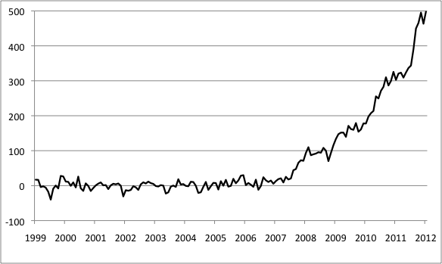
Source: Bundesbank.

The payments system is a critical utility of any currency area, and TARGET has played this role efficiently. Yet, the exposures resulting from the euro area’s cross-border payment system have made it highly controversial. Leading German economists have described it as “the ECB’s stealth bailout” – a large, hidden subsidy to the fiscally and financially weakest countries that could otherwise not fund themselves at such low interest rates. One analyst proposed that the ECB require an annual inter-country settlement of TARGET liabilities in marketable assets such as gold or foreign exchange to prevent such large imbalances.

For comparison, when imbalances arise in the United States between different Federal Reserve banks, annual settlements do occur, but these are merely accounting arrangements: the Federal Reserve Board re-allocates ownership shares in the System Open Market Account that holds the Federal Reserve’s portfolio of securities. In theory, the Board could allow a Federal Reserve Bank to continue making transfers within the System even if the Bank had negative net worth. Naturally, such inter-district imbalances have little impact on U.S. taxpayers because they are consolidated within the Federal Reserve System, which is an asset of the U.S. Federal Government.

In the euro area, however, the TARGET imbalances make one country exposed to the willingness and ability of other countries to pay. In particular, Germany has a large and growing exposure through the payments system to defaults on the part of the fiscally stressed economies. Yet, any attempt to cap these TARGET imbalances could threaten the end of the euro. Without the settlement of cross-border payments through TARGET, a euro deposited in a weak-country bank might not be usable as a means of payment across the euro area. For comparison, it would be as if a San Francisco dollar were worth less than a New York dollar (not unlike the 19th century discounting of U.S. private note issuance). Unsurprisingly, the ECB has defended its TARGET system (and, implicitly, cross-border settlement at par value) as a necessary component of the single currency area. It has not proposed a mechanism to settle the cumulated imbalances, but a paper transfer of its assets (akin to the Fed’s practice) would not reduce the controversy. Indeed, debate likely would sharpen if asset transfers threatened to erase the net worth of an NCB.

Stumbling into Fiscal Operations

The intensification of the global financial crisis in 2008 prompted the ECB to move beyond its normal monetary policy standards in notable ways. One mechanism was to provide longer-term financing (initially in 2008 with a maturity of six months and, beginning in late 2011, with a maturity of three years) in euros in unlimited amounts at fixed interest rates. The ECB also gradually relaxed its collateral standards for liquidity-supplying operations. For example, in October 2008, the ECB lowered the credit threshold of acceptable collateral to BBB- from A-. Over time, the type of collateral used in ECB liquidity operations shifted increasingly toward less liquid, more difficult-to-value assets like asset-backed securities and non-marketable instruments (see Figures y and z).

Separately, the ECB was obliged to provide a large volume of credit in U.S. dollars (rather than euros) to European banks that could no longer roll over their dollar liabilities in the aftermath of the Lehman failure. To fund itself in U.S. dollars, the ECB relied on an unlimited currency swap line provided by the U.S. Federal Reserve. Outstanding non-euro loans by the ECB to euro-area residents peaked at nearly EUR 250 billion at the end of 2008 and, after receding in 2009 and 2010, climbed back above EUR 100 billion as of February 2012.

Figure y. Breakdown of Assets Submitted as Collateral By Type (Billions of Euros), 2005-2010

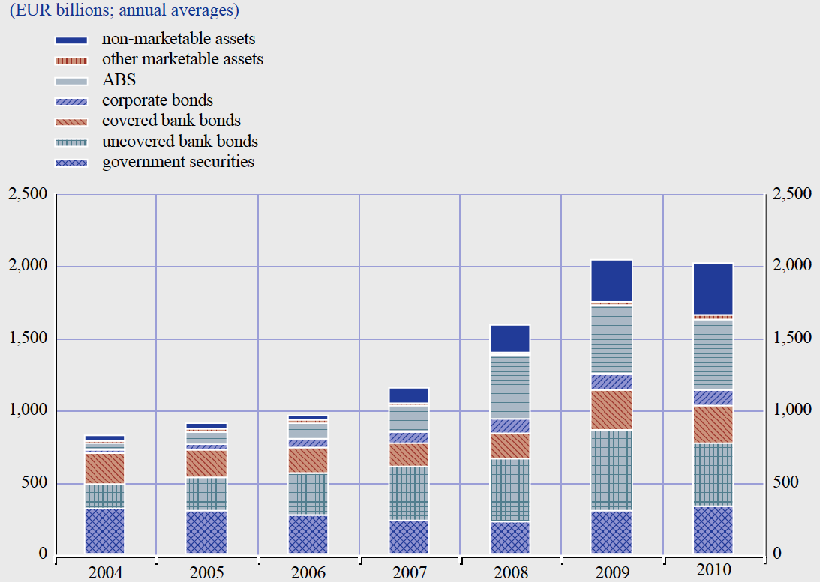

Source: ECB, The Monetary Policy of the ECB 2011, page 98.

Figure z. Breakdown of Assets Submitted as Collateral by Type (Share), 2005-2010

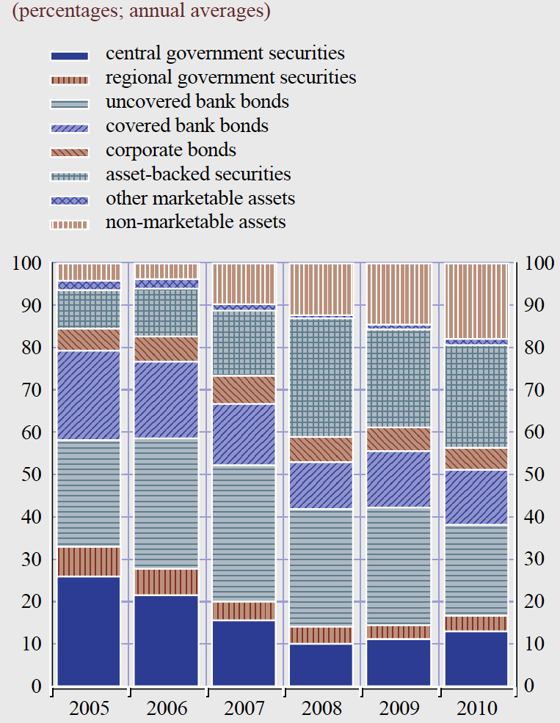

Source: ECB Annual Report 2010, page 98.

The intensification of the euro-area crisis in 2010 led to further relaxation of the ECB’s collateral standards in order to avoid exacerbating the financial disruption.
One notable example was the suspension of the credit threshold for euro-area governments (in 2010 for Greece and in 2011 for Ireland and Portugal) as their credit ratings sank below investment grade. In the case of Greece, the ECB accepted the central government’s debt as collateral until February 28, 2012, when it was declared to be in selective default by Standard and Poor’s. Because Greek banks could no longer fund themselves privately, an ECB refusal to accept Greek government collateral likely would have triggered a collapse of the Greek banking system.

In July 2010, the ECB established a Securities Market Program (SMP) to acquire in the secondary market the debt of those euro-area governments in fiscal distress (initially Greece, Ireland, and Portugal; later Italy and Spain). The SMP is the most controversial aspect of ECB operations during the crisis because: (1) it transparently violates the usual monetary policy principle of “asset neutrality” by favoring specific governments’ debt; (2) it comes closest to violating the Treaty’s “no bailout” clause regarding the financing of distressed governments; and (3) the ECB does not disclose the composition of its purchases by country or maturity.

The ECB justified the SMP by stating that it was necessary to ensure the transmission of monetary policy in dysfunctional markets – much like the Fed’s justification for acquiring mortgage-backed securities. Like the Fed’s MBS purchases, the SMP program constituted a quasi-fiscal action that openly picks winners – in this case, governments that can no longer access private markets at a sustainable interest rate. However, it also directly weakened market discipline on euro-area fiscal policy. Within the ECB, controversy over the SMP helped lead to the 2010 resignation of Bundesbank President Axel Weber and to the 2011 resignation of Governing Board member Juergen Stark.

To illuminate the nature of the SMP program, one might usefully compare it with a hypothetical effort by the Federal Reserve to acquire the debt of a U.S. state or municipality that had been shut out of private debt markets and faced imminent bankruptcy since it could no longer roll over outstanding liabilities. As one observer puts it: “It is as if the Federal Reserve were buying large amounts of Californian debt and reducing credit to banks, say, in New York. This would certainly be regarded as an improper risk transfer that has nothing to do with monetary policy.” To our knowledge, despite numerous instances of financing stress facing individual U.S. states or municipalities, the Fed has never intervened in this fashion. The Federal Reserve Act does empower the Fed to acquire non-Federal government debt, but this authority is limited to issues with up to six months in remaining maturity that are financed by specific revenue streams. In short, the Fed lacks explicit authority to engage in a program identical to the ECB’s SMP.

In addition, it is far from clear that the SMP is necessary to ensure the ECB’s usual goal of price stability. Indeed, the alternative of providing massive liquidity to the banks – as the ECB eventually did in late 2011 – conceivably would have been sufficient to meet the financing needs of illiquid, but truly solvent governments. While some observers might interpret the SMP as bridge financing for insolvent governments awaiting a restructuring of their debt, no ECB official would justify it on this basis, which would violate the Maastricht Treaty.

In implicit recognition of this controversy and the risks of promoting fiscal profligacy. the ECB has limited the volume of SMP purchases. As of January, 2012, SMP holdings remained below 10% of ECB assets (EUR 220 billion out of total assets of EUR 2,940 billion). Yet, the SMP probably represents only a fraction of the ECB’s exposure to the debt of fiscally stressed euro-area governments. According to one estimate, the ECB’s exposure (including SMP assets and collateral against ECB lending) to Greece, Ireland, Italy, Portugal, and Spain collectively reached Euro 705 billion in late 2011, or more than three times the SMP program.

The ECB’s deep involvement in the fiscal affairs of distressed EMU member states raises serious questions about its policy independence, despite the protections of the Maastricht Treaty. As a member (along with the European Commission and the IMF) of the “troika” assessing the Greek, Irish and Portuguese fiscal programs, the ECB’s credibility depends at least partly on the evolution of those programs. Concerns about a sovereign default and ensuing contagion have led ECB officials to favor restructuring schemes that effectively undermine the risk-mitigation role of credit default swaps. And the ECB has agreed – partly in response to pressure from EMU member states – to forgo profits on its Greek debt holdings in order to lower the costs to EMU countries of the second Greek bailout. The figleaf of not accepting losses on the Greek debt – and thereby not engaging in monetary finance of a distressed government – is unlikely to persuade skeptics of ECB independence. Finally, the ECB’s unlimited supply of long-term liquidity to euro-area banks – beginning in December 2011 – was only a modest step from the more direct acquisition of governments debts. In various ways, the ECB lowered the bar for future interventions in the debt of fiscally distressed member states.

The ECB and Financial Stability

Well before the crisis, ECB officials and others focused on the weaknesses of the financial stability regime established under the Maastricht Treaty as a serious threat to EMU. Unlike the Federal Reserve system, which was created precisely to counter threats to U.S. financial stability, the Eurosystem envisioned by the Maastricht Treaty aimed at making the anti-inflation credibility of the Bundesbank and a few other European central banks the collective legacy of the euro area as a whole. The Treaty achieved this goal admirably, but fell far short on ensuring financial stability in the new currency area. It left in place “disparate supervisory agencies, piecemeal and ad hoc bilateral cooperation between these supervisory agencies, [and] uncertainty at the identity of the lender of last resort against Euroland-wide systemic risk. It amounts more to destructive than to constructive ambiguity.”

ECB officials were highly conscious of these ambiguities and worried about the conflicts that could arise in their various legal roles as representatives of the euro area and of particular national financial systems. Consider, for example, the pre-crisis assessment of current BIS General Manager (and former Bank of Spain Governor) Jaime Caruana:

“When I was going to Frankfurt as a central banker, my role was clear. I had to vote for the best monetary policy for the euro zone. When I participated in financial stability discussions, my role was clear: as the Spanish banking supervisor, my mandate in the Spanish law was to defend the Spanish banking system. I was accountable to the Spanish Parliament. Fortunately, protecting the Spanish banking system was consistent with protecting the European one, but I think that introducing some balance, some European mandate would be better.”

In the Federal Reserve, the roles of monetary policymaker and supervisor have frequently been at odds, but not because, as in the euro area, they serve different government masters. The differences in financial regulations and supervision across euro-area countries created numerous strains that officials sought to overcome through exhortation and the promotion of good citizenship on the part of national regulators. In 2007, former ECB President Jean-Claude Trichet expressed the challenge in this form: “At this stage, what we are calling for is a close relationship – intimate cooperation between the banking surveillance authorities themselves, and very close links with the central bank, including a full transfer of information.”

Yet, ECB officials also saw the limits of such enlightened cooperation, highlighting that even a common euro-area regulator would have faced serious challenges as a result of differing national rules and practices. In 2007, Governor Christian Noyer of the Banque de France underscored this concern: “We need to have the same rules. Even if we had a single supervision authority, it would not solve the problem simply because there are differences in the regulations. The single authority would have to implement 15 different legislations of regulation. Unifying the rules is certainly the first thing to do.”

What are the key fault lines in the Treaty’s mechanisms for ensuring financial stability? Conceptually, regulation and supervision of financial intermediaries and markets were organized virtually exclusively at the national level. The ECB itself is neither a supervisor nor a regulator. Similarly, the fiscal backstops for the financial system – including the various deposit guarantee schemes – were exclusively located at the national level, making the ECB reluctant to be involved in any financial stability activity (including supervision or lender of last resort) that might make it dependent on a member government’s fiscal behavior. Separately, from the perspective of policy coordination, the role of the lender of last resort (LOLR) in the euro area involves joint decisions by NCBs and the ECB Governing Council that could postpone or prevent emergency liquidity provision.

Financial rules differ markedly across euro-area countries. The euro area lacks a common handbook of financial supervision. The 2009 report of the High-Level Group on Financial Supervision in the EU highlighted many examples of “excessive diversity,” such as:

- Reporting obligations
- Definitions of core and regulatory capital
- Accounting practices (e.g. pension provisions) that affect regulatory capital
- Differing interpretations of EU directives (e.g. insurance rules) that create an EU-wide passport for classes of intermediaries
- Differing methodologies for validating risk assessments
- Differing rules regarding deposit insurance (including differing levels of protection) and their funding
- Company law provisions regarding asset transfers in times of crisis
- Company law in resolutions (protect creditors or protect the institution; establishing the rank of creditors)
- Lack of common standards for clearing and settlement in securities markets
- Lack of common registration and supervision of credit rating agencies
- Lack of framework in cross-border resolution/rescue operations for burden-sharing, customer protection, and transfer of assets

To be sure, in the United States, financial regulation and supervision also are highly fragmented. Yet, when it comes to supervision of banks, U.S. bank overseers generally share the rules provided in the supervisory handbooks promulgated by the Federal Reserve. In contrast, the euro area lacks “consistent crisis management and resolution tools.” The European High-Level group considered this shortfall sufficient to put “Europe at a disadvantage vis-à-vis the US.”

The role of the LOLR is particularly challenging in the euro area compared to the United States. One reason is their fiscal differences. In the United States, the Federal Reserve System was expressly created to serve as the LOLR. The Federal Reserve Act allows the Federal Reserve Board to authorize any District Bank to lend broadly to banks against virtually any collateral. The resulting risk on the balance sheet of a District Bank is an implicitly shared exposure of the System as a whole. This risk-sharing reflects the understanding that the Fed balance sheet is ultimately an asset (or loss) of U.S. Federal taxpayers: Just as Fed profits feed into the Treasury’s coffers, so would their absence diminish Treasury’s revenues. If the Federal Reserve System felt the need to seek a recapitalization, the Federal Government would be the source.

Another reason is the Fed’s informational advantages as an LOLR. The Fed oversees bank holding companies – a group that includes many systemically important financial intermediaries (SIFIs) – and has an army of supervisors designated to monitor them fulltime on site. Going forward, as a result of the Dodd-Frank Act, the Fed also will supervise any intermediary that is designated as a SIFI by the new Financial System Oversight Council (FSOC). Dodd-Frank further allows the Fed to influence the information collection by other Federal financial supervisors and guarantees Fed officials privileged and timely access to that information in a crisis.

The LOLR role in the euro area is more decentralized and faces numerous informational and burden-sharing challenges. NCBs may lend to distressed intermediaries with the approval of the ECB, but the risks arising from the loan may be national, rather than system-wide, depending on the collateral and financial conditions of the borrower. The various Emergency Lending Authorities (ELA) currently in place in Belgium, Greece and Ireland – amounting to a record Euro 123 billion as of November 2011 – are exposures that are first borne by the NCB and local taxpayers.

This division of LOLR costs ultimately reflects the broader lack of fiscal burden sharing in the euro area. Just as the national deposit guarantee schemes are backed by local taxpayers, so are weakly collateralized NCB loans to intermediaries. In effect, this system relies on the ability and willingness of national governments to step in quickly to restructure weakened intermediaries before they can trigger a broader panic. When governments are fiscally challenged, this reliance creates systemic risks. Imagine, for example, that banks in California had to rely on a California-only deposit insurance scheme, and that any losses on loans (collateralized by California state debt) to them by the Federal Reserve Bank of San Francisco also would be borne first by California: It would not be difficult to imagine a broad run on fragile California banks and on the state’s debt.

The lack of burden-sharing could pose a special problem were a large cross-border financial institution in the euro area to run short of high-quality collateral. Who would lend: the “home” or the “host” NCB? How would the lack of rules on burden sharing affect their incentives to serve as lender of last resort? Were euro-area intermediaries to become truly euro-area-wide in character, even the home and host definitions would become arbitrary and the NCB incentives even more uncertain. Which government(s) would step in to absorb the resolution costs before a panic of private bank creditors ensued? Importantly, none of these questions are acute in the United States, because it does not matter which District Bank provides liquidity, while the cost of resolving a systemic intermediary would be borne federally, not at the state level.

Because the ECB itself does not directly supervise any intermediary, it must rely on its member NCBs’ assessments of prospective borrowers, especially if (as now) the NCBs accept illiquid and impaired collateral. As the Caruana quote above hints, these borrower assessments may be influenced by conflicting obligations to satisfy legal requirements at home and to protect the balance sheet of the ECB. In some countries, such as France, Italy, or the Netherlands, the NCBs are the bank supervisory agencies and have direct access to borrower information that they can (should they wish) choose to share with the ECB. In other countries, such as Germany, supervision is separated from the central bank, so that the ECB is yet further removed from first-hand knowledge of the financial condition of potential borrowers.

The weakness of these LOLR arrangements in the euro area – especially the obstacles to acquiring timely information about the state of distressed borrowers – may be one reason why the ECB has relied on occasion on very broad aggressive supplies of liquidity to the financial system. Notably, the ECB was the first major central bank to lend aggressively when global liquidity conditions tightened in the summer of 2007. Similarly, the late-2011 re-introduction of unlimited long-term repurchase operations (LTROs) at a fixed interest rate meant that only collateral availability limited the delivery of liquidity to weaker intermediaries. To ensure a broad takeup of funds, the ECB also relaxed further its collateral rules. Such broad additions to liquidity may have been a necessary, if poorly targeted, means of delivering funds where market access had been lost.

The ECB and the Evolving Regulatory Structure

In 2011, the European Commission created four new EU authorities to promote more effective regulation and supervision, consistent with the roadmap of the High-Level Group report cited earlier. These are the European Banking Authority (EBA), the European Insurance and Occupational Pensions Authority (EIOPA), the European Securities and Markets Authority (ESMA), and the European Systemic Risk Board (ESRB).

These four institutions, which are responsible to the European Parliament and the European Council (of heads of state), have mandates that could help them gain influence over time. For example, the regulation that founds the EBA instructs it to “prevent regulatory arbitrage and guarantee a level playing field, and strengthen international supervisory coordination … [and to promote]supervisory convergence.”

However, the regulations creating these authorities fall far short of the legal status of the Maastricht Treaty, which ensures ECB officials an extraordinary degree of independence. For some (possibly extended) period, these new authorities seem likely to act as “colleges” of national supervisors encouraged to cooperate voluntarily on the basis of enlightened self-interest, rather than obliged to do so. Importantly, too, their new, untested authorities are EU-wide, meaning that they extend beyond the euro area, and may not be well placed to address problems that are euro-area-specific, rather than EU-wide.

Consequently, it remains to be seen how far these new authorities will help the ECB to overcome its policy challenges. One new advantage going forward is that the ECB serves as the secretariat for the ESRB, while the ECB President also currently heads the ESRB. As a result, the ECB has an opportunity to play the leading role in systemic risk assessment in the EU and the euro area. For comparison, while the Federal Reserve is a member of the Financial Stability Oversight Council (which has the obligation to assess systemic risks in the U.S. financial system), it is neither its FSOC leader (the Treasury Secretary) nor its primary provider of analysis (the Treasury Office of Financial Research).

However, unlike the Federal Reserve, the ECB will not become a supervisor. Even the largest euro-area intermediaries that are both systemic and cross-border in nature will continue to be supervised directly by their traditional national supervisors. The de Larosiere report articulates the reasons: (1) concern that supervisory responsibilities would affect monetary policy; (2) the need for supervisors to work with finance ministries to resolve insolvencies; (3) lack of supervisory experience at the ECB and some NCBs; (4) the goal of EU-wide, rather than euro-area-wide, integration of supervision; and (5) the lack of ECB authority to deal with insurers.

In our view, the key obstacle to an ECB supervisory role is the lack of fiscal and prudential union in the euro area. Even under the new regulatory framework, the euro area lacks institutions and rules for sharing fiscal burdens arising from bank failures. As a result, the ECB as liquidity provider has no official euro-area (or EU) counterpart for resolving systemic cross-border insolvencies. In this complex international setting, it may not be feasible to give the ECB politically sensitive supervisory authority while simultaneously protecting its monetary policy independence. For comparison, in the United States, if the Federal Reserve deems an intermediary that it supervises to be insolvent, the responsibility for resolving it resides with the Federal Deposit Insurance Corporation (FDIC). The FDIC has a line of credit at the U.S. Treasury for this purpose and the authority to levy fees on systemic intermediaries to recoup any temporary losses. Allocating this politically sensitive, quasi-fiscal role to the FDIC allows the Fed to act as a supervisor without undermining its independence in setting monetary policy.

In this context, two aspects of the new regulatory framework appear particularly important for the success going forward of the ECB as lender of last resort and as overseer of systemic risk. First, to what extent will the new regulatory structure compel timely information sharing in a crisis? Second, how will the balance of power evolve between the new European authorities and the national ones?

It is difficult at this stage to draw any firm conclusions. However, the experience of the EBA as it sought to implement its first round of European bank stress tests in 2011 raises serious concerns on both fronts. Following the failure of the 2010 stress tests undertaken by its predecessor (the Committee of European Banking Supervisors -- CEBS), the EBA promised to enforce a “single rule book” and a more “top-down” approach on national supervisors. In terms of transparency, the EBA’s publication in 2011 of extensive data about the condition of European banks constituted an important step forward, compared to prior CEBS practices. Yet, some national regulators attacked the legitimacy of the stress tests themselves or denied the resulting need to raise new capital, highlighting the potential for regulatory competition in the new regime.

No less worrisome, the EBA sharply underestimated the European banking system’s overall capital shortfall, putting it in July 2011 at a mere Euro 2.5 billion. It also gave a clean bill of health to banks such as Dexia, a large cross-border lender that failed in a bank run only three months later. Overtaken by crisis events, the EBA re-analyzed the same banking data in December and raised its estimate of the system’s capital shortfall to Euro 115 billion. Even this result remained far below the IMF’s Euro 200-billion “spillover” estimate from sovereign exposure alone.

Ultimately, the unresolved question is whether the EBA (and the other new European authorities) will control or be controlled by national regulators, who may have been captured long ago by the banks they supervise. The EBA’s supervisory board is composed of national regulators who, unlike the ECB’s Governing Board, are not independent of their respective governments. If the national regulators act as champions of their domestic banks, the benefits of EBA coordination will be particularly limited.

Even effective information-gathering and -sharing would not allow these authorities to overcome the fundamental challenges posed by the lack of fiscal and prudential union in the euro area. Until the region has legitimate rules for burden-sharing say, in the event that a systemically important bank fails, the only way to manage systemic risk will be to prevent it. Yet, national regulators have poor incentives to limit the negative spillovers from their domestic financial systems on their common-currency neighbors. The ECB alone cannot provide the public goods needed to overcome these externalities.

“The ECB’s structure was created in the image of the Bundesbank because of the success of the German central bank in monetary affairs…” Karl Kaltenthaler, Policymaking in the European Central Bank, Rowman and Littlefield, 2006, page 12.
Data on the usage of the euro are taken from: ECB, The International Role of the Euro, July 2011, Table 1.
See Thomas M. Humphrey, “Lender of Last Resort: The Concept in History,” Federal Reserve Bank of Richmond Economic Review, March/April 1989, pp. 8-16.
See, for example, Thomas Sargent and Neil Wallace, “Some Unpleasant Monetarist Arithmetic,” Federal Reserve Bank of Minneapolis Quarterly Review, Fall 1981.
See, for example, European Central Bank, The Monetary Policy of the European Central Bank, third edition, 2011.
See Cooley et al. “The Power of Central Banks and the Future of the Federal Reserve System,” in Acharya et al. (editors), Regulating Wall Street: The Dodd-Frank Act and the New Architecture of Global Finance, Wiley, 2011.
The ECB Governing Council is composed of the six members of the Executive Board plus the governors of the national central banks in the euro area.
As of February 2012, Treasuries again constitute the largest share of Fed assets (totaling nearly $3 trillion), but these are now mostly long-term issues and only moderately exceed those of agency debt and mortgage-backed securities, which temporarily dominated the Fed’s balance sheet in 2009 and 2010.
The fiscal well-being of the home states plays a number of roles, including: (1) the creditworthiness of banks usually is no better than that of their home government; (2) banks’ government debt holdings, which usually constitute their most liquid assets, often exceed their capital; (3) many banks in the euro are public institutions whose creditworthiness explicitly depends on that of their public owner; (4) deposit guarantees in the euro area are national, rather than euro-area-wide, commitments; and (5) the ECB’s exposure to an national central bank (NCB) ultimately is an exposure to that NCB’s government, which is its domestic fiscal backer.
To understand how the choice of acceptable collateral relates to the structure of finance and capital markets in the euro area, see Samuel Cheun, Isabel von Koeppen-Mertes, and Benedict Weller, “The Collateral Frameworks of the Eurosystem, the Federal Reserve System and the Bank of England and the Financial Market Turmoil,” ECB Occasional Paper No. 107, December 2009.
See European Central Bank, Guideline of the ECB of 31 August 2000 on monetary policy and procedures of the Eurosystem.
As of the latest ECB rules (Guideline of the ECB of 20 September 2011 in monetary policy and procedures of the Eurosystem), central government debt continues to be treated as equivalently liquid across countries, but haircuts vary with their credit rating (Table 7, pages 47-48).
See, for example, Christopher Sims, “The Precarious Fiscal Foundations of EMU,” DNB Staff Reports No. 34, 1999. For comparison, the Fed has long accepted U.S. agency debt as collateral in selected open market operations. This practice probably buttressed investor expectations of a U.S. federal backstop for the government-sponsored enterprises (GSEs), adding to the implicit subsidy of GSE debt.
Federal Reserve, “Discount Window and Payment System Risk Collateral Margins Table,” http://www.frbdiscountwindow.org/discountmargins.xls.
See, Willem Buiter and Anne Sibert, “How the Eurosystem’s Treatment of Collateral in its Open Market Operations Weakens Fiscal Discipline in the Eurozone (and what to do about it),” CEPR Discussion Paper No. 5387, December 2005.
The Eonia (Euro Overnight Index Average) overnight rate for unsecured euro interbank loans has averaged less than 0.7% since 2009, and was only 0.38% in January 2012.
For an early warning about the TARGET system, see Peter Garber, “Notes on the Role of Target in a Stage III Crisis,” NBER Working Paper 6619, June 1998. For a recent explanation of TARGET risks, see Peter Garber, “The Mechanics of Intra Euro Capital Flight,” Deutsche Bank Economics Special Report, December 10, 2010.
Imagine the process as follows: When a depositor in an Italian bank sends funds to a recipient in Germany, the Italian bank receives funding from the Bank of Italy which, in turn, is funded by the Eurosystem. In Germany, the recipient bank receives a claim for reserves at the Bundesbank which, in turn, gains a claim against the Eurosystem. In effect, the Eurosystem’s TARGET mechanism intermediates between the Bundesbank (the lender) and the Bank of Italy (the borrower). This example makes clear how a run on banks in peripheral countries in favor of German banks would lead to rapid increases in TARGET imbalances.
See Hans-Werner Sinn, VoxEU contribution, June 1, 2011.
Federal Reserve Act Section 16(14) provides the Board with authority regarding inter-district settlements: “The Board […] shall make and promulgate from time to time regulations governing the transfer of funds and charges therefor among Federal reserve banks and their branches, and may at its discretion exercise the functions of a clearing house for such Federal reserve banks, or may designate a Federal reserve bank to exercise such functions….” For a viewing emphasizing the Board’s discretion, see J.P. Koning, “The Idiot’s Guide to the Federal Reserve Interdistrict Settlement Account,” February 5, 2012, http://jpkoning.blogspot.com/2012/02/idiots-guide-to-federal-reserve.html.
Note that Germany’s total exposure is less than its TARGET II asset position, since it would be legally responsible for ECB losses only in proportion to its capital share of 27%. However, if the euro area were to break up, other EMU countries may be unable or unwilling to honor their ECB capital obligations, resulting in a larger German exposure than its capital share implies.
Unfortunately, unlike the Fed, the ECB does not disclose the mix of assets accepted as collateral with each open-market operation but only as an annual average and with a considerable lag (in its annual report). At this writing, the latest available data is for 2010.
Similar financing challenges eventually affected the banking systems in the other fiscally-stressed countries, so that – to avoid a banking debacle – the ECB again had little alternative to accepting these governments’ debts as collateral when market views of their creditworthiness plunged.
Daniel Gros, “Monetary Policy, Fiscal Policy, and Financial Stability: A Fat Hypothesis on Mutual Linkages,” European Parliament, Directorate General for Internal Policies, June 2010.
When it ran out of cash in 2009, California, which is larger economically than most euro-area countries, paid its creditors in IOUs that many leading banks refused to accept. New York City famously turned to its employees and to the State of New York for funding when it faced bankruptcy in 1975. As far as we know, the notion of Fed intervention never arose in these instances.
The Fed could accept state general obligation debt as collateral against a non-recourse loan, but only if it believed that the collateral was adequate to back the loan.
Open Europe, “Briefing note: The battle for the heart and the soul of the ECB,” December 19, 2011.
For example, ECB Vice President Vitor Constancio stated that the ECB sought to “avoid any restructuring involving haircuts or partial default, which would constitute a credit event” (Reuters, June 6, 2011).
Michel Aglietta, “A Lender of Last Resort for Europe,” CEPII No. 1999-12, 1999.
The citation can be found in Stephen Cecchetti and Kermit L. Schoenholtz, “How Central Bankers See It: The First Decade of European Central Bank Policy and Beyond,” in Alberto Alesina and Francesco Giavazzi, Europe and the Euro, The University of Chicago Press, 2010.
Same as previous footnote.
Same as previous footnote.
See, for example, IMF, “EMU, Banking System Performance, and Supervision and Regulation,” Capital Markets Report Chapter 5, September 1998.
The report is known as the “de Larosiere report” in recognition of the group chairman, former IMF Managing Director and Banque de France Governor Jacques de Larosière. The list that follows in the text is based on the one that appearing on page 28 of the report, but also includes other examples mentioned in the report.
See Koning, op. cit. for an argument that the System itself could permit a District Bank to operate with negative net worth.
See Figure 1 in Willem Buiter, “Is the Euro Zone at Risk of Turning into the Rouble Zone?” Citi, February 13, 2012.
Report of The High-Level Group on Financial Supervision in the EU, op. cit., page 45.
The process for resolving systemic intermediaries in the United States also involves the FSOC. The responsibilities of these three authorities are delineated in the Dodd-Frank Act of 2010.
The section on stress tests draws extensively on: David Greenlaw, Anil Kashyap, Kermit Schoenholtz, and Hyun Song Shin, “Stressed Out: Macroprudentil Principles for Stress Testing,” U.S. Monetary Policy Forum Final Report, January 2012.
See, for example, “EU banks to get ‘single rulebook’,” Financial Times, February 14, 2011.
See, for example, ”EU Stress Tests Compromised by Greek Non-Default, German Mutiny,” Bloomberg, July 14, 2011, and “Europe’s Banks: Ignoring the Obvious,” The Economist, July 15, 2011.
European Banking Authority, 2011 EU-Wide Stress Test Aggregate Report, July 2011.
IMF Global Financial Stability Report, September 2011, page 19.

