w

Wal-Mart Expansion: The India Challenge
Global Economy – Final Project

April 29, 2008

Prepared by:

Santiago Arámbula
Claudio Boada
Milos Maricic
Roxana Mostowfi
Michael Spitzer
Tushar Kanungo
Table of Contents
I. Executive Summary 1
A. Objective 1
B. Main Recommendation 1
C. Implementation and Risk Assessment 1
II. Local Market Assessment 2
A. Overview of the Indian Retail Market 2
III. Macroeconomic Considerations 4
A. Infrastructure 4
B. Inflation / Interest Rates 5
C. Government Regulation for Foreign Entry 5
D. Formal / Informal Government Preferences for Local Vs. Foreign Firms e.g. Reliance Retail vs. Wal-Mart 6
E. Competition rules 6
F. Publicity issues 6
G. Labor market skills 7
H. Tax system 7
I. Double taxation and repatriation of income 7
J. Currency Volatility 7
IV. The Wal-Mart Organization 8
A. Company Overview 8
B. Adapting to the Indian Market 9
V. Implementation Strategy 12
A. Alternatives for Entering the Market 12
B. Geographic Locations 13

Index of Figures
Figure 1: India’s demographics and infrastructure vs. other Wal-Mart countries 4
Figure 2: Recent inflation and interest rates trends in India 5
Figure 3: Distribution of US sales by merchandise categories 9
Figure 4: Strategic framework for entering a new market 12
Figure 5: Geographic distribution: population, wealth, family income and demand of consumer products 14
Figure 6: Geographic distribution of existing land and water transportation infrastructure 15
Figure 7: Geographic distribution of existing air transportation infrastructure 16
Figure 6: Flood and earthquake prone areas 17

I. Executive Summary

A. Objective
The report has three primary objectives:

- To assess current macroeconomic and market conditions of the retail industry in India to validate the theses that it is an interesting target for the worldwide expansion goals of Wal-Mart
- To analyze Wal-Mart and understand its current business model and how it can leverage its strengths and previous experience to outweigh its weaknesses and successfully enter the Indian market
- To design a high level implementation strategy for Wal-Mart to enter the Indian market by analyzing different options

B. Main Recommendation
Wal-Mart should continue to engage in the announced strategic joint venture with Bharti Enterprises. To execute this project successfully the company has to focus on catering to the local (customs, store formats, tastes, etc) and implementing efficient distribution networks to serve the metropolitan areas of Mumbai, New Delhi, Kolkata and Bangalore. Based on the existing wealth distribution, demand location and geographic allocation of resources, these areas should be Wal-Mart’s initial targets in the country in order to lay out the foundation for long term business expansion in India, which represents a great opportunity to achieve Wal-Mart’s worldwide corporate growth in the following decades.

C. Implementation and Risk Assessment
The implementation of this strategy should incorporate big cooperation between the participants of the joint venture. By following the proposed recommendation Wal-Mart faces the following risks:

- Inability to adapt
- Political risk
- Product Quality Issues
- Infrastructure Development
- Currency Risk
- Natural Disasters

II. Local Market Assessment

A. Overview of the Indian Retail Market
The Indian retail market is currently underdeveloped in comparison to many developed economies. In 2007, only 4% of the retail sector in India was organized through chain stores. However, organized retail is expected to grow at approximately 27% per annum through to 2011. It is predicted that Indian consumers will spend approximately $31 billion per annum at retail stores by 2010 (2004: $6.15bn), which is 10% of total consumer spending in India. Currently, the food and grocery sectors account for 74% of the total Indian retail market. On the basis of these, there is significant growth potential in the Indian retail market for Wal-Mart to earn economic rents from.

There are three incumbents in the Indian food and grocery sector:

- Reliance Fresh: A subsidiary of the Indian multi-billion dollar Reliance Industries conglomerate, Reliance Fresh opened their first store in September 2006. Reliance Fresh currently has 135 stores in 16 cities across India and plans to invest $5 billion over the next 3-4 years to reach a target of 1,500 stores. The majority of Reliance Fresh stores are currently in the format of local convenience stores rather than superstores.

- Metro Cash & Carry: A 100% owned subsidiary of the German Metro Cash & Carry International Group, Metro is a business-to-business wholesaler selling a wide variety of products including, groceries, electronics, household wares, and apparel. Metro currently has five stores in four cities (Mumbai, Kolkata, Bangalore, and Hyderabad), and plans to have stores in 30 cities nationwide. The cash and carry concept is seen to be successful in India, however government regulations restrict customers to be only of local businesses rather than individuals. This is in an effort to protect small local businesses.

- Mom & Pop shops: There is an enormous proliferation of mom and pop shops and local markets from where Indian consumers have bought the household consumables from. Typically, these stores and stalls have low prices and prices are often negotiable.

In terms of the local market, Wal-Mart would have to overcome a number of challenges:

- Consumer behavior: Indian consumers are used to purchasing their household wares from local stores and stalls, and bargaining with local store owners on price. Encouraging consumers to purchase their goods from large retailers such as Wal-Mart would be a challenge because consumers would have to travel to and from the store, and pay a fixed price. The benefit of late entry to the Indian market is that these attitudes are changing somewhat following the entry of Reliance Fresh and Metro.

- Consumer segmentation: It is expected that only the middle and upper classes in India would be able to afford to travel to and purchase goods from supermarkets. These segments are currently small, but are growing as India’s economy develops at a fast rate.

- Incumbent market share: Reliance Fresh is the domestic store and has been established in the Indian market for 18 months. Metro already has five stores nationwide. Wal-Mart will need to choose which segment of the market they would like to compete in and endeavor to break the incumbents’ market position.

- Regional product mix: India is a vast and diverse country and as a result, consumers in each region and city have different tastes in consumer products. For example, alcohol is banned in some states, and meat is not consumed in some regions. Wal-Mart will require an intricate understanding of local consumer tastes and customs to stock its stores appropriately and be successful in India.

- New Entrants: The growth of the Indian economy and middle class has attracted other foreign supermarket chains such as, Tesco in the UK and Carrefour in France. Although these firms will face similar challenges to Wal-Mart, it is imperative that Wal-Mart address the challenges and build market share before the entry of additional competitors.

Source: Standard & Poors Global Industry Surveys: Supermarkets & Drugstores, Asia (May 2007)

III. Macroeconomic Considerations

A. Infrastructure
Wal-Mart is one of the world’s largest cash and carry and retail outlets. It is known for its huge stores outside the major cities, and for its low prices. To achieve this objective, Wal-Mart is continuously investing in several critical issues:

- Technology: state-of-the-art technology is needed to update stocks, manage stores, inventories, and databases, as well as to obtain insight into future product positive and negative trends and take decisions upon them.

- Global expertise in supply chain management and logistics, which allows them to gain higher efficiencies.

- These logistics involve production and supply to stores by all available means: road, air, and sea transportation.

For Wal-Mart to offer the same service in India as it does in other countries, India has to be prepared in terms of infrastructure. We have identified the most important factors and have compared to the US, as well as to other high growth countries where Wal-Mart already operates internationally (see Figure 1).

Figure 1: India’s demographics and infrastructure vs. other Wal-Mart countries

Source: CIA World Factbook

In terms of population density, it appears that India is 11 times more densely populated than the US, offering a unique opportunity to install large stores outside of the major cities, with access to a large number of potential customers. It also seems that road transportation is more than adequate, with similar number of km of roadway per square km as in the US, and much larger when compared to other emerging markets such as Mexico, Brazil, or China. A similar number comes out for railway transportation. On the other hand, as internet purchases are growing in developed countries, India still doesn’t have a large penetration of internet users, but the overall number of population with access to internet (60 million), is a lot larger than in Mexico (22 million), Brazil (42.6 million), or even the United Kingdom.

B. Inflation / Interest Rates
Inflation is one of the major risks to India’s economic growth, as it is to most developing economies. This is the reason why the Reserve Bank of India (RBI) has the priority to reduce inflationary pressures. The objective was being achieved at the end of 2007, but inflation started to rise again at the beginning of 2008 due to high international prices of commodities, mainly oil and food. The RBI has applied heavy subsidies for the purchase of these basic products, and the strength of the Rupee vs. the U$D has also helped to contain inflation from imported goods.
Regarding interest rates, these are a lot higher in India than in most developed countries. Recent performance by the RBI has been focused on increasing interest rates to contain inflation but the rapid decreases of interest rates in the US by the Fed on March 18th has led experts to believe that interest rates in India will be lowered by 25 b.p. at the end of 2008, and by another 25 b.p. at the beginning of 2009, with the objective to reduce the spread, and as food and oil price inflation pressures start to ease. Figure 2 presents recent trends and expected short term behavior for these variables.

Figure 2: Recent inflation and interest rates trends in India

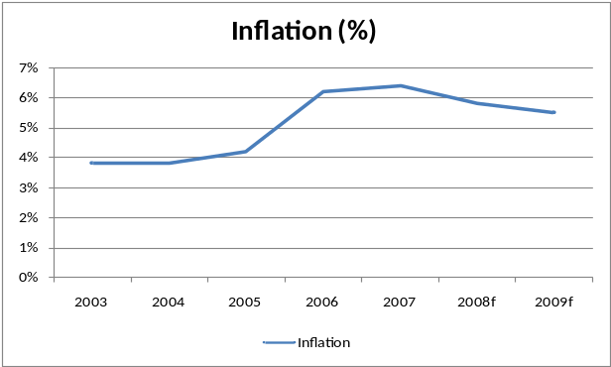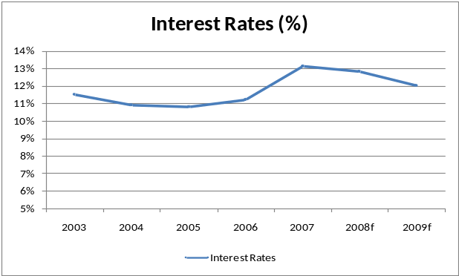
Source: EIU

C. Government Regulation for Foreign Entry
Indian government maintains a certain restriction on foreign investment, although openness to selective foreign investment is one of its government’s priorities. Basic restrictions apply through the so-called Foreign Direct Investment (FDI), in which foreign companies can acquire a maximum stake in local companies, which in most cases is set at 51%. Some sectors have already been opened permitting a 100% foreign investment ownership, but it isn’t the case of retail and commerce. For a foreign company to operate in India, in most cases an agreement with a local partner is necessary. The largest foreign country investing in India is Mauritius (as a result of tax benefits, many foreign companies establish branches in Mauritius), followed by the UK and the United States.

Approval of foreign investments applies through the automatic approval (where government approval is not required), or through the Foreign Investment Promotion Board (FIPB), which is required for most large multinationals with large investment plans. The FIPB reviews the applications on a case-by-case scenario.

In the trading sector, FDI approval is allowed to a 100% stake for small businesses. Indian laws actually explicitly mention that FIPB approval might be allowed for retail trading of single brand products; these must carry only a single brand, be branded while manufactured and be sold under the same brand internationally. Other types of retail trading remain closed to foreign companies. Based on this scenario, Wal-Mart decided to partner up with Bharti Enterprises to offer wholesale cash-and-carry to serve small retailers, manufacturers, and farmers. The 50:50 company is called Bharti Wal-Mart Private Limited.

D. Formal / Informal Government Preferences for Local Vs. Foreign Firms e.g. Reliance Retail vs. Wal-Mart
The objective of the FDI is obviously to allow foreign direct investments in the country to acquire knowledge, expertise and foreign currency reserves, together with protecting small, local producers-retailers’ interests. But at the same time seems to be a contradictory measure. Wal-Mart faces investment restrictions while local giants such as Reliance Industries have freedom to operate. Reliance Industries decided to launch a $ 5 billion supermarket chain and has faced tough opposition from local farmers and wholesalers who claim that their jobs are in danger. There seems to be no real difference between the potential threat to jobs posed by foreign retail groups, who have to face investment restrictions, and large Indian groups such as Reliance. Both of them offer modernization, convenience, efficiency, and will end up probably also offering lower prices and higher quality.

As the problem and differences arise, the FDI will have to make a decision which could go in opposite directions: either it reverses recent trends, and starts to increase restrictions on quantity and quality of foreign investors, or decides to fully open the market and allow foreign investments with the same restrictions that apply to local companies in an open market environment.

E. Competition rules
India still keeps some state-owned monopolies in strategic national sectors such as postal service and railways. Monopolies per se are not forbidden, but the Competition Act forbids any type of anti-competitive agreement: cartels, sharing territories, restrictions on production and supply to affect prices, collusive bidding, or predatory pricing. Other practices are objectable, such as the exclusive supply or distribution agreements, or the refusal to deal with certain persons or class of persons.

F. Publicity issues
In a country such as India, of still prevalent poverty and considerable income disparities, foreign investors are often portrayed as being merely after the ‘cheap labor’. It is not inappropriate to consider the publicity issues with the expansion of a company with such a Wal-Mart. Wal-Mart has historically been portrayed by some segments of the media and the public as the stereotypical exploiter, and depictions of its alleged malpractices abound, from the home market of the United States to rural China. A marketing campaign, and/or a local partnership, such as that Wal-Mart has established with Bharti Enterprises, are advisable to ease the entry into the market and avoid public hostility.

G. Labor market skills
It is unlikely that Wal-Mart will have problems in terms of labor market skills. India’s workers are skilled enough for the not-so-demanding jobs that the company provides. In terms of higher levels of employment, again, India is a booming with a new echelon of ambitious, highly educated (domestically or abroad) competent people, especially in the field of information and communication technologies, which are a considerable strength of Wal-Mart and a key ingredient of its business model.

H. Tax system
The tax system in India is somewhat chaotic and tax enforcement leaves a lot to be desired due to an overly bureaucratic and inefficient government, and the multiple levels of it. As a basis, foreign corporations are taxed at the 40% rate on a national level, although a myriad of other smaller taxes, both federal and state, could potentially apply as well. However, potential benefits could result from taking deductions as a result of infrastructure investments involved, as per incentives of the Indian government. Clearly, Wal-Mart would need to heavily rely on intimate knowledge of Indian taxation system to take advantage of the opportunities presented.

I. Double taxation and repatriation of income
In terms of income taxation and repatriation, India has a Double Taxation Relief agreement with the United States, according to which interest and capital gain repatriation is taxed at the 15-20% level. Again, as above, intricacies could be key. For example, the US offers its citizens a ‘tax holiday’ every several years, allowing them to repatriate income earned abroad at much lower tax rates. In addition, capital gains in differently classified investments may be subject to varying degrees of tax relief.

J. Currency Volatility
A final macroeconomic consideration Wal-Mart will need to take is the potential volatility of the respective level of the two currencies, the dollar and the Rupee. An obvious remedy to this is matching both currency and duration of both debt and investments. This is to say that Wal-Mart should be looking to use local, Rupee-denominated loans or capital, or somehow peg its relevant interest payments, if debt if to be taken on in dollars, to negate the potential adverse effects of exchange rate volatility.

IV. The Wal-Mart Organization
The Indian retail industry is expected to grow from $300 billion to $637 billion by 2015. Industry experts argue that the eventual leaders in Indian retail could each build up to $10 billion to $50 billion in annual revenue within a decade. That is significant even for Wal-Mart. (NY Times, Nov. 28, 06).

A. Company Overview
Incorporated in Delaware in October of 1969, the Wal-Mart business began in 1945 by Sam M. Walton in Arkansas. Since fiscal 1992, Wal-Mart’s international presence has continued to expand. While the company does not specifically break out sales by country in all instances, the vast majority of international sales are generated in the UK (37%), Mexico (24%), and Canada (15-20%). (Jeffries & Company, Inc. - October 1997) In order to explore the company-level challenges and opportunities in the Indian market, we will analyze the transferability of the attributes that have driven Wal-Mart’s success in the United States.

During fiscal year 2008, Wal-Mart had net sales of $375 billion, with business operations in three segments:
- Wal-Mart Stores
- Sam’s Club
- International.

The Wal-Mart Stores segment is the largest segment of the business, accounting for 64% of the fiscal 2008 net sales. This segment operates stores in three different formats in the United States:

- Supercenters, which average approximately 187,000 square feet in size and offer a wide assortment of general merchandise and a full-line supermarket
- Discount stores, which average approximately 108,000 square feet in size and offer a wide assortment of general merchandise and a limited variety of food products; and
- Neighborhood Markets, which average approximately 42,000 square feet in size and offer a full-line supermarket and a limited assortment of general merchandise.
The second business segment, Sam’s Club, accounted for 12% of the fiscal 2008 net sales. Its focus is to provide exceptional value on brand name merchandise at “members only” prices for both business and personal use. These stores average approximately 132,000 square feet in size.

The last business segment, International, accounted for 24% of the fiscal 2008 net sales. It includes numerous different formats of retail stores and restaurants, including discount stores, supercenters and Sam’s Clubs that operate outside of the United States. Wal-Mart’s ability to offer customers low prices on quality merchandise that offers exceptional value and its ability to effectively operate the food departments tends to have a major impact on the International segment’s competitive position in the markets.

In the United States, Wal-Mart discount stores and the general merchandise area of supercenters carry items in the apparel, stationery, books, shoes, housewares, hardware, electronics, home furnishings, small appliances, automotive accessories, sporting goods, toys, pet food and accessories, cameras, health and beauty aids, and pharmaceuticals categories. The grocery assortment in supercenters consist of full line grocery items, including meat, produce, deli, bakery, dairy, frozen foods, floral and dry grocery. The general merchandise categories for Wal-Mart Stores in the United States during fiscal 2008 and it corresponding sales participations are presented in Figure 3.

Figure 3: Distribution of US sales by merchandise categories
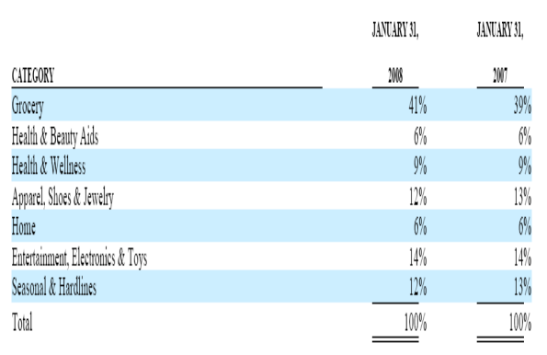
Source: Wal-Mart 10K, Fiscal 2008

The merchandise for the International segment is similar to that of their operations in the United States in terms of breadth and scope of merchandise. This practice has proved successful in most of the markets such as Mexico, Canada, Brazil, and Argentina.

However, at the same time, such strategies failed in markets such as Germany and South Korea. What led to such failures can be partially contributed to misjudging the local tastes. For instance, in Korea, where Wal-Mart abandoned operations in 16 stores after two years of operating losses, the company was not able to adapt to regional tastes. Korean customers did not like the warehouse-style layout. They looked to discount supermarkets for fresh produce, which Wal-Mart did not emphasize. Also, customers did not like the frozen and prepackaged food that Wal-Mart stocked. (The International Herald Tribute, May 26, 2006)

B. Adapting to the Indian Market
With regards to the Indian market, we recommend that Wal-Mart focus on the customer’s receptiveness and cultural differences to their retail concepts. It is difficult to predict consistently and successfully the products and services that customers demand. The success of this expansion depends in part on Wal-Mart’s ability to identify and respond to evolving trends in demographics and consumer preferences. Throughout its global operations, Wal-Mart should continue a heavy emphasis on operating a “store of the community.” For instance, Reliance Fresh, a competitor in the grocery segment, separates vegetarian and non-vegetarian items in the store and even in the supply chain. It has learned that Indian people are very sensitive to this issue. ("Top 10 Global Leaders in Food." iReports April 2006) Wal-Mart must adapt a similar strategy to ensure that cultural sensitivities are addressed. Foreign retailers are allowed to operate through franchisees and also permitted to invest their own capital in wholesale shops.

Another factor that has contributed to Wal-Mart’s success in the United States has been its strong distribution network. During fiscal 2008, approximately 81% of the Wal-Mart Stores segment’s purchases of merchandise were shipped through distribution centers. Wal-Mart Stores segment operations are supported by 121 distribution facilities, located strategically throughout the continental United States. Of these 121 distribution facilities, they own and operate 106. By buying direct from vendors with bulk purchases in centralized distribution, Wal-Mart has a sustainable low-cost advantage. Currently, Wal-Mart’s International segment is comprised of wholly-owned subsidiaries operating in Argentina, Brazil, Canada, Puerto Rico and the United Kingdom, majority-owned subsidiaries operating in Central America, Japan and Mexico, and joint ventures in China and potentially India.

During fiscal 2008, approximately 70% of the International segment’s purchases flowed through these distribution facilities. Of these 143 facilities, Wal-Mart owns 38 and leases 68. Third parties own and operate the remaining 37 distribution facilities. Most of these operations are in the Americas. Since India is geographically outside of where most of the current International operations exist, we recommend that Wal-Mart enter the Indian market through a joint venture (per current Indian regulations) in order to start building a solid distribution network. Such alliance with local partners via a joint venture would also further help Wal-Mart by providing access to local knowledge and resources. A solid centralized distribution network is critical to Wal-Mart’s success in the market.

In addition, access to and relationships with suppliers in the American market has contributed significantly to Wal-Mart’s success. The products Wal-Mart sells are sourced from a wide variety of domestic and international suppliers. We recommend that Wal-Mart leverage these resources in the Indian market.

Over the past 10 years, the market for the top 10 global brands of food has grown significantly - these brands include Unilever, Cadbury-Schweps, Pepsi, General Mills, etc. In the cereals, dairy, snacks, and confectionary markets, the Indian market has grown between 50% and 120% over the last 10 years. These trends are indicative of the strong demand in India for the global brands that Wal-Mart has built its business around. Because of growing demand, global food manufacturers have been setting up operations in India to reduce costs and develop insight into local markets. Unilever, for example, has a strong India manufacturing presence and requires all of its employees in India to spend 6 weeks in rural villages to better understand local consumer insights. Proximity and strong relationships with suppliers is one of Wal-Mart’s key competitive advantages. Based on the current trends of the biggest global brands in India, Wal-Mart will be able to maintain this advantage upon entering the Indian market. ("Top 10 Global Leaders in Food." iReports April 2006)

We also recommend that Wal-Mart pay close attention to the real estate market in India. Choosing strategic store locations in the United States has contributed significantly to Wal-Mart’s success. As a result, Wal-Mart should explore the markets and its local land use and other regulations restricting the construction of buildings. This factor will be especially important in the long-term as regulations liberalize in India. Wal-Mart’s success will depend on its ability to acquire new store sites.

In addition, people development and execution have also been critical to Wal-Mart’s success in the United States. Wal-Mart’s ability to open and add stores depends upon their ability to locate, hire, and retain qualified personnel. Furthermore, we recommend that Wal-Mart emphasizes its efforts on identifying appropriate candidates for acquisitions and alliances. Integrating any newly acquired operations into their business will be a critical element to their growth. There is a significant working-class demographic in India. Wal-Mart will need to tap into this employee pool to recruit employees in its stores. With the booming growth in India, demand for labor is increasing and this will pose a challenge for Wal-Mart in keeping labor costs low. There is also a strong organized labor movement in India which runs counter to Wal-Mart’s US non-unionized workforce. ("Left trade unions on nationwide protest Oct 13 against oil price hike,” <http://www.hartford-hwp.com/archives/52a/058.html>)

The importance of people management and development can be further illustrated by Japan, where Wal-Mart has generally lost money so far. In Japan, American-style management does not seem to be working. Stores often run out of stock because Wal-Mart is so obsessed with reducing inventory. Employees are being asked to do multiple jobs and some are being laid-off to increase efficiency. Wal-Mart should take these issues into consideration in its labor force expansion.

Finally, Wal-Mart has clear superiority in technology versus its competitors. The company has implemented one of the most sophisticated systems, which has facilitated its reduction of overheard expenses consistently over time. The systems have resulted in greater inventory accuracy, improved in-stocks, and more effective replenishment of out-of-stock products. As Information Technology is one of Wal-Mart’s key competitive advantages, we recommend that the company explores any issues that may disrupt its computer systems and create back-up strategies.

V. Implementation Strategy

A. Alternatives for Entering the Market
In a broad sense Wal-Mart has several alternatives to enter this new strategic market that India has become for its worldwide plan expansion: start from scratch, acquire an existing player or partner with an existing player in strategic joint venture. Figure 4 presents a holistic framework approach to this end.

Figure 4: Strategic framework for entering a new market

CURRENT
MARKET
ASSESSMENT
ENTERING STRATEGY
Major Players & Market Share
Product Differentiation
Barriers to Entry/Exit
Start form Scratch
Acquire Existing Player
Strategic Joint Venture
COMPANY
ASSESSMENT
POS/CONS
Macroeconomic Conditions & External Factors
COST BENEFIT ANALYSIS
RISK ASSESSMENT
& MANAGEMENT
IMPLEMENTATION
STRATEGY
Based on: P. Consentino, 2005

The first level components of the model presented are discussed in the above sections. In assessing the three entering strategies we concluded the following:

- Start form Scratch: India’s retail market is very attractive to other big players as it is to Wal-Mart. In order to capture a substantial part of the proceeds in this industry, Wal-Mart needs to ramp up and secure long term production of fresh groceries and other consumer products. Therefore, this strategy is not advisable because it is too expensive and too time consuming to build the business from the ground up securing the vertical integration it requires. In addition the lack of experience in the local market is a risk too big to retain by itself, and it is best to acquire local knowledge through involvement with third parties that understand local networks and ways of business in India as well as the local consumer preferences.

- Acquire Existing Player: According to existing legislation foreign retailers are allowed to operate through franchisees and also permitted to invest their own capital in wholesale shops. This alternative would require Wal-Mart to franchise its business model to local third parties that are not adequately prepared to implement it, and may not be able to capitalize on. It would be a challenge to align interests of corporate headquarters with franchisees since the corporation model is sales oriented while the franchisees are more profit oriented. In addition, this alternative implies lack of control in the company’s strategic growth market for the decades to come.

- Strategic Joint Venture: This alternative reconciles the lack of knowledge and experience in the local market as well as leverages in the existing strengths of the organization in terms of operations, technology and relations with global consumer product companies (e.g. Proctor & Gamble). In anticipation of further policy changes, in 2007 Wal-Mart decided to enter the market via a joint venture with local Group Bharti. The wholesale cash-and-carry venture will invest in setting up an efficient supply chain. This will link farmers and small manufacturers directly to retailers, thereby maximizing value for farmers and manufacturers on the one end and retailers, and in turn, consumers on the other. The venture will support farmers and small manufacturers who have limited infrastructure and distribution strength, and the supply chain will enable minimum wastage, particularly of fresh foods and vegetables.

Therefore we see Wal-Mart’s current joint venture strategy with Bharti as adequate. “Over the next seven years, the venture is expected to open 10 to 15 wholesale cash-and-carry facilities and employ approximately 5,000. A typical facility will stand between 50,000 and 100,000 square feet and sell a wide range of fruits and vegetables, groceries and staples, stationery, footwear, clothing, consumer durables and other general merchandise items.”

B. Geographic Locations
As mentioned above, the location of the distribution centers and the stores is paramount for the success of the business; in particular targeting the adequate segments at a local level will require the venture to be able to offer high quality products at relatively lower prices to its customers. Figure 5 presents a summary of relevant facts about India’s geographic distribution of population, wealth and income as well as demand for consumer products.

Figure 5: Geographic distribution: population, wealth, family income and demand of consumer products

Population distribution Wealth distribution
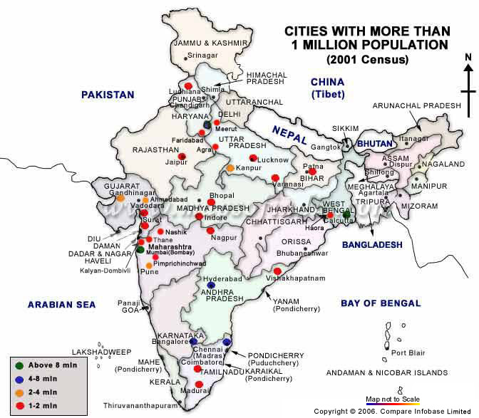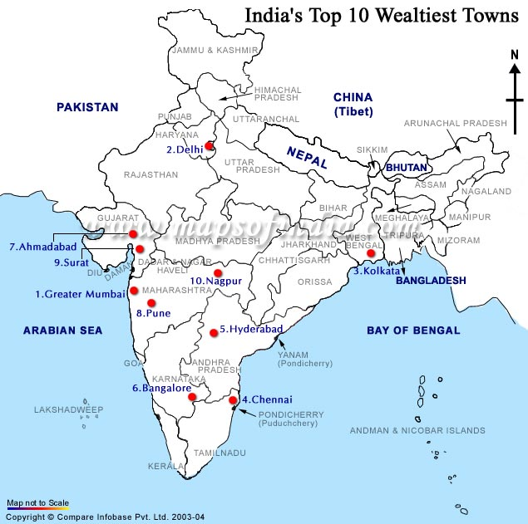

Family income Consumer goods spending
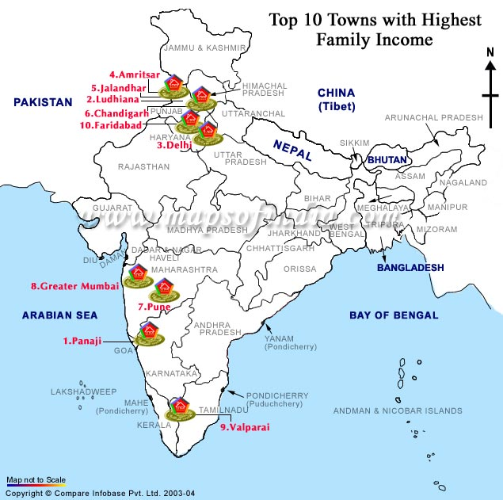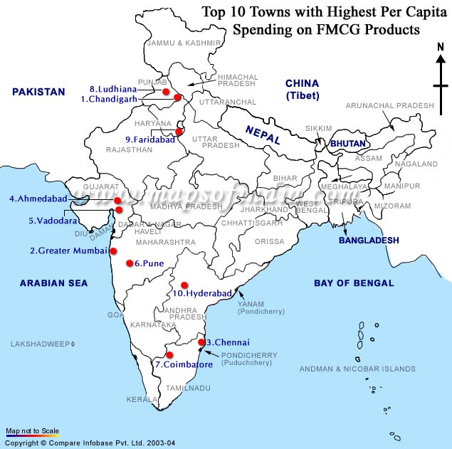
Source: http://www.mapsofindia.com/top-ten-cities-of-india/index.html

The above information combined with country wide supply and existing infrastructure required to set up the distribution network, will allow determining the best locations. Figures 6 and 7 present the geographic distribution and resource availability in terms of transportation infrastructure (railroads, roads, waterways, sea ports and air ports).

Figure 6: Geographic distribution of existing land and water transportation infrastructure

Rail road network National highway network
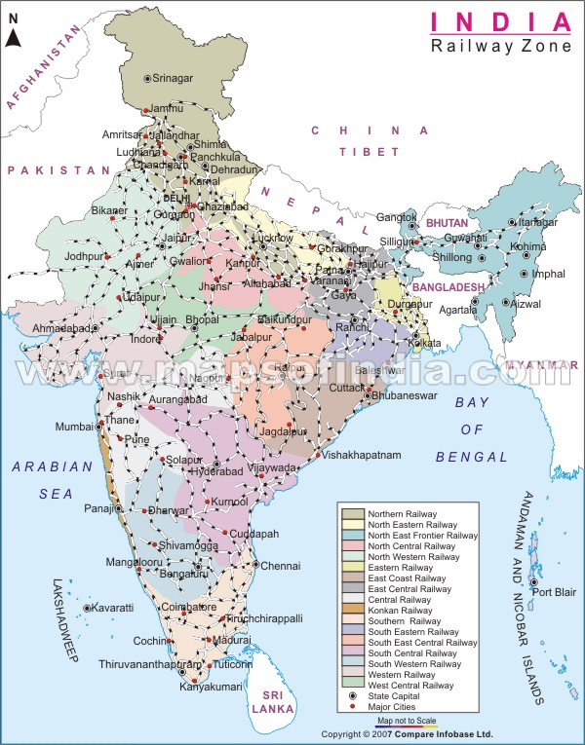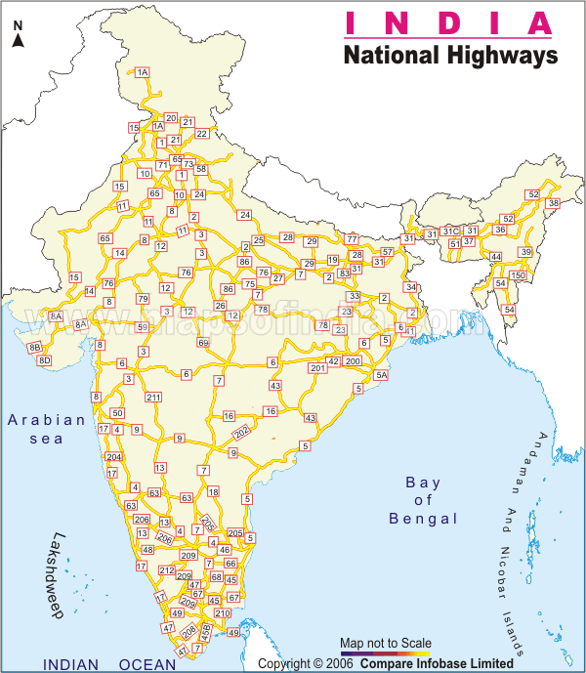

Inland waterways and Sea-port infrastructure
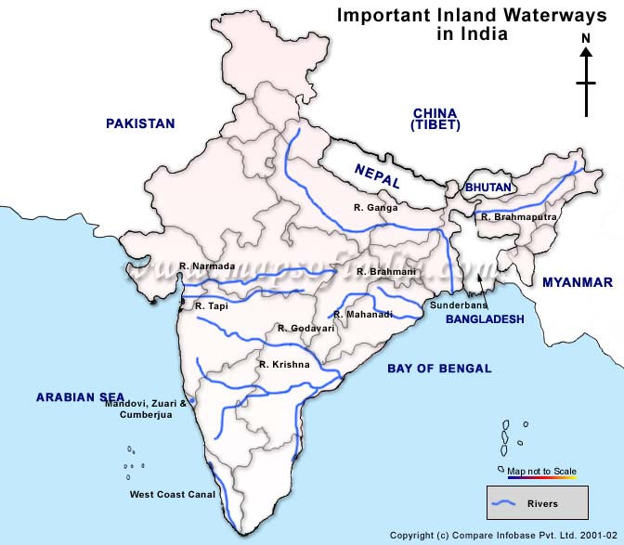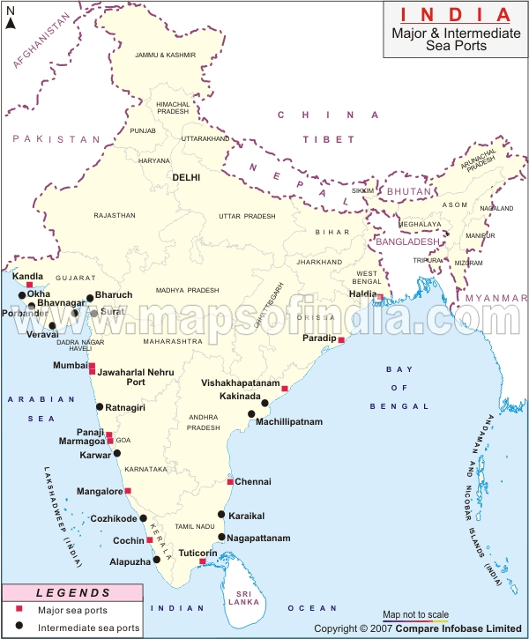
Source: http://www.mapsofindia.com/top-ten-cities-of-india/index.html

Figure 7: Geographic distribution of existing air transportation infrastructure

Major airport infrastructure
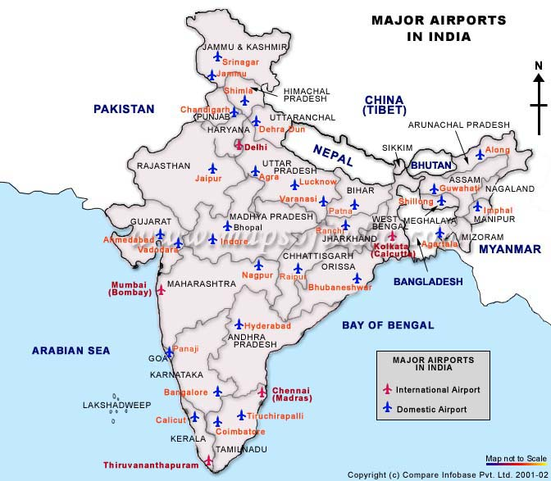
Source: http://www.mapsofindia.com/top-ten-cities-of-india/index.html

From the above information, we recommend that the strategy is implemented initially in metropolitan areas with high population density, higher family income and consumer goods demand. The scope of the network has to be at a national level in order to achieve long term growth objectives and economies of scale. Based on these principles and the existing infrastructure we recommend initiating the action plan in the following cities: Mumbai in the west, New Delhi in the north, Kolkata in the east and Bangalore in the south-east.

The risks associated to this strategy include the following aspects:

- Inability to adapt: Although Wal-Mart has adopted a strategy that helps it to transfer part of the risk by partnering with a strong local player, its long term success will depend on the organization’s ability to adapt to the local culture in terms of business practices and consumer demands. In addition, the ability of both organizations to share information, coordinate efforts in execution and ensure knowledge transfer in both ways will be determinant to become market leaders.

- Political risk: India’s future governments are expected to be coalitions including communists; therefore it is reasonable to expect that government will be implementing many pro-Indian policies (i.e. support to the caste system and rigid labor laws). Other sensitive issues are the India-Pakistan situation and other geopolitical issues in the region, which raise security concerns and pose a threat to the required internal stability for long term investments.

- Product Quality Issues: Since the venture will buy most of its fresh products from third party local companies, it faces the risk of contamination that can adversely affect the perception of the brand and raise legal disputes and costly settlements.

- Infrastructure Development: Lack of reliability in some basic infrastructure such as the maintenance of roads and railways, the recurrent power cuts in some regions and other negative affects that are not under control of Wal-Mart have potential to hinder its operations.

- Currency Risk: Inability to maintain adequate match levels between debt and revenues in Rupee, especially as Wal-Mart scales up its operations.

- Natural Disasters: Floods and earthquakes are the two main hazards that may disrupt the normal operation of Wal-Mart in India. In particular floods can be catastrophic in terms of damaged crops and inability to transport and distribute products between producers, distribution centers and retail stores. Figure 6 presents flood and earthquake prone areas in India.

Figure 6: Flood and earthquake prone areas
Flood Prone Areas Earthquake Prone Areas
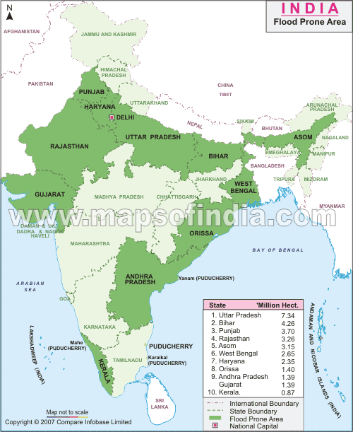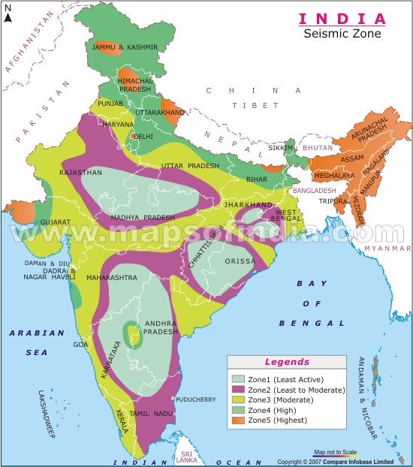
Source: http://www.mapsofindia.com/top-ten-cities-of-india/index.html

Based on the framework presented in: Mark P. Cosentino, “Case In Point 4th Edition” Burgee Press, 2005.
http://walmartstores.com/Careers/276.aspx?p=7792

