David Batista

DAT 1001

20th October 2024

**Excel Project - Written Report**

**Abstract**

In this project sales data was collected over a six month span for the Maven Roasters coffee franchise spanning three locations in Manhattan. Then using Microsoft Excel the data was transformed to display relevant information extracted from what has been collected which was then explored and analyzed further utilizing pivot tables to extrapolate significant data relationships. Then these relationships tables were used to create a reader friendly, interactive visualization dashboard to draw valuable insights and analysis about the data.Some of these insights were proof of steady business success with the gross revenue visualization and possible ways to optimize closing hours from transactions by hour statistics.

**Introduction**

The Maven Roasters coffee franchise wants to better streamline operations and understand customer purchasing behavior better. To accomplish this transactional sales data has been collected from January to June of 2023. The purpose of this project is to prepare, transform, visualize and analyze this data into an interactive dashboard that will help Maven Roasters franchise owners accomplish their goal by finding opportunities within the data and identifying trends to improve the efficiency of their operations and sales. The primary scope of the project focuses on analyzing data based on transactions in correlation to time and franchise location to accomplish the main goal.

**Methodology & Steps**

After the data was collected Microsoft Excel was used to transform and prepare the data further by calculating relevant data such as revenue and separating date data from the less legible date codes recorded by utilizing excel functions like **TEXT** and basic math operators based on the corresponding relative cells. An excel ability that was pivotal to duplicating these functions across the thousands of rows of data was the excel **duplicate tool**, using the shortcut **Ctrl + D**.

Next pivot tables were created with the prepared and transformed data to bring forth the important relationships in the data, such as the sales depending on the hour of day and the general gross revenue by month. For instance, the gross revenue by month pivot table was created by adding **total revenue** as a row then adding a column of the **isolated months** to get, both of these data columns only having just been added in the data preparation process.

These data relationships from the pivot tables were then illustrated and visualized using the corresponding best fit chart in excel to make it quickly readable to humans, such as a **line chart** to display the **gross revenue by month pivot table** or using a **clustered column chart** for the **gross transactions by month**. These charts were made to be most readable utilizing excel **chart formatting** options.

Lastly these visualizations were neatly organized to form an interactive dashboard utilizing a **pivot table slicer** so that deep and valuable insights can be made with little effort. For simplicity and viewability, all extra excel UI was disabled, such as **gridlines and headers**. To make the dashboard cleaner.

**Results**

Here are the data relationship visualization results

**Scope:** All three locations, however, the dashboard can isolate locations on this dashboard with the pivot table slicer

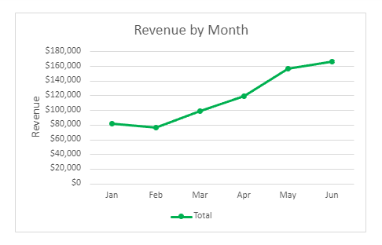

**Quick Insights:**

Revenue is on a steady increase since february, peaking at the most recent data in the month of June. The franchises can use this to acknowledge that their business is generally doing well.

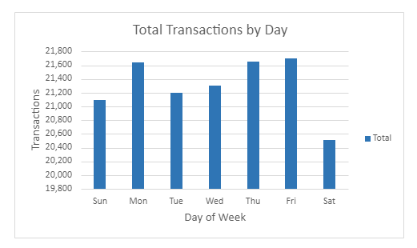

**Quick Insights:**

Saturday is by far the least popular day of the week for transactions at the locations, whilst Monday, Thursday and Friday are about even at the most popular.

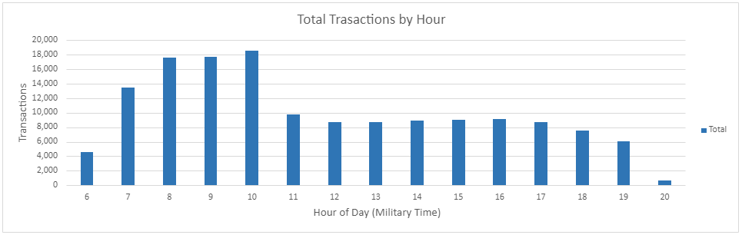

**Quick Insights:**

The standout most popular hours for customers is 7-10 am. Whilst, pretty unsurprisingly, almost nobody gets coffee at 8 pm.

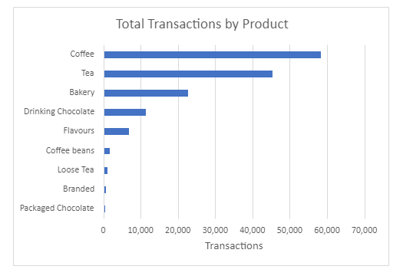

**Quick Insights:**

The most popular drinks are Coffee and Tea by far, whilst coffee beans sales aren’t too common, this could be a que to keep stock decently low on these items.

**Top 15 Product Types Table**

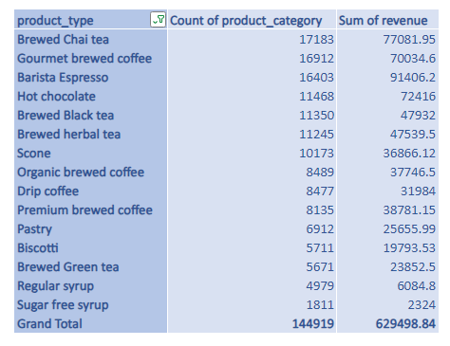

**Quick Insights:**Sugar free syrup is the least common product type of the top 15. Barista Espresso takes in more revenue than Gourmet brewed coffee, despite having less transactional sales.

**Discussion - Insights, Analysis and Recommendations**

One major insight that can be drawn from the top product types table, seen above, is that Scones, Premium brewers coffee and Pastries are particularly lucrative, despite not having nearly as many sales as other products. This generally makes sense as things like Premium coffee are a niche market. A good suggestion made from these insights is to focus on maintaining brand loyalty to keep these more price sensitive products at their steady rate or even increase their sales.

Another simple but crucial insight that can be found in the data is the steady growth in revenue over the months since february, peaking at the most recent month of June. It is a very simple statistic but it is the most important metric in measuring business success. To analyze this further, it can be seen that all of the franchises follow this growth quite consistently, there is no apparent outliers, this likely means that the parent company is likely doing a good job marketing as a whole.

**Pseudo-Anomaly Insight & Recommendation**

A slight anomaly that can be found is that the Astoria Manhattan location does not have any sales at 8 pm, this is likely not an actual anomaly and is because the store closes at 7 am, however, if this is true, there could be some merit to this decision. The transactions by time data supports that 8 pm sales are incredibly rare, it might be financially more economical to close locations at 7 am and not pay the extra wage hours like the Astoria location already is. It is also observed that the Astoria isn’t open at 6 am either, however, I’m not sure I entirely agree with this, as there is likely enough 6 am sales to make it worth opening early.

**Conclusion**

The project successfully utilized the collected data on the Maven Roasters franchises’ sales to create a dashboard of useful insights and analysis based on relationships of relevant data from the set. Overall Maven Roasters franchises should consider closing at 8 pm to save money, maintain their current marketing strategy and growth tactics as it is showing success and they should focus on maintaining brand loyalty and public relations to ensure their lucrative products stay at their sales level or grow further. Many other further insights and recommendations can be found through the user friendly dashboard.

**References:**

*Analytics, Maven. “Data Analyst Portfolio Project: Build an Excel Dashboard.” YouTube, YouTube, www.youtube.com/watch?v=OMFlZ6PI6Sk&t=207s. Accessed 16 Oct. 2024.*

*“How to Apply a Formula to an Entire Column in Excel.” Indeed.om, Indeed Editorial Team, www.indeed.com/career-advice/career-development/apply-formula-to-an-entire-column*

*-in-excel. Accessed 14 Oct. 2024.*

**Appendices**

Tools Used: Microsoft Excel, Google (to access references above)

**Raw data** available in repository