|  |
| --- |
| C:\Users\Tsubaki Yukino\Desktop\FlyAwayPlus Project\Capture.JPG |
| **FLY AWAY PLUS** |
| **Software Requirement Specification** |
|  |
| |  |  |  | | --- | --- | --- | | **Fly Away Plus** | | | | **Group Members** | Hoàng Nghĩa Đức | SE02882 | | Dương Thanh Hải | SE02856 | | Nguyễn Minh Hoàng | SE02819 | | Trần Mạnh Hiếu | SE02778 | | Phan Tiến Lực | SE02923 | | Lê Minh Thúy | SE02881 | | **Supervisor** | Mr. Nguyễn Văn Sang | | | **Project code** | FAP | | |
|  |

**- Hanoi, 05/2015 –**

**RECORD OF CHANGE**

*A-Added; M-Modified; D-Deleted

|  |  |  |  |  |
| --- | --- | --- | --- | --- |
| **Effective Date** | **Change Items** | **A*M, D** | **Change Description** | **New Version** |
| 2015/05/29 | Functional Requirement | M |  | v1.0 |
| Non-functional Requirement | M |  |
| 2015/06/11 | Use Case | M | Add new functions | v1.1 |
| Business Rules | M | Add new rules |
| Entity Relationship Diagram | M |  |
| Entity Detail | M |  |
|  |  |  |  |  |
|  |  |  |  |  |
|  |  |  |  |  |

*Table 1: Record of change*

**SIGNATURE PAGE**

|  |  |  |
| --- | --- | --- |
| **ORIGINATOR** | Trần Mạnh Hiếu |  |
|  | Developer |  |
|  |  |  |
|  |  |  |
| **REVIEWERS** | Lê Minh Thúy |  |
|  | Developer |  |
|  |  |  |
|  |  |  |
| **APPROVAL** | Nguyễn Văn Sang |  |
|  | Supervisor |  |
|  |  |  |

Table of Contents

**1.** **INTRODUCTION** 5

1.1. Purpose 5

1.2. Definitions and Acronyms 5

1.3. System Purpose 6

**2.** **OVERALL DESCRIPTION** 7

2.1. System overview 7

2.2. Use Case Diagram 7

2.3. Product Features 8

2.3.1. User Characteristics 11

2.3.2. User Documentation 12

2.3.3. Assumption 12

2.4. Entity Relation Model 12

2.4.1. Entity-Relationship Diagram 12

2.4.2. Entity Detail 12

**3.** **FUNCTIONAL SPECIFICATION** 15

3.1. Appendix 15

3.2. Business Rules 15

3.3. Use Cases 17

3.3.1. Common Module 17

3.3.2. Suggest Module 22

3.3.3. Social Module 25

3.3.4. Account Management Module 71

3.3.4.1. Login 72

3.3.4.2. UC049-Logout 73

3.3.4.3. UC050-Register 74

3.3.4.4. UC051-Edit profile 75

3.3.4.5. UC052-Forgot password 76

3.3.5. Admin Module 78

3.3.5.1. UC053-Lock user’s account 78

3.3.5.2. UC054-Unlock user’s account 79

3.3.5.3. UC055-Send warning 80

3.3.5.4. UC056-Review user 81

3.3.5.5. UC057-Review post 82

3.3.5.6. UC058-Delete user’s post 83

3.3.5.7. UC059-Reply question 84

**4.** **NON-FUNCTIONAL SPECIFICATION** 85

Reliability 85

Performance Requirements 85

User Interface 85

Maintainability 85

Usability 86

Security Requirements 86

Hardware/Software Requirements 86

# **INTRODUCTION**

## Purpose

This is the Software Requirements Specification for the FAP system. This document will provide the describing of general requirement and non-functional requirements of our FAP system. The FAP is designed to be a website that help users sharing their journey and connecting to their friends. These requirements will assure that the system will correctly and reliably perform its intended functionality. This specification will provide general, as well as specific requirements to be used in the design, testing and validation of the system. It is intended for both stakeholders and the project team of the system.

## Definitions and Acronyms

This section describes the definitions, terms, and acronyms that are used in software requirements specification.

|  |  |  |
| --- | --- | --- |
| **Acronym** | **Definition** | **Note** |
| FAP | Fly Away Project |  |

*Table 1-3: Definition and Acronyms*

## System Purpose

Our project – FAP will include some main functions of existing social networks and add some new features such as create room, connect user’s trips as a journey of their life. With the slogan “Share all we have!” we toward on sharing information and experiences between users and spread the joy of travelling together. People can make new friends by join in groups, Fly Away Plus and have new experiences together. We hope we can share all we have, and we hope people who loves travelling can be connected and easily share information about their trips.

# **OVERALL DESCRIPTION**

## System overview

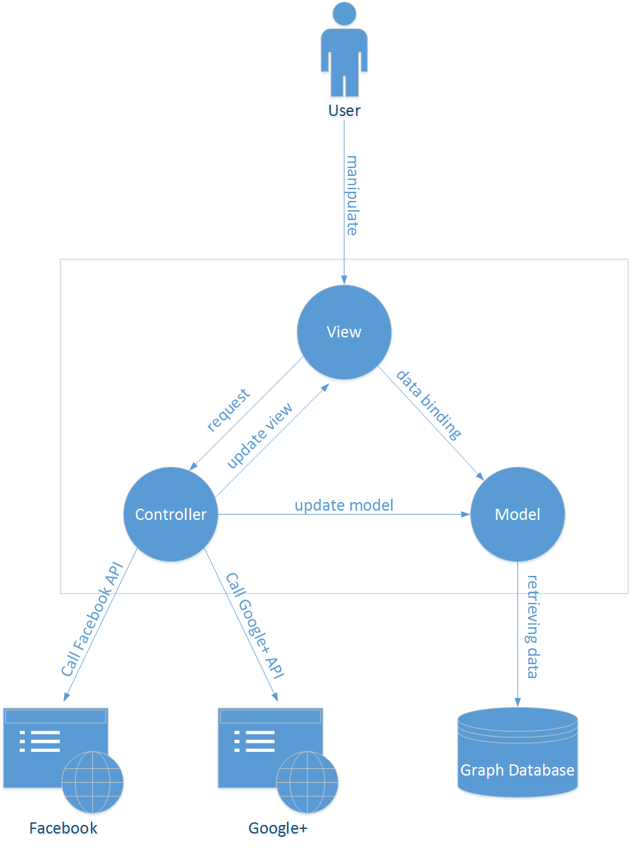

## Use Case Diagram

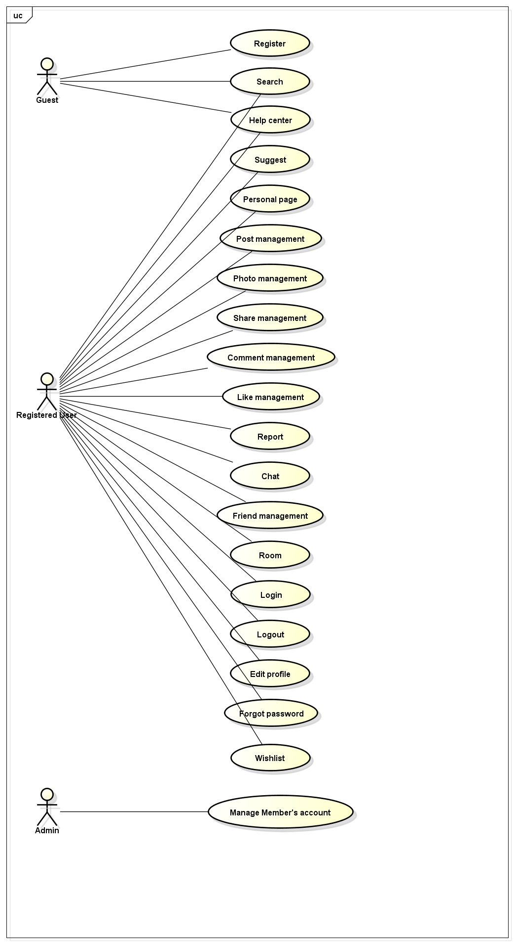

Figure 3-1: Use case diagram of FAP system

## Product Features

|  |  |  |  |
| --- | --- | --- | --- |
| **UC No.** | **Group of functions** | **Functions** | **Glossary** |
| **FAP GUEST/MEMBER MODULE** | | | |
| **Common Module** | | | |
|  | Search | Search by name | Tìm kiếm những thông tin đang có trên FAP |
|  | Help Center | Send question | Người dùng gửi các câu hỏi liên quan đến FAP |
|  | Basic guide | Hướng dẫn sử dụng cơ bản hệ thống FAP |
|  | Search question | Người dùng có thể tìm kiếm hướng dẫn sử dụng qua các câu hỏi thông thường |
| **FAP MEMBER MODULE** | | | |
| **Suggest Module** | | | |
|  | Suggest | Suggest place | Gợi ý những địa điểm nằm trong xu hướng mới nhất trên FAP |
|  | Suggest friend | Gợi ý kết bạn với những người dùng có nhiều bạn chung/thông tin chung |
|  | Suggest activity | Gợi ý những hoạt động đang là trào lưu hoặc những hoạt động có bạn bè đang tham gia |
|  | Look around | Gợi ý những bài viết được chú ý nhất quanh địa điểm hiện tại của người dùng |
| **Social Module** | | | |
|  | Personal Page | Display timeline | Hiển thị các bài viết và ảnh của người dùng trên một dòng thời gian |
|  | Display news feed | Hiển thị các bài viết của bạn bè và các gợi ý cho các địa điểm/hoạt động v.v… |
|  | Post management | Add post | Thêm bài viết mới |
|  | Edit post | Chỉnh sửa bài viết đã tồn tại |
|  | Delete post | Xóa bài viết đã tồn tại và tất cả những nội dung liên quan |
|  | Photo management | Add photo | Thêm ảnh mới |
|  | Edit photo caption | Chỉnh sửa tiêu đề của một ảnh đã được đăng |
|  | Delete photo | Xóa một ảnh và toàn bộ nội dung liên quan |
|  | Video management | Add video | Thêm video mới |
|  | Edit video caption | Chỉnh sửa tiêu đề của một video đã được đăng |
|  | Delete video | Xóa một video và toàn bộ nội dung liên quan |
|  | Share management | Share post | Chia sẻ một bài viết của một người dùng khác |
|  | Delete shared post | Xóa bài chia sẻ |
|  | Comment management | Add comment | Thêm một bình luận vào bài đăng hoặc ảnh |
|  | Edit comment | Chỉnh sửa một bình luận |
|  | Delete comment | Xóa một bình luận |
|  | Like management | Like | Thích một bài đăng/ảnh |
|  | Unlike | Bỏ thích một bài đăng/ảnh |
|  | Dislike | Không thích một bài đăng/ảnh |
|  | Un-dislike | Bỏ không thích một bài đăng/ảnh |
|  | Report | Report a post | Báo cáo một bài đăng có nội dung vi phạm tới quản trị viên |
|  | Report an user | Báo cáo một người dùng có hành vi vi phạm tới quản trị viên |
|  | Chat | Chat with others | Tán gẫu với người dùng khác |
|  | Friend management | Add friend | Kết bạn với thành viên khác |
|  | Edit relationship | Chỉnh sửa mối quan hệ với thành viên đã là bạn |
|  | Unfriend | Hủy kết bạn với một thành viên |
|  | Block | Chặn người dùng khác |
|  | Tag friend | Tag bạn bè vào bài đăng/ảnh |
|  | Follow user | Theo dõi người dùng khác để có thể nhìn thấy bài đăng và hình ảnh ở chế độ cộng đồng mà không trở thành bạn |
|  | Room | Join room | Tham gia vào một phòng |
|  | Leave room | Thoát khỏi một phòng đã tham gia |
|  | Create room | Tạo một phòng |
|  | Edit room’s information | Chỉnh sửa thông tin một phòng đã tạo |
|  | Create plan/schedule | Tạo kế hoạch/lịch trình cho một chuyến đi trong phòng |
|  | Edit plan/schedule | Chỉnh sửa kế hoạch/lịch trình cho một chuyến đi trong phòng |
|  | Add member | Thêm thành viên mới vào phòng |
|  | Remove member | Mời một thành viên ra khỏi phòng |
|  | Update schedule status | Cập nhật lịch trình |
|  | Chat | Tán gẫu với thành viên phòng |
| **Account Management Module** | | | |
|  | Login | Login by social network’s account | Đăng nhập bằng tài khoản Facebook/Google |
| Login by registered account | Đăng nhập bằng tài khoản được đăng ký trên FAP |
|  |  | Logout | Đăng xuất |
|  |  | Register | Đăng ký thành viên để sử dụng tất cả các chức năng của FAP |
|  |  | Edit Profile | Chỉnh sửa thông tin cá nhân |
|  |  | Forgot Password | Yêu cầu hệ thống giúp đỡ khi quên mật khẩu |
| **FAP ADMIN MODULE** | | | |
|  | Management Member’s account | Lock user’s account | Khóa tài khoản của người dùng vi phạm |
|  | Unlock user’s account | Mở khóa tài khoản người dùng |
|  | Send warning | Gửi cảnh báo đến người dùng |
|  | Review user | Kiểm tra một người dùng bị báo cáo vi phạm |
|  | Review post | Kiểm tra một bài post bị báo cáo vi phạm |
|  | Delete post | Xóa một bài post có nội dung vi phạm |
|  | Reply question | Trả lời câu hỏi của người dùng gửi đến |

### User Characteristics

This website developed towards those who love travel, looking for a website to share about their trips, searching for information, review of places, searching for friends for new trips and keep in touch with their fellow traveler. There are three main actors that system support:

* **Guest:** Do not have account on system. In general, they can use common features (search a place, search food and drinks, search on maps) and register feature.
* **Member:** Have account on system, they can use all functions of website. For example: Searching, posting, connect to friends etc…
* **Administrator:** They can use all functions of normal member and have an Administrator control panel to manage all configuration of system.

### User Documentation

|  |  |
| --- | --- |
| **Name** | **Description** |
| User Guide | Provide detailed explanation about the system, screens and guide users how to use all features of FAP website. |
| Installation guide | Provide detailed guide to install the system |

### Assumption

* Receive the guidance and good support of teacher.
* No one of member got sick in the software development process.
* In the development process, no device got fail.
* Every report meets the deadline.
* Team member do not conflict in the work process.

## Entity Relation Model

### Entity-Relationship Diagram



### Entity Detail

#### Place

|  |  |  |  |  |
| --- | --- | --- | --- | --- |
| No | Attribute | Type | Mandatory | Description |
|  | Place ID | Number | Y | Place’s id |
|  | Longitude | Number | Y | Place’s longitude |
|  | Latitude | Number | Y | Place’s latitude |

#### Chat

|  |  |  |  |  |
| --- | --- | --- | --- | --- |
| No | Field Name | Type | Mandatory | Description |
|  | Chat ID | Number | Y | Chat’s id |
|  | Content | String | Y | Chat’s content |
|  | Date Created | Date | Y | Chat’s date created |

#### Room

|  |  |  |  |  |
| --- | --- | --- | --- | --- |
| No | Field Name | Type | Mandatory | Description |
|  | Room ID | Number | Y | Room’s id |
|  | Room Name | String | Y | Room’s name |
|  | Date Created | Date | Y | Room’s date created |

#### Post

|  |  |  |  |  |
| --- | --- | --- | --- | --- |
| No | Field Name | Type | Mandatory | Description |
|  | Post ID | Number | Y | Post’s id |
|  | Content | String | Y | Post’s content |
|  | Date Created | String | Y | Post’s date created |

#### Picture

|  |  |  |  |  |
| --- | --- | --- | --- | --- |
| No | Field Name | Type | Default | Description |
|  | Picture ID | Number | Y | Picture’s id |
|  | Path | String | Y | Picture’s path |
|  | Date Created | Date | Y | Picture’s date created |

#### Video

|  |  |  |  |  |
| --- | --- | --- | --- | --- |
| No | Field Name | Type | Mandatory | Description |
|  | Video ID | Number | Y | Video’s id |
|  | Path | String | Y | Video’s path |
|  | Date_created | Date | Y | Video’s date created |

#### Comment

|  |  |  |  |  |
| --- | --- | --- | --- | --- |
| No | Field Name | Type | Mandatory | Description |
|  | Comment ID | Number | Y | Comment’s id |
|  | Content | String | Y | Comment’s content |
|  | Date Created | Date | Y | Comment’s date created |

#### User

|  |  |  |  |  |
| --- | --- | --- | --- | --- |
| No | Field Name | Type | Mandatory | Description |
|  | User ID | Number | Y | User’s id |
|  | First Name | String | Y | User’s first name |
|  | Last Name | String | Y | User’s last name |
|  | Email | String | Y | User’s email |
|  | Password | String | Y | User’s password |
|  | Address | String | Y | User’s address |
|  | Genre | String | Y | User’s genre |
|  | Phone Number | String |  | User’s phone number |
|  | Date of Birth | Date | Y | User’s date of birth |
|  | Username | String | Y | User’s username |
|  | Status | String | Y | User’s status |
|  | Date Joined | Date | Y | User’s date joined |
|  | Type | String | Y | User’s type |

# **FUNCTIONAL SPECIFICATION**

## Message

|  |  |
| --- | --- |
| **Message ID** | **Description** |
|  | Your Q&A is sent |
|  | No location found |
|  | Cannot Auto-Located |
|  | Post is created |
|  | Required fields are not entered |
|  | Wrong type of data |
|  | Post is edited |
|  | This post has been reported |
|  | Friend request has been sent |
|  | This user has been added to your block list |
|  | Nothing found |
|  | [Username] has left room |
|  | Your room name cannot be blank |
|  | Wrong user name or password. Please try again! |
|  | Your entered email is invalid |
|  | This user has been reported |

## Business Rules

|  |  |
| --- | --- |
| **No** | **Description** |
|  | Search textbox cannot be empty |
|  | Subject cannot be empty |
|  | Content cannot be empty |
|  | Subject is limited to xxx characters |
|  | Content is limited to xxx characters |
|  | Allowed file extension: .jpg, .png, .bmp |
|  | File size is limited to xxx MB |
|  | Comment is limited to xxx characters |
|  | If user choose Others, textbox cannot be empty |
|  | Chat box cannot be empty |
|  | Friend must be chosen, cannot be entered |
|  | Name cannot be empty |
|  | Place must be chosen |
|  | Start date and end date must be chosen |
|  | Milestones must be chosen |
|  | Post lazy loading technique displays at most 10 more each time |
|  | If user accesses to nonexistent page, FAP displays error message “Page not found” |
|  | User name must be at least xxx characters |
|  | Password must be at least xxx characters |
|  | Password cannot be same as user name |
|  | Email must content characters ‘@’ and ‘.’ |
|  | Date of birth must be chosen |
|  | Phone number must be number phrase |
|  | Locked user cannot comment |
|  | Locked user cannot create post |
|  | Information of each item in friend list includes: avatar (profile picture), friend name, “User” menu |
|  | Friend request has 3 states: “pending”, “accepted”, “declined” |
|  | The target user must be available, not locked or deleted |
|  | User mouse over menu includes: avatar (profile picture), user name, “User” menu |
|  | Room’s privacy is default set to Public |
|  | Milestones default status is Not passed |
|  | Video hosts must be xxx, xxx and xxx |
|  | Allowed file extension: avi, mp4, flv |
|  | File size is limited to xxx MB |

## Use Cases

### Common Module

#### Search

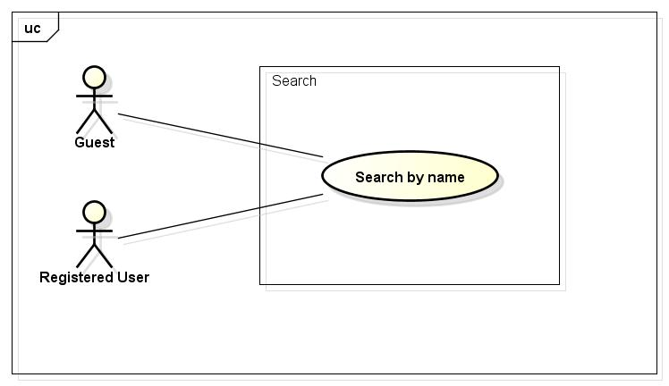

##### UC001-Search

|  |  |  |  |  |
| --- | --- | --- | --- | --- |
| **Use Case ID** | | UC001 | **Version** | 1.1 |
| **Use Case Name** | | Search by name | | |
| **Created by:** | | HieuTM | **Date Created:** | 28/05/2015 |
| **Primary Actor** | | Registered user | **Secondary Actor** | Guest |
| **Description:** | | This function allows user to search existing information stored on FAP by a phrase (name of places, food and drinks, activities, friends…) | | |
| **Preconditions:** | | 1. FAP website is available 2. User browsed FAP website | | |
| **Trigger:** | | User enters search phrase and click Search or press Enter | | |
| **Post conditions:** | | List all results that matched with the keyword user enters will be displayed in the Search Details screen | | |
| **Normal Flow** | | | | |
| **Step** | **Actor** | **Action** | | |
| 1 | User | Enter search phrase to text box. | | |
| 2 | User | Click Search or press Enter | | |
| 3 | FAP | Redirect to Search Result screen includes   * Header * Results hyperlink * Suggest Bar * Footer | | |
| 4 | FAP | List all results that matched with the keyword user entered | | |
| **Alternative Flows:** | | | | |
| **AT1** | At step 2 in the main flows, if user click other hyperlinks or buttons | | | |
| **Step** | **Actor** | **Action** | | |
| 2.1 | FAP | Redirects user to chosen hyperlink or button | | |
|  | | | | |
| **Exceptions:** | | | | |
| **EC1** | The connection is terminated | | | |
| **Step** | **Actor** | **Action** | | |
| 1 | FAP | All fields are cleared and FAP return to the wait state. | | |
|  | | | | |
| **EC2** | At step 2 in the main flows, if user click other hyperlinks or buttons | | | |
| **Step** | **Actor** | **Action** | | |
| 2.1 | FAP | Redirects user to chosen hyperlink or button | | |
|  | | | | |
| **Priority** | | High | | |
| **Frequency of Use:** | | High | | |
| **Business Rules:** | | B1 | | |
| **Other Information:** | | N/A | | |

#### Help Center

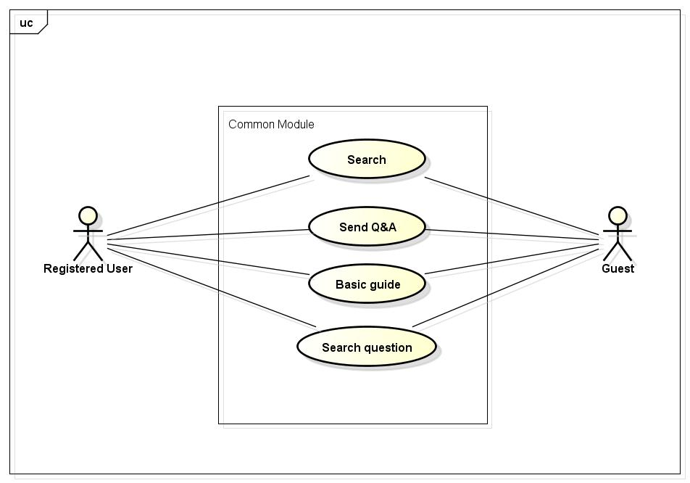

##### UC002-Send question

|  |  |  |  |  |
| --- | --- | --- | --- | --- |
| **Use Case ID** | | UC002 | **Version** | 1.1 |
| **Use Case Name** | | Send question | | |
| **Created by:** | | HieuTM | **Date Created:** | 06/09/2015 |
| **Primary Actor** | | Registered user | **Secondary Actor** | Guest |
| **Description:** | | This function allows user to send questions, ideas, opinions to admin. | | |
| **Preconditions:** | | 1. FAP website is available 2. User browsed FAP website | | |
| **Trigger:** | | User enters questions and click Send while is in Q&A page. | | |
| **Post conditions:** | | 1. Message is displayed 2. User’s content is sent to admin | | |
| **Normal Flow** | | | | |
| **Step** | **Actor** | **Action** | | |
| 1 | User | Click Q&A in FAP website footer | | |
| 2 | FAP | Display Q&A page includes:   * Header * Subject textbox * Content text area * Send button * Footer | | |
| 3 | User | Enter required fields | | |
| 4 | User | Click Send or press Enter | | |
| 5 | FAP | Display message with ID MSG1 | | |
| 6 | FAP | Redirect user to previous page | | |
| **Alternative Flows:** | | | | |
| **AT1** | At step 2 in the main flows, if user click other hyperlinks or buttons | | | |
| **Step** | **Actor** | **Action** | | |
| 2.1 | FAP | Redirects user to chosen hyperlink or button | | |
|  | | | | |
| **Exceptions:** | | | | |
| **EC1** | The connection is terminated | | | |
| **Step** | **Actor** | **Action** | | |
| 1 | FAP | All fields are cleared and FAP return to the wait state. | | |
|  | | | | |
| **EC2** | At step 3 in the main flows, if required fields are not entered | | | |
| **Step** | **Actor** | **Action** | | |
| 3.1 | FAP | Display Q&A Form with text: “You have to fill all required fields” | | |
| 3.2 | FAP | Mark all error fields | | |
|  | | | | |
| **Priority** | | Normal | | |
| **Frequency of Use:** | | Normal | | |
| **Business Rules:** | | B2 B3 B4 B5 | | |
| **Other Information:** | | N/A | | |

##### UC003-Basic Guide

|  |  |  |  |  |
| --- | --- | --- | --- | --- |
| **Use Case ID** | | UC003 | **Version** | 1.1 |
| **Use Case Name** | | Basic guide | | |
| **Created by:** | | HieuTM | **Date Created:** | 09/06/2015 |
| **Primary Actor** | | Registered user | **Secondary Actor** | Guest |
| **Description:** | | A guide page to let user know how to use FAP website or frequently asked questions. | | |
| **Preconditions:** | | 1. FAP website is available 2. User browsed FAP website | | |
| **Trigger:** | | User click Basic Guide in FAP website footer | | |
| **Post conditions:** | | FAP display Basic Guide page | | |
| **Normal Flow** | | | | |
| **Step** | **Actor** | **Action** | | |
| 1 | User | Click Basic Guide in FAP website footer | | |
| 2 | FAP | Redirect user to Basic Guide page includes:   * Header * Search textbox * Search button * FAQ paragraphs * Footer | | |
| **Alternative Flows: N/A** | | | | |
| **Exceptions:** | | | | |
| **EC1** | The connection is terminated | | | |
| **Step** | **Actor** | **Action** | | |
| 1 | FAP | Return to wait state | | |
|  | | | | |
| **Priority** | | Normal | | |
| **Frequency of Use:** | | Normal | | |
| **Business Rules:** | | N/A | | |
| **Other Information:** | | N/A | | |

##### UC004-Search Question

|  |  |  |  |  |
| --- | --- | --- | --- | --- |
| **Use Case ID** | | UC004 | **Version** | 1.1 |
| **Use Case Name** | | Search question | | |
| **Created by:** | | HieuTM | **Date Created:** | 09/06/2015 |
| **Primary Actor** | | Registered user | **Secondary Actor** | Guest |
| **Description:** | | This function allows user to search a question in frequently asked questions list | | |
| **Preconditions:** | | 1. FAP website is available 2. User browsed FAP website 3. User browsed Basic Guide page | | |
| **Trigger:** | | User enters search phrase and click Search while in Basic Guide page | | |
| **Post conditions:** | | Question is displayed | | |
| **Normal Flow** | | | | |
| **Step** | **Actor** | **Action** | | |
| 1 | User | Enter search phrase to text box | | |
| 2 | User | Click Search or press Enter | | |
| 3 | FAP | Scroll to question | | |
| **Alternative Flows: N/A** | | | | |
| **Exceptions:** | | | | |
| **EC1** | The connection is terminated | | | |
| **Step** | **Actor** | **Action** | | |
| 1 | FAP | All fields are cleared and FAP return to the wait state. | | |
|  | | | | |
| **EC2** | At step 3 in the main flows, if there is no result matched the keywords | | | |
| **Step** | **Actor** | **Action** | | |
| 3.1 | FAP | Display Basic Guide page with text: “Nothing found :(” | | |
|  | | | | |
| **Priority** | | Normal | | |
| **Frequency of Use:** | | Normal | | |
| **Business Rules:** | | N/A | | |
| **Other Information:** | | N/A | | |

### Suggest Module

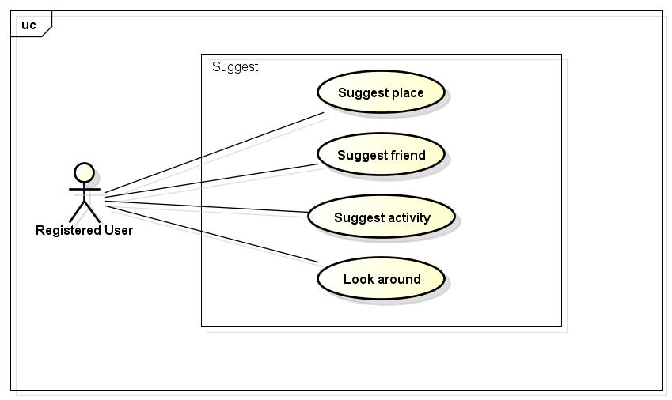

#### UC005-Suggest place

|  |  |  |  |  |
| --- | --- | --- | --- | --- |
| **Use Case ID** | | UC005 | **Version** | 1.1 |
| **Use Case Name** | | Suggest place | | |
| **Created by:** | | HieuTM | **Date Created:** | 09/06/2015 |
| **Primary Actor** | | Registered user | **Secondary Actor** | N/A |
| **Description:** | | FAP suggests places to user base on users traveled, viewed history, wish list and trends. | | |
| **Preconditions:** | | 1. FAP website is available 2. User browsed FAP website 3. User logged in to system | | |
| **Trigger:** | | User browses FAP website | | |
| **Post conditions:** | | 1. Suggests is displayed | | |
| **Normal Flow** | | | | |
| **Step** | **Actor** | **Action** | | |
| 1 | User | Click Place in Suggest Bar | | |
| 2 | FAP | Display Suggest Place List includes:   * Place thumbnail and short description | | |
| **Alternative Flows: N/A** | | | | |
| **Exceptions: N/A** | | | | |
| **Priority** | | High | | |
| **Frequency of Use:** | | High | | |
| **Business Rules:** | | N/A | | |
| **Other Information:** | | N/A | | |

#### UC006-Suggest friend

|  |  |  |  |  |
| --- | --- | --- | --- | --- |
| **Use Case ID** | | UC006 | **Version** | 1.1 |
| **Use Case Name** | | Suggest friend | | |
| **Created by:** | | HieuTM | **Date Created:** | 09/06/2015 |
| **Primary Actor** | | Registered user | **Secondary Actor** | N/A |
| **Description:** | | FAP suggests friends to user base on mutual friends, activities or likes | | |
| **Preconditions:** | | 1. FAP website is available 2. User browsed FAP website 3. User logged in to system | | |
| **Trigger:** | | User browses FAP website | | |
| **Post conditions:** | | Suggests is displayed | | |
| **Normal Flow** | | | | |
| **Step** | **Actor** | **Action** | | |
| 1 | User | Click Friend in Suggest Bar | | |
| 2 | FAP | Display Suggest Friend List includes:   * Friends’ name and avatar | | |
| **Alternative Flows: N/A** | | | | |
| **Exceptions: N/A** | | | | |
| **Priority** | | High | | |
| **Frequency of Use:** | | High | | |
| **Business Rules:** | | N/A | | |
| **Other Information:** | | N/A | | |

#### UC007-Suggest activity

|  |  |  |  |  |
| --- | --- | --- | --- | --- |
| **Use Case ID** | | UC007 | **Version** | 1.1 |
| **Use Case Name** | | Suggest activity | | |
| **Created by:** | | HieuTM | **Date Created:** | 09/06/2015 |
| **Primary Actor** | | Registered user | **Secondary Actor** | N/A |
| **Description:** | | FAP suggests activities to user base on users traveled, viewed history, wish list and trends. | | |
| **Preconditions:** | | 1. FAP website is available 2. User browsed FAP website 3. User logged in to system | | |
| **Trigger:** | | N/A | | |
| **Post conditions:** | | Suggests is displayed | | |
| **Normal Flow** | | | | |
| **Step** | **Actor** | **Action** | | |
| 1 | User | Click Activity in Suggest Bar | | |
| 2 | FAP | Display Suggest Activity List includes:   * Activities’ thumbnail and short description | | |
| **Alternative Flows: N/A** | | | | |
| **Exceptions: N/A** | | | | |
| **Priority** | | High | | |
| **Frequency of Use:** | | High | | |
| **Business Rules:** | | N/A | | |
| **Other Information:** | | N/A | | |

#### UC008-Look around

|  |  |  |  |  |
| --- | --- | --- | --- | --- |
| **Use Case ID** | | UC008 | **Version** | 1.1 |
| **Use Case Name** | | Look around | | |
| **Created by:** | | HieuTM | **Date Created:** | 28/05/2015 |
| **Primary Actor** | | Registered user | **Secondary Actor** |  |
| **Description:** | | This function allows user to see activities of others around | | |
| **Preconditions:** | | 1. FAP website is available 2. User browsed FAP website 3. User logged in to system | | |
| **Trigger:** | | User click Look Around in header | | |
| **Post conditions:** | | 1. Look Around page is displayed | | |
| **Normal Flow** | | | | |
| **Step** | **Actor** | **Action** | | |
| 1 | User | Click Look Around | | |
| 2 | FAP | Redirect user to Look Around page includes:   * Header * Suggest Bar * Map * Post thumbnail and short description * Footer | | |
| 3 | User | Enter location to text box | | |
| 4 | User | Click Look or press Enter | | |
| 5 | FAP | Display Look Around page with results | | |
| **Alternative Flows** | | | | |
| **AT1** | At step 3 in the main flow, user click Auto-Located | | | |
| **Step** | **Actor** | **Action** | | |
| 3.1 | FAP | Display Look Around page with results | | |
|  | | | | |
| **AT2** | At step 4 in the main flows, if user click other hyperlinks or buttons | | | |
| **Step** | **Actor** | **Action** | | |
| 4.1 | FAP | Redirects user to chosen hyperlink or button | | |
|  | | | | |
| **Exceptions:** | | | | |
| **EC1** | The connection is terminated | | | |
| **Step** | **Actor** | **Action** | | |
| 1 | FAP | All fields are cleared and FAP return to the wait state. | | |
|  | | | | |
| **EC2** | At step 5 in the main flows, if there is no result matched the keywords | | | |
| **Step** | **Actor** | **Action** | | |
| 5.1 | FAP | Display Look Around page with message with ID MSG2 | | |
|  | | | | |
| **EC2** | At step 3.1 in the alternative flows, if FAP cannot locate user’s current location | | | |
| **Step** | **Actor** | **Action** | | |
| 3.1 | FAP | Display Look Around page with message with ID MSG3 | | |
|  | | | | |
| **Priority** | | Normal | | |
| **Frequency of Use:** | | High | | |
| **Business Rules:** | | N/A | | |
| **Other Information:** | | N/A | | |

### Social Module

#### Personal Page

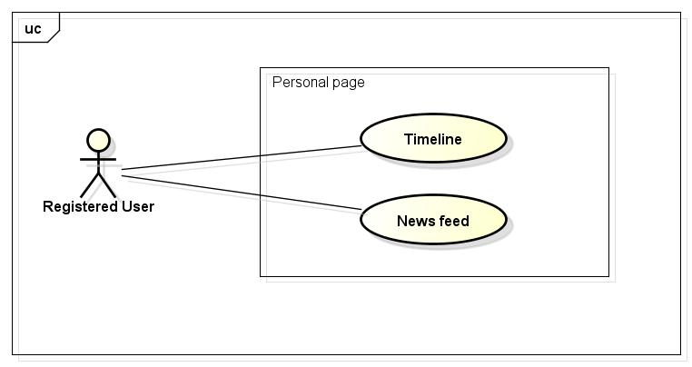

##### UC009-Display Timeline

|  |  |  |  |  |
| --- | --- | --- | --- | --- |
| **Use Case ID** | | UC009 | **Version** | 1.1 |
| **Use Case Name** | | Display Timeline | | |
| **Created by:** | | HieuTM | **Date Created:** | 28/05/2015 |
| **Primary Actor** | | Registered user | **Secondary Actor** |  |
| **Description:** | | FAP records all of user’s activities and display in time order | | |
| **Preconditions:** | | 1. FAP website is available 2. User browsed FAP website 3. User logged in to system | | |
| **Trigger:** | | User click Timeline in Homepage | | |
| **Post conditions:** | | Timeline page is displayed | | |
| **Normal Flow** | | | | |
| **Step** | **Actor** | **Action** | | |
| 1 | User | Click Timeline | | |
| 2 | FAP | Redirect user to Timeline page includes:   * Header * Suggest Bar * Activities panel * Footer | | |
| **Alternative Flows: N/A** | | | | |
| **Exceptions:** | | | | |
| **EC1** | The connection is terminated | | | |
| **Step** | **Actor** | **Action** | | |
| 1 | FAP | Return to the wait state. | | |
| **Priority** | | High | | |
| **Frequency of Use:** | | High | | |
| **Business Rules:** | | N/A | | |
| **Other Information:** | | N/A | | |

##### UC010-Display News feed

|  |  |  |  |  |
| --- | --- | --- | --- | --- |
| **Use Case ID** | | UC010 | **Version** | 1.1 |
| **Use Case Name** | | Display News feed | | |
| **Created by:** | | HieuTM | **Date Created:** | 28/05/2015 |
| **Primary Actor** | | Registered user | **Secondary Actor** |  |
| **Description:** | | FAP updates activities of user’s friends automatically | | |
| **Preconditions:** | | 1. FAP website is available 2. User browsed FAP website 3. User logged in to system | | |
| **Trigger:** | | User click New feed in Homepage | | |
| **Post conditions:** | | 1. News feed page is displayed | | |
| **Normal Flow** | | | | |
| **Step** | **Actor** | **Action** | | |
| 1 | User | Click News feed | | |
| 2 | FAP | Redirect user to News Feed page includes:   * Header * Suggest Bar * Activities panel * Footer | | |
| **Alternative Flows: N/A** | | | | |
| **Exceptions:** | | | | |
| **EC1** | The connection is terminated | | | |
| **Step** | **Actor** | **Action** | | |
| 1 | FAP | Return to the wait state. | | |
|  | | | | |
| **Priority** | | High | | |
| **Frequency of Use:** | | High | | |
| **Business Rules:** | | N/A | | |
| **Other Information:** | | N/A | | |

#### Post management

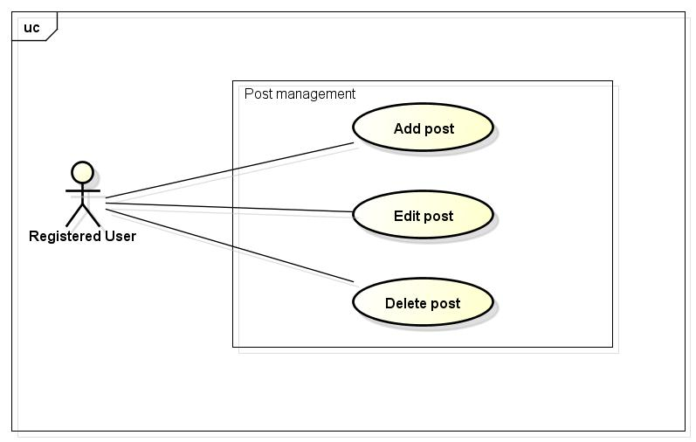

##### UC011-Add Post

|  |  |  |  |  |
| --- | --- | --- | --- | --- |
| **Use Case ID** | | UC011 | **Version** | 1.1 |
| **Use Case Name** | | Add post | | |
| **Created by:** | | HieuTM | **Date Created:** | 28/05/2015 |
| **Primary Actor** | | Registered user | **Secondary Actor** | None |
| **Description:** | | This function allows user to share information, knowledge, experience | | |
| **Preconditions:** | | 1. FAP website is available 2. User browsed FAP website 3. User logged in to system | | |
| **Trigger:** | | User click Create Post | | |
| **Post conditions:** | | 1. Post is updated to user’s timeline. 2. Post is updated to News feed of user’s friends. 3. Post is updated to Database. | | |
| **Normal Flow** | | | | |
| **Step** | **Actor** | **Action** | | |
|  | User | Click Create Post. | | |
|  | FAP | Redirects user to Add Post Page includes:   * Header * Suggest Bar * Name textbox * Place textbox * Privacy combo box * Description text area * Footer | | |
|  | User | Enter information in fields. | | |
|  | User | Choose privacy | | |
|  | User | Click Create or press Enter. | | |
|  | FAP | Create a post | | |
|  | FAP | Updates to user’s timeline | | |
|  | FAP | Updates to News feed of user’s friends | | |
|  | FAP | Displays message with ID MSG4 | | |
|  | FAP | Redirects user to Post Page which contain created post. | | |
| **Alternative Flows** | | | | |
| **AT1** | At step 5, user click Cancel | | | |
| **Step** | **Actor** | **Action** | | |
| 5.1 | FAP | FAP redirects user to previous page. | | |
|  | | | | |
| **AT2** | At step 5 in the main flows, if user click other hyperlinks or buttons | | | |
| **Step** | **Actor** | **Action** | | |
| 5.1 | FAP | Redirects user to chosen hyperlink or button | | |
|  | | | | |
| **Exceptions:** | | | | |
| **EC1** | The connection is terminated | | | |
| **Step** | **Actor** | **Action** | | |
| 1 | FAP | All fields are cleared and FAP return to the wait state. | | |
|  | | | | |
| **EC2** | At step 4, required fields are not entered | | | |
| **Step** | **Actor** | **Action** | | |
| 4.1 | FAP | Display Add Post page with message with ID MSG5 | | |
| 4.2 | FAP | Mark error fields | | |
|  | | | | |
| **EC3** | At step 4, fields are entered with wrong type of data | | | |
| **Step** | **Actor** | **Action** | | |
| 4.1 | FAP | Display Add Post page with message with ID MSG6 | | |
| 4.2 | FAP | Mark error fields | | |
|  | | | | |
| **Priority** | | High | | |
| **Frequency of Use:** | | High | | |
| **Business Rules:** | | B25 | | |
| **Other Information:** | | N/A | | |

##### UC012-Edit Post

|  |  |  |  |  |
| --- | --- | --- | --- | --- |
| **Use Case ID** | | UC012 | **Version** | 1.1 |
| **Use Case Name** | | Edit post | | |
| **Created by:** | | HieuTM | **Date Created:** | 28/05/2015 |
| **Primary Actor** | | Registered user | **Secondary Actor** | None |
| **Description:** | | This function allows user to edit their post | | |
| **Preconditions:** | | 1. FAP website is available 2. User browsed FAP website 3. User logged in to system 4. User are viewing their own post | | |
| **Trigger:** | | User click Edit post while viewing an own post | | |
| **Post conditions:** | | 1. Post is updated to FAP website. 2. Post is updated to User Detail. 3. Post is updated to Database. | | |
| **Normal Flow** | | | | |
| **Step** | **Actor** | **Action** | | |
| 1 | User | Click Edit | | |
| 2 | FAP | Redirects user to Edit Post Page includes:   * Header * Suggest Bar * Name textbox * Place textbox * Plan date & time picker * Privacy combo box * Description text area * Footer | | |
| 3 | User | Edits information in fields. | | |
| 4 | User | Click Update or press Enter. | | |
| 5 | FAP | Edit this post | | |
| 6 | FAP | Displays message with ID MSG7 | | |
| 7 | FAP | Redirects user to Post Page which contain edited post. | | |
| **Alternative Flows** | | | | |
| **AT1** | At step 4, user click Cancel | | | |
| **Step** | **Actor** | **Action** | | |
| 4.1 | FAP | FAP redirects user to previous page. | | |
|  | | | | |
| **AT2** | At step 4 in the main flows, if user click other hyperlinks or buttons | | | |
| **Step** | **Actor** | **Action** | | |
| 4.1 | FAP | Redirects user to chosen hyperlink or button | | |
|  | | | | |
| **Exceptions:** | | | | |
| **EC1** | The connection is terminated | | | |
| **Step** | **Actor** | **Action** | | |
| 1 | FAP | All fields are cleared and FAP return to the wait state. | | |
|  | | | | |
| **EC2** | At step 4, required fields are not entered | | | |
| **Step** | **Actor** | **Action** | | |
| 4.1 | FAP | Display Add Post page with message with ID MSG5 | | |
| 4.2 | FAP | Mark error fields | | |
|  | | | | |
| **EC3** | At step 4, fields are entered with wrong type of data | | | |
| **Step** | **Actor** | **Action** | | |
| 4.1 | FAP | Display Add Post page with message with ID MSG6 | | |
| 4.2 | FAP | Mark error fields | | |
|  | | | | |
| **Priority** | | Normal | | |
| **Frequency of Use:** | | High | | |
| **Business Rules:** | | N/A | | |
| **Other Information:** | | N/A | | |

##### UC013-Delete Post

|  |  |  |  |  |
| --- | --- | --- | --- | --- |
| **Use Case ID** | | UC013 | **Version** | 1.1 |
| **Use Case Name** | | Delete post | | |
| **Created by:** | | HieuTM | **Date Created:** | 28/05/2015 |
| **Primary Actor** | | Registered user | **Secondary Actor** | None |
| **Description:** | | This function allows user to delete what they posted | | |
| **Preconditions:** | | 1. FAP website is available 2. User browsed FAP website 3. User logged in to system 4. User are viewing their own post | | |
| **Trigger:** | | User click Delete while viewing a post | | |
| **Post conditions:** | | 1. Post is deleted in user’s Timeline. 2. Post status is updated to Database. | | |
| **Normal Flow** | | | | |
| **Step** | **Actor** | **Action** | | |
| 1 | User | Click Delete | | |
| 2 | FAP | Display confirm popup “Delete this post?” | | |
| 3 | User | Click OK | | |
| 4 | FAP | Delete this post | | |
| 5 | FAP | Redirects user to Homepage | | |
| **Alternative Flows** | | | | |
| **AT1** | At step 3, user click Cancel | | | |
| **Step** | **Actor** | **Action** | | |
| 3.1 | FAP | Closes confirm popup | | |
| **Exceptions:** | | | | |
| **EC1** | The connection is terminated | | | |
| **Step** | **Actor** | **Action** | | |
| 1 | FAP | Return to the wait state. | | |
|  | | | | |
| **Priority** | | Normal | | |
| **Frequency of Use:** | | Low | | |
| **Business Rules:** | | N/A | | |
| **Other Information:** | | N/A | | |

#### Photo management

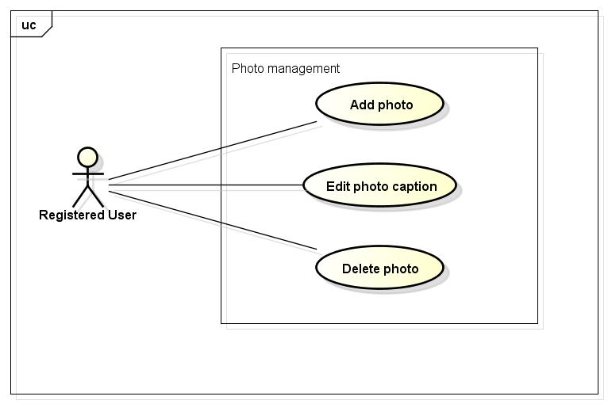

##### UC014-Add Photo

|  |  |  |  |  |  |  |
| --- | --- | --- | --- | --- | --- | --- |
| **Use Case ID** | | | UC014 | | **Version** | 1.1 |
| **Use Case Name** | | | Add photo | | | |
| **Created by:** | | | HieuTM | | **Date Created:** | 28/05/2015 |
| **Primary Actor** | | | Registered user | | **Secondary Actor** |  |
| **Description:** | | | This function allows user to share information, knowledge, experience via picture and captions | | | |
| **Preconditions:** | | | 1. FAP website is available 2. User browsed FAP website 3. User logged in to system | | | |
| **Trigger:** | | | User click Add Photo while in Add Post page | | | |
| **Post conditions:** | | | 1. Post is updated to FAP website. 2. Post is updated to User Detail. 3. Post is updated to Database. | | | |
| **Normal Flow** | | | | | | |
| **Step** | **Actor** | | **Action** | | | |
|  | User | | Click Create Post. | | | |
|  | FAP | | Redirects user to Add Post Page which contain a create form. | | | |
|  | User | | Click Add Photo. | | | |
|  | User | | Redirects user to Add Photo Page includes:   * Header * Suggest Bar * Name textbox * Place textbox * Browse image button * Privacy combo box * Description text area * Footer | | | |
|  | User | | Click Browse to choose photo. | | | |
|  | FAP | | Display photo and Caption field | | | |
|  | User | | Enters information in fields. | | | |
|  | User | | User click Create or press Enter. | | | |
|  | FAP | | Create a post | | | |
|  | FAP | | Updates to user’s timeline | | | |
|  | FAP | | Updates to News feed of user’s friends | | | |
|  | FAP | | Displays message with ID MSG4 | | | |
|  | FAP | | Redirects user to Post Page which contain created post. | | | |
| **Alternative Flows** | | | | | | |
| **AT1** | At step 8, user click Cancel | | | | | |
| **Step** | **Actor** | | **Action** | | | |
| 8.1 | FAP | | Redirects user to previous page. | | | |
|  | | | | | | |
| **AT2** | | At step 8 in the main flows, if user click other hyperlinks or buttons | | | | | |
| **Step** | | **Actor** | | **Action** | | | |
| 8.1 | | FAP | | Redirects user to chosen hyperlink or button | | | |
|  | | | | | | | |
| **Exceptions:** | | | | | | |
| **EC1** | The connection is terminated | | | | | |
| **Step** | **Actor** | | **Action** | | | |
| 1 | FAP | | All fields are cleared and FAP return to the wait state. | | | |
|  | | | | | | |
| **EC2** | At step 8, required fields are not entered | | | | | |
| **Step** | **Actor** | | **Action** | | | |
| 8.1 | FAP | | Display Add Post page with message with ID MSG5 | | | |
| 8.2 | FAP | | Mark error fields | | | |
|  | | | | | | |
| **EC3** | At step 8, fields are entered with wrong type of data | | | | | |
| **Step** | **Actor** | | **Action** | | | |
| 8.1 | FAP | | Display Add Post page with message with ID MSG6 | | | |
| 8.2 | FAP | | Mark error fields | | | |
|  | | | | | | |
| **Priority** | | | High | | | |
| **Frequency of Use:** | | | High | | | |
| **Business Rules:** | | | B6 B7 B25 | | | |
| **Other Information:** | | | N/A | | | |

##### UC015-Edit Photo Caption

|  |  |  |  |  |
| --- | --- | --- | --- | --- |
| **Use Case ID** | | UC015 | **Version** | 1.1 |
| **Use Case Name** | | Edit photo caption | | |
| **Created by:** | | HieuTM | **Date Created:** | 28/05/2015 |
| **Primary Actor** | | Registered user | **Secondary Actor** | None |
| **Description:** | | This function allows user to edit what they posted | | |
| **Preconditions:** | | 1. FAP website is available 2. User browsed FAP website 3. User logged in to system 4. User are viewing their own post | | |
| **Trigger:** | | User click Edit while viewing a post | | |
| **Post conditions:** | | 1. Post is updated to FAP website. 2. Post is updated to User Detail. 3. Post is updated to Database. | | |
| **Normal Flow** | | | | |
| **Step** | **Actor** | **Action** | | |
|  | User | Click Edit | | |
|  | FAP | Redirects user to Edit Post Page includes:   * Header * Suggest Bar * Name textbox * Place textbox * Browse image button * Privacy combo box * Description text area * Footer | | |
|  | User | Edits information in fields. | | |
|  | User | Click Update or press Enter. | | |
|  | FAP | Edit this post | | |
|  | FAP | Displays message with ID MSG7 | | |
|  | FAP | Redirects user to Post Page which contain edited post. | | |
| **Alternative Flows** | | | | |
| **AT1** | At step 4, user click Cancel | | | |
| **Step** | **Actor** | **Action** | | |
| 4.1 | FAP | FAP redirects user to previous page. | | |
|  | | | | |
| **AT2** | At step 4 in the main flows, if user click other hyperlinks or buttons | | | |
| **Step** | **Actor** | **Action** | | |
| 4.1 | FAP | Redirects user to chosen hyperlink or button | | |
|  | | | | |
| **Exceptions:** | | | | |
| **EC1** | The connection is terminated | | | |
| **Step** | **Actor** | **Action** | | |
| 1 | FAP | All fields are cleared and FAP return to the wait state. | | |
|  | | | | |
| **EC2** | At step 4, required fields are not entered | | | |
| **Step** | **Actor** | **Action** | | |
| 4.1 | FAP | Display Add Post page with message with ID MSG5 | | |
| 4.2 | FAP | Mark error fields | | |
|  | | | | |
| **EC3** | At step 4, fields are entered with wrong type of data | | | |
| **Step** | **Actor** | **Action** | | |
| 4.1 | FAP | Display Add Post page with message with ID MSG6 | | |
| 4.2 | FAP | Mark error fields | | |
|  | | | | |
| **Priority** | | Normal | | |
| **Frequency of Use:** | | Normal | | |
| **Business Rules:** | | B6 B7 | | |
| **Other Information:** | | N/A | | |

##### UC016-Delete Photo

|  |  |  |  |  |
| --- | --- | --- | --- | --- |
| **Use Case ID** | | UC016 | **Version** | 1.1 |
| **Use Case Name** | | Delete photo | | |
| **Created by:** | | HieuTM | **Date Created:** | 28/05/2015 |
| **Primary Actor** | | Registered user | **Secondary Actor** |  |
| **Description:** | | This function allows user to delete what they posted | | |
| **Preconditions:** | | 1. FAP website is available 2. User browsed FAP website 3. User logged in to system 4. User are viewing their own post | | |
| **Trigger:** | | User click Delete while viewing a post | | |
| **Post conditions:** | | 1. Post is deleted in user’s Timeline. 2. Post status is updated to Database. | | |
| **Normal Flow** | | | | |
| **Step** | **Actor** | **Action** | | |
| 1 | User | Click Delete | | |
| 2 | FAP | Display confirm popup “Delete this post?” | | |
| 3 | User | Click OK | | |
| 4 | FAP | Delete this post | | |
| 5 | FAP | Redirects user to Homepage | | |
| **Alternative Flows** | | | | |
| **AT1** | At step 3, user click Cancel | | | |
| **Step** | **Actor** | **Action** | | |
| 3.1 | FAP | Closes confirm popup | | |
|  | | | | |
| **Exceptions:** | | | | |
| **EC1** | The connection is terminated | | | |
| **Step** | **Actor** | **Action** | | |
| 1 | FAP | All fields are cleared and FAP return to the wait state. | | |
|  | | | | |
| **Priority** | | Normal | | |
| **Frequency of Use:** | | Low | | |
| **Business Rules:** | | N/A | | |
| **Other Information:** | | N/A | | |

#### Video management

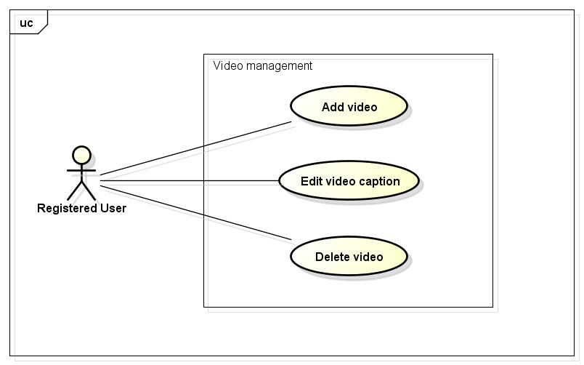

##### UC017-Add Video

|  |  |  |  |  |
| --- | --- | --- | --- | --- |
| **Use Case ID** | | UC017 | **Version** | 1.1 |
| **Use Case Name** | | Add video | | |
| **Created by:** | | HieuTM | **Date Created:** | 28/05/2015 |
| **Primary Actor** | | Registered user | **Secondary Actor** |  |
| **Description:** | | This function allows user to share information, knowledge, experience via picture and captions | | |
| **Preconditions:** | | 1. FAP website is available 2. User browsed FAP website 3. User logged in to system | | |
| **Trigger:** | | User click Add video in Homepage | | |
| **Post conditions:** | | 1. Post is updated to FAP website. 2. Post is updated to User Detail. 3. Post is updated to Database. | | |
| **Normal Flow** | | | | |
| **Step** | **Actor** | **Action** | | |
|  | User | Click Create Post. | | |
|  | FAP | Redirects user to Add Post Page includes:   * Header * Suggest Bar * Name textbox * Place textbox * Browse video button * Video link button * Privacy combo box * Description text area * Footer | | |
|  | User | Click Add Video. | | |
|  | User | Redirects user to Add Video Page which contain an Add video form. | | |
|  | User | Click Browse to choose video. | | |
|  | FAP | Display video and Caption field | | |
|  | User | Enters information in fields. | | |
|  | User | User click Create or press Enter. | | |
|  | FAP | Create a post | | |
|  | FAP | Updates to user’s timeline | | |
|  | FAP | Updates to News feed of user’s friends | | |
|  | FAP | Displays message with ID MSG4 | | |
|  | FAP | Redirects user to Post Page which contain created post. | | |
| **Alternative Flows** | | | | |
| **AT1** | At step 8, user click Cancel | | | |
| **Step** | **Actor** | **Action** | | |
| 8.1 | FAP | Redirects user to previous page. | | |
|  | | | | |
| **Exceptions:** | | | | |
| **EC1** | The connection is terminated | | | |
| **Step** | **Actor** | **Action** | | |
| 1 | FAP | All fields are cleared and FAP return to the wait state. | | |
|  | | | | |
| **EC2** | At step 8, required fields are not entered | | | |
| **Step** | **Actor** | **Action** | | |
| 8.1 | FAP | Display Add Post page with message with ID MSG5 | | |
| 8.2 | FAP | Mark error fields | | |
|  | | | | |
| **EC3** | At step 8, fields are entered with wrong type of data | | | |
| **Step** | **Actor** | **Action** | | |
| 8.1 | FAP | Display Add Post page with message with ID MSG6 | | |
| 8.2 | FAP | Mark error fields | | |
|  | | | | |
| **Priority** | | High | | |
| **Frequency of Use:** | | High | | |
| **Business Rules:** | | B25 B32 B33 B34 | | |
| **Other Information:** | | N/A | | |

##### UC018-Edit Video Caption

|  |  |  |  |  |
| --- | --- | --- | --- | --- |
| **Use Case ID** | | UC018 | **Version** | 1.1 |
| **Use Case Name** | | Edit video caption | | |
| **Created by:** | | HieuTM | **Date Created:** | 28/05/2015 |
| **Primary Actor** | | Registered user | **Secondary Actor** | None |
| **Description:** | | This function allows user to edit what they posted | | |
| **Preconditions:** | | 1. FAP website is available 2. User browsed FAP website 3. User logged in to system 4. User are viewing their own post | | |
| **Trigger:** | | User click Edit caption while viewing an own post | | |
| **Post conditions:** | | 1. Post is updated to FAP website. 2. Post is updated to User Detail. 3. Post is updated to Database. | | |
| **Normal Flow** | | | | |
| **Step** | **Actor** | **Action** | | |
|  | User | Click Edit | | |
|  | FAP | Redirects user to Edit Post Page includes:   * Header * Suggest Bar * Name textbox * Place textbox * Browse video button * Video link button * Privacy combo box * Description text area * Footer | | |
|  | User | Edits information in fields. | | |
|  | User | Click Update or press Enter. | | |
|  | FAP | Edit this post | | |
|  | FAP | Displays message with ID MSG7 | | |
|  | FAP | Redirects user to Post Page which contain edited post. | | |
| **Alternative Flows** | | | | |
| **AT1** | At step 4, user click Cancel | | | |
| **Step** | **Actor** | **Action** | | |
| 4.1 | FAP | FAP redirects user to previous page. | | |
|  | | | | |
| **AT2** | At step 4 in the main flows, if user click other hyperlinks or buttons | | | |
| **Step** | **Actor** | **Action** | | |
| 4.1 | FAP | Redirects user to chosen hyperlink or button | | |
|  | | | | |
| **Exceptions:** | | | | |
| **EC1** | The connection is terminated | | | |
| **Step** | **Actor** | **Action** | | |
| 1 | FAP | All fields are cleared and FAP return to the wait state. | | |
|  | | | | |
| **EC2** | At step 4, required fields are not entered | | | |
| **Step** | **Actor** | **Action** | | |
| 4.1 | FAP | Display Add Post page with message with ID MSG5 | | |
| 4.2 | FAP | Mark error fields | | |
|  | | | | |
| **EC3** | At step 4, fields are entered with wrong type of data | | | |
| **Step** | **Actor** | **Action** | | |
| 4.1 | FAP | Display Add Post page with message with ID MSG6 | | |
| 4.2 | FAP | Mark error fields | | |
|  | | | | |
| **Priority** | | Normal | | |
| **Frequency of Use:** | | Normal | | |
| **Business Rules:** | | B32 B33 B34 | | |
| **Other Information:** | | N/A | | |

##### UC019-Delete Video

|  |  |  |  |  |
| --- | --- | --- | --- | --- |
| **Use Case ID** | | UC019 | **Version** | 1.1 |
| **Use Case Name** | | Delete video | | |
| **Created by:** | | HieuTM | **Date Created:** | 28/05/2015 |
| **Primary Actor** | | Registered user | **Secondary Actor** |  |
| **Description:** | | This function allows user to delete what they posted | | |
| **Preconditions:** | | 1. FAP website is available 2. User browsed FAP website 3. User logged in to system 4. User are viewing their own post | | |
| **Trigger:** | | User click Delete video while viewing an own post | | |
| **Post conditions:** | | 1. Post is deleted in user’s Timeline. 2. Post status is updated to Database. | | |
| **Normal Flow** | | | | |
| **Step** | **Actor** | **Action** | | |
| 1 | User | Click Delete | | |
| 2 | FAP | Display confirm popup “Delete this post?” | | |
| 3 | User | Click OK | | |
| 4 | FAP | Delete this post | | |
| 5 | FAP | Redirects user to Homepage | | |
| **Alternative Flows** | | | | |
| **AT1** | At step 3, user click Cancel | | | |
| **Step** | **Actor** | **Action** | | |
| 3.1 | FAP | Closes confirm popup | | |
|  | | | | |
| **Exceptions:** | | | | |
| **EC1** | The connection is terminated | | | |
| **Step** | **Actor** | **Action** | | |
| 1 | FAP | All fields are cleared and FAP return to the wait state. | | |
|  | | | | |
| **Priority** | | Normal | | |
| **Frequency of Use:** | | Low | | |
| **Business Rules:** | | N/A | | |
| **Other Information:** | | N/A | | |

#### Wish list

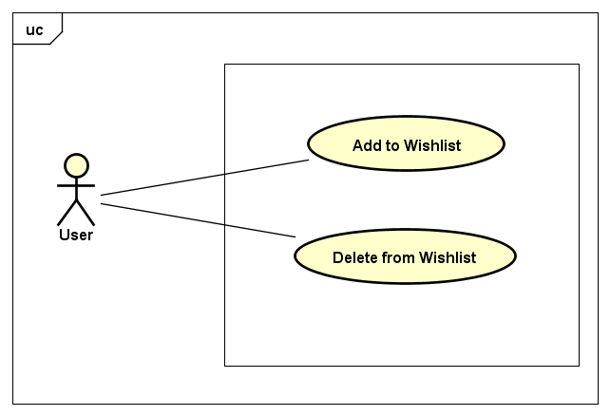

##### Add to Wishlist

|  |  |  |  |  |
| --- | --- | --- | --- | --- |
| **Use Case ID** | | UC | **Version** | 1.1 |
| **Use Case Name** | | Add to Wishlist | | |
| **Created by:** | | HieuTM | **Date Created:** | 23/07/2015 |
| **Primary Actor** | | Registered user | **Secondary Actor** |  |
| **Description:** | | This function allows user to add a post to their wish list | | |
| **Preconditions:** | | 1. FAP website is available 2. User browsed FAP website 3. User logged in to system 4. User are viewing a post | | |
| **Trigger:** | | User click Heart button to add the place to their wish list | | |
| **Post conditions:** | | 1. Place is added to user’s wish list. 2. User’s wish list is updated to database. | | |
| **Normal Flow** | | | | |
| **Step** | **Actor** | **Action** | | |
| 1 | User | Click Heart image button in a post | | |
| 2 | FAP | Place of that post is added to wish list | | |
| **Alternative Flows** | | | | |
|  | | | | |
| **Exceptions:** | | | | |
| **EC1** | The connection is terminated | | | |
| **Step** | **Actor** | **Action** | | |
| 1 | FAP | FAP return to the wait state. | | |
|  | | | | |
| **Priority** | | Normal | | |
| **Frequency of Use:** | | High | | |
| **Business Rules:** | | N/A | | |
| **Other Information:** | | N/A | | |

##### Delete from wishlist

|  |  |  |  |  |
| --- | --- | --- | --- | --- |
| **Use Case ID** | | UC0 | **Version** | 1.1 |
| **Use Case Name** | | Delete from wish list | | |
| **Created by:** | | HieuTM | **Date Created:** | 23/07/2015 |
| **Primary Actor** | | Registered user | **Secondary Actor** |  |
| **Description:** | | This function allows user to delete what they posted | | |
| **Preconditions:** | | 1. FAP website is available 2. User browsed FAP website 3. User logged in to system 4. User are viewing a post which has been added to wish list | | |
| **Trigger:** | | User click Heart button in a post which has been added to wish list | | |
| **Post conditions:** | | 1. Post is deleted from user’s wish list. 2. User’s wish list is updated to database. | | |
| **Normal Flow** | | | | |
| **Step** | **Actor** | **Action** | | |
| 1 | User | Click Heart image button in a post which has been added to wish list | | |
| 2 | FAP | Delete that post from wish list | | |
| **Alternative Flows** | | | | |
|  | | | | |
| **Exceptions:** | | | | |
| **EC1** | The connection is terminated | | | |
| **Step** | **Actor** | **Action** | | |
| 1 | FAP | FAP return to the wait state. | | |
|  | | | | |
| **Priority** | | Normal | | |
| **Frequency of Use:** | | Low | | |
| **Business Rules:** | | N/A | | |
| **Other Information:** | | N/A | | |

#### Share

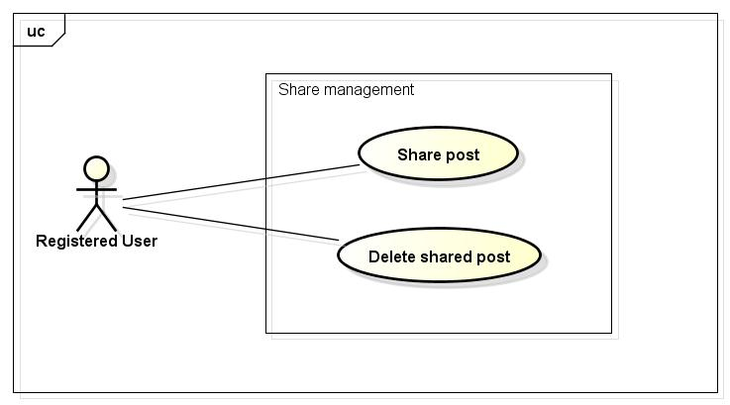

##### UC020-Share Post

|  |  |  |  |  |
| --- | --- | --- | --- | --- |
| **Use Case ID** | | UC020 | **Version** | 1.1 |
| **Use Case Name** | | Share post | | |
| **Created by:** | | HieuTM | **Date Created:** | 28/05/2015 |
| **Primary Actor** | | Registered user | **Secondary Actor** | None |
| **Description:** | | This function allows user to share a post, makes it available on timeline | | |
| **Preconditions:** | | 1. FAP website is available 2. User browsed FAP website 3. User logged in to system 4. User are viewing a post | | |
| **Trigger:** | | User click Share while viewing a post | | |
| **Post conditions:** | | 1. Create a post in Facebook with shared content | | |
| **Normal Flow** | | | | |
| **Step** | **Actor** | **Action** | | |
| 1 | User | Click Share. | | |
| 2 | FAP | Displays a textbox dialog. | | |
| 3 | User | Enters comment. | | |
| 4 | User | Click Share or press Enter. | | |
| 5 | FAP | Closes dialog. | | |
| 6 | FAP | Send request to Facebook | | |
| **Alternative Flows** | | | | |
| **AT1** | At step 3, user click Cancel | | | |
| **Step** | **Actor** | **Action** | | |
| 3.1 | FAP | Closes confirm popup | | |
|  | | | | |
| **AT2** | At step 4 in the main flows, if user click other hyperlinks or buttons | | | |
| **Step** | **Actor** | **Action** | | |
| 4.1 | FAP | Redirects user to chosen hyperlink or button | | |
|  | | | | |
| **Exceptions:** | | | | |
| **EC1** | The connection is terminated | | | |
| **Step** | **Actor** | **Action** | | |
| 1 | FAP | All fields are cleared and FAP return to the wait state. | | |
|  | | | | |
| **Priority** | | High | | |
| **Frequency of Use:** | | High | | |
| **Business Rules:** | | N/A | | |
| **Other Information:** | | N/A | | |

##### ~~(Delete)-Delete Shared Post~~

|  |  |  |  |  |
| --- | --- | --- | --- | --- |
| **Use Case ID** | | UC021 | **Version** | 1.1 |
| **Use Case Name** | | Delete shared post | | |
| **Created by:** | | HieuTM | **Date Created:** | 28/05/2015 |
| **Primary Actor** | | Registered user | **Secondary Actor** |  |
| **Description:** | | This function allows user to share a post, makes it available on timeline | | |
| **Preconditions:** | | 1. FAP website is available 2. User browsed FAP website 3. User logged in to system 4. User are viewing Timeline | | |
| **Trigger:** | | User click Delete while viewing a post | | |
| **Post conditions:** | | 1. Delete shared post in user’s timeline 2. Update share number of shared post | | |
| **Normal Flow** | | | | |
| **Step** | **Actor** | **Action** | | |
|  | User | Click Delete | | |
|  | FAP | Displays confirm popup “Delete this post?” | | |
|  | User | Click OK | | |
|  | FAP | Closes confirm popup. | | |
|  | FAP | Updates user’s Timeline. | | |
|  | FAP | Updates share number | | |
| **Alternative Flows** | | | | |
| **AT1** | At step 3, user click Cancel | | | |
| **Step** | **Actor** | **Action** | | |
| 3.1 | FAP | Closes confirm popup | | |
|  | | | | |
| **Exceptions:** | | | | |
| **EC1** | The connection is terminated | | | |
| **Step** | **Actor** | **Action** | | |
| 1 | FAP | All fields are cleared and FAP return to the wait state. | | |
|  | | | | |
| **Priority** | | Normal | | |
| **Frequency of Use:** | | Low | | |
| **Business Rules:** | | N/A | | |
| **Other Information:** | | N/A | | |

#### Comment

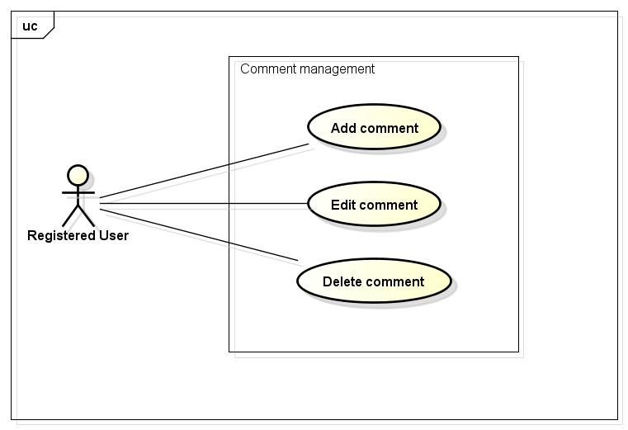

##### UC022-Add Comment

|  |  |  |  |  |
| --- | --- | --- | --- | --- |
| **Use Case ID** | | UC022 | **Version** | 1.1 |
| **Use Case Name** | | Add comment | | |
| **Created by:** | | HieuTM | **Date Created:** | 28/05/2015 |
| **Primary Actor** | | Registered user | **Secondary Actor** |  |
| **Description:** | | This function allows user to comment opinion in a post | | |
| **Preconditions:** | | 1. FAP website is available 2. User browsed FAP website 3. User logged in to system 4. User are viewing a post | | |
| **Trigger:** | | User enters comment and click Send while viewing a post | | |
| **Post conditions:** | | Updates post’s comments | | |
| **Normal Flow** | | | | |
| **Step** | **Actor** | **Action** | | |
|  | User | Entered comment into textbox | | |
|  | User | Click Send or press Enter | | |
|  | FAP | Updates post’s comment | | |
|  | FAP | Displays comment | | |
| **Alternative Flows:** | | | | |
| **AT1** | At step 2 in the main flows, if user click other hyperlinks or buttons | | | |
| **Step** | **Actor** | **Action** | | |
| 2.1 | FAP | Redirects user to chosen hyperlink or button | | |
|  | | | | |
| **AT2** | At step 2 in the main flows, if user click other hyperlinks or buttons | | | |
| **Step** | **Actor** | **Action** | | |
| 2.1 | FAP | Redirects user to chosen hyperlink or button | | |
|  | | | | |
| **Exceptions:** | | | | |
| **EC1** | The connection is terminated | | | |
| **Step** | **Actor** | **Action** | | |
| 1 | FAP | All fields are cleared and FAP return to the wait state. | | |
|  | | | | |
| **Priority** | | High | | |
| **Frequency of Use:** | | High | | |
| **Business Rules:** | | B8 B24 | | |
| **Other Information:** | | N/A | | |

##### UC023-Edit Comment

|  |  |  |  |  |
| --- | --- | --- | --- | --- |
| **Use Case ID** | | UC023 | **Version** | 1.1 |
| **Use Case Name** | | Edit comment | | |
| **Created by:** | | HieuTM | **Date Created:** | 28/05/2015 |
| **Primary Actor** | | Registered user | **Secondary Actor** |  |
| **Description:** | | This function allows user to edit what they commented | | |
| **Preconditions:** | | 1. FAP website is available 2. User browsed FAP website 3. User logged in to system 4. User are viewing a post has their own comments | | |
| **Trigger:** | | User click Edit while viewing an own comment | | |
| **Post conditions:** | | Updates post’s comments | | |
| **Normal Flow** | | | | |
| **Step** | **Actor** | **Action** | | |
|  | User | Click Edit | | |
|  | User | Displays a textbox | | |
|  | User | Entered comment into textbox | | |
|  | User | Click Edit or press Enter | | |
|  | FAP | Updates comment | | |
|  | FAP | Displays edited comment | | |
| **Alternative Flows:** | | | | |
| **AT1** | At step 4 in the main flows, if user click other hyperlinks or buttons | | | |
| **Step** | **Actor** | **Action** | | |
| 4.1 | FAP | Redirects user to chosen hyperlink or button | | |
|  | | | | |
| **AT2** | At step 4 in the main flows, if user click other hyperlinks or buttons | | | |
| **Step** | **Actor** | **Action** | | |
| 4.1 | FAP | Redirects user to chosen hyperlink or button | | |
|  | | | | |
| **Exceptions:** | | | | |
| **EC1** | The connection is terminated | | | |
| **Step** | **Actor** | **Action** | | |
| 1 | FAP | All fields are cleared and FAP return to the wait state. | | |
|  | | | | |
| **Priority** | | Normal | | |
| **Frequency of Use:** | | Normal | | |
| **Business Rules:** | | B8 | | |
| **Other Information:** | | N/A | | |

##### UC024-Delete Comment

|  |  |  |  |  |
| --- | --- | --- | --- | --- |
| **Use Case ID** | | UC024 | **Version** | 1.1 |
| **Use Case Name** | | Delete comment | | |
| **Created by:** | | HieuTM | **Date Created:** | 28/05/2015 |
| **Primary Actor** | | Registered user | **Secondary Actor** |  |
| **Description:** | | This function allows user to edit what they commented | | |
| **Preconditions:** | | 1. FAP website is available 2. User browsed FAP website 3. User logged in to system 4. User are viewing a post has their own comments | | |
| **Trigger:** | | User click Delete while viewing an own comment | | |
| **Post conditions:** | | 1. Post’s comment is deleted | | |
| **Normal Flow** | | | | |
| **Step** | **Actor** | **Action** | | |
|  | User | Click Delete | | |
|  | User | Displays confirm popup “Delete this comment?” | | |
|  | User | Click OK | | |
|  | User | Deletes comment | | |
|  | FAP | Display post without deleted comment | | |
| **Alternative Flows: N/A** | | | | |
| **Exceptions:** | | | | |
| **EC1** | The connection is terminated | | | |
| **Step** | **Actor** | **Action** | | |
| 1 | FAP | All fields are cleared and FAP return to the wait state. | | |
|  | | | | |
| **Priority** | | Normal | | |
| **Frequency of Use:** | | Low | | |
| **Business Rules:** | | N/A | | |
| **Other Information:** | | N/A | | |

#### Like

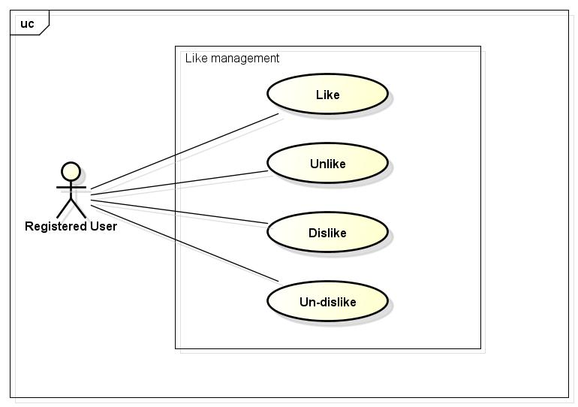

##### UC025-Like

|  |  |  |  |  |
| --- | --- | --- | --- | --- |
| **Use Case ID** | | UC025 | **Version** | 1.1 |
| **Use Case Name** | | Like | | |
| **Created by:** | | HieuTM | **Date Created:** | 28/05/2015 |
| **Primary Actor** | | Registered user | **Secondary Actor** |  |
| **Description:** | | This function allows user to rate a post or a comment | | |
| **Preconditions:** | | 1. FAP website is available 2. User browsed FAP website 3. User logged in to system 4. User are viewing a post or a comment | | |
| **Trigger:** | | User click Like while viewing a post or a comment | | |
| **Post conditions:** | | 1. Liked post is updated to user’s timeline 2. Liked post is updated to News feed of user’s friends if available 3. Update like number of liked post or comment | | |
| **Normal Flow** | | | | |
| **Step** | **Actor** | **Action** | | |
|  | User | Click Like | | |
|  | FAP | Updates liked post to user’s timeline | | |
|  | FAP | Updates liked post to News feed of user’s friends | | |
|  | FAP | Update like number of liked post | | |
|  | FAP | Displays post or comment as Liked | | |
| **Alternative Flows: N/A** | | | | |
| **Exceptions:** | | | | |
| **EC1** | The connection is terminated | | | |
| **Step** | **Actor** | **Action** | | |
| 1 | FAP | Return to the wait state. | | |
|  | | | | |
| **Priority** | | High | | |
| **Frequency of Use:** | | High | | |
| **Business Rules:** | | N/A | | |
| **Other Information:** | | N/A | | |

##### UC026-Unlike

|  |  |  |  |  |
| --- | --- | --- | --- | --- |
| **Use Case ID** | | UC026 | **Version** | 1.1 |
| **Use Case Name** | | Unlike | | |
| **Created by:** | | HieuTM | **Date Created:** | 28/05/2015 |
| **Primary Actor** | | Registered user | **Secondary Actor** |  |
| **Description:** | | This function allows user to remove Like status of a post or comment | | |
| **Preconditions:** | | 1. FAP website is available 2. User browsed FAP website 3. User logged in to system 4. User are viewing a post or a comment they liked | | |
| **Trigger:** | | User click Like a liked post or comment | | |
| **Post conditions:** | | 1. Unlike post is updated to user’s timeline 2. Update like number of liked post or comment | | |
| **Normal Flow** | | | | |
| **Step** | **Actor** | **Action** | | |
|  | User | Click Unlike | | |
|  | FAP | Updates unlike post to user’s timeline | | |
|  | FAP | Update like number of liked post | | |
|  | FAP | Displays post or comment as normal | | |
| **Alternative Flows: N/A** | | | | |
| **Exceptions:** | | | | |
| **EC1** | The connection is terminated | | | |
| **Step** | **Actor** | **Action** | | |
| 1 | FAP | Return to the wait state. | | |
|  | | | | |
| **Priority** | | Normal | | |
| **Frequency of Use:** | | Normal | | |
| **Business Rules:** | | N/A | | |
| **Other Information:** | | N/A | | |

##### UC027-Dislike

|  |  |  |  |  |
| --- | --- | --- | --- | --- |
| **Use Case ID** | | UC027 | **Version** | 1.1 |
| **Use Case Name** | | Dislike | | |
| **Created by:** | | HieuTM | **Date Created:** | 28/05/2015 |
| **Primary Actor** | | Registered user | **Secondary Actor** |  |
| **Description:** | | This function allows user to rate a post or a comment | | |
| **Preconditions:** | | 1. FAP website is available 2. User browsed FAP website 3. User logged in to system 4. User are viewing a post or a comment | | |
| **Trigger:** | | User click Dislike a post or comment | | |
| **Post conditions:** | | 1. Dislike post is updated to user’s timeline 2. Dislike post is updated to News feed of user’s friends if available 3. Update dislike number of dislike post or comment | | |
| **Normal Flow** | | | | |
| **Step** | **Actor** | **Action** | | |
|  | User | Click Dislike | | |
|  | FAP | Updates dislike post to user’s timeline | | |
|  | FAP | Updates dislike post to News feed of user’s friends | | |
|  | FAP | Update dislike number of dislike post | | |
|  | FAP | Display post or comment as Disliked | | |
| **Alternative Flows: N/A** | | | | |
| **Exceptions:** | | | | |
| **EC1** | The connection is terminated | | | |
| **Step** | **Actor** | **Action** | | |
| 1 | FAP | All fields are cleared and FAP return to the wait state. | | |
|  | | | | |
| **Priority** | | High | | |
| **Frequency of Use:** | | High | | |
| **Business Rules:** | | N/A | | |
| **Other Information:** | | N/A | | |

##### UC028-Un-dislike

|  |  |  |  |  |
| --- | --- | --- | --- | --- |
| **Use Case ID** | | UC028 | **Version** | 1.1 |
| **Use Case Name** | | Un-dislike | | |
| **Created by:** | | HieuTM | **Date Created:** | 28/05/2015 |
| **Primary Actor** | | Registered user | **Secondary Actor** |  |
| **Description:** | | This function allows user to remove Like status of a post or comment | | |
| **Preconditions:** | | 1. FAP website is available 2. User browsed FAP website 3. User logged in to system 4. User are viewing a post or a comment they liked | | |
| **Trigger:** | | User click Dislike a disliked post or comment | | |
| **Post conditions:** | | 1. Un-dislike post or comment is updated to user’s timeline 2. Update dislike number of un-dislike post or comment | | |
| **Normal Flow** | | | | |
| **Step** | **Actor** | **Action** | | |
|  | User | Click Unlike | | |
|  | FAP | Updates unlike post to user’s timeline | | |
|  | FAP | Update like number of liked post | | |
|  | FAP | Displays post or comment as normal | | |
| **Alternative Flows: N/A** | | | | |
| **Exceptions:** | | | | |
| **EC1** | The connection is terminated | | | |
| **Step** | **Actor** | **Action** | | |
| 1 | FAP | All fields are cleared and FAP return to the wait state. | | |
|  | | | | |
| **Priority** | | Normal | | |
| **Frequency of Use:** | | Normal | | |
| **Business Rules:** | | N/A | | |
| **Other Information:** | | N/A | | |

#### Report

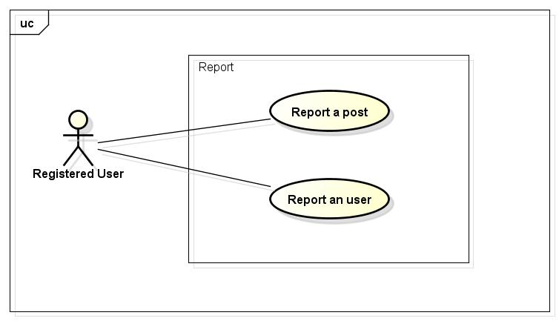

##### UC029-Report a post

|  |  |  |  |  |
| --- | --- | --- | --- | --- |
| **Use Case ID** | | UC029 | **Version** | 1.1 |
| **Use Case Name** | | Report a post | | |
| **Created by:** | | HieuTM | **Date Created:** | 28/05/2015 |
| **Primary Actor** | | Registered user | **Secondary Actor** |  |
| **Description:** | | This function allows user to report a post or comment violated rules | | |
| **Preconditions:** | | 1. FAP website is available 2. User browsed FAP website 3. User logged in to system 4. User are viewing a post or a comment | | |
| **Trigger:** | | User click Report while viewing a post | | |
| **Post conditions:** | | 1. Report is sent to admin | | |
| **Normal Flow** | | | | |
| **Step** | **Actor** | **Action** | | |
|  | User | Click Report. | | |
|  | FAP | Displays popup. | | |
|  | User | Choose common reason. | | |
|  | User | Click Report or press Enter. | | |
|  | FAP | Closes dialog. | | |
|  | FAP | Sent report to admin | | |
|  | FAP | Display message with ID MSG8 | | |
| **Alternative Flows** | | | | |
| **AT1** | At step 3, user choose Other: | | | |
| **Step** | **Actor** | **Action** | | |
| 3.1 | FAP | Displays a textbox dialog. | | |
| 3.2 | User | Enters reason into textbox. | | |
| 3.3 | User | Click Report or press Enter. | | |
| 3.4 | FAP | Closes dialog. | | |
| 3.5 | FAP | Sent report to admin | | |
| 3.6 | FAP | Display message with ID MSG8 | | |
|  | | | | |
| **AT2** | At step 4, user choose Cancel: | | | |
| **Step** | **Actor** | **Action** | | |
| 4.1 | FAP | Closes popup. | | |
|  | | | | |
| **AT3** | At step 4 in the main flows, if user click other hyperlinks or buttons | | | |
| **Step** | **Actor** | **Action** | | |
| 4.1 | FAP | Redirects user to chosen hyperlink or button | | |
|  | | | | |
| **Exceptions:** | | | | |
| **EC1** | The connection is terminated | | | |
| **Step** | **Actor** | **Action** | | |
| 1 | FAP | All fields are cleared and FAP return to the wait state. | | |
|  | | | | |
| **Priority** | | Normal | | |
| **Frequency of Use:** | | Normal | | |
| **Business Rules:** | | B3 B5 | | |
| **Other Information:** | | N/A | | |

##### UC030-Report a user

|  |  |  |  |  |
| --- | --- | --- | --- | --- |
| **Use Case ID** | | UC030 | **Version** | 1.1 |
| **Use Case Name** | | Report an user | | |
| **Created by:** | | HieuTM | **Date Created:** | 28/05/2015 |
| **Primary Actor** | | Registered user | **Secondary Actor** |  |
| **Description:** | | This function allows user to report an user who violated rules | | |
| **Preconditions:** | | 1. FAP website is available 2. User browsed FAP website 3. User logged in to system 4. User are viewing a post or a comment | | |
| **Trigger:** | | User click Report in User menu | | |
| **Post conditions:** | | 1. Report is sent to admin | | |
| **Normal Flow** | | | | |
| **Step** | **Actor** | **Action** | | |
|  | User | Click a User name. | | |
|  | FAP | Displays a menu includes these hyperlinks:   * Add Friend * Unfriend * Edit Relationship * Follow * Block * Report | | |
|  | User | Click Report. | | |
|  | FAP | Displays popup. | | |
|  | User | Choose common reason. | | |
|  | User | Click Report or press Enter. | | |
|  | FAP | Closes dialog. | | |
|  | FAP | Sent report to admin | | |
|  | FAP | Display message with ID MSG16 | | |
| **Alternative Flows** | | | | |
| **AT1** | At step 3, user choose Other: | | | |
| **Step** | **Actor** | **Action** | | |
| 3.1 | FAP | Displays a textbox dialog. | | |
| 3.2 | User | Enters reason into textbox. | | |
| 3.3 | User | Click Report or press Enter. | | |
| 3.4 | FAP | Closes dialog. | | |
| 3.5 | FAP | Sent report to admin | | |
| 3.6 | FAP | Display message with ID MSG8 | | |
|  | | | | |
| **AT3** | At step 4, user choose Cancel: | | | |
| **Step** | **Actor** | **Action** | | |
| 4.1 | FAP | Closes popup. | | |
| **Exceptions:** | | | | |
| **EC1** | The connection is terminated | | | |
| **Step** | **Actor** | **Action** | | |
| 1 | FAP | All fields are cleared and FAP return to the wait state. | | |
|  | | | | |
| **Priority** | | Normal | | |
| **Frequency of Use:** | | Normal | | |
| **Business Rules:** | | B3 B5 | | |
| **Other Information:** | | N/A | | |

#### Chat

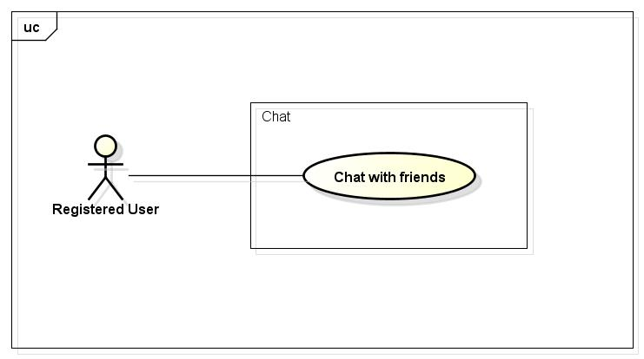

##### UC031-Chat with Friends

|  |  |  |  |  |
| --- | --- | --- | --- | --- |
| **Use Case ID** | | UC031 | **Version** | 1.1 |
| **Use Case Name** | | Report a post | | |
| **Created by:** | | HieuTM | **Date Created:** | 28/05/2015 |
| **Primary Actor** | | Registered user | **Secondary Actor** |  |
| **Description:** | | This function allows user to report a post or comment violated rules | | |
| **Preconditions:** | | 1. FAP website is available 2. User browsed FAP website 3. User logged in to system | | |
| **Trigger:** | | User type message to chat box and click Send | | |
| **Post conditions:** | | 1. Chat contents is sent | | |
| **Normal Flow** | | | | |
| **Step** | **Actor** | **Action** | | |
|  | User | Click Friend List. | | |
|  | FAP | Displays friend list. | | |
|  | User | Click friend’s name. | | |
|  | FAP | Displays chat box. | | |
|  | User | Enters message to chat box. | | |
|  | User | Click Send or press Enter. | | |
|  | FAP | Sends message to friend. | | |
|  | FAP | Displays message on chat box. | | |
| **Alternative Flows:** | | | | |
| **AT1** | At step 6 in the main flows, if user click other hyperlinks or buttons | | | |
| **Step** | **Actor** | **Action** | | |
| 6.1 | FAP | Redirects user to chosen hyperlink or button | | |
|  | | | | |
| **Exceptions:** | | | | |
| **EC1** | The connection is terminated | | | |
| **Step** | **Actor** | **Action** | | |
| 1 | FAP | All fields are cleared and FAP return to the wait state. | | |
|  | | | | |
| **Priority** | | High | | |
| **Frequency of Use:** | | High | | |
| **Business Rules:** | | B10 | | |
| **Other Information:** | | N/A | | |

#### Friend management

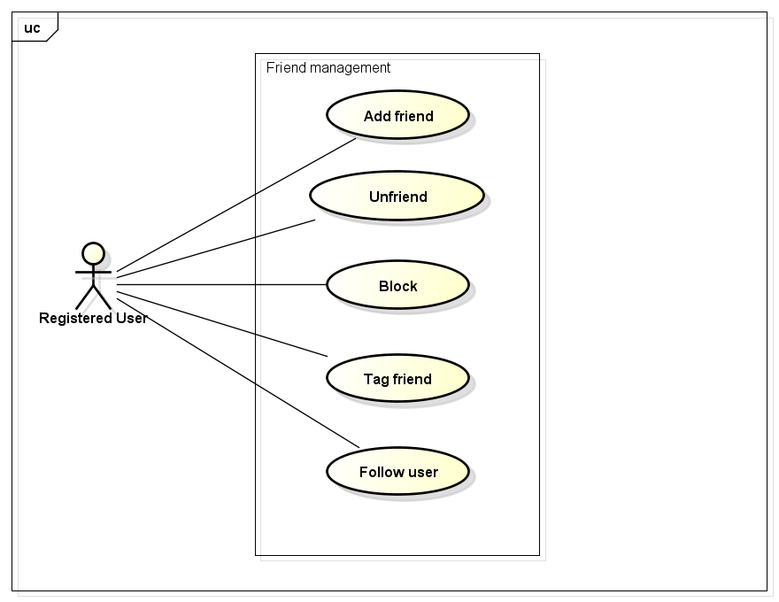

##### UC032-Add Friend

|  |  |  |  |  |
| --- | --- | --- | --- | --- |
| **Use Case ID** | | UC032 | **Version** | 1.1 |
| **Use Case Name** | | Add friend | | |
| **Created by:** | | HieuTM | **Date Created:** | 28/05/2015 |
| **Primary Actor** | | Registered user | **Secondary Actor** |  |
| **Description:** | | This function allows user to add others to friend list to chat or see their activities and updates | | |
| **Preconditions:** | | 1. FAP website is available 2. User browsed FAP website 3. User logged in to system 4. User are viewing a post or a comment | | |
| **Trigger:** | | User click Add Friend in User menu | | |
| **Post conditions:** | | 1. Friend request is sent | | |
| **Normal Flow** | | | | |
| **Step** | **Actor** | **Action** | | |
|  | User | Click a User name. | | |
|  | FAP | Displays a menu includes these hyperlinks:   * Add Friend * Unfriend * Edit Relationship * Follow * Block * Report | | |
|  | User | Click Add Friend. | | |
|  | FAP | Displays message popup. | | |
|  | User | Enters message into textbox. | | |
|  | User | Click Add or press Enter. | | |
|  | FAP | Closes popup. | | |
|  | FAP | Sends request to user | | |
|  | FAP | Display message with ID MSG9 | | |
| **Alternative Flows** | | | | |
| **AT1** | At step 6, user choose Cancel: | | | |
| **Step** | **Actor** | **Action** | | |
| 6.1 | FAP | Closes popup. | | |
|  | | | | |
| **Exceptions:** | | | | |
| **EC1** | The connection is terminated | | | |
| **Step** | **Actor** | **Action** | | |
| 1 | FAP | All fields are cleared and FAP return to the wait state. | | |
|  | | | | |
| **Priority** | | High | | |
| **Frequency of Use:** | | High | | |
| **Business Rules:** | | N/A | | |
| **Other Information:** | | N/A | | |

##### ~~(Delete)-Edit Relationship~~

|  |  |  |  |  |
| --- | --- | --- | --- | --- |
| **Use Case ID** | | UC033 | **Version** | 1.1 |
| **Use Case Name** | | Edit relationship | | |
| **Created by:** | | HieuTM | **Date Created:** | 28/05/2015 |
| **Primary Actor** | | Registered user | **Secondary Actor** |  |
| **Description:** | | This function allows user to change default relationship or makes self-define relationship with friends | | |
| **Preconditions:** | | 1. FAP website is available 2. User browsed FAP website 3. User logged in to system 4. User are viewing a post or a comment 5. User can change relationship with others are in friend list only | | |
| **Trigger:** | | User click Edit Relationship in User menu | | |
| **Post conditions:** | | 1. Relationship change request is sent | | |
| **Normal Flow** | | | | |
| **Step** | **Actor** | **Action** | | |
|  | User | Click a User name. | | |
|  | FAP | Displays a menu includes these hyperlinks:   * Add Friend * Unfriend * Edit Relationship * Follow * Block * Report | | |
|  | User | Click Relationship. | | |
|  | FAP | Displays popup. | | |
|  | User | Choose relationship. | | |
|  | User | Click Change or press Enter. | | |
|  | FAP | Closes dialog. | | |
|  | FAP | Sends change relationship request | | |
|  | FAP | Display message “Request has been sent” | | |
| **Alternative Flows** | | | | |
| **AT1** | At step 5, user choose Other: | | | |
| **Step** | **Actor** | **Action** | | |
| 5.1 | FAP | Displays a textbox dialog. | | |
| 5.2 | User | Enters relationship into textbox. | | |
| 5.3 | User | Click Change or press Enter. | | |
| 5.4 | FAP | Closes dialog. | | |
| 5.5 | FAP | Sends change relationship request | | |
| 5.6 | FAP | Display message “Request has been sent” | | |
|  | | | | |
| **AT3** | At step 6, user choose Cancel: | | | |
| **Step** | **Actor** | **Action** | | |
| 6.1 | FAP | Closes popup. | | |
|  | | | | |
| **Exceptions:** | | | | |
| **EC1** | The connection is terminated | | | |
| **Step** | **Actor** | **Action** | | |
| 1 | FAP | All fields are cleared and FAP return to the wait state. | | |
|  | | | | |
| **Priority** | | Normal | | |
| **Frequency of Use:** | | Normal | | |
| **Business Rules:** | | N/A | | |
| **Other Information:** | | N/A | | |

##### UC034-Unfriend

|  |  |  |  |  |
| --- | --- | --- | --- | --- |
| **Use Case ID** | | UC034 | **Version** | 1.1 |
| **Use Case Name** | | Unfriend | | |
| **Created by:** | | HieuTM | **Date Created:** | 28/05/2015 |
| **Primary Actor** | | Registered user | **Secondary Actor** |  |
| **Description:** | | This function allows user to remove others from friend list | | |
| **Preconditions:** | | 1. FAP website is available 2. User browsed FAP website 3. User logged in to system 4. User are viewing a post or a comment | | |
| **Trigger:** | | User click Unfriend in User menu | | |
| **Post conditions:** | | 1. Friend is removed from list | | |
| **Normal Flow** | | | | |
| **Step** | **Actor** | **Action** | | |
|  | User | Click a User name. | | |
|  | FAP | Displays a menu includes these hyperlinks:   * Add Friend * Unfriend * Edit Relationship * Follow * Block * Report | | |
|  | User | Click Unfriend. | | |
|  | FAP | Displays confirm popup “Unfriend this user?” | | |
|  | User | Click OK. | | |
|  | FAP | Closes popup. | | |
|  | FAP | Remove friend from list | | |
| **Alternative Flows** | | | | |
| **AT1** | At step 5, user choose Cancel: | | | |
| **Step** | **Actor** | **Action** | | |
| 5.1 | FAP | Closes popup. | | |
|  | | | | |
| **Exceptions:** | | | | |
| **EC1** | The connection is terminated | | | |
| **Step** | **Actor** | **Action** | | |
| 1 | FAP | All fields are cleared and FAP return to the wait state. | | |
|  | | | | |
| **Priority** | | High | | |
| **Frequency of Use:** | | High | | |
| **Business Rules:** | | N/A | | |
| **Other Information:** | | N/A | | |

##### UC035-Block

|  |  |  |  |  |
| --- | --- | --- | --- | --- |
| **Use Case ID** | | UC035 | **Version** | 1.1 |
| **Use Case Name** | | Block | | |
| **Created by:** | | HieuTM | **Date Created:** | 28/05/2015 |
| **Primary Actor** | | Registered user | **Secondary Actor** |  |
| **Description:** | | This function allows user to block a user to not receive notifications or to not view that user posts and comments. | | |
| **Preconditions:** | | 1. FAP website is available 2. User browsed FAP website 3. User logged in to system 4. User are viewing a post or a comment | | |
| **Trigger:** | | User click Block in User menu | | |
| **Post conditions:** | | 1. Blocked user’s posts is not displayed 2. Blocked user’s comments is not displayed | | |
| **Normal Flow** | | | | |
| **Step** | **Actor** | **Action** | | |
|  | User | Click a User name. | | |
|  | FAP | Displays a menu includes these hyperlinks:   * Add Friend * Unfriend * Edit Relationship * Follow * Block * Report | | |
|  | User | Click Block. | | |
|  | FAP | Displays confirm popup “Block this user?” | | |
|  | User | Click OK. | | |
|  | FAP | Closes dialog. | | |
|  | FAP | Hide all blocked user’s posts and comments | | |
|  | FAP | Display message with ID MSG10 | | |
| **Alternative Flows** | | | | |
| **AT1** | At step 5, user choose Cancel: | | | |
| **Step** | **Actor** | **Action** | | |
| 5.1 | FAP | Closes popup. | | |
|  | | | | |
| **Exceptions:** | | | | |
| **EC1** | The connection is terminated | | | |
| **Step** | **Actor** | **Action** | | |
| 1 | FAP | All fields are cleared and FAP return to the wait state. | | |
|  | | | | |
| **Priority** | | Normal | | |
| **Frequency of Use:** | | Normal | | |
| **Business Rules:** | | N/A | | |
| **Other Information:** | | N/A | | |

##### UC036-Tag Friend on Post

|  |  |  |  |  |
| --- | --- | --- | --- | --- |
| **Use Case ID** | | UC036 | **Version** | 1.1 |
| **Use Case Name** | | Tag friend on post | | |
| **Created by:** | | HieuTM | **Date Created:** | 28/05/2015 |
| **Primary Actor** | | Registered user | **Secondary Actor** |  |
| **Description:** | | This function allows user to tag friends, let friend receive notification about post or comment they were tagged. | | |
| **Preconditions:** | | 1. FAP website is available 2. User browsed FAP website 3. User logged in to system 4. User are viewing Add Post page or Add Video page | | |
| **Trigger:** | | User click Tag while creating a post | | |
| **Post conditions:** | | Notification is sent to tagged users | | |
| **Normal Flow** | | | | |
| **Step** | **Actor** | **Action** | | |
|  | User | Click Tag | | |
|  | FAP | Type whole or part of friends’ name into textbox. | | |
|  | User | Choose friends in suggest menu | | |
|  | FAP | Enters required fields | | |
|  | User | Click Create. | | |
|  | FAP | Sends notifications to tagged friends. | | |
| **Alternative Flows** | | | | |
| **AT3** | At step 5, user choose Cancel: | | | |
| **Step** | **Actor** | **Action** | | |
| 5.1 | FAP | Redirects user to previous page. | | |
| **Exceptions:** | | | | |
| **EC1** | The connection is terminated | | | |
| **Step** | **Actor** | **Action** | | |
| 1 | FAP | All fields are cleared and FAP return to the wait state. | | |
|  | | | | |
| **EC2** | At step 4, required fields are not entered | | | |
| **Step** | **Actor** | **Action** | | |
| 4.1 | FAP | Display Add Post page with message with ID MSG5 | | |
| 4.2 | FAP | Mark error fields | | |
|  | | | | |
| **EC3** | At step 4, fields are entered with wrong type of data | | | |
| **Step** | **Actor** | **Action** | | |
| 4.1 | FAP | Display Add Post page with message with ID MSG6 | | |
| 4.2 | FAP | Mark error fields | | |
|  | | | | |
| **Priority** | | High | | |
| **Frequency of Use:** | | High | | |
| **Business Rules:** | | N/A | | |
| **Other Information:** | | N/A | | |

##### UC037-Follow

|  |  |  |  |  |
| --- | --- | --- | --- | --- |
| **Use Case ID** | | UC037 | **Version** | 1.1 |
| **Use Case Name** | | Follow | | |
| **Created by:** | | HieuTM | **Date Created:** | 28/05/2015 |
| **Primary Actor** | | Registered user | **Secondary Actor** |  |
| **Description:** | | This function allows user to know others activity. | | |
| **Preconditions:** | | 1. FAP website is available 2. User browsed FAP website 3. User logged in to system 4. User are viewing a post or a comment | | |
| **Trigger:** | | User click Follow in User menu. | | |
| **Post conditions:** | | 1. Followed user is added to Follow list 2. Activities of followed user are updated to News feed | | |
| **Normal Flow** | | | | |
| **Step** | **Actor** | **Action** | | |
|  | User | Click a User name. | | |
|  | FAP | Displays a menu includes these hyperlinks:   * Add Friend * Unfriend * Edit Relationship * Follow * Block * Report | | |
|  | User | Click Follow. | | |
|  | FAP | Adds followed user to Follow list | | |
|  | FAP | Updates activities of followed user to News feed automatically | | |
| **Alternative Flows: N/A** | | | | |
| **Exceptions:** | | | | |
| **EC1** | The connection is terminated | | | |
| **Step** | **Actor** | **Action** | | |
| 1 | FAP | All fields are cleared and FAP return to the wait state. | | |
|  | | | | |
| **Priority** | | High | | |
| **Frequency of Use:** | | High | | |
| **Business Rules:** | | N/A | | |
| **Other Information:** | | N/A | | |

#### Room

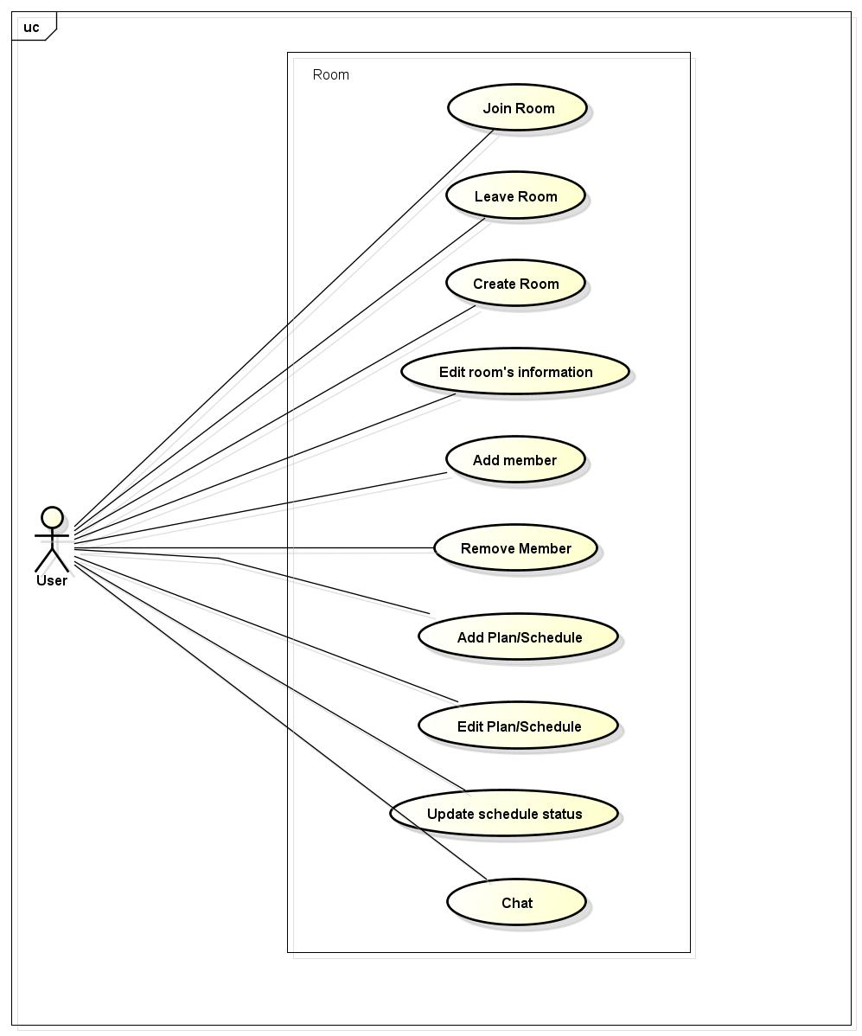

##### UC038-Join room

|  |  |  |  |  |
| --- | --- | --- | --- | --- |
| **Use Case ID** | | UC038 | **Version** | 1.0 |
| **Use Case Name** | | Join room | | |
| **Created by:** | | ThuyLM | **Date Created:** | 11/06/2015 |
| **Primary Actor** | | Registered user | **Secondary Actor** | None |
| **Description:** | | This function allows user join an existing room | | |
| **Preconditions:** | | 1. FAP must be connected to the Internet 2. User browsed FAP website 3. User logged in to system 4. Room have been existing | | |
| **Trigger:** | | User enters Room ID and click Search | | |
| **Post conditions:** | | User join a room | | |
| **Normal Flow** | | | | |
| **Step** | **Actor** | **Action** | | |
|  | User | Click on Room in Room list screen/Search Result screen | | |
|  | FAP | Redirect user to Room Details screen | | |
| **Alternative Flows:** | | | | |
| **AT1** | At step 1, if Room is private | | | |
| **Step** | **Actor** | **Action** | | |
| 1.1 | User | Enter Room ID on Search panel | | |
| 1.2 | User | Click Search or press Enter | | |
| 1.3 | FAP | Display Room on Search Result screen | | |
| 1.4 | User | Click on Room thumbnail | | |
| 1.5 | FAP | Redirect user to Room Details screen | | |
|  | | | | |
| **AT2** | If user has been invited by a member of room | | | |
| **Step** | **Actor** | **Action** | | |
| 1.1 | FAP | Display notification to user | | |
| 1.2 | User | Click on invitation | | |
| 1.3 | FAP | Redirect user to Room Details screen | | |
|  | | | | |
| **Exceptions:** | | | | |
| **EC1** | The connection is terminated | | | |
| **Step** | **Actor** | **Action** | | |
| 1 | FAP | All fields are cleared and FAP return to the wait state. | | |
|  | | | | |
| **EC2** | Room ID is not existed | | | |
| **Step** | **Actor** | **Action** | | |
| 1 | FAP | Display Search Result screen with message with ID MSG11 | | |
|  | | | | |
| **Priority** | | High | | |
| **Frequency of Use:** | | High | | |
| **Business Rules:** | |  | | |
| **Other Information:** | | N/A | | |

##### UC039-Leave room

|  |  |  |  |  |
| --- | --- | --- | --- | --- |
| **Use Case ID** | | UC039 | **Version** | 1.0 |
| **Use Case Name** | | Leave room | | |
| **Created by:** | | ThuyLM | **Date Created:** | 11/06/2015 |
| **Primary Actor** | | Registered user | **Secondary Actor** |  |
| **Description:** | | This function allows users to leave a room that they have join | | |
| **Preconditions:** | | 1. FAP must be connected to the Internet 2. User browsed FAP website 3. User logged in to system 4. User has join a room | | |
| **Trigger:** | | User click Exit in Setting menu | | |
| **Post conditions:** | | 1. User is no longer on that room 2. Room has been deleted from user’s room list | | |
| **Normal Flow** | | | | |
| **Step** | **Actor** | **Action** | | |
|  | User | Click on Setting button on Room Screen | | |
|  | User | Click “Exit” | | |
|  | FAP | 1. Redirect user to Homepage 2. Delete room name from user’s room list 3. Show message with ID MSG12 on Room Screen 4. Replace username on schedule/plan by “Left member” | | |
| **Alternative Flows: N/A** | | | | |
| **Exceptions:** | | | | |
| **EC1** | The connection is terminated | | | |
| **Step** | **Actor** | **Action** | | |
| 1 | FAP | FAP return to the wait state, user did not leave the room. | | |
|  | | | | |
| **Priority** | | High | | |
| **Frequency of Use:** | | High | | |
| **Business Rules:** | | N/A | | |
| **Other Information:** | | N/A | | |

##### UC040-Create room

|  |  |  |  |  |
| --- | --- | --- | --- | --- |
| **Use Case ID** | | UC040 | **Version** | 1.0 |
| **Use Case Name** | | Create room | | |
| **Created by:** | | ThuyLM | **Date Created:** | 11/06/2015 |
| **Primary Actor** | | Registered user | **Secondary Actor** |  |
| **Description:** | | This function allows user to create new room | | |
| **Preconditions:** | | 1. FAP must be connected to the Internet 2. User browsed FAP website 3. User logged in to system | | |
| **Trigger:** | | User click Create Room in Homepage | | |
| **Post conditions:** | | A new room will be created | | |
| **Normal Flow** | | | | |
| **Step** | **Actor** | **Action** | | |
|  | User | Click on (+) float icon on any page of FAP | | |
|  | User | Click “Create Room” button | | |
|  | FAP | Display a window with fields and button:   * Room name * Place + Locate button * Start date * End date * Public/Private state * Add friend button * Create button * Cancel button | | |
|  | User | Fill information of room | | |
|  | User | Click “Create” | | |
|  | FAP | Create room | | |
|  | FAP | Redirect user to their new room | | |
| **Alternative Flows** | | | | |
| **AT1** | At step 5 in the main flows, user left Room name blank | | | |
| **Step** | **Actor** | **Action** | | |
| 5.1 | FAP | Display message with ID MSG13 | | |
| 5.2 | FAP | Return to step 4 | | |
|  | | | | |
| **AT2** | At step 3 in the main flow, user clicks on Cancel button | | | |
| **Step** | **Actor** | **Action** | | |
| 5.1 | FAP | Return to previous screen | | |
|  | | | | |
| **Exceptions:** | | | | |
| **EC1** | The connection is terminated | | | |
| **Step** | **Actor** | **Action** | | |
| 1 | FAP | All fields are cleared and FAP return to the wait state. | | |
|  | | | | |
| **Priority** | | High | | |
| **Frequency of Use:** | | High | | |
| **Business Rules:** | |  | | |
| **Other Information:** | | Not required fields will be filled with default value of FAP | | |

##### UC041-Edit room’s information

|  |  |  |  |  |
| --- | --- | --- | --- | --- |
| **Use Case ID** | | UC041 | **Version** | 1.0 |
| **Use Case Name** | | Edit room’s information | | |
| **Created by:** | | ThuyLM | **Date Created:** | 11/06/2015 |
| **Primary Actor** | | Registered user | **Secondary Actor** |  |
| **Description:** | | This function allow user edit room’s information | | |
| **Preconditions:** | | 1. FAP must be connected to the Internet 2. User browsed FAP website 3. User logged in to system 4. User created room | | |
| **Trigger:** | | User click Edit in Room Details screen | | |
| **Post conditions:** | | Room’s information is edited | | |
| **Normal Flow** | | | | |
| **Step** | **Actor** | **Action** | | |
|  | User | Click on button Edit on Room Details screen | | |
|  | FAP | Display a window with fields:   * Room name * Place + Locate button * Start date * End date * Public/Private state * Add friend button * Edit button * Cancel button | | |
|  | User | Edit room’s information | | |
|  | User | Click edit button | | |
|  | FAP | Redirect user to Room details screen | | |
| **AT1** | At step 5 in the main flows, user left Room name blank | | | |
| **Step** | **Actor** | **Action** | | |
| 5.1 | FAP | Display message with ID MSG13 | | |
| 5.2 | FAP | Return to step 4 | | |
|  | | | | |
| **AT2** | At step 3 in the main flow, user clicks on Cancel button | | | |
| **Step** | **Actor** | **Action** | | |
| 3.1 | FAP | Return to previous screen | | |
|  | | | | |
| **Exceptions:** | | | | |
| **EC1** | The connection is terminated | | | |
| **Step** | **Actor** | **Action** | | |
| 1 | FAP | All fields are cleared and FAP return to the wait state. | | |
|  | | | | |
| **Priority** | | High | | |
| **Frequency of Use:** | | High | | |
| **Business Rules:** | |  | | |
| **Other Information:** | | N/A | | |

##### UC042-Create plan/schedule

|  |  |  |  |  |
| --- | --- | --- | --- | --- |
| **Use Case ID** | | UC042 | **Version** | 1.0 |
| **Use Case Name** | | Create plan/schedule | | |
| **Created by:** | | ThuyLM | **Date Created:** | 11/06/2015 |
| **Primary Actor** | | Registered user | **Secondary Actor** |  |
| **Description:** | | This function allow user create a plan or schedule for their trips | | |
| **Preconditions:** | | 1. FAP must be connected to the Internet 2. User browsed FAP website 3. User logged in to system 4. User is administrator of room (creator of room) | | |
| **Trigger:** | | User click Plan in Room Details screen | | |
| **Post conditions:** | | Plan or schedule be created | | |
| **Normal Flow** | | | | |
| **Step** | **Actor** | **Action** | | |
|  | User | Click on Plan button on Room details screen | | |
|  | FAP | Display a window with fields and button:   * Plan * Add milestones button * Milestone * Transportation * Task * Doer * Save button * Cancel button | | |
|  | User | Fill information on fields | | |
|  | User | Click Save | | |
|  | FAP | Save information and display on Room details screen | | |
| **Alternative Flows** | | | | |
| **AT1** | At step 2, user click Add milestones button | | | |
| **Step** | **Actor** | **Action** | | |
| 2.1 | FAP | Popup a calendar | | |
| 2.2 | User | Choose date of milestone | | |
| 2.3 | FAP | Display a text field | | |
| 2.4 | User | Fill information of milestone (name of place etc…) | | |
| 2.5 | FAP | Save information of milestone and display on a timeline | | |
|  | | | | |
| **AT2** | At step 3 in the main flow, user clicks on Cancel button | | | |
| **Step** | **Actor** | **Action** | | |
| 3.1 | FAP | Return to previous screen | | |
|  | | | | |
| **Exceptions:** | | | | |
| **EC1** | The connection is terminated | | | |
| **Step** | **Actor** | **Action** | | |
| 1 | FAP | All fields are cleared and FAP return to the wait state. | | |
|  | | | | |
| **Priority** | | High | | |
| **Frequency of Use:** | | High | | |
| **Business Rules:** | |  | | |
| **Other Information:** | | N/A | | |

##### UC043-Edit plan/schedule

|  |  |  |  |  |
| --- | --- | --- | --- | --- |
| **Use Case ID** | | UC043 | **Version** | 1.0 |
| **Use Case Name** | | Edit plan/schedule | | |
| **Created by:** | | ThuyLM | **Date Created:** | 11/06/2015 |
| **Primary Actor** | | Registered user | **Secondary Actor** |  |
| **Description:** | | This function allow user edit plan or schedule of a trip on their room | | |
| **Preconditions:** | | 1. FAP must be connected to the Internet 2. User browsed FAP website 3. User logged in to system 4. User is administrator of room (creator of room) | | |
| **Trigger:** | | User click Edit in Plan bar | | |
| **Post conditions:** | | Plan and schedule is updated and display on Room details screen | | |
| **Normal Flow** | | | | |
| **Step** | **Actor** | **Action** | | |
|  | User | Click on Edit icon on Plan bar | | |
|  | FAP | Display a window with fields and button:   * Plan * Add milestones button * Milestone * Transportation * Task * Doer * Save button * Cancel button | | |
|  | User | Fill information on fields | | |
|  | User | Click Save | | |
|  | FAP | Save information and display on Room details screen | | |
| **Alternative Flows** | | | | |
| **AT1** | At step 2, user click Add milestones button | | | |
| **Step** | **Actor** | **Action** | | |
| 2.1 | FAP | Popup a calendar | | |
| 2.2 | User | Choose date of milestone | | |
| 2.3 | FAP | Display a text field | | |
| 2.4 | User | Fill information of milestone (name of place etc…) | | |
| 2.5 | FAP | Save information of milestone and display on a timeline | | |
|  | | | | |
| **AT2** | At step 3 in the main flow, user clicks on Cancel button | | | |
| **Step** | **Actor** | **Action** | | |
| 3.1 | FAP | Return to previous screen | | |
|  | | | | |
| **Exceptions:** | | | | |
| **EC1** | The connection is terminated | | | |
| **Step** | **Actor** | **Action** | | |
| 1 | FAP | All fields are cleared and FAP return to the wait state. | | |
|  | | | | |
| **Priority** | | High | | |
| **Frequency of Use:** | | High | | |
| **Business Rules:** | |  | | |
| **Other Information:** | | N/A | | |

##### UC044-Add member

|  |  |  |  |  |
| --- | --- | --- | --- | --- |
| **Use Case ID** | | UC044 | **Version** | 1.0 |
| **Use Case Name** | | Add member | | |
| **Created by:** | | ThuyLM | **Date Created:** | 11/06/2015 |
| **Primary Actor** | | Registered user | **Secondary Actor** |  |
| **Description:** | | This function allows user add member to room | | |
| **Preconditions:** | | 1. FAP must be connected to the Internet 2. User browsed FAP website 3. User logged in to system 4. User is currently a member of room | | |
| **Trigger:** | | User click Add member in Setting menu | | |
| **Post conditions:** | | New member is added to room | | |
| **Normal Flow** | | | | |
| **Step** | **Actor** | **Action** | | |
|  | User | Click on Setting button on Room details screen | | |
|  | User | Click on Add member on list | | |
|  | FAP | Display a window with user’s friend list | | |
|  | User | Select friend(s) on list | | |
|  | User | Click Add button | | |
|  | FAP | 1. Add new member to room and send notification to each people 2. Redirect user to Room details screen | | |
| **Alternative Flows** | | | | |
| **AT2** | At step 3 in the main flow, user clicks on Cancel button | | | |
| **Step** | **Actor** | **Action** | | |
| 3.1 | FAP | Return to previous screen | | |
|  | | | | |
| **Exceptions:** | | | | |
| **EC1** | The connection is terminated | | | |
| **Step** | **Actor** | **Action** | | |
| 1 | FAP | Return to the wait state. | | |
|  | | | | |
| **Priority** | | High | | |
| **Frequency of Use:** | | High | | |
| **Business Rules:** | |  | | |
| **Other Information:** | | N/A | | |

##### UC045-Update schedule status

|  |  |  |  |  |
| --- | --- | --- | --- | --- |
| **Use Case ID** | | UC045 | **Version** | 1.0 |
| **Use Case Name** | | Update schedule status | | |
| **Created by:** | | ThuyLM | **Date Created:** | 11/06/2015 |
| **Primary Actor** | | Registered user | **Secondary Actor** |  |
| **Description:** | | Update status of schedule of a trip | | |
| **Preconditions:** | | 1. FAP must be connected to the Internet 2. User browsed FAP website 3. User logged in to system 4. User is administrator of room (creator of room) | | |
| **Trigger:** | | User click a milestone in Plan bar and chooses status | | |
| **Post conditions:** | | Status of schedule is updated | | |
| **Normal Flow** | | | | |
| **Step** | **Actor** | **Action** | | |
|  | User | Click on a milestone of trip | | |
|  | FAP | Display a popup window allows user selects status:   * Passed * Not passed * Dismiss | | |
|  | User | User selects status of milestone | | |
|  | User | Click Save | | |
|  | FAP | Save status of milestone, display on timeline and mark with colors:   * Passed: Green * Not passed: White * Dismiss: Gray | | |
| **Alternative Flows** | | | | |
| **AT2** | At step 3 in the main flow, user clicks on Cancel button | | | |
| **Step** | **Actor** | **Action** | | |
| 3.1 | FAP | Closes popup. | | |
|  | | | | |
| **Exceptions:** | | | | |
| **EC1** | The connection is terminated | | | |
| **Step** | **Actor** | **Action** | | |
| 1 | FAP | Return to the wait state. | | |
|  | | | | |
| **Priority** | | High | | |
| **Frequency of Use:** | | High | | |
| **Business Rules:** | |  | | |
| **Other Information:** | | N/A | | |

##### UC046-Remove member

|  |  |  |  |  |
| --- | --- | --- | --- | --- |
| **Use Case ID** | | UC046 | **Version** | 1.0 |
| **Use Case Name** | | Remove member | | |
| **Created by:** | | ThuyLM | **Date Created:** | 11/06/2015 |
| **Primary Actor** | | Registered user | **Secondary Actor** |  |
| **Description:** | | This function allows user removes a member is already join the room | | |
| **Preconditions:** | | 1. FAP must be connected to the Internet 2. User browsed FAP website 3. User logged in to system 4. User is administrator of room (creator of room) | | |
| **Trigger:** | | User click Remove in Member menu | | |
| **Post conditions:** | | Member is removed from room | | |
| **Normal Flow** | | | | |
| **Step** | **Actor** | **Action** | | |
|  | User | Right click on Member profile picture on Member List | | |
|  | User | Choose Remove | | |
|  | FAP | 1. Delete this member from Member List 2. Send notification to member who had been remove from room | | |
| **Alternative Flows: N/A** | | | | |
| **Exceptions:** | | | | |
| **EC1** | The connection is terminated | | | |
| **Step** | **Actor** | **Action** | | |
| 1 | FAP | Return to the wait state. | | |
|  | | | | |
| **Priority** | | High | | |
| **Frequency of Use:** | | High | | |
| **Business Rules:** | |  | | |
| **Other Information:** | | N/A | | |

##### UC047-Chat

|  |  |  |  |  |
| --- | --- | --- | --- | --- |
| **Use Case ID** | | UC047 | **Version** | 1.0 |
| **Use Case Name** | | Chat | | |
| **Created by:** | | ThuyLM | **Date Created:** | 11/06/2015 |
| **Primary Actor** | | Registered user | **Secondary Actor** |  |
| **Description:** | | This function allows user chat with all member on room | | |
| **Preconditions:** | | 1. FAP must be connected to the Internet 2. User browsed FAP website 3. User logged in to system 4. User is currently a member of room | | |
| **Trigger:** | | User type chat message to chat box and click Send | | |
| **Post conditions:** | | User can chat with all member on room | | |
| **Normal Flow** | | | | |
| **Step** | **Actor** | **Action** | | |
|  | User | Type a message on chat box | | |
|  | User | Click Send button or press Enter | | |
|  | FAP | Display message on chat windows; all member on room can see this message | | |
| **Alternative Flows: N/A** | | | | |
| **Exceptions:** | | | | |
| **EC1** | The connection is terminated | | | |
| **Step** | **Actor** | **Action** | | |
| 1 | FAP | All fields are cleared and FAP return to the wait state. | | |
|  | | | | |
| **Priority** | | High | | |
| **Frequency of Use:** | | High | | |
| **Business Rules:** | |  | | |
| **Other Information:** | | N/A | | |

## Account Management Module

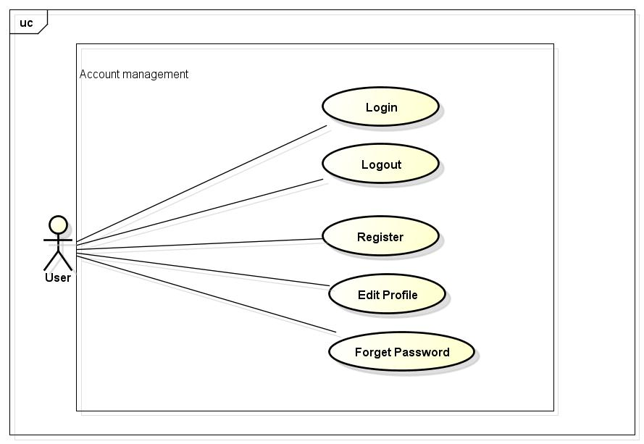

### Login

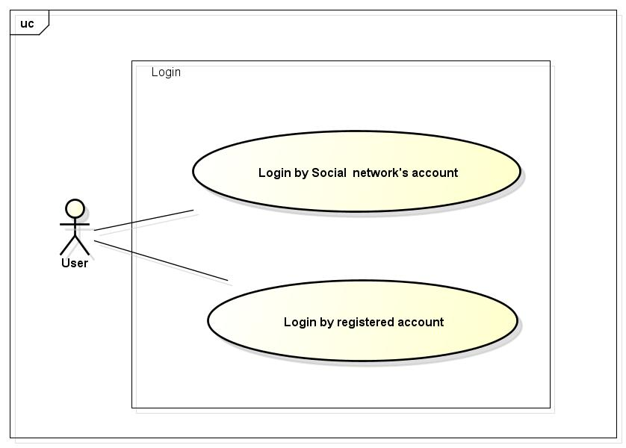

#### UC048-Login

|  |  |  |  |  |
| --- | --- | --- | --- | --- |
| **Use Case ID** | | UC048 | **Version** | 1.1 |
| **Use Case Name** | | Login by social network’s account  Login by registered account | | |
| **Created by:** | | LucPT | **Date Created:** | 28/05/2015 |
| **Primary Actor** | | Registered User | **Secondary Actor** |  |
| **Description:** | | When Member, Administrator want to login by Facebook/Google/Register account to use more functions in website | | |
| **Preconditions:** | | 1. FAP must be connected to the Internet 2. User browsed FAP website 3. Account Facebook/Google/Register must be exist and correctly 4. User are viewing Login page | | |
| **Trigger:** | | User click Login or Login by Social network in Homepage | | |
| **Post conditions:** | | 1. Log user into system 2. Redirect user to previous page and display as Member | | |
| **Normal Flow** | | | | |
| **Step** | **Actor** | **Action** | | |
|  | User | Click Login in Homepage | | |
|  | FAP | Display Login popup includes:   * User name text box * Password text box * Login button * Cancel button * Facebook button * Google+ button * Forgot password hyperlink | | |
|  | User | Enters User name and Password | | |
|  | User | Click Login | | |
|  | FAP | Logs user into system | | |
|  | FAP | Close popup | | |
|  | FAP | Display previous page as Member | | |
| **Alternative Flows** | | | | |
| **AT1** | At step 3 in the main flows, if user click Facebook or Google+ button | | | |
| **Step** | **Actor** | **Action** | | |
| 3.1 | FAP | Redirects user to confirm site | | |
| 3.2 | FAP | Logs user into system with Facebook or Google+ account | | |
|  | | | | |
| **AT2** | At step 4, user choose Cancel: | | | |
| **Step** | **Actor** | **Action** | | |
| 4.1 | FAP | Closes popup. | | |
|  | | | | |
| **AT3** | At step 8 in the main flows, if user click other hyperlinks or buttons | | | |
| **Step** | **Actor** | **Action** | | |
| 8.1 | FAP | Redirects user to chosen hyperlink or button | | |
|  | | | | |
| **Exceptions:** | | | | |
| **EC1** | The connection is terminated | | | |
| **Step** | **Actor** | **Action** | | |
| 1 | FAP | All fields are cleared and FAP return to the wait state. | | |
|  | | | | |
| **EC2** | At step 4 in main flow, if user entered wrong User name or Password | | | |
| **Step** | **Actor** | **Action** | | |
| 3.1 | FAP | Display Login popup message with ID MSG14 | | |
| 3.2 | FAP | Mark error fields | | |
|  | | | | |
| **Priority** | | High | | |
| **Frequency of Use:** | | High | | |
| **Business Rules:** | | N/A | | |
| **Other Information:** | | N/A | | |

### UC049-Logout

|  |  |  |  |  |
| --- | --- | --- | --- | --- |
| **Use Case ID** | | UC049 | **Version** | 1.1 |
| **Use Case Name** | | Logout | | |
| **Created by:** | | LucPT | **Date Created:** | 28/05/2015 |
| **Primary Actor** | | User/ admin | **Secondary Actor** |  |
| **Description:** | | When Member, Admin want to logout their account | | |
| **Preconditions:** | | 1. FAP must be connected to the Internet 2. User browsed FAP website 3. User logged in to system | | |
| **Trigger:** | | User click Logout in header | | |
| **Post conditions:** | | 1. Log user out from system. 2. Redirect user to previous page and display as Guest | | |
| **Normal Flow** | | | | |
| **Step** | **Actor** | **Action** | | |
| 1 | User | Click Logout | | |
| 2 | FAP | Display page as Guest | | |
| **Alternative Flows: N/A** | | | | |
| **Exceptions:** | | | | |
| **EC1** | The connection is terminated | | | |
| **Step** | **Actor** | **Action** | | |
| 3 | FAP | FAP return to the wait state. | | |
|  | | | | |
| **Priority** | | High | | |
| **Frequency of Use:** | | High | | |
| **Business Rules:** | | N/A | | |
| **Other Information:** | | N/A | | |

### UC050-Register

|  |  |  |  |  |  |
| --- | --- | --- | --- | --- | --- |
| **Use Case ID** | | | UC050 | **Version** | 1.1 |
| **Use Case Name** | | | Register | | |
| **Created by:** | | | LucPT | **Date Created:** | 28/05/2015 |
| **Primary Actor** | | | Guest | **Secondary Actor** |  |
| **Description:** | | | Visitor can create new account to use more function as a register user | | |
| **Preconditions:** | | | 1. FAP must be connected to the Internet 2. User browsed FAP website | | |
| **Trigger:** | | | Click on register link on the website | | |
| **Post conditions:** | | | 1. Add account information to database 2. Send confirm email 3. Logs user into system 4. Redirect user to Homepage and display as Member | | |
| **Normal Flow** | | | | | |
| **Step** | **Actor** | | **Action** | | |
|  | User | | Click Register in header | | |
|  | FAP | | Display Register page includes:   * Header * User name text box * Password text box * Email text box * Date of Birth date picker * Phone number text box * Register button * Cancel button | | |
|  | User | | Enters data in fields | | |
|  | User | | Click Register | | |
|  | FAP | | Send confirm email | | |
|  | FAP | | Logs user into system | | |
|  | FAP | | Display Homepage as Member | | |
| **Alternative Flows** | | | | | |
| **AT1** | At step 4, user click Cancel | | | | |
| **Step** | **Actor** | | **Action** | | |
| 4.1 | FAP | | Redirects user to previous page | | |
|  | | | | | |
| **AT2** | At step 4 in the main flows, if user click other hyperlinks or buttons | | | | |
| **Step** | **Actor** | **Action** | | | |
| 4.1 | FAP | Redirects user to chosen hyperlink or button | | | |
|  | | | | | |
| **Exceptions:** | | | | | |
| **EC1** | The connection is terminated | | | | |
| **Step** | **Actor** | | **Action** | | |
| 3 | FAP | | All fields are cleared and FAP return to the wait state. | | |
|  | | | | | |
| **EC2** | At step 4, required fields are not entered | | | | |
| **Step** | **Actor** | | **Action** | | |
| 4.1 | FAP | | Display Register page with message: with ID MSG5 | | |
| 4.2 | FAP | | Mark error fields | | |
|  | | | | | |
| **EC3** | At step 4, fields are entered with wrong type of data | | | | |
| **Step** | **Actor** | | **Action** | | |
| 4.1 | FAP | | Display Register page with message: with ID MSG6 | | |
| 4.2 | FAP | | Mark error fields | | |
|  | | | | | |
| **Priority** | | | High | | |
| **Frequency of Use:** | | | High | | |
| **Business Rules:** | | | B18 B19 B20 B21 B22 B23 | | |
| **Other Information:** | | | N/A | | |

### UC051-Edit profile

|  |  |  |  |  |  |
| --- | --- | --- | --- | --- | --- |
| **Use Case ID** | | UC051 | | **Version** | 1.1 |
| **Use Case Name** | | Edit profile | | | |
| **Created by:** | | LucPT | | **Date Created:** | 28/05/2015 |
| **Primary Actor** | | User/Admin | | **Secondary Actor** |  |
| **Description:** | | When user want to change their profile | | | |
| **Preconditions:** | | 1. FAP must be connected to the Internet 2. User browsed FAP website 3. User logged in to system | | | |
| **Trigger:** | | User click Edit profile while in Profile page | | | |
| **Post conditions:** | | 1. Edit information in database | | | |
| **Normal Flow** | | | | | |
| **Step** | **Actor** | **Action** | | | |
|  | User | Click Profile in header | | | |
|  | FAP | Display Profile page includes:   * Header * User profile panel * Footer | | | |
|  | User | Click Edit profile | | | |
|  | FAP | Display Profile page with data entered and editable fields | | | |
|  | User | Modifies fields | | | |
|  | User | Click OK | | | |
|  | FAP | Display Profile page with entered information | | | |
| **Alternative Flows** | | | | | |
| **AT2** | At step 3 in the main flow, user clicks on Cancel button | | | | |
| **Step** | **Actor** | **Action** | | | |
| 3.1 | FAP | Return to previous screen | | | |
|  | | | | | |
| **AT2** | At step 4 in the main flows, if user click other hyperlinks or buttons | | | | |
| **Step** | **Actor** | **Action** | | | |
| 4.1 | FAP | Redirects user to chosen hyperlink or button | | | |
|  | | | | | |
| **Exceptions:** | | | | | |
| **EC1** | The connection is terminated | | | | |
| **Step** | **Actor** | **Action** | | | |
| 3 | FAP | All fields are cleared and FAP return to the wait state. | | | |
|  | | | | | |
| **EC3** | At step 4, fields are entered with wrong type of data | | | | |
| **Step** | **Actor** | | **Action** | | |
| 4.1 | FAP | | Display Register page with message: with ID MSG6 | | |
| 4.2 | FAP | | Mark error fields | | |
|  | | | | | |
| **Priority** | | High | | | |
| **Frequency of Use:** | | High | | | |
| **Business Rules:** | | B18 B19 B20 B21 B22 B23 | | | |
| **Other Information:** | | N/A | | | |

### UC052-Forgot password

|  |  |  |  |  |
| --- | --- | --- | --- | --- |
| **Use Case ID** | | UC052 | **Version** | 1.1 |
| **Use Case Name** | | Forgot password | | |
| **Created by:** | | LucPT | **Date Created:** | 28/05/2015 |
| **Primary Actor** | | User/admin | **Secondary Actor** |  |
| **Description:** | | When Member, Admin forgot their password to login the system, this function will receiving their password to email | | |
| **Preconditions:** | | 1. FAP must be connected to the Internet 2. User browsed FAP website 3. User logged in to system | | |
| **Trigger:** | | Click Forgot password in Login popup | | |
| **Post conditions:** | | 1. Send confirm email | | |
| **Normal Flow** | | | | |
| **Step** | **Actor** | **Action** | | |
|  | User | Click Forgot password in Login popup | | |
|  | FAP | Display Email text box | | |
|  | User | Enter registered email | | |
|  | User | Click OK | | |
|  | FAP | Sends confirm email | | |
|  | FAP | Close popup | | |
| **Alternative Flows** | | | | |
| **AT2** | At step 3 in the main flow, user clicks on Cancel button | | | |
| **Step** | **Actor** | **Action** | | |
| 3.1 | FAP | Return to previous screen | | |
|  | | | | |
| **AT2** | At step 4 in the main flows, if user click other hyperlinks or buttons | | | |
| **Step** | **Actor** | **Action** | | |
| 4.1 | FAP | Redirects user to chosen hyperlink or button | | |
|  | | | | |
| **Exceptions:** | | | | |
| **EC1** | The connection is terminated | | | |
| **Step** | **Actor** | **Action** | | |
| 1 | FAP | All fields are cleared and FAP return to the wait state. | | |
|  | | | | |
| **EC2** | At step 4, entered email is invalid | | | |
| **Step** | **Actor** | **Action** | | |
| 4.1 | FAP | Displays Login popup with message: with ID MSG15 | | |
| 4.2 | FAP | Marks email text box | | |
|  | | | | |
| **Priority** | | High | | |
| **Frequency of Use:** | | High | | |
| **Business Rules:** | | N/A | | |
| **Other Information:** | | N/A | | |

## Admin Module

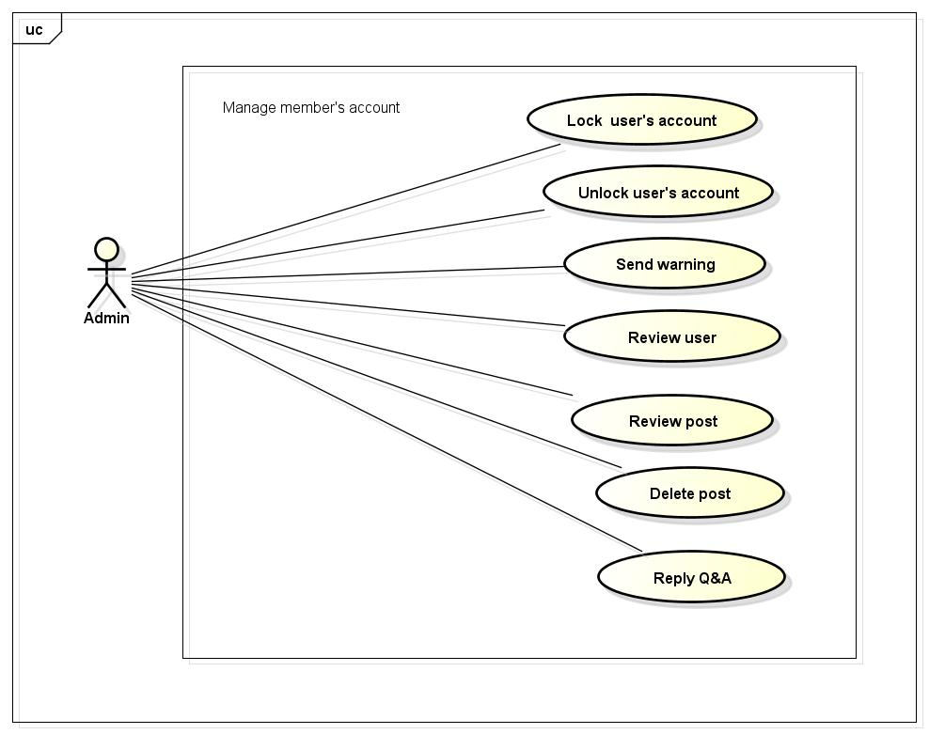

### UC053-Lock user’s account

|  |  |  |  |  |
| --- | --- | --- | --- | --- |
| **Use Case ID** | | UC053 | **Version** | 1.1 |
| **Use Case Name** | | Lock user’s account | | |
| **Created by:** | | LucPT | **Date Created:** | 28/05/2015 |
| **Primary Actor** | | Admin | **Secondary Actor** | None |
| **Description:** | | Administrator can lock user account in a period of time depending on severity | | |
| **Preconditions:** | | 1. FAP must be connected to the Internet 2. User browsed FAP website 3. User logged into system as Admin | | |
| **Trigger:** | | User click Lock in User menu | | |
| **Post conditions:** | | 1. Chosen account is locked 2. Lock notification is sent 3. User’s status is updated to database | | |
| **Normal Flow** | | | | |
| **Step** | **Actor** | **Action** | | |
|  | User | Click a User name | | |
|  | FAP | Displays a menu includes these hyperlinks:   * Add Friend * Unfriend * Edit Relationship * Follow * Block * Lock * Warn | | |
|  | User | Click Lock | | |
|  | FAP | Displays message popup. | | |
|  | User | Enters text box into textbox. | | |
|  | User | Click Lock or press Enter | | |
|  | FAP | Closes popup. | | |
|  | FAP | Locks chosen account | | |
|  | FAP | Sends notification to locked account: “Your account has been locked” | | |
| **Alternative Flows** | | | | |
| **AT1** | At step 6 in the main flows, if user click Cancel | | | |
| **Step** | **Actor** | **Action** | | |
| 6.1 | FAP | Close popup | | |
|  | | | | |
| **Exceptions:** | | | | |
| **EC1** | The connection is terminated | | | |
| **Step** | **Actor** | **Action** | | |
| 1 | FAP | All fields are cleared and FAP return to the wait state. | | |
|  | | | | |
| **Priority** | | High | | |
| **Frequency of Use:** | | High | | |
| **Business Rules:** | | N/A | | |
| **Other Information:** | | N/A | | |

### UC054-Unlock user’s account

|  |  |  |  |  |
| --- | --- | --- | --- | --- |
| **Use Case ID** | | UC054 | **Version** | 1.1 |
| **Use Case Name** | | Unlock user’s account | | |
| **Created by:** | | LucPT | **Date Created:** | 28/05/2015 |
| **Primary Actor** | | Admin | **Secondary Actor** |  |
| **Description:** | | Administrator can unlock user account | | |
| **Preconditions:** | | 1. FAP must be connected to the Internet 2. User browsed FAP website 3. User logged into system as Admin 4. Only locked user can be unlock | | |
| **Trigger:** | | User click Unlock in User menu | | |
| **Post conditions:** | | 1. Chosen account is unlocked 2. Unlock notification is sent 3. User’s status is updated to database | | |
| **Normal Flow** | | | | |
| **Step** | **Actor** | **Action** | | |
|  | User | Click Locked list | | |
|  | User | Click a User name in Locked list | | |
|  | FAP | Displays a menu includes these hyperlinks:   * Add Friend * Unfriend * Edit Relationship * Follow * Block * Unlock * Warn | | |
|  | User | Click Unlock | | |
|  | FAP | Display confirm popup: “Unlock this user?” | | |
|  | User | Click OK | | |
|  | FAP | Unlocks chosen account | | |
|  | FAP | Sends notification to unlocked account: “Your account has been unlocked” | | |
| **Alternative Flows:** | | | | |
| **AT1** | At step 6 in the main flows, if user click Cancel | | | |
| **Step** | **Actor** | **Action** | | |
| 6.1 | FAP | Close popup | | |
| **Exceptions:** | | | | |
| **EC1** | The connection is terminated | | | |
| **Step** | **Actor** | **Action** | | |
| 1 | FAP | All fields are cleared and FAP return to the wait state. | | |
|  | | | | |
| **Priority** | | High | | |
| **Frequency of Use:** | | High | | |
| **Business Rules:** | | N/A | | |
| **Other Information:** | | N/A | | |

### UC055-Send warning

|  |  |  |  |  |
| --- | --- | --- | --- | --- |
| **Use Case ID** | | UC055 | **Version** | 1.1 |
| **Use Case Name** | | Send warning | | |
| **Created by:** | | LucPT | **Date Created:** | 28/05/2015 |
| **Primary Actor** | | Admin | **Secondary Actor** |  |
| **Description:** | | Administrator can warn user when they violate some rule of website but just quite small | | |
| **Preconditions:** | | 1. FAP must be connected to the Internet 2. User browsed FAP website 3. User logged into system as Admin | | |
| **Trigger:** | | User click Warn in User menu | | |
| **Post conditions:** | | 1. Warn is sent to user | | |
| **Normal Flow** | | | | |
| **Step** | **Actor** | **Action** | | |
| 1 | Admin | Click a User name | | |
| 2 | FAP | Displays a menu includes these hyperlinks:   * Add Friend * Unfriend * Edit Relationship * Follow * Block * Lock * Warn | | |
| 3 | Admin | Click Warn | | |
| 4 | FAP | Displays text box popup. | | |
| 5 | Admin | Enters message into textbox. | | |
| 6 | Admin | Click Warn or press Enter | | |
| 7 | FAP | Closes popup. | | |
|  |  | Locks chosen account | | |
|  |  | Sends notification to locked account: “Your account has been locked” | | |
| **Alternative Flows** | | | | |
| **AT1** | At step 6 in the main flows, if user click Cancel | | | |
| **Step** | **Actor** | **Action** | | |
| 6.1 | FAP | Close popup | | |
|  | | | | |
| **Exceptions:** | | | | |
| **EC1** | The connection is terminated | | | |
| **Step** | **Actor** | **Action** | | |
| 3 | FAP | All fields are cleared and FAP return to the wait state. | | |
|  | | | | |
| **Priority** | | High | | |
| **Frequency of Use:** | | High | | |
| **Business Rules:** | | N/A | | |
| **Other Information:** | | N/A | | |

### UC056-Review user

|  |  |  |  |  |
| --- | --- | --- | --- | --- |
| **Use Case ID** | | UC056 | **Version** | 1.1 |
| **Use Case Name** | | Review user | | |
| **Created by:** | | LucPT | **Date Created:** | 28/05/2015 |
| **Primary Actor** | | Admin | **Secondary Actor** |  |
| **Description:** | | Review reported user | | |
| **Preconditions:** | | 1. FAP must be connected to the Internet 2. User browsed FAP website 3. User logged into system as Admin | | |
| **Trigger:** | | User click Reported User list | | |
| **Post conditions:** | | 1. Display list of reported user | | |
| **Normal Flow** | | | | |
| **Step** | **Actor** | **Action** | | |
| 1 | User | Click Reported User list | | |
| 2 | FAP | Display Reported User list page includes:   * Header * Reported user table * Footer | | |
| **Alternative Flows: N/A** | | | | |
| **Exceptions:** | | | | |
| **EC1** | The connection is terminated | | | |
| **Step** | **Actor** | **Action** | | |
| 1 | FAP | All fields are cleared and FAP return to the wait state. | | |
|  | | | | |
| **Priority** | | High | | |
| **Frequency of Use:** | | High | | |
| **Business Rules:** | | N/A | | |
| **Other Information:** | | N/A | | |

### UC057-Review post

|  |  |  |  |  |
| --- | --- | --- | --- | --- |
| **Use Case ID** | | UC057 | **Version** | 1.1 |
| **Use Case Name** | | Review post | | |
| **Created by:** | | LucPT | **Date Created:** | 28/05/2015 |
| **Primary Actor** | | Admin | **Secondary Actor** |  |
| **Description:** | | Review reported post | | |
| **Preconditions:** | | 1. FAP must be connected to the Internet 2. Admin browsed FAP website 3. Admin logged in to system | | |
| **Trigger:** | | User click Reported Post list | | |
| **Post conditions:** | | 1. Display list of reported post | | |
| **Normal Flow** | | | | |
| **Step** | **Actor** | **Action** | | |
| 1 | User | Click Reported User list | | |
| 2 | FAP | Display Reported User list page includes:   * Header * Reported user table   Footer | | |
| **Alternative Flows: N/A** | | | | |
| **Exceptions:** | | | | |
| **EC1** | The connection is terminated | | | |
| **Step** | **Actor** | **Action** | | |
| 3 | FAP | All fields are cleared and FAP return to the wait state. | | |
|  | | | | |
| **Priority** | | High | | |
| **Frequency of Use:** | | High | | |
| **Business Rules:** | | N/A | | |
| **Other Information:** | | N/A | | |

### UC058-Delete user’s post

|  |  |  |  |  |
| --- | --- | --- | --- | --- |
| **Use Case ID** | | UC058 | **Version** | 1.1 |
| **Use Case Name** | | Delete post | | |
| **Created by:** | | LucPT | **Date Created:** | 28/05/2015 |
| **Primary Actor** | | Admin | **Secondary Actor** |  |
| **Description:** | | Administrator can delete post when this post violate rule of website | | |
| **Preconditions:** | | 1. FAP must be connected to the Internet 2. User browsed FAP website 3. User logged into system as Admin 4. User is viewing a post | | |
| **Trigger:** | | User click Delete post in menu | | |
| **Post conditions:** | | 1. Post is deleted 2. Update database 3. Notification is sent | | |
| **Normal Flow** | | | | |
| **Step** | **Actor** | **Action** | | |
|  | User | Click Delete | | |
|  | FAP | Display text box popup | | |
|  | User | Enters message in text box | | |
|  | User | Click Delete or press Enter | | |
|  | FAP | Deletes this post | | |
|  | FAP | Closes popup | | |
|  | FAP | Sends notification to post’s owner | | |
|  | FAP | Update to database | | |
| **Alternative Flows** | | | | |
| **AT1** | At step 4 in the main flows, user click Cancel | | | |
| **Step** | **Actor** | **Action** | | |
| 4.1 | FAP | Closes popup | | |
| **Exceptions:** | | | | |
| **EC1** | The connection is terminated | | | |
| **Step** | **Actor** | **Action** | | |
| 1 | FAP | All fields are cleared and FAP return to the wait state. | | |
|  | | | | |
| **Priority** | | High | | |
| **Frequency of Use:** | | High | | |
| **Business Rules:** | | N/A | | |
| **Other Information:** | | N/A | | |

### UC059-Reply question

|  |  |  |  |  |
| --- | --- | --- | --- | --- |
| **Use Case ID** | | UC059 | **Version** | 1.1 |
| **Use Case Name** | | Reply question | | |
| **Created by:** | | LucPT | **Date Created:** | 28/05/2015 |
| **Primary Actor** | | Admin | **Secondary Actor** |  |
| **Description:** | | Reply question of user or guest. | | |
| **Preconditions:** | | 1. FAP must be connected to the Internet 2. Admin browsed FAP website 3. Admin logged in to system | | |
| **Trigger:** | | Click on “Opinion/Q&A Management ” tab, User search question then click Reply link corresponding | | |
| **Post conditions:** | | Answer is sent to user | | |
| **Normal Flow** | | | | |
| **Step** | **Actor** | **Action** | | |
| 1 | Admin | Enter website link on web browser | | |
| 2 | FAP | Display Homepage screen | | |
| 3 | Admin | Administrator enter necessary and mandatory information and click Login | | |
| 4 | FAP | Display homepage screen | | |
| 5 | Admin | Admin click Reply link corresponding | | |
| 6 | User | Displays Reply screen with these elements: Contact_Content, Contact_Email, Answer | | |
| 7 | Admin | Administrator enter the answer | | |
| 8 | Admin | Administrator click Reply button | | |
| 9 | FAP | FAP sent answer to member. | | |
| **Alternative Flows** | | | | |
| **AT1** |  | | | |
| **Step** | **Actor** | **Action** | | |
| 5 | Admin | Administrator fill information of the member that they want to find into these fields then click on another link | | |
| 6 | FAP | Will switch to selected page | | |
| **Exceptions:** | | | | |
| **EC1** | The connection is terminated | | | |
| **Step** | **Actor** | **Action** | | |
| 3 | FAP | All fields are cleared and FAP return to the wait state. | | |
|  | | | | |
| **EC2** |  | | | |
| **Step** | **Actor** | **Action** | | |
| 8 | Admin | Administrator answer then click on another link | | |
| 8 | FAP | FAP switch to selected page | | |
|  | | | | |
| **Priority** | | High | | |
| **Frequency of Use:** | | High | | |
| **Business Rules:** | | N/A | | |
| **Other Information:** | | N/A | | |

# **NON-FUNCTIONAL SPECIFICATION**

### Reliability

1. Mean time between failures: The mean time between each failure is expected to be about 480 hours of using.
2. Mean time to repair: Immediately when Administrator finds out problem or website is attacked/hacked by someone. Average 1 day.
3. The maximum bugs per function are 2 bugs/a function when user uses software within 2 months. The average number of bugs in the software during system testing is about to be around 1 bugs/1000 LOC.
4. The database must be backed up daily and can be recovered if necessary

### Performance Requirements

#### Availability

The application must be available 95% of time. Users can access to it everywhere from their

Web browser with internet connection.

#### Response time

In term of response time, waiting time of processing will be 2 to 5 seconds; time to process any functions will not exceed 7 seconds.

### User Interface

● **Color:** The background color will be white and blue in default. The color of text will be black or white.

● **Text:** All texts bases on Helvetica style and title or label will use upper case with the first letter.

### Maintainability

* **Coding standards and naming conventions**
  + Output of the project must include coding standards and naming conventions documentations. Implementation code must be easy to maintain.
  + All code must be clearly commented, including class, method documentations.
  + If some components are reused, the documentations of those components must also be included.
* **Design**
  + The design of the system must be loosely coupled that chances on some module will not affect others.
* **Logging**
  + All the errors should be logged, supporting for bug fixing and maintenance.
  + All strange or sensitive situations should also be logged.

### Usability

Usability Requirements support the following from the perspective of its primary users:

● **Efficiency of use:** user can complete each function in less than 12 actions

● **Intuitiveness:** User can understand approximately 90% help/error messages

### Security Requirements

In order to avoid unwanted access by strangers, the security implemented in various ways:

1. **User layer**: Each function must be distributed system access and manipulate the individual parts. To edit information, user must declare their username and password before the operation. Functions will be show after users login dependencies user’s role and permission of each user.
2. **Manage Data Layer**: Only Administrator can modify database system.
3. **Stored Data**: All data about information of user, tested...will be saved in SQL Server, and be easy for data classification or backup...

### Hardware/Software Requirements

● **Hardware requirement:** PC/Laptop (window 7, window 8, window XP…)

● **Software requirements:** Web browser (Chrome 43.0, Firefox 39.0, IE 11…) with internet connection