# Common Module

## Search

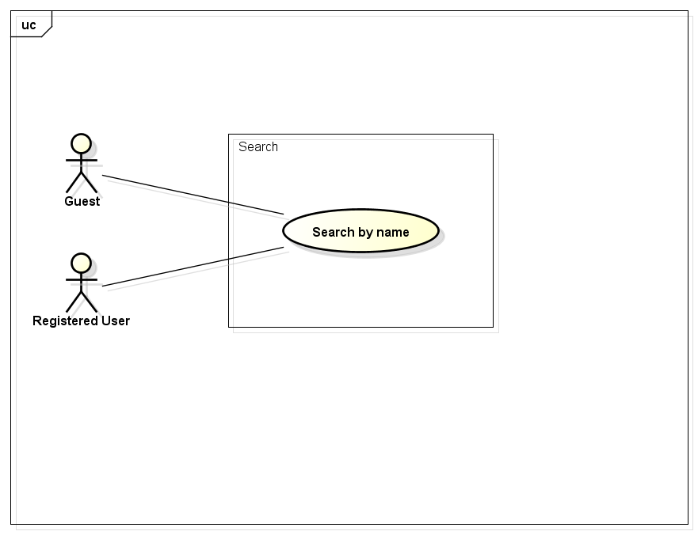

### Search by name

|  |  |  |  |  |
| --- | --- | --- | --- | --- |
| **Use Case ID** | | UC001-01 | **Version** | 1.1 |
| **Use Case Name** | | Search by name | | |
| **Created by:** | | HieuTM | **Date Created:** | 28/05/2015 |
| **Primary Actor** | | Registered user | **Secondary Actor** | Guest |
| **Description:** | | This function allows user to search existing information stored on FAP by a phrase (name of places, food and drinks, activities, friends…) | | |
| **Preconditions:** | | 1. FAP website is available 2. User browsed FAP website | | |
| **Trigger:** | | Application runs normally and displays Homepage | | |
| **Post conditions:** | | List all results that matched with the keyword user enters will be displayed in the Search Details screen | | |
| **Normal Flow** | | | | |
| **Step** | **Actor** | **Action** | | |
| 1 | User | Enter search phrase to text box. | | |
| 2 | User | Click Search or press Enter | | |
| 3 | FAP | Redirect to Search Result screen | | |
| 4 | FAP | List all results that matched with the keyword user entered | | |
| **Alternative Flows** | | | | |
| **AT2** |  | | | |
| **Step** | **Actor** | **Action** | | |
| 1 |  |  | | |
| 2 |  |  | | |
| **Exceptions:** | | | | |
| **EC1** | The connection is terminated | | | |
| **Step** | **Actor** | **Action** | | |
| 1 | FAP | All fields are cleared and FAP return to the wait state. | | |
|  | | | | |
| **EC2** | At step 4 in the main flows, if there is no result matched the keywords | | | |
| **Step** | **Actor** | **Action** | | |
| 4.1 | FAP | Display Search Results screen with text: “Nothing found :(” | | |
|  | | | | |
| **Priority** | | High | | |
| **Frequency of Use:** | | High | | |
| **Business Rules:** | | N/A | | |
| **Other Information:** | | N/A | | |

## Help Center

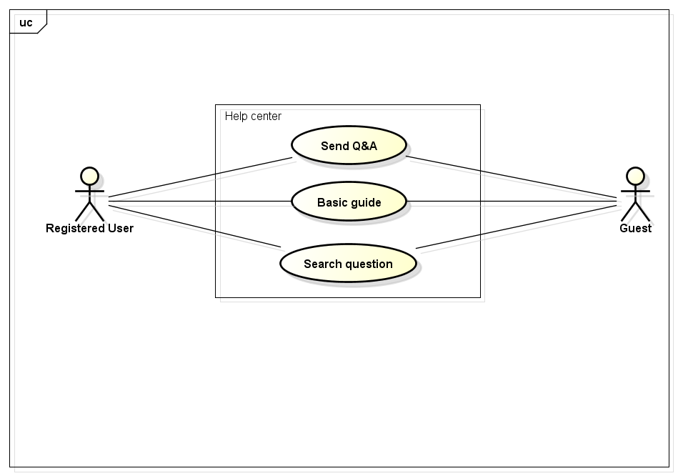

### Send Q&A

|  |  |  |  |  |
| --- | --- | --- | --- | --- |
| **Use Case ID** | | UC002 | **Version** | 1.1 |
| **Use Case Name** | | Send Q&A | | |
| **Created by:** | | HieuTM | **Date Created:** | 06/09/2015 |
| **Primary Actor** | | Registered user | **Secondary Actor** | Guest |
| **Description:** | | This function allows user to send questions, ideas, opinions to admin. | | |
| **Preconditions:** | | 1. FAP website is available 2. User browsed FAP website | | |
| **Trigger:** | | User want to send questions, ideas, opinions about FAP website. | | |
| **Post conditions:** | | 1. Message is displayed 2. User’s content is sent to admin | | |
| **Normal Flow** | | | | |
| **Step** | **Actor** | **Action** | | |
| 1 | User | Click Q&A in FAP website footer | | |
| 2 | FAP | Display Q&A Form | | |
| 3 | User | Enter required fields | | |
| 4 | User | Click Send or press Enter | | |
| 5 | FAP | Display message: “Your Q&A is sent” | | |
| 6 | FAP | Redirect user to previous page | | |
| **Alternative Flows** | | | | |
| **AT2** |  | | | |
| **Step** | **Actor** | **Action** | | |
| 1 |  |  | | |
| 2 |  |  | | |
| **Exceptions:** | | | | |
| **EC1** | The connection is terminated | | | |
| **Step** | **Actor** | **Action** | | |
| 1 | FAP | All fields are cleared and FAP return to the wait state. | | |
|  | | | | |
| **EC2** | At step 3 in the main flows, if required fields are not enterd | | | |
| **Step** | **Actor** | **Action** | | |
| 4.1 | FAP | 1. Display Q&A Form with text: “You have to fill all required fields” 2. Mark all error fields | | |
|  | | | | |
| **Priority** | | Normal | | |
| **Frequency of Use:** | | Normal | | |
| **Business Rules:** | | 1. Subject field cannot be empty 2. Content field cannot be empty | | |
| **Other Information:** | | N/A | | |

### Basic Guide

|  |  |  |  |  |
| --- | --- | --- | --- | --- |
| **Use Case ID** | | UC003 | **Version** | 1.1 |
| **Use Case Name** | | Basic guide | | |
| **Created by:** | | HieuTM | **Date Created:** | 09/06/2015 |
| **Primary Actor** | | Registered user | **Secondary Actor** | Guest |
| **Description:** | | A guide page to let user know how to use FAP website or frequently asked questions. | | |
| **Preconditions:** | | 1. FAP website is available 2. User browsed FAP website | | |
| **Trigger:** | | User want to know how to use FAP website | | |
| **Post conditions:** | | 1. Display Basic Guide page | | |
| **Normal Flow** | | | | |
| **Step** | **Actor** | **Action** | | |
| 1 | User | Click Basic Guide in FAP website footer | | |
| 2 | FAP | Redirect user to Basic Guide page | | |
| **Alternative Flows** | | | | |
| **AT2** |  | | | |
| **Step** | **Actor** | **Action** | | |
| 1 |  |  | | |
| 2 |  |  | | |
| **Exceptions:** | | | | |
| **EC1** | The connection is terminated | | | |
| **Step** | **Actor** | **Action** | | |
| 1 | FAP |  | | |
| **Priority** | | Normal | | |
| **Frequency of Use:** | | Normal | | |
| **Business Rules:** | | N/A | | |
| **Other Information:** | | N/A | | |

### Search Question

|  |  |  |  |  |
| --- | --- | --- | --- | --- |
| **Use Case ID** | | UC004 | **Version** | 1.1 |
| **Use Case Name** | | Search question | | |
| **Created by:** | | HieuTM | **Date Created:** | 09/06/2015 |
| **Primary Actor** | | Registered user | **Secondary Actor** | Guest |
| **Description:** | | This function allows user to search a question in frequently asked questions list | | |
| **Preconditions:** | | 1. FAP website is available 2. User browsed FAP website 3. User browsed Basic Guide page | | |
| **Trigger:** | | User want to search a question in Basic Guide page | | |
| **Post conditions:** | | 1. Question is displayed | | |
| **Normal Flow** | | | | |
| **Step** | **Actor** | **Action** | | |
| 1 | User | Enter search phrase to text box | | |
| 2 | User | Click Search or press Enter | | |
| 3 | FAP | Scroll to question | | |
| **Alternative Flows** | | | | |
| **AT2** |  | | | |
| **Step** | **Actor** | **Action** | | |
| 1 |  |  | | |
| 2 |  |  | | |
| **Exceptions:** | | | | |
| **EC1** | The connection is terminated | | | |
| **Step** | **Actor** | **Action** | | |
| 1 | FAP | All fields are cleared and FAP return to the wait state. | | |
|  | | | | |
| **EC2** | At step 3 in the main flows, if there is no result matched the keywords | | | |
| **Step** | **Actor** | **Action** | | |
| 4.1 | FAP | Display Basic Guide page with text: “Nothing found :(” | | |
|  | | | | |
| **Priority** | | Normal | | |
| **Frequency of Use:** | | Normal | | |
| **Business Rules:** | | N/A | | |
| **Other Information:** | | N/A | | |

# Suggest Module

## Suggest

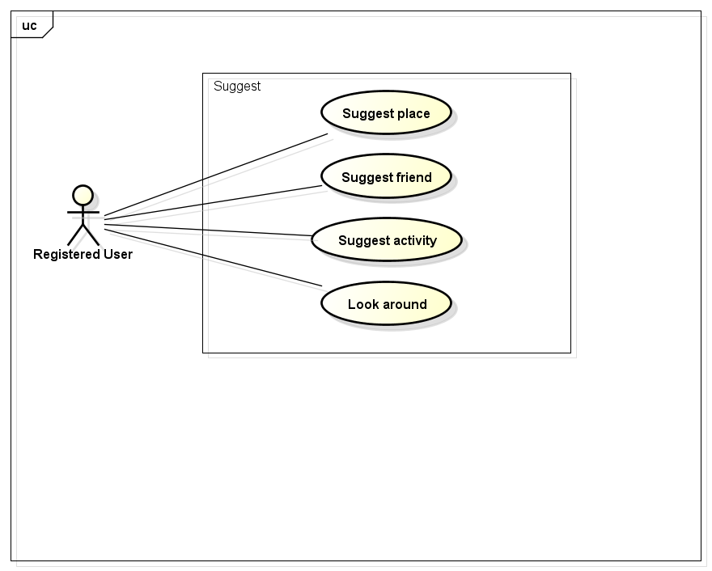

### Suggest Place

|  |  |  |  |  |
| --- | --- | --- | --- | --- |
| **Use Case ID** | | UC005 | **Version** | 1.1 |
| **Use Case Name** | | Suggest place | | |
| **Created by:** | | HieuTM | **Date Created:** | 09/06/2015 |
| **Primary Actor** | | Registered user | **Secondary Actor** | Guest |
| **Description:** | | FAP suggests places to user base on users traveled, viewed history, wish list and trends. | | |
| **Preconditions:** | | 1. FAP website is available 2. User browsed FAP website 3. User logged in to system | | |
| **Trigger:** | | User browses FAP website | | |
| **Post conditions:** | | 1. Suggests is displayed | | |
| **Normal Flow** | | | | |
| **Step** | **Actor** | **Action** | | |
| 1 | User | Click Place | | |
| 2 | FAP | Display Suggest Place List | | |
| **Alternative Flows** | | | | |
| **AT2** |  | | | |
| **Step** | **Actor** | **Action** | | |
| 1 |  |  | | |
| 2 |  |  | | |
| **Exceptions:** | | | | |
| **Priority** | | High | | |
| **Frequency of Use:** | | High | | |
| **Business Rules:** | | N/A | | |
| **Other Information:** | | N/A | | |

### Suggest Friend

|  |  |  |  |  |
| --- | --- | --- | --- | --- |
| **Use Case ID** | | UC006 | **Version** | 1.1 |
| **Use Case Name** | | Suggest friend | | |
| **Created by:** | | HieuTM | **Date Created:** | 09/06/2015 |
| **Primary Actor** | | Registered user | **Secondary Actor** | Guest |
| **Description:** | | FAP suggests places to user base on users Friend List | | |
| **Preconditions:** | | 1. FAP website is available 2. User browsed FAP website 3. User logged in to system | | |
| **Trigger:** | | User browses FAP website | | |
| **Post conditions:** | | 1. Suggests is displayed | | |
| **Normal Flow** | | | | |
| **Step** | **Actor** | **Action** | | |
| 1 | User | Click Friend | | |
| 2 | FAP | Display Suggest Friend List | | |
| **Alternative Flows** | | | | |
| **AT2** |  | | | |
| **Step** | **Actor** | **Action** | | |
| 1 |  |  | | |
| 2 |  |  | | |
| **Exceptions:** | | | | |
| **Priority** | | High | | |
| **Frequency of Use:** | | High | | |
| **Business Rules:** | | N/A | | |
| **Other Information:** | | N/A | | |

### Suggest Activity

|  |  |  |  |  |
| --- | --- | --- | --- | --- |
| **Use Case ID** | | UC007 | **Version** | 1.1 |
| **Use Case Name** | | Suggest activity | | |
| **Created by:** | | HieuTM | **Date Created:** | 09/06/2015 |
| **Primary Actor** | | Registered user | **Secondary Actor** | Guest |
| **Description:** | | FAP suggests activities to user base on users traveled, viewed history, wish list and trends. | | |
| **Preconditions:** | | 1. FAP website is available 2. User browsed FAP website 3. User logged in to system | | |
| **Trigger:** | | User browses FAP website | | |
| **Post conditions:** | | 1. Suggests is displayed | | |
| **Normal Flow** | | | | |
| **Step** | **Actor** | **Action** | | |
| 1 | User | Click Activity | | |
| 2 | FAP | Display Suggest Activity List | | |
| **Alternative Flows** | | | | |
| **AT2** |  | | | |
| **Step** | **Actor** | **Action** | | |
| 1 |  |  | | |
| 2 |  |  | | |
| **Exceptions:** | | | | |
| **Priority** | | High | | |
| **Frequency of Use:** | | High | | |
| **Business Rules:** | | N/A | | |
| **Other Information:** | | N/A | | |

### Look Around

|  |  |  |  |  |
| --- | --- | --- | --- | --- |
| **Use Case ID** | | UC008 | **Version** | 1.1 |
| **Use Case Name** | | Look around | | |
| **Created by:** | | HieuTM | **Date Created:** | 28/05/2015 |
| **Primary Actor** | | Registered user | **Secondary Actor** | Guest |
| **Description:** | | This function allows user to see activities of others around | | |
| **Preconditions:** | | 1. FAP website is available 2. User browsed FAP website 3. User logged in to system | | |
| **Trigger:** | | User browses FAP website | | |
| **Post conditions:** | | 1. Look Around page is displayed | | |
| **Normal Flow** | | | | |
| **Step** | **Actor** | **Action** | | |
| 1 | User | Click Look Around | | |
| 2 | FAP | Redirect user to Look Around page | | |
| 3 | User | Enter location to text box | | |
| 4 | User | Click Look or press Enter | | |
| 5 | FAP | Display Look Around page with results | | |
| **Alternative Flows** | | | | |
| **AT2** | At step 3 in the main flow, user click Auto-Located | | | |
| **Step** | **Actor** | **Action** | | |
| 3.1 | FAP | Display Look Around page with results | | |
| **Exceptions:** | | | | |
| **EC1** | The connection is terminated | | | |
| **Step** | **Actor** | **Action** | | |
| 1 | FAP | All fields are cleared and FAP return to the wait state. | | |
|  | | | | |
| **EC2** | At step 5 in the main flows, if there is no result matched the keywords | | | |
| **Step** | **Actor** | **Action** | | |
| 5.1 | FAP | Display Look Around page with message: “No location found” | | |
|  | | | | |
| **EC2** | At step 3.1 in the alternative flows, if FAP cannot locate user’s current location | | | |
| **Step** | **Actor** | **Action** | | |
| 3.2 | FAP | Display Look Around page with message: “Cannot Auto-Located” | | |
|  | | | | |
| **Priority** | | Normal | | |
| **Frequency of Use:** | | High | | |
| **Business Rules:** | | N/A | | |
| **Other Information:** | | N/A | | |

# Social Module

## Personal Page

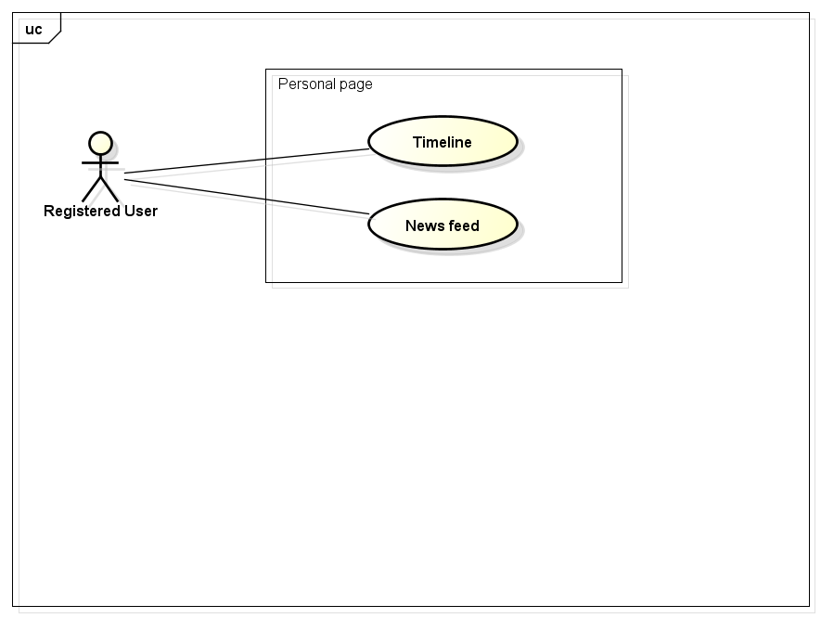

### Timeline

|  |  |  |  |  |
| --- | --- | --- | --- | --- |
| **Use Case ID** | | UC009 | **Version** | 1.1 |
| **Use Case Name** | | Timeline | | |
| **Created by:** | | HieuTM | **Date Created:** | 28/05/2015 |
| **Primary Actor** | | Registered user | **Secondary Actor** |  |
| **Description:** | | FAP records all of user’s activities and display in time order | | |
| **Preconditions:** | | 1. FAP website is available 2. User browsed FAP website 3. User logged in to system | | |
| **Trigger:** | | User wants to see history of activities | | |
| **Post conditions:** | | 1. Timeline page is displayed | | |
| **Normal Flow** | | | | |
| **Step** | **Actor** | **Action** | | |
| 1 | User | Click Timeline | | |
| 2 | FAP | Redirect user to Timeline page | | |
| **Alternative Flows** | | | | |
| **AT2** |  | | | |
| **Step** | **Actor** | **Action** | | |
| 1 |  |  | | |
| 2 |  |  | | |
| **Exceptions:** | | | | |
| **EC1** | The connection is terminated | | | |
| **Step** | **Actor** | **Action** | | |
| 1 | FAP | All fields are cleared and FAP return to the wait state. | | |
| **Priority** | | High | | |
| **Frequency of Use:** | | High | | |
| **Business Rules:** | | N/A | | |
| **Other Information:** | | N/A | | |

### News feed

|  |  |  |  |  |
| --- | --- | --- | --- | --- |
| **Use Case ID** | | UC010 | **Version** | 1.1 |
| **Use Case Name** | | News feed | | |
| **Created by:** | | HieuTM | **Date Created:** | 28/05/2015 |
| **Primary Actor** | | Registered user | **Secondary Actor** |  |
| **Description:** | | FAP updates activities of user’s friends automatically | | |
| **Preconditions:** | | 1. FAP website is available 2. User browsed FAP website 3. User logged in to system | | |
| **Trigger:** | | User wants to see friends’ activity | | |
| **Post conditions:** | | 1. News feed page is displayed | | |
| **Normal Flow** | | | | |
| **Step** | **Actor** | **Action** | | |
| 1 | User | Click News feed | | |
| 2 | FAP | Redirect user to News Feed page | | |
| **Alternative Flows** | | | | |
| **AT2** |  | | | |
| **Step** | **Actor** | **Action** | | |
| 1 |  |  | | |
| 2 |  |  | | |
| **Exceptions:** | | | | |
| **EC1** | The connection is terminated | | | |
| **Step** | **Actor** | **Action** | | |
| 1 | FAP | All fields are cleared and FAP return to the wait state. | | |
| **Priority** | | High | | |
| **Frequency of Use:** | | High | | |
| **Business Rules:** | | N/A | | |
| **Other Information:** | | N/A | | |

## Post Management

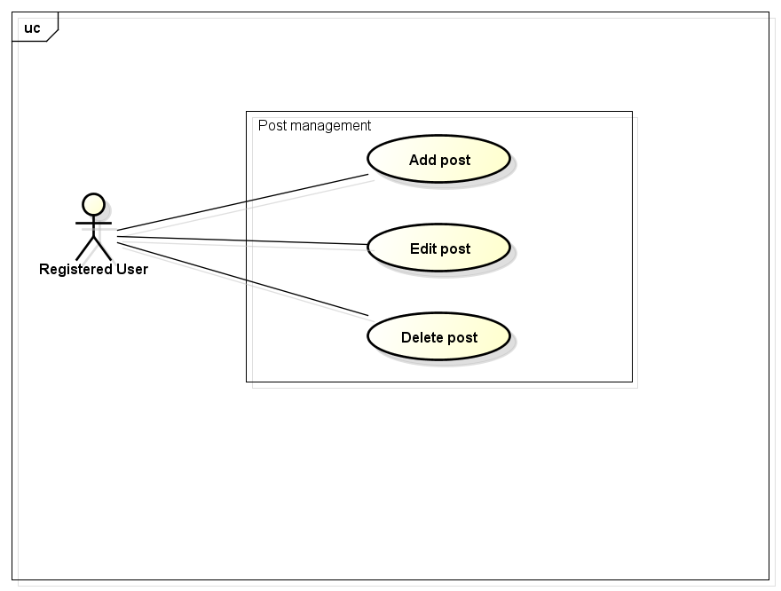

### Add Post

|  |  |  |  |  |
| --- | --- | --- | --- | --- |
| **Use Case ID** | | UC011 | **Version** | 1.1 |
| **Use Case Name** | | Add post | | |
| **Created by:** | | HieuTM | **Date Created:** | 28/05/2015 |
| **Primary Actor** | | Registered user | **Secondary Actor** |  |
| **Description:** | | This function allows user to share information, knowledge, experience | | |
| **Preconditions:** | | 1. FAP website is available 2. User browsed FAP website 3. User logged in to system | | |
| **Trigger:** | | User wants to share information | | |
| **Post conditions:** | | 1. Post is updated to user’s timeline. 2. Post is updated to News feed of user’s friends. 3. Post is updated to Database. | | |
| **Normal Flow** | | | | |
| **Step** | **Actor** | **Action** | | |
|  | User | Click Create Post. | | |
|  | FAP | Redirects user to Add Post Page which contain a create form. | | |
|  | User | Enter information in fields. | | |
|  | User | Choose privacy | | |
|  | User | Click Create or press Enter. | | |
|  | FAP | Create a post | | |
|  | FAP | Updates to user’s timeline | | |
|  | FAP | Updates to News feed of user’s friends | | |
|  | FAP | Displays message “Post is created” | | |
|  | FAP | Redirects user to Post Page which contain created post. | | |
| **Alternative Flows** | | | | |
| **AT2** | At step 5, user click Cancel | | | |
| **Step** | **Actor** | **Action** | | |
| 5.1 | FAP | FAP redirects user to previous page. | | |
| **Exceptions:** | | | | |
| **EC1** | The connection is terminated | | | |
| **Step** | **Actor** | **Action** | | |
| 1 | FAP | All fields are cleared and FAP return to the wait state. | | |
|  | | | | |
| **EC2** | At step 4, required fields are not entered | | | |
| **Step** | **Actor** | **Action** | | |
| 4.1 | FAP | Display Add Post page with message “Required fields are not entered” | | |
| 4.2 | FAP | Mark error fields | | |
|  | | | | |
| **EC3** | At step 4, fields are entered with wrong type of data | | | |
| **Step** | **Actor** | **Action** | | |
| 4.1 | FAP | Display Add Post page with message “Wrong type of data” | | |
| 4.2 | FAP | Mark error fields | | |
|  | | | | |
| **Priority** | | High | | |
| **Frequency of Use:** | | High | | |
| **Business Rules:** | | N/A | | |
| **Other Information:** | | N/A | | |

### Edit Post

|  |  |  |  |  |
| --- | --- | --- | --- | --- |
| **Use Case ID** | | UC012 | **Version** | 1.1 |
| **Use Case Name** | | Edit post | | |
| **Created by:** | | HieuTM | **Date Created:** | 28/05/2015 |
| **Primary Actor** | | Registered user | **Secondary Actor** |  |
| **Description:** | | This function allows user to edit what they posted | | |
| **Preconditions:** | | 1. FAP website is available 2. User browsed FAP website 3. User logged in to system 4. User are viewing their own post | | |
| **Trigger:** | | User wants to edit information of their own posts | | |
| **Post conditions:** | | 1. Post is updated to FAP website. 2. Post is updated to User Detail. 3. Post is updated to Database. | | |
| **Normal Flow** | | | | |
| **Step** | **Actor** | **Action** | | |
| 1 | User | Click Edit | | |
| 2 | FAP | Redirects user to Edit Post Page which contain a create form with information is filled. | | |
| 3 | User | Edits information in fields. | | |
| 4 | User | Click Update or press Enter. | | |
| 5 | FAP | Edit this post | | |
| 6 | FAP | Displays message “Post is edited” | | |
| 7 | FAP | Redirects user to Post Page which contain edited post. | | |
| **Alternative Flows** | | | | |
| **AT2** | At step 4, user click Cancel | | | |
| **Step** | **Actor** | **Action** | | |
| 4.1 | FAP | FAP redirects user to previous page. | | |
| **Exceptions:** | | | | |
| **EC1** | The connection is terminated | | | |
| **Step** | **Actor** | **Action** | | |
| 1 | FAP | All fields are cleared and FAP return to the wait state. | | |
|  | | | | |
| **EC2** | At step 4, required fields are not entered | | | |
| **Step** | **Actor** | **Action** | | |
| 4.1 | FAP | Display Add Post page with message “Required fields are not entered” | | |
| 4.2 | FAP | Mark error fields | | |
|  | | | | |
| **EC3** | At step 4, fields are entered with wrong type of data | | | |
| **Step** | **Actor** | **Action** | | |
| 4.1 | FAP | Display Add Post page with message “Wrong type of data” | | |
| 4.2 | FAP | Mark error fields | | |
|  | | | | |
| **Priority** | | Normal | | |
| **Frequency of Use:** | | High | | |
| **Business Rules:** | | N/A | | |
| **Other Information:** | | N/A | | |

### Delete Post

|  |  |  |  |  |
| --- | --- | --- | --- | --- |
| **Use Case ID** | | UC013 | **Version** | 1.1 |
| **Use Case Name** | | Delete post | | |
| **Created by:** | | HieuTM | **Date Created:** | 28/05/2015 |
| **Primary Actor** | | Registered user | **Secondary Actor** |  |
| **Description:** | | This function allows user to delete what they posted | | |
| **Preconditions:** | | 1. FAP website is available 2. User browsed FAP website 3. User logged in to system 4. User are viewing their own post | | |
| **Trigger:** | | User wants to delete information of their own posts | | |
| **Post conditions:** | | 1. Post is deleted in user’s Timeline. 2. Post status is updated to Database. | | |
| **Normal Flow** | | | | |
| **Step** | **Actor** | **Action** | | |
| 1 | User | Click Delete | | |
| 2 | FAP | Display confirm popup “Delete this post?” | | |
| 3 | User | Click OK | | |
| 4 | FAP | Delete this post | | |
| 5 | FAP | Redirects user to Homepage | | |
| **Alternative Flows** | | | | |
| **AT2** | At step 3, user click Cancel | | | |
| **Step** | **Actor** | **Action** | | |
| 3.1 | FAP | Closes confirm popup | | |
| **Exceptions:** | | | | |
| **EC1** | The connection is terminated | | | |
| **Step** | **Actor** | **Action** | | |
| 1 | FAP | All fields are cleared and FAP return to the wait state. | | |
|  | | | | |
| **Priority** | | Normal | | |
| **Frequency of Use:** | | Low | | |
| **Business Rules:** | | N/A | | |
| **Other Information:** | | N/A | | |

## Photo Management

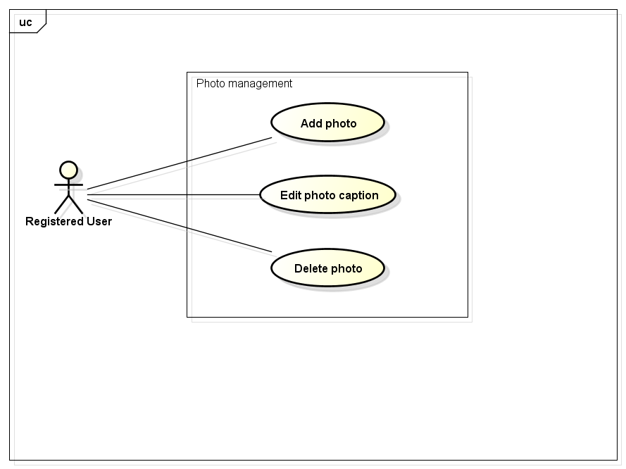

### Add Photo

|  |  |  |  |  |
| --- | --- | --- | --- | --- |
| **Use Case ID** | | UC014 | **Version** | 1.1 |
| **Use Case Name** | | Add photo | | |
| **Created by:** | | HieuTM | **Date Created:** | 28/05/2015 |
| **Primary Actor** | | Registered user | **Secondary Actor** |  |
| **Description:** | | This function allows user to share information, knowledge, experience via picture and captions | | |
| **Preconditions:** | | 1. FAP website is available 2. User browsed FAP website 3. User logged in to system | | |
| **Trigger:** | | User wants to share information | | |
| **Post conditions:** | | 1. Post is updated to FAP website. 2. Post is updated to User Detail. 3. Post is updated to Database. | | |
| **Normal Flow** | | | | |
| **Step** | **Actor** | **Action** | | |
|  | User | Click Create Post. | | |
|  | FAP | Redirects user to Add Post Page which contain a create form. | | |
|  | User | Click Add Photo. | | |
|  | User | Redirects user to Add Photo Page which contain an add photo form. | | |
|  | User | Click Browse to choose photo. | | |
|  | FAP |  | | |
|  | User | Enters information in fields. | | |
|  | User | User click Create or press Enter. | | |
|  | FAP | Create a post | | |
|  | FAP | Updates to user’s timeline | | |
|  | FAP | Updates to News feed of user’s friends | | |
|  | FAP | Displays message “Post is created” | | |
|  | FAP | Redirects user to Post Page which contain created post. | | |
| **Alternative Flows** | | | | |
| **AT2** | At step 8, user click Cancel | | | |
| **Step** | **Actor** | **Action** | | |
| 8.1 | FAP | Redirects user to previous page. | | |
| **Exceptions:** | | | | |
| **EC1** | The connection is terminated | | | |
| **Step** | **Actor** | **Action** | | |
| 1 | FAP | All fields are cleared and FAP return to the wait state. | | |
|  | | | | |
| **EC2** | At step 8, required fields are not entered | | | |
| **Step** | **Actor** | **Action** | | |
| 8.1 | FAP | Display Add Post page with message “Required fields are not entered” | | |
| 8.2 | FAP | Mark error fields | | |
|  | | | | |
| **EC3** | At step 8, fields are entered with wrong type of data | | | |
| **Step** | **Actor** | **Action** | | |
| 8.1 | FAP | Display Add Post page with message “Wrong type of data” | | |
| 8.2 | FAP | Mark error fields | | |
|  | | | | |
| **Priority** | | High | | |
| **Frequency of Use:** | | High | | |
| **Business Rules:** | | N/A | | |
| **Other Information:** | | N/A | | |

### Edit Photo Caption

|  |  |  |  |  |
| --- | --- | --- | --- | --- |
| **Use Case ID** | | UC015 | **Version** | 1.1 |
| **Use Case Name** | | Edit photo caption | | |
| **Created by:** | | HieuTM | **Date Created:** | 28/05/2015 |
| **Primary Actor** | | Registered user | **Secondary Actor** |  |
| **Description:** | | This function allows user to edit what they posted | | |
| **Preconditions:** | | 1. FAP website is available 2. User browsed FAP website 3. User logged in to system 4. User are viewing their own post | | |
| **Trigger:** | | User wants to edit information of their own posts | | |
| **Post conditions:** | | 1. Post is updated to FAP website. 2. Post is updated to User Detail. 3. Post is updated to Database. | | |
| **Normal Flow** | | | | |
| **Step** | **Actor** | **Action** | | |
|  | User | Click Edit | | |
|  | FAP | Redirects user to Edit Post Page which contain a create form with information is filled. | | |
|  | User | Edits information in fields. | | |
|  | User | Click Update or press Enter. | | |
|  | FAP | Edit this post | | |
|  | FAP | Displays message “Post is edited” | | |
|  | FAP | Redirects user to Post Page which contain edited post. | | |
| **Alternative Flows** | | | | |
| **AT2** | At step 4, user click Cancel | | | |
| **Step** | **Actor** | **Action** | | |
| 4.1 | FAP | FAP redirects user to previous page. | | |
| **Exceptions:** | | | | |
| **EC1** | The connection is terminated | | | |
| **Step** | **Actor** | **Action** | | |
| 1 | FAP | All fields are cleared and FAP return to the wait state. | | |
|  | | | | |
| **EC2** | At step 4, required fields are not entered | | | |
| **Step** | **Actor** | **Action** | | |
| 4.1 | FAP | Display Add Post page with message “Required fields are not entered” | | |
| 4.2 | FAP | Mark error fields | | |
|  | | | | |
| **EC3** | At step 4, fields are entered with wrong type of data | | | |
| **Step** | **Actor** | **Action** | | |
| 4.1 | FAP | Display Add Post page with message “Wrong type of data” | | |
| 4.2 | FAP | Mark error fields | | |
|  | | | | |
| **Priority** | | Normal | | |
| **Frequency of Use:** | | Normal | | |
| **Business Rules:** | | N/A | | |
| **Other Information:** | | N/A | | |

### Delete Photo

|  |  |  |  |  |
| --- | --- | --- | --- | --- |
| **Use Case ID** | | UC016 | **Version** | 1.1 |
| **Use Case Name** | | Delete photo | | |
| **Created by:** | | HieuTM | **Date Created:** | 28/05/2015 |
| **Primary Actor** | | Registered user | **Secondary Actor** |  |
| **Description:** | | This function allows user to delete what they posted | | |
| **Preconditions:** | | 1. FAP website is available 2. User browsed FAP website 3. User logged in to system 4. User are viewing their own post | | |
| **Trigger:** | | User wants to delete information of their own posts | | |
| **Post conditions:** | | 1. Post is deleted in user’s Timeline. 2. Post status is updated to Database. | | |
| **Normal Flow** | | | | |
| **Step** | **Actor** | **Action** | | |
| 1 | User | Click Delete | | |
| 2 | FAP | Display confirm popup “Delete this post?” | | |
| 3 | User | Click OK | | |
| 4 | FAP | Delete this post | | |
| 5 | FAP | Redirects user to Homepage | | |
| **Alternative Flows** | | | | |
| **AT2** | At step 3, user click Cancel | | | |
| **Step** | **Actor** | **Action** | | |
| 3.1 | FAP | Closes confirm popup | | |
| **Exceptions:** | | | | |
| **EC1** | The connection is terminated | | | |
| **Step** | **Actor** | **Action** | | |
| 1 | FAP | All fields are cleared and FAP return to the wait state. | | |
|  | | | | |
| **Priority** | | Normal | | |
| **Frequency of Use:** | | Low | | |
| **Business Rules:** | | N/A | | |
| **Other Information:** | | N/A | | |

## Share

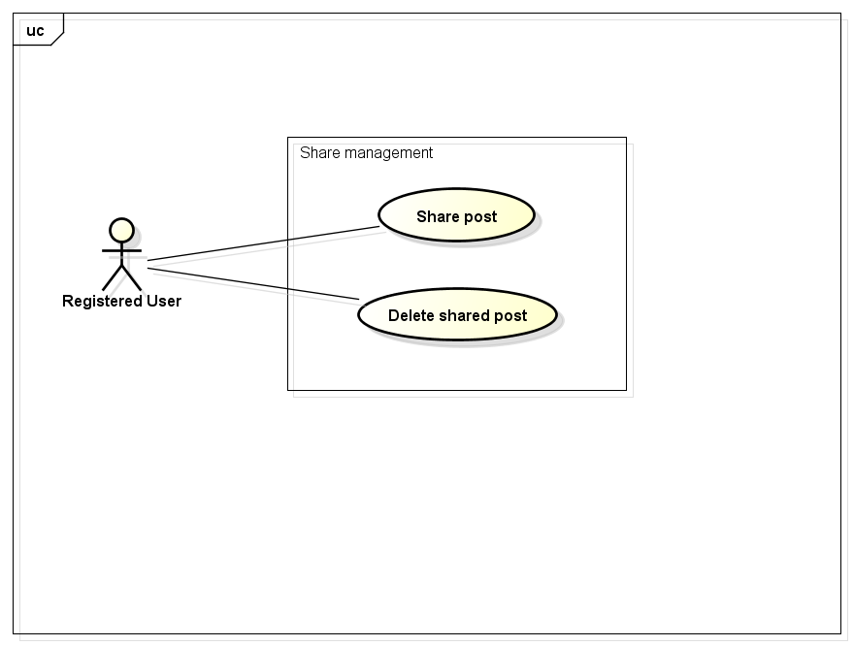

### Share Post

|  |  |  |  |  |
| --- | --- | --- | --- | --- |
| **Use Case ID** | | UC017 | **Version** | 1.1 |
| **Use Case Name** | | Share post | | |
| **Created by:** | | HieuTM | **Date Created:** | 28/05/2015 |
| **Primary Actor** | | Registered user | **Secondary Actor** |  |
| **Description:** | | This function allows user to share a post, makes it available on timeline | | |
| **Preconditions:** | | 1. FAP website is available 2. User browsed FAP website 3. User logged in to system 4. User are viewing a post | | |
| **Trigger:** | | User wants to share information of others | | |
| **Post conditions:** | | 1. Shared post is updated to user’s timeline 2. Shared post is updated to News feed of user’s friends if available 3. Update share number of shared post | | |
| **Normal Flow** | | | | |
| **Step** | **Actor** | **Action** | | |
| 1 | User | Click Share. | | |
| 2 | FAP | Displays a textbox dialog. | | |
| 3 | User | Enters comment. | | |
| 4 | User | Click Share or press Enter. | | |
| 5 | FAP | Closes dialog. | | |
|  |  | Updates shared post to user’s timeline. | | |
|  |  | FAP redirects user to Post Page. | | |
| **Alternative Flows** | | | | |
| **AT2** | At step 3, user click Cancel | | | |
| **Step** | **Actor** | **Action** | | |
| 3.1 | FAP | Closes confirm popup | | |
| **Exceptions:** | | | | |
| **EC1** | The connection is terminated | | | |
| **Step** | **Actor** | **Action** | | |
| 1 | FAP | All fields are cleared and FAP return to the wait state. | | |
|  | | | | |
| **Priority** | | High | | |
| **Frequency of Use:** | | High | | |
| **Business Rules:** | | N/A | | |
| **Other Information:** | | N/A | | |

### Delete Shared Post

|  |  |  |  |  |
| --- | --- | --- | --- | --- |
| **Use Case ID** | | UC018 | **Version** | 1.1 |
| **Use Case Name** | | Delete shared post | | |
| **Created by:** | | HieuTM | **Date Created:** | 28/05/2015 |
| **Primary Actor** | | Registered user | **Secondary Actor** |  |
| **Description:** | | This function allows user to share a post, makes it available on timeline | | |
| **Preconditions:** | | 1. FAP website is available 2. User browsed FAP website 3. User logged in to system 4. User are viewing Timeline | | |
| **Trigger:** | | User wants to share information of others | | |
| **Post conditions:** | | 1. Delete shared post in user’s timeline 2. Update share number of shared post | | |
| **Normal Flow** | | | | |
| **Step** | **Actor** | **Action** | | |
|  | User | Click Delete | | |
|  | FAP | Displays confirm popup “Delete this post?” | | |
|  | User | Click OK | | |
|  | FAP | Closes confirm popup. | | |
|  | FAP | Updates user’s Timeline. | | |
|  | FAP | Updates share number | | |
| **Alternative Flows** | | | | |
| **AT2** | At step 3, user click Cancel | | | |
| **Step** | **Actor** | **Action** | | |
| 3.1 | FAP | Closes confirm popup | | |
| **Exceptions:** | | | | |
| **EC1** | The connection is terminated | | | |
| **Step** | **Actor** | **Action** | | |
| 1 | FAP | All fields are cleared and FAP return to the wait state. | | |
|  | | | | |
| **Priority** | | Normal | | |
| **Frequency of Use:** | | Low | | |
| **Business Rules:** | | N/A | | |
| **Other Information:** | | N/A | | |

## Comment

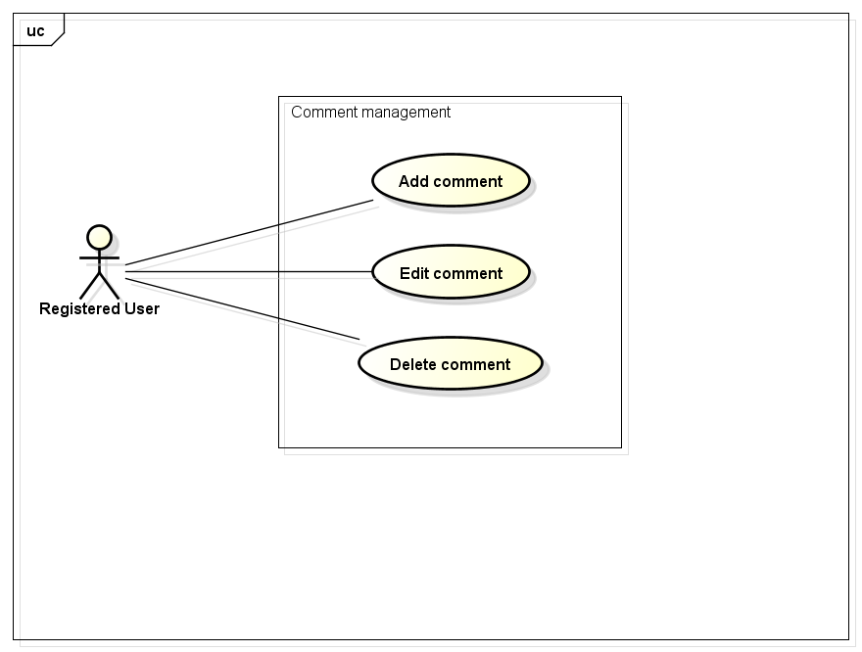

### Add Comment

|  |  |  |  |  |
| --- | --- | --- | --- | --- |
| **Use Case ID** | | UC019 | **Version** | 1.1 |
| **Use Case Name** | | Add comment | | |
| **Created by:** | | HieuTM | **Date Created:** | 28/05/2015 |
| **Primary Actor** | | Registered user | **Secondary Actor** |  |
| **Description:** | | This function allows user to comment opinion in a post | | |
| **Preconditions:** | | 1. FAP website is available 2. User browsed FAP website 3. User logged in to system 4. User are viewing a post | | |
| **Trigger:** | | User wants to comment in a post | | |
| **Post conditions:** | | 1. Updates post’s comments | | |
| **Normal Flow** | | | | |
| **Step** | **Actor** | **Action** | | |
|  | User | Entered comment into textbox | | |
|  | User | Click Send or press Enter | | |
|  | FAP | Updates post’s comment | | |
|  | FAP | Displays comment | | |
| **Alternative Flows** | | | | |
| **AT2** |  | | | |
| **Step** | **Actor** | **Action** | | |
|  |  |  | | |
| **Exceptions:** | | | | |
| **EC1** | The connection is terminated | | | |
| **Step** | **Actor** | **Action** | | |
| 1 | FAP | All fields are cleared and FAP return to the wait state. | | |
|  | | | | |
| **Priority** | | High | | |
| **Frequency of Use:** | | High | | |
| **Business Rules:** | | N/A | | |
| **Other Information:** | | N/A | | |

### Edit Comment

|  |  |  |  |  |
| --- | --- | --- | --- | --- |
| **Use Case ID** | | UC020 | **Version** | 1.1 |
| **Use Case Name** | | Edit comment | | |
| **Created by:** | | HieuTM | **Date Created:** | 28/05/2015 |
| **Primary Actor** | | Registered user | **Secondary Actor** |  |
| **Description:** | | This function allows user to edit what they commented | | |
| **Preconditions:** | | 1. FAP website is available 2. User browsed FAP website 3. User logged in to system 4. User are viewing a post has their own comments | | |
| **Trigger:** | | User wants to edit comments | | |
| **Post conditions:** | | 1. Updates post’s comments | | |
| **Normal Flow** | | | | |
| **Step** | **Actor** | **Action** | | |
|  | User | Click Edit | | |
|  | User | Displays a textbox | | |
|  | User | Entered comment into textbox | | |
|  | User | Click Edit or press Enter | | |
|  | FAP | Updates comment | | |
|  | FAP | Displays edited comment | | |
| **Alternative Flows** | | | | |
| **AT2** |  | | | |
| **Step** | **Actor** | **Action** | | |
|  |  |  | | |
| **Exceptions:** | | | | |
| **EC1** | The connection is terminated | | | |
| **Step** | **Actor** | **Action** | | |
| 1 | FAP | All fields are cleared and FAP return to the wait state. | | |
|  | | | | |
| **Priority** | | Normal | | |
| **Frequency of Use:** | | Normal | | |
| **Business Rules:** | | N/A | | |
| **Other Information:** | | N/A | | |

### Delete Comment

|  |  |  |  |  |
| --- | --- | --- | --- | --- |
| **Use Case ID** | | UC021 | **Version** | 1.1 |
| **Use Case Name** | | Delete comment | | |
| **Created by:** | | HieuTM | **Date Created:** | 28/05/2015 |
| **Primary Actor** | | Registered user | **Secondary Actor** |  |
| **Description:** | | This function allows user to edit what they commented | | |
| **Preconditions:** | | 1. FAP website is available 2. User browsed FAP website 3. User logged in to system 4. User are viewing a post has their own comments | | |
| **Trigger:** | | User wants to edit comments | | |
| **Post conditions:** | | 1. Post’s comment is deleted | | |
| **Normal Flow** | | | | |
| **Step** | **Actor** | **Action** | | |
|  | User | Click Delete | | |
|  | User | Displays confirm popup “Delete this comment?” | | |
|  | User | Click OK | | |
|  | User | Deletes comment | | |
|  | FAP | Display post without deleted comment | | |
| **Alternative Flows** | | | | |
| **AT2** |  | | | |
| **Step** | **Actor** | **Action** | | |
|  |  |  | | |
| **Exceptions:** | | | | |
| **EC1** | The connection is terminated | | | |
| **Step** | **Actor** | **Action** | | |
| 1 | FAP | All fields are cleared and FAP return to the wait state. | | |
|  | | | | |
| **Priority** | | Normal | | |
| **Frequency of Use:** | | Low | | |
| **Business Rules:** | | N/A | | |
| **Other Information:** | | N/A | | |

## Like Management

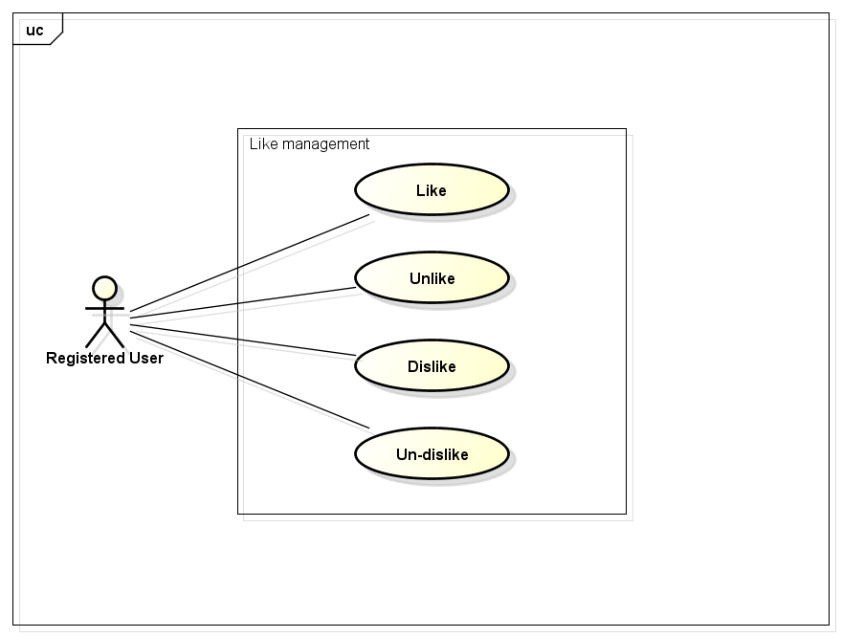

### Like

|  |  |  |  |  |
| --- | --- | --- | --- | --- |
| **Use Case ID** | | UC022 | **Version** | 1.1 |
| **Use Case Name** | | Like | | |
| **Created by:** | | HieuTM | **Date Created:** | 28/05/2015 |
| **Primary Actor** | | Registered user | **Secondary Actor** |  |
| **Description:** | | This function allows user to rate a post or a comment | | |
| **Preconditions:** | | 1. FAP website is available 2. User browsed FAP website 3. User logged in to system 4. User are viewing a post or a comment | | |
| **Trigger:** | | User likes a comment and rates as Liked | | |
| **Post conditions:** | | 1. Liked post is updated to user’s timeline 2. Liked post is updated to News feed of user’s friends if available 3. Update like number of liked post or comment | | |
| **Normal Flow** | | | | |
| **Step** | **Actor** | **Action** | | |
|  | User | Click Like | | |
|  | FAP | Updates liked post to user’s timeline | | |
|  | FAP | Updates liked post to News feed of user’s friends | | |
|  | FAP | Update like number of liked post | | |
|  | FAP | Displays post or comment as Like | | |
| **Alternative Flows** | | | | |
| **AT2** |  | | | |
| **Step** | **Actor** | **Action** | | |
|  |  |  | | |
| **Exceptions:** | | | | |
| **EC1** | The connection is terminated | | | |
| **Step** | **Actor** | **Action** | | |
| 1 | FAP | All fields are cleared and FAP return to the wait state. | | |
|  | | | | |
| **Priority** | | High | | |
| **Frequency of Use:** | | High | | |
| **Business Rules:** | | N/A | | |
| **Other Information:** | | N/A | | |

### Unlike

|  |  |  |  |  |
| --- | --- | --- | --- | --- |
| **Use Case ID** | | UC023 | **Version** | 1.1 |
| **Use Case Name** | | Unlike | | |
| **Created by:** | | HieuTM | **Date Created:** | 28/05/2015 |
| **Primary Actor** | | Registered user | **Secondary Actor** |  |
| **Description:** | | This function allows user to remove Like status of a post or comment | | |
| **Preconditions:** | | 1. FAP website is available 2. User browsed FAP website 3. User logged in to system 4. User are viewing a post or a comment they liked | | |
| **Trigger:** | | User wants to remove their Liked rate | | |
| **Post conditions:** | | 1. Unlike post is updated to user’s timeline 2. Update like number of liked post or comment | | |
| **Normal Flow** | | | | |
| **Step** | **Actor** | **Action** | | |
|  | User | Click Unlike | | |
|  | FAP | Updates unlike post to user’s timeline | | |
|  | FAP | Update like number of liked post | | |
|  | FAP | Displays post or comment as normal | | |
| **Alternative Flows** | | | | |
| **AT2** |  | | | |
| **Step** | **Actor** | **Action** | | |
|  |  |  | | |
| **Exceptions:** | | | | |
| **EC1** | The connection is terminated | | | |
| **Step** | **Actor** | **Action** | | |
| 1 | FAP | All fields are cleared and FAP return to the wait state. | | |
|  | | | | |
| **Priority** | | Normal | | |
| **Frequency of Use:** | | Normal | | |
| **Business Rules:** | | N/A | | |
| **Other Information:** | | N/A | | |

### Dislike

|  |  |  |  |  |
| --- | --- | --- | --- | --- |
| **Use Case ID** | | UC024 | **Version** | 1.1 |
| **Use Case Name** | | Dislike | | |
| **Created by:** | | HieuTM | **Date Created:** | 28/05/2015 |
| **Primary Actor** | | Registered user | **Secondary Actor** |  |
| **Description:** | | This function allows user to rate a post or a comment | | |
| **Preconditions:** | | 1. FAP website is available 2. User browsed FAP website 3. User logged in to system 4. User are viewing a post or a comment | | |
| **Trigger:** | | User does not like a comment and rates as Dislike | | |
| **Post conditions:** | | 1. Dislike post is updated to user’s timeline 2. Dislike post is updated to News feed of user’s friends if available 3. Update dislike number of dislike post or comment | | |
| **Normal Flow** | | | | |
| **Step** | **Actor** | **Action** | | |
|  | User | Click Dislike | | |
|  | FAP | Updates dislike post to user’s timeline | | |
|  | FAP | Updates dislike post to News feed of user’s friends | | |
|  | FAP | Update dislike number of dislike post | | |
|  | FAP | Display post or comment as Dislike | | |
| **Alternative Flows** | | | | |
| **AT2** |  | | | |
| **Step** | **Actor** | **Action** | | |
|  |  |  | | |
| **Exceptions:** | | | | |
| **EC1** | The connection is terminated | | | |
| **Step** | **Actor** | **Action** | | |
| 1 | FAP | All fields are cleared and FAP return to the wait state. | | |
|  | | | | |
| **Priority** | | High | | |
| **Frequency of Use:** | | High | | |
| **Business Rules:** | | N/A | | |
| **Other Information:** | | N/A | | |

### Un-dislike

|  |  |  |  |  |
| --- | --- | --- | --- | --- |
| **Use Case ID** | | UC025 | **Version** | 1.1 |
| **Use Case Name** | | Un-dislike | | |
| **Created by:** | | HieuTM | **Date Created:** | 28/05/2015 |
| **Primary Actor** | | Registered user | **Secondary Actor** |  |
| **Description:** | | This function allows user to remove Like status of a post or comment | | |
| **Preconditions:** | | 1. FAP website is available 2. User browsed FAP website 3. User logged in to system 4. User are viewing a post or a comment they liked | | |
| **Trigger:** | | User wants to remove their Liked rate | | |
| **Post conditions:** | | 1. Un-dislike post or comment is updated to user’s timeline 2. Update dislike number of un-dislike post or comment | | |
| **Normal Flow** | | | | |
| **Step** | **Actor** | **Action** | | |
|  | User | Click Unlike | | |
|  | FAP | Updates unlike post to user’s timeline | | |
|  | FAP | Update like number of liked post | | |
|  | FAP | Displays post or comment as normal | | |
| **Alternative Flows** | | | | |
| **AT2** |  | | | |
| **Step** | **Actor** | **Action** | | |
|  |  |  | | |
| **Exceptions:** | | | | |
| **EC1** | The connection is terminated | | | |
| **Step** | **Actor** | **Action** | | |
| 1 | FAP | All fields are cleared and FAP return to the wait state. | | |
|  | | | | |
| **Priority** | | Normal | | |
| **Frequency of Use:** | | Normal | | |
| **Business Rules:** | | N/A | | |
| **Other Information:** | | N/A | | |

## Report

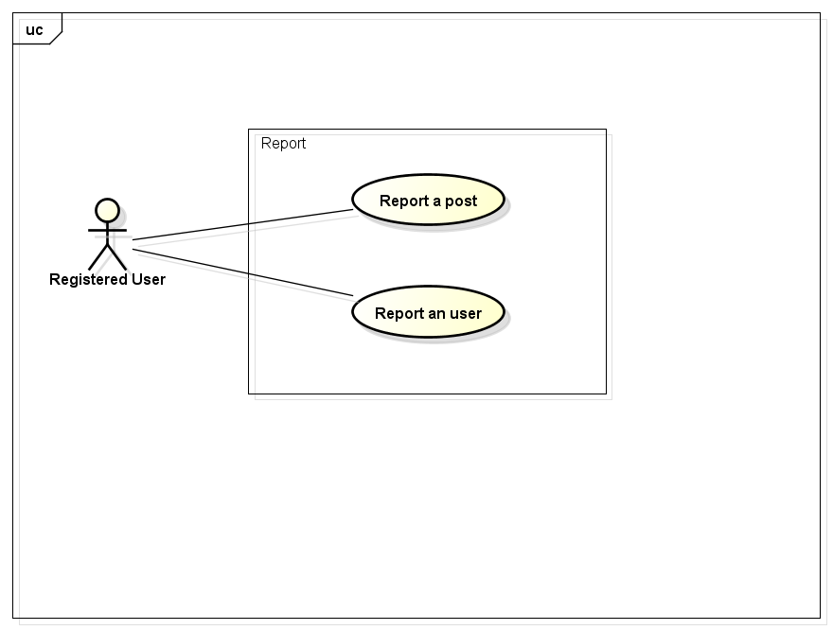

### Report a post

|  |  |  |  |  |
| --- | --- | --- | --- | --- |
| **Use Case ID** | | UC026 | **Version** | 1.1 |
| **Use Case Name** | | Report a post | | |
| **Created by:** | | HieuTM | **Date Created:** | 28/05/2015 |
| **Primary Actor** | | Registered user | **Secondary Actor** |  |
| **Description:** | | This function allows user to report a post or comment violated rules | | |
| **Preconditions:** | | 1. FAP website is available 2. User browsed FAP website 3. User logged in to system 4. User are viewing a post or a comment | | |
| **Trigger:** | | User wants to report a post violated rules | | |
| **Post conditions:** | | 1. Report is sent to admin | | |
| **Normal Flow** | | | | |
| **Step** | **Actor** | **Action** | | |
|  | User | Click Report. | | |
|  | FAP | Displays popup. | | |
|  | User | Choose common reason. | | |
|  | User | Click Report or press Enter. | | |
|  | FAP | Closes dialog. | | |
|  | FAP | Sent report to admin | | |
|  | FAP | Display message “This post has been reported” | | |
| **Alternative Flows** | | | | |
| **AT2** | At step 3, user choose Other: | | | |
| **Step** | **Actor** | **Action** | | |
| 3.1 | FAP | Displays a textbox dialog. | | |
| 3.2 | User | Enters reason into textbox. | | |
| 3.3 | User | Click Report or press Enter. | | |
| 3.4 | FAP | Closes dialog. | | |
| 3.5 | FAP | Sent report to admin | | |
| 3.6 | FAP | Display message “This post has been reported” | | |
|  | | | | |
| **AT2** | At step 4, user choose Cancel: | | | |
| **Step** | **Actor** | **Action** | | |
|  | FAP | Closes popup. | | |
| **Exceptions:** | | | | |
| **EC1** | The connection is terminated | | | |
| **Step** | **Actor** | **Action** | | |
| 1 | FAP | All fields are cleared and FAP return to the wait state. | | |
|  | | | | |
| **Priority** | | Normal | | |
| **Frequency of Use:** | | Normal | | |
| **Business Rules:** | | N/A | | |
| **Other Information:** | | N/A | | |

### Report a user

|  |  |  |  |  |
| --- | --- | --- | --- | --- |
| **Use Case ID** | | UC027 | **Version** | 1.1 |
| **Use Case Name** | | Report an user | | |
| **Created by:** | | HieuTM | **Date Created:** | 28/05/2015 |
| **Primary Actor** | | Registered user | **Secondary Actor** |  |
| **Description:** | | This function allows user to report an user who violated rules | | |
| **Preconditions:** | | 1. FAP website is available 2. User browsed FAP website 3. User logged in to system 4. User are viewing a post or a comment | | |
| **Trigger:** | | User wants to report an user who violated rules | | |
| **Post conditions:** | | 1. Report is sent to admin | | |
| **Normal Flow** | | | | |
| **Step** | **Actor** | **Action** | | |
|  | User | Click a User name. | | |
|  | FAP | Displays a menu. | | |
|  | User | Click Report. | | |
|  | FAP | Displays popup. | | |
|  | User | Choose common reason. | | |
|  | User | Click Report or press Enter. | | |
|  | FAP | Closes dialog. | | |
|  | FAP | Sent report to admin | | |
|  | FAP | Display message “This user has been reported” | | |
| **Alternative Flows** | | | | |
| **AT2** | At step 3, user choose Other: | | | |
| **Step** | **Actor** | **Action** | | |
| 3.1 | FAP | Displays a textbox dialog. | | |
| 3.2 | User | Enters reason into textbox. | | |
| 3.3 | User | Click Report or press Enter. | | |
| 3.4 | FAP | Closes dialog. | | |
| 3.5 | FAP | Sent report to admin | | |
| 3.6 | FAP | Display message “This post has been reported” | | |
|  | | | | |
| **AT3** | At step 4, user choose Cancel: | | | |
| **Step** | **Actor** | **Action** | | |
|  | FAP | Closes popup. | | |
| **Exceptions:** | | | | |
| **EC1** | The connection is terminated | | | |
| **Step** | **Actor** | **Action** | | |
| 1 | FAP | All fields are cleared and FAP return to the wait state. | | |
|  | | | | |
| **Priority** | | Normal | | |
| **Frequency of Use:** | | Normal | | |
| **Business Rules:** | | N/A | | |
| **Other Information:** | | N/A | | |

## Chat

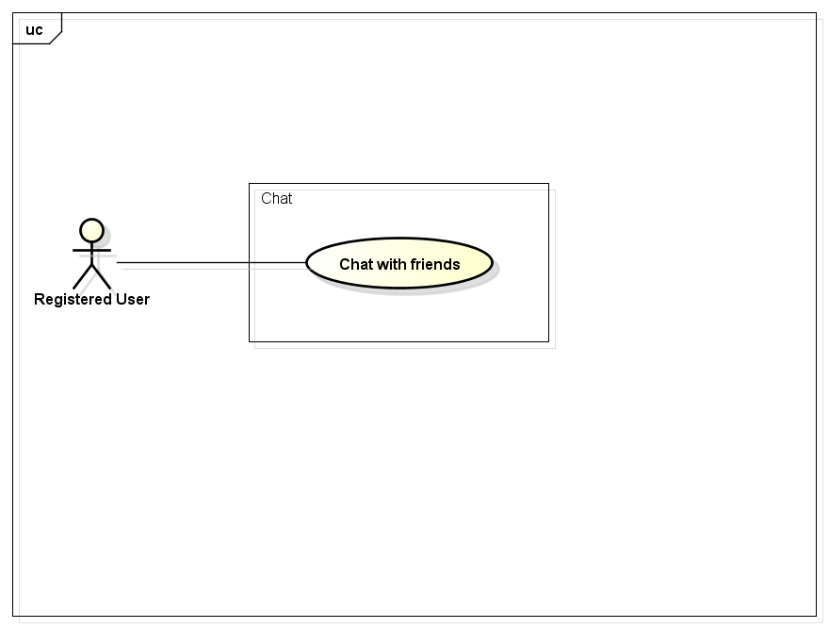

### Chat with Friends

|  |  |  |  |  |
| --- | --- | --- | --- | --- |
| **Use Case ID** | | UC028 | **Version** | 1.1 |
| **Use Case Name** | | Report a post | | |
| **Created by:** | | HieuTM | **Date Created:** | 28/05/2015 |
| **Primary Actor** | | Registered user | **Secondary Actor** |  |
| **Description:** | | This function allows user to report a post or comment violated rules | | |
| **Preconditions:** | | 1. FAP website is available 2. User browsed FAP website 3. User logged in to system | | |
| **Trigger:** | | User wants to report a post violated rules | | |
| **Post conditions:** | | 1. Chat contents is sent | | |
| **Normal Flow** | | | | |
| **Step** | **Actor** | **Action** | | |
|  | User | Click Friend List. | | |
|  | FAP | Displays friend list. | | |
|  | User | Click friend’s name. | | |
|  | FAP | Displays chat box. | | |
|  | User | Enters message to chat box. | | |
|  | User | Click Send or press Enter. | | |
|  | FAP | Sends message to friend. | | |
|  | FAP | Displays message on chat box. | | |
| **Alternative Flows** | | | | |
| **AT2** |  | | | |
| **Step** | **Actor** | **Action** | | |
|  |  |  | | |
| **Exceptions:** | | | | |
| **EC1** | The connection is terminated | | | |
| **Step** | **Actor** | **Action** | | |
| 1 | FAP | All fields are cleared and FAP return to the wait state. | | |
|  | | | | |
| **Priority** | | High | | |
| **Frequency of Use:** | | High | | |
| **Business Rules:** | | N/A | | |
| **Other Information:** | | N/A | | |

## Friend Management

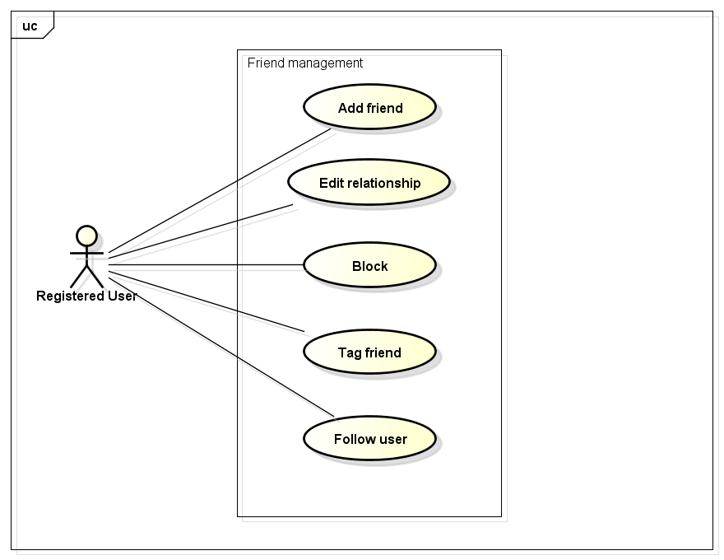

### Add Friend

|  |  |  |  |  |
| --- | --- | --- | --- | --- |
| **Use Case ID** | | UC029 | **Version** | 1.1 |
| **Use Case Name** | | Add friend | | |
| **Created by:** | | HieuTM | **Date Created:** | 28/05/2015 |
| **Primary Actor** | | Registered user | **Secondary Actor** |  |
| **Description:** | | This function allows user to add others to friend list to chat or see their activities and updates | | |
| **Preconditions:** | | 1. FAP website is available 2. User browsed FAP website 3. User logged in to system 4. User are viewing a post or a comment | | |
| **Trigger:** | | User wants to add others to friend list | | |
| **Post conditions:** | | 1. Friend request is sent | | |
| **Normal Flow** | | | | |
| **Step** | **Actor** | **Action** | | |
|  | User | Click a User name. | | |
|  | FAP | Displays a menu. | | |
|  | User | Click Add Friend. | | |
|  | FAP | Displays message popup. | | |
|  | User | Enters message into textbox. | | |
|  | User | Click Add or press Enter. | | |
|  | FAP | Closes popup. | | |
|  | FAP | Sends request to user | | |
|  | FAP | Display message “Friend request has been sent” | | |
| **Alternative Flows** | | | | |
| **AT3** | At step 6, user choose Cancel: | | | |
| **Step** | **Actor** | **Action** | | |
| 6.1 | FAP | Closes popup. | | |
| **Exceptions:** | | | | |
| **EC1** | The connection is terminated | | | |
| **Step** | **Actor** | **Action** | | |
| 1 | FAP | All fields are cleared and FAP return to the wait state. | | |
|  | | | | |
| **Priority** | | High | | |
| **Frequency of Use:** | | High | | |
| **Business Rules:** | | N/A | | |
| **Other Information:** | | N/A | | |

### Edit Relationship

|  |  |  |  |  |
| --- | --- | --- | --- | --- |
| **Use Case ID** | | UC030 | **Version** | 1.1 |
| **Use Case Name** | | Edit relationship | | |
| **Created by:** | | HieuTM | **Date Created:** | 28/05/2015 |
| **Primary Actor** | | Registered user | **Secondary Actor** |  |
| **Description:** | | This function allows user to change default relationship or makes self-define relationship with friends | | |
| **Preconditions:** | | 1. FAP website is available 2. User browsed FAP website 3. User logged in to system 4. User are viewing a post or a comment 5. User can change relationship with others are in friend list only | | |
| **Trigger:** | | User wants to change relationship | | |
| **Post conditions:** | | 1. Relationship change request is sent | | |
| **Normal Flow** | | | | |
| **Step** | **Actor** | **Action** | | |
|  | User | Click a User name. | | |
|  | FAP | Displays a menu. | | |
|  | User | Click Relationship. | | |
|  | FAP | Displays popup. | | |
|  | User | Choose relationship. | | |
|  | User | Click Change or press Enter. | | |
|  | FAP | Closes dialog. | | |
|  | FAP | Sends change relationship request | | |
|  | FAP | Display message “Request has been sent” | | |
| **Alternative Flows** | | | | |
| **AT2** | At step 5, user choose Other: | | | |
| **Step** | **Actor** | **Action** | | |
| 5.1 | FAP | Displays a textbox dialog. | | |
| 5.2 | User | Enters relationship into textbox. | | |
| 5.3 | User | Click Change or press Enter. | | |
| 5.4 | FAP | Closes dialog. | | |
| 5.5 | FAP | Sends change relationship request | | |
| 5.6 | FAP | Display message “Request has been sent” | | |
|  | | | | |
| **AT3** | At step 6, user choose Cancel: | | | |
| **Step** | **Actor** | **Action** | | |
| 6.1 | FAP | Closes popup. | | |
| **Exceptions:** | | | | |
| **EC1** | The connection is terminated | | | |
| **Step** | **Actor** | **Action** | | |
| 1 | FAP | All fields are cleared and FAP return to the wait state. | | |
|  | | | | |
| **Priority** | | Normal | | |
| **Frequency of Use:** | | Normal | | |
| **Business Rules:** | | N/A | | |
| **Other Information:** | | N/A | | |

### Unfriend

|  |  |  |  |  |
| --- | --- | --- | --- | --- |
| **Use Case ID** | | UC031 | **Version** | 1.1 |
| **Use Case Name** | | Unfriend | | |
| **Created by:** | | HieuTM | **Date Created:** | 28/05/2015 |
| **Primary Actor** | | Registered user | **Secondary Actor** |  |
| **Description:** | | This function allows user to remove others from friend list | | |
| **Preconditions:** | | 1. FAP website is available 2. User browsed FAP website 3. User logged in to system 4. User are viewing a post or a comment | | |
| **Trigger:** | | User wants to add others to friend list | | |
| **Post conditions:** | | 1. Friend is removed from list | | |
| **Normal Flow** | | | | |
| **Step** | **Actor** | **Action** | | |
|  | User | Click a User name. | | |
|  | FAP | Displays a menu. | | |
|  | User | Click Unfriend. | | |
|  | FAP | Displays confirm popup “Unfriend this user?”. | | |
|  | User | Click OK. | | |
|  | FAP | Closes popup. | | |
|  | FAP | Remove friend from list | | |
| **Alternative Flows** | | | | |
| **AT2** | At step 5, user choose Cancel: | | | |
| **Step** | **Actor** | **Action** | | |
| 5.1 | FAP | Closes popup. | | |
| **Exceptions:** | | | | |
| **EC1** | The connection is terminated | | | |
| **Step** | **Actor** | **Action** | | |
| 1 | FAP | All fields are cleared and FAP return to the wait state. | | |
|  | | | | |
| **Priority** | | High | | |
| **Frequency of Use:** | | High | | |
| **Business Rules:** | | N/A | | |
| **Other Information:** | | N/A | | |

### Block

|  |  |  |  |  |
| --- | --- | --- | --- | --- |
| **Use Case ID** | | UC032 | **Version** | 1.1 |
| **Use Case Name** | | Block | | |
| **Created by:** | | HieuTM | **Date Created:** | 28/05/2015 |
| **Primary Actor** | | Registered user | **Secondary Actor** |  |
| **Description:** | | This function allows user to block a user to not receive notifications or to not view that user posts and comments. | | |
| **Preconditions:** | | 1. FAP website is available 2. User browsed FAP website 3. User logged in to system 4. User are viewing a post or a comment | | |
| **Trigger:** | | User wants to block an user | | |
| **Post conditions:** | | 1. Blocked user’s posts is not displayed 2. Blocked user’s comments is not displayed | | |
| **Normal Flow** | | | | |
| **Step** | **Actor** | **Action** | | |
|  | User | Click a User name. | | |
|  | FAP | Displays a menu. | | |
|  | User | Click Block. | | |
|  | FAP | Displays confirm popup “Block this user?” | | |
|  | User | Click OK. | | |
|  | FAP | Closes dialog. | | |
|  | FAP | Hide all blocked user’s posts and comments | | |
|  | FAP | Display message “This user has been added to your block list” | | |
| **Alternative Flows** | | | | |
| **AT3** | At step 5, user choose Cancel: | | | |
| **Step** | **Actor** | **Action** | | |
| 5.1 | FAP | Closes popup. | | |
| **Exceptions:** | | | | |
| **EC1** | The connection is terminated | | | |
| **Step** | **Actor** | **Action** | | |
| 1 | FAP | All fields are cleared and FAP return to the wait state. | | |
|  | | | | |
| **Priority** | | Normal | | |
| **Frequency of Use:** | | Normal | | |
| **Business Rules:** | | N/A | | |
| **Other Information:** | | N/A | | |

### Tag Friend on Post

|  |  |  |  |  |
| --- | --- | --- | --- | --- |
| **Use Case ID** | | UC033 | **Version** | 1.1 |
| **Use Case Name** | | Tag friend on post | | |
| **Created by:** | | HieuTM | **Date Created:** | 28/05/2015 |
| **Primary Actor** | | Registered user | **Secondary Actor** |  |
| **Description:** | | This function allows user to tag friends, let friend receive notification about post or comment they were tagged. | | |
| **Preconditions:** | | 1. FAP website is available 2. User browsed FAP website 3. User logged in to system 4. User are viewing Add Post page or Add Photo page | | |
| **Trigger:** | | User wants to send notification to friends | | |
| **Post conditions:** | | 1. Notification is sent to tagged users | | |
| **Normal Flow** | | | | |
| **Step** | **Actor** | **Action** | | |
|  | User | Click Tag | | |
|  | FAP | Type whole or part of friends’ name into textbox. | | |
|  | User | Choose friends in suggest menu | | |
|  | FAP | Enters required fields | | |
|  | User | Click Create. | | |
|  | FAP | Sends notifications to tagged friends. | | |
| **Alternative Flows** | | | | |
| **AT3** | At step 5, user choose Cancel: | | | |
| **Step** | **Actor** | **Action** | | |
| 5.1 | FAP | Redirects user to previous page. | | |
| **Exceptions:** | | | | |
| **EC1** | The connection is terminated | | | |
| **Step** | **Actor** | **Action** | | |
| 1 | FAP | All fields are cleared and FAP return to the wait state. | | |
|  | | | | |
| **EC2** | At step 4, required fields are not entered | | | |
| **Step** | **Actor** | **Action** | | |
| 4.1 | FAP | Display Add Post page with message “Required fields are not entered” | | |
| 4.2 | FAP | Mark error fields | | |
|  | | | | |
| **EC3** | At step 4, fields are entered with wrong type of data | | | |
| **Step** | **Actor** | **Action** | | |
| 4.1 | FAP | Display Add Post page with message “Wrong type of data” | | |
| 4.2 | FAP | Mark error fields | | |
|  | | | | |
| **Priority** | | High | | |
| **Frequency of Use:** | | High | | |
| **Business Rules:** | | N/A | | |
| **Other Information:** | | N/A | | |

### Follow

|  |  |  |  |  |
| --- | --- | --- | --- | --- |
| **Use Case ID** | | UC033 | **Version** | 1.1 |
| **Use Case Name** | | Follow | | |
| **Created by:** | | HieuTM | **Date Created:** | 28/05/2015 |
| **Primary Actor** | | Registered user | **Secondary Actor** |  |
| **Description:** | | This function allows user to know others activity. | | |
| **Preconditions:** | | 1. FAP website is available 2. User browsed FAP website 3. User logged in to system 4. User are viewing a post or a comment | | |
| **Trigger:** | | User wants to know others activity without becoming friend. | | |
| **Post conditions:** | | 1. Followed user is added to Follow list 2. Activities of followed user are updated to News feed | | |
| **Normal Flow** | | | | |
| **Step** | **Actor** | **Action** | | |
|  | User | Click a User name. | | |
|  | FAP | Displays a menu. | | |
|  | User | Click Follow. | | |
|  | FAP | Adds followed user to Follow list | | |
|  | FAP | Updates activities of followed user to News feed automatically | | |
| **Alternative Flows** | | | | |
| **AT2** |  | | | |
| **Step** | **Actor** | **Action** | | |
|  |  |  | | |
| **Exceptions:** | | | | |
| **EC1** | The connection is terminated | | | |
| **Step** | **Actor** | **Action** | | |
| 1 | FAP | All fields are cleared and FAP return to the wait state. | | |
|  | | | | |
| **Priority** | | High | | |
| **Frequency of Use:** | | High | | |
| **Business Rules:** | | N/A | | |
| **Other Information:** | | N/A | | |

## Room

### 3.3.10.1 Join Room

### 3.3.10.2 Create Room

### 3.3.10.3 Edit Room Information

### 3.3.10.4 Create Plan/Schedule

### 3.3.10.5 Add member

### 3.3.10.6 Update Schedule Status

### 3.3.10.7 Chat

# 3.4 Account management module

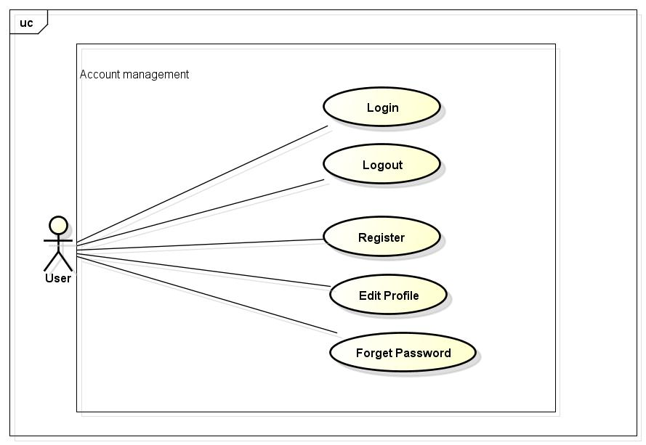

## 3.4.1 Login

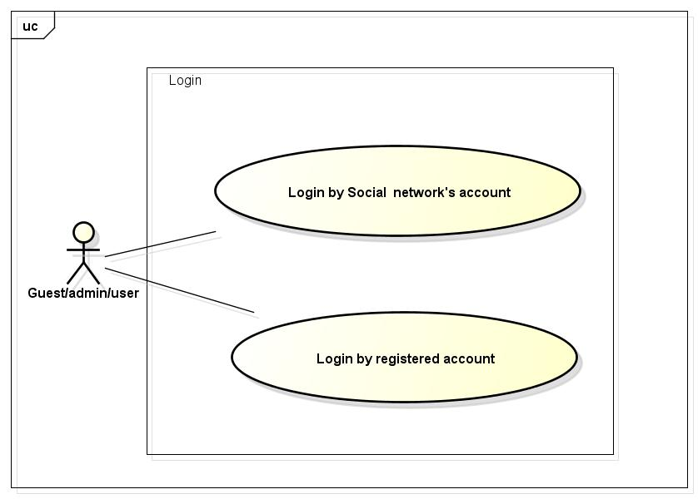

### 3.4.1.1 Login by social network’s account/ registered account

|  |  |  |  |  |
| --- | --- | --- | --- | --- |
| **Use Case ID** | | UC043 | **Version** | 1.1 |
| **Use Case Name** | | Login by social network’s account / login by registered account | | |
| **Created by:** | | LucPT | **Date Created:** | 28/05/2015 |
| **Primary Actor** | | User/guest/ admin | **Secondary Actor** |  |
| **Description:** | | When Member, Administrator want to login by Facebook/Google/Register account to use more functions in website | | |
| **Preconditions:** | | 1. Account Facebook/Google/Register must be exist and correctly 2. User are viewing login page | | |
| **Trigger:** | | User choose the login method, input data and click on Login button | | |
| **Post conditions:** | | 1. Login successfully and redirect user to previous page. | | |
| **Normal Flow** | | | | |
| **Step** | **Actor** | **Action** | | |
| 1 | User | Enter website link on web browser | | |
| 2 | FAP | Display Homepage screen | | |
| 3 | User | Choose login method ( login by Facebook/Google/register account), input account and password and then click Login button | | |
| 4 | FAP | Validate information and log user into system. | | |
| **Alternative Flows** | | | | |
| **AT1** | At step 3: When user enter data in username and password area then click on another link FAP will switch to selected page | | | |
| **Step** | **Actor** | **Action** | | |
| 3 | FAP | Redirects to selected page. | | |
| **Exceptions:** | | | | |
| **EC1** | The connection is terminated | | | |
| **Step** | **Actor** | **Action** | | |
| 3 | FAP | All fields are cleared and FAP return to the wait state. | | |
|  | | | | |
| **EC2** | At step 3, when user enter wrong user name or password FAP will send message: “Wrong password. Please try again!” | | | |
| **Step** | **Actor** | **Action** | | |
| 3.1 | FAP | Display message “Wrong password. Please try again!” | | |
| 3.2 | FAP | Mark error fields | | |
|  | | | | |
| **EC3** | At step 3, user enter wrong type of email address | | | |
| **Step** | **Actor** | **Action** | | |
| 3.1 | FAP | Display login page with message “The Email field is not a valid e-mail address.” | | |
| 3.2 | FAP | Mark error fields | | |
|  | | | | |
| **Priority** | | High | | |
| **Frequency of Use:** | | High | | |
| **Business Rules:** | | N/A | | |
| **Other Information:** | | N/A | | |

## 3.4.2

### 3.4.2.1 Logout

|  |  |  |  |  |
| --- | --- | --- | --- | --- |
| **Use Case ID** | | UC044 | **Version** | 1.1 |
| **Use Case Name** | | Logout | | |
| **Created by:** | | LucPT | **Date Created:** | 28/05/2015 |
| **Primary Actor** | | User/ admin | **Secondary Actor** |  |
| **Description:** | | When Member, Admin want to logout their account | | |
| **Preconditions:** | | 1. FAP website is available 2. User browsed FAP website 3. User/admin must be login | | |
| **Trigger:** | | Click on logout button | | |
| **Post conditions:** | | 1. Redirect user to previous page. | | |
| **Normal Flow** | | | | |
| **Step** | **Actor** | **Action** | | |
| 1 | User | Click on Logout button | | |
| 2 | FAP | Redirect to homepage | | |
| **Alternative Flows** N/A | | | | |
| **Exceptions:** | | | | |
| **EC1** | The connection is terminated | | | |
| **Step** | **Actor** | **Action** | | |
| 3 | FAP | All fields are cleared and FAP return to the wait state. | | |
|  | | | | |
| **Priority** | | High | | |
| **Frequency of Use:** | | High | | |
| **Business Rules:** | | N/A | | |
| **Other Information:** | | N/A | | |

### Register

|  |  |  |  |  |
| --- | --- | --- | --- | --- |
| **Use Case ID** | | UC045 | **Version** | 1.1 |
| **Use Case Name** | | Register | | |
| **Created by:** | | LucPT | **Date Created:** | 28/05/2015 |
| **Primary Actor** | | Guest | **Secondary Actor** |  |
| **Description:** | | Visitor can create new account to use more function as a register user | | |
| **Preconditions:** | | 1. Guest browsed FAP website | | |
| **Trigger:** | | Click on register link on the website | | |
| **Post conditions:** | | Create account for guest | | |
| **Normal Flow** | | | | |
| **Step** | **Actor** | **Action** | | |
| 1 | User | Enter website link on web browser | | |
| 2 | FAP | Display Homepage screen | | |
| 3 | User | Click on register link | | |
| 4 | FAP | Display register form | | |
| 5 | User | Enter necessary and mandatory information and click Register button. | | |
| 6 | FAP | Display message to register successfully and redirect to homepage | | |
| **Alternative Flows** | | | | |
| **AT1** |  | | | |
| **Step** | **Actor** | **Action** | | |
| 5 | User | Enter necessary and mandatory information and click another link | | |
| 6 | FAP | Switch to selected page | | |
| **Exceptions:** | | | | |
| **EC1** | The connection is terminated | | | |
| **Step** | **Actor** | **Action** | | |
| 3 | FAP | All fields are cleared and FAP return to the wait state. | | |
|  | | | | |
| **EC2** | Missing user name | | | |
| **Step** | **Actor** | **Action** | | |
| 5 | User | Missing “User name” field and click Register button | | |
| 5 | FAP | Display error message beside “password” field. | | |
| 5 | FAP | Mark error fields | | |
|  | | | | |
| **EC3** | Missing password | | | |
| **Step** | **Actor** | **Action** | | |
| 5 | User | Enter incorrect information or missing “password” field and click Register button | | |
| 5 | FAP | Display login page with message “The Email field is not a valid e-mail address.” | | |
| 5 | FAP | Mark error fields | | |
|  | | | | |
| **Priority** | | High | | |
| **Frequency of Use:** | | High | | |
| **Business Rules:** | | N/A | | |
| **Other Information:** | | N/A | | |

### Edit profile

|  |  |  |  |  |
| --- | --- | --- | --- | --- |
| **Use Case ID** | | UC046 | **Version** | 1.1 |
| **Use Case Name** | | Edit profile | | |
| **Created by:** | | LucPT | **Date Created:** | 28/05/2015 |
| **Primary Actor** | | User/admin | **Secondary Actor** |  |
| **Description:** | | When user want to change their profile | | |
| **Preconditions:** | | 1. Member login the website | | |
| **Trigger:** | | Login the website and click on the edit profile link | | |
| **Post conditions:** | | Edit profile successful and redirect user to edited profile page | | |
| **Normal Flow** | | | | |
| **Step** | **Actor** | **Action** | | |
| 1 | User | Enter website link on web browser | | |
| 2 | FAP | Display Homepage screen | | |
| 3 | User | Enter necessary and mandatory information and click Login | | |
| 4 | FAP | Redirect to previous page and logged user into system. | | |
| 5 | User | Click on Personal link. | | |
| 6 | FAP | Display “Personal” page | | |
| 7 | User | User changes profile and click Save button | | |
| 8 | FAP | Update new profile | | |
| **Alternative Flows** | | | | |
| **AT1** |  | | | |
| **Step** | **Actor** | **Action** | | |
| 7 | User | Enter necessary and mandatory information and click another link | | |
| 8 | FAP | Switch to selected page | | |
| **Exceptions:** | | | | |
| **EC1** | The connection is terminated | | | |
| **Step** | **Actor** | **Action** | | |
| 3 | FAP | All fields are cleared and FAP return to the wait state. | | |
|  | | | | |
| **EC2** |  | | | |
| **Step** | **Actor** | **Action** | | |
| 7 | User | Enter new password that incorrect form or missing information and click Save button | | |
| 8 | FAP | Display error message | | |
|  | | | | |
| **EC3** |  | | | |
| **Step** | **Actor** | **Action** | | |
| 7 | User | Enter new email that incorrect form or missing information and click Save button | | |
| 8 | FAP | Display error message | | |
|  | | | | |
| **Priority** | | High | | |
| **Frequency of Use:** | | High | | |
| **Business Rules:** | | N/A | | |
| **Other Information:** | | N/A | | |

### Forgot password

|  |  |  |  |  |
| --- | --- | --- | --- | --- |
| **Use Case ID** | | UC047 | **Version** | 1.1 |
| **Use Case Name** | | Forgot password | | |
| **Created by:** | | LucPT | **Date Created:** | 28/05/2015 |
| **Primary Actor** | | User/admin | **Secondary Actor** |  |
| **Description:** | | When Member, Admin forgot their password to login the system, this function will receiving their password to email | | |
| **Preconditions:** | | 1. Website is available 2. Guest browsed FAP website | | |
| **Trigger:** | | Click on forgot password link on the website | | |
| **Post conditions:** | | Receiving their password to their email | | |
| **Normal Flow** | | | | |
| **Step** | **Actor** | **Action** | | |
| 1 | User | Enter website link on web browser | | |
| 2 | FAP | Display Homepage screen | | |
| 3 | User | Click on “forgot password” link | | |
| 4 | FAP | Display “forgot password” page | | |
| 5 | User | Enter necessary and mandatory information in the “forgot password” form and click Send request button. | | |
| 6 | FAP | System will send the password into user’s email | | |
| **Alternative Flows** | | | | |
| **AT1** |  | | | |
| **Step** | **Actor** | **Action** | | |
| 5 | User | Enter necessary and mandatory information and click another link | | |
| 6 | FAP | Switch to selected page | | |
| **Exceptions:** | | | | |
| **EC1** | The connection is terminated | | | |
| **Step** | **Actor** | **Action** | | |
| 3 | FAP | All fields are cleared and FAP return to the wait state. | | |
|  | | | | |
| **EC2** |  | | | |
| **Step** | **Actor** | **Action** | | |
| 5 | User | Enter email incorrect with email that use to register account | | |
| 6 | FAP | Display error message and request to re-enter email | | |
|  | | | | |
| **Priority** | | High | | |
| **Frequency of Use:** | | High | | |
| **Business Rules:** | | N/A | | |
| **Other Information:** | | N/A | | |

# FAP Admin modules

## Manage member’s account

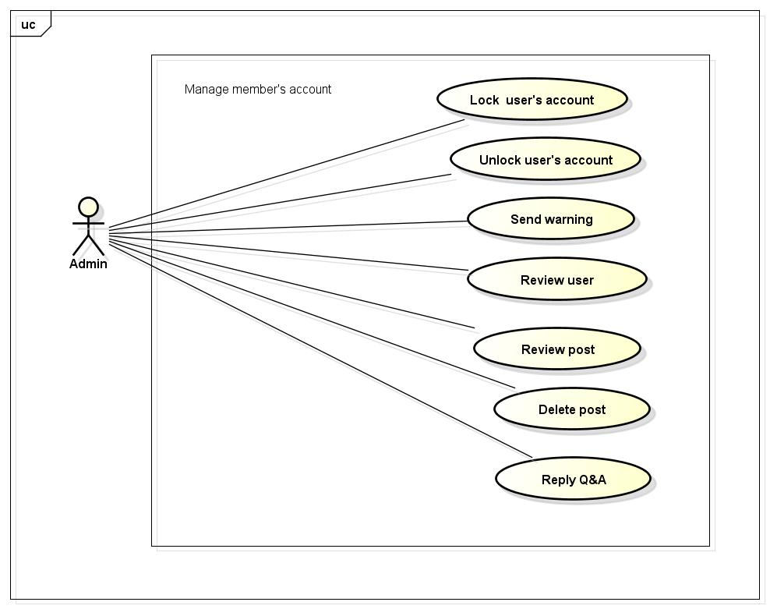

### Lock user’s account

|  |  |  |  |  |
| --- | --- | --- | --- | --- |
| **Use Case ID** | | UC048 | **Version** | 1.1 |
| **Use Case Name** | | Lock user’s account | | |
| **Created by:** | | LucPT | **Date Created:** | 28/05/2015 |
| **Primary Actor** | | Admin | **Secondary Actor** |  |
| **Description:** | | Administrator can lock user account in a period of time depending on severity | | |
| **Preconditions:** | | 1. Website is available 2. Admin must be login | | |
| **Trigger:** | | Admin login the website and click on member’s account and then click Lock button | | |
| **Post conditions:** | | Member’s account will be locked by administrator | | |
| **Normal Flow** | | | | |
| **Step** | **Actor** | **Action** | | |
| 1 | Admin | Enter website link on web browser | | |
| 2 | FAP | Display Homepage screen | | |
| 3 | Admin | Administrator enter necessary and mandatory information and click Login | | |
| 4 | FAP | Display homepage screen | | |
| 5 | Admin | Administrator click on Search member button and input member’s account or email. | | |
| 6 | Admin | Administrator click Lock link | | |
| 7 | FAP | FAP will lock member | | |
| **Alternative Flows** | | | | |
| **AT1** |  | | | |
| **Step** | **Actor** | **Action** | | |
| 5 | Admin | Administrator fill information of the member that they want to find into these fields then click on another link | | |
| 6 | FAP | Will switch to selected page | | |
| **Exceptions:** | | | | |
| **EC1** | The connection is terminated | | | |
| **Step** | **Actor** | **Action** | | |
| 3 | FAP | All fields are cleared and FAP return to the wait state. | | |
|  | | | | |
| **EC2** |  | | | |
| **Step** | **Actor** | **Action** | | |
| 5 | Admin | Administrator fill information of the member that they want to find (that do not exist in database) into these fields then click Search button. | | |
| 6 | FAP | Return Error message to inform that member cannot be found | | |
|  | | | | |
| **Priority** | | High | | |
| **Frequency of Use:** | | High | | |
| **Business Rules:** | | N/A | | |
| **Other Information:** | | N/A | | |

### 3.5.1.2 Unlock user’s account

|  |  |  |  |  |
| --- | --- | --- | --- | --- |
| **Use Case ID** | | UC049 | **Version** | 1.1 |
| **Use Case Name** | | Unlock user’s account | | |
| **Created by:** | | LucPT | **Date Created:** | 28/05/2015 |
| **Primary Actor** | | Admin | **Secondary Actor** |  |
| **Description:** | | Administrator can unlock user account | | |
| **Preconditions:** | | 1. Website is available 2. Admin must be login 3. This user must have been locked | | |
| **Trigger:** | | Admin login the website and click on member’s account and then click Unlock button | | |
| **Post conditions:** | | Member’s account will be unlock by administrator | | |
| **Normal Flow** | | | | |
| **Step** | **Actor** | **Action** | | |
| 1 | Admin | Enter website link on web browser | | |
| 2 | FAP | Display Homepage screen | | |
| 3 | Admin | Administrator enter necessary and mandatory information and click Login | | |
| 4 | FAP | Display homepage screen | | |
| 5 | Admin | Administrator click on Search member button and input member’s account or email. | | |
| 6 | Admin | Administrator click Unlock link | | |
| 7 | FAP | FAP will unlock member | | |
| **Alternative Flows** | | | | |
| **AT1** |  | | | |
| **Step** | **Actor** | **Action** | | |
| 5 | Admin | Administrator fill information of the member that they want to find into these fields then click on another link | | |
| 6 | FAP | Will switch to selected page | | |
| **Exceptions:** | | | | |
| **EC1** | The connection is terminated | | | |
| **Step** | **Actor** | **Action** | | |
| 3 | FAP | All fields are cleared and FAP return to the wait state. | | |
|  | | | | |
| **EC2** |  | | | |
| **Step** | **Actor** | **Action** | | |
| 5 | Admin | Administrator fill information of the member that they want to find (that do not exist in database) into these fields then click Search button. | | |
| 6 | FAP | Return Error message to inform that member cannot be found | | |
|  | | | | |
| **Priority** | | High | | |
| **Frequency of Use:** | | High | | |
| **Business Rules:** | | N/A | | |
| **Other Information:** | | N/A | | |

### Send warning

|  |  |  |  |  |
| --- | --- | --- | --- | --- |
| **Use Case ID** | | UC050 | **Version** | 1.1 |
| **Use Case Name** | | Send warning | | |
| **Created by:** | | LucPT | **Date Created:** | 28/05/2015 |
| **Primary Actor** | | Admin | **Secondary Actor** |  |
| **Description:** | | Administrator can warn user when they violate some rule of website but just quite small | | |
| **Preconditions:** | | 1. Website is available 2. Admin must be login | | |
| **Trigger:** | | Admin login the website and click on member’s account and then click send message. | | |
| **Post conditions:** | | Member’s account will be warn by administrator | | |
| **Normal Flow** | | | | |
| **Step** | **Actor** | **Action** | | |
| 1 | Admin | Enter website link on web browser | | |
| 2 | FAP | Display Homepage screen | | |
| 3 | Admin | Administrator enter necessary and mandatory information and click Login | | |
| 4 | FAP | Display homepage screen | | |
| 5 | Admin | Administrator click on Search member button and input member’s account or email. | | |
| 6 | Admin | Administrator click send message | | |
| 7 | FAP | FAP will send message to user. | | |
| **Alternative Flows** | | | | |
| **AT1** |  | | | |
| **Step** | **Actor** | **Action** | | |
| 5 | Admin | Administrator fill information of the member that they want to find into these fields then click on another link | | |
| 6 | FAP | Will switch to selected page | | |
| **Exceptions:** | | | | |
| **EC1** | The connection is terminated | | | |
| **Step** | **Actor** | **Action** | | |
| 3 | FAP | All fields are cleared and FAP return to the wait state. | | |
|  | | | | |
| **EC2** |  | | | |
| **Step** | **Actor** | **Action** | | |
| 5 | Admin | Administrator fill information of the member that they want to find (that do not exist in database) into these fields then click Search button. | | |
| 6 | FAP | Return Error message to inform that member cannot be found | | |
|  | | | | |
| **Priority** | | High | | |
| **Frequency of Use:** | | High | | |
| **Business Rules:** | | N/A | | |
| **Other Information:** | | N/A | | |

### Review user

|  |  |  |  |  |
| --- | --- | --- | --- | --- |
| **Use Case ID** | | UC051 | **Version** | 1.1 |
| **Use Case Name** | | Review user | | |
| **Created by:** | | LucPT | **Date Created:** | 28/05/2015 |
| **Primary Actor** | | Admin | **Secondary Actor** |  |
| **Description:** | | Review reported user | | |
| **Preconditions:** | | 1. Administrator login the website 2. This user is reported | | |
| **Trigger:** | | Administrator login the website and review user who has been reported | | |
| **Post conditions:** | | Member’s account will be review by administrator | | |
| **Normal Flow** | | | | |
| **Step** | **Actor** | **Action** | | |
| 1 | Admin | Enter website link on web browser | | |
| 2 | FAP | Display Homepage screen | | |
| 3 | Admin | Administrator enter necessary and mandatory information and click Login | | |
| 4 | FAP | Display homepage screen | | |
| 5 | Admin | Administrator click on Search member button and input member’s account or email. | | |
| **Alternative Flows** | | | | |
| **AT1** |  | | | |
| **Step** | **Actor** | **Action** | | |
| 5 | Admin | Administrator fill information of the member that they want to find into these fields then click on another link | | |
| 6 | FAP | Will switch to selected page | | |
| **Exceptions:** | | | | |
| **EC1** | The connection is terminated | | | |
| **Step** | **Actor** | **Action** | | |
| 3 | FAP | All fields are cleared and FAP return to the wait state. | | |
|  | | | | |
| **EC2** |  | | | |
| **Step** | **Actor** | **Action** | | |
| 5 | Admin | Administrator fill information of the member that they want to find (that do not exist in database) into these fields then click Search button. | | |
| 6 | FAP | Return Error message to inform that member cannot be found | | |
|  | | | | |
| **Priority** | | High | | |
| **Frequency of Use:** | | High | | |
| **Business Rules:** | | N/A | | |
| **Other Information:** | | N/A | | |

### Review post

|  |  |  |  |  |
| --- | --- | --- | --- | --- |
| **Use Case ID** | | UC052 | **Version** | 1.1 |
| **Use Case Name** | | Review post | | |
| **Created by:** | | LucPT | **Date Created:** | 28/05/2015 |
| **Primary Actor** | | Admin | **Secondary Actor** |  |
| **Description:** | | Review reported post | | |
| **Preconditions:** | | 1. Administrator login the website 2. This post is reported | | |
| **Trigger:** | | Administrator login the website and review post which has been reported | | |
| **Post conditions:** | | Member’s post will be review by administrator | | |
| **Normal Flow** | | | | |
| **Step** | **Actor** | **Action** | | |
| 1 | Admin | Enter website link on web browser | | |
| 2 | FAP | Display Homepage screen | | |
| 3 | Admin | Administrator enter necessary and mandatory information and click Login | | |
| 4 | FAP | Display homepage screen | | |
| 5 | Admin | Administrator click on Search member button and input member’s account or email. | | |
| 6 | Admin | Administrator finds post and review | | |
| **Alternative Flows** | | | | |
| **AT1** |  | | | |
| **Step** | **Actor** | **Action** | | |
| 5 | Admin | Administrator fill information of the member that they want to find into these fields then click on another link | | |
| 6 | FAP | Will switch to selected page | | |
| **Exceptions:** | | | | |
| **EC1** | The connection is terminated | | | |
| **Step** | **Actor** | **Action** | | |
| 3 | FAP | All fields are cleared and FAP return to the wait state. | | |
|  | | | | |
| **EC2** |  | | | |
| **Step** | **Actor** | **Action** | | |
| 5 | Admin | Administrator fill information of the member that they want to find (that do not exist in database) into these fields then click Search button. | | |
| 6 | FAP | Return Error message to inform that member cannot be found | | |
|  | | | | |
| **Priority** | | High | | |
| **Frequency of Use:** | | High | | |
| **Business Rules:** | | N/A | | |
| **Other Information:** | | N/A | | |

### Delete post

|  |  |  |  |  |
| --- | --- | --- | --- | --- |
| **Use Case ID** | | UC053 | **Version** | 1.1 |
| **Use Case Name** | | Delete post | | |
| **Created by:** | | LucPT | **Date Created:** | 28/05/2015 |
| **Primary Actor** | | Admin | **Secondary Actor** |  |
| **Description:** | | Administrator can delete post when this post violate rule of website | | |
| **Preconditions:** | | 1. Admin must be login 2. Post must violate rule | | |
| **Trigger:** | | Administrator login the website and review post which has been reported | | |
| **Post conditions:** | | Member’s post will be review by administrator | | |
| **Normal Flow** | | | | |
| **Step** | **Actor** | **Action** | | |
| 1 | Admin | Enter website link on web browser | | |
| 2 | FAP | Display Homepage screen | | |
| 3 | Admin | Administrator enter necessary and mandatory information and click Login | | |
| 4 | FAP | display homepage screen | | |
| 5 | Admin | Administrator click on Search member button and input member’s account or email. | | |
| 6 | Admin | Administrator finds post and review | | |
| 7 | Admin | Admin click delete button | | |
| 8 | FAP | FAP delete post | | |
| **Alternative Flows** | | | | |
| **AT1** |  | | | |
| **Step** | **Actor** | **Action** | | |
| 5 | Admin | Administrator fill information of the member that they want to find into these fields then click on another link | | |
| 6 | FAP | Will switch to selected page | | |
| **Exceptions:** | | | | |
| **EC1** | The connection is terminated | | | |
| **Step** | **Actor** | **Action** | | |
| 3 | FAP | All fields are cleared and FAP return to the wait state. | | |
|  | | | | |
| **EC2** |  | | | |
| **Step** | **Actor** | **Action** | | |
| 5 | Admin | Administrator fill information of the member that they want to find (that do not exist in database) into these fields then click Search button. | | |
| 6 | FAP | Return Error message to inform that member cannot be found | | |
|  | | | | |
| **Priority** | | High | | |
| **Frequency of Use:** | | High | | |
| **Business Rules:** | | N/A | | |
| **Other Information:** | | N/A | | |

### Reply Q&A

|  |  |  |  |  |
| --- | --- | --- | --- | --- |
| **Use Case ID** | | UC054 | **Version** | 1.1 |
| **Use Case Name** | | Reply Q&A | | |
| **Created by:** | | LucPT | **Date Created:** | 28/05/2015 |
| **Primary Actor** | | Admin | **Secondary Actor** |  |
| **Description:** | | Reply question of user or guest. | | |
| **Preconditions:** | | 1. Website is available 2. User has to login as Administrator 3. Administrator has to input answer | | |
| **Trigger:** | | Click on “Opinion/Q&A Management ” tab, User search question then click Reply link corresponding | | |
| **Post conditions:** | | Answer is sent to user | | |
| **Normal Flow** | | | | |
| **Step** | **Actor** | **Action** | | |
| 1 | Admin | Enter website link on web browser | | |
| 2 | FAP | Display Homepage screen | | |
| 3 | Admin | Administrator enter necessary and mandatory information and click Login | | |
| 4 | FAP | Display homepage screen | | |
| 5 | Admin | Admin click Reply link corresponding | | |
| 6 | User | Displays Reply screen with these elements: Contact_Content,Contact_Email, Answer | | |
| 7 | Admin | Administrator enter the answer | | |
| 8 | Admin | Administrator click Reply button | | |
| 9 | FAP | FAP sent answer to member. | | |
| **Alternative Flows** | | | | |
| **AT1** |  | | | |
| **Step** | **Actor** | **Action** | | |
| 5 | Admin | Administrator fill information of the member that they want to find into these fields then click on another link | | |
| 6 | FAP | Will switch to selected page | | |
| **Exceptions:** | | | | |
| **EC1** | The connection is terminated | | | |
| **Step** | **Actor** | **Action** | | |
| 3 | FAP | All fields are cleared and FAP return to the wait state. | | |
|  | | | | |
| **EC2** |  | | | |
| **Step** | **Actor** | **Action** | | |
| 8 | Admin | Administrator answer then click on another link | | |
| 8 | FAP | FAP switch to selected page | | |
|  | | | | |
| **Priority** | | High | | |
| **Frequency of Use:** | | High | | |
| **Business Rules:** | | N/A | | |
| **Other Information:** | | N/A | | |