|  |
| --- |
|  |

Fly Away Plus

**Report #1 – Project Introduction**

**Project Code: FAP**

**Document Code: FAP_Introduction_EN**

**- Hanoi, 05/2015 –**

Table of Contents

1 INTRODUCTION 3

1.1 Purpose 3

1.2 Acronyms and Definitions 3

2 ABSTRACT 3

3 LITERATURE REVIEW 3

4 PROPOSAL 7

4.1 The idea 7

4.2 Objectives 7

4.3 Brief description about system 7

4.4 System features 7

5 BENEFIT FROM PROJECT 9

5.1 For our group 9

5.2 For Community 9

6 CRITICAL ASSUMPTION AND CONSTRAINTS 9

7 POTENTIAL RISKS 10

8 REFERENCES 10

# INTRODUCTION

## Purpose

This document is created as the introduction for project Fly Away Plus – our Capstone Project at FPT University. In this document, we will descript the overview of some existing systems, the initial idea for our project, a brief description about our expected system and some potential risks, critical assumptions, constrains. Moreover, this document also shows opportunities what it offers for users.

## Acronyms and Definitions

|  |  |
| --- | --- |
| Acronym & Abbreviation | Definition |
| FAP | Fly Away Plus |
| FU | FPT University |
| Q&A | Question and Answer |

**Table 1-1:** Definitions and Acronyms

# ABSTRACT

Nowadays, there are many social networks are using by billions of people. Facebook, Twitter, Tumblr are the most famous social networks. As of the first quarter of 2015, Market leader Facebook was the first social network to surpass 1 billion registered accounts, tenth-ranked microblogging network Twitter had over 288 million monthly active accounts. Meanwhile, blogging service Tumblr had more than 230 million active blog users on their site. On social networks, every day we can see many people share photos, post about their trips around the world, between millions of other things like school, family, works etc…Our website is developed by travel-lovers with the aim of helping user share experiences about their trips, read others people’s real opinion, keeps beautiful memories and connecting people to travel together.

# LITERATURE REVIEW

Facebook, Twitter and Tumblr etc…are popular social networks. However still have no social network are just specific about travelling. There are many websites about travelling, but most of them aim to booking tickets, flights, tours with good deals, or advertisements, people cannot be connected and keeps memories about their own trips on these website. For example: wego.vn, budgettravel.com…

**Facebook**

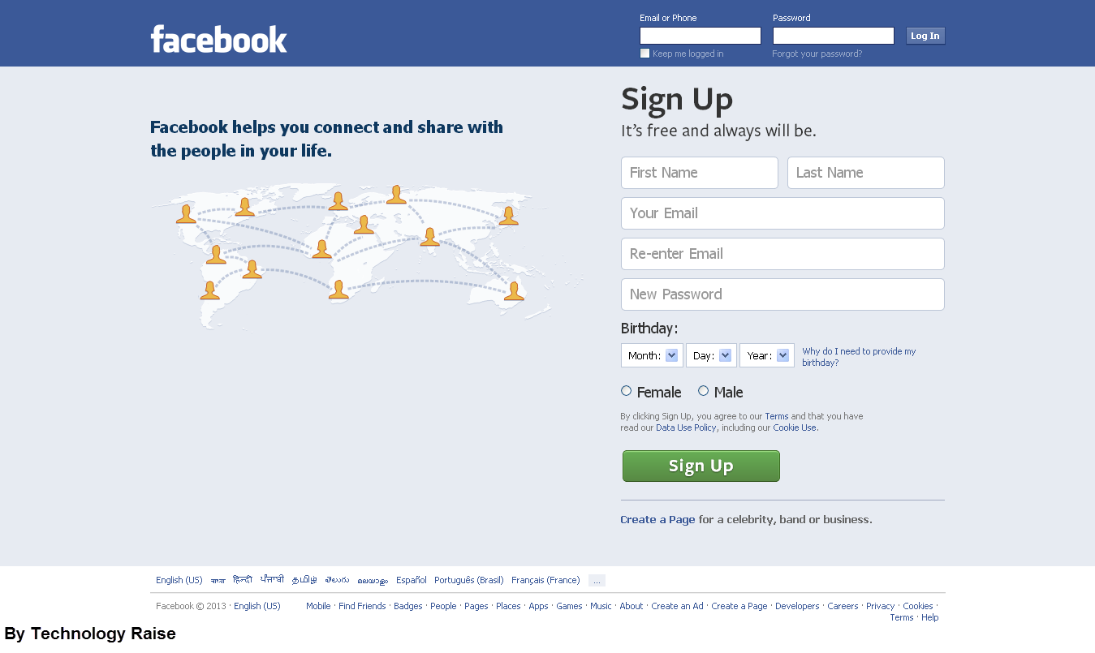

Facebook is an online social networking service, users can create a [user profile](http://en.wikipedia.org/wiki/User_profile), add other users as ["friends"](http://en.wikipedia.org/wiki/Friending), exchange messages, post status updates and photos, share videos and receive notifications when others update their profiles.

**Advantages:**

* Is a global social networking site available in various languages
* Helped a lot to create a personal brand for many individuals and for business.
* Easy to find friends, college, like-minded people
* Hosting site for images and videos
* Source of information and news

**Disadvantages:**

* Too many unuseful information
* Time consuming

**tumbrl.**

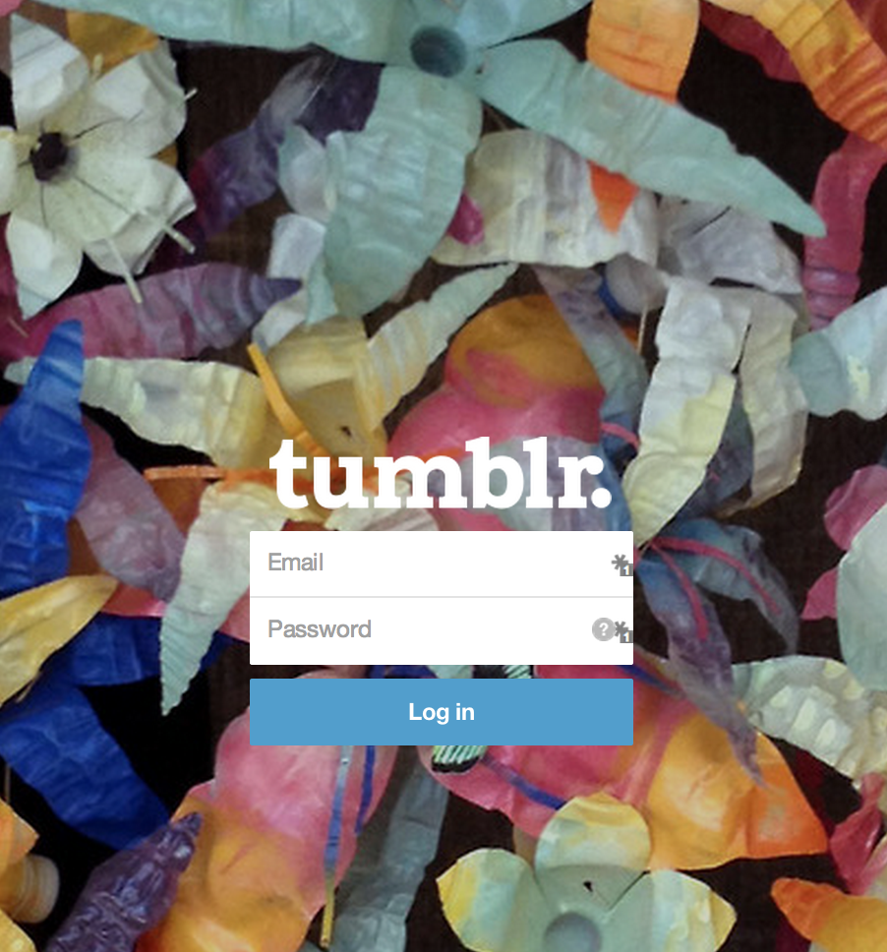

Tumblr is a [microblogging](http://en.wikipedia.org/wiki/Microblogging) platform and [social networking](http://en.wikipedia.org/wiki/Social_networking_service) website. Users can follow other users' blogs, as well as make their blogs private.

**Advantages:**

* Has friendly user interface; Simply add content and click button to upload.
* Gives its users the option to incorporate Google analytics so they can track the effectiveness of their posts and visitor numbers.

**Disadvantages:**

* Is mostly used for sharing images and video.
* Is known to have stability issues, resulting in a lot of downtime.
* Posts are difficult to optimize for Search Engine Optimization (SEO).

**WeGo.vn**

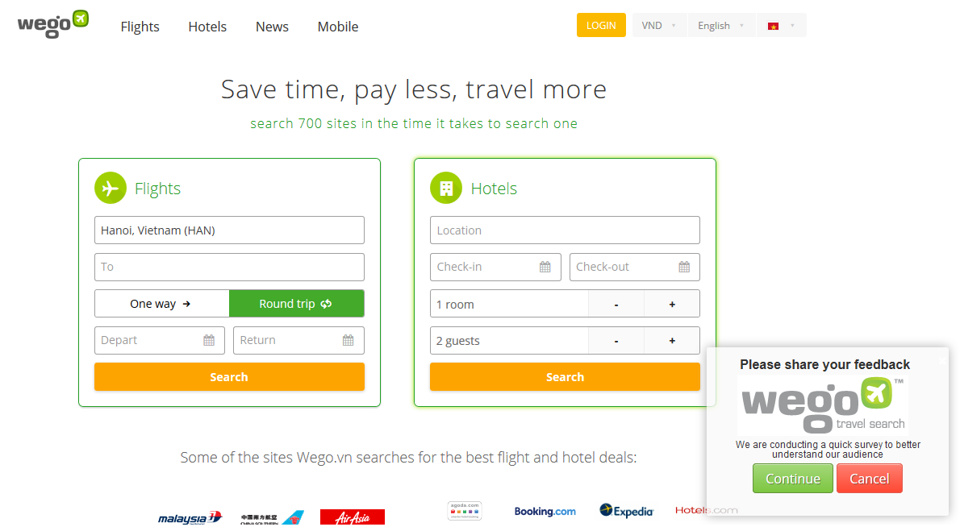

**Advantages:**

* Easy to find best deals for flight and hotel on many countries

**Disadvantages:**

* This website is only for booking, no sharing information or connecting to others
* User cannot read information or review about places, flight, hotel etc…
* Mostly used by Vietnamese

# PROPOSAL

## The idea

Nowadays there are many social networks, and many people update every moments of their life on social network to share with friends and keep it as an archive, so they can see things they have on their life on past. All of social networks have been create for the purpose of helping users sharing and connecting to friends.

Our project – FAP will include some main functions of existing social networks and add some new features such as create room, connect user’s trips as a journey of their life. With the slogan “Share all we have!” we toward on sharing information and experiences between users and spread the joy of travelling together.

## Objectives

This project is the Capstone Project in FPT University studying program.

First, this project is responsibility for all team members. So we must complete all requirements from teacher and FU. During the time doing project, we can learn how to develop a project, how to manage project, how to communicate better between team member, how to control time, how to perform teamwork effectively. Moreover, we also have experience about .NET, website design, test website… Therefore, we think this project is very necessary for us to improve skills, knowledge which we studied in FU. This project also makes our CV more beautiful after graduating from FU. This is also an opportunity for us to prove capacity with recruiters.

Second, because we love travel. When we go to new places, we want to share with people experiences we have lived, things we have done, where and what we have eaten. People can make new friends by join in groups, Fly Away Plus and have new experiences together. We hope we can share all we have, and we hope people who loves travel can be connected and easily share information about their trips.

## Brief description about system

This software is a social network with friendly and attractive interface, users can easily find out what they want without registration. User also can send opinion to admin if there is anything that needs to be modified.

FAP uses familiar technologies as: JavaScript, ASP.NET…And we are planning to develop a mobile version for easily sharing and connecting.

## System features

About the features of FAP, we focus to provide for users main features as searching, sharing posts, photos and videos, check-in, scheduling their trips, reading others’ posts, connecting and interacting to other travelers etc…Admin can manage members, manage database, manage contribute database and manage Q&A.

In here, we focus on features which can help users can understand the best way what user want to have with features of FAP. There are the detailed features of FAP:

* **Search**: User and guest can search for places, food and drinks, experiences or friends and FAP will display results match with words user have searched. With searching features, user can easily search information of places they want to go, things they can experience at this places, and finding people who want to go to this place. The very new point and useful of FAP when compare with others is FAP is not only show the results match with words user have search but also show things related. User have the following searching option:
  + *Searching with name of places:* user can search with name of a place and FAP will display information about place(s), things related to this places (post, photos, reviews, suggestion etc…), friends and other users are going to/went to this place(s). FAP will also suggest rooms for user (information about room features are below)
  + *Searching with name of friends, group or another user:* user can search with name of friends, groups or another users (who is not friend with user), FAP will display basic information of user and link to user’s homepage
  + *Searching with name of food, drinks, or activities (skies, swimming, diving…):* user can search with name of food, drinks or activities…and FAP will suggest places to enjoying. FAP will also suggest like-minded people.
  + *Searching by maps:* User can search for a place directly on maps.
* **Registering:** User can register an account and login to use all features of FAP
* **Suggesting:** FAP can suggest places, activities or friends for user (must-go places, trendy activities, friend’s activities etc…)
* **Look around:** User can check-in and look around their position and see suggestion about places, activities, experiences
* **News feed:** User can see friend’s sharing
* **Timeline:** User personal information and all posts will display on user’s timeline
* **Sharing:** User can share their trips, destinations, photos, videos or write review to their personal page, their post will appear on the News Feed.
* **Like/dislike and comment:** User can like/dislike and comment on others’ post
* **Share:**  User can share a post (depend on this post’s privacy)
* **Report:** User can report a post to administrator
* **Connecting:** Registered user can connect with others
  + **Add friends:** User can add other users as friends, friend’s posts will appear on user’s news feed.
  + **Follow other users:** User can see others’ post without become friends with those user
  + **Tagging:** User can tag friends to a post
* **Room:** This is a new useful features of FAP for connecting users. In a room, user can discuss, share information and make a plan for their journey with others
  + **Create a room:** User can create a room with expected number of peoples
  + **Manage room:** User who has created the room as administrator can manage privacy of this room, manage resources and member of room. Admin of a room can set another to admin to share responsibilities.
  + **“Ready to go”:** When every member of room are ready to start a journey, the room will be temporarily closed
  + **Join to others’ rooms:** There are private room and public room, the privacy will be set by administrator of room
    - **Private room:** With this kind of privacy, room cannot be found in search result, user only can join a private room when they are invited by this room’s member.
    - **Public room:** With this kind of privacy, room can be found in search result, all of the users can join this kind of room.
* **Managing account:** User can manage their personal information
  + **Login/Logout**: User can login to use more features of FAP. User can register an account to login or login by using Facebook, Google account.
  + **Changing password/Forgetting password**: User can change new password or require new password if user forgot current password.
* **Managing member**: Admin can review report sent from users. If the report is reasonable, admin can delete post, send warning to user who has reported, admin can also lock/unlock users’ account.

# BENEFIT FROM PROJECT

## For our group

After developing and implementing this project, our group will get some benefits:

* Have more experiences of managing a software project: how to manage plan, time, member and risk.
* Have more knowledge and skill about .NET programming
* Know how to communicate with team members and how to teamwork more effective.
* Have more knowledge about managing and travelling.

## For Community

Just need to have a device that connect to the internet and any web browser, user can:

* Easy join to a community of travel-lovers
* Easy search for places information and connect to friends
* Easy share and keep memories of their trips
* Create an online passport to show where they went to
* Find more friends
* Free for all users.

# CRITICAL ASSUMPTION AND CONSTRAINTS

* Critical assumption:
  + Training: We assumed that all developer can train .NET in a short time. Before starting this project, just 2 member in our team have knowledge about .NET, but with programming techniques which we studied at FU, we have to try the best to not missing any deadline in project plan. Besides that, we also assumed that all members in team have a good healthy to do their tasks.
* Constraints:
  + Time and deadline: we must complete task on time. We do not have more time for us to complete developing and deliver application to teachers. Besides, we have to submit report documents before deadline to teacher can review.
  + Quality: The products must be run well when users perform main functions in Google Chrome 44 and Firefox 37 or higher.

# POTENTIAL RISKS

After studying about this project, we find out some problem that we may be encountered:

* Lack of experience in group working, managing and controlling work so we may be miss the deadline or under estimate scope, time.
* Lack of knowledge and experience in the framework and technique of .NET and web. Therefore, we have to study all of them from the beginning. The project team may face with the difficult technical problems that may requires long time to resolve so that causes the project be delayed.
* Lack of knowledge and experience in management.
* Sometime, because of careless, team members can lose data, source code… before uploading data to server.

# REFERENCES

* **Facebook at URL**  <http://www.facebook.com/>
* **Tumblr at URL** <https://www.tumblr.com/>
* **WeGo at URL** <http://www.wego.vn/>