David DeFazio
CS455
Final Report

How to run code/about code:
All code is written in Python 3. OpenCv was used for loading images, accessing and modifying pixel values, resizing images, applying morphological erosion and dilation, and viewing the image. Sklearn was used for an SVM implementation. Numpy was used to store pixel values. Pickle was used to save and load my SVM model to and from a file.
expression_parser.py <Usage: python3 expression_parser.py image_name.jpg> is the main program. Input an image, output the answer.
svm.py <Usage: python3 svm.py> fits a SVM model to the MNIST data, and saves it to svm.sav. It takes roughly 30 minutes to run from my laptop.
view_dataset.py <Usage: python3 view_dataset.py> will read through MNIST data, and display each row as an image. Press any key to go to the next image.
add_plus_to_dataset <Usage: python3 add_plus_to_dataset.py> will simply add plus signs to MNIST dataset

Abstract:
Learning math comes as challenging to many, and automated tools to solve problems step by step can be extremely helpful in the learning process. From basic algebra, to advanced higher math, handwritten digit and operation recognition could be instrumental in building automated tools to solve a picture of an expression or equation, and display the result step by step. I attempted to build a basic version of an expression solver, such that a user can take a picture of an expression (just + and – operators), and obtain the result.

Introduction:
To achieve my goal, I used a subset of the popular MNIST dataset. For classification of digits, error rates as low as 0.21% have been achieved (my error rate was roughly 2%), using a DropConnect neural network (see https://cs.nyu.edu/~wanli/dropc/). Applications such as handwritten equation recognition have also been implemented, which are significantly more advanced and complete than the one I attempted. Many implementations support fractions, equations, trigonometry, summations, exponents, and various other mathematical functions and operations. The following links describe current implementations:

http://reference.wolfram.com/language/tutorial/HandwrittenMathRecognition.html
http://cat.prhlt.upv.es/mer/
https://venturebeat.com/2015/01/20/khan-academys-new-math-handwriting-recognition-software-is-impressive-video/
Algorithms/Procedure:
I split my ultimate goal of evaluating a picture of a basic math expression into 3 parts: segmentation, digit and operation recognition, and evaluation. Here is the original image I will use as an example:
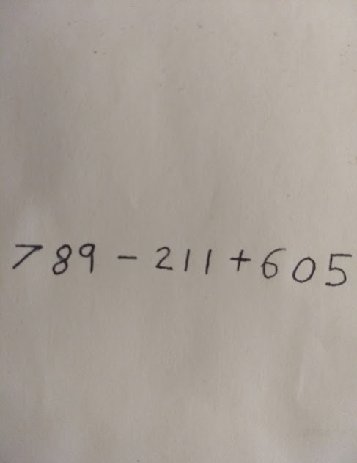

Segmentation:
My first step was to take an image of an expression, and reduce it to 28x28 subimages, with each image containing a digit or operator. This must be done left to right, in order to maintain the correct order. First, I transformed the original image to a binary image, with the digits being white and background black, because this is the format MNIST uses.
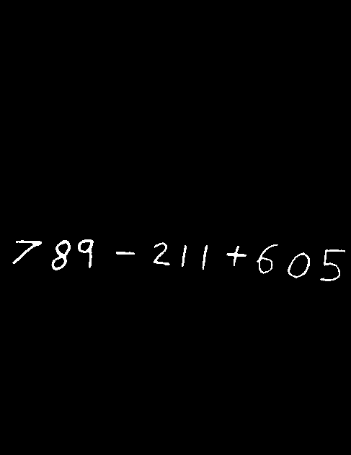

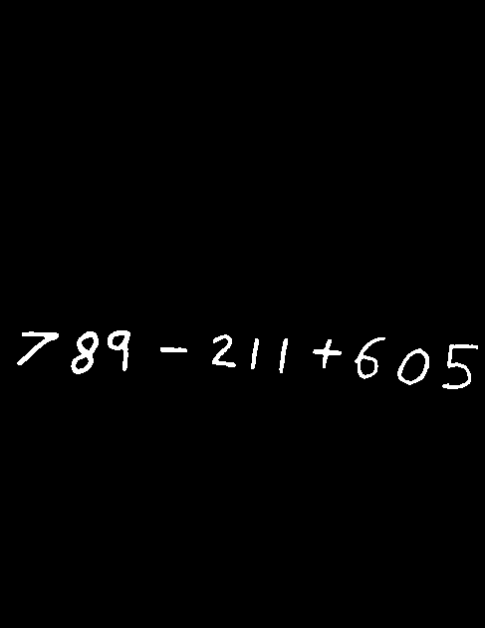
Next, I used a 2x2 structuring element to dilate my image. I did this to ensure that all components (digits and operators) are connected.

Next, I used a modified version of 4-connected component algorithm, in order to find a bounding box for each digit and operator. This works as follows:
1. Scan the image column by column, going from left to right.
2. If a white pixel is found, then recursively check if its 4 neighbors are white, and overwrite the current pixel as black (clone the image before running the algorithm, this image will end up being completely black).
3. If a neighbor is white, check if it is further left, right, above, or below the previous leftmost, rightmost, topmost, or bottommost. If so, then update the appropriate value.
4. Return the leftmost, rightmost, bottommost, and topmost locations found. This is the bounding box of a single component.
Run this algorithm until no white pixels in the image remain. Now we have a list of bounding boxes, from the leftmost digit, to the rightmost. Here is what this list looks like:
[(17, 58, 333, 366), (71, 98, 333, 375), (108, 130, 332, 372), (161, 187, 349, 353), (213, 236, 336, 368), (252, 259, 340, 370), (280, 288, 340, 374), (314, 342, 341, 369), (356, 386, 339, 380), (399, 430, 350, 386), (444, 479, 346, 390)]

Next, I used these bounding boxes to extract the sub-images of each digit or operator.











From these sub-images, it can be seen that minus signs are mostly white, so immediately I classify minus signs as follows:
If the image consists of at least 60% white pixels, and the length of the image is greater than the width, then classify it as minus.
This classifies all minus signs fairly accurately. I also use this technique to detect some 1's (width must be greater than length now), however not all 1's consist of at least 60% white pixels (because they are longer and can be slanted), so if not, I use my digit detector to detect it later.

Of the remaining digits, I now need to prepare them to be classified from a model trained from MNIST. To do this, first I add black border to all sub-images, as MNIST data are not bounded box images, but somewhat centered digits instead. Next, I scale each image down to 28x28, in order to match the number of features of MNIST exactly. This works by taking a group of nearby pixels in the source image, and inserting their average value in the destination image. This has the side effect of converting the image to non-binary, as the average value of a group of black and white pixels can average to something in between. After this, I applied morphological erosion with a 2x2 structuring element, in order to reduce the thickness of the lines. At this point, my images are ready to be classified, and are displayed below (excluding minus sign because it has already been classified):












Before classifying these digits, I first must add + to MNIST, as + is not included, and I have done nothing separate in order to classify +. To do this, I drew roughly 100 plus signs, and following my previous segmentation procedure, I converted the image to binary, dilated it, found the bounding box to each plus sign, added padding, downscaled to 28x28, and eroded each subimage. After this, I converted each sub-image to a row of pixel values, added class label 10 (no other digits have this label), and appended this to the MNIST dataset (see add_plus_to_dataset.py).
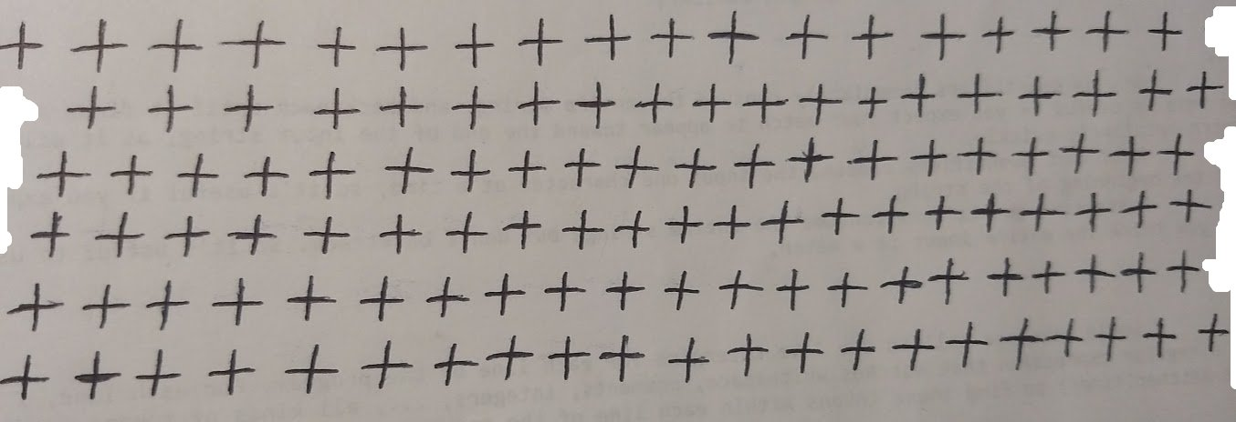
Now I am ready for digit and operation classification.

Digit and operation recognition:
For my digit recognizer, I used SVM, with a RGB kernel. First I divided each pixel value by 255, in order for the distances between all data points to be manageable for an SVM classifier to separate. Next, I trained SVM on 80% of my dataset (MNIST with plus signs), and achieved an accuracy of 98%. This was achieved using one against one classification. One against one classification works as follows:

Build a binary SVM classifier for each pair of classes, which yields ((n-1)*n)/2 classifiers. In my case I have 11 classes (0-9,+), so 55 different classifiers will be produced. (classify 0 against 1, 0 against 2, and so on… do this for every pair). When classifying a data point, each classifier will take a vote, and the class with the most votes is what SVM will classify the point as.

After successful training, I saved this model to a file (svm.sav), in order for my segmentation program to load this model and classify its digits.
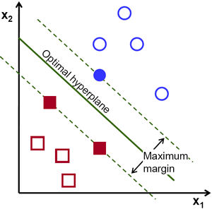

Evaluation:
Now that I segmented my image into sub-images of appropriate dimensions and format, and I have an accurate digit and + sign recognizer, I am ready to evaluate my expression. First, I loaded my model from svm.sav, and decomposed each sub-image into a long row of pixels. I then entered these rows into my classifier (from left to right), and got predictions as to which digit (or operator) the sub-image is. I stored these predictions in a list. Then I concatenated adjacent digits from this list together into numbers. Next, I step by step applied the classified binary operators to these numbers, to achieve my final result. As I applied each operator, I output the result of the step. For my example image, the output was the following (the 6 was misclassified as a 5, but the rest is correct):
789 - 211
578 + 505
Answer: 1083

Results:
For well formatted input, the only issue is that my SVM classifier mis-classifies 6's as 5's.
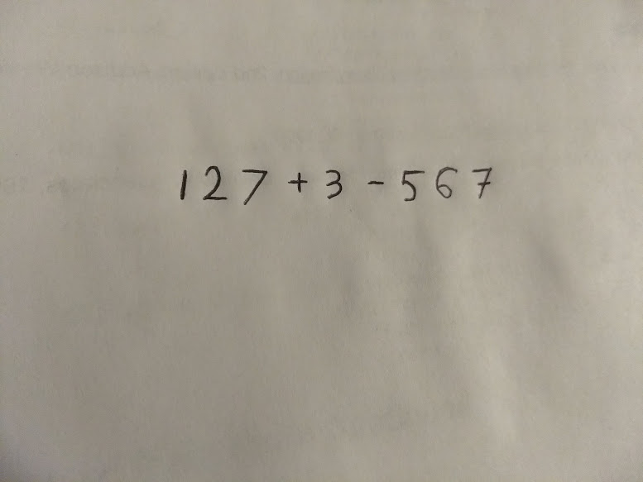

127 + 3
130 - 557
Answer: -427

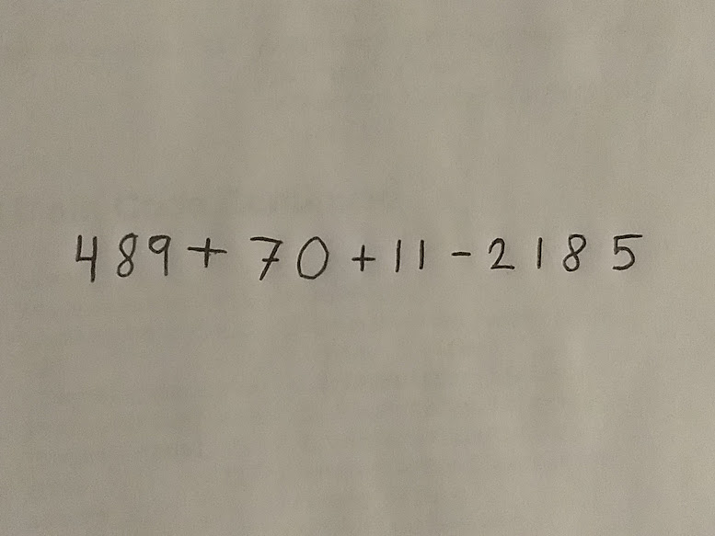

489 + 70
559 + 11
570 - 2185
Answer: -1615

Notice in the following example that all 6's are misclassified as 5's:

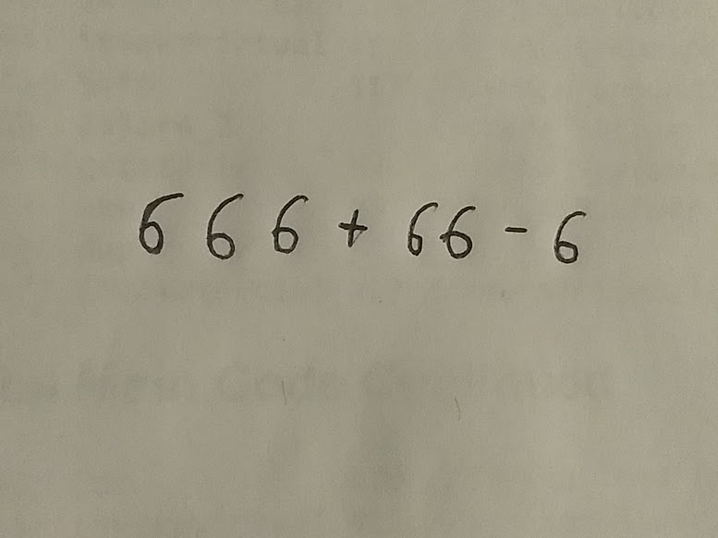

555 + 55
610 - 5
Answer: 605
For real world examples, my program fails:
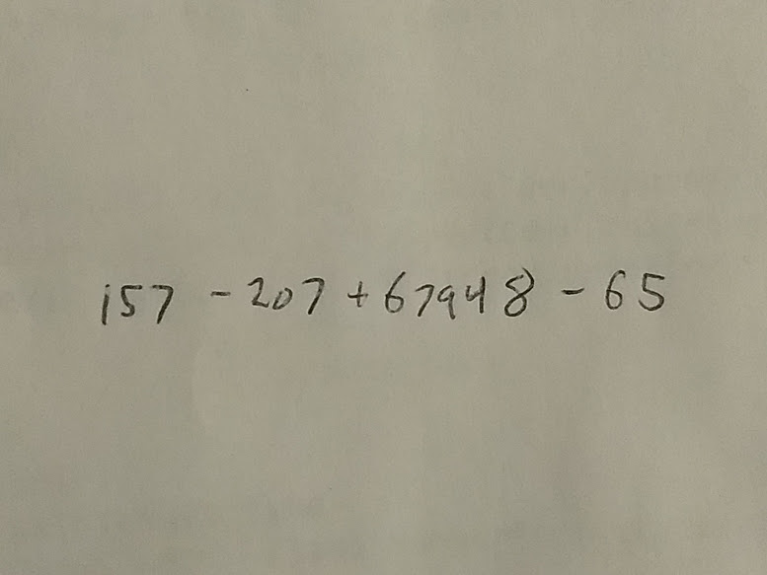

1 - 57
Traceback (most recent call last):
File "expression_parser.py", line 154, in <module>
operand2 = int(numbers.pop(0))
ValueError: invalid literal for int() with base 10: ''

Conclusion:
At the start of this, my goal was to accurately evaluate pictures of well formated basic expressions. Although 6's are misclassified, overall I think my goal has been achieved. The purpose of this was not to build a production ready application, but rather see how applications of this type work on a basic level.

Future work:
Notice how the first 1 is not fully connected in my last example. Because of this, my segmentation will make 2 bounding boxes, and consider it as 2 digits. If one of those 'digits' is now classified as an operator, and the binary operator is not where a binary operator is expected, then my program will crash during evaluation. Even if it happens to succeed, the result will be far off. A new technique to find bounding boxes must be implemented to fix this.
Also notice how every 6 is misclassified as a 5. This seems to be a more tricky problem, as 5's and 6's look very similar. One possible solution is to add some of my own handwritten 6's to MNIST, however MNIST already has thousands of 6's. I'm not quite sure how to proceed in fixing this.
Other things that could be added include other operators, support for equations, functions, calculus, etc…

References:
I built this application only from my own knowledge of machine learning, and visual information processing. Aside from this knowledge, I used documentation from various libraries. Below are the links that I used:

SVM implementation: http://scikit-learn.org/stable/modules/generated/sklearn.svm.SVC.html
Example of very accurate MNIST classification: https://cs.nyu.edu/~wanli/dropc/
Explanation of one vs one classification: http://www.mit.edu/~9.520/spring09/Classes/multiclass.pdf
Download MNIST: https://www.kaggle.com/c/digit-recognizer/data
OpenCv python: https://docs.opencv.org/3.0-beta/doc/py_tutorials/py_tutorials.html
pickle (for saving/loading model): https://docs.python.org/3/library/pickle.html
Examples of more complete math recognition software:
https://venturebeat.com/2015/01/20/khan-academys-new-math-handwriting-recognition-software-is-impressive-video/
http://reference.wolfram.com/language/tutorial/HandwrittenMathRecognition.html
http://cat.prhlt.upv.es/mer/

