# Collaborative Research: Multi-proxy Reconstructions of North Pacific Decadal Variability from Bivalve Mollusks and Trees 1. Background and Motivation

|  |  |
| --- | --- |
| *Figure 1. Pacific Decadal Oscillation climatology. Typical wintertime sea surface temperature anomalies (colors, in °C), sea level pressure (contours) and surface wind stress (arrows) during A) warm, positive PDO phases and B) cool, negative PDO phases. From Mantua et al., 2000.* | (Peterson et al. 2003). These regime shifts profoundly affect energy flows [*Hunt et al.*, 2002; *Hunt et al.*, 2011], trophic linkages [*Aydin and* |

Instrumental records indicate that North Pacific climate is characterized by low-frequency variability and rapid shifts between broadly coherent states. These patterns have traditionally been described by the Pacific Decadal Oscillation (PDO) index, defined as the leading mode of North Pacific sea surface temperature anomalies poleward of 20°N latitude after subtraction of the global mean anomaly [*Mantua et al.*, 1997]. “Warm”, positive phases are characterized by anomalously warm sea surface temperatures (SST) along the west coast of North America, anomalously cool SST across the central North Pacific, and a strong Aleutian Low, especially during the winter and early spring. Opposite conditions occur during “cool”, negative phases

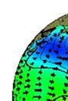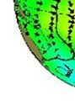

A

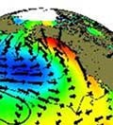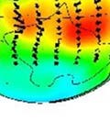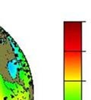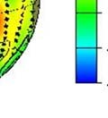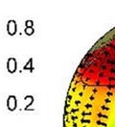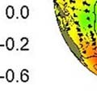

B

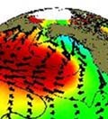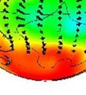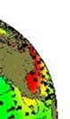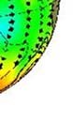

[*Mantua and Hare*, 2002;

*Mantua et al.*, 1997] [Figure

1]. Over the 20th century, the PDO has flipped signs on average at 20-30 yr intervals, most recently passing into a warm phase in 1977 and possibly switching back into a cool phase around 2000

*Mueter*, 2007], transport [*Keister et al.*, 2011], and recruitment patterns [*Clark et al.*, 1999; *Hollowed et al.*, 2001] that can cause major reorganizations of North Pacific marine communities [*Anderson and Piatt*, 1999; *Conners et al.*,

2002; *Hollowed et al.*, 2001]. For example, reversals in PDO polarity correspond to dramatic shifts in North Pacific salmon production regimes, underscoring the importance of low-frequency climate variability to fisheries productivity and management [*Hare and Francis*, 1995; *Hare et al.*, 1999; *Mantua et al.*, 1997]. On land, the PDO is linked to precipitation, temperature, drought, and snowpack patterns in western North America with implications for water resources, wildfire, and the phenology, demographics, and community composition of freshwater and terrestrial ecosystems [*Benson et al.*, 2003; *Dai*, 2013; *Hessl et al.*, 2004; *Mantua and Hare*, 2002; *McCabe*, 2013; *Mote*, 2006; *Neal et al.*, 2002; *Trouet et al.*, 2009]. As an important, spatially cohesive climate pattern with teleconnections to the tropics [*D'Arrigo et al.*, 2005; *Evans et al.*, 2001; *Rodriguez-Ramirez et al.*, 2014; *Schneider and Cornuelle*, 2005], PDO signals are evident in climate patterns across Asia, Australia, and South America [*Andres et al.*, 2009; *D'Arrigo and Ummenhofer*, 2015; *Kim et al.*, 2014; *Rodriguez-Ramirez et al.*, 2014; *Shen et al.*, 2006], as well as in global-scale trends in sea level [*Hamlington et al.*, 2013] and temperature [*Trenberth and Fasullo*, 2013; *Trenberth et al.*, 2014].

Although the impacts of 20th and early 21st century North Pacific decadal-scale oscillations have been broadly described, instrumental climate records are limited to the past 120 years and the longer-term ranges of variability remain poorly quantified. In the absence of direct climate observations, proxies can greatly increase historical perspective. Tree rings are the archetypal example, yielding well-replicated, annually-resolved (one value per year) time series for which each point is assigned the exact calendar year of formation [*Fritts*, 1976; *Speer*, 2010]. The global network of high-quality chronologies is one of the most important data sources for quantifying long-term, broad-scale patterns of climate variability and change [*D'Arrigo et al.*, 2006; *Moberg et al.*, 2005]. Given the often strong coupling between ocean and atmospheric teleconnections, tree rings have been used to skillfully reconstruct the periodicity and intensity of such phenomena as the El Niño Southern Oscillation (ENSO), the Atlantic Multidecadal Oscillation, and the North Atlantic Oscillation [*Cook et al.*, 1998; *Gray et al.*, 2004; *Li et al.*, 2011].

Multiple studies have used tree rings to reconstruct broad patterns of North Pacific sea surface temperatures, several of which explicitly target the PDO [*D'Arrigo et al.*, 1999; *Gedalof and Smith*, 2001; *Kadonaga et al.*, 1999; *MacDonald and Case*, 2005; *Shen et al.*, 2006]. However, these reconstructions poorly agree with one another, even on interdecadal timescales at which the PDO is believed to be most energetic [*Kipfmueller et al.*, 2012; *Mantua and Hare*, 2002] (Figure 2). Considering that the PDO likely originates in the tropics and is linked with low-frequency patterns in the Southern Hemisphere [*Shakun and Shaman*, 2009], sea surface reconstructions from the isotopic and micro-chemical constituents of coral increments can provide an additional perspective on past variability. For example, a time series from Rarotonga (1840-1994) in the subtropical South Pacific and another from Maiana (1726-1997) in the equatorial Pacific correlate with indices of 20th century North Pacific climate as well as PDO-sensitive tree-ring chronologies in western North America [*Gedalof et al.*, 2002]. However, correlations among these marine and terrestrial indicators drop prior to 1900 and are especially poor over the 19th century, a finding reflected in a broader subsequent survey of tropical coral and tree-ring chronologies [*D'Arrigo et al.*, 2005]. From the paleoclimate perspective, these results indicate that the PDO we know, and possibly its coupling to tropical Pacific, has been unusually strong and cohesive over the 20th century [*D'Arrigo et al.*, 2005; *Gedalof et al.*, 2002]. **Ultimately, historical ranges of North Pacific climate variability remain poorly constrained, including the extent to which the strength, coherence, remote forcing, and periodicity of 20th century oscillations are anomalous in the multi-centennial context.**

|  |  |
| --- | --- |
| 1500 1600 1700 1800 1900 2000  Year  **2. Proposed Research** | *earlier.* |

*Figure 2. Instrumental and tree-ring reconstructed PDO indices, smoothed to highlight interdecadal variability. Note agreement during instrumental period, but strong disagreement*

Normalized index

-2

-1

0

1

2

PDO index

MacDonald and Case 2005

Shen et al. 2006

D'Arrigo 2001

Biondi et al. 2001

D'Arrigo and Wison 2006

Here, we propose to use a new proxy of North Pacific inter-decadal variability, Pacific geoduck (*Panopea generosa*, formerly *P. abrupta*), which is a long-lived (>150 yr) bivalve mollusk abundant from approximately Puget Sound through Kodiak, AK. Our recent work with geoduck indicates that dendrochronology techniques can be successfully applied to develop exactly dated, well replicated chronologies from their growth-increment widths. To date, a network of nine geoduck chronologies has been completed, some of which extend into the mid-1800s. This pilot research has demonstrated:

1. The quality of geoduck chronologies is comparable to that of climate-sensitive tree-ring chronologies, as evidenced by strong growth synchrony (crossdating) among within and among sites [*Black et al.*, 2009; *Strom et al.*, 2004].
2. The periodicity of increment formation is annual, as has been verified using the pulse in 14C fallout following thermonuclear testing of the 1950s and 60s [*Helser et al.*, 2012].
3. Three of the nine chronologies strongly correlate to North Pacific sea surface temperatures, including 20th century multidecadal-scale regime shifts. In a linear regression, the mean of these three chronologies explains 44% of the variability in the PDO index (1900-1999) and 70% of the variability in regional sea surface temperatures along the British Columbia coast (1942-1999).
4. Dead geoduck shells collected from shallow sediments have been crossdated to extend a live geoduck chronology back into the early 19th century. These pilot results, coupled with the abundance of dead geoduck shells in lower sedimentary layers, suggests that exactly dated, annually resolved, multi-century (300-400 yr) geoduck reconstructions of Pacific variability are possible.

New instrumental indicators of Pacific Decadal variability are now available to target in reconstructions, defined as the leading Empirical Orthogonal Function of sea surface temperatures (SST1) and sea level pressure (SLP1) bounded by 60°N-20°N, 180°W-100°W [*Johnstone and Mantua*, 2014]. In contrast, the PDO index is the leading EOF of North Pacific sea surface temperature anomalies poleward of 20°N latitude *after subtraction of the* *global mean anomaly*. Thus, and important difference to PDO is that these new northeast Pacific indicators preserve all long-term variability, including a significant centennial-length trend toward warmer temperatures and lower pressure. They also more clearly link the ocean and atmosphere. SST in any given month is a function of that month’s SLP and the prior month’s

(t-1) SST where: [SSTt = SSTt-1 + βSLPt + εt]. In this equation, the  term describes the persistence (autocorrelation) of SST from one month to the next while the β term describes the effect SLP on the ocean surface mixing and transport of heat (plus an εt error term) [*Johnstone and Mantua*, 2014]. Together, these two variables explain 83% of the variance in monthly SST and 73% of the variance in annually averaged SST (1900-2008 period of analysis). Thus, SST1 is an ideal target for reconstruction given that it captures ocean-atmosphere dynamics and retains long-term trends. This will be particularly important for multi-proxy reconstructions involving geoduck, which reflect SST, and trees, which reflect atmospheric drivers of terrestrial temperature and precipitation.

**Geoduck is a high quality predictor for SST1. By creating multi-century geoduck chronologies, we will be able to:**

## 2.1 Generate multi-proxy reconstructions from geoduck and trees

Unlike earlier studies limited to the post-1900 instrumental record, the geoduck record will provide a much longer time series (300-400 yr) with which to screen tree-ring chronologies with stable relationships to Pacific decadal variability. These tree-ring chronologies can be combined with geoduck in multi-proxy reconstructions using techniques similar to those employed by [*Black et al.*, 2009]. In theory, geoduck and trees should provide complementary “perspectives” of SST variability from their unique life histories and habitats.

## 2.2 Evaluate the long-term stability of ocean-atmosphere connections in the North Pacific

Many tree-ring chronologies will not consistently relate to geoduck over time, as evidenced by poor agreement among existing tree-ring based PDO reconstructions. The periodicity, geography, and/or climate sensitivity (e.g. temperature or precipitation) of chronologies that decouple from the geoduck SST reconstruction could provide information regarding the mechanisms behind such instability.

## 2.3 Assess the role of tropical (ENSO) variability on North Pacific decadal variability

The close coupling between North Pacific and South Pacific decadal variability suggests that these patterns may be driven by tropical (ENSO) activity [*Newman et al.*, 2003; *Shakun and Shaman*, 2009]. Indeed, annual PDO can be explained by its one-year lag (SSTt-1) and the current Niño 3.4 index (ENSOt) as summarized by the equation: PDOt = PDOt-1 + βENSOt + εt in which the  term reflects the persistence (autocorrelation) of the PDO from one year to the next while the β term reflects the perturbation of ENSO to the extratropical North Pacific [*Newman et al.*, 2003; *Shakun and Shaman*,

2009]. This relationship is true for SST1 in which Nino3.4 explains 31% of the variance while SST1 lagged by one year explains an additional 16% of the variance; both are highly significant (p < 0.0001). Multiproxy ENSO [*Braganza et al.*, 2009; *Li et al.*, 2011; *Wilson et al.*, 2010] and Pacific decadal variability reconstructions can be substituted into this equation to test the influence of ENSO on the North Pacific over much longer time periods.

## 2.4 Examine decadal variability in water-mass age as an additional proxy for ocean circulation

A final test of North Pacific Ocean circulation will be to use the marine radiocarbon reservoir effect

(MRRE) an indicator of water-mass age. As part of the geoduck chronology-building process, deadcollected shell material will have to be roughly (±30 yr) placed in time using 14C dating. The shell-derived

14 C values, once crossdated, will provide robust temporal estimates of water mass ages at each site (for an example, see Wanamaker et al., [2012]), indicating whether relatively “14C old” or “14C young” water was present. Strong covariance with MRRE would corroborate the broader oceanographic significance of the Pacific decadal variability reconstruction from geoduck and trees. Moreover, a modern and late Holocene MRRE reconstruction will provide needed constraints on radiocarbon reservoir dynamics in the Pacific Northwest in studies that have addressed the issue on deeper timescales [*Hutchinson et al.*, 2004]. Specifically, MRRE estimates based on modern proxy data will inform the construction of age/depth models based on radiocarbon dating of macro and micro fossils in marine sediment cores during the Holocene and earlier times.

## 2.5 Hypotheses

1. Chronologies of geoduck growth-increment width are robust proxies for Pacific sea surface temperatures, the leading indicator Pacific decadal variability.
2. Geoduck preserved in shallow marine sediments with unknown dates of death can be crossdated against live-collected specimens to generate continuous, annually resolved, exactly dated SST histories that extend multiple centuries (200-300 years and perhaps longer).
3. The degree of atmospheric-oceanic coupling in not constant, as indicated by time-varying correspondence among geoduck and tree-ring chronologies of the North Pacific rim.
4. At least some tree-ring chronologies will consistently correspond to the geoduck SST history, enabling multi-proxy reconstructions.
5. Coupling between the tropics and North Pacific varies over time and was particularly strong over the 20th century, which could explain a lack of coherence between Pacific Decadal variability and tree-ring chronologies.
6. The marine radiocarbon reservoir effect history will track decadal-scale variability from geoduck and trees, underscoring the broader oceanographic importance of decadal-scale variability.

## 2.6 Research Objectives

1. Collect dead geoduck shell material from the ocean floor at three sites in which growth has been shown to have strong sensitivity to regional sea surface temperatures.
2. Date dead collected shell material via 14CAMS to provide rough placement in time, then use crossdating to assign exact calendar years of growth and extend chronologies as far back as possible (at least 300-400 yr).
3. Combine measurements from living and dead geoduck specimens. Calculate chronologies using the signal-free standardization technique designed to preserve maximum common variability at high, medium, and low frequencies.
4. Identify North Pacific rim tree-ring chronologies with time-stable relationships to the geoduck SST history and use them to build 300-400 yr multi-proxy North Pacific reconstructions.
5. Use existing, independent, multiproxy ENSO reconstructions to evaluate the time-varying strength of tropical forcing on North Pacific SST reconstructions.
6. Identify tree-ring chronologies with time-unstable relationships to North Pacific decadal variability and use them to characterize the spatial and temporal patterns of shifting linkages between marine and terrestrial climate around the North Pacific rim.
7. Use the MRRE data to further evaluate coastal ocean circulation associated with decadal-scale climate variability.

# 3. Research Plan

## 3.1 Living geoduck chronologies

Many marine bivalve species have shells with annually-resolved growth increment bands that result from seasonal ocean temperature variability influence on the calcification process. Over the past decade, treering techniques applied to bivalve shells have led to precisely dated and annually resolved chronologies that extend back in time from decades to several centuries. Central to this process is the meticulous procedure of crossdating, an iterative process of comparing and matching annual growth patterns, first within individual organisms from a site, and then among numerous sites across a region [*Douglass, 1941; Stokes and Smiley 1996*]. Starting with living samples and the increment formed during the known year of collection, the synchronous growth pattern is cross-matched backward through time. Subsequently, overlapping dead-collected material may be appended to yield chronologies that far exceed the species’ maximum longevity. Ring width measurements can be complemented by measurements of density or isotopic variation [*Cook and Kairiukstis*, 1990; *Fritts*, 1976].

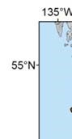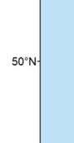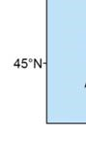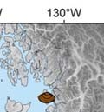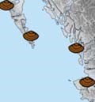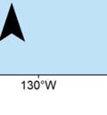

Tre

No

Poole

S

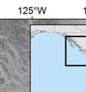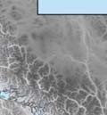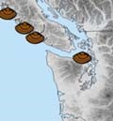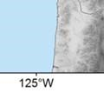

e

b

trom

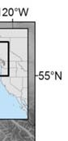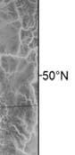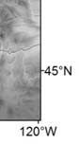

These approaches have been successfully applied to marine bivalves with some of the best examples from the species *Arctica islandica*, which has been used to reconstruct long-term trends in the surface component of the Atlantic meridional overturning circulation, variability in polar fronts, and the infiltration of anthropogenic carbon into the deep ocean [Butler et al., 2013; Butler et al., 2010; Wanamaker et al., 2012]. *Arctica* chronologies are well replicated to multicentennial timescales, and with clear potential for continuous, exactly dated time series multiple millennia in length [Butler et al., 2013]. Parallel potential now exists for the North Pacific Ocean.

Along the west coast of North America from approximately Puget Sound, WA, through Kodiak, AK,

|  |  |
| --- | --- |
| *Figure 3. The northeastern Pacific and locations of Pacific geoduck chronologies; the locations of the three sites sensitive to basin-wide signals are labeled.* | the Pacific geoduck (*Panopea generosa*, formerly *P. abrupta*) are widely abundant, long-lived (> 150 yr),  filter-feeding bivalves that occur from the lower intertidal  *Bernard Coan et al.* |

to depths up to 100 m [ , 1983; , 2000].

Geoduck shells contain beautifully varying, annually resolved growth increments that robustly crossdate within and between sites. To date, nine geoduck chronologies have been developed, all of which are of high quality by dendrochronology standards (Figure 3, Table 1). The first was developed by Strom et al. [2004] with samples from Washington’s Puget Sound followed by eight others along the British Columbia, four of which are not yet published [*Black et al.*, 2009].

In each case, the same methods for chronology development were used, as will be applied to extend the chronologies with dead material. Specimens were prepared from a single geoduck shell that was embedded in epoxy and cut with a diamond-bladed lapidary saw along the height axis of the valve, passing through the center of the hinge plate region. The cut surface was polished with 15um followed by 9um and 3um lapping film and then etched with two-percent hydrochloric acid. An impression (acetate peel) was made by placing a piece of acetate film on the polished shell surface, flooding it with acetone to soften, and then removing (peeling off) the acetate film once dry. The resulting “peel,” which captures the three-dimensional surface of the etched geoduck, was placed between two glass slides and viewed through a dissecting microscope using transmitted light. The hinge plate (inner shell layer) grows at a rate proportional to that of the outer shell layer, but is better protected from erosion and provides the most complete record possible.

For each hinge, two to eight overlapping digital photographs were taken with a Leica DC300 7.2 megapixel camera at 60-100X magnification using transmitted light and tiled into a single panoramic image. Growth increment widths were measured using Image Pro Plus 6.0 or Image Pro Premier (Media Cybernetics Inc., Silver Spring, MD) along continuous transects that followed the axis of growth, delineated at the end of the winter line. Crossdating and measurement quality control was performed with the discipline standard program COFECHA [*Holmes*, 1983; *Grissino-Mayer*, 2001]. Beyond the compelling visual and statistical evidence that crossdating works within and among sites, the annual periodicity of Pacific geoduck has been independently validated using the rapid increase in 14C fallout that followed thermonuclear testing in the late 1950s and early 1960s [*Helser et al.*, 2012].

*Table 1. Properties of Pacific geoduck chronologies.*Site-level geoduck chronologies

|  |  |  |  |  |  |
| --- | --- | --- | --- | --- | --- |
| **Site** | **Span1** | **N2** | **ISC3** | **MS4** | **SST**  **correl.5** |
| Barkley  Bartlett  Brady's Beach  Cape Mark  Goletas  Poole  Strom  Tree Nob | 1903-2004  1937-2003  1934-2001  1887-2004  1948-2001  1874-2005  1877-1999  1846-2002 | 30  40  30  28  22  75  74  74 | 0.65  0.71  0.71  0.67  0.76  0.72  0.76  0.74 | 0.25  0.24  0.22  0.25  0.23  0.21  0.25  0.29 | 0.20  0.19  0.18  0.11  0.44  0.55  0.62  0.60 |

were developed with methods standard in dendrochronology [*Cook and Kariukstis*, 1990].

The program ARSTAN [*Cook,* 1985; *Cook and Holmes*, 1986, *Cook and Krusic,* 2005] was used to remove growthincrement trend related to biological age and shell geometry and calculate normalized indices with a

1. *Chronology span, limited to a minimum of six measurement time* common mean and stabilized *series contributing* variance. The final numerical
2. *Number of measurement time series* chronology was estimated as the
3. *Interseries correlation, as calculated by COFECHA* robust bi-weight mean value of
4. *Mean sensitivity, as calculated by COFECHA* all available indices in a given 5. *Correlation with regional sea surface temperatures (SSTBC)* year [*Cook et al*, 1990]. Once

completed, the quality of the chronology was quantified using the Expressed Population Signal (EPS) statistic, which describes how well the sample means represents the mean of the theoretical population from which it was drawn. Though there is no significant threshold for this statistic, an EPS value of 0.85 or greater is considered adequate, which for geoduck was reached in all cases with a sample depth of five or six individuals [*Wigley et al.*, 1984]. As an index of chronology quality, the series intercorrelation is reported here, defined as the average correlation between each measurement time series and the average of all others after low-frequency variability has been removed (Table 1). Also reported is the mean sensitivity, an index of high-frequency (year-to-year) variability among pairs of successive increments that ranges from a minimum of 0 (a pair of increments of the same width) to a maximum of 2 (a pair in which one width is 0) [*Fritts*, 1976]. (Table 1)

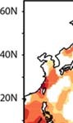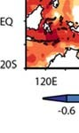

A

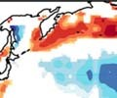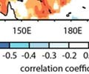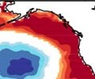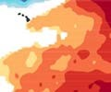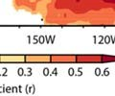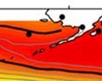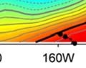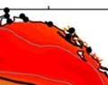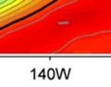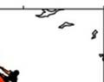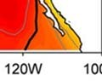

B

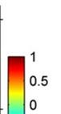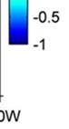

*Figure 4. A) Correlation between spring and summer (Jan-Jul) gridded SST data and the mean of the Tree Nob, Strom, and Poole geoduck chronologies for the period 1946-1999. B) Correlation of the leading EOF of North Pacific SST and gridded SST anomalies (SST1 from Johnstone and Mantua [2014]; the target of our reconstruction). The bold black line encloses correlations > 0.6.*

## 3.2 Climate-growth relationships

Work to date has demonstrated that geoduck chronologies reflect variability in SST, though only some capture a regional to basin-wide signal while others appear to capture highly local processes [*Black et al.*, 2009; *Strom et al.*, 2004]. To determine which of the nine chronologies capture a regional- to basinwide signal, we used SST data collected at six lighthouse stations located along the British Columbia coast, all spanning 1942-2005 (archived at http://www.pac.dfo-mpo.gc.ca/sci/osap/data/Search Tools/Searchlighthouse_e.htm). The leading principal component of annual average SST (SSTBC) captured 86.1% of the variance in the dataset, reflecting a high degree of synchrony across the region [*Black et al.*, 2009]. Of the nine chronologies, Tree Nob, Poole, and Strom correlate most strongly to SSTBC and also happen to have the longest-lived individuals (Figure 1, Table 1). The average of these three chronologies correlates remarkably well (r = 0.81; p < 0.0001) with SSTBC, highlighting a strong relationship between regional geoduck growth patterns and climate signals (Table 1).

Correlations between the mean of the three chronologies and Hadley iSST 0.5° gridded SST data (1946-1999) show that the climate signal captured by geoduck is relevant far beyond the British Columbia coast. Indeed, the positive alongshore and negative offshore (central North Pacific) correlation pattern reflects the spatial “fingerprint” of the PDO (Figures 1,5A). Moreover, peak positive correlations between SST and geoduck reflect the pattern of SST1 developed by Johnstone and Mantua (2014) (Figure 4 A,B). Thus, the mean of the three geoduck chronologies is a skillful proxy for SST indicators, accounting in a linear regression for 70% of the variance in SSTBC, 49% of the variance in SST1, and the 44% of the variance in the PDO (Figure 5). Note that SST1 contains a significant linear increasing trend (R2 = 0.22 p < 0.001), which was removed prior to comparisons with geoduck. Considering that geoduck measurement time series rarely spanned more than 100 years, such long-term trends would be lost to the detrending “segment length curse” and thus absent from the final chronology [*Cook et al.,* 1995]. A major motivation for this proposed research is to maximize low frequency signals in the proxy data. This can be accomplished by incorporating dead-collected geoduck in the dataset and utilizing the signal-free standardization approach [*Melvin and Briffa*, 2008; *Briffa and Melvin*, 2011, *Cook et al.,* 2013], a state of the art innovation in chronology estimation designed to maximize preservation of medium and low frequency signals common amongst individuals at a site.

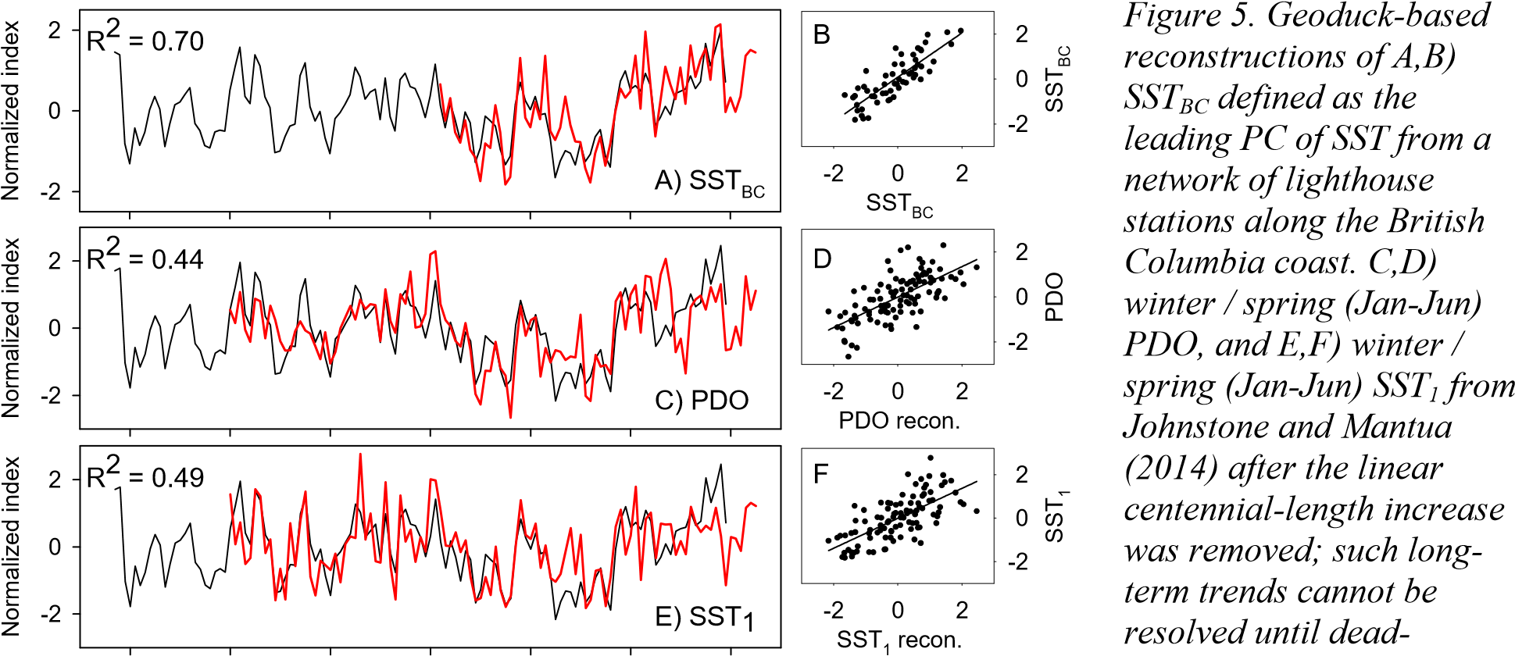

1880 1900 1920 1940 1960 1980 2000 *collected shells are added.*

Year

## 3.3 Incorporation of dead geoduck shells to extend existing chronologies

Here, we propose to collect dead geoduck from the ocean floor at the three sites sensitive to basin-wide SST in collaboration with the Washington Dept. of Fish and Wildlife (DFW) (Strom site), the West Coast Geoduck Research Corp. (Tree Nob site) and Haida Nations Fisheries (Poole Inlet site). These three organizations extensively collect live geoduck in support of fishery management and thus have the experience, expertise, and trained personnel. Dead geoduck will be collected by divers working at 10-30 m using a Venturi device to excavate overlying sediment and harvest shells; substrate composition (sandy) and geoduck density is especially favorable at Tree Nob and Poole. The live geoduck used in the Strom chronology were collected around Protection Island in Puget Sound, the northeast corner of which has a sandy substrate and dead shells. Another alternative is to sample at the nearby Dungeness Spit from which 600 live animals have already been collected. Coherence with the Strom chronology and SST1 will be checked using these live-collected individuals should that site be required. Based on pilot work, we anticipate that one full day of sampling at each of three sites will allow us to collect at least 200 large geoduck shells, taking care to sample as many sedimentary layers possible. We believe this should be adequate to extend the chronology as far as possible given that a minimum sample

depth of four to six individuals provides an EPS greater than the target value of 0.85. In July 2009, DFO divers collected 77 dead geoduck from Tree Nob in approximately three hours of effort, eight of which could be crossdated against the living chronology, extending it back in time from 1877 to 1846 (with EPS > 0.85) (Figure 6). In this test, other geoduck

Year

2000

1950

1900

1850

Increment index

0.0

0.5

1.0

1.5

2.0

2.5

3.0

Live

Dead

|  |  |
| --- | --- |
| *Figure 6. Geoduck growth increment index chronology at Tree Nob, with site level mean chronology indicated in black. Standardized time series of live and dead-collected geoducks are shown in grey and red, respectively. Dead collected materials extend the chronology into the early 19th century.* | could be matched to one another, but not anchored in time to the live-collected chronology. This evidence suggests that these individuals |

grew in earlier centuries. We propose that more exhaustive sampling would lead to recovery and crossdating of individuals stratified through time, which is expected to lead to a continuous, multi-century geoduck proxy record. Targeting only large individuals in combination with improved etching techniques will increase the percentage of individuals that can be used to generate chronologies. Ten to fifteen living geoduck will also be collected so that each chronology can also be updated to present (2014).

Once shells are collected, acetate peels will be taken using techniques comparable to those applied to live-collected individuals. An important difference is that dead-collected material tends to be relatively soft and thus requires weaker acid (1% HCl as opposed to 2%) and / or less etching time. As necessary, we will also thin-section and stain with Mutvei’s solution to better resolve increment boundaries [*Hickey and Banas*, 2003; *Schone et al.*, 2005], though this to date has not worked as well as acetate peels in live-collected material. Samples will be digitally photographed at approximately 80-100x magnification, after which the visual crossdating process will begin via skeleton plotting. In this technique, the growth pattern of each individual is transferred to graph paper and slid back and forth through time in search of a match [*Douglass*, 1941; *Stokes and Smiley*, 1996]. For trees, the focus is usually on narrow increments, though wide increments are just as useful for dating in geoduck and will also be recorded. Once visual crossdating is complete, increment widths will be measured using Image Pro Premier and dating will be statistically verified using COFECHA in the same manner as was used for live-collected samples. Undoubtedly, “floating” chronology segments (or individuals) will occur. To at least roughly date (±30 yr) these time series, shell material (~10 mg of CaCO3) will be sampled with a New Wave micromill and sent for 14CAMS dating at the National Ocean Sciences Accelerator Mass

Spectrometry (NOSAMS) facility at Woods Hole Oceanographic Institution. Earlier work [*Helser et al.*, 2012] has found that material from the first few increments is sufficient, and we are allowing for approximately 20 samples to be sent for dating from each site. Ideally, this will allow us to organize these floating measurements in time and maximize chances for crossdating success. At the minimum, we can know approximately what calendar years the floating series span and assess ranges of variability typical for that era.

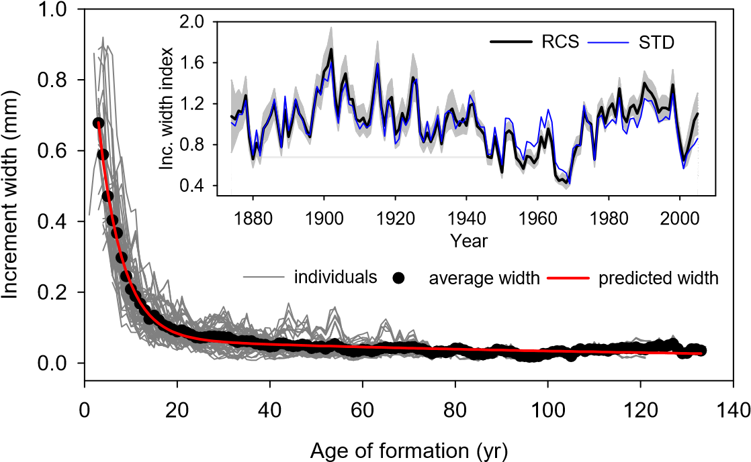Once all dead-collected material has been dated, we will use the signal free approach of Regional Curve Standardization (RCS) [*Melvin and Briffa,* 2008; *Briffa and Melvin,* 2011; *Cook et al.,* 2013] to maximize low-frequency signals in the final chronologies. To date, geoduck have been detrended by fitting each measurement time series with a separate negative exponential function and dividing observed values by those predicted. This approach removes not only age-related growth declines, but also any trends at or beyond the length of the measurement time series. Given that measurement time series are generally 50-100 years for geoduck, this “segment length curse” precludes the capture of low-frequency, centennial-length variability [*Black et al.*, 2009; *E R Cook et al.*, 1995]. By adding dead-collected material and using signal-free RCS for detrending, low-frequency processes can be retained. To accomplish this, all geoduck measurements will be arranged by age of formation and the mean increment width will be calculated for each age. The final RCS detrending curve will be a smoothed estimate of mean growth by age. [*Melvin et al.*, 2007]. The key to this is to be as consistent as possible in placing the axis of measurement on each individual, as was done with the Poole dataset (Figure 7). A potential drawback to RCS in trees is that there can be considerable ranges of values within each age class, translating to

|  |  |
| --- | --- |
| wide confidence intervals in the final chronology. However, grow trajectories in geoduck are highly regular, and this issue of extra error is not so pronounced (Figure 7). If RCS is performed using only live-collected individuals, low-frequency variability is modestly amplified (Figure 7). However, including dead-collected individuals that lived over a variety of | *Figure 7. Poole geoduck increment-width measurements arranged by age of formation, illustrating the potential for RCS. Inset: chronology developed using RCS (with 95% confidence intervals) compared to a chronology (STD) developed by detrending each measurement series individually.*  *The RCS chronology exhibits a modest gain in low-frequency signal. Incorporation of dead material and the signal-free estimation of the RCS detrending curve are expected to preserve the maximum amount of low frequency signal available from the data.* |

climate regimes would allow for low-

frequency variability to be captured. Individuals that lived during (cool) periods unfavorable for growth would fall below the detrending curve and those growing during (warm) periods favorable for growth would fall above the detrending curve (red line in Figure 7). By incorporating many shells from living and dead cohorts, we will be able to avoid these problems, as advocated by *Briffa and Melvin* [2011]. When detrending using that single function in RCS, information from these low- and high-growth periods will be preserved in the final chronology.

## 3.4 Multi-proxy reconstructions

The target for reconstruction will be SST1 in Johnstone and Mantua [2014] because it has strong atmospheric linkages, targets the northeastern Pacific, and unlike the PDO, retains centennial-length trends. SSTBC will also be targeted because it has such strong relationships to geoduck and is derived from high-quality data sources. The average of the three geoduck chronologies regressed against the target variable provides the simplest and most effective approach in a preliminary analysis (Figure 6). Ideally, all three geoduck chronologies could be extended over the past few centuries, though combinations of two are also skillful. For SSTBC, the average of all three chronologies has an R2 of 0.7 while combinations of two chronologies produce R2 values from 0.53 to 0.64 (in contrast to 0.38 to 0.42 for single chronologies). All chronologies will be truncated to include only those years in which EPS exceeds a value of 0.85 [*Wigley et al.*, 1984].

Although tree-ring PDO reconstructions poorly agree with one another, tree-ring data almost certainly contain useful information on long-term Pacific decadal variability. In theory, this information could be combined with geoduck to generate reconstructions with greater explanatory power than either proxy could provide alone. Trees and geoduck would have complementary mechanisms through which these climate signals are integrated into growth, each capturing different aspects or seasons of Pacific decadal variability through unique “perspectives” of habitat and life history. Indeed, previous work has shown that trees significantly increased reconstruction skill of SSTBC beyond what two geoduck chronologies (Tree Nob and Strom) could provide [*Black et al.*, 2009].

A key component of this project is that the extended geoduck history will enable a much longer interval over which to screen tree-ring chronologies for relationships to Pacific decadal variability. To date, tree-ring data can only be compared against the instrumental index, which for the PDO begins in 1900. Here, geoduck can be a used as a multi-centennial SST index for longer-term comparisons. In a preliminary analysis using PDO, we correlated publicly-available tree-ring chronologies from western North America with the mean of the three geoduck chronologies over the period 1877-1920 and 1921-present. Many chronologies correlated strongly over the 1921-present period, but relatively few also correlated (r > 0.3) in the earlier period. Those that consistently correlated were temperaturesensitive, occurring in Alaska or high-elevation sites in Oregon and Washington (Figure 8). When those tree-ring chronologies were averaged and entered into a multiple regression with geoduck, both variables were significant in a stepwise linear regression; trees explained an additional 6% of variance (Figure

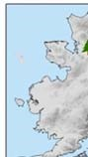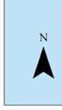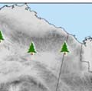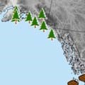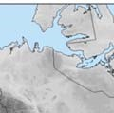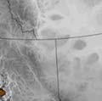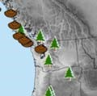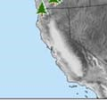

9).

For subsequent analyses, the target will be SSTBC and

SST1 from Johnstone and Mantua, and tree-ring chronologies will first be detrended using the signal-free standardization

|  |  |
| --- | --- |
| *Figure 8. Public tree-ring chronologies that consistently relate to geoduck chronologies in western North America. Many privately held chronologies from British Columbia will also be provided for this work, courtesy of Dan Smith at the University of Victoria.* | [*Melvin and Briffa*, 2008] that preserves the maximum amount of medium to low frequency variations common within a dataset. This ensures that multidecadal and long-term trends are retained when possible; as with geoduck, only those portions in which the EPS exceeds 0.85 will be retained. Several hundred tree-ring chronologies are publically available through the International Tree-Ring Databank for western North America and eastern Asia (North Pacific rim) [*NOAA*, 2007] and we will |

also have access to other privately held chronologies from northern Boundary Ranges, the Kitimat Ranges, and the Pacific Ranges on mainland British Columbia, as well as chronologies from the Insular

Mountain Ranges on Haida Gwaii and Vancouver Island [Dan Smith, University of Victoria, personal communication]. To ensure consistent agreement over time, tree-ring data and geoduck will be screened using lagged box-car and running 100-year correlations, as well as a Kalman filter approaches [*Visser and Molinaar*, 1988; *Wilson et al.,* 2010], which will allow us to evaluate changes in the nature of the relationship through regression models in which coefficients are allowed to vary through time. Simple averaging across tree-ring chronologies, as done in this example, will be considered as will multiple regression and principal component regression for the final reconstructions. Lags will also be considered, and regression diagnostics such as the Durbin-Watson statistic and Variance Inflation Factors to ensure that regression assumptions are met. As a final note, only one existing PDO reconstruction, D’Arrigo et al. [1999], consistently corresponded with geoduck, including the even longer 1846-2002 Tree Nob chronology. It was generated from temperature-sensitive tree-ring data and may be the most accurate long-term record to date.

Reconstruction length will be maximized using a nested approach, and the error around reconstructions quantified using bootstrapping [*Black et al.*, 2014]. Specifically, the number of chronologies contributing to the reconstruction (sample depth) will diminish back through time. For each change in sample depth, contributing chronologies will be randomly selected with replacement as will those calendar years shared with the instrumental record (SST1 or SSTBC). The regression procedure

relating climate and proxy will be applied using these selected samples and years. This procedure will be repeated 10,000 times and the median values and associated percentiles (errors) will be calculated. Within each iteration, some calendar years will not be chosen for the regression, and these values will be used for independent verification using the Reduction of Error statistic, which is a measure of shared variance between the

Normalized PDO

-3

-2

-1

0

1

2

3

4

tre

es

reconstruction

DO

P

geoduck

|  |  |
| --- | --- |
| 1750 1800 1850 1900 1950 2000  Year  *Figure 9. The PDO instrumental record, the mean of three geoduck chronologies (R2 = 0.44), the mean of PDO-sensitive tree-ring chronologies (R2 = 0.26) (see Fig. 9), and a multi-proxy PDO reconstruction from trees and geoduck (R2 = 0.50). Ideally, geoduck would extend over 300 years or more to fully complement the trees.* | withheld (independent) data and the values modeled from the calibration data set. The maximum theoretical value of the RE statistic is +1 and any positive value indicates some degree of skill [*Fritts*, 1976].  The ensemble medians and associated error (one set at each sample depth) will be spliced together to form the final nested reconstruction. Frequency characteristics of |

the multi proxy reconstruction will be characterized using singular spectrum analysis and the wavelet power transform [*Ghil et al.*, 2002; *Torrence and Compo*, 1998].

## 3.5 Marine radiocarbon reservoir effect (MRRE) and ocean dynamics

14 C dating will be used to roughly place shells in time to aid in development of the geoduck growth-increment width chronologies. This same information can also be used to develop a decadal-scale reconstruction of the MRRE from our three locations and checked for agreement with Pacific decadal variability derived from trees and geoduck. We argue that the MRRE data and what it suggests about water mass age (deep, “old” water vs. surface “young” water) will provide complementary insight into regional oceanographic processes. Indeed, the PDO has been linked to a suite of covarying northeast Pacific oceanographic processes including alongshore transport, freshwater discharge, and upwelling/downwelling [*Mantua and Hare*, 2002], which could impart decadal-scale signatures in the MRRE. Radiocarbon data from the CALIB database (http://calib.qub.ac.uk/marine/) for this region

(specifically near the Strom site to the south) indicate a strong inverse relationship (r2 = 0.74; p < 0.01; N = 6) between the PDO index and the MRRE in the early 20th century. Although the sample size is rather small, the result is dynamically consistent with PDO-associated variability. The 14C pulse following nuclear weapons testing in the late 1950s coupled with the coarse temporal resolution of MRRE reconstructions will preclude us from testing correlates with instrumental oceanographic records of upwelling and transport. However, we can establish whether the MRRE covaries with trees and geoduck and corroborate its broader oceanographic significance of Pacific decadal variability. Moreover, MRRE in this general region has been examined in some detail during glacial or deglacial climate (e.g. *Hutchinson et al.*, 2004), but very few workers have investigated modern and late Holocene variability. An absolutely dated reconstruction of the MRRE from this region, as proposed here, will provide needed constraints on radiocarbon reservoir dynamics in the Pacific Northwest. MRRE estimates from recent centuries may also be useful in glacial/deglacial time scales (despite vastly different boundary conditions) by providing the natural range of variability of the MRRE and rates of change from absolutely dated shell records. Specifically, such estimates based on modern proxy data will inform the construction of age/depth models based on radiocarbon dating of macro and micro fossils in marine sediment cores during the Holocene and earlier times.

MRRE records will be constructed by sampling along increments of known age in the geoduck hinge region with a micromilling device to produce a decadal-scale MRRE record prior to 1950 (prior to the detonation of thermonuclear bombs) for each site. For each MRRE determination, a total of 10 increments of a sectioned shell section will be sampled (1 mg from each increment for a total of 10 mg of CaCO3). Once dead-collected shell material has been crossdated, additional MRRE estimates can be made using the same procedure noted above to extend the temporal framework for these estimates. We have budgeted for 60 radiocarbon analyses, which will be carefully spaced over time from our three locations to maximize the potential of MRRE reconstructions. Given earlier difficulties in establishing 18O as a climate proxy in geoduck [*Hallmann et al.*, 2008] plus the robust relationship between temperature and increment width, other isotopic indicators will not be addressed in the study. Shells will, however, be archived for future studies that may address geochemical proxies (boron isotopes, Ba/Ca ratios, etc.).

**3.6 Tropical teleconnections** The close coupling between North Pacific and South Pacific decadal variability suggests that these mid-latitude patterns may be driven by tropical (ENSO) activity [*Newman et al.*, 2003; *Shakun and Shaman*, 2009]. Annual PDO can be explained by its one-year lag (SSTt-1) and the current Niño 3.4 index

(ENSOt) as summarized by the equation: PDOt = PDOt-1 + βENSOt + εt in which the  term reflects the persistence (autocorrelation) of the PDO from one year to the next while the β term reflects the perturbation of ENSO to the extratropical North Pacific [*Newman et al.*, 2003; *Shakun and Shaman*, 2009]. This relationship is true for the SST1 indicator in which Nino3.4 explains 31% of the variance and aSST1 lagged by one year explains an additional 16% of the variance; both are highly significant (p < 0.0001). Multiproxy ENSO reconstructions [*Braganza et al.*, 2009; *Li et al.*, 2011; *Wilson et al.*, 2010] and the multiproxy North Pacific variability record can be substituted into this equation to evaluate changing contributions of ENSO to SST1 over time. In a preliminary analysis, we found that the Braganza et al. [2009] Nino 3.4 reconstruction consistently explains over time approximately 6% of the variability in the mean of the three geoduck chronologies. Once our new Pacific decadal variability reconstructions are complete, we will test this relationship more extensively through comparison against the other independent ENSO reconstructions. We will employ correlation and Kalman filter approaches [*Visser and Molinaar*, 1988; *Wilson et al.,* 2010], to assess the temporal stability of tropical-north pacific covariability. Complementary analysis with the cross-wavelet transformation [*Grinstead et al.,* 2004] will be used to assess coherence and phase relationships between tropical and north Pacific climate reconstructions as a function of time and frequency.

## 3.7 Variability in coupling with terrestrial climate processes

Poor agreement among tree-ring PDO reconstructions suggests that coupling between terrestrial climatic processes and Pacific decadal variability is unstable, changing in intensity or spatial extent over time and possibly driven by different “flavors” or “modes.” For example, *Cook* [2009] found an important distinction between PDO reconstructions that utilize North American tree-ring chronologies north or south of approximately 40º latitude. Here, we will use a suite of exploratory data analyses to investigate the time-dependent relationships between the multiproxy reconstruction and independent tree ring chronologies from the North Pacific Rim. For example, lagged box-car correlation and Kalman filter techniques focused on approximately 50 to 100-year windows, will be used to identify tree-ring data that exhibit statistically significant but temporally unstable covariance with the reconstruction of Pacific decadal variability. Running covariance between the tree-ring chronology and Pacific decadal variability will be estimated for each chronology and these coefficients will be entered in a matrix of chronology by year. Correlation matrices will be calculated and principal components analysis with Varimax rotation will be used to examine spatial and temporal patterns for the full, multi-century period of the reconstruction (i.e. 1600–2000). This process will be repeated for 100-year blocks lagged by 50 years (i.e. 1600–1700, 1650–1750, 1700–1800, and so on), to elucidate time-varying spatial patterns in the chronologies, which will subsequently be interpreted in terms of geographic distribution and tree-species composition. For example, lower-elevation moisture-sensitive tree-ring chronologies in California may cluster and correspond well to geoduck in some time periods but not others. At other times, temperaturesensitive high-elevation or high-latitude sites may cluster and correspond well during other time periods. Albeit largely exploratory, these types of analyses are expected to provide valuable clues in the changing nature of ocean-atmospheric coupling, the spatial “fingerprint” of any dominant patterns or modes, and the extent to which 20th century marine-terrestrial linkages are atypical in the long-term context.

# 4. Relevance to NSF P2C2 Program

## 4.1 Intellectual Merit

Foremost, this work will produce a network of novel, exactly dated marine proxies to reconstruct North Pacific decadal variability, a major mode of Earth’s climate system that remains poorly constrained by instrumental observations, paleoclimate data, and general circulation models. In addition, integrating tree-ring chronologies with growth and radiocarbon signatures from live and dead-collected geoduck shells will facilitate a multifaceted approach to maximize reconstruction skill. At the same time, this project should address lingering questions regarding poor agreement among earlier tree-ring reconstructions and the possibility of time variant linkages across marine and terrestrial systems. Moreover, long-term relationships between the North Pacific and tropical Pacific can be addressed by integrating independent, annually-resolved ENSO reconstructions. The potential for success with this proxy and paleoclimate reconstruction has been clearly demonstrated through the unpublished pilot studies illustrated in this proposal. Ultimately, these North Pacific paleoclimate reconstructions will yield unique benchmarks for comparison to paleo, modern, and model datasets of hemispheric climate, and on timescales ranging from interannual to centennial. Therefore, this work is a strong match for both of the important scientific objectives articulated in the P2C2 request for proposals.

## 4.2 Broader Impacts

This work has strong potential to transform understanding for how North Pacific climate has varied in the past, and through comparison with model projections, how it may respond to future climate change. As such, the development and synthesis of these annually-resolved records will be of value to the broad climate/paleoclimate communities. All data produced as part of this project will be made publicly available and archived on community websites including the NSF BCO-DMO website and NOAA National Centers for Environmental Information Paleoclimatology Database. At least five high-impact, peer-reviewed papers are expected.

The project brings together an international team of academic (U. Texas, Iowa State, U.

Minnesota, U. Victoria) and federal (NOAA Fisheries) researchers to address long-term climate dynamics in the North Pacific through multidisciplinary research that will facilitate training for a number of junior researchers. Co-PI Wanamaker will mentor two undergraduate researchers who will contribute to the project as part of senior capstone projects at Iowa State University. This project supports Co-PI Griffin, an early career faculty member who will bring expertise in the most current chronology development techniques and time series analysis while gaining exposure to sclerochronology, marine science, and multi-proxy reconstructions. At the same time, an MS student and a postdoctoral researcher will be mentored in state-of-the-art climate reconstruction at interface among marine science, terrestrial science, climate science, and geoscience. All participants will gain experience working in diverse, multiinstitutional teams and the “business” of conducting science, including data development and interpretation, collaboration, publication, and dissemination of results.

# 5. Research Schedule and PI Responsibilities

## 5.1 Timetable and associated personnel

|  |  |  |  |  |
| --- | --- | --- | --- | --- |
| Project Task | Y 1 | Y 2 | Y 3 | Senior Personnel |
| Standardization, analysis of geoduck chronologies | X | X | X | BAB, DG, ADW |
| Collection of dead geoduck shells | X |  |  | BAB, Contractors |
| Dating of dead geoduck shells | X | X |  | BAB, ADW |
| Water Mass Age Analysis | X | X |  | ADW |
| Compilation and standardization of tree ring data. | X | X | X | DG, BAB |
| Synthesis of results |  |  | X | BAB, ADW, DG, NM, DS |
| Publication and presentation of results | X | X | X | BAB, ADW, DG, NM, DS |
| Dissemination of data |  | X | X | BAB, ADW, DG |

**5.2 Contribution of Key Participants** *Principal investigator* Bryan Black is originally trained as a forest ecologist and applies techniques developed by dendrochronologists to generate chronologies from the growth increments of marine and freshwater species of bivalves and fish. He has extensive experience with environmental reconstruction from terrestrial and marine organisms, including Pacific geoduck. His role in the project will be to develop extended geoduck chronologies from dead-collected material and coordinate multi-proxy reconstructions in collaboration with an MS student and post-doc. As the lead PI, he will coordinate all research activities amongst participating institutions and convene regular meetings for project collaborators to review progress, discuss results, and prioritize next steps.

*Co-investigator* Alan Wanamaker directs the Iowa State University Stable Isotope Laboratory in the Department of Geological and Atmospheric Sciences. His research is largely focused on documenting and understanding past climates and ecosystems using width and isotopic properties of bivalve growth increments, especially in the high latitudes of the Arctic and North Atlantic region. He will oversee all 14C isotopic analysis and reconstruction of water mass age.

*Co-investigator* Daniel Griffin is a dendroclimotologist with over 15 years of experience in tree-ring chronology development, time-series standardization, spatiotemporal data analysis and paleoclimate reconstruction. His role in this project is focused on compilation and numerical analysis of the treering and proxy data, including detrending, signal free standardization, spatiotemporal analysis, and multiproxy paleoclimate reconstruction.

*Co-investigator* Nathan Mantua is a leading expert and author on a number of seminal studies on largescale climate variability in the North Pacific basin, including ecosystem and human impacts. His role in the project will be to interpret apparent “modes” of variability in Pacific Decadal processes and ocean-terrestrial coupling. As a federal employee (NOAA), Dr. Mantua cannot receive funding through this proposal.

*Collaborator* Dan Smith is the director of the University of Victoria Tree-Ring Laboratory (Canada) and has extensive experience in dendrochronology and reconstructing climate variability in the North Pacific region. He will contribute privately held tree-ring chronologies in the British Columbia region and assist with multi-proxy reconstructions.

*Contractors* Washington Dept. of Fish and Wildlife, Haida Nation Fisheries, and West Coast Geoduck Research Corporation are familiar with the chosen study sites and have extensive experience in geoduck harvesting, including pilot work to collect dead shell from the ocean floor.

# 6. Results from Previous NSF Support

**BA Black** was lead PI on two previous NSF grants on the seasonality of coastal upwelling and ecosystem responses in the California Current (a) OCE-0929017, $223,705, 2009-2011 and OCE-1130125, $337,992, 2011-2013, (b) entitled “Importance of Winter Upwelling to California Current Ecosystem

Dynamics” and “History and Future of Coastal Upwelling Modes and Biological Responses in the California Current”. (c, d) **Results, Intellectual Merit**: these studies have results in 7 directly related peer-reviewed publications, including two in *Science* [*Black et al.*, 2010; *Black et al.*, 2011; *Black et al.*,

2014; *Garcia-Reyes et al.*, 2013a; *Garcia-Reyes et al.*, 2013b; *Sydeman et al.*, 2014; *Thompson et al.*,

2012] and have resulted in more than 20 contributed or invited scientific talks; one by BA Black received an award for “best oral presentation” at the North Pacific Marine Science Organization and another at the International Council for the Exploration of the Sea (out of more than 300 talks). (e) **Results, Broader Impacts:** Three post-doctoral research associates (M García-Reyes, ID Schroeder, and JA Santora) and one M.Sc.-level biologist (SA Thompson) have received cross-disciplinary training in oceanography and marine ecology. Findings from our research have been integrated in fisheries stock assessments (splitnose rockfish) and Integrated Ecosystem Assessment (IEA) reports [*Bjorkstedt et al.*, 2012; *Wells et al.*, 2013]. Black co-convened a symposium at the AGU/Ocean Sciences meeting, Portland, Feb. 2010 and also taught workshops on techniques employed in this study as part of the North American Dendroecology Fieldweek (2011, 2014), the Johann Heinrich von Thünen Institute in Hamburg, Germany (May 2012), and the 3rd International Sclerochronology Fieldweek (May 2013, Wales UK). Black is also a member of the steering committee for the 4th International Sclerochronology Conference to be held in May 2016, Portland, ME. (e) Biological (otolith chronologies) and physical indices (“CC winter”) as well as the 600year winter climate reconstruction are available through the NSF BCO-DMO website site and the NOAA National Centers for Environmental Information Paleoclimate website. **Wanamaker, PI, and others**. (a) OCE-1003438, $300,000, 2010-2014. (b) Collaborative research:

Construction of a continuous, high resolution and absolutely-dated marine chronology from the Gulf of Maine during the last millennium. (c,d) **Results, Intellectual Merit**: 1) We have produced two highquality *Arctica islandica* shell chronologies (MSC) from two sites in the Gulf of Maine that explain approximately 65% of springtime (MAM) temperatures. We are currently exploring the physical mechanisms that appear to be driving the seawater temperature variability during recent centuries. 2. Annually-resolved oxygen isotope data since AD 1696 reveal multi-decadal variability likely related to the Atlantic meridional overturning circulation. 3) Using the absolutely-dated shell material, a two century, decadally-resolved, pre-bomb timeseries of the marine radiocarbon reservoir effect (MRRE) was established. The 14C data clearly illustrate a highly variable MRRE and that 14C data can also be used to trace different water masses (Labrador Current versus Gulf Stream) as they enter the Gulf of Maine. (e) **Results, Broader Impacts:** This grant partially supportedfour female graduate students and resulted in four Masters theses (Erin Beirne; Shelly Griffin; Erin Lower; Nina Whitney). These students were trained in mass spectrometry techniques, chronology construction, image analysis, data analysis/data assurance, oceanography, climatology, and paleoclimatology. These students participated in five sampling and fieldwork events in the Gulf of Maine. Presentations at National/International Conferences: student (12), PI (10). PI Wanamaker and graduate students participated in several K-12 lectures and outreach events, including Edwards Elementary Science Night. PI Wanamaker has been involved during the last four years and has co-directed the event for the last two years. Each year, graduate students from Wanamaker’s research group have had interactive exhibits on various aspects of climate change, proxy records, and paleoclimatology. In the last four years, at least 1,000 students and community members were impacted by these outreach events. Three manuscripts, led by graduate students, are under preparation and expected to be submitted by spring 2016. Wanamaker is also head of the steering committee for the 4th

International Sclerochronology Conference to be held in May 2016, Portland, ME. d) One manuscript has been produced thus far from this work by graduate student Erin Beirne [*Beirne et al.*, 2012].

**D. Griffin** has not previously requested NSF support as an investigator. He participated on earlier NSF grants in the capacity of graduate student personnel.