Epic/MPOG

## Overview

The Multicenter Perioperative Outcomes Group (MPOG) is a group of anesthesia departments and institutions that submit anesthesia related information gathered in AIMS to a common database server for research purposes. Through submitting to MPOG customers have the ability to forward the data directly to the Anesthesia Quality Institute (AQI) for further reporting without additional technical set-up.

This document provides an overview for implementation including involved parties, specific set-up steps and estimated timelines for completion.

## Involved Parties

Because of the broad span of data that the MPOG registry collects and the technical nature of the set-up, implementation will require coordination across a number of roles at your organization including:

#### Epic Personnel

- **Clarity Database Administrator:** Identified by Epic

- **Willow Application Analyst:** Identified by Epic

- **Anesthesia Application Analyst:** Identified by Epic

#### Institutional Personnel

- **Anesthesia Clinicians:** MPOG Anesthesia Champion who will be the primary contact

- **IT Project Management:** Person responsible to keep the project on task and primary contact to set up meetings with Epic and MPOG Representatives.

- **MPOG Database Administrator:** Technical IT person for the project

- **Pharmacy Clinicians:** A pharmacy clinician is required to assist in mapping the medications to the MPOG concepts.

#### MPOG Personnel

- **Program Manager:** The MPOG Program Manager will assist in setting up time lines and act as the liaison between Epic and institution.

- **Anesthesia Clinician**: Dr. Sachin Kheterpal will assist institutions at various points

- **MPOG IT**: Will be available as necessary

Conceptual Data Flow



Implementation Plan: Overview

While the process of MPOG implementation includes multiple roles, much of the work can occur concurrently. The estimated time to perform each step is located on Steps and Time Table Section. We have divided the implementation into three separate stages.

## Stage 1:

1. Preparation: Complete all MPOG membership steps 1 – 5 located on the MPOG website: <http://mpog.med.umich.edu/become-member>
2. Obtain a local MPOG Server and install SQL
3. MPOG Project Manager will work with Epic and the institution to identify all involved parties and set up time lines for Epic and the institution.
4. Install Required SUs from Epic

## Stage 2:

1. Check to see if your current Epic instances are compatible or up-to-date with MPOG
   1. If not, you will be given special updates from Epic
2. Exporting your Epic chronicles content into the MPOG-EPIC mapping spreadsheet
   1. The spreadsheet will be provided to you from your Epic Technical Services (TS) Team
3. Meet with Sachin…
4. Working with the Epic mapping spreadsheet and MPOG mapping utility from the MPOG Application Suite to map the Epic content
   1. Map all concepts on the Epic Spreadsheet and return it to the TS
5. The TS will install the MPOG tables into the Clarity instance
6. Uploading the MPOG mapping spreadsheet into the MPOG mapping tables
7. Running the existing MPOG extract from clarity into clarity and debug any problems

## Stage 3:

1. Exporting data from clarity server MPOG tables to local MPOG/SQL server
2. Run data diagnostics to see if there is anything obvious missing
   1. Keep rerunning the data extract and running the diagnostics until you can be sure you have cleared all issues
3. Perform the case validations in the MPOG Suite, if there are any problems you must fix them
   1. If there is a problem, fix it, rerun the extract and then validate
   2. Repeat until all problems are fixed
4. Run the PHI Scrubbing Application in the MPOG Suite
5. Send data to the MPOG Repository

Implementation Plan: Step-by-Step

## Stage 1: Preparation

Involved parties: Anesthesia Clinical, IT Project Manager, Epic Technical Service (TS) and Anesthesia Application Analyst

1. MPOG Membership and IRB
   1. **Owner:** Institutional Anesthesia Clinician

*Institutions interested in joining MPOG must follow the MPOG membership steps located on the MPOG Website (*[*http://mpog.med.umich.edu/become-member*](http://mpog.med.umich.edu/become-member)*). You must complete Steps 1 – 5.*

1. Obtain a local database server
   1. **Owner:** Institutional Anesthesia Clinician/IT Project Manager
   2. **Cost:** Additional costs to obtain a server.

*Institutions will need to obtain a separate local database server to store MPOG. Maintaining a separate server allows departmental activities that require high throughput (research analysis, QI analysis) to remain isolated and not affect other systems or processes.*

*Obtaining a server may require additional hardware and time to implement a budget plan within the institution. The server requirements are located on the MPOG website under the Technical Downloads Tab:* [*http://mpog.med.umich.edu/downloads-1*](http://mpog.med.umich.edu/downloads-1)

1. Install required Special Updates (SU)
   1. **Owner:** Epic Technical Service (TS) and Anesthesia Application Analyst

*Epic made changes to the program in 2012, so there are different SUs for Epic.*

*For Customers live on Epic 2012: I7900704, I7903692*

*For Customers live on Epic 2010: I7807403, I7808159, I7808765, I7816841*

*Please touch base with the Epic Team to ensure necessary SUs are in place*

## Stage 2: Server Set-up, Mapping and Build

**Involved Parties:** Institutional Anesthesia Clinician, MPOG Database Administrator, Clarity Database Administrator, Pharmacy Clinician, Willow Application Analyst and MPOG Anesthesia Clinician

### Local Database Server Set-up

**Owner:** MPOG Database Administrator

* Obtain standard scripts from MPOG and run the scripts on the local MPOG database server
  + The scripts are available on MPOG’s website under the Technical Downloads tab: <http://mpog.med.umich.edu/downloads-1>. Running the MPOG scripts will create the AIMS tables on the local MPOG database server.
* Give the Institutional Anesthesia Clinician the “MPOG importer” database role, this is necessary to do case validation later in the process
* Install the MPOG Suite
  + The MPOG Suite is available from the MPOG website under the Technical MPOG Suite tab: <http://mpog.med.umich.edu/mpog-suite>. The suite comes with a utility that will pull the most recent set of concepts from the MPOG central server and will allow you to submit data to MPOG.
* From the MPOG Suite, run the content synchronization utility to pull the most recent set of concepts and other information from the MPOG central server to your local MPOG database server.
* Enable the bulk import on your local MPOG database server

### Stored Procedure Property Review

**Owner:** Anesthesia Application Analyst, Institutional Anesthesia Clinician, Clarity Database Administrator

* Obtain a list of properties from your Anesthesia Technical Services Representative
* Review the list of properties and populate missing information (anesthesia application analyst)
* Consult your Institutional anesthesia clinician for final review and sign-off of properties (anesthesia application analyst)
* Provide your Clarity Database Administrator with changes to the properties of the stored procedures ESP_MPOG_* and ESP_F_MPOG_EXTRACT in Hyperspace

### Clarity Database: Server Set-up

**Owner:** Clarity Database Administrator

* Obtain reporting and staging scripts from Anesthesia TS and run the scripts on your Clarity server
  + *Running these scripts will create the AIMS_*, MPOG_Institutions, and MPOG_FLOW_ALL_CATS_MPOG_Concepts, MPOG_ConceptTypes, and MPOG_LabVariables.*
* Using the standard compass upgrade procedure, create:
  + Create the MPOG_MAP_* tables
  + Create the ESP_MPOG_* stored procedures (this step is dependent on the stored procedure property review above)
  + Create the stored procedure and the derived table, F_MPOG_EXTRACT

### Medication Grouper Build

**Owner:** Pharmacy Clinician and Willow Application Analyst

* Create medication groups (VCG) to populate the HFR
  + *Within the mapping table you will map individual MPOG concepts for medications to medication groupers. For example, propofol will be mapped to a propofol medication grouper. With the list of medication concepts that MPOG uses you should create a medication grouper for each MPOG medication concept to eliminate the need to list and maintain each medication record (ERX) within the HFR record.*

### Mapping

**Owner:** Anesthesia Application Analyst and Institutional Anesthesia Clinician

* Obtain the MPOG spreadsheet from your Anesthesia TS
* Download MPOG Epic Mapping Utility
  + *This can be found within the technical downloads on MPOG’s website (*[*http://mpog.med.umich.edu/downloads-1*](http://mpog.med.umich.edu/downloads-1)*).*
* Run the utility and populate the MPOG spreadsheet
  + The utility will provide suggestions for mapping of specific concepts for a bulk of concept types that need to be mapped. Once the utility is complete, you should review the output in preparation for anesthesia clinician review.
  + Populate the output from the MPOG utility in the MPOG spreadsheet provided by your Anesthesia TS.
* Set up 30-minute Webex including MPOG Anesthesia Clinician, Institutional Anesthesia Clinician and MPOG Database Administrator to review mapping
* Map the remaining concept types
  + The remaining concept types that cannot be populated by the utility will need to be mapped within the MPOG spreadsheet. You should complete the mapping prior to anesthesia clinician review.

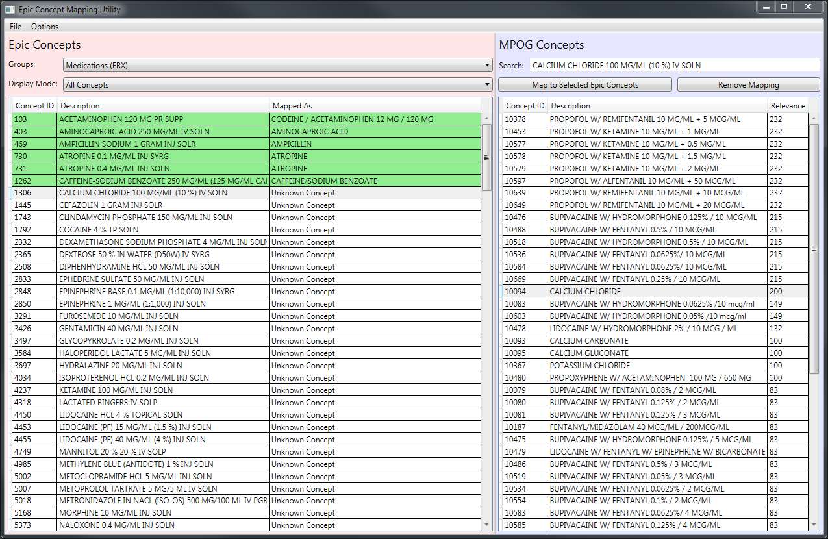

* Submit the mapping spreadsheet to your anesthesia clinician for final review of the MPOG concept mappings
  + *Your anesthesia clinician should review all the concepts that need to be mapped for any errors*
* Import the MPOG spreadsheet with your finalized concept mappings to populate the HFR record

## Stage 3: Extracting and Submitting Data

**Involved Parties:** Clarity Database Administrator, Anesthesia Application Analyst, Institutional Anesthesia Clinician and MPOG Database Administrator

### Extracting Data

**Owner:** Clarity Database Administrator, Anesthesia Application Analyst, MPOG Database Administrator and Institutional Anesthesia Clinician

* Run a full extract of the MPOG_MAP_* tables and run every time there are nightly scheduled regular extracts
* Run a test extract of F_MPOG_EXTRACT
* Use transfer package to move test extract to local MPOG database server
  + We recommend that if a research /QI has a mirror of Clarity then the transfer to MPOG should come from that mirror
  + Email your MPOG IT contact for the version of the package suited to your environment
* Run data diagnostics in MPOG database
* Use the MPOG Suite to review results of test extract and provide feedback (Anesthesia Application Analyst/Anesthesia Clinician)
* Schedule regular extracts of F_MPOG_EXTRACT

### Submitting Data to MPOG: All data from Epic uploaded to Local MPOG Server

**Owner:** Institutional Anesthesia Clinician and MPOG Database Administrator

* Run extract to the MPOG Application and then run the diagnostics to see if there is anything obvious missing.
  + Keep running the diagnostics until you can be sure you have cleaned all issues
* Perform the case validations in the MPOG Suite, if there are any problems you must fix them
* Make sure AIMS PHI dictionary has been populated
* Run the PHI Scrubbing Application in the MPOG Suite
* Once you have completed all the extracts and feel comfortable with your case validations and PHI scrubbing you will send data to the MPOG Repository

Steps to Set up EPIC and MPOG Overview and Time Table

## Steps and Time Table:

| Step # | Task Description | Resource | Estimated Time | FTE % | Dependencies | System Used |
| --- | --- | --- | --- | --- | --- | --- |
|  | BAA + ASPIRE Developer Access | Site Admin/IT | 1 - 2 weeks | BAA: 20%  Access: 10% | None |  |
|  | Exporting your EPIC Chronicles content into the MPOG/ASPIRE-EPIC mapping spreadsheet | Epic TS | < 3 hours | 100% | None | Chronicles |
|  | MPOG/ASPIRE Server Hardware/Virtual Machine Ordered and Installed | Site IT | 4 - 6 weeks | 10% | None | MPOG/ASPIRE Local DB |
|  | MPOG/ASPIRE SQL Server Database & Application Suite Installed | Site IT | 2 weeks | 10% | Step 3 | MPOG/ASPIRE Local DB |
|  | Installing MPOG/ASPIRE tables into the Clarity instance | Epic TS and Site IT | 1 week | 10% | None | Clarity |
|  | Working with the EPIC mapping spreadsheet and MPOG/ASPIRE mapping utility to map the EPIC content. Create medication groupers. | Site Clinician and Willow Team | 2 - 5 weeks | 50% | Step 2 | Excel |
|  | Uploading the MPOG/ASPIRE mapping spreadsheet back into Chronicles | Epic TS and Site IT | < 3 hours | 100% | Step 6 | Chronicles |
|  | Running the existing MPOG/ASPIRE extract from Chronicles to Clarity. Debug any problems. | Epic TS and Site IT | 3 weeks | 20% | Steps 5, 7 | Chronicles & Clarity |
|  | Exporting data from MPOG/ASPIRE tables on the Clarity server to Local MPOG/ASPIRE SQL server | Site IT | 1 day | 50% | Step 4, 8 | Clarity, MPOG/ASPIRE Local DB |
|  | Running MPOG/ASPIRE data diagnostics, refining mapping and extracts | Site IT/Site Clinician | 4 weeks | Clinician: 50%  IT: 20% | Step 9 | MPOG/ASPIRE Local DB |
|  | Upload data to MPOG/ASPIRE Central Repository | Site Clinician | 1 - 3 days | 20% | Step 10 | MPOG/ASPIRE Local DB |

Institutional Resources/Database System

#### Epic Personnel:

- **Clarity Database Administrator:** Identified by Epic

- **Willow Application Analyst:** Identified by Epic

- **Anesthesia Application Analyst:** Identified by Epic

#### Institutional Personnel:

- **Anesthesia Clinicians:** MPOG Anesthesia Champion who will be the primary contact

- **IT Project Management:** Person responsible to keep the project on task and primary contact to set up meetings with Epic and MPOG Representatives. May be the Anesthesia Clinician.

- **MPOG Database Administrator:** Technical IT person for the project

- **Pharmacy Clinicians:** A pharmacy clinician is required to assist in mapping the medications to the MPOG concepts.

- **NSQIP Surgical Champion:** Primary point of contact if your institution decided to contribute NSQIP data.

#### MPOG Personnel

- **Program Manager:** The MPOG Program Manager will assist in setting up time lines and act as the liaison between Epic and institution.

- **Anesthesiology Clinician**: Dr. Sachin Kheterpal – will assist institutions at various points

- **MPOG IT**: Will be available as necessary

**Fill out the table below with Institutional Specific Information:**

|  |  |
| --- | --- |
| Role | Person Identified |
| Epic Personnel: | |
| Clarity database Administrator |  |
| Willow Application Analyst |  |
| Anesthesia Application Analyst |  |
|  |  |
| Hospital Personnel: | |
| Anesthesia Clinician/PI |  |
| IT Program Manager |  |
| MPOG Database Administrator |  |
| Pharmacy Clinician |  |
|  |  |
| MPOG Personnel: |  |
| Program Manager | Tory Lacca |
| Anesthesia Clinician | Dr. Sachin Kheterpal |
| MPOG IT | TBD |

**Systems Used:**

|  |  |
| --- | --- |
| Data Requested | System |
| Anesthesia Billing |  |
| Hospital Billing |  |
| QA/QI Data |  |