**MPOG - NSQIP interface**

* Process
  + Log into the registry.acsnsqip.org website
  + Select “Data download”
  + Select the following options:

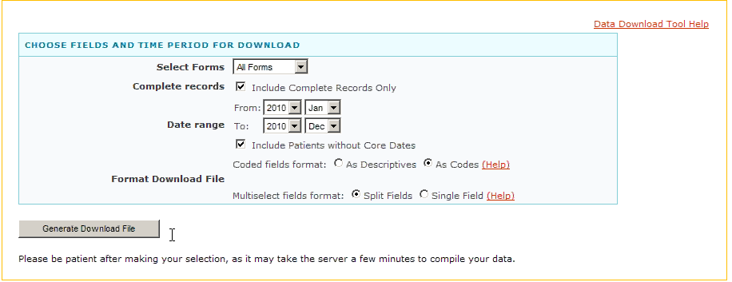

* + Adjust the date range as necessary
  + Each site downloads their NSQIP content from the outcome science download tool
    - The site has to use specific parameters
      * “coded” instead of “descriptions”
      * “split fields” instead of “single field” for multi select options
      * “complete records only”
      * “Include cases without core dates”
    - Save that zip file into a local directory on NSQIP SCNR workstation
    - Unzip the file into a local directory
  + Launch the MPOG local interface application
    - Application switch only enables “Merge NSQIP data” option
  + Choose “Merge NSQIP data”
    - Point application at directory containing files
    - Application will import NSQIP data into local MPOG database
      * Does not import duplicate records, creates an error for any duplicate records
    - Application will attempt to match records
    - User will confirm matches and perform remaining matches
    - User alerted to unmapped cases or multiple cases, confirms they wish to discard them
* NSQIP tables
  + Contained with the MPOG_MAS database
  + NSQIP_Case_Form
    - Primary key: site_os_id + case_number
    - Add a column called “Transmission_Status_CD”
      * Identifies whether this case has been sent to the MAS_Central
  + NSQIP_Intraop_Occurrences
    - Primary key: site_os_id + case_number + elemdata_seq
  + NSQIP_Postop_Occurrences
    - Primary key: site_os_id + case_number + elemdata_Seq
  + NSQIP_Demographics
    - Primary key: site_os_id + patient_os_id
    - Add a column called “Transmission_Status_CD”
      * Identifies whether this case has been sent to the MAS_Central
      * Requires separate column because this is not a case-linked table or row
  + NSQIP_Concurrent_Procedures
    - Primary key: site_os_id + case_number + elemdata_seq
  + NSQIP_Other_Procedures
    - Primary key: site_os_id + case_number + elemdata_Seq
  + NSQIP_Return_CPT_Code
    - Primary key: site_os_id + case_number + elemdata_Seq
  + NSQIP_Return_ICD9_Code
    - Primary key: site_os_id + case_number + elemdata_Seq
  + NSQIP_MPOG_Case_Linking
    - MPOG_Case_ID (guid, auto assigned)
    - MPOG_NSQIP_Case_Number (guid, auto assigned)
    - Link_Status_CD
      * 10 = committed link
      * 20 = proposed perfect match
      * 30 = proposed date match
      * 40 = proposed manual select match by user (ie, user clicked on it, but has not hit “commit” yet
* Matching logic
  + Reg num management
    - Strip leading zeroes from both NSQIP and AIMS reg number
    - Strip leading and trailing blanks
  + Highest confidence match
    - NSQIP regnum + Case_Form.dt_anes_start (including time) = AIMS regnum + AIMS_IntraopNotes.AIMS_Note_observation_DT (including time) for concept id = 50002 (anes start)
  + Medium confidence match
    - NSQIP regnum + Case_Form.dt_anes_start (without time) = exactly one AIMS regnum + AIMS_IntraopNotes.AIMS_Note_observation_DT (without time) for concept id = 50002 (anes start)
  + Manual review
    - NSQIP regnum + Case_Form.dt_anes_start (without time) = more than one AIMS regnum + AIMS_IntraopNotes.AIMS_Note_observation_DT (without time) for concept id = 50002 (anes start)
    - NSQIP regnum + Case_Form.dt_anes_start (without time) = NO AIMS regnum + AIMS_IntraopNotes.AIMS_Note_observation_DT (without time) for concept id = 50002 (anes start)
      * Show all AIMS cases for that reg num within two day before, day of, and two day after case_form_dt_anes_start
      * Show procedure description from mpog and from nsqip
* Deidentification / provider / patient scrubbing applied to following tables and columns
  + NSQIP_Case_Form
    - Comments
    - Created_by
    - Updated_by
  + NSQIP_Concurrent_Procedures
    - Created_by
    - Updated_by
  + NSQIP_Intraop_Occurrences
    - Created_by
    - Updated_by
    - Comments_intra
  + NSQIP_Other_Procedures
    - Created_by
    - Updated_by
  + NSQIP_Postop_Occurrences
    - Comments_post
    - Created_by
    - Updated_by
  + NSQIP_Return_CPT_Code
    - Created_by
    - Updated_by
  + NSQIP_Return_ICD9_Code
    - Created_by
    - Updated_by
* Tables not transferred (all PHI)
  + NSQIP_Demographics