

**VIP Release Process Training**

Veteran-focused Integration Process (VIP)



VIP is the new, lean process for work delivery in OI&T.

VIP is supported by:

• A single portal for project requests – VIP Request (VIPR)

• A single, simplified Release Process – VIP Release Process

• A single, authoritative, unified Calendar POLARIS (Planning and On-Line

Activity/Release Integration Scheduler)

• Tools that support the functions, above:

• Intake for IT projects (via VIPR, initially a Microsoft SharePoint-based application)

• Calendar (initially, a Microsoft SharePoint- based application)

• Time-tracking for all OI&T resources (via Oracle Primavera Progress Reporter)

• Enterprise Portfolio Management (via IBM Rational Collaborative Application

Lifecycle Management (CALM) Project/Product Data Repository)

VIP employs the Agile Project Management Methodology.

• Requestors express requirements in Epics, Sub-epics, and User Stories.

• Requestors submit Epics and User Stories to initiate VIP via VIP Request

(VIPR).

• The Portfolio Manager, Product Owner, and Receiving Organization determine if the request becomes a project at Critical Decision #1.

• If the project is approved at CD#1, the VIP Release Process begins.

• Build/Development work is done in 2-week Sprints for no more than a total

of 3 months.

• Project Team has Daily Scrums to provide quick status and plan updates.

• Project Team has Sprint Planning, Backlog Grooming, and Sprint Review

Ceremonies throughout the Build/Development cycle.

VIP Workflow

Critical Decision #1

Project Release

Critical Decision #2

Product Release

Initiation

Product Start *I*

Build Start Release

PROJECT PHASE PRODUCT PHASE SUSTAINMENT

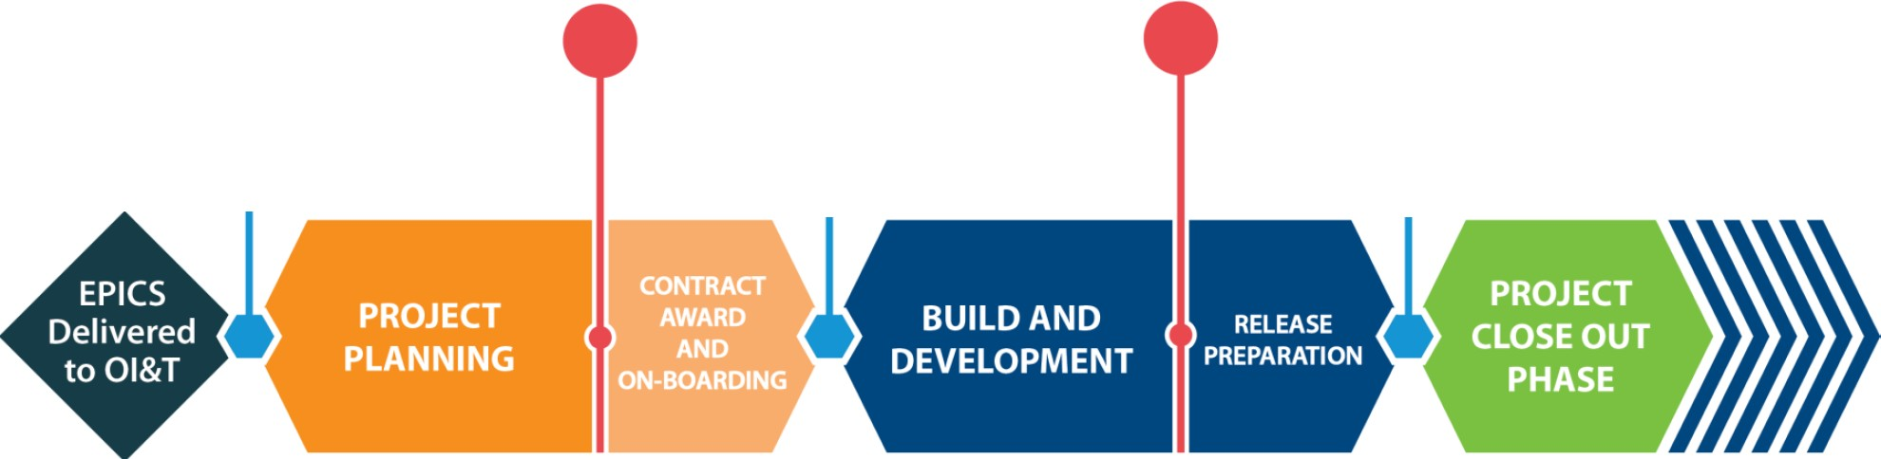

• Epics required

– Business

– Architecture/engineering

– Security

– Infrastructure/Support

– Sustainment

– Service /Operational Level Agreements (SLA/OLA)

– IOC sites selected and MOUs in place

– Others as required for the particular effort

• Other required artifacts

– Project charter

– Project Management Plan

– Project Financial Plan

During Contract Award and On-boarding, a Release Agent is assigned to

monitor your release.

• The Project Team adds the planned Release to the Release Calendar.

• The Release Agent ensures that the Project Team has the complete list of

product data deliverables.

• The Project Manager establishes a Product Account in the Rational Tool repositories, if one does not already exist. Contact [Rational@va.gov](mailto:Rational@va.gov).

• The PM ensures that the Release Agent has access to the Product Account.

• The Project Team’s Configuration Manager and Testing Manager obtain training in the use of the Rational Tool repositories, if necessary. Contact [Rational@va.gov](mailto:Rational@va.gov).

Throughout the Build/Development phase, the Release Agent monitors the data in the repositories.

• Throughout the Build/Development phase, the PM ensures that the Configuration manager and Testing Manager are managing necessary product data appropriately in the tool’s repositories.

• The Release Agent provides feedback to the Project Manager, the

Configuration Manager, and the Testing Manager.

• The Release Agent collects certain metrics at the end of each Sprint.

• Near the end of the Build/Development phase, the Release Agent provides the status of the product data to the three decision-makers: the Portfolio Manager, the Product Owner, and the Receiving Organization.

• At CD#2, the three decision-makers determine if the Release Candidate can be released into production.*

*IOC evaluation or full release, if no IOC evaluation is included

IOC evaluation or full production installation occurs.

• During IOC or full production deployment, product changes are updated in repositories.

– Significant issues or severe defects that necessitate changes to requirements are reported to the decision-makers, who determine if product will be backed out or deployed nationally.

– If backed out, Release Candidate returns to appropriate step in the VIP Process.

• If national deployment is successful, 90-day Product Warranty begins.

– The Product Warranty covers everything stated in the requirements.

– Transfer of knowledge and transition of product into sustainment occurs.

• At the end of Product Warranty, transfer of ownership occurs and is recorded in the tool.

Configuration Manager records “as-built” data in the Rational Tool.

Release Agent evaluates release metrics.

Subsequent releases, defect repairs, upgrades, and all other production releases to

the product go through the VIP Release Process.

|  |  |
| --- | --- |
| **As-Is Release Processes** | **To-Be Release Process** |
| 10+ Review Groups and Processes | 1 Review Group |
| 50+ Steps | 4 Steps |
| 30+ Categories of Data | 6 Categories of Data |
| Data Duplicated across Artifacts | Data Element Entered Once, Updated as Necessary, Used Multiple Times, as Needed |
| Late-stage Review | Continuous Feedback throughout  Development |
| Multiple Email Messages and Reports concerning Status | Approval and Product Ownership  Recorded in the Tool |

**Questions?**

OFFICE OF INFORMATION AND TECHNOLOGY 11

• Other required artifacts

– Project charter

– Project Management Plan

– Project Financial Plan

• Agile process

• Epics required

– Business

– Architecture/engineering

– Security

– Infrastructure/Support

– Sustainment

– Service /Operational Level Agreements (SLA/OLA)

– IOC site

• Other required artifacts

– Project charter

– Project Management Plan

– Project Financial Plan

Will request become a project?

Decision Makers:

– Portfolio Manager

– Product Owner

– Receiving Organization

• On CD#1 approval

– Contracts awarded, team formed

– Configuration Manager trained in Rational Tools

– Release Agent assigned

– Project Manager ensure access to repository

• CD#2 review

– Product Team build data placed in repository

– Release Agent monitors reviews, provides feedback on build

– Release Agent reviews, reports on status of build data to Decision Makers*

– Decision Makers determine if build acceptable for production release

• Once approved, no changes allowed to requirements

– If approved, build moves to Release Preparation and Execution

• If IOC

– Track changes, monitor significance

– Deal with any issues

• Contact VA ESE Release Office [vaESEreleaseoffice@va.gov](mailto:vaESEreleaseoffice@va.gov) .

• Attend any optional recurring Friday 1PM training session. *Contact*

[*vaESEreleaseoffice@va.gov*](mailto:vaESEreleaseoffice@va.gov) *and ask to be invited to the*

*recurring optional ERF training.*