Introducing web typography and CSS font controls
Author: Dave Everit
Updated: 14 Jan 2012

In this exercise we will gain an understanding of basic typography for the web, and explore the various font controls available in CSS.

Download the files from Blackboard
1. Open both ‘index.html’ and ‘styles.css’ in TextWrangler (or if in Dreamweaver set the view to ‘code’).

2. Drag ‘index.html’ to the Firefox web browser. You should see a horrible-looking page of plain, unformatted text like this:

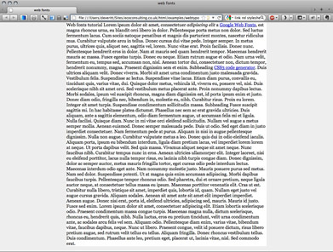

Look at the CSS code
3. Now take a look at the code in ‘styles.css’. You will notice that some basic styles are already set up for the body tag, and for the div containing the text, so we’ll focus only on the typography, not the page layout.

Styles for the body tag affect the whole page, while styles set for div tags only affect elements contained inside a div tag (if we wanted to target only certain div tags, we’d add an “id” or “class” attribute to them).

The basic styles for paragraphs and headings (p, h1, h2)—which will be contained in the div tag—have also been set up, but the text in the HTML file is not yet marked up with HTML tags for paragraphs or headings (we’ll do this in a moment), so the CSS styles have no effect at this point.

First, it is important to understand a little about CSS selectors, and why the three styles we’ll be working on start with ‘div’.

Understanding basic CSS selectors
Containment is the key to basic CSS selectors—the styles we will build apply only to HTML heading and paragraph tags that are contained in our div tag (if we added more div tags to our layout, we’d need to give each a unique ID or a shared class (for several divs to share the styles for that class).

Each of the CSS rules below is preceded by ‘div’ so that only HTML h1, h2 and p tags contained in our div tag are affected (don’t think about the CSS padding values, we’ll tinker with those later):

div h1 {
padding:0 10px 1em;
}

div h2 {
padding:0 10px 1em;
}

div p {
padding:0 10px 1em;
}

We could actually leave off the preceding div with no effect on our test file, but on a real website this would affect every single paragraph and level 1 and 2 heading, when we might want to style them separately according to where they appear—say in another div for a sidebar or menu.

So, when writing CSS, it’s best to be as specific as necessary, but no more—i.e. we don’t need to put body before div h1.

Mark up the headings with HTML tags
4. The text in ‘index.html’ consists of long chunks and three short lines. In a moment, we’ll mark up the short lines as headings, and the long chunks as paragraphs.

The text in the HTML code is indented to show that it is contained in the div tag. This kind of indentation is used throughout computer programming, and here, it helps us find our way around the HTML tags and CSS selectors.

5. Add <h1> to the beginning of the first line (immediately before the text, or else the heading will have a space before it), then close the tag with </h1> at the end of the line, like this:

<h1>Main heading</h1>

6. Similarly, add <h2> tags to the two lines called ‘subheading’, like this:

<h2>Subheading</h2>

7. Reload the page in your browser (keyboard shortcut: Cmd-R). You should see the unformatted headings, complete with their basic CSS styles:

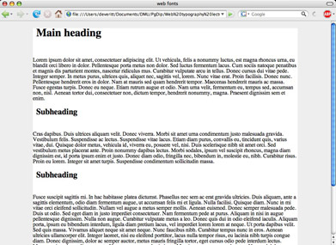

Oops! The top of the div has been pushed down from the top of the browser window so the body background colour is showing at the top of the page. Most browsers apply default settings for padding and margins. In this case, it is the default margin that’s causing the problem. Let’s fix it.

8. In the div h1 rule, make a new line at the end of the semicolon:

div h1 {
padding:0 10px 1em;

}

Then, to set margins on the HTML h1 tag to zero, type the following CSS rule on the new line, like this:

div h1 {
padding:0 10px 1em;
margin:0;
}

Now reload the page in the browser. The margin (space) above the level one heading has gone.

Mark up the text with paragraph tags
9. In the HTML file, find the first long chunk of text (the one that starts ‘Lorem ipsum dolor sit amet ‘) and contain it in paragraph tags:

<p>Lorem ipsum dolor sit amet, consectetuer adipiscing elit. Ut vehicula, felis a nonummy luctus, est magna rhoncus urna, eu blandit orci [. . .] Etiam rutrum augue et odio. Nam urna velit, fermentum eu, tempus sed, accumsan non, nisl. Aenean tortor dui, consectetuer non, dictum tempor, hendrerit nonummy, magna. Praesent dignissim sem et enim.</p>

Do the same for all the other long chunks of text, and reload the page in your browser.

10. You’ll notice that the basic padding in the CSS file has been applied to the paragraphs, but the gaps between the headings and the text are too large. We’ll begin to fix that by ‘flattening’ the margins for the level 2 headings and paragraphs to zero, just as we did for the level 1 heading (to save typing, you can copy and paste the margin CSS rule from the div h1 selector—be sure to copy the whole line, carriage return and all). Your CSS code should now look like this (lines in bold indicate the added CSS rules):

div h2 {
padding:0 10px 1em;
margin:0;
}

div p {
padding:0 10px 1em;
margin:0;
}

11. Reload the page in your browser—it should now look like this:

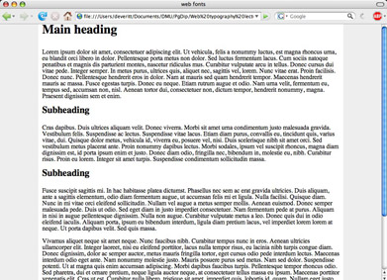

12. Finally, let’s fix the padding and apply a font-size rule to the headings.

div h1 {
padding:0 10px 0.5em;
margin:0;
font-size:2em;
}

div h2 {
padding:0 10px 0.25em;
margin:0;
font-size:1.5em;
}

13. Reload. Padding is fixed, but you’ll see the headings haven’t changed size at all. That’s because the font-size rule we added is the same as the default (for Firefox on the Mac, at least). Let’s change the h2 font size:

div h2 {
padding:0 10px 0.25em;
margin:0;
font-size:1.25em;
}

Reload to see the level 2 headings shrink a little. People sometimes use various heading tags to alter font size, but this is bad practice. We now have a page with…

Well-formed HTML!
This simply means that there is one level 1 heading (Google likes meaningful level 1 headings that describe the page contents), after which there are some paragraphs, divided into sections with level 2 headings.

If our content has further logical subsections under each level 2 heading, we could add (and style) further level 3 headings between the paragraphs of text under each level 2 heading, but we’d want to keep them in order.

This is one of the principles of what is known as well-formed HTML, which is good practice for usability, accessibility and machine-readability (and the coming semantic web and increasing demands for stricter coding).

Now we can begin some serious styling.

Serif or sans-serif?
14. Change the CSS ‘font-family‘ rule for the body tag from ‘serif’ to ‘sans-serif’:

body {
margin:0;
padding:0;
color:#000;
background:#eee;
font-family:sans-serif;
}

The ‘serif’ and ‘sans-serif’ values of the CSS font property are two of the generic font styles—so that, if you specify one or more serif fonts, like Baskerville or Palatino and these are not installed on the user’s computer, adding the generic serif font-family to the end of your list will fall back the user’s default sans-serif font. Add ‘Sabon’ (with a comma after) like this:

font-family:Sabon,serif;

Reload the page in your browser and you’ll see no change, since Sabon (a serif font not available as standard) cannot be found. You can double-check that the generic ‘serif’ font family is being used instead of the unavailable Sabon by altering ‘serif’ to ‘sans-serif’ and reloading.

15. Now change the font from Sabon to Georgia:

font-family:Georgia,serif;

…and reload. The font for the whole page—headings included—has now changed from the default ‘serif’ to ‘Georgia’.

16. Now lets be more specific. Add a font-family rule to the h1 and h2 styles:

div h1 {
padding:0 10px 0.5em;
margin:0;
font-size:2em;
font-family:Verdana,sans-serif;
}

div h2 {
padding:0 10px 0.25em;
margin:0;
font-size:1.25em;
font-family:Verdana,sans-serif;
}

These will override the ‘Georgia,serif’ font-family style for the body tag, so the headings will now appear in Verdana (or the default sans-serif in the unlikely case that Verdana isn’t available on the user’s computer).

Georgia and Verdana, were both commissioned by Microsoft to be designed specifically for the screen (rather than print), so they’re very readable on screen at any size.

You can add as many font-families as you like (Dreamweaver has standard sets that are sure to be found on most machines), separating each with a comma, and surrounding names with more than one word like ‘Century Gothic’ (which is what you’re looking at right now on this printed page) in either single or double quotes (doesn’t matter which).

EXTRA: If you want fonts outside the normal ‘web fonts’ (i.e. not on other computers), you can use Google web fonts –the files ‘index_mod.html’ and ‘styles_mod.css’ give examples of this and other enhancements.

17. The paragraph font size is a little too large by default, so let’s reduce it and, while we’re in there, add a bit of space between the lines of text within the paragraphs:

div p {
padding:0 10px 1em;
margin:0;
font-size:0.9em;
line-height:140%;
}

As well as using ems (an em is the height of a single letter) for the font-size and line-height properties for units of measurement, you can also use percentage (%), points (pt), pixels (px) and some other more obscure units. However, for various reasons it is best to use em or %.

Reload. Your page should now look like this:

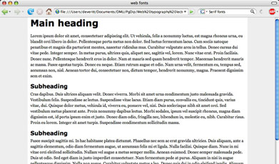

It may still appear very basic, but there are actually quote a few CSS style rules in there, each of which can be adjusted separately.

A bit more style
18. Those headings are a bit stark, so let’s knock back the black to a dark grey and add some letter-spacing to the headings:

div h1 {
padding:0 10px 0.5em;
margin:0;
font-size:2em;
font-family:Verdana,sans-serif;
color:#333;
letter-spacing:0.1em;
}

div h2 {
padding:0 10px 0.25em;
margin:0;
font-size:1.25em;
font-family:Verdana,sans-serif;
color:#333;
letter-spacing:0.1em;
}

Again, as with the line-height property, it’s best to use ems for the letter spacing property . Then, if the browser font size is enlarged or reduced by the user, the line-height and letter-spacing remains in proportion.

19. Reload, and change the text size in the browser:
View > Text size > Increase/Decrease
or (recent versions of Firefox)
View > Zoom > Zoom In (or Zoom Out)

The letter-spacing and line-height stay in relative proportion to the font size because the em unit is enlarged and reduced with the browser’s text size.

Semantic markup
20. There are a few more HTML tags that are useful in marking up text semantically. Semantic markup is becoming increasingly important on the web, and indicates the actual meaning of the text contained within the HTML tags, e.g. instead of using bold <b> and italic <i> tags, it is now good practice to use <strong> (approximately: ‘loud’) and <em> (for ‘emphasis) instead, as they impart semantic meaning to the enclosed text.

Let’s use those on a couple of words in the first paragraph:
<p><strong>Lorem ipsum dolor</strong> sit amet, consectetuer <em>adipiscing elit</em>. Ut vehicula, felis

Reload to see the default result, which is more or less as you’d expect.

21. However, we can alter this default style by adding CSS rules that target only the HTML strong and em(phasis) tags in our paragraph:

div p strong {
color:#900;
}

div p em {
letter-spacing:0.05em;
background:#ff0;
}

Now reload—your first paragraph should appear something like this:

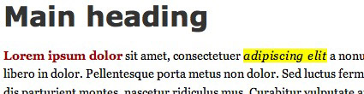

22. Perhaps we’d like a drop capital letter in one of our opening paragraphs. This is easily done with a CSS class and pseudo-class.

First, add a CSS class attribute to the paragraph just after the second level 2 subheading:

<h2>Subheading</h2>

<p class="firstpara">Fusce suscipit sagittis mi. In hac…

We could name this class anything we like (although no spaces, and it can’t start with a number) but it’s best to use a name that describes what it does. Semantic markup can be applied to CSS as well as to HTML.

Now add the CSS that targets only the first letter of the paragraph with a CSS class attribute of firstpara:

div p.firstpara:first-letter {
padding:2px;
border:1px solid #ccc;
background:#fcc;
float:left;
font-size:4.5em;
margin-top:0.1em;
margin-right:0.1em;
}

…and reload:

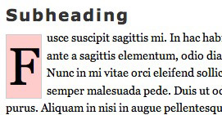

Semantic HTML markup
There are more HTML tags that lend semantic meaning to your text, such as blockquote (for long quotations), cite (for brief quotations or publication titles), abbr (abbreviations), all of which can be styled as you wish.

HTML lists are a special case, and not covered in this tutorial.

For instance, the ‘abbr’ tag is often given a subtle dotted underline and used with an HTML ‘title’ attribute to give a rollover ‘tooltip’ that explains what the abbreviation stands for, and ‘blockquote’ can be styled with large graphic quotation marks (see ‘index_mod.html’).

Curly quotes and stuff
You can also use curly quotes and other refined typographic elements like proper hyphens and ellipses (three dots). These used to require specific HTML entity codes, but changes on the web mean that most browsers now support such characters by including somewhere in the HTML file the charset (character set) UTF-8.

More CSS font control
There are also a few other useful font control rules in CSS. Here are a few of them (the bar | separates the various possible values, so use only one):

font-style:normal|italic;
font-weight:normal|bold;
font-variant:normal|small-caps;

and for paragraphs:

text-align:left|right|center|justify);
word-spacing:normal|length;
text-indent:length|percent;

and the pseudo-class

p:first-line {style rules here}

which can be styled however you like.

Useful links to take you further
If you follow up only one of these links, make it this one:
6 Ways To Improve Your Web Typography

If you’d like to know more, take a look at these:
Beautiful Web Typography: 7 tips on de-sucking the web
Typetester: compare various settings for screen type
The Elements of Typographic Style Applied to the Web
Setting Type on the Web to a Baseline Grid

