How to use this file
The article works exactly as it is. Swapping in your class’s real Games Day numbers makes it land harder, and the five faults survive the swap because they are built into the structure, not the figures. Every number you might change is marked [like this].
What has to stay true if you change the numbers:
- The sample in paragraph 2 must stay tiny — four or five buddies — and the percentage must be worked out from it as though it spoke for the whole cohort.
- The three team totals must be close together. The chart’s axis starts above zero, which is what makes a small difference look enormous. If the real totals are far apart, the trick stops working.
- The "every buddy won a prize" claim must be true of one stall only.
- The "twice as many" claim must have no starting number anywhere in the article.
- The last sentence must not follow from anything above it.
To rebuild the chart with your own numbers, open L14_Misleading_Charts.xlsx, type them in, and copy the chart across. Its axis is already set to start above zero.

DRAFT — not published. For checking.
GAMES DAY A HUGE SUCCESS
Preps love Year 6’s maths games
by a parent helper
Last Friday our Year 6 students ran their Buddy Games Day. [Thirty-eight] Prep buddies came through the hall and played the chance games the Year 6 students had designed, built and tested themselves over the last few weeks.
We asked [four] Prep students what they thought of the day. [Three] of them told us it was the best day of the whole year. That means [75%] of Prep students rated Games Day the best day of the year.
Some games were far more popular than others. The graph below shows how many buddies said they liked each game. Team [Comet]’s game was [three] times more popular than Team [Nebula]’s.
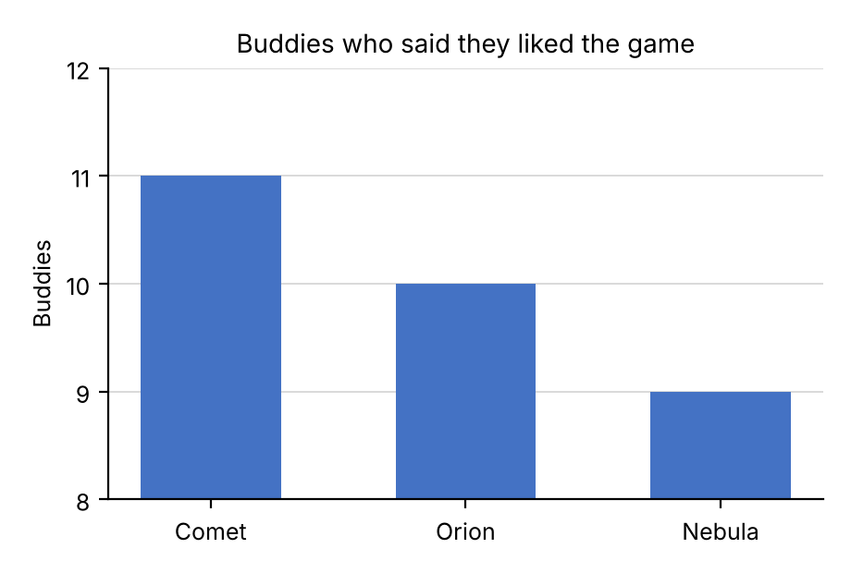
At one stall, every single buddy who played won a prize. Games Day was a win for everyone.
Twice as many Preps asked to play again next year as asked last year.
The results show that playing chance games is the best way for children to learn mathematics.
This article is a classroom exercise written for Year 6 Mathematics. The author and the figures in it are invented.

