Machine Learning Nanodegree

David Geretti - dec. 2015

# P1 : Predicting Boston Housing Prices

## 1) Statistical analysis and data exploration

* Number of houses in dataset: **506**
* Number of features: **13**
* Minimum price: **5.0**
* Maximum price: **50.0**
* Mean price: **22.53**
* Median price: **21.2**
* Std dev.: **9.19**

## 2) Evaluating Model Performance

Which measure of model performance is best to use for predicting Boston housing data and analyzing the errors? Why do you think this measurement most appropriate? Why might the other measurements not be appropriate here?

A regression metric is needed in this case, because housing prices are continuous.   
Common choices among regression metrics include *Mean absolute error*, *Mean squared error* or *r-squared score*.   
Classification metrics, such as *precision*, *recall,* or *f-score*, give a score based on how many guess were true or false related to the total number of guesses. A real estate agent would be more interested at knowing how far from realty his model predicted a price, than knowing if the model actually predicted a perfect price.

The mean absolute error (*mean_absolute_error*) was chosen here because the calculated error has the same unit as the data (=> dollars).   
This is more intuitive to understand than a mean squared error for instance.   
The mean absolute error averages the (positive) distance between the prediction and the actual values.

Why is it important to split the Boston housing data into training and testing data? What happens if you do not do this?

By training and testing the model on different datasets, we can measure how the model performs on unseen data. If we don't use a portion of the data for testing, we cannot see if our model is underfit or overfit, as we cannot compare testing and training errors.

What does grid search do and why might you want to use it?

The parameters of an algorithm play a role in the quality of the model. Like the maximum depth allowed for a decision tree for instance.

In order to make the best predictions, Grid Search is useful to automatically try multiple values of said parameters and chose the optimal one. Otherwise, one would have to try all these possible values by hand.

Why is cross validation useful and why might we use it with grid search?

Cross validation splits data into multiple different training/testing sets and measure the average error by running the model on all these sets. This maximizes the use of the available data.   
Without it, we would have only one error measurement, and depending on how the data was split, it could be an edge value, not representing how the model performs for more common data.

## 3) Analyzing Model Performance

Look at all learning curve graphs provided. What is the general trend of training and testing error as training size increases?

For small training sizes, the training error is low because it is easy for the model to find a perfect function fitting all the data points. This model will likely not be good for unknown data points though, thus the high testing error

Both errors tend to plateau toward the same error value past a certain dataset size. What it means is that there is a minimum threshold of training size below which the model is unreliable.   
Bigger training size means better model and more accurate error measurement.

The plateau seems to indicate that no matter how big the training size get, the algorithm we chose will not be more accurate with the given parameter. For improved performances, we may need to tune the parameters of the algorithm, or chose a different algorithm.

Look at the learning curves for the decision tree regressor with max depth 1 and 10 (first and last learning curve graphs). When the model is fully trained does it suffer from either high bias/underfitting or high variance/overfitting?

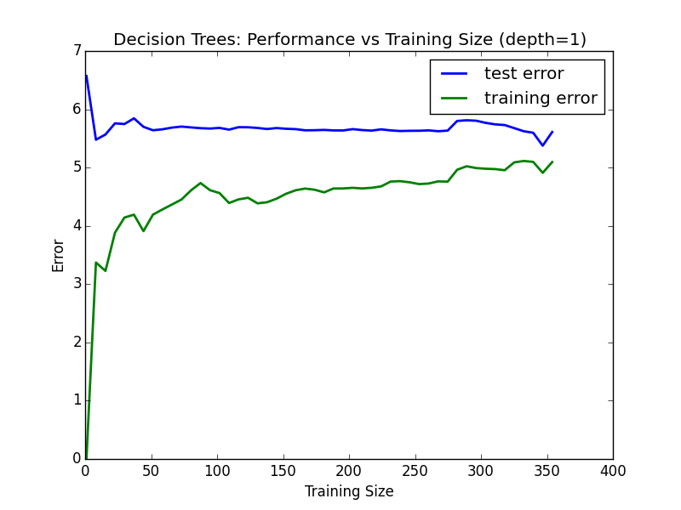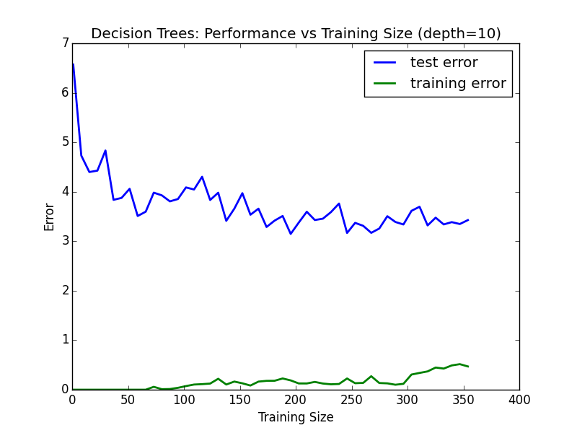

With max_depth = 1, there is a higher bias than with max_depth = 10 because the error toward which both curves tend is high. (around 5 for the left graph, and maximum 3 for the right one)  
This means the model cannot accurately predict new data because of an oversimplified training (=underfitting).

At max_depth = 10, there is a high variance => the gap between training and testing is the highest. No matter the size of the training size, it seems impossible for the model to predict the new data as good as the training data. The model is too closely linked to the training set (=overfitting)

Look at the model complexity graph. How do the training and test error relate to increasing model complexity? Based on this relationship, which model (max depth) best generalizes the dataset and why?

The training error obviously tends to 0. The more complex the model, the best it can include every data point provided with the training set. Thus a smaller training error.

The testing error plateaus at some error value. No matter how much complexity is added, it doesn't help predict better unknown data.

Based on the image, the threshold for max_depth seems to be just after 5, where both the **testing error** and the **model complexity** are minimized. A less complex model is better at generalizing data.

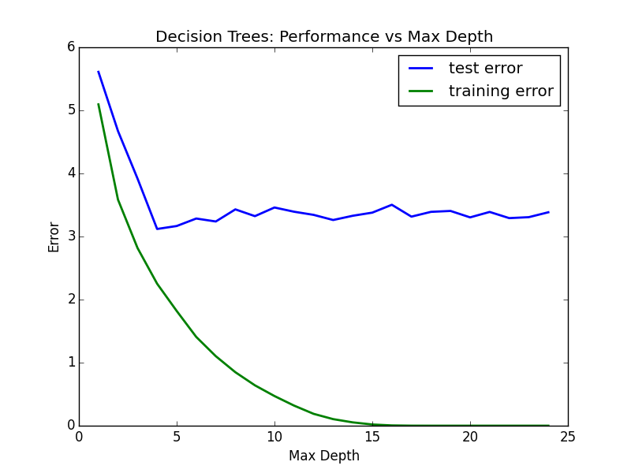

Note : As the data is randomized, each try will output slightly different graphs and results. A max_depth of 5 is therefore not a perfect choice, but a reasonable one. (see below)

## 4) Model Prediction

Model makes predicted housing price with detailed model parameters (max depth) reported using grid search. Note due to the small randomization of the code it is recommended to run the program several times to identify the most common/reasonable price/model complexity.

As said, data is randomized, making each program execution a little different.   
*fit_predict_model* wasrun 20 times to give a better idea of how the optimal values of *max_depth* and the predicted price varied each time. The result is consistent with the previously computed statistics (for the price), and the max_depth found in the graph at point 3) :

Averaged on 20 executions :

* + Predicted house price : **20.97** (std. dev.: 0.48)
  + max_depth : **5.32** (std. dev.: 0.98)

Compare prediction to earlier statistics and make a case if you think it is a valid model.

* With a mean price for the dataset equals to **22.53**, and a standard deviation of **9.19**, the predicted price has a z-score of (20.97 - 22.53) / 9.19 = -0.17.  
  the predicted prices is within less than a standard deviation of the mean.
* the predicted price is also very close to the median price of 21.2

by comparison to the statistics computed at point 1), this price seems to be valid.