TITAN APP – DEVELOPMENT TO-DO LIST
Prepared for Dave – screenshots included against the exact tasks they relate to.
IMPORTANT DEVELOPMENT RULE: Do not rebuild working Titan functionality unnecessarily. Where a feature already works correctly elsewhere – particularly Casual Golf – reuse the existing component, calculation or logic.

1. Merge Players Tab & Player Library – I NEED TO DISCUSS THIS MORE - DAVE
- Merge the Players tab in the Platform/Admin area with the existing Player Library in the player/profile section.
- We do not need two separate places managing the same players. Create one central Player Library / source of truth.
- Retain player profiles, handicap, profile picture, contact details, Owner/Admin/Member permissions, Captain status and add/edit functionality.
- All areas of Titan requiring player information should use the same central player record and avoid duplicates.

I need to create another bit to this… Called T-Cards, to go with T-Tags.. This is going to be epic… ;-)

Photo 1 – Players screen
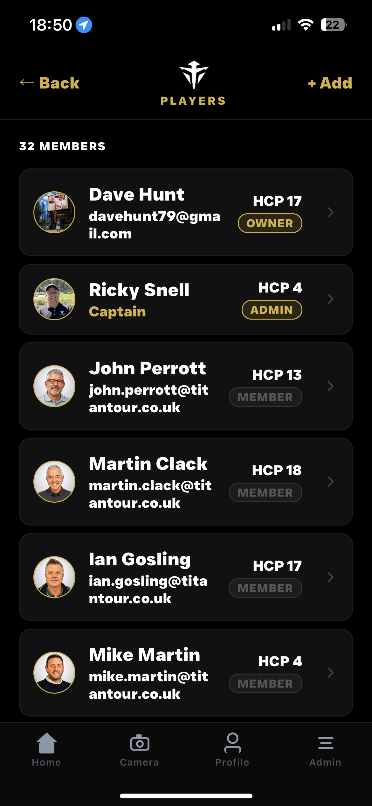

2. Fix 'Complete' Display Scaling
- The large COMPLETE text is wrapping and the final 'e' is dropping onto another line.
- Rescale responsively so COMPLETE always fits on one line while remaining large and prominent.
- This is a UI correction only – do not alter completed-game logic.
Photo 2 – Match Complete screen
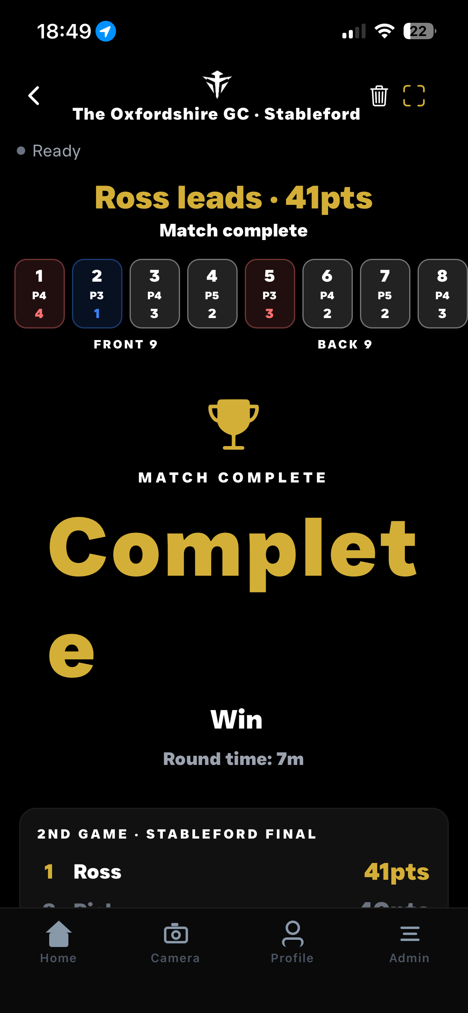

3. Correct Back Button Navigation
- Review Back button behaviour throughout the app.
- Back must return the user one screen/page back in their navigation journey, not automatically to Home.
- The dedicated Home button is the route back to the Home screen. Apply this consistently throughout supported areas.

4. Tournament Kronos / Stableford Side Game
- Tournament Mode must use the same proven Stableford side-game functionality already working in Casual Golf.
- Reuse the existing calculation logic and relabel this competition KRONOS on the Tournament Leaderboard.
- Stableford points must calculate from actual golf scores and accumulate correctly across the tournament where applicable.
- Current issue: the Stableford scores being shown in Tournament Mode are not correct.
- Do not interfere with the main tournament scoring engine while fixing Kronos.

5. Casual Golf – Final News / Match Report
- Add a News/Match Report feature to Casual Golf.
- Unlike Tournament News, Casual Golf only needs one final report after the game is completed – no preview or Day 1 reports.
- Use completed game data to create a match summary including winner, scores/points, key moments, close finishes, side games and useful stats where enabled.

6. Notification Badges – Inbox & Titan News
- Add number badges to the Inbox and Titan News tiles/icons.
- 1 unread item displays 1, 2 unread items displays 2, etc.
- Inbox reflects unread messages; Titan News reflects unread/new News items.
- Badges update as items are read and disappear when the unread count reaches zero.
- Keep the design consistent with Titan's black/gold visual identity.
Photo 3 – Home screen
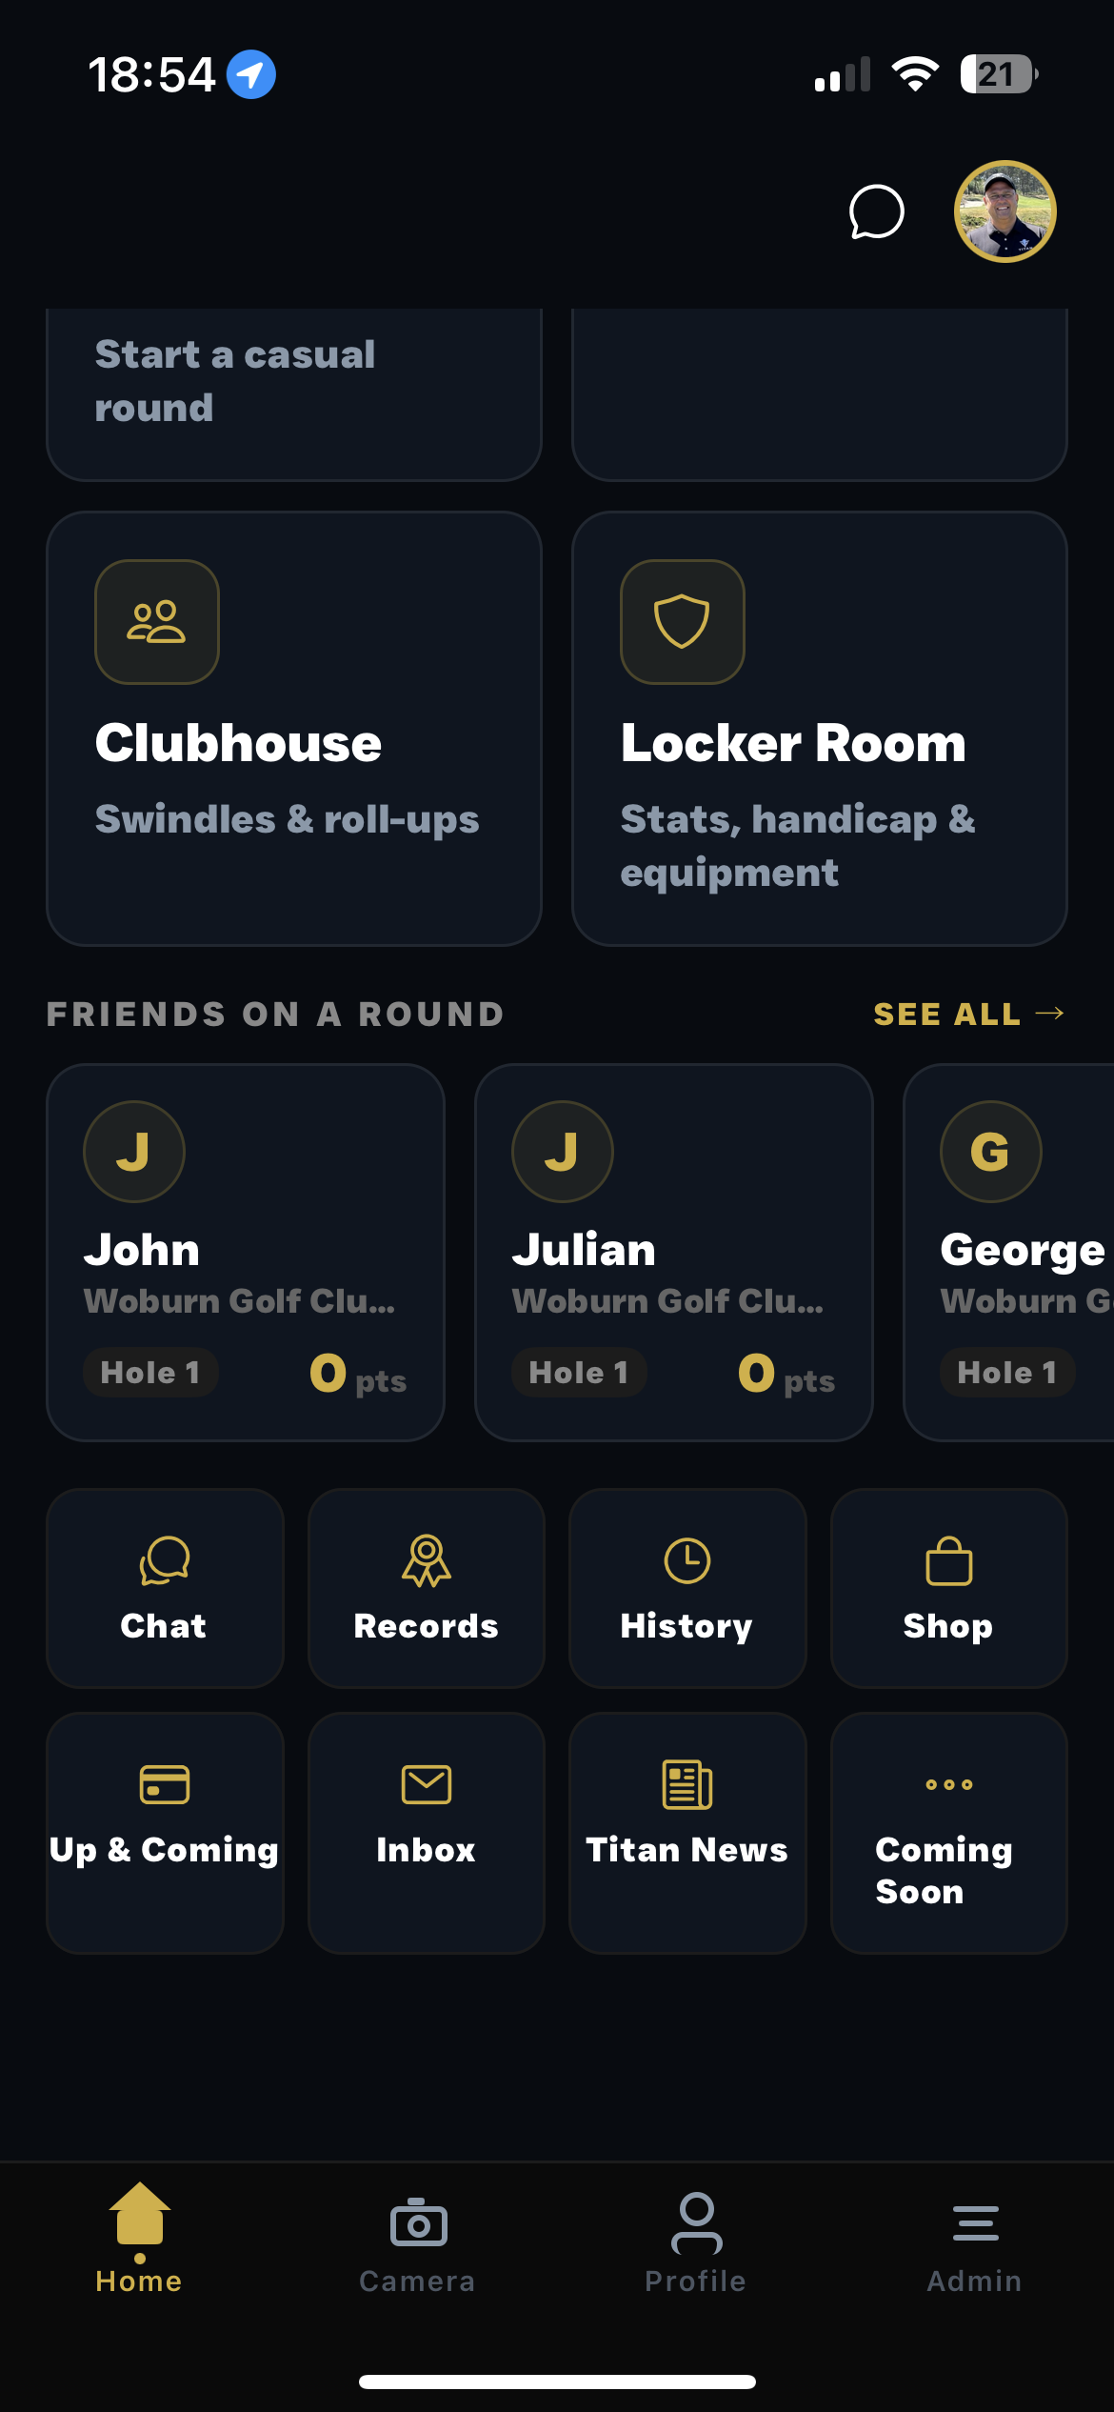

7. Tournament Game Builder – Stats, Chip & Birdie & Options
- Tournament Mode needs the same relevant game-building controls already available in Casual Golf.
- Track Stats must be selectable ON/OFF. Chip & Birdie must be selectable ON/OFF.
- Reuse the existing Casual Golf components and logic wherever possible.
- Selections must carry through into the live game; disabled features should not require unnecessary entry.
Photo 4 – Casual Golf game builder
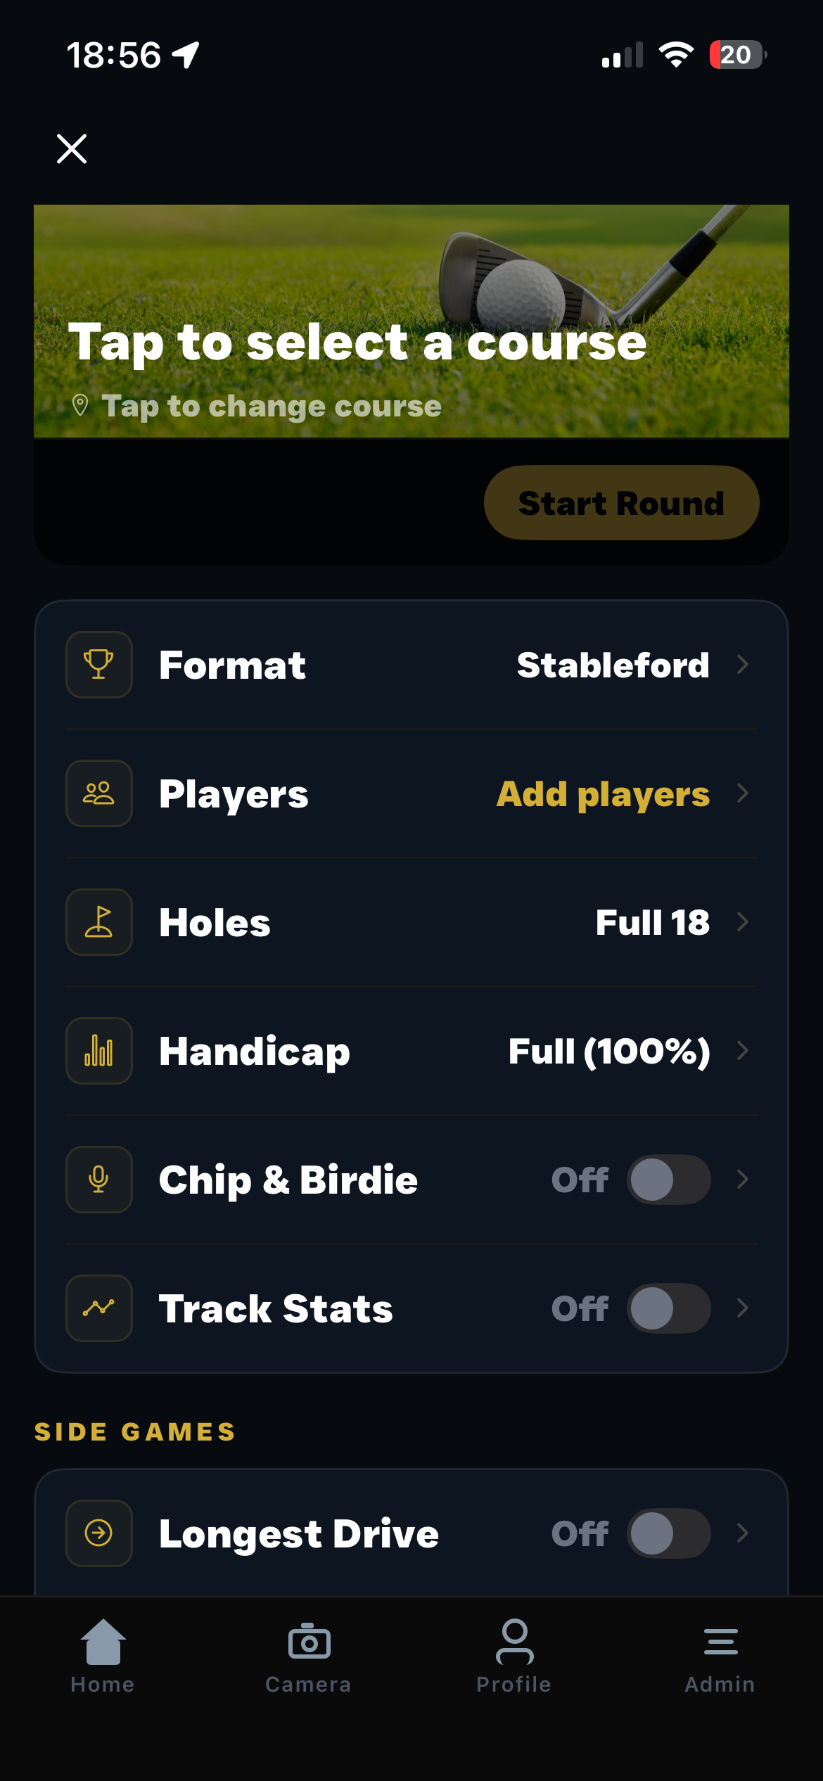

8. Tournament Area – UI Redesign
- Bring the Tournament area visually in line with the rest of Titan.
- Replace the current emoji-style graphics with proper Titan-style icons.
- Review Leaderboard, Info Pack, Live & Social, Players and other Tournament tiles.
- Fix typography/text fitting – for example Leaderboard must not break awkwardly.
- Retain existing functionality and use the established dark background, gold highlights, white typography, card style and spacing.
Photo 5 – Tournament home screen
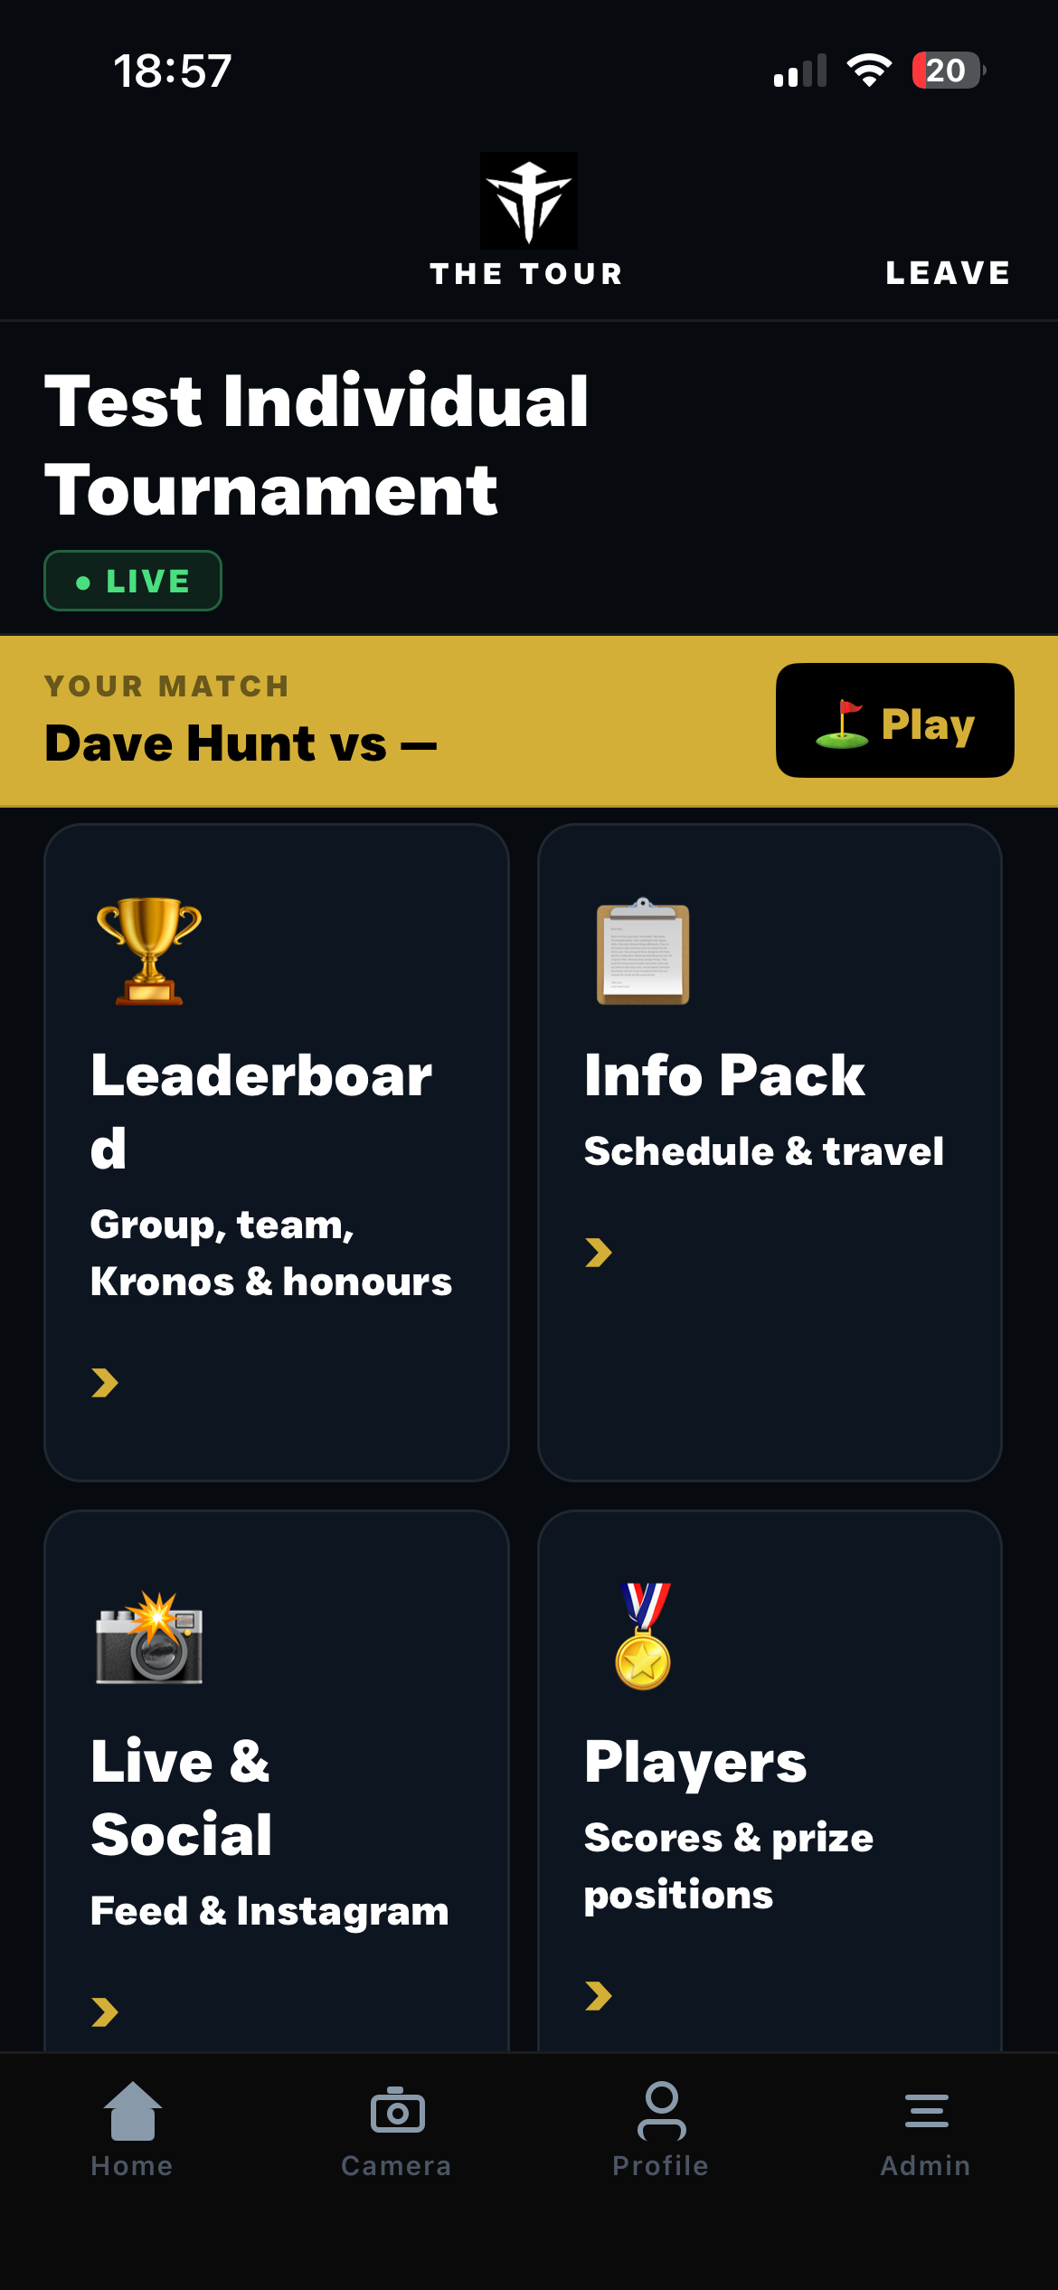

9. Swindle Money – 'Who Owes Who'
- Fully test the Swindle settlement system.
- Confirm the correct payer, recipient and amount are calculated.
- Confirm settlement information/messages hit the correct person's Inbox.
- Test multiple winners/losers and settlement combinations and ensure duplicate payment instructions are not generated.

10. Spectator Mode – Bottom Score Bar
- Fully test Spectator Mode, specifically the bottom live score bar.
- Confirm correct players, scores, holes, match/game position and relevant live information are displayed and update correctly.
- Check supported screen sizes and ensure spectators have no scoring/editing permissions.

11. Individual Tournament Mode – Full Logic Check
- Perform a full check of Individual Tournament Mode.
- There has previously been confusion between Individual Tournament structure and betting functionality.
- Retain the existing division splitting functionality unless an actual fault is identified.
- Check betting is not interfering with tournament/division logic.
- Check the back/division splits: a split appears to occur at the start and then repeat itself. Identify and correct the duplication without damaging the working division logic.
- Test from tournament creation through completion, including leaderboards, scores, divisions and results.

12. World Handicap System (WHS) Integration
- Implement the World Handicap System (WHS) so handicaps are correctly adjusted using the selected course and tee data.
- WHS must use the Course Rating and Slope Rating stored against the specific tee being played.
- Tee selection must happen before the WHS calculation because different tees can have different Course Ratings and Slope Ratings.
- Add a WHS ON/OFF control in the same game-building area and visual style as Chip & Birdie and Track Stats.
- When WHS is OFF, Titan must continue using the existing handicap/game setup without applying the WHS course adjustment.
- When WHS is ON, Titan must automatically calculate the appropriate playing handicap for each player using the Player Handicap Index, selected tee, Slope Rating, Course Rating, Par and the applicable handicap allowance for the selected game format.
- The adjusted handicap must feed into the existing scoring engine so strokes are allocated correctly using the course Stroke Index.
- Where different players select different tees, each player must be calculated using the Course Rating and Slope Rating for their own selected tee.
- If the selected course/tee does not contain valid WHS data, Titan must not guess the Course Rating or Slope Rating. It should tell the user the tee does not contain sufficient WHS data and require another valid tee or WHS to be switched off.
- WHS must work with the existing Titan game formats without changing or damaging their proven scoring logic.
Required flow: Course selection -> Tee selection -> WHS calculation -> Game-format handicap allowance -> Stroke allocation.
IMPORTANT: WHS is an optional layer over the existing working scoring engine, not a replacement for it. Reuse existing handicap and scoring functionality wherever possible.
STATUS: 12 development/testing items currently outstanding. Further screenshots and tasks can be added as development continues.

