TITAN APP - NEW “UP & COMING” HOME SECTION
Developer brief for Claude - home screen extension and society-only trip information

1. What needs to change
Add a new row of FOUR square shortcut icons directly underneath the existing four shortcuts Chat, Records, History and Shop. The existing home screen must otherwise remain unchanged.
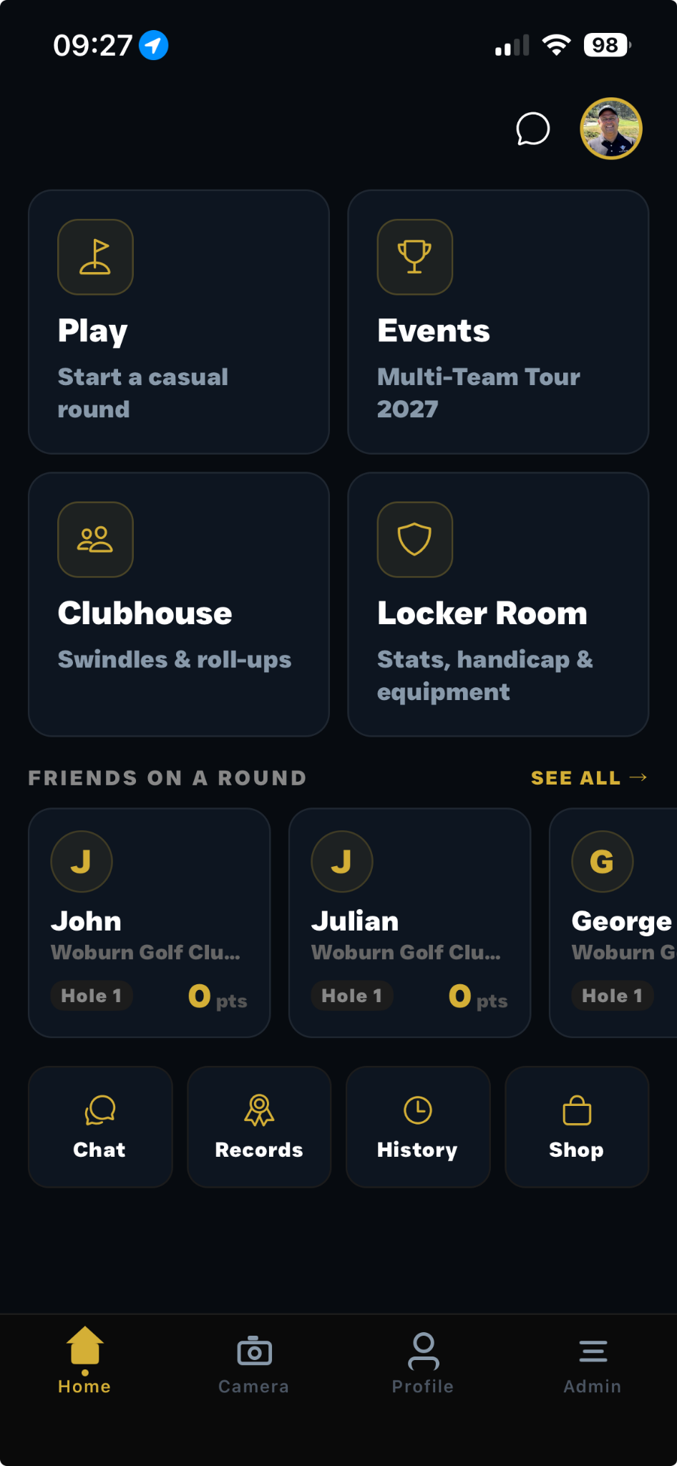
Current Titan home screen supplied for reference.

2. New row of four icons
The new row should visually match the existing Chat / Records / History / Shop row: same card size, spacing, dark styling, gold icon treatment, typography and overall Titan look.
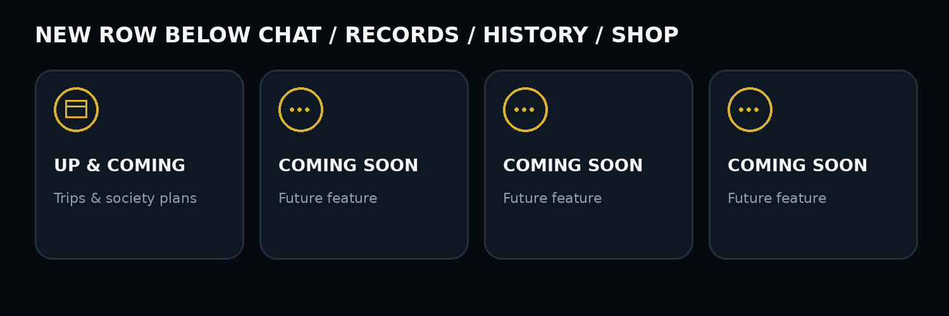
The FIRST shortcut should display “Up & Coming” and is the functional one described below. The other THREE shortcuts should display “Coming Soon” and are placeholders for future features with no functionality yet.

3. First “Up & Coming” shortcut - trip information
When the user taps the first Up & Coming shortcut, open a simple trip-information area for the society. This is intended for upcoming society trips and should allow the society/admin to enter and display:
- Name of trip
- Date of trip - ideally support a start date and end date
- Location of trip
- Airport, when travelling by air
- Outbound flight number/details
- Return flight number/details
- Total cost of the trip

4. Illustration of the trip screen
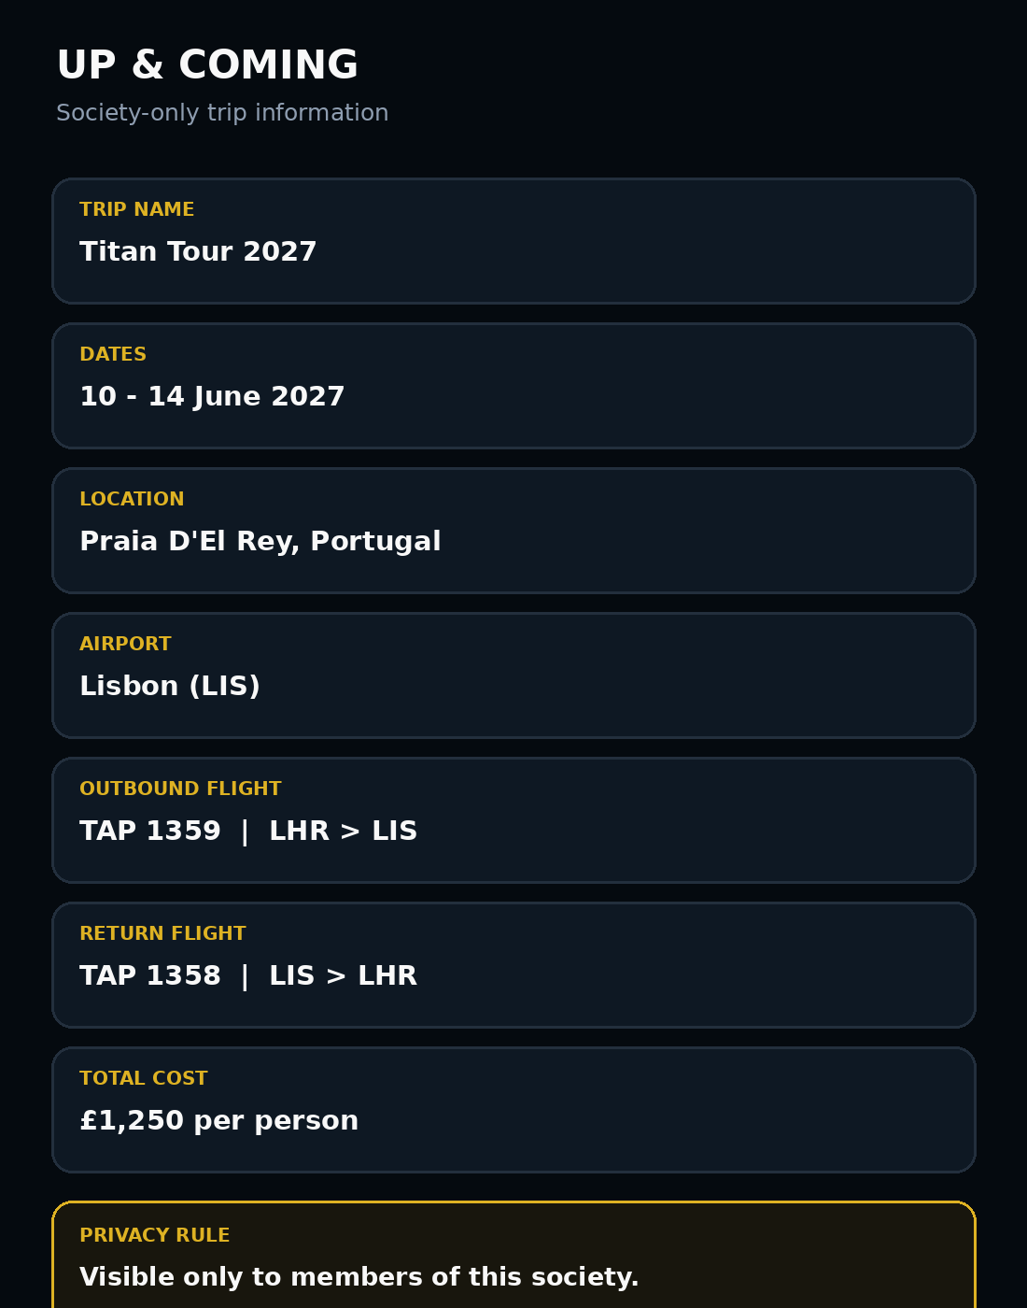
Illustrative layout only - Claude can adapt the exact UI while keeping the existing Titan design language.

5. Society-only visibility - important
This information must be private to the society.
Only users who are members of that specific society should be able to see its Up & Coming trip information. It must not be visible publicly, to users outside the society, or to members of another society. IMPORTANT: only the OWNER of that society can create, add, edit, update or delete the information in this section. All other society members have VIEW-ONLY access. They can see the trip information but cannot change any of it. These permissions must be enforced in the data/backend permissions, not just hidden in the interface.

6. Expected behaviour
Area | Required behaviour
Home screen | Add one new row of four shortcut cards below Chat / Records / History / Shop.
Shortcut 1 | Up & Coming - opens the society trip-information section.
Shortcuts 2-4 | Display Coming Soon as placeholders only for now.
Trip data | Store trip name, dates, location, airport, flight details and total cost.
Privacy | Only members of the relevant society can view that society's trip information.
Design | Keep the same Titan dark / gold visual style and sizing as the existing shortcut row.
Existing features | Do not alter the behaviour of the existing home-screen buttons or other working features.
Permissions | Only the society owner can create, edit, update or delete trip information. All other society members are view-only.

7. Simple implementation summary for Claude
Do not redesign the home screen. Extend it by adding four matching shortcut cards below the current bottom four. Make the first card a working society-only Up & Coming trip area. The other three cards are visual placeholders labelled Coming Soon. The trip area must support the fields above. Only members of that society can view the information, and ONLY the society owner can create, edit, update or delete it. Every other society member must have read-only access.

