Ban Review: June 15, 2017

# Description:

On the 15th of every month, a semiformal ban review is conducted. This allows members of chat to vote for user bans to be revoked.

# Summary of Ban Review:

Jesus – Unbanned

Yonic – Unbanned

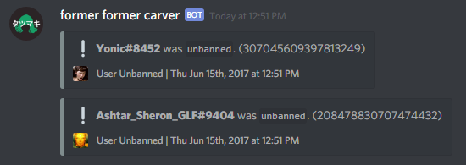

# Case #1 – Jesus

## Ban Reason:

By user request, multiple cases of sexual harassment.

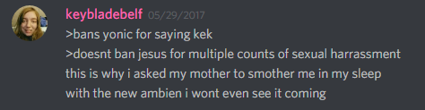

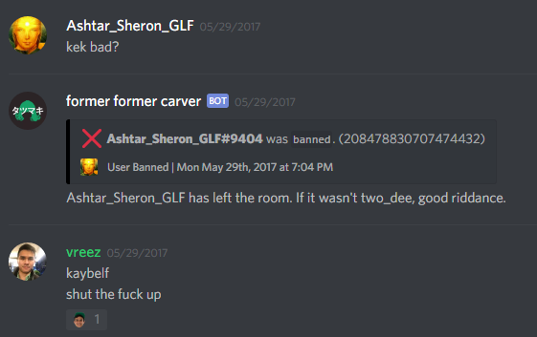

## Date of Ban:

05/29/2017

## Days spent Banned:

17

## Ban Review Discourse:

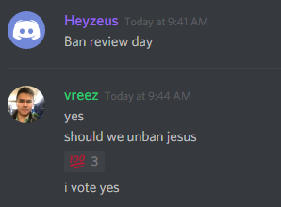

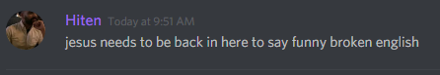

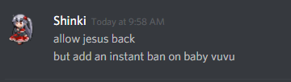

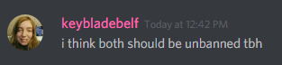

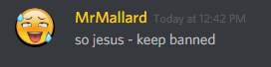

## Ruling:

Jesus has been unbanned, because he is generally funny to keep around, and he does tend to behave better for a few weeks after being unbanned. We do fully anticipate that he will eventually be banned again.

# Case #2 – Yonic

## Ban Reason:

Automatic ban by ari4 for saying kek 4 times

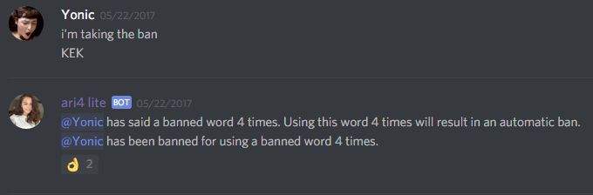

## Date of Ban:

05/22/2017

## Days spent Banned:

24

## Ban Review Discourse:





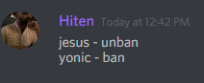

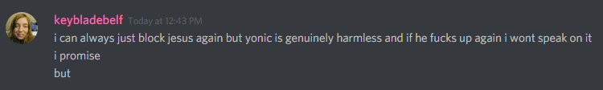



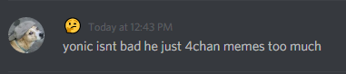

## Ruling:

Yonic has been unbanned. While he does 4chan meme too much, he is well liked by certain users. The “kek” check was indeed specifically targeted at him and some felt that the rule was unfair in the first place.

A caveat is that the “kek” check will remain in place. 200+ in 2 weeks really is excessive.

# Conclusion

Both users were unbanned, we hope that they have learned their lessons. (Even though we know for sure that Jesus won’t)

We hope that both users will contribute to a more friendly and active chat.