**Date: 19/09/24**

# Lab Practical #10:

Study the concept of routing using packet tracer. (Static Routing)

# Practical Assignment #10:

1. Connect the two different networks based on the calculated IP addresses and subnet using a packet tracer.
2. Connect the three different networks based on the calculated IP addresses and subnet using a packet tracer.

Instructions:

* 1. Static routing screenshot with routing table. (Take two or more different networks)
  2. Mention IP address of each node and network ID of each network as label.
  3. Ping command / Packet transfer screenshot between two different network nodes.

## Static Routing in Two Different Networks

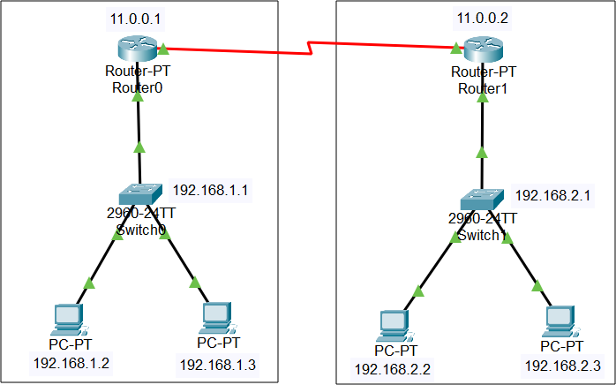

**Date: 12/09/24**

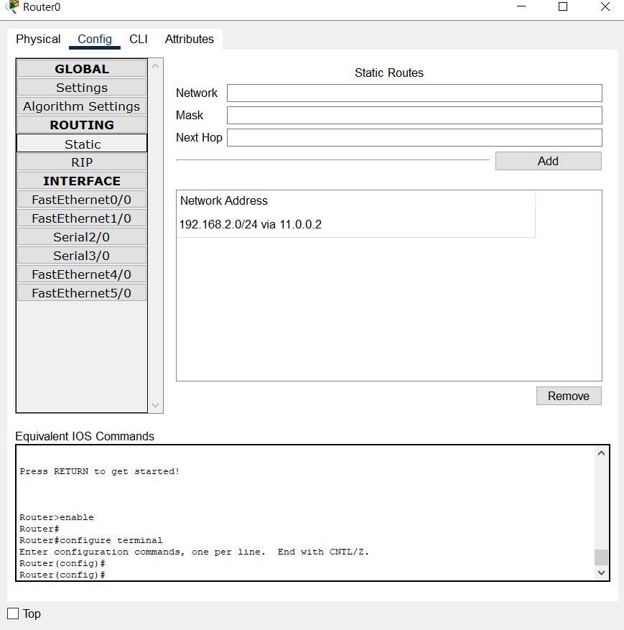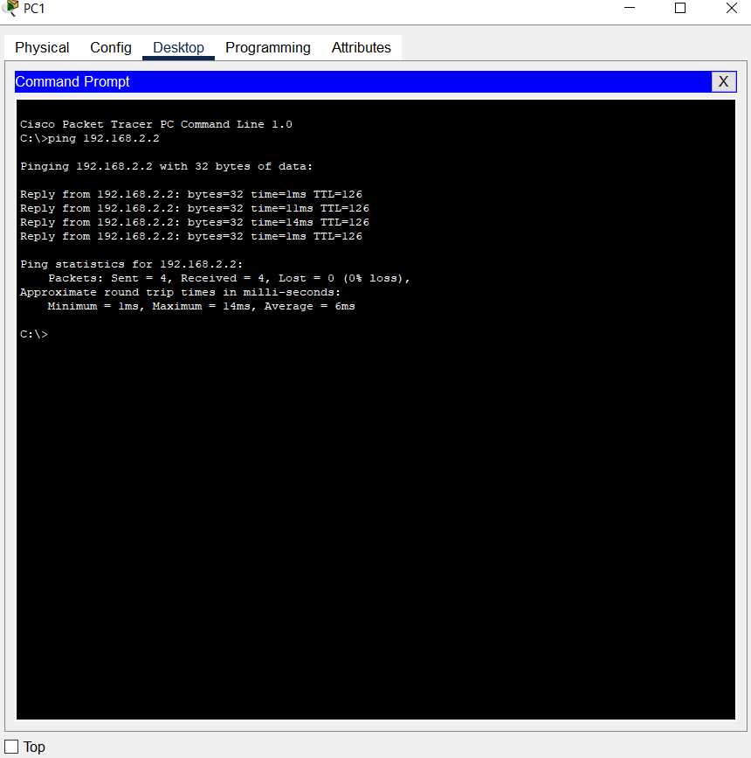

## Static Routing in Three Different Networks

**Date: 12/09/24**

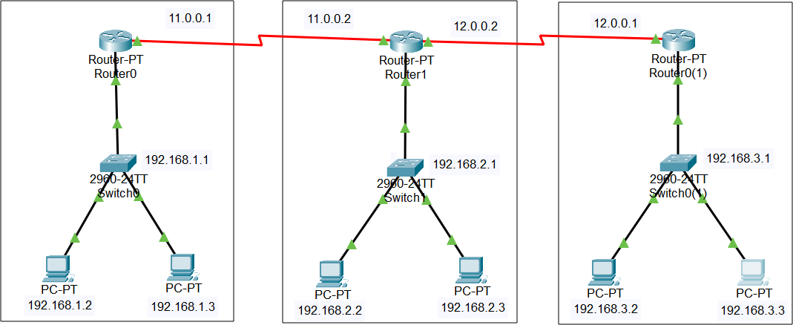

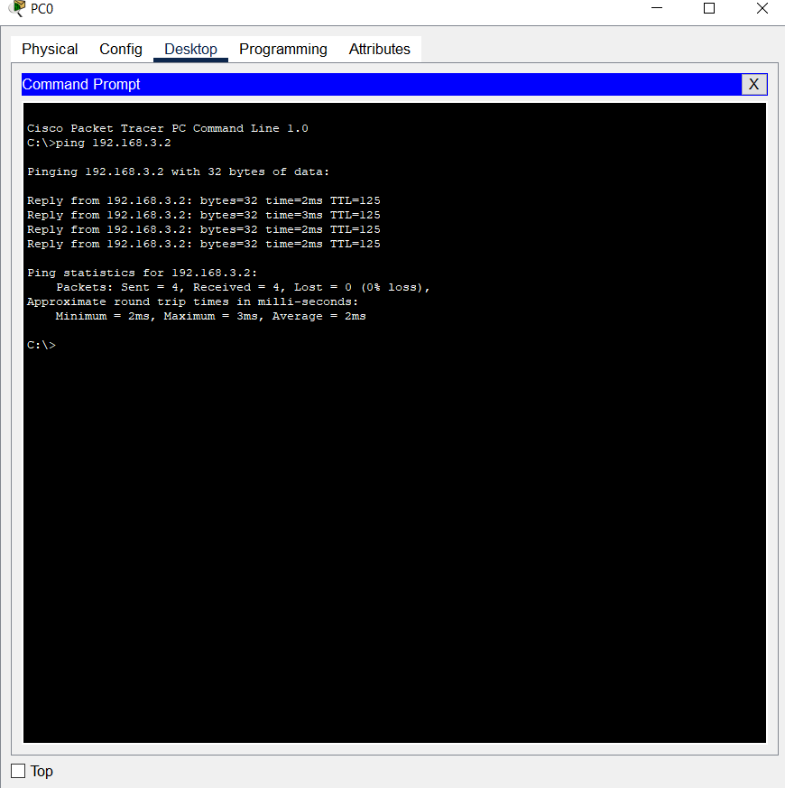

**Date: 12/09/24**

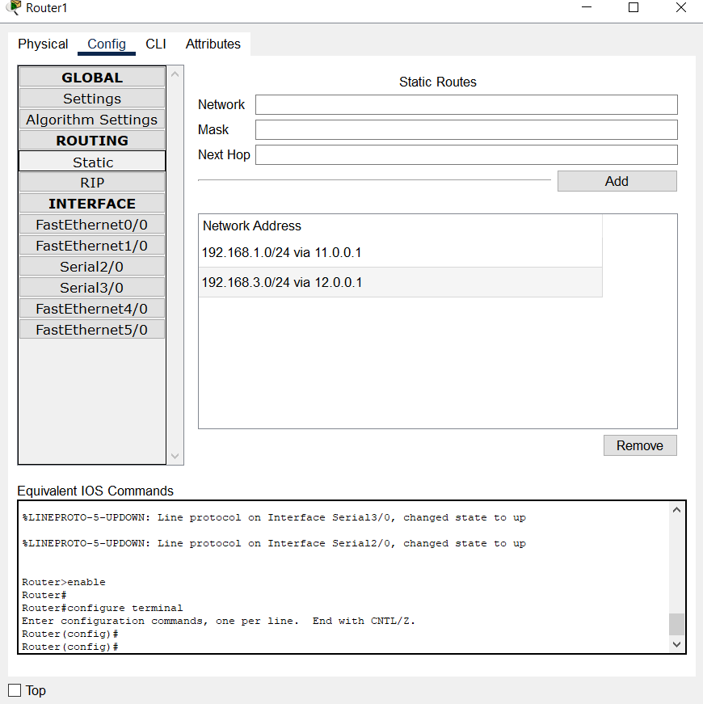

**Date: 12/09/24**

