**Lab Practical #13:**

Study &Survey of Institute organization network infrastructure.

**Practical Assignment #13:**

1. **Identify type of network in your institute. Draw a design of network in your institute (Any Lab/Floor/Building).**

**Lab No : C- 302**

**Topology : Star Topology**

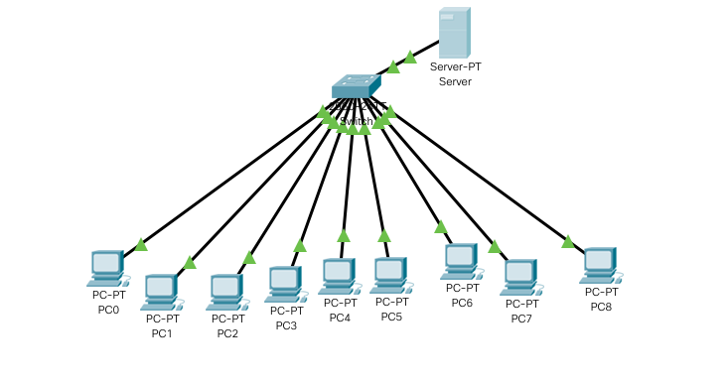

1. **List how many network devices and types of cable used and give its details.**

Total No Of PC :- 9

Total Number Of Switch :- 1

Total Server : DHCP Server

Types Of Cable:- Twisted Pair Cable

Connectors : RJ-45

Network Type : Lan