**Lab Practical #05:**

Study the concept of VLAN using packet tracer.

**Practical Assignment #05:**

1. **Implement the different network structures in VLAN and VLAN trunking. Also check connectivity between them using ping command or PDU utility.**

**1st V-lan :-**

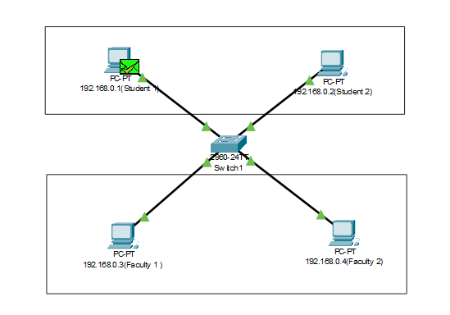

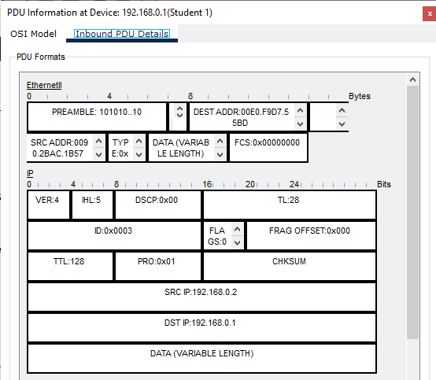

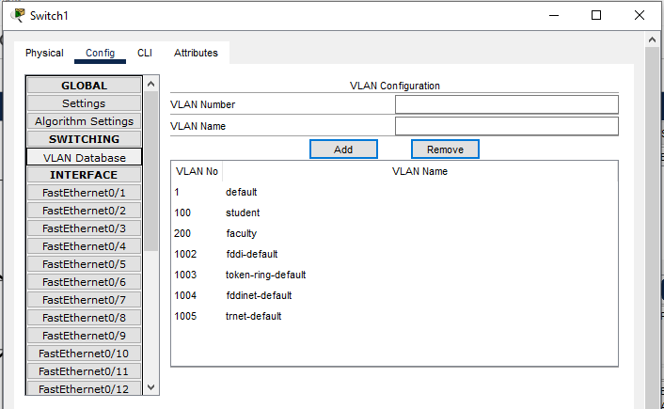

**Steps :-**

* Create a 4 devices and each divides connect between switch.
* Each devices add IP Address and same name as Label.
* For example IP 192.168.0.1 same as all Ip.
* Two V-lan are created Name is Student and Faculty.
* Now Switch configuration .click switch and click Vlan_Database.
* In Vlan_Database Add Vlan Number and Vlan Name and click Add Button.
* In Switch click Fast Eathernet portnumber and config the portnumber of devices.
* To Pass Msg between Two vlan but it not be send because devices connect different lan.
* Two devices connect same vlan it will be sent msg one to another succesfully.

**2 nd V-lan :-**

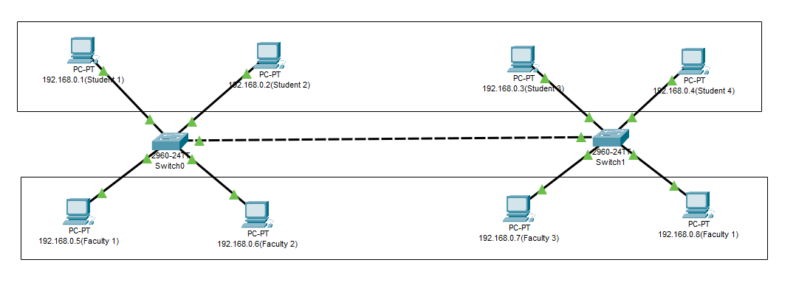

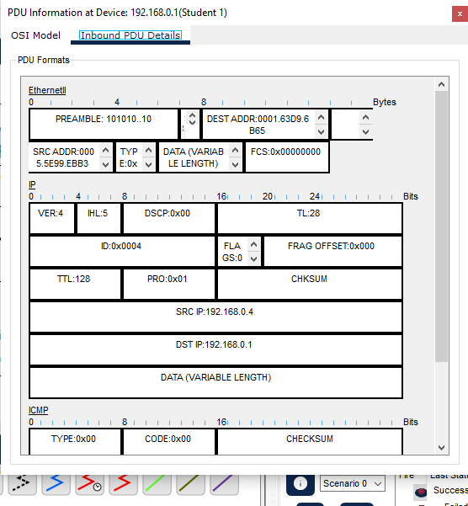

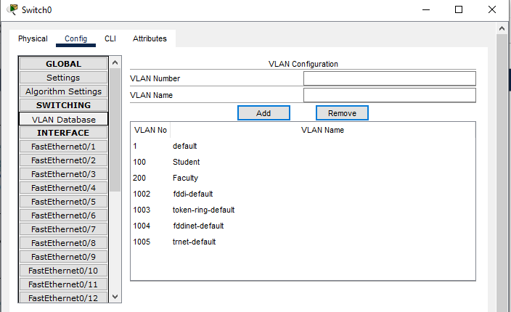

**Steps :-**

* Take 8 pc and assign Ip address and label to each pc.
* Take 2 Switch and Make 2 Lan with 4 pc each.
* Now there is local area network but We need to implement Virtual Lan database for implement Virtual Lan we need to configure Virtual Lan database in configure Section in switch.
* Make 2 New Virtual Lan configuration with unique Virtual Lan number and name.
* Now check the Port where the pc is connected and open that port configuration in switch and set Virtual Lan to access mode and select your Virtual Lan database name in dropdown.
* Now we need to connect both Switch but here we need to give Virtual Lan mode to trunk because there are number different Virtual Lan signal travel threw it.
* Now you configure two Virtual Lan in different local area network.

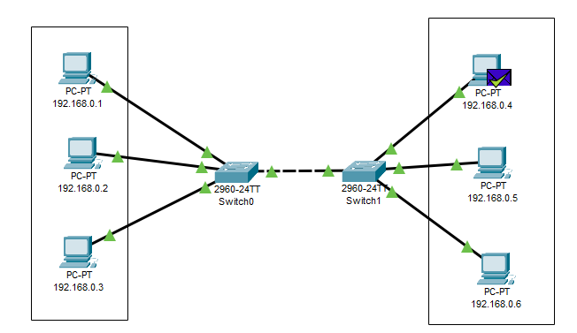**3 rd V-lan :-**

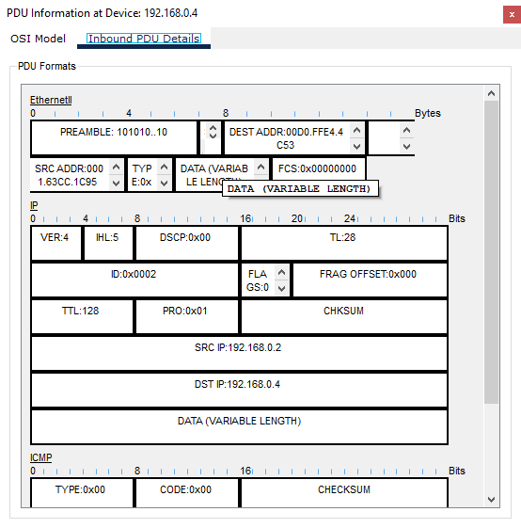

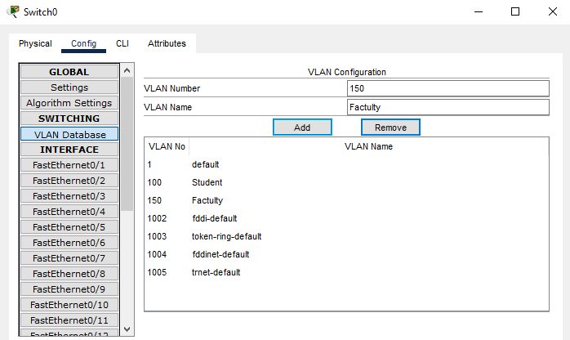

**Steps :-**

* Take 6 pc and assign Ip address and label to each pc.
* Take 2 Switch and Make 2 Lan with 3 pc each.
* Now there is local area network but We need to implement Virtual Lan database for implement Virtual Lan we need to configure Virtual Lan database in configure Section in switch.
* Make 2 New Virtual Lan configuration with unique Virtual Lan number and name.
* Now check the Port where the pc is connected and open that port configuration in switch and set Virtual Lan to access mode and select your Virtual Lan database name in dropdown.
* Now we need to connect both Switch but here we need to give Virtual Lan mode to trunk because there are number different Virtual Lan signal travel threw it.
* Now you configure two Virtual Lan in different local area network.

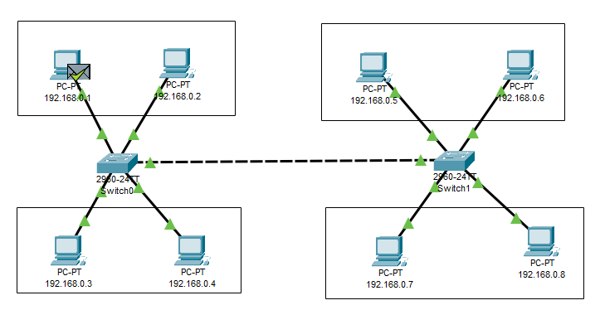**4 th V-lan :-**

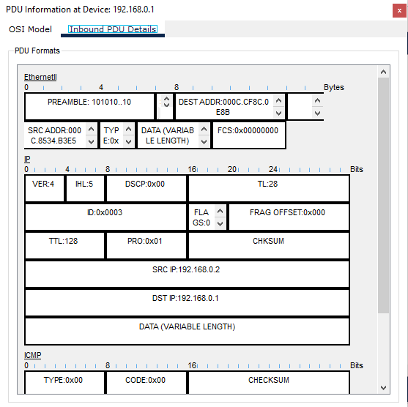

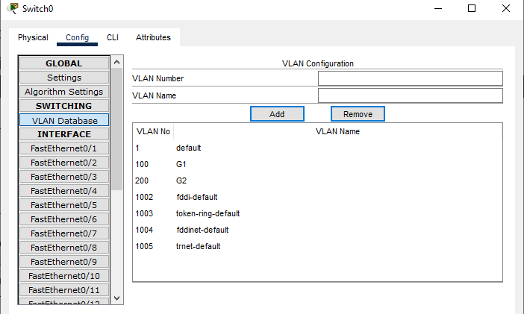

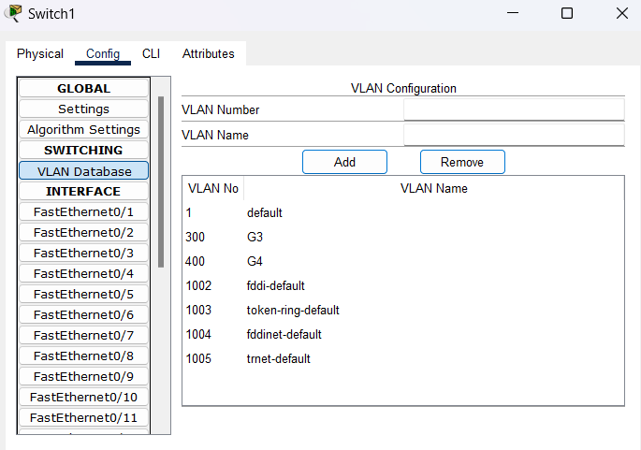

**Steps :-**

* Take 8 pc and assign Ip address and label to each pc.
* Take 2 Switch and Make 2 Lan with 4 pc each.
* Now there is local area network but We need to implement Virtual Lan database for implement Virtual Lan we need to configure Virtual Lan database in configure Section in switch.
* Make 4 New Virtual Lan configuration with unique Virtual Lan number and name.
* Now check the Port where the pc is connected and open that port configuration in switch and set Virtual Lan to access mode and select your Virtual Lan database name in dropdown.
* Now we need to connect both Switch but here we need to give Virtual Lan mode to trunk because there are number different Virtual Lan signal travel threw it.
* Now you configure two Virtual Lan in different local area network