**Lab Practical #08:**

Study Packet capture and header analysis by Wireshark (HTTP, TCP, UDP, IP, etc.)

**Practical Assignment #08:**

1. **Explain usage of Wireshark tool:**

* **Capture Traffic: Start capturing network traffic by selecting the appropriate network interface.**
* **Apply Filters: Use capture filters (before capturing) or display filters (after capturing) to focus on specific traffic, like http for HTTP traffic or ip.addr == 192.168.1.1 for traffic to/from a specific IP.**
* **Analyze Packets: Examine packet details, including protocol layers, headers, and payloads. Expand sections for in-depth analysis.**
* **Follow Streams: Use the "Follow TCP/UDP Stream" feature to view continuous data exchanges between endpoints.**
* **Identify Issues: Spot anomalies, such as retransmissions, duplicate packets, or protocol errors, to diagnose network problems.**
* **Export Data: Save captured data in various formats, or export specific packets for further analysis.**
* **Use Statistics: Access tools like "Protocol Hierarchy," "Conversations," and "Endpoint" statistics for summary views of the traffic.**
* **Customize Views: Colorize packets and customize columns to highlight important information for easier analysis.**
* **Decrypt SSL/TLS Traffic: If you have the right keys, decrypt SSL/TLS traffic for deeper inspection.**
* **Automate Tasks: Use command-line tools like tshark for automated packet capturing and analysis.**

1. **Packet capture and header analysis by Wireshark (HTTP, TCP, UDP, IP, etc.)**

* **Steps Of Packet capture and header analysis by Wireshark:**
* **1. Install and Launch Wireshark**
* **Download and Install: Get Wireshark from its** [**official website**](https://www.wireshark.org/)**.**
* **Launch Wireshark: Open the application after installation.**
* **2. Start Packet Capture**
* **Select Network Interface: Choose the network interface you want to monitor (e.g., Wi-Fi, Ethernet). You will see a list of interfaces with activity graphs.**
* **Begin Capturing: Click the "Start Capturing Packets" button (the shark fin icon) to begin capturing packets.**
* **3. Generate Network Traffic**
* **While Wireshark is capturing, generate some network traffic related to the protocols you're interested in (e.g., visit a website for HTTP traffic, use a network application for TCP/UDP traffic).**
* **4. Stop Capture**
* **Once you've captured enough packets, click the red stop button to stop capturing.**
* **5. Filter Packets**
* **Apply Protocol Filters: Use the filter bar at the top to focus on specific protocols. For example:**
* **HTTP: Type http in the filter bar.**
* **TCP: Type tcp.**
* **UDP: Type udp.**
* **IP: Type ip.**
* **Apply Filter: Press Enter after typing the filter to view only the relevant packets.**
* **6. Select and Analyze Packets**
* **Packet List Pane: This pane shows a summary of captured packets, including time, source, destination, protocol, and length.**
* **Packet Details Pane: Click on a packet in the list to see its details in the middle pane. This pane displays a hierarchical view of the packet's headers.**
* **7. Header Analysis**
* **Frame Header: Displays basic information about the packet, including capture length and timestamp.**
* **Ethernet Header:**
* **Source and Destination MAC Addresses: Hardware addresses of the sender and receiver.**
* **Type: Indicates the type of payload (e.g., IPv4).**
* **HTTP:**

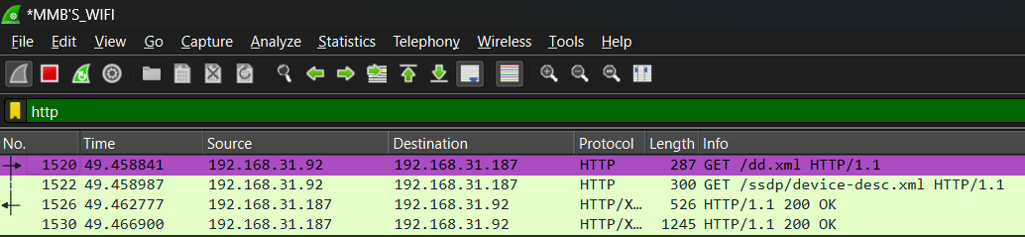

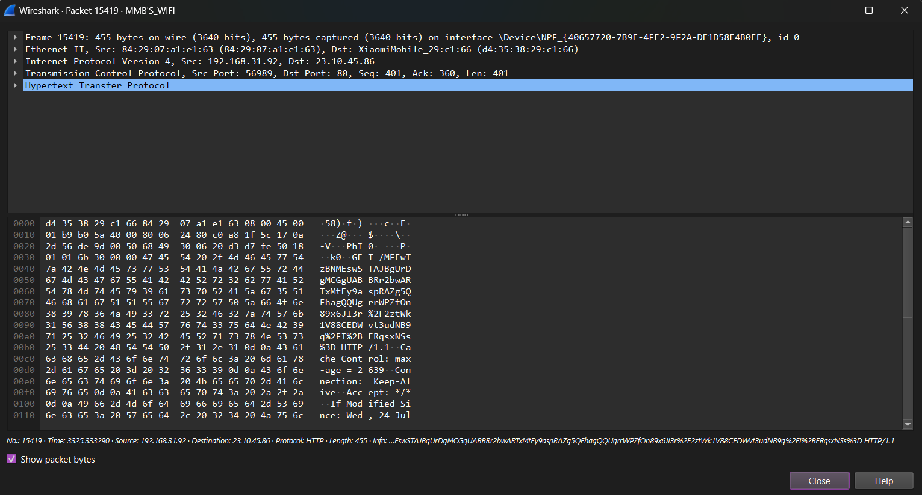

* **TCP:**

