# Setting up Google Cloud

You will need to create a Google Cloud account. From the Google Cloud Home page, click the dropdown menu for projects.

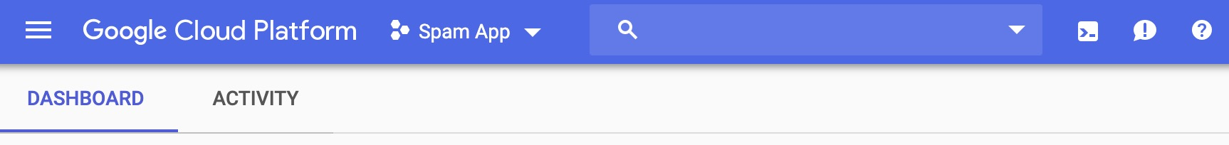

Then, click on New Project.

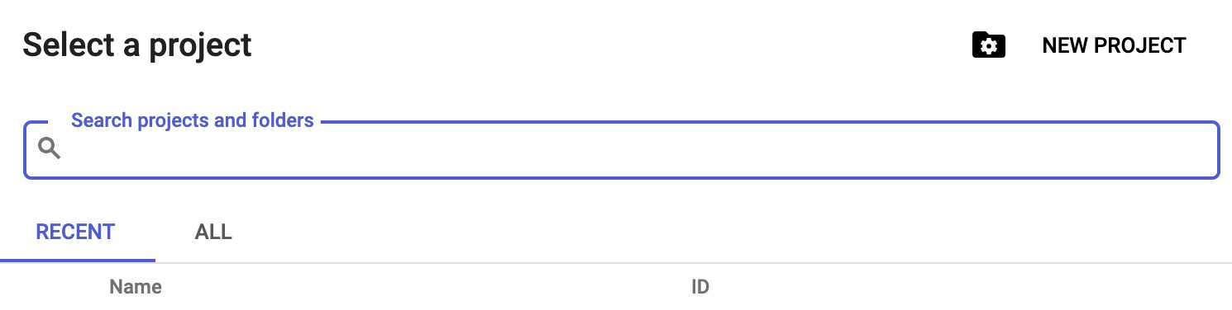

Give your project a name that is easy to remember. Once your project is created, open it to see the dashboard page.

From here, click on Activate Cloud Shell on the top menu.



This will open a split screen view. From the console menu on the middle of the page, click on the Launch Editor icon to open the console.



Create a folder for your app to upload the files. You will need to create a templates folder within the main folder for the html files.

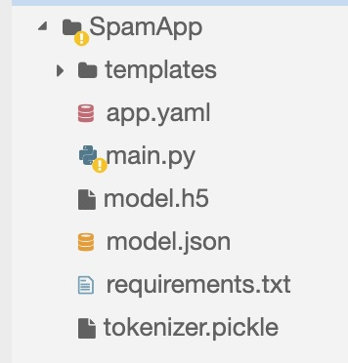

With all of the files loaded, you are ready to deploy! In the console, type the following commands:

1. cd [name of folder]
2. gcloud app deploy

The process is generated and then you will be asked if you would like to continue. Press Y and enter and soon after running through the requirements.txt file and loading the necessary programs, your predictor will be deployed online. Enter the website address and predict away!

This [video](https://www.youtube.com/watch?v=RbejfDTHhhg) provides a good reference for the GoogleCloud deployment steps.