Multiple Sequence Alignment Using Genetic Algorithms
Table of Contents
Multiple Sequence Alignment Using Genetic Algorithms 1
Abstract 1
Introduction 1
State of the art 3
Optimisation 5
Multi-objective Optimisation 6
Genetic Algorithm 8
Implementation 9
Testing 17
Results 17
Discussion 27
Bibliography 31

Abstract
Multiple sequence alignment is one of the most used tools available in bioinformatics. While good solutions and software do exist there is as of yet no definitive tool to carry out multiple sequence alignments in a fast and biologically relevant manner. This project will implement a genetic algorithm which will attempt to create fast biological relevant alignments. Multi-objective optimisation will be used to find a balance between the two objectives used to measure the quality of the solution. To prevent the population converging on a small set of solutions Niche Pareto Domination will be used to reduce the fitness of solutions that are similar. The algorithm will be tested using the BAliBASE data set of alignments. It will be tested against a selection of high quality multiple sequence alignment programs. The python source code is available on https://github.com/DaveM8/NAlineGA.

Introduction
Multiple Sequence Alignment(MSA) is a common problem in bioinformatics [2], it involves lining up sequences which represent genes or proteins. Properly aligned sequences allow the similarities and differences of sequences to be seen [3]. They can show characteristic motifs [16] which are short sequences or patterns which are conserved, and may be functionality related [15]. Another use is the re-construction of Phylogenetic Trees [17] which are diagrams showing the evolutionary relationships between organisms [15]. With the information given by aligned sequences and knowing that similarities of sequences may infer similarities of function. Multiple sequence alignments help to provide information about the functionality of genes and proteins in newly sequenced organisms [1], by comparing similarities found to other organisms where the functionality of the sequences has already been discovered.

scxa_buteu vrdgyiaddkdcayfcgr---naycdeeck---kgaesgkcwyagqygnacwcyklpdwvpikqkvsgk-cn----
scx1_titse -kdgypveydncayicwnyd-naycdklck--dkkadsgycyw---vhilcycyglpdseptktn--gk-cksgkk
scx6_titse -regypadskgckitcflta-agycntect--lkkgssgycaw-----pacycyglpesvkiwtsetnk-c-----
scx1_cenno -kdgylvdakgckkncyklgkndycnrecrmkhrggsygyc-----ygfgcyceglsdstptwplp-nktcsgk--
six2_leiqu --dgyirkrdgcklsclfg--negcnkeck--syggsygycwt---wglacwceglpd-ektwksetn-tcg---
Table 1: A multiple sequence alignment, The fully aligned columns are highlighted

A sample multiple sequence is shown in table 1. On the left hand side the name of each sequence is shown, followed by the sequence where the fully aligned columns are highlighted. Each letter represents one of twenty amino acids. The sequences can be adjusted by inserting or removing gaps which are represented by the dash character '-'. During a sequence alignment gaps will be inserted and removed until an optimal solution is found. During the process the sequence of the amino acids not including the gaps must not be changed or it would not be the same sequence.
Multiple sequence alignments are created by rearranging the sequences of an alignment by inserting or removing gaps [22]. It is not a trivial matter to arrange the proteins and create biologically likely alignment. Multiple sequence alignment is an NP-complete problem [26]. This means there is no solution that can be calculated fast. The time taken to compute the solution gets very large as the size of the problem grows [27], in this case as the length of the sequences increase or if more sequences are added to the alignment.
Given the large number of possible ways one could arrange the sequences until the mathematically best alignment is found. It is undesirable [4] to calculate the best possible alignment as it would take too much time [18] and computational resources. Given the above constraints many heuristics have been developed which sacrifice finding the optimal alignment [18] for finding a good alignment quickly [4]. In this paper I will examine and implement the use of a genetic algorithm to solve this problem.

State of the art
The most basic way of aligning sequences is pairwise alignments. Pairwise alignments use algorithms to align two sequences in biologically relevant ways. Needleman and Wunsch in their 1970 paper [29] described a method of aligning two protein sequences using dynamic programming. The algorithm tries to maximize the number of similar proteins matched on each line of the sequence. A two dimensional array is created with every possible comparison. A pathway can then be piloted through the matrix. The quality of the alignment can be calculated by matching amino acids receiving a score of one and mismatches given a score of zero, this being the simplest scoring method. Other scoring methods include the use of scoring matrices, where each combination of amino acids is scored based on how biologically likely it is that one could be replaced by the other. A gap penalty is used when a gap is inserted between two amino acids this can range from -2 to -10. The gap penalty should be low enough to allow gaps to be inserted if necessary but high enough to prevent too many gaps being inserted. A diagram of an alignment matrix is shown in figure 1. One of the sequences is shown along the top and the other is shown on the left margin. The value between each pair is calculated and the path with the greatest value is choose. A gap is inserted when the line dose not go through the box. Notice there are two equally good solutions. The following alignment would be calculated by figure 1.
AGCNS-RQCLCR-PM
ASC-SNR-CKCRGP-
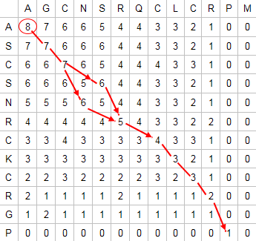
Figure 1: Once a matrix with the scores of the combination of each amino acid has been created then the highest scoring path can be plotted through the matrix. Image Source[30]

There have been many different algorithms developed for multiple sequence alignments. The most successful of these use a progressive or iterative approach[9]. Progressive algorithms work by aligning the two sequences which give the best alignment using a method such as Needleman and Wunsch described above, and subsequently adding the remaining sequences. and progressively adding more sequences. Some programs which implement this method are CLUSTAL W[10] and MULTAL[11].
CLUSTAL W is one of the most popular sequence alignment methods used by biologist. It first a pairwise alignment of all the sequences which are to be aligned is carried out. Using the pairwise alignments a distance matrix can be calculated, which gives information of the divergence between each alignment. A guide tree is then calculated using the distance matrix and this guide tree is used to decided the order in which the sequences are added to the alignment [10]. CLUSTAL W increases the quality of the alignment by changing the gap penalty and the scoring matrix depending on the divergence of the sequence being added to the alignment[10]. The disadvantage of progressive algorithms is they can get stuck at a 'local minimum' because of the greedy nature of aligning the most similar sequences first, and later being unable to change them[12] prevent newly added sequences being properly aligned[9].
Progressive methods described above have been improved by algorithms such as the popular T-COFFEE[14]. Which uses a progressive approach and creates a library of alignment information before the main alignment takes place. When each sequence is being added to the alignment information about future sequences is used to help guide the alignment. This helps to prevent a mistake being made early on and progressing through out the alignment. Also prevents the greedy nature of the progressive algorithm interfering with the alignment[14].
Iterative methods start with a complete alignment and try to improve it each iteration[9]. Statistical methods such as hidden Markov models have also been introduced to improve alignments during the iterations[13]. The genetic algorithm developed in this project is an iterative method, each generation the solution is improved until a good but not necessarily the optimal solution is found.

Optimisation
The goal of this project is the development of a computer program which will find a good solution to the multiple sequence problem described above. This is an optimisation problem. Optimisation seeks to improve a solution toward the optimal, the best solution [33]. In this project the perfect alignment is not being looked for, an alignment which is close to the optimal and is calculated in a reasonable amount of time will be sufficient.

Multi-objective Optimisation
Multi-objective optimisation is a method of finding a set of optimal solutions for a problem, where there are many conflicting objectives, or the search space is large and complex. The set of solutions that is going to be looked for is this application is known as the pareto optimal set. The pareto optimal set is the set of solutions which dominate the other solutions. A solution dominates another if no objective of it is smaller that the other and at least one objective is greater than the other.
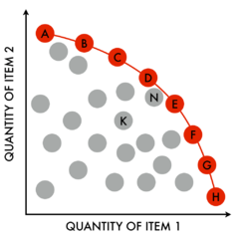
Figure 2: The pareto optimal set are the points in red. The red points dominate the grey points. The objectives are represented by the x or y axis. Image Source[31]

A pareto optimal set is shown in figure 2 the red points dominate the grey points, notice that the red points are greater than all of the grey points in at least one objective and none of the grey points are greater than any of the red points in any objective.
In this application there are two parameters which we want to maximize. As we are maximizing two values it is possible that these parameters will be conflicting. Multi-objective optimisation will be used to select the candidate solutions which will be kept for the next generation and be used in the crossover operators.
All of the candidate solutions which are not dominated by another solution form the pareto optimal front [8]. The solutions on this front will be kept for the next generation and they will have a higher chance of being selected for crossover operations. There will still be a chance of the solutions that are dominated by other solutions being selected for crossover, this prevents the algorithm becoming greedy and can help to break out of local optimal solutions.
The individuals in the population will be assigned different probability of being selected for crossover based on how many if any other individuals dominate them. With the non-dominated individuals having the highest probability of being selected and the dominated having less chance of being selected.
To guarantee that the optimal front has been produced would require too much computational power and time [8]. Our genetic algorithmic approach fits well into this model where we sacrifice a guarantee of the optimal solution for a good approximate solution which is quickly computed.
It is preferable to keep as much diversity as possible in the in the population. We want to keep a diversity set of non-dominated solutions in the population [8]. To help prevent the pareto front from converging to a set of very similar solutions and to keep the population spread along the pareto front density will be considered when selecting the population. All individuals are given a niche count based on the number of individuals with similar fitness which are near to them. Candidates with similar individuals nearby will have there fitness reduced which will increase the probability that they will be removed from the population[24].
The measures used to determine the strength of a solution are Identity which counts the number of fully aligned columns, where the same protein is in the same position in each line. Sum of pairs, where a scoring matrix is used to determine the biological relevance of an alignment [6].
The scoring matrix used in sum-of-pairs was first developed by Dayhoff et. al . In 1972[6]. It uses knowledge of protein point mutation to work out the statistical likelihood of one protein evolving into another over evolutionary time. The PAM350 (Point Accepted Mutation)[6] used in this application gives each of the 20 amino acids a probability of mutating into another given that their has been 350 point mutations per 100 amino acid links. This matrix makes it likely that every point has under gone more than one mutation. The matrix was calculated using the a PAM Matrix calculator[7].
The sum of pairs score is calculated by comparing the the amino acids for each position against all the other lines at the same position and checking the value for the two proteins in the PAM350 scoring matrix. These values are then added or subtracted and a value calculated the higher the value the more biological relevant the alignment. A gap penalty of -10 is used when an amino acid compared against a gap in another line.

Genetic Algorithm
In this project I implement a Genetic Algorithm which is a computer application based on Darwinian evolution [28]. Genetic algorithms represent possible solutions to a problem as a genotype which is this case is a mutilate sequence alignment such as the one shown in table 1.
Over a number of generations diversity is introduced to the population by mutation and crossover operators. The fitness of the candidate solutions is increased by selecting the better solutions for crossover and removing the weak solutions at the end of each generation. The mutation operators randomly make changes to the genotype of the candidate solutions, with the intent of introducing better solutions and also to stop the algorithm becoming too greedy, that is to stop the algorithm finding a less than optimal solution and getting stuck there.
The crossover operators select two candidate solutions and joins one half of one with the other half of the other and vice versa, this produces two child solutions that may incorporate some of the best parts of both parents. The fittest solutions present in each generation are used during crossover to create the next generation [20]. Mutations may be applied in a random manner to some of the candidate solutions.
At the end of each generation the fittest solutions are kept and the least fit solutions are removed from the population. With every generation the population becomes a little bit fitter, that is best individuals of the population become closer to the optimal solution.
A genetic algorithm is more efficient that other kinds of optimisation algorithms. This is because it always has many competing solutions and it dose not require any auxiliary information to help with it's dissension making process because genetic algorithms are blind selecting the best solutions from many candidates [33].

Implementation
The genetic algorithm in this project will be implemented in the python programming language.
The development of a genetic algorithm requires for candidate solutions being represented this is known as the genotype. The genotype in this case is a string representing each sequence[2] and all sequences are printed on a line of there own making up the alignment (see table 1). The internal representation of the genotype is a 2 dimensional numpy[21] array. numpy allows for quick and accurate indexing and changing of values stored in the array.
The evaluation of the fitness of each candidate solution is measured using two indicators. The sum-of-pairs compares the value in each position of each line with the values in that same position in every other line, and looks up a value in a table holding biologically relevant [6] scores for the proteins, all the values are added together to give the sum-of-pairs for the alignment. The identity is the sum of all the columns which have the same value on all the lines. An example of the calculation of sum of pairs is shown in table 2 for clarity only three lines are shown of a set of short sequences
1.vrdgyiaddkd
2.k-dgypveydn
3.-regypadskg
Table 2: Example of calculated sum-of-pairs

First line 1 and line 2 are compared the score of each corisponding value is looked up in a PAM350 table.
Socre += vk + r- + dd + …
Score += (-2) + (-10) + 4 + …
Then line 1 and 3 are compared using the same table
Score += v- + rr + de + …
Score += (-10) + 7 + 4 + …
Then line 2 and line 3 are compared using the same method
Score += k- + -r + de + …
Score += (-10) + (-10) + 4 …
That method is continued until all the amino acids in all the sequences have been compared giving a final total which is the sum of pairs.
The crossover and mutation operators are specially designed to produce robust solutions to the multiple sequence alignment problem. For the sequences to remain valid the sequence and order of the proteins must be preserved. The only modifications that can be made is to add, move, or delete the gaps in between the proteins[22].
The Crossover operator takes two parent operators and mixes them together. There are three crossover operators in this algorithm. The first preforms a vertical split by choosing a position at random and spiting both parents at that column and putting the left of parent 1 with the right of parent 2, and the right of parent 1 with the left of parent 2. Care is taken to cut parent 2 in the correct index of the sequence to ensure that two valid alignments will be produced. Parent 1 is cut straight on which ever column is randomly chosen and parent 2 is cut at the location that will allow it to be joined with parent 1, producing a valid alignment table 4 shows two alignments would be split and joined to produce two valid alignments.
Parent 1
1hpi erlseddpaaq aleyrhdass vq-----hpa y---eegqtc lnclly-tda -sa-qdwgp- ---csv--fp
1hip navaadnatai alkynqdatk se---vaaar pglppeeqhc adcqfmqada agatdewkg- ---cql--fp
2hipA pr-aed---gh ahdyvneaad asg----hpr y---qegqlc encafw-gea vq--dgwgr- ---cthpdfd
hpis -apv-deknpq a-valgy--v sdaakadkak ykqfvagshc gncal---fq ---gkat-da vggcpl--fa

Parent 2
1hpi -erlseddpaa q-ale----y rhdass-v-- qhpay--e-- gqtclnc-ll -ytdasaq-d wgpcsv----
1hip -navaadnata i-alk----y nqdatkserv aaarpglppe eqhcadcqfm qadaagatde wkgcql----
2hipA --p-raedgh- --ahd----y vneaad-a-s ghpry--q-e gqlcencafw -geavqdgwg rcthpd----
hpis apvdeknp--q aval-gyvsd aaka-d-kak ykqfvag--s -h-cg--n-- --calfqgka t--davggcp
Table 4: Preforming a vertical alignment the yellow will form one alignment and the green will form the other.

The second crossover operator randomly selects a horizontal position and places the top of parent 1 with the bottom of parent 2 and the top of parent 1 is put with the bottom of parent 1. A diagram showing how this cross is preformed is in table 5.
Parent 1
1frr a-yktv-lktp sge-ftldvp egttildaae eagydlpfs- cragacsscl gkvvsgsvde
1fxa atfkvtlinea egtkheievp ddeyildaae eqgydlpfs- cragacstca gklvsgtvdq
dmpp --ynvt-i-ep tge--vieve dgqtilqaal rqgvwlpfa- cghgtcatck vqvvegevdi
fer ----------- -edygtmeva egeyileaae aqgydwpf-s cragacanca sivkegeidm-

Parent 2
1frr a-yk-tvlk-t psgeftl--- --vpegttil -daaeea-gy -l-pfscra- gacssclgkv
1fxa atfkvtlinea egtkhei--- -evpd-deyi ldaaeeq-gy dlpfs-cra- gacstcagkl
dmpp --yn-vti--e p-tgevi--- -evedgqtil -qaalrq-gv wl-pfacgh- gtcatckvqv
fer -------e-dy --gtmevaeg ey---ile-- --aa-eaqgy dwpf-sc-ra gacancasiv
Table 5: When performing a horizontal crossover the top of parent 1 is mixed with the bottom of parent 2 and vice versa.

The third operator selects the parent with the least number of fully aligned columns. A random column which is fully aligned in the other parent is selected. Then by inserting gaps that complete column is created in the other parent. Again great care is taken to ensure a valid alignment is produced. Note the final operator only creates one offspring. As can be seen from the diagram in table 6 all the columns which are fully aligned in both parents are marked in yellow these columns are ignored. From the columns which are fully aligned in one but not the other marked in green. The operator will insert gaps in parent 1 in this case. The offspring is also shown this is identical to parent 1 only gaps have been inserted marked in orange to make the column fully aligned. A gap can be inserted at the end of one of the columns so they remain the same length.
Parent 1
scxa_buteu -----vrdgyiaddkdcayfc-g-r-naycdee------c---kkgaes-g
scx1_titse ------kdgypveydncayicwnyd-naycdkl------ck---kkads-g
scx6_titse ------regypadskgckitcflta-agycnte------ct--lkkgss-g
scx1_cenno ------kdgylvdakgckkncyklgkndycnre------crmkhrggsy-g
six2_leiqu dgyirkrdgc--kls------c-----lfg--negcnkeck--syggsygy

Parent 2
scxa_buteu -----vrdgyiaddkdcayfc-g-r-naycdee------c---kkgaesgk
scx1_titse ------kdgypveydncayicwnyd-naycdkl------ck---kkadsgy
scx6_titse ------regypadskgckitcflta-agycnte------ct--lkkgssgy
scx1_cenno ------kdgylvdakgckkncyklgkndycnre------crmkhrggsygy
six2_leiqu dgyirkrdgc--kls-----c------lfg--negcnkeck--syggsygy
Offspring
scxa_buteu -----vrdgyiaddkdcayf-c-g-r-naycdee------c---kkgaes-g
scx1_titse ------kdgypveydncayi-cwnyd-naycdkl------ck---kkads-g
scx6_titse ------regypadskgckit-cflta-agycnte------ct--lkkgss-g
scx1_cenno ------kdgylvdakgckkn-cyklgkndycnre------crmkhrggsy-g
six2_leiqu dgyirkrdgc--kls------c------lfg--negcnkeck--syggsygy
Table 6: Shows the operation of matched column crossover operator.

There are seven mutation operators 4 regular and 3 smart the difference is the smart operators check to see if the mutation has improved the alignment. If it has not the mutation is tried again with the original alignment this is repeated twice by default and if no improvement is made the original sequence is kept[23].

The first regular operator is Gap Insertion a random number of gaps is inserted into the alignment the user can choose the maximum number of gaps to insert [23] the default is between 3 and10. The second operator is Gap Shift where a gap is randomly chosen and and moved to another location of the sequence [23]. Merge Space is the third regular operator it randomly selects 2 or three consecutive gaps which may or may not be adjacent and makes them adjacent and moves them to a random place in the sequence.
The final regular mutation operator is gap remove. Gap remove is not in PNPAlineGA but while I was testing I noticed that many of the alignments had a large amounts of consecutive gaps as shown in table 7. Once these gaps have been inserted there is no mutagen operator that can remove them. I noticed in my results that once large amounts of consecutive gaps were inserted they would remain in the population. So I developed a mutation operator which randomly selects a row them picks one of the gaps on that row and removes it.
vrd-gyiaddk dcayfcgr-- -naycdeeck ---kgaes-- -------gk- --------cw yagqygnacw cyklpdwvpi kqkvsgkcn
-kd-gypveyd ncayicwnyd -naycdklck --dkkads-- -------gy- --------cy w---vhilcy cyglpdsept ktngkcksg
-re-gypadsk gckitcflta -agycntect --lkkgss-- -------gy- --------ca w-----pacy cyglpesvki wtsetnkc
kd--gylvdak gckkncyklg kndycnrecr mkhrggsy-- -------gy- --------c- y----gfgcy ceglsdstpt wplpnktcs
---dg---yir krdg----ck ls-------c lfg--negcn kecksyggsy gycwtwglac w--------- ceglpdektw ksetntcg

Table 7: The highlighted area shows that large amounts of consecutive gaps can be inserted into an alignment. remove_gap() prevents these gaps building up.

The smart mutation operators make use of a global probability value. In the first generation this is set to 50%. When a decision is to be made about whether to insert a gap or move a gap at the start or end of a sequence, this probability value is used. If a better alignment is found after making a selecting the start then next time it will be 1% more likely that the start is chosen. If a better alignment is not found it becomes 1% more likely that the other side will be chosen next time.
The first of the smart operators is Smart Gap Insertion. It selects a position at random and inserts a number selected by the user of gaps at that position and gaps are inserted at the start and end of all the other lines to keep them the same length. At the first attempt there is equal chance of inserting the gaps at the start or end of the sequence but this changes depending on the success of previous operations [23].
The next smart operator Smart Gap Shift which randomly selects a gap and tries to move it left or right a random number of spaces until the fitness improves. The amount of times to try to move the gap is set by the user, defaults at 3. The probability of moving a gap left of right is equal at the start but changes depending on the success of previous operations [23].
The final smart operator is Smart Merge Space which is similar to regular merge space but only accepts mutations if they improve fitness [23].
When running a smart mutation operator, the new solution will only be used if it is un-dominated by the starting solution. That is, one of the identity or the sum-of-pairs values improves and the other remains the same [8]. A candidate solution is said to dominate another if no component of that solution is smaller than the corresponding component of the other candidate solution and at least one component is greater [8].
A pareto dominate binary tournament is held to select the individuals to use in crossover. Two candidates are randomly selected they are the candidate set. A set of six randomly selected solutions are selected, they are the comparison set. The individual in the candidate set who dominates more of the comparison set wins the tournament. If it is a tie the candidate solution which has the least number of individuals in it's neighbourhood is used for crossover [32]. The diagram in figure 2 shows a pareto front and the neighbourhoods of the candidate set, candidate 2 would be chosen because there are less individuals from the comparison set in its neighbourhood. The size of the neighbourhood sigma_share should be calculated at the beginning of each generation.
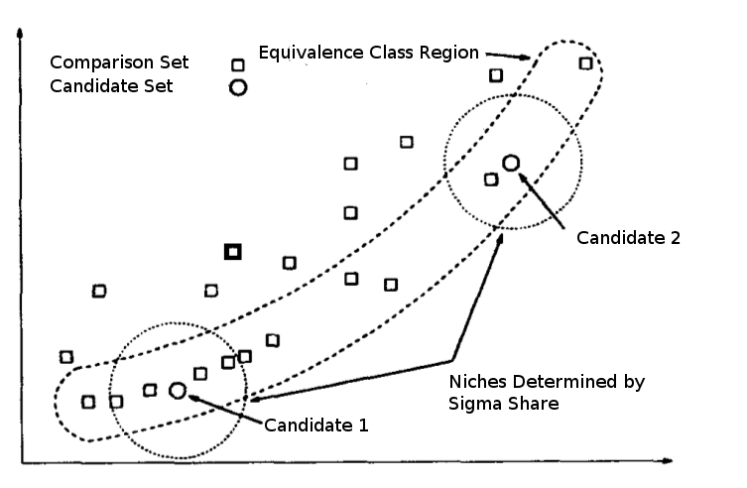
Figure 3: Diagram showing the pareto front with the niche of candidate 1 and candidate 2 circled. Image source [32]
In the original design of PNPAlineaGA the method of calculating sigma_share is based on Shir & Bäck [36] where some assumptions are made about the range of the data. Sigma_share is then calculate by sum of the absolute value between the individual with the highest and lowest fitness summed over all of the fitness indicators in this case identity and sum of pairs. sigma_share is calculated using the following formula where q is the number of peaks in the data[36] as it is not possible to know this value before hand 4 is used [2], n is the number of fitness measures 2 in this application.
r is calculated using the following formula where xk_{max} xk_{min} are the values of the fitness and the least it individual.
After implementation the quality of the results was reduced to below the results which were generated using the value 3.14 during the testing of sharing method. The sigma_share calculated was much higher often greater than 100 and most of the time the neighbourhood of every individual included ever other individual which made it not a good niching system. This problem may have been caused by the fact that there is a large distance between the two fitness indicators. The values of sum-of-pairs would be above 1000 while the value of identity would be around 10. Which would have heavily weighted the result on the value of sum of pairs. Another thing that could detract from the usefulness of the calculated sigma_share is the range that sum of pairs can have it is possible for it to have the range -2000 to 1200. All of these factors made me go back to the arbitrary constant of 3.14 which was picked just to test the rest of the algorithm but has given good results
I would like to remove all of the indivduls who were not part of the pareto optimal set at the end of each generation. I developed a method of quickly finding the pareto optimal set. I found the fittest individual for each indicator and compared all other individuals to them. All individuals not completely dominated by one of these two best solutions make up the pareto optimal set. I ran into some problems with this some times one individual would be best in both indicators and completely dominate every other individual in the population. This causes the program fail because new individuals are only created by crossovers. If there is only one individual no crossovers can be successfully completed so the population will remain with this one individual until the last generation. To get the pareto optimal set of individuals at the end of each generation would be good but I did not have time to implement correctly.
The algorithm takes the best individuals from the population until the populations is at the correct size. The population is kept diverse by using the niche dominance while selecting individuals for crossover. This ensures the next generation contains a diverse set of individuals.

Testing
This genetic algorithm will then be tested using the BAliBASE(Benchmark Alignment dataBASE). A set of sequences containing high-quality, documented alignments[5] which allow the comparison of different alignment software.

Results
The algorithm was tested using 8 sample alignments from the BAliBASE dataset. The results which obtained can then be compared with results from the literature. Which have been generated using other alignment programs. The programs I will use for comparison are CLUSTAL W [10] one of the most popular alignments programs, T-COFFEE [14] one of the best alignment programs, and PNPAlineGA [2] the genetic algorithm which this project is based on.
The genetic algorithm will be run with the same parameters for all 8 of the test sets, and will be averaged over ten runs.
The algorithm was run with the following parameters, number of generations 500, population size 20, sigma_share 3.14, candidate set size 2, comparison set size 6, in each generation every candidate will have a 80% chance of being used is a used in a crossover, and 40% chance of being mutated.
These parameters were chosen to strike a balance between, accuracy, robustness and the length of time for the algorithm to run. Increasing the number of generations or the population size produces better output but increases the execution time greatly.
The results of this algorithm (NAlineGA) compared with results of some of the leading algorithms for multiple sequence alignment are shown in table 8. The results for NalineGA show the best alignments produced in testing.
Dataset | Clustal W |  | T-Coffee |  | PNPAlineGA |  | NAlineGA
Dataset | SOP | ID | SOP | ID | SOP | ID | SOP | ID
1aho | 1644 | 8 | 2010 | 11 | 2116 | 12 | 1169 | 11
1fmb | 1780 | 24 | 1805 | 24 | 1836 | 26 | 613 | 0
1plc | 2387 | 14 | 2529 | 18 | 2432 | 18 | 1596 | 16
1dox | 1020 | 19 | 1133 | 21 | 1177 | 22 | 782 | 22
1fjiA | 1770 | 6 | 1801 | 6 | 1531 | 5 | 1351 | 1
1hpi | 1087 | 10 | 1148 | 11 | 1165 | 12 | 537 | 10
1pfc | 2231 | 9 | 2425 | 12 | 2389 | 15 | 1447 | 15
1ycc | 798 | 5 | 520 | 11 | 996 | 8
Table 8: The results of different algorithms applied to the set test alignments. NalineGA is the algorithm designed in this project. data source [2].
Population Evolution of 1aho
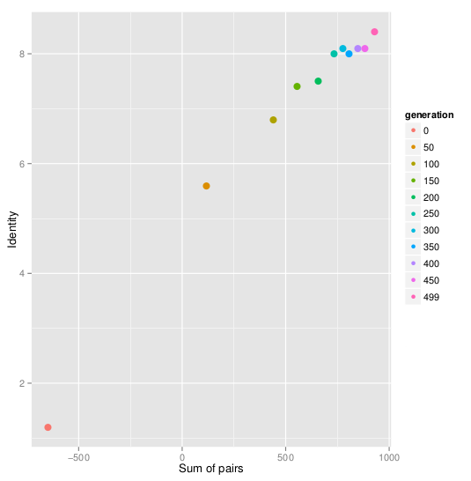
Figure 4: The evolution of the population for the dataset 1aho over 500 generations with a population size of 20.

A scatter plot showing the evolution of the population for the dataset 1aho is shown in figure 4. The sum-of-pairs value is shown on the x axis and the identity value is shown on the y axis. The legend on the right shows the colour coding of each generation. Starting at generation 50 and going to generation 500 the plot shows the fitness of the population increasing with every generation.
Population Evolution of 1dox
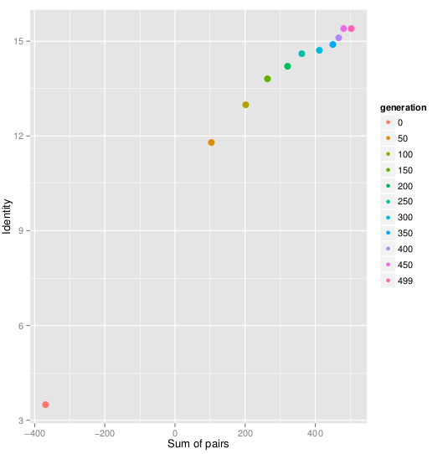
Figure 5: The evolution of the population for the dataset 1dox over 500 generations with a population size of 20.
A plot showing the evolution of the population in the data set 1dox is shown in figure 5. Notice the very large improvement in fitness in the first 50 generations and the steady increase until the fitness levels out in the last hundred generations.
Population evolution of 1fljA
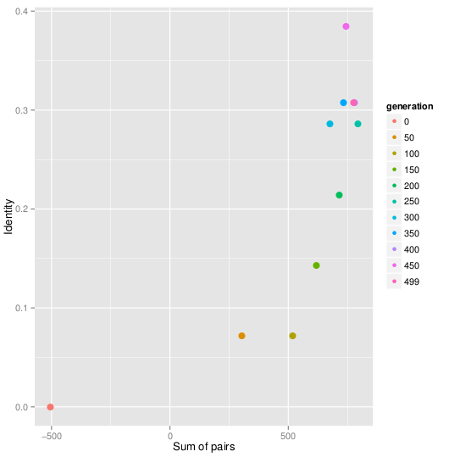
Figure 6: The evolution of the population for the dataset 1fjlA over 500 generations with a population size of 20.

The evolution of the population of the data set 1fjlA is shown in figure 6. Notice the large increase in fitness in the first 50 generations. The population fitness then grows at a steady amount and stops growing increasing around generation 200. The Identity measured in this graph is not very good because the algorithm only lined up one column is some of the test runs.

Population Evolution of 1fmb
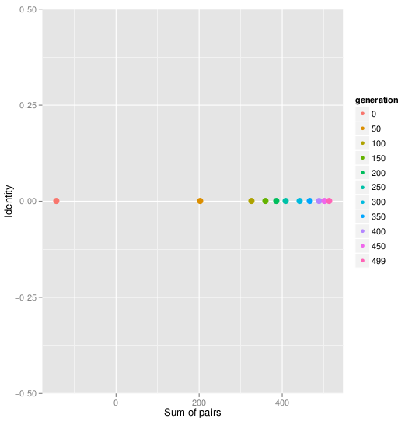
Figure 7: The evolution of the population for the dataset 1fmb over 500 generations with a population size of 20.

The population evolution of the data set 1fmb shown by figure 7 shows that the value for sum of pairs increases at a steady rate. While the value of identity stays at zero which is very surprising because all of the other algorithm which used this data got an identity score greater than 20.
Population Evolution of data set 1hpi
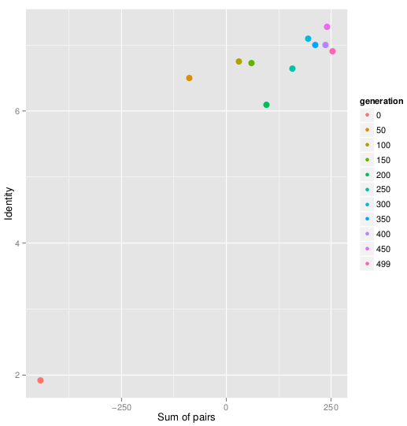
Figure 8: The evolution of the population for the dataset 1hpi over 500 generations with a population size of 20.

The population of the data set 1hpi shown in figure 8 jumps after 50 generations and then increases little for the rest of the generations. Notice both the sum of pairs and the identity drop at generation 200.
Evolution of the population 1plc
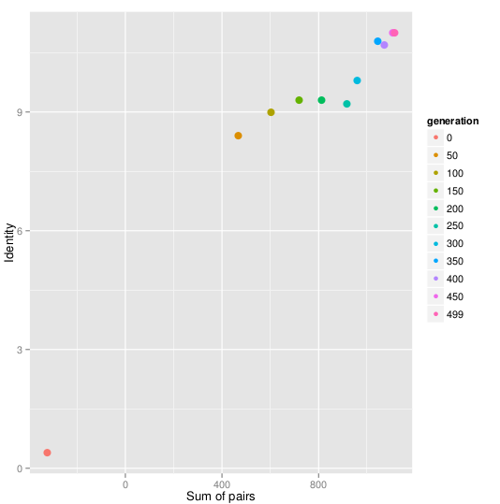
Figure 9: The evolution of the population for the dataset 1hpi over 500 generations with a population size of 20.

The evolution of the population on the data set 1plc is shown Figure 9. The population starts being very unfit and improves every generation.
Population Evolution of 1pcf data set
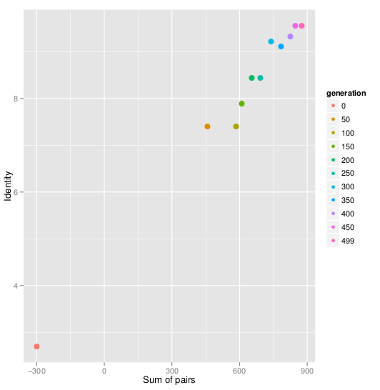
Figure 10: The evolution of the population for the dataset 1hpi over 500 generations with a population size of 20.

The evolution of the population 1pcf is shown in figure 10. The population starts off unfit and gradual gets better with every generation.

Discussion
Over all the results show that the genetic algorithm work, it begins with a random population and then every generation the fitness of the population increases a little. Although it dose not compare well to the top of the range software for multiple sequence alignment it is a good start. With some adjustments of the parameters especially the number of generations. PNPAlineaGA use 1000 generations in a 4 or 8 parallel system which is equivalently to 4000 or 8000 generations. In the testing I choose to keep the generations to 500 and to run the algorithm on 10 time on each of the 8 data sets. It takes an average of 45 minutes to run the algorithm on each data set. The time varies depending on which data set is being tested.
The preliminary tests which I ran while adjusting and searching for the best parameters showed that increasing the number of crossovers and the number of generations gives better results but at a great increase of time. Some results comparable to PAPAlineaGA were gotten on one data set but it took over 3 hours to run. As the algorithm uses random processes the quality of the alignments found can vary quite a lot between runs of the algorithm even with the same parameters. That is why it is necessary to run the algorithm many times to get a useful average. It was not feasible to run the algorithm ten times on eight data sets if it could take up to 3 hours. Some of the better results I got cannot be used as reference because I was changing the parameters constantly and it would not be comparing like with like.
The the goal of this project was to develop an algorithm which can be used to align multiple sequences of proteins, a task very common in biological research and bioinformatics. The design of the algorithm was based mainly on PNPAlineaGA (Parallel Niche Pareto AlineaGA)[2] with some modifications the largest being the removing of the ability of the algorithm to work in parallel. A genetic algorithm that works in parallel is more than the sum of it's parts, because it keeps a number (usually the number of cores in the CPU on the computer) of separate populations better solutions can be found because you would have 4 or 8 populations which would all converge on different points. The different populations would ever 100 or so generations send there best solutions to one process and it would send back the set of best candidates to all other process'. The parallel ability of the algorithm was left out because of time constraints and because of the inherently single process nature of python. Python is an interpreted language and the interpreter runs on just one core of the CPU this dose not easily lead parallel processing [34].
While I was designing the algorithm I took into account that it would work much better in parallel. I created an object orientated design which is robust and could easily be adjusted to run in parallel using some of pythons librarys such as pp (Parallel Python) [35].
Without the the parallel ability also caused some problems for the pareto functionality. At the end of each generation I would like to only keep the pareto non-dominated set, but once I implemented that the algorithm did worst as often in the first few generations there would only be 1 or 2 non-dominated individuals. When the population dropped down to that size there is not enough genetic diversity to create a better population, this is known an a bottle neck in biology once genetic diversity is lost from a population it is impossible for it to come back. A parallel algorithm would not suffer from this problem as there would be other populations to increase the diversity after a bottle neck incident. To avoid this at the end of each generation the candidates which are fittest are chosen to make up the next generation. The crossover operators use pareto dominance to choose the the solutions which will be crossed. The best most unique solutions are most likely to be used in crossover and there offspring will make up the next generation.
While the algorithm gets worst results than the best software in the field of sequence alignment. The development of NAlineaGA was completed in 8 weeks. In that time I developed a very good understanding of the problem area. The multiple sequence alignment problem is probability the most common applications done in bioinformatics it is the starting point on nearly all modern molecular biological research. The current best and most used software T-COFFEE and CUSTAL-W work well but there is much room for improvement. The current software produces many biologically irrelevant alignments and for them to work fast they need to create a search path using data from web databases. While my version NAlineaGA is not yet as good more time spent adjusting the parameters could greatly increase the performance.
Now that I have implemented a genetic algorithm for multiple sequence alignment there is some changes I would make. One chance which would increase performance a lot by reducing the amount error checking nesseary would be to use a different coding method to represent the genotype. PNPAlineaGA stores the sequences in there proper form throughout the complete process. The more common practice when implementing genetic algorithms is to have some sort of coding system [33] which is known as the genotype, and then before outputting to the user the coding system is converted into a phenotype. Below is a sample of a short sequence coded in, first the method used in this program, and second an alternative model of coding the genotype.
Current genotype coding method yeeg-----q–t---clnc
Alternative genotype coding method 0000111110101110000
The advantage of using the first method is it avoids the need to convert between a genotype and a phenotype before printing the alignment to the user, and more importantly the genotype would have to be converted into the phenotype before the fitness value sum of pairs is calculate which would add more over head to the fitness evaluation method.
The major disadvantage in using the single genotype phenotype method is in the crossover methods great care must be taken to ensure the cuts are made in the correct sequence position in the second parent.
The two alignments top parent 1 and bottom parent 2 shown in table 9 are an example of a vertical crossover. A random column is selected in parent 1 and al the sequences are cut at the same point. For the sequences to remain valid each sequence must be cut in exactly the correct place in parent 2. This is also true for the matched column crossover operation.

scxa_buteu vrdgyiaddkd cayfcgr--- nayc
scx1_titse -kdgypveydn cayicwnyd- nayc
scx6_titse -regypadskg ckitcflta- agyc
scx1_cenno -kdgylvdakg ckkncyklgk ndyc
six2_leiqu --dgyirkrdg cklsclfg-- negc
scxa_buteu d ee------c- --kkgaes-g
scx1_titse d kl------ck ---kkads-g
scx6_titse n te------ct --lkkgss-g
scx1_cenno n re------cr mkhrggsy-g yc-
six2_leiqu nkeck --syggs
Table 9: The top alignment is parent on cut at a randomly chosen column. The bottom alignment is parent 2 notice the cuts must be made at different places on each line.

Using the true sequences as the genotype required much more computationally heavy crossover operators because the correct location must be calculated for each sequence of the alignment, and resized so the complete alignment will remain the same length. Error checking also had to be preformed to ensure the alignments remain valid. There was also a lot of time spent debugging and testing the methods which carry out the crossovers again to ensure they always produce valid crossovers.
If the separate genotype and phenotype system mentioned above had been used none of this checking would have been necessary because where ever you cut the alignment would not matter as you are only saving the positions of the gaps. When the correct alignment is needed it would be easy to create the correct sequence by inserting letters from the sequence and gaps where necessary.

Bibliography
[1] Thompson, J.D., Plewniak, F., Ripp, R., Thierry, J.-C., and Poch, O. (2001). Towards a reliable objective function for multiple sequence alignments. Journal of Molecular Biology, 314(4):937-951.
[2] da Silva, F. J. M.J., Pérez, J. M. S.M., Pulido, J. A. G.A., and Rodríguez, M. V.A. (2011). Parallel niche pareto AlineaGA-an evolutionary multiobjective approach on multiple sequence alignment. Journal of integrative bioinformatics, 8(3).
[3] da Silva, F., Sánchez Pérez, J., Gómez Pulido, J., and Vega Rodríguez, M. (2010). AlineaGA—a genetic algorithm with local search optimization for multiple sequence alignment. Applied Intelligence, 32(2):164-172.
[4] Pevzner, A. Pavel.(2000), Computational Molecular Biology An Algorithmic Approach, Chapter 7 MIT Press 0-262-16197-4
[5] Thompson, J. D., Plewniak, F., and Poch, O. (1999). BAliBASE: a benchmark alignment database for the evaluation of multiple alignment programs. Bioinformatics, 15(1):87- 88.
[6] Dayhoff, M. O. and Schwartz, R. M. (1978). A model of evolutionary change in proteins. I n in Atlas of Protein Sequence and Structure.
[7] http://www.bioinformatics.nl/tools/pam.html
[8] Zitzler, E., Laumanns, M., and Bleuler, S. (2004). A tutorial on evolutionary multiobjective optimization. In Gandibleux, X., Sevaux, M., Sörensen, K., and T'kindt, V., editors, Metaheuristics for Multiobjective Optimisation, volume 535 of Lecture Notes in Economics and Mathematical Systems, pages 3-37. Springer Berlin Heidelberg.
[9] Wang, Y. and Li, K.-B. (2004). An adaptive and iterative algorithm for refining multiple sequence alignment. Computational Biology and Chemistry, 28(2):141-148.
[10] Thompson, J. D., Higgins, D. G., and Gibson, T. J. (1994). CLUSTALW : improving the sensitivity of progressive multiple sequence alignment through sequence weighting, position-specific gap penalties and weight matrix choice. Nucleic Acids Research, 22(22):4673-4680.
[11] Taylor, W. (1988). A flexible method to align large numbers of biological sequences. 28(1-2):161-169.
[12] Notredame, C. and Higgins, D. G. (1996). SAGA: Sequence alignment by genetic algorithm. Nucleic Acids Research, 24(8):1515-1524.
[13] Gotoh, O. (1996). Significant improvement in accuracy of multiple protein sequence alignments by iterative refinement as assessed by reference to structural alignments. Journal of molecular biology, 264(4):823-838.
[14] Notredame, C., Higgins, D. G., and Heringa, J. (2000). T-coffee: a novel method for fast and accurate multiple sequence alignment. Journal of Molecular Biology, 302(1):205- 217.
[15] Zvelebil, M. and Baum. understanding bioinformatics. Garland Science, New York, second edition.
[16] Thompson, J. D., Plewniak, F., and Poch, O. (1999). A comprehensive comparison of multiple sequence alignment programs. Nucleic Acids Research, 27(13):2682-2690.
[17] Marti-Renom, M. A., Madhusudhan, M. S., and Sali, A. (2004). Alignment of protein sequences by their profiles. Protein Science, 13(4):1071-1087.
[18] Kupis, P. and Mańdziuk, J. (2007). Multiple sequence alignment with Evolutionary- Progressive method. In Beliczynski, B., Dzielinski, A., Iwanowski, M., and Ribeiro, B., editors, Adaptive and Natural Computing Algorithms, volume 4431 of Lecture Notes in Computer Science, pages 23-30. Springer Berlin Heidelberg.
[19] Mitchell, M. (1999). An Introduction To Genetic Algorithms. MIT Press, Cambridge, Massachusetts.
[20] Manning, T., Sleator, R. D., and Walsh, P. (2013). Naturally selecting solutions: The use of genetic algorithms in bioinformatics. Bioengineered, 4(5):266-278.
[21] http://www.numpy.org
[22] da Silva, F. J. M., Sanchez-Perez, J. M., Gomez-Pulido, J. A., and Vega-Rodriguez, M. A. (2010). An evolutionary approach for performing multiple sequence alignment. In Evolutionary Computation (CEC), 2010 IEEE Congress on, pages 1-7. IEEE.
[23] da Silva, F. J. M., Sanchez Perez, J. M., Pulido, J. A. G., and Rodriguez, M. A. V. (2009). Optimizing multiple sequence alignment by improving mutation operators of a genetic algorithm. In Intelligent Systems Design and Applications, 2009. ISDA &#039;09. Ninth International Conference on, pages 1257-1262. IEEE.
[24] Horn, J., Nafpliotis, N., and Goldberg, D. E. (1994). A niched pareto genetic algorithm for multiobjective optimization. In Evolutionary Computation, 1994. IEEE World Congress on Computational Intelligence., Proceedings of the First IEEE Conference on, pages 82-87 vol.1. IEEE.
[25] Chellapilla, K. and Fogel, G. B. (1999). Multiple sequence alignment using evolutionary programming. In Evolutionary Computation, 1999. CEC 99. Proceedings of the 1999 Congress on, volume 1, pages 445-452 Vol. 1. IEEE.
[26] Wang, L. and Jiang, T. (1994). On the complexity of multiple sequence alignment. Journal of Computational Biology, 1(4):337-348.
[27] http://en.wikipedia.org/wiki/NP-complete (download on 2014-03-06)
[28] Darwin C. (1859) On the Origin of Species ISBN-13: 978-1853267802 Wordsworth Editions.
[29] Needleman, S. B. and Wunsch, C. D. (1970). A general method applicable to the search for similarities in the amino acid sequence of two proteins. Journal of Molecular Biology, 48(3):443-453.
[30] http://www.quretec.com/u/vilo/edu/2005-06/Text_Algorithms/index.cgi? f=L5_Edit&p=NW&d=next
[31] http://en.wikipedia.org/wiki/File:PareoEfficientFrontier1024x1024.png
[32] Horn, J., Nafpliotis, N., and Goldberg, D. E. (1994). A niched pareto genetic algorithm for multiobjective optimization. In Evolutionary Computation, 1994. IEEE World Congress on Computational Intelligence., Proceedings of the First IEEE Conference on, pages 82-87 vol.1. IEEE.
[33] Goldberg D. E. (1989) Gentic Algoritmms in Search, Optimization & Machine Learning. Addison-Wesley. Massachusetts 0-201-15767-5
[34] Beaxley M. David. (2009). Python Essential Reference. Addison Wsley. 4th edition 978- 0672329784
[35] http://www.parallelpython.com/
[36] Shir, O. and Bäck, T. (2006). Niche radius adaptation in the CMA-ES niching algorithm. In Runarsson, T., Beyer, H.-G., Burke, E., Merelo-Guervós, J., Whitley, and Yao, X., editors, Parallel Problem Solving from Nature - PPSN IX, volume 4193 of Lecture Notes in Computer Science, pages 142-151. Springer Berlin Heidelberg.

Conserved genes or proteins remain the same over evolutionary time and can be found in distantly related organisms.

