**Laptop Prep for “Hands-on: Machine Learning Made Easy”**

**with Python**

**Overview**

Laptop preparation for the class consists of three steps, with detailed instructions below:

1. Download course files from GitHub
2. Installation of Anaconda Python
3. Verify installation

NOTE – When using a work laptop, please keep the following in mind:

* Administrator permission may be required to complete laptop prep.
* It is often necessary to disable anti-virus software to allow for the installation. As such, disabling any anti-virus is recommended before laptop prep.
* Corporate proxy servers and firewalls can block the installation. Be sure to consult your IT department as needed.
* Lastly, installing the latest version of Anaconda Python is recommended – even if you have Python already installed.

The GitHub repository with all required course files is located here:

* <https://github.com/DaveOnData/TDWIMachineLearningMadeEasyWithPython>

**Hardware Requirements**

1. Windows or Mac OS X preferred (instructors have no experience with Linux)
2. 64-bit operating system
3. 8GB of RAM, 16GB preferred
4. 5GB of free drive space

**Step 1 - Download the files from GitHub**

1. Within the GitHub repository page, click on the “Code” button and select “Download ZIP”:

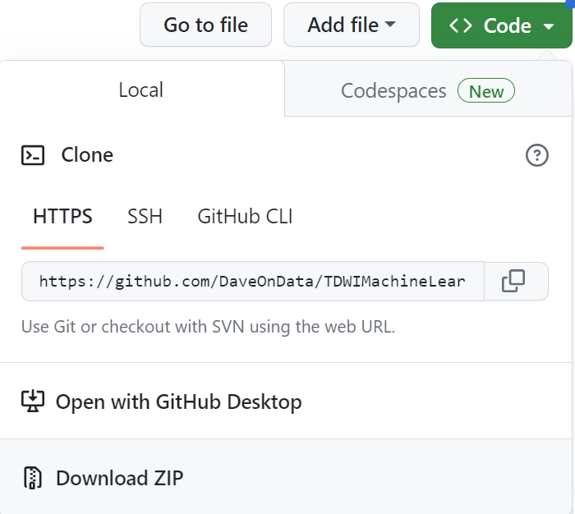

1. Copy the file folder within the downloaded ZIP to a well-known location on your laptop (e.g., the Desktop):

1. Open the file folder. You should see the following files:

**Step 2 – Anaconda Python Installation**

1. Open your browser and navigate to: <https://www.anaconda.com/products/distribution>
2. Click the download button.
3. When the installer has downloaded, start the installer and follow the instructions (accepting defaults) to complete the installation.

**Step 3 – Verify Installation**

1. With Anaconda Python installed, start the Anaconda Navigator application:

1. You may be prompted to upgrade Anaconda Navigator. Follow the dialogs to do so:

1. If needed, relaunch Anaconda Navigator
2. NOTE – Your Anaconda Navigator window might not look exactly like the following. Within Anaconda Navigator, launch Jupyter Notebook:

1. Within the Jupyter browser, navigate to where you copied the course file folder:

**Congratulations! You are now ready for the class!**