**GOVERNMENT POYTECHNIC FOR GIRLS**

Diploma In Computer Engineering 2020-2021

Project Report On

***“Digital Vehicle Maintenance”***

## C:\Users\JIGISH\Downloads\gpg_new_logo.jpg

**Submitted To: Submitted**

**By:**

**Dave Rucha**

**Mahendra J. Gohil Badgujar Sweta**

**Doctor Tanushree**

Digital Vehicle Maintenance

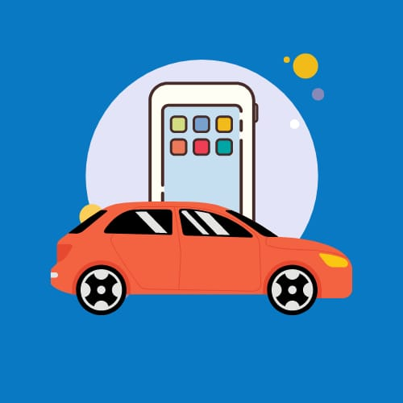

## Abstract

Everyone who owns a vehicle like a cars ,Sometimes customers having complexities in managing vehicle like Particular services of vehicle,Replace the Particular part of that vehicle etc.

Through this app you can easily book the particular services online.For example Car wash, AC Repair etc. What parts need replacement Customer can also replace the vehicle’s particular part.

User can book car for one or more day whenever we want to travel and also give our car for rental purpose.

## INDEX

|  |  |  |
| --- | --- | --- |
| Sr. No | Title | Page No. |
| 1 | Introduction Of Project | 5 |
| 2 | Problem Identification and Definition | 7 |
|  | a.     Feasibility Study | 8 |
|  | b.     Modification of System | 9 |
|  | * Study of Current System | 9 |
|  | * Problems and weakness of current system | 9 |
|  | * Purpose | 9 |
|  | * Scope | 9 |
| 3 | The Problem Study | 10 |
|  | * Requirement Analysis | 11 |
|  | * Problem Solving Technique | 12 |
| 4 | The Outline Of Problem Solution | 14 |
|  | * Hardware and Software Requirement | 15 |
|  | * Module Description | 16 |
|  | * Data Dictionary | 18 |
|  | * E-R Diagram | 21 |
|  | * Data Flow Diagram / Use Case Diagram | 24 |
| 5 | The Outline of Work | 31 |
| 6 | Conclusion | 38 |
| 7 | Bibliography | 40 |
| 8 | Self-Appraisal Form | 42 |

**CHAPTER: 1**

*Introduction of Project*

## Introduction Of Project

Digital vehicle maintenance project is developed for the customer. The project objective is to deliver the service for vehicles on time on the android platform.

Digital Vehicle maintenance service is an application from where customers can directly get service for their vehicle from a service-center in a real-time. This project is an attempt to provide the advantage of booking online services for vehicle like cleaning, detailing, AC services and repair etc from home. User can Replace the Particular part of that vehicle Whenever user want to replace. User can book car for one or more day whenever we want to travel and also give our car for rental purpose.

This application is available in the smartphone. It is easily accessible and always available.

So using this application customer can get all the benefits of services and Other features.

**CHAPTER: 2**

*Problem Identification and Definition*

**(A)Feasibility Study**

**Feasibility of System :**

Feasibility is defined as the practical extent to which a project can be performed successfully. To evaluate feasibility, a feasibility study is performed, which determines whether the solution considered to accomplish the requirements is practical and workable in the software. Information such as resource availability, cost estimation for software development, benefits of the software to the organization after it is developed and cost to be incurred on its maintenance are considered during the feasibility study. Various types of feasibility that are commonly considered include technical feasibility, operational feasibility, and economic feasibility.

**1.Technical Feasibility:**

Technical feasibility determines whether the work for the project can be done with the existing equipment, software technology and available personnel.

1. Hardware: The application can be used by everyone who has a android based smartphone and tablets. Here it is assumed that everyone has a smartphone.
2. Software: It provides the high level of reliability, availability and compatibility. All these make Java an appropriate language for this project. Thus the existing software Java is a powerful language.

**2.Operational Feasibility:**

Operational feasibility corresponds to whether user are aware of interface environment and sufficient resource are available or not. People with basic knowledge of using the smartphone can easily run this application.

**3.Economical Feasibility:**

Economical feasibility determines whether there are sufficient benefits in creating to make the cost acceptable, or is the cost of the system too high.

This software is economically feasible because it is developed using android studio which is a free software and xampp which is also a free service.

## (B) Modification of System

1. **Study Of Current System**

* In Current System when we need service for the vehicle we can book the service online but we have to go to the place where the service is done.
* Customer can book a car for one or more day whenever we want to Travel,but does not provide rental feature for the customer.

1. **Problem And Weakness Of System**

* Usually when Customer allow vehicle to be serviced,sometimes the vehicle is not properly serviced,so custoemer money service is wasted.
* The user and service provider become untrustable as the service is not proper working condition.

1. **Purpose**

* The primary purpose of this app is to provide the facility of the customer about their vehicle services, replace the vehicle’s particular part.
* This application will also allow customer to book customized services as per their requirements. They can also cancel their booking at any point of time. For customized services, it can offer discount to the regular customers.
* Customer can book a car for one or more day whenever we want to Travel.

1. **Scope**

* This app makes it easy for customer to get service , replace the vehicle’s particular part when vehicle need.
* They can also book a service by viewing its details and pricing details available, according to particular car they own. Customer can give a car for rental purpose and also book the car whenever we want.

**CHAPTER: 3**

*The Problem Study*

## Requirement Analysis

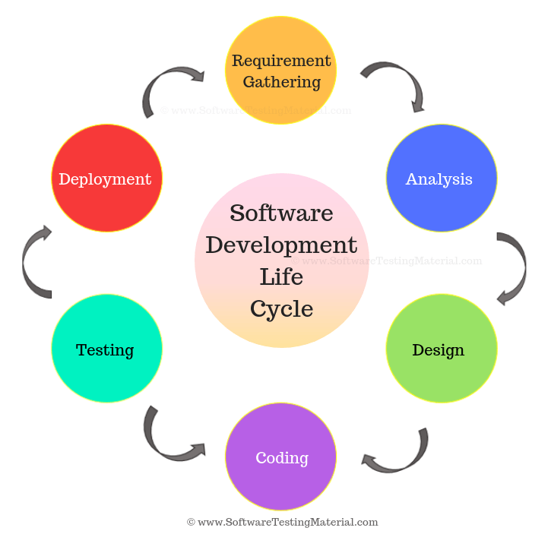The systems development life cycle (SDLC), also referred to as the application development life-cycle, is a term used in [systems engineering](https://en.wikipedia.org/wiki/Systems_engineering), [information systems](https://en.wikipedia.org/wiki/Information_system) and [software engineering](https://en.wikipedia.org/wiki/Software_engineering) to describe a process for planning, creating, testing, and deploying an [information system](https://en.wikipedia.org/wiki/Information_system). The systems development lifecycle concept applies to a range of hardware and software configurations, as a system can be composed of hardware only, software only, or a combination of both

A systems development life cycle is composed of a number of clearly defined and distinct work phases which are used by systems engineers and systems developers to plan for, design, build, test, and deliver [information systems](https://en.wikipedia.org/wiki/Information_system).

To manage this level of complexity, a number of SDLC models or methodologies have been created, such as [waterfall](https://en.wikipedia.org/wiki/Waterfall_model), [spiral](https://en.wikipedia.org/wiki/Spiral_model), [Agile software development](https://en.wikipedia.org/wiki/Agile_software_development), [rapid prototyping](https://en.wikipedia.org/wiki/Software_prototyping#Throwaway_prototyping), [incremental](https://en.wikipedia.org/wiki/Incremental_development), and synchronize and stabilize.

## Problem Solving Technique

* **Incremental model**

**Incremental Process Models**

The process models in this category tend to be among the most widely used (and effective) in the industry.

**The Incremental Model**

The *incremental model* combines elements of the *waterfall* model applied in an iterative fashion. The model applies linear sequence staggered fashion as calendar time progresses.

**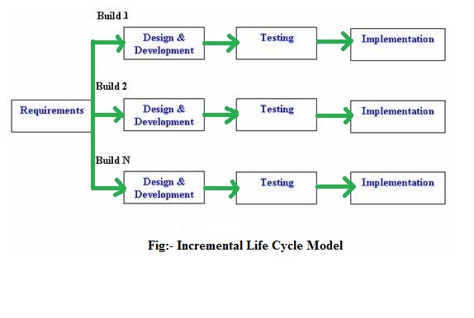**Each linear sequence produces deliverable “increments” of the software. (Ex: a Word Processor delivers basic file mgmt., editing, in the first increment; more sophisticated editing, document production capabilities in the 2nd increment; spelling and grammar checking in the 3rd increment.

When an increment model is used, the 1st increment is often a *core product*. The core product is used by the customer.

As a result of use and / or evaluation, a plan is developed for the next increment.

The plan addresses the modification of the core product to better meet the needs of the customer and the delivery of additional features and functionality.

The process is repeated following the delivery of each increment, until the complete product is produced.

If the customer demands delivery by a date that is impossible to meet, suggest delivering one or more increments by that date and the rest of the Software later.

* **Advantage**
* The software will be generated quickly during the software life cycle
* Thought the development stages changes can be done
* A customer can respond to each building
* It is flexible and less expensive to change requirements and scope
* This model is less costly compared to others
* Errors are easy to be identified

* **Disadvantage**
* It requires a good planning designing
* Each iteration phase is rigid and does not overlap each other
* Rectifying a problem in one unit requires correction in all the units and consumes a lot of time

**CHAPTER: 4**

*The Outline of Problem Solution*

## Hardware and Software Requirement

* **Hardware Requirement:**

|  |  |
| --- | --- |
| Processor | Intel(R)core (TM)i5-10400T 3.60 GHz |
| RAM | 1.00 GB |
| HDD | 1 GB |
| Application Type | Mobile Based |
| Mobile | Android phone with 5.0 version |
| Storage | 60 MB |

* **Software Requirement**:

|  |  |
| --- | --- |
| Operating system | Windows or Linux |
| JDK version | JDK 8 |

* **Development technology**:

|  |  |
| --- | --- |
| Front End | Android |
| Back End | PHP |
| Technology | Android studio |

## Module Description

1. **Admin**
2. **User**
3. **Admin:**

Admin is the real time entities which manages all the users, company and worker who are registered with the application. Admin can register, login, view all service provider and user details and manage website contents. Detail information of each sub module is described below:

* **Registration:**

Admin has to do registration to enter in the system for first time.

* **Login:**

Admin have to login in system whenever he/she enters in system by entering correct id and password for authorized and security purpose.

* **View all service provider details:**

Admin can rights to see all details of service provider.

* **View all users details:**

Admin can also right to see user details.

* **Manage website contents:**

Admin manage the all website contents.

1. **User:**

Customers are the real time entities which are those for whom this application is made. Customers will be able to use application after registering. Customer can do registration, login, search and order for services, view order, get time-to-time reminder for services and review it. Details information about each sub module is given below:

* **Registration:**

To login and order the services the customer have to first register.

* **Login:**

To order the services and to redeem the existing services time to time customer have to login.

* **Search Service:**

User can search a service provided as per requirement. i.e. AC service, paint job, car wash...

* **Make Order Of Service:**

User can make order as per their requirement.

* **View Order:**

User can view order status after the service is selected.

* **Service reminder :**

It will remind the customer to redeem the upcoming services time to time.

* **Add Review:**

User can give review to service provider after the services provided.

## Data Dictionary

* A data dictionary is a collection of descriptions of the data objects or items in a data model for the benefit of programmers and others who need to refer to them. A first step in analyzing a system of objects with which users interact is to identify each object and its relationship to other objects. This process is called data modeling and results in a picture of object relationships.
* After each data object or item is given a descriptive name, its relationship is described (or it becomes part of some structure that implicitly describes relationship), the type of data (such as text or image or binary value) is described, possible predefined values are listed, and a brief textual description is provided. This collection can be organized for reference into a book called a data dictionary.
* **USER :**

|  |  |  |  |  |
| --- | --- | --- | --- | --- |
| **ATTRIBUTE** | **DATATYPE** | **SIZE** | **CONSTRAIN** | **DESCRIPTION** |
| **ID** | Int | 11 | Primary key | Customer ID |
| **NAME** | Varchar2() | 30 | (Not Null) | Customer name |
| **EMAIL** | Varchar2() | 30 | (Not Null) | Customer Email Id |
| **PASSWORD** | Varchar2() | 30 | (Not Null) | Customer password |
| **MOBILE** | Number() | 10 | (Not Null) | Customer contact no. |

**Table 1.0 (Customer Registration)**

* **SERVICE :**

|  |  |  |  |  |
| --- | --- | --- | --- | --- |
| **ATTRIBUTE** | **DATATYPE** | **SIZE** | **CONSTRAIN** | **DESCRIPTION** |
| **Service\_ID** | Int() | 11 | Primary key | Service ID |
| **Service \_NAME** | Varchar() | 30 | (Not Null) | Service name |
| **Service\_Price** | Int() | 11 | (Not Null) | Service Price |
| **Service\_Duration** | Int() | 11 | (Not Null) | Service Duration |
| **Service\_Warranty** | Varchar() | 30 | (Not Null) | Service Warranty |
| **Service\_Image** | Varchar() | 100 | (Not Null) | Service Image |
| **Service\_Included** | Text | - | (Not Null) | Service Included |

**Table 2.0 (vehicle Service)**

* **BOOK\_SERVICE**

|  |  |  |  |  |
| --- | --- | --- | --- | --- |
| ATTRIBUTE | DATATYPE | SIZE | CONSTRAIN | DESCRIPTION |
| Booking\_ID | Int() | 11 | Primary key | Booking ID |
| User\_ID | Int() | 11 | (Not Null) | User ID |
| User\_Name | Varchar() | 30 | (Not Null) | User Name |
| User\_Mobile | Varchar() | 10 | (Not Null) | User Mobile |
| Service\_ID | Int() | 11 | (Not Null) | Service ID |
| Booking\_Date | Varchar() | 55 | (Not Null) | Booking Date |
| Booking\_Time | Time | - | (Not Null) | Booking Time |

**Table 3.0 (Book Service)**

* **PART**

|  |  |  |  |  |
| --- | --- | --- | --- | --- |
| **ATTRIBUTE** | **DATATYPE** | **SIZE** | **CONSTRAIN** | **DESCRIPTION** |
| **Part\_ID** | Int() | 11 | Primary key | Part ID |
| **Part\_Name** | Varchar() | 30 | (Not Null) | Part Name |
| **Part\_Number** | Varchar() | 50 | (Not Null) | Part Number |
| **Part\_Brand** | Varchar() | 50 | (Not Null) | Part Brand |
| **Part\_Price** | Int() | 11 | (Not Null) | Part Price |
| **Part\_Image** | Varchar() | 100 | (Not Null) | Part Image |

**Table 4.0 (vehicle Part)**

* **BOOK\_PART**

|  |  |  |  |  |
| --- | --- | --- | --- | --- |
| **ATTRIBUTE** | **DATATYPE** | **SIZE** | **CONSTRAIN** | **DESCRIPTION** |
| **Booking\_ID** | Int() | 11 | Primary key | Booking ID |
| **Part\_ID** | Int() | 11 | Primary key | Part ID |
| **User\_ID** | Int() | 11 | Primary key | User ID |
| **User\_Name** | Varchar() | 30 | (Not Null) | User Name |
| **User\_Mobile** | Varchar() | 10 | (Not Null) | User Mobile |
| **User\_Pincode** | Int() | 11 | (Not Null) | User Pincode |
| **User\_Address** | Varchar() | 100 | (Not Null) | User Address |

**Table 5.0 (Book Part)**

* **Admin**

|  |  |  |  |  |
| --- | --- | --- | --- | --- |
| **ATTRIBUTE** | **DATATYPE** | **SIZE** | **CONSTRAIN** | **DESCRIPTION** |
| **ID** | Int() | 11 | Primary key, | Admin ID |
| **NAME** | Varchar2() | 30 | (Not Null) | Admin name |
| **EMAIL** | Varchar2() | 30 | (Not Null) | Admin Email id |
| **PASSWORD** | Varchar2() | 30 | (Not Null) | Admin password |
| **MOBILE** | Number() | 10 | (Not Null) | Admin contact no. |

**Table 6.0 (Admin Registration)**

* **GARAGE**

|  |  |  |  |  |
| --- | --- | --- | --- | --- |
| **ATTRIBUTE** | **DATATYPE** | **SIZE** | **CONSTRAIN** | **DESCRIPTION** |
| **Garage\_ID** | Int() | 11 | Primary key, | Garage ID |
| **Mobile\_No** | Varchar() | 10 | (Not Null) | Mobile No |
| **Email** | Varchar() | 30 | (Not Null) | Email |
| **Name** | Varchar() | 30 | (Not Null) | Name |
| **Garage\_Address** | Varchar() | 30 | (Not Null) | Garage Address |

**Table 6.0 (Garage)**

## (D) E-R Diagram

* An entity-relationship diagram (ERD) is a data modeling technique that graphically illustrates an information system’s entities and the relationships between those entities. An ERD is a conceptual and representational model of data used to represent the entity framework infrastructure.
* **The elements of an ERD are:**
* Entities
* Relationships
* Attributes
* **Steps involved in creating an ERD include:**
* Identifying and defining the entities.
* Determining all interactions between the entities.
* Analyzing the nature of interactions/determining the cardinality of the relationships.
* Creating the ERD
* **Entity Relationship Diagram Notation**

Developed ERDs in 1976. Since then Charles Bachman and James Martin have added some slight refinements to the basic ERD principles.

* **Entity**

An entity is an object or concept about which you want to store information.

Entity Name

* **Weak Entity**

A weak entity is an entity that must defined by a foreign key relationship with another entity as it cannot be uniquely identified by its own attributes alone.

Entity Name

* **Key Attribute**

A key attribute is the unique, distinguishing characteristic of the entity. For example, an employee's social security number might be the employee's key attribute.

* **Multi-valued Attribute**

A multi-valued attribute can have more than one value. For example, an employee entity can have multiple skill values.

* **Derived Attribute**

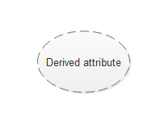A derived attribute is based on another attribute. For example, an employee's monthly salary is based on the employee's annual salary.

* **Relationship**

Relationships illustrate how two entities share information in the database structure.

Relationship

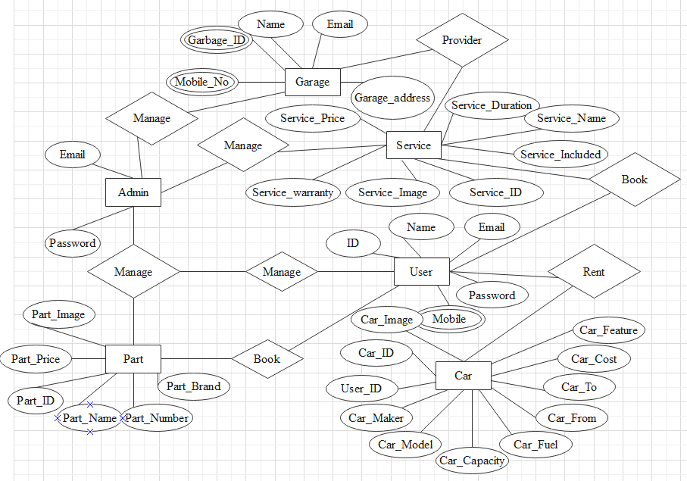

**(E) Data Flow Diagram**

The flow of data among them. A data flow diagram illustrates the processes, data Stores, external entities and the connecting data flows in a system. It is a common Practice to draw a context-level Data Flow Diagram first which shows the interaction Between the system and outside entities. This context-level DFD is then "exploded" into a detailed DFD. Figure 3 is an example of a typical DFD.

* There are four components for a Data Flow Diagram.

1. External Entities/ Terminators are outside of the system being modeled. They represent where information comes from and where it goes. These are represented by rectangles.
2. Processes, usually represented by an ellipse (circle), which modify the
3. Input to generate the output.
4. Data Stores represents a place in the process where data rests. This is represented by an open-ended rectangles or a cylinder symbol.
5. Data Flows, represented by arrows, are how data moves between terminators, processes, and data stores.

* The Symbol used in DFD Diagram:-

1. Process:-

* Here flow of data is transformed e.g. update donor file, update patient file etc.

1. External entity:-

* A source of destination of data, which is external to the system. e.g. donor, etc

1. Dataflow:-

* It is packet of data. It may be in the form of document, latter etc.

1. Data store:-

* Any store data but with no reference to the physical method of storing.

**0 LEVEL:**

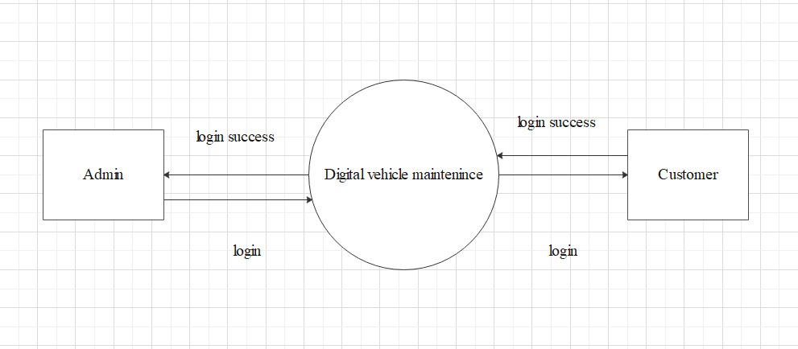

**1 LEVEL:**

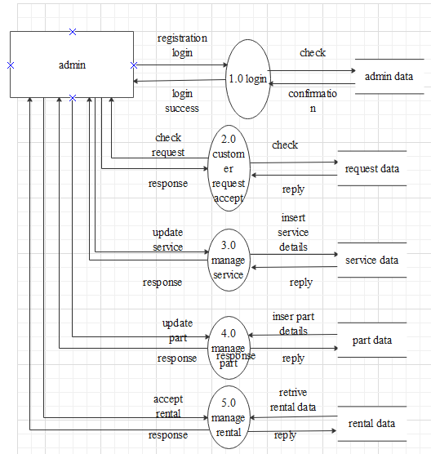

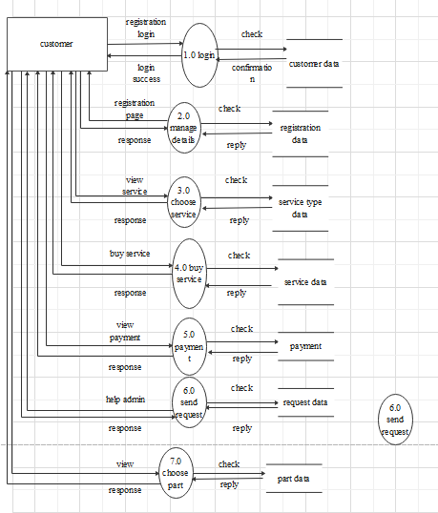

**2 LEVEL:**

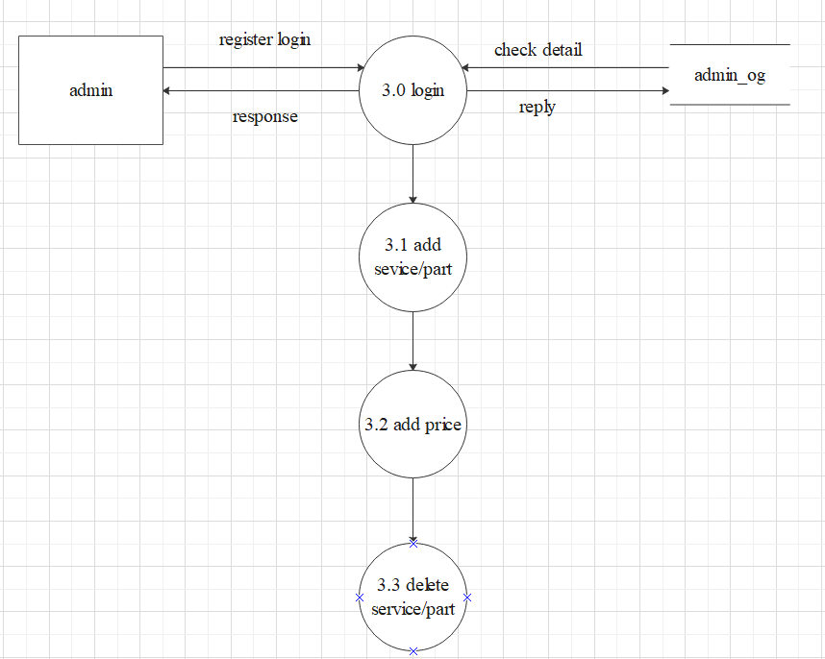

**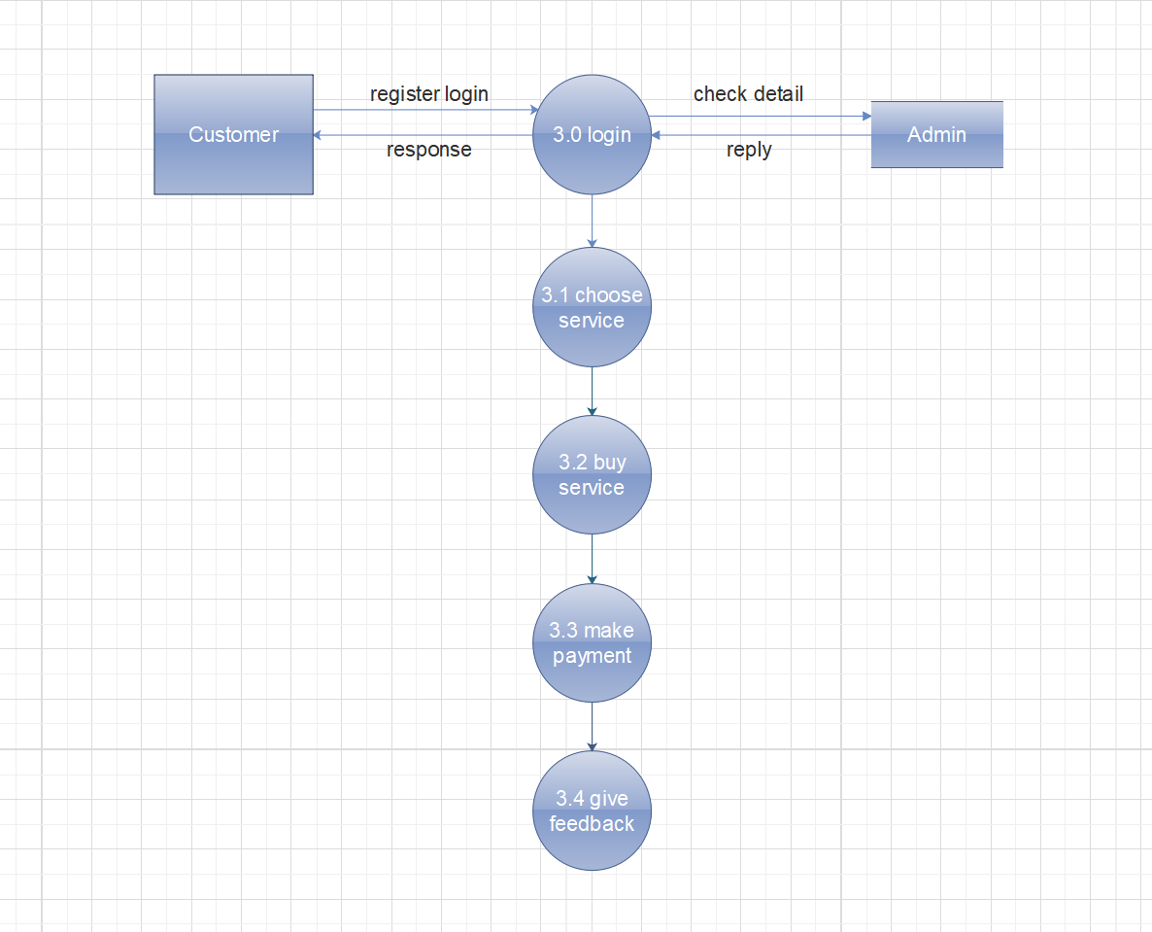**

## (F) Use Case Diagram

* **What is Use Case?**
* A requirements analysis concept
* A case of a use of the system/product
* Describes the system's actions from the point of view of a user.
* Tells a story (A sequence of events involving)
* Interactions of a user with the system
* Specifies one aspect of the behavior of a system, without specifying the structure of the system is oriented toward satisfying a user's goal

* **Use Case Descriptions**
* **Actors-** something with a behavior or role, e.g., a person, another system, organization
* **Scenario-** a specific sequence of actions and interactions between actors and the system
* **Use Case-** a collection of related success and failure scenarios, describing actors using the system to support a goal.
* **Documenting the use case**

In addition to diagramming your use case, it is important to document it. Every use case should be documented in either its own document or at least in its own section of the specification. The following list is comprehensive, so not every use case need contain every element below; but you should think carefully before leaving something out.

* **Name:** A brief, descriptive, and unique name for the use case.
* **Description:** A short description of what the use case does.
* **Actors:** A list of all the actors that interact with the use case.
* **Priority:** A short description of how important the use case is in the overall scope of the application. Knowing the priority of each use case lets you design the architecture accordingly.
* **Status:** Notes how complete (or incomplete) the development of the use case is.
* **Preconditions:** A list of conditions that must be true before the use case starts.
* **Post conditions:** A list of conditions that must be true after the use case is complete.
* **Use case interactions:** Identifies other use cases the use case interacts with or relies upon.
* **Flow of events:** A list of events that happen during the execution of the use case. This could also contain alternative paths.
* **Activity diagram:** An activity diagram or diagrams of the flow of events or some part of the flow of events.
* **Secondary scenarios:** If the flow of events contains only a primary scenario, then here secondary scenarios might also be documented.
* **User interface:** A simplified picture of the user interface for the use case. A prototype of the user interface helps the development team see if the design is on the right track.
* **Sequence diagrams:** Sequence diagrams of the different scenarios.
* **View of participating classes:** A diagram of all the classes whose instances work together to implement the use case.
* **Other requirements:** Other requirements might include quality attributes if you do not have a specific document for them.
* **Admin-Customer Use Case Diagram:**

**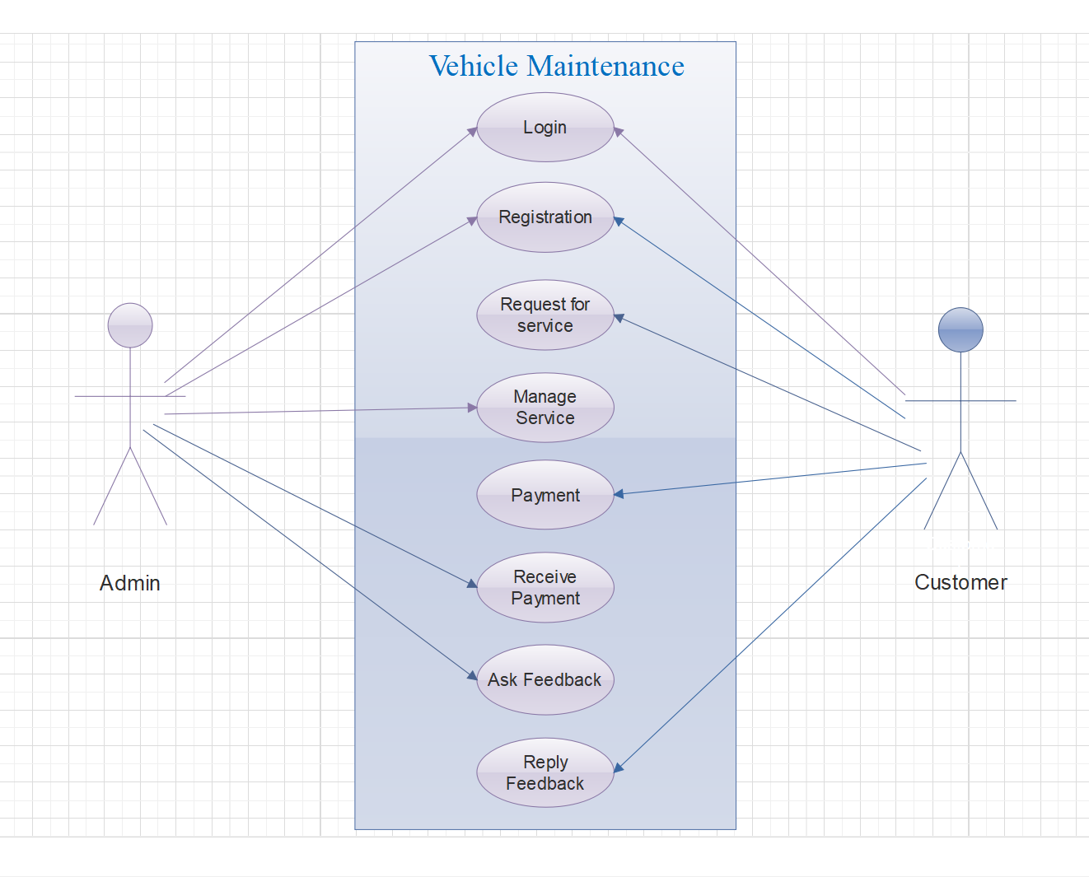**

**CHAPTER: 5**

*The Outline of Problem Work*

**:- Admin Website -:**

**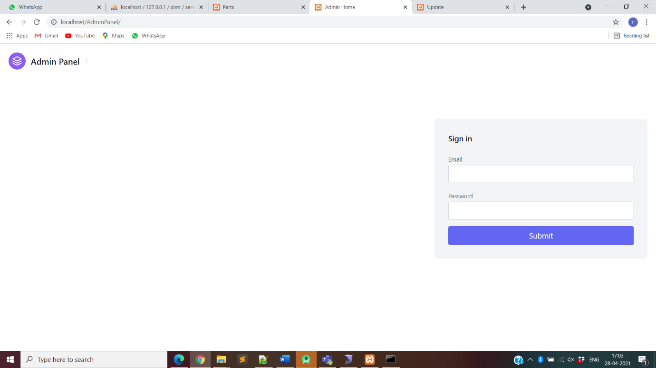**

**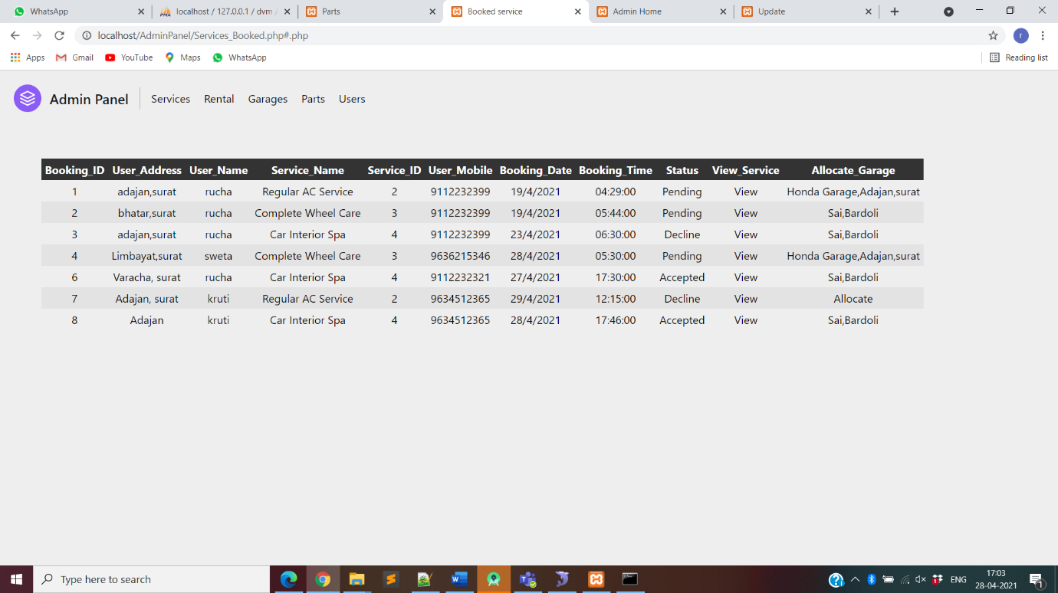**

**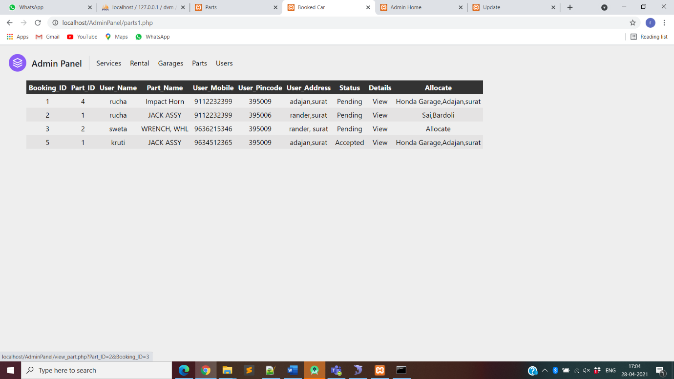**

**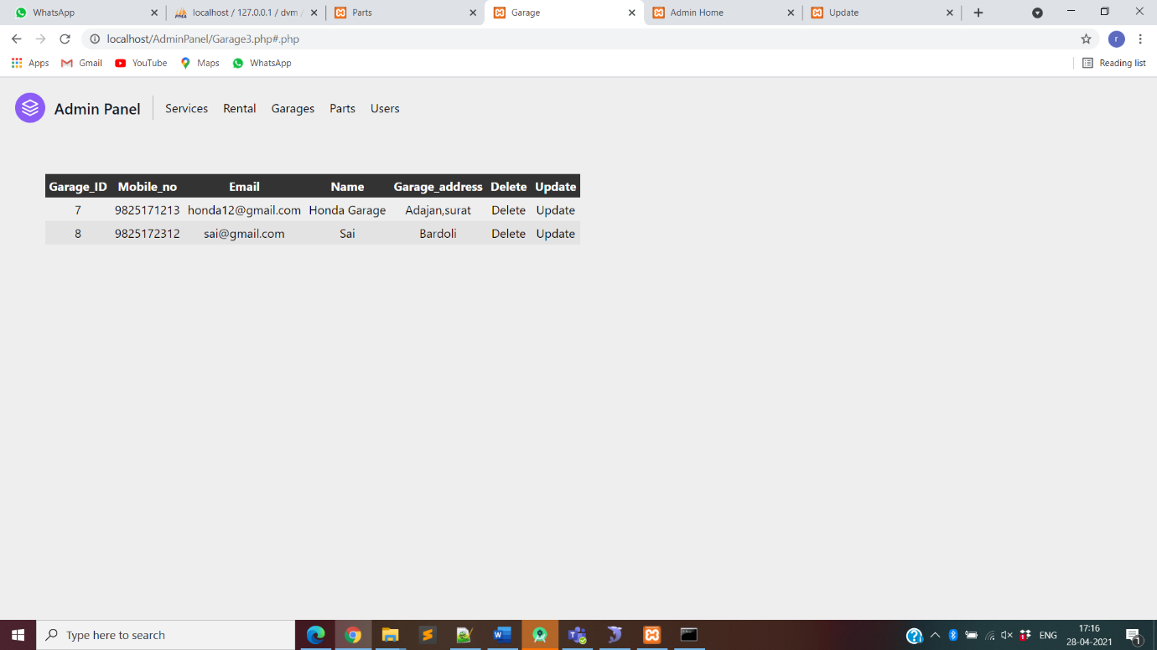**

**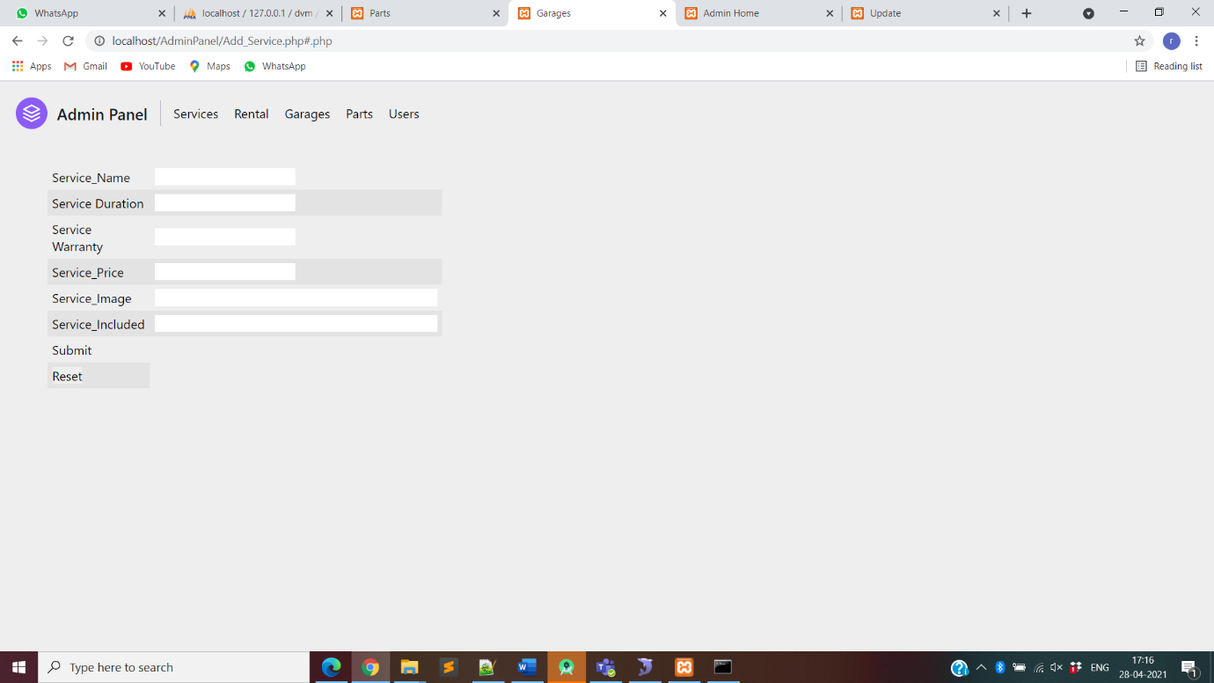**

**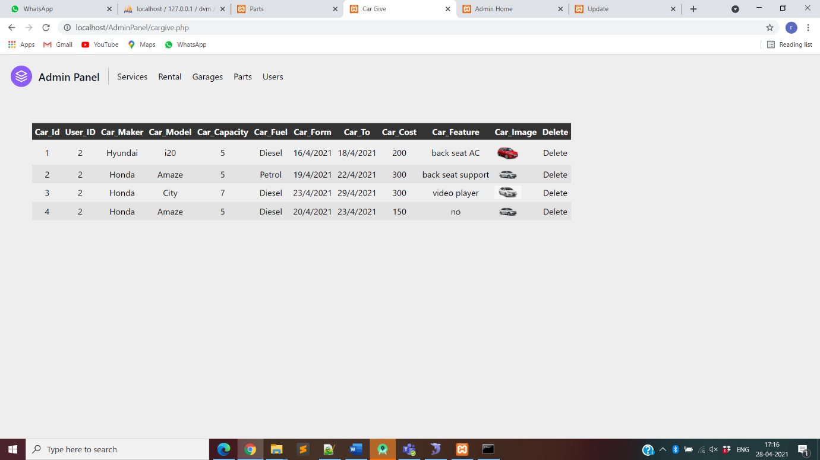**

**:- Application -:**

**Splash Activity Login Activity**

**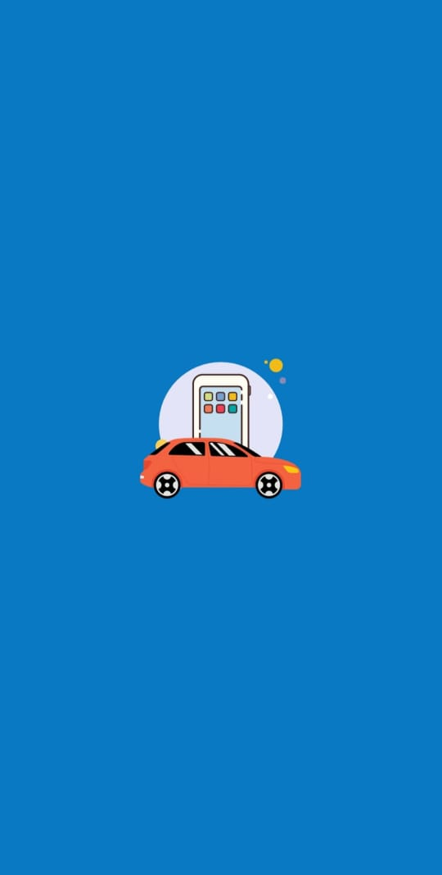 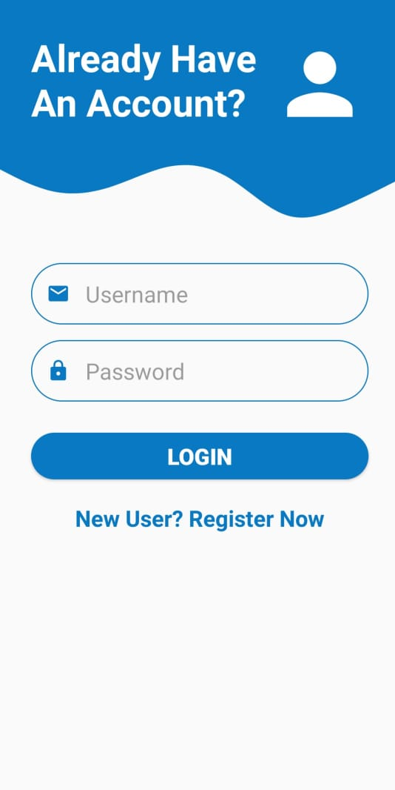**

**Sign Up Activity Home Activity**

**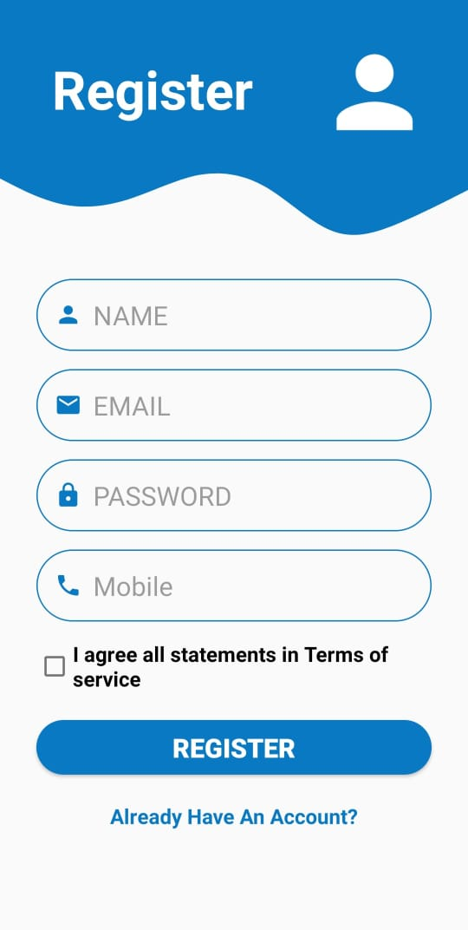 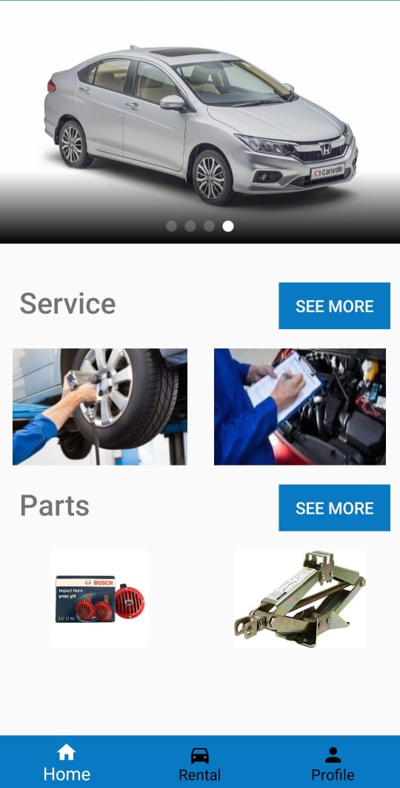**

**Available Services Service Detail**

**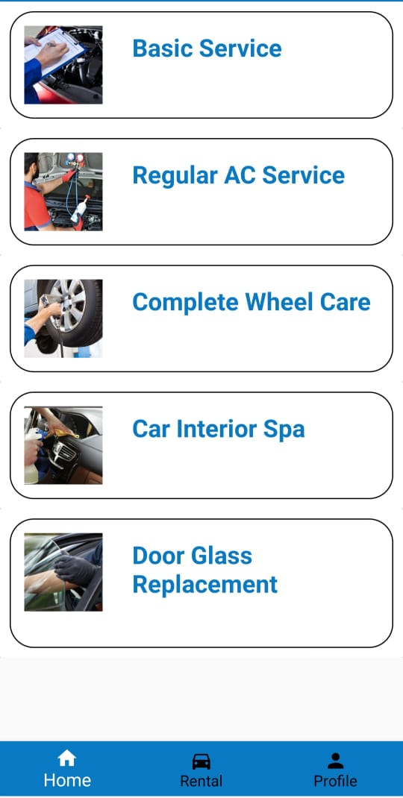 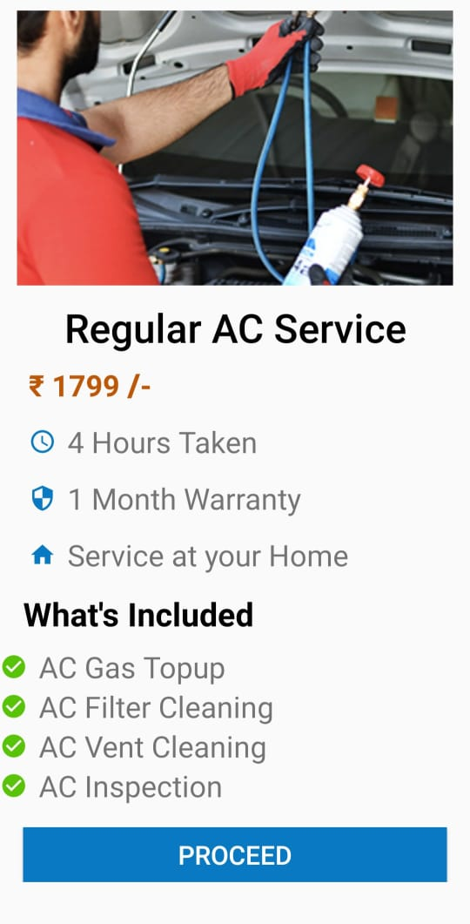**

**Service Booking Profile Page**

**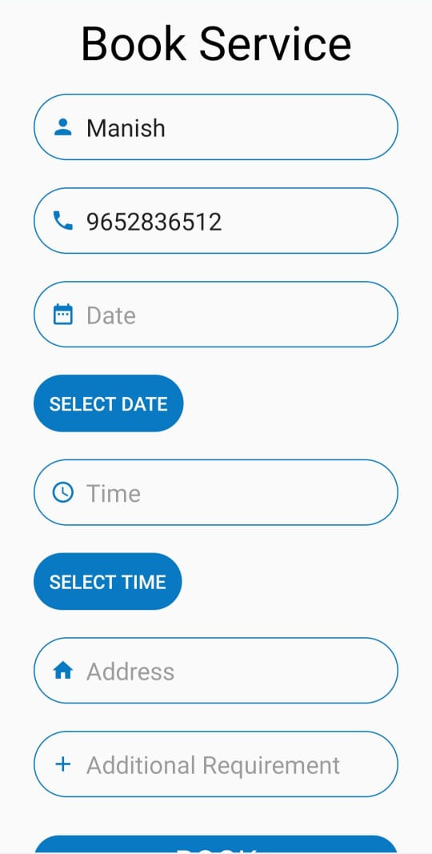 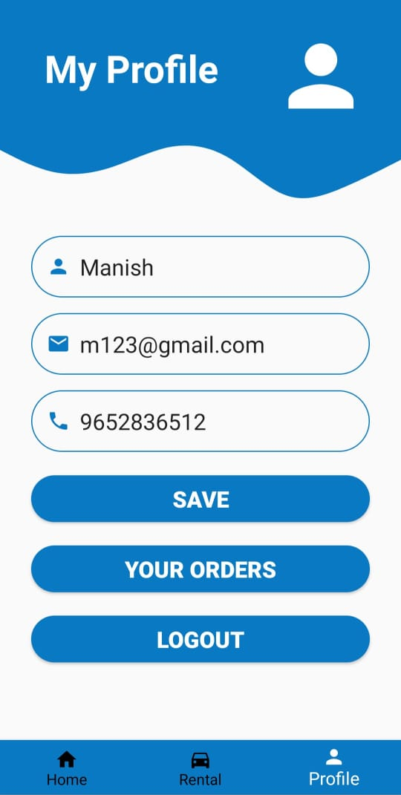**

**Car Rental Page Form**

**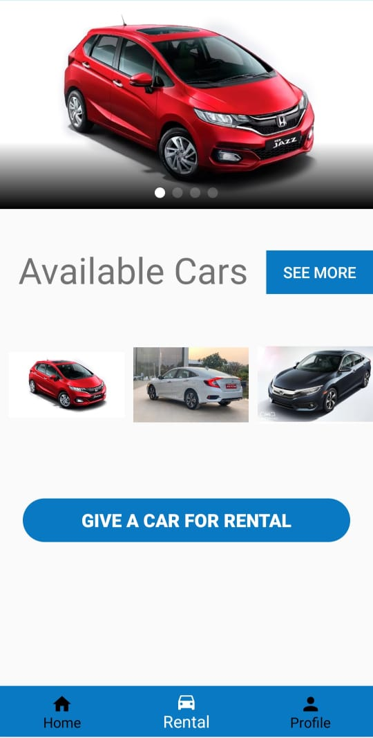 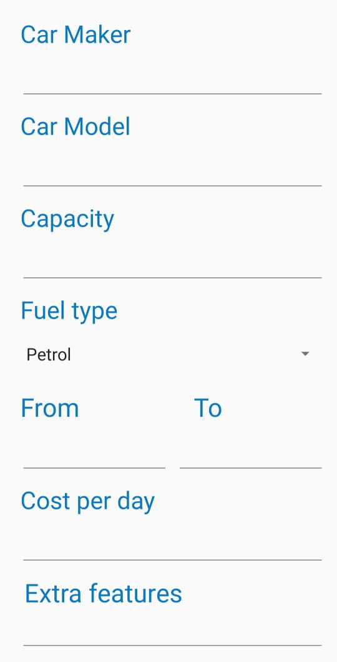**

**Available Cars Book Car for rental**

**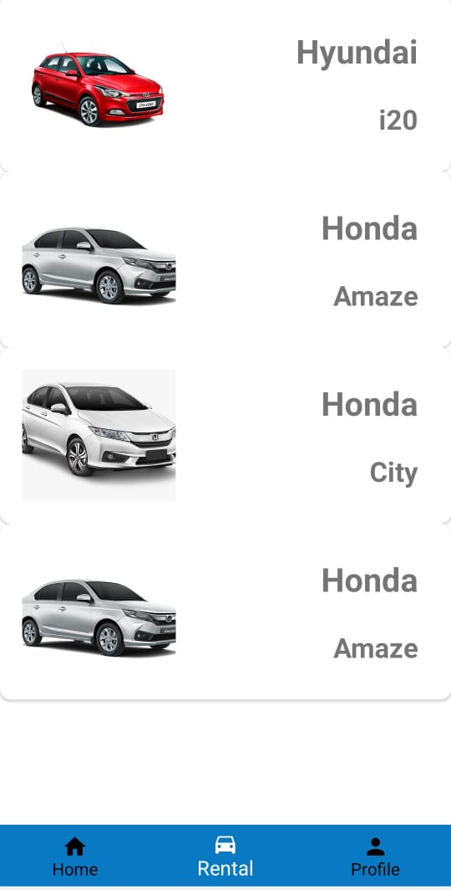 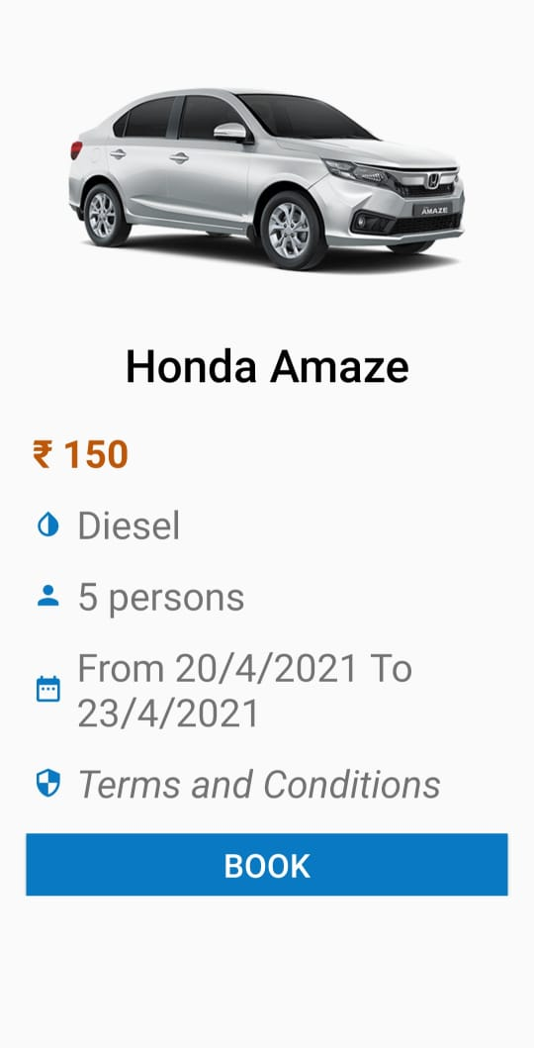**

**Available Parts Part Detail**

**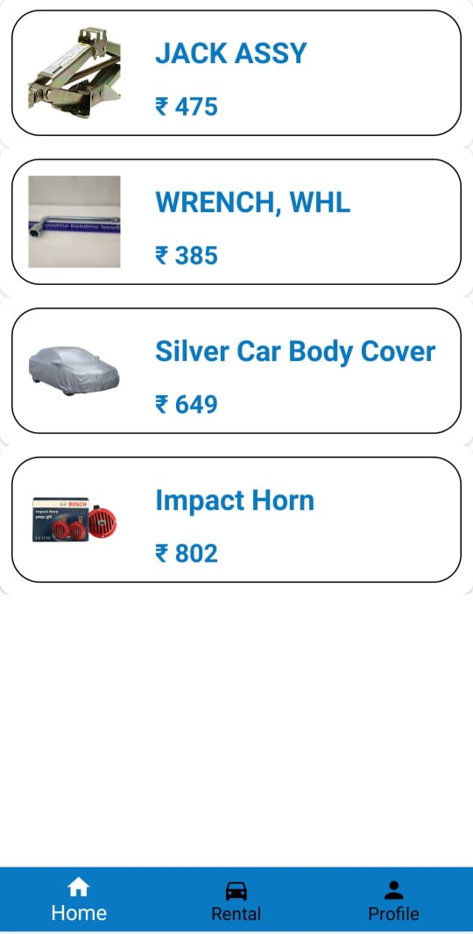 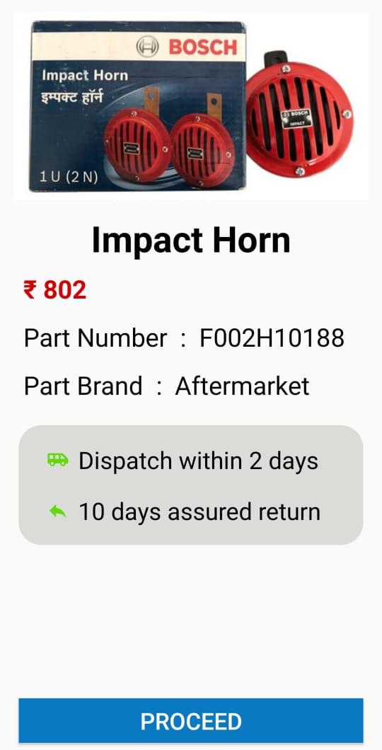**

**Part Booking**

**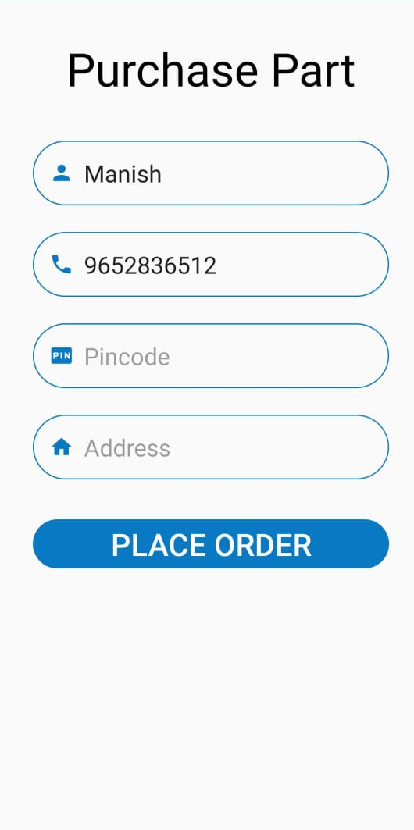**

**CHAPTER: 6**

*Conclusion*

**Conclusion:**

From this project we can conclude that with the help of this project the vehicle owners won’t have to worry about services of vehicle,won’t have to worry about particular parts of vehicle need to replace we can buy particular part through online booking. We can book a car for one or more day whenever we want to travel and also give our car for rental purpose. In this semester we have completed the designing part and in the next we are going work on the implementation of working of the application.

**CHAPTER: 7**

*Bibliography*

**Bibliography:**

During the development of our System, we have taken the reference from Mobile Application

GoMechanic Pitstop



Simply Auto

**CHAPTER: 8**

*Self-Appraisal Form*

### **Name: Dave Rucha (186150307016)**

|  |  |  |  |  |  |
| --- | --- | --- | --- | --- | --- |
| **STUDENT'S SELF APPRAISAL FORM FOR UDP PART-1** | | | | | |
|  | **As a IDP Group** | A | B | C | D |
| 1 | All Students of group understood and agreed on how the whole project was broken down into subtasks. |  |  |  |  |
| 2 | Work was distributed according to the skills and knowledge and capacity of each student. |  |  |  |  |
| 3 | All Students were clear about the time frame and their own responsibilities. |  |  |  |  |
| 4 | All students involved understood that their work would contribute to the group’s success. |  |  |  |  |
| 5 | Individual difficulties experienced by individuals were discussed in the group and other students helped to resolve the difficulties. |  |  |  |  |
|  | **The Task Execution** |  |  |  |  |
| 6 | The work was perfectly & clearly distributed among all students. |  |  |  |  |
| 7    8    9 | The timing and sequencing of sub-tasks done to progress stage by stage.    Survey and Data collected were organized systematically for later use.    On-going checking throughout the process was made to ensure that everything was on the right track. |  |  |  |  |
| 10      11 | Appropriate corrective measures were taken to handle unexpected problems.    The quality of work produced was assessed regularly during the process and also at the end.  Systematic Survey and Literature study done. |  |  |  |  |
|  | **My Roll in the IDP Group** |  |  |  |  |
| 12      13      14      15 | I tried my level best to accomplish the part I taken and in time.    I tried my level best to complete IDP and produce good quality Solution.    I fell strongly that the group success is my own success.    I feel that this IDP is a Real life Problem.  I learned from other students of the Group. |  |  |  |  |
|  | **Marking : A= Strongly in favors , B =**  **Moderately in favors , C = Not Much , D = Not at all** |  |  |  |  |

### **Name: Badgujar Sweta (186150307005)**

|  |  |  |  |  |  |
| --- | --- | --- | --- | --- | --- |
| **STUDENT'S SELF APPRAISAL FORM FOR UDP PART-1** | | | | | |
|  | **As a IDP Group** | A | B | C | D |
| 1 | All Students of group understood and agreed on how the whole project was broken down into subtasks. |  |  |  |  |
| 2 | Work was distributed according to the skills and knowledge and capacity of each student. |  |  |  |  |
| 3 | All Students were clear about the time frame and their own responsibilities. |  |  |  |  |
| 4 | All students involved understood that their work would contribute to the group’s success. |  |  |  |  |
| 5 | Individual difficulties experienced by individuals were discussed in the group and other students helped to resolve the difficulties. |  |  |  |  |
|  | **The Task Execution** |  |  |  |  |
| 6 | The work was perfectly & clearly distributed among all students. |  |  |  |  |
| 7    8    9 | The timing and sequencing of sub-tasks done to progress stage by stage.    Survey and Data collected were organized systematically for later use.    On-going checking throughout the process was made to ensure that everything was on the right track. |  |  |  |  |
| 10      11 | Appropriate corrective measures were taken to handle unexpected problems.    The quality of work produced was assessed regularly during the process and also at the end.  Systematic Survey and Literature study done. |  |  |  |  |
|  | **My Roll in the IDP Group** |  |  |  |  |
| 12      13      14      15 | I tried my level best to accomplish the part I taken and in time.    I tried my level best to complete IDP and produce good quality Solution.    I fell strongly that the group success is my own success.    I feel that this IDP is a Real life Problem.  I learned from other students of the Group. |  |  |  |  |
|  | **Marking : A= Strongly in favors , B =**  **Moderately in favors , C = Not Much , D = Not at all** |  |  |  |  |

### **Name: Doctor Tanushree (186150307021)**

|  |  |  |  |  |  |  |  |  |  |  |  |
| --- | --- | --- | --- | --- | --- | --- | --- | --- | --- | --- | --- |
| **STUDENT'S SELF APPRAISAL FORM FOR UDP PART-1** | | | | | | | | | | | |
|  | | **As a IDP Group** | | A | | B | | C | | D | |
| 1 | | All Students of group understood and agreed on how the whole project was broken down into subtasks. | |  | |  | |  | |  | |
| 2 | | Work was distributed according to the skills and knowledge and capacity of each student. | |  | |  | |  | |  | |
| 3 | | All Students were clear about the time frame and their own responsibilities. | |  | |  | |  | |  | |
| 4 | | All students involved understood that their work would contribute to the group’s success. | |  | |  | |  | |  | |
| 5 | | Individual difficulties experienced by individuals were discussed in the group and other students helped to resolve the difficulties. | |  | |  | |  | |  | |
|  | | **The Task Execution** | |  | |  | |  | |  | |
| 6 | | The work was perfectly & clearly distributed among all students. | |  | |  | |  | |  | |
| 7    8    9 | | The timing and sequencing of sub-tasks done to progress stage by stage.    Survey and Data collected were organized systematically for later use.    On-going checking throughout the process was made to ensure that everything was on the right track. | |  | |  | |  | |  | |
| 10      11 | | Appropriate corrective measures were taken to handle unexpected problems.    The quality of work produced was assessed regularly during the process and also at the end.  Systematic Survey and Literature study done. | |  | |  | |  | |  | |
|  | | **My Roll in the IDP Group** | |  | |  | |  | |  | |
| 12      13      14      15 | | I tried my level best to accomplish the part I taken and in time.    I tried my level best to complete IDP and produce good quality Solution.    I fell strongly that the group success is my own success.    I feel that this IDP is a Real life Problem.  I learned from other students of the Group. | |  | |  | |  | |  | |
|  | | **Marking : A= Strongly in favors , B =**  **Moderately in favors , C = Not Much , D = Not at all** | |  | |  | |  | |  | |