July 21st 2026

Erin R. Jacoby

T (206) 622-2295 D (206) 565-3004
146 N Canal St, Suite 220,
Seattle, WA 98103

Letter of Engagement

Dear Erin:

As requested, DRS Engineering Inc. is pleased to provide this letter of engagement for services in connection with the matter of Barkley Heights II, LLC v. Bradley Engineering - Whatcom County Case No. 26-2-01269-37

Pursuant to our agreement, we will provide services to you as independent professionals. Payment to DRS Engineering Inc. for the services provided is not dependent upon our findings, nor on the outcome of any legal action, mediation, arbitration, or the amount or terms of any settlement of the underlying legal cause, nor on any contractual arrangement between you and any other person or party.

We understand the scope of work to be:
Review of failure mechanism of a soldier pile wall

Excluded:
Any cost estimation

Fees
Fees for our services shall be paid by you at the rates detailed on the attached fee schedule for analysis, calculations, conclusions, preparation of reports, and necessary travel time. Fees will be billed by the hour, with a minimum charge for any discrete task of one half of an hour. For testimony at deposition or trial, we shall be paid at the rate indicated in the Legal section of the attached fee schedule, to be billed in hourly increments. This rate for testimony shall apply both while we are waiting to give testimony, whether at an office or court, and for time taken for breaks or meals as well as for time spent giving testimony.

Most of the work will be performed by David R. Salter BSc PhD PE at the Senior Principal Engineer / President rates attached. At times, the work may require the assistance of supporting engineering and/or administrative staff. We shall be paid at the appropriate rates as indicated on the attached fee schedule to be billed hourly with a minimum charge for any discrete task of one half of an hour.

Attached are our billing rates for time and materials expended on the project.

Travel and Lodging Expense:
You agree to reimburse DRS Engineering Inc. for expenses as follows:

• Travel by Car: Mileage charged at seventy (70) cents per mile.
• Travel by Air or Train: The actual cost of the round-trip ticket, plus fifteen percent (15%)
handling fee.
• Expenses associated with photography, reproduction of documents and photographs, preparation of exhibits, storage of material or evidence, and other reasonable expenditures shall be reimbursed at market rates.
• Lodging: For any journey of more than eighty (100) miles from my office, we shall be reimbursed for the cost of meals and lodging, plus a fifteen percent (15%) handling fee.
• Car Rental: In the event of traveling beyond the local area, we shall be reimbursed for the cost of a mid-sized rental car and any associated expenses, plus a fifteen percent (15%) handling fee.
• Unless you otherwise instruct, or unless refundable tickets are not available, we will purchase refundable tickets for any necessary travel. Should you request that we purchase non-refundable tickets to travel at a lower cost, or if refundable tickets are not available, you shall reimburse DRS Engineering Inc. for the cost of any non-refundable ticket at the rate outlined herein whether the ticket is used or not.

You may avoid the fifteen percent handling fee associated with certain travel expenses by arranging to directly purchase round-trip travel tickets on my behalf, and by arranging for the direct payment of any car rental expense, lodging and meal expenses by your office.

Invoicing and Payments:
Monthly invoices will be issued to
Erin R. Jacoby
Davis Rothwell
Earle & Xochihua
146 N Canal St, Suite 220,
Seattle, WA 98103

for payment associated with the services requested. Invoices are due on receipt and shall be considered delinquent if unpaid more than sixty days after their date of issuance. Interest shall accrue to any delinquent balance at the maximum rate permitted by law, not to exceed one percent per month. If a bill remains unpaid for sixty or more days after the date of issuance, we shall have the unrestricted right to resign from performing additional services in all cases that we are working on for your firm. This agreement shall be interpreted under the laws of the State of California. Any litigation under this agreement shall be resolved in the trial courts of County Santa Barbara, State of California.

Your signature below represents your agreement with the terms set forth herein. Please return a signed copy of this letter to my office.
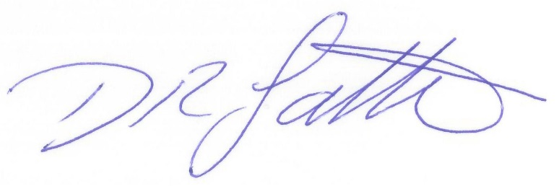
Very truly yours,

David R Salter BSc PhD PE
President
DRS Engineering Inc.

Attorneys Signature

Printed Name______________________

Title______________________________

Organization_______________________

Date______________________________

2026 FEE SCHEDULE

Hourly Personnel Rates
Senior Principal Engineer / President $ 375.00
Principal Engineer $ 340.00
Senior Project Engineer $ 275.00
Project Engineer $ 235.00
Senior Designer $ 235.00
Designer $ 210.00

INSURanCE
- All costs associated with the provision of insurances and endorsements not stated on the attached sample certificate will be charged at 15% over actual cost.
Legal
- Fees for participation in deposition, arbitration, trial, etc., will be charged at an hourly rate of $425.00 (4-hour minimum, portal-to-portal).
Outside Services
- All outside services will be charged at 15% over actual cost.
- Mileage charged at $0.70 per mile

Rates subject to increase after Dec 31st 2026

