Deep Learning Lab

Starting the Servers

# SSH Into the Machines

### On Windows

Use Bash on Windows – Setup Instructions here <http://www.howtogeek.com/265900/everything-you-can-do-with-windows-10s-new-bash-shell/>

### On Linux

Use your regular shell

# Start Servers

Open a bash shell

* Execute: ssh drcrook@<yourserver ip>
  + When asked to enter a password, use ‘David!234567890’
* Execute: cd digits
* Execute: ./digits-devserver –port 8888 &
  + Do not use sudo.
* You should see output as below:
* 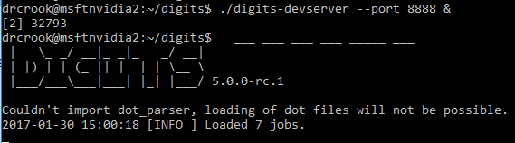
* Verify by using a browser to navigate to: YOURIPADDRESS:8888

Open a new bash shell

* Execute: ssh drcrook@<yourserver ip>
  + When asked to enter a password, use ‘David!234567890’
* Execute: cd DLI_RoboWorkshop_1
* Execute: git reset --hard
* Execute: git pull
* Execute: cd notebooks
* Execute: sudo jupyter notebook &
* You should see output as below:
  + 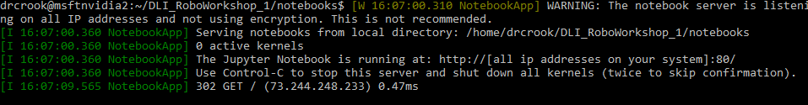
* Using a browser Navigate to: <YOURIP>
* You should see similar to below:
  + Use password: msftnvidia
  + 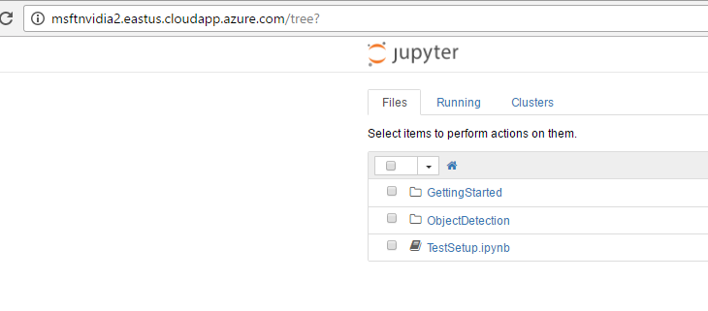

# Test Configuration

* Open TestSetup.ipynb from your jupyter notebook server
* Clear the output of all cells
  + 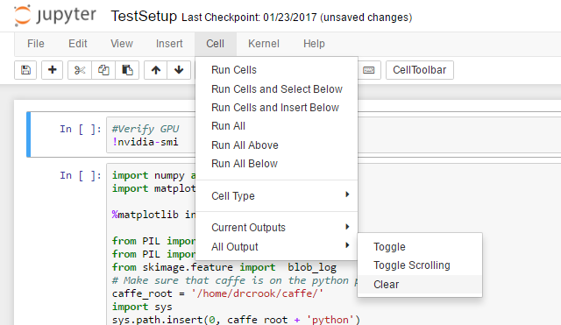
* Execute All Cells
* You should see the following outputs
* 
 