Cell Type Image Recognition of Cells in Bone Marrow Aspirates

**INTRODUCTION**

The bone marrow is the principal organ for blood cell production in the body. In the course of one day the bone marrow will produce in the order of 12 million cells to replace those lost from the circulation. A wide number of diseases and drugs can affect the bone marrow causing the baseline numbers of cells to change. Bone marrow examination is therefore a cornerstone diagnostic for many conditions. The bone marrow is obtained by aspiration (performed under local or general anaesthesia) and then smears made on glass slides that are then stained and examined. Examination of bone marrow in this manner is a time consuming task that is potentially biased by over or undercounting of cells and or miss-identification. Typically therefore bone marrow examination is only performed by highly specialist individuals (pathologists).

This project aims to create a proof of concept ML algorithm that can take as input microscope images of bone marrow cells and then identify and classify each cell in the image.

**MORE ON BONE MARROEW**

Bone Marrow is a highly active complex cellular mixture that through a series of cellular divisions and maturation steps turns pleuripotent stem cells in to the red cells and white cells seen in the blood (figure 1).

Fig 1. Blood that has been allowed to stand separates out into red and white fractions

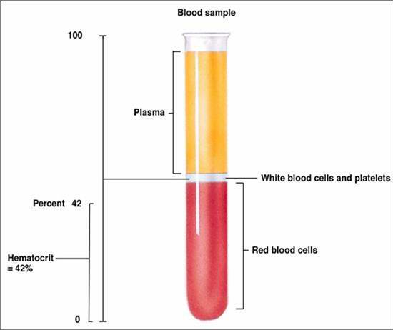

**BLOOD CONSTITUENTS**

**The red cells (erythrocytes) are responsible for oxygen transport in the body. The typical red cell is a bi-concave disc with no nucleus.**

**White cells are a mix of nucleated cells (have blue blobs in the centre). These are the neutrophil, lymphocyte, eosinophil, monocyte and basophil. These cells are involved in immunity either as effectors (neutrophils) or co-ordinators (lymphocytes)**

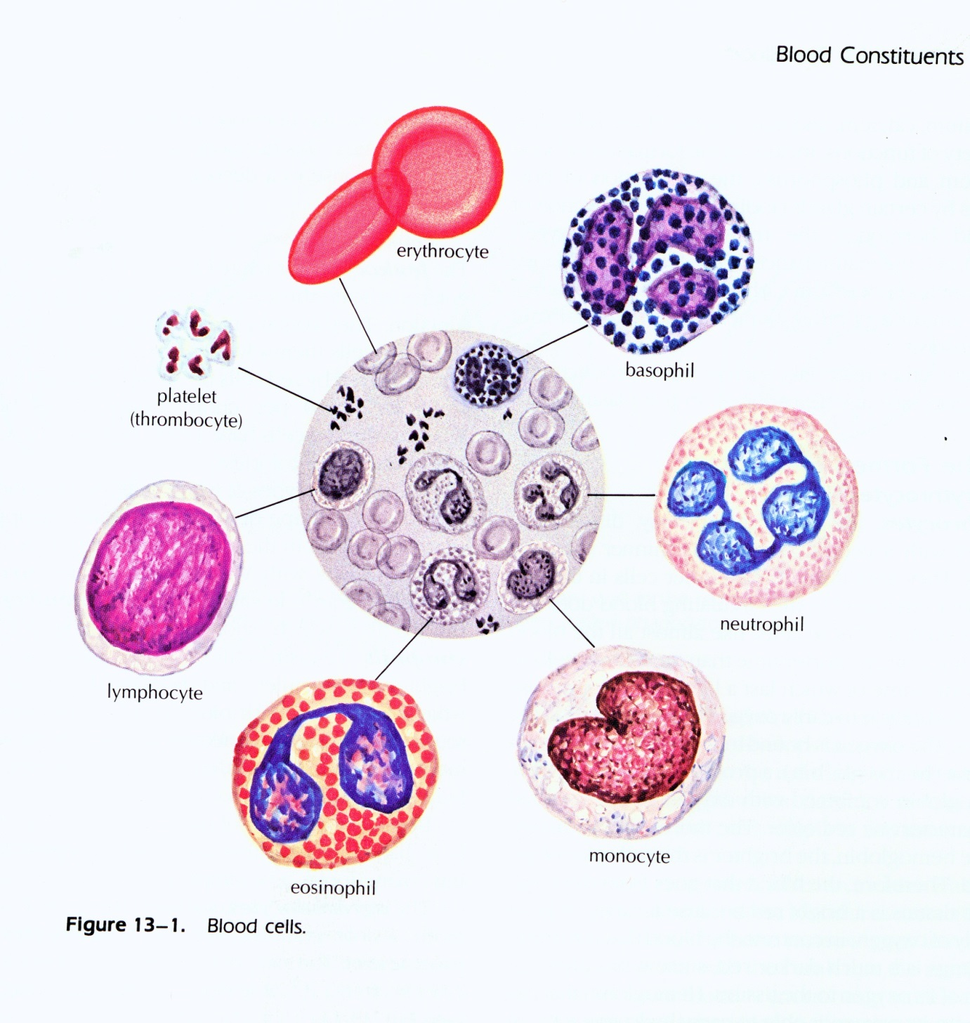

**These cells can be thought of as the output from the bone marrow. Consequently these cells will be the most numerous in the bone marrow.**

**BONE MARROW – THE NITTY GRITTY**

**Each stem cell divides and develops and then eventually pursues a course of committed development down one of the pathways outlined below.**

**At each stage the cells divide so their numbers increase by ~x2 at each step. Consequently the cells at the bottom (especially granular leukocytes and reticulocytes) make up ~50% of the cells seen on a smear.**

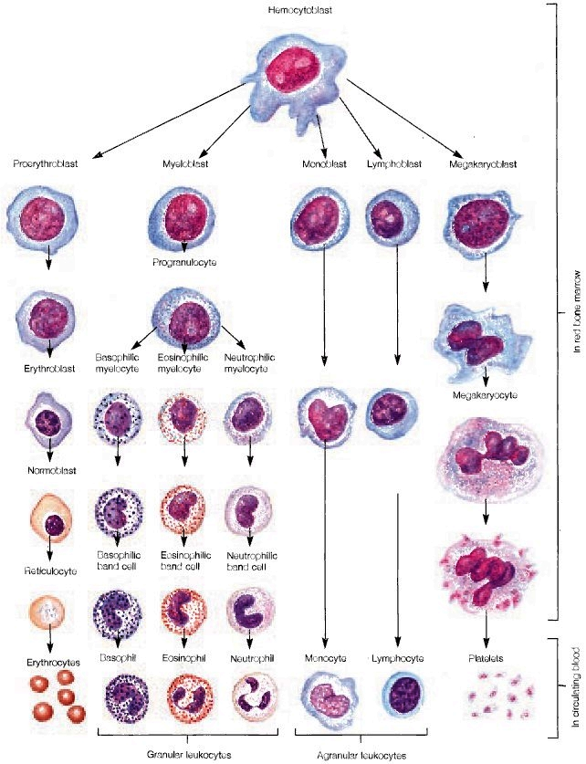

**HOW DO EXPERTS IDENTIFY THE CELLS**

**There are a number of features that are used:**

1. **Cell size**
2. **Cell shape**
3. **Nucleus size (blueish blob in middle)**
4. **Nucleus shape**
5. **Nucleus colour(or granularity)**
6. **Cytoplasm colour (light grey blue stuff that surrounds the nucleus)**
7. **Cytoplasm granules/Vacuoles (any coloured or clear blobs in the cytoplasm)**

**THE DATASET**

**The dataset consists of a number of high quality .jpg images of bone marrow aspirates taken from normal dogs.**

**THE CHALLENGE**

**Create algorithm that can take each primary image and create a set of images for all the individual cells on the primary image. – lets call this the individual cell isolator (ICI)**

**From these images I can then identify the cell in the image and thus create a training set.**

**Next create an algorithm that can learn from this training set to identify new cell images that are presented to it.**

**NEXT STEPS**

**Clearly in this case creating an algorithm that can determine cell from not cell or cell from group of cells will be a crucial first step. We have a couple of features that might help. Firstly, erythrocytes and neutrophils are almost always a standard size and colour (not always) – and almost always present. Secondly, most of our cells are round or roughly round. Third I’ll try and select fields to photograph where the cells are separate from one another to make it as easy a possible.**

**OTHER CHALLENGES (to be mindful of)**

**There are a number of issues that we may need to tackle but maybe not yet –**

1. **preprocessing the images to a standard colour palette,**
2. **dealing with variable cell staining**
3. **dealing with clumps of cells**
4. **dealing with variable cell size in the image depending on the microscope that took the image**