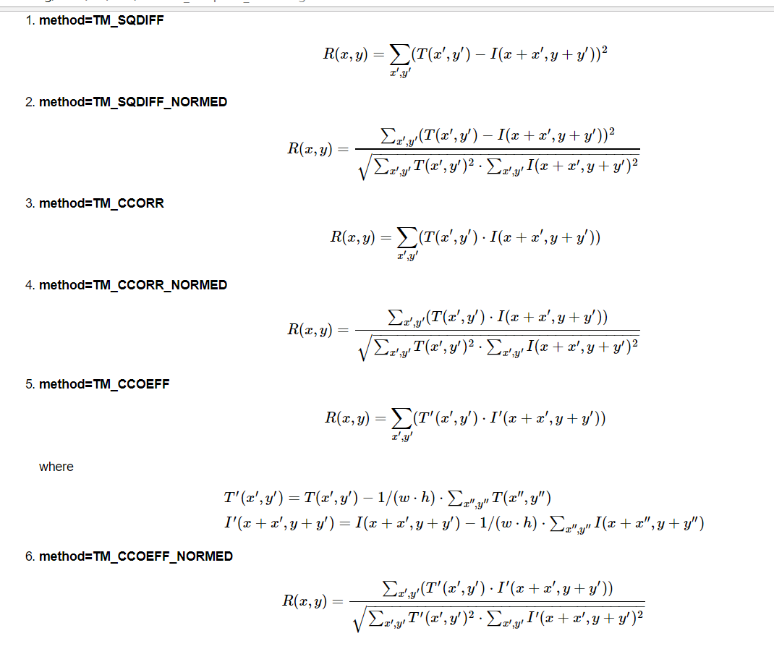
a)method=CV_TM_SQDIFF，平方差匹配法
b)method=CV_TM_SQDIFF_NORMED，归一化平方差匹配法
c)method=CV_TM_CCORR，相关匹配法
d)method=CV_TM_CCORR_NORMED，归一化相关匹配法
e)method=CV_TM_CCOEFF，系数匹配法
f)method=CV_TM_CCOEFF_NOR，归一化相关系数匹配法

